**AFRL Research Collaboration Program**

**Contract FA8650-13-C-5800**

**Effect of Constituents and Microstructure on Energy Dissipation Mechanisms During Damage Growth**

**University: Texas A&M University**

**REPORT COVERS PERIOD: 7-1-16 THRU 9-30-16**

1. **PROJECT TEAM MEMBERS**
2. **LEAD UNIVERSITY POC:** John Whitcomb, 979-845-4006, jdw@tamu.edu
3. **PROJECT TEAM MEMBERS:** John Whitcomb,Keith Ballard, Collin Blake
4. **AFRL TECHNICAL POC:** Craig Przybyla
5. **TECHNICAL DISCUSSION**
6. **CURRENT WORK**This quarter we continued work on damage evolution and model result convergence.

**Background**

With the increasingly widespread use of fiber/matrix composites, the accurate prediction of the progression of damage and final failure is an important topic for researchers. Consequently, researchers have proposed numerous computational models to predict progressive damage within a multiscale framework. At the microscale, where fibers and matrix are modelled discretely, some popular approaches to model damage include the use of continuum damage elements, which models the effect of a damage parameter on the response of a material, cohesive elements placed along a predetermined potential crack path, which models the discrete crack explicitly, a plasticity model for matrix damage combined with cohesive zone elements for interfacial debonding, and mesh independent methods, which allow the crack to grow along an arbitrary path.

With all of these methods, very little of the literature compares the results of these methods, and no work compares the different methods using the same meshes and material properties. To confidently predict the progression of damage at the fiber matrix scale, the differences between the available models and their agreement with experimental results should be understood.

**Approach**

This work compares the progression of damage using a continuum damage model and cohesive zone model. Both of these models have been used extensively in previous research. Continuum damage offers the benefits of allowing damage to occur anywhere, easier mesh generation, and better numerical stability. However, continuum damage does not directly model discrete cracks or fiber/matrix debonding. The use of cohesive elements alleviates this shortcoming, but the analyses have mesh dependency and much worse numerical stability.

During this quarter, the focal problem was an infinite hexagonal array of fibers subjected to uniaxial loads. Because of periodic boundary conditions, only one fiber was modeled. Analysis of the dependence of the continuum damage model on the mesh refinement was conducted. Uniaxial load was applied. The direction is defined by the angle theta. For this study, the direction of the loading is at theta= 0 deg. The parameters for the mesh for the matrix is defined radially and circumferentially and were increased individually by factors of 2, resulting in overall refinements of 4. Each refinement was subjected to the same loading with the same properties. The strength and energy dissipated was determined for each analysis and analyzed for convergence.

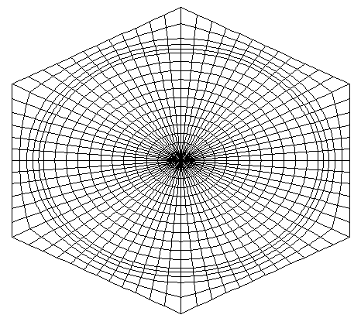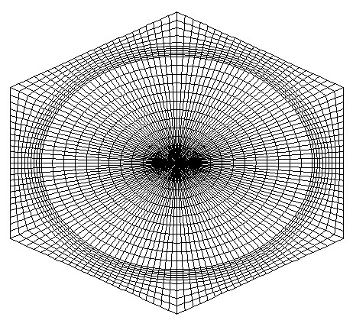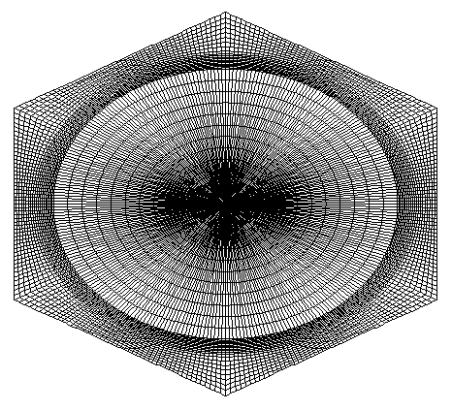

Figure 1: Progression of Mesh Refinement (5x6, 10x12, 20x24)

The initial refinement chosen was 5 radial elements (outwards) and 6 circumferential elements (from the axis of symmetry through each face). Figure 1 shows a progression of refinements with their parameters (radial x circumferential). As the refinement is increased, both the strength and the energy dissipated begin converging to their respective values, as can be seen in Figure 2.

Figure 2: Strength and Energy Dissipated as functions of Refinement Factor

Figure 2 shows fairly similar convergence rates for both values. Note that the values on the vertical axis are very close, indicating that even a very coarse mesh has very similar values compared to the more refined meshes. The energy dissipated is affected by mesh refinement. A coarser mesh has the ability to hold a small amount of load after the initial failure. As each load step is applied more energy can be released due to this phenomenon. Therefore, the energy dissipated is calculated assuming full model failure after the first load step. Figure 3 shows the differences in the energy dissipated using the two calculations. Note, Figure 2 uses the second method for energy dissipation.

Figure 3: Energy of First Failure and Total Energy versus Refinement Factor

Figure 4 shows the log base 10 of the relative errors of both the strength and energy dissipated compared to the log base 10 of refinement.

Figure 4: Relative Errors of Strength and Energy Dissipated versus Increasing Refinement

Figure 4 shows a nearly perfect linear convergence rate for both the strength and energy dissipated. This rate can be used to predict the values both metrics are converging to.

1. **CONCLUSIONS/ANALYSIS TO DATE**

The mesh refinement of the model being analyzed does not contribute significantly to the strength of the model. While there is some convergence, the variation in less than 0.5% between the coarsest and most refined meshes. The mesh refine does, however, affect the energy dissipated depending on the formulation of the calculation of energy dissipated. Taking the total area of the curve allows for the coarse models ability to hold small loads after initial failure to increase the total energy dissipated. However, if the model is assumed to fail completely after the initial failure, then the energy dissipated shows a very small dependence on the mesh refinement. This allows for coarser models to be run without a significant loss in accuracy for favor of runtime.

1. **WORK FORECAST AND PLANS**Collin Blake is planning to be at AFRL as an intern this summer. This will be an ideal opportunity for collaboration. In addition to the great educational opportunity for Collin, I expect our efforts in the fall to be guided by the interaction this summer. My personal efforts during the summer will focus on remote advising, collaboration with AFRL researchers, and developing strategic plans for the next quarter.