**AFRL Research Collaboration Program**

**Contract FA8650-13-C-5800**

**Effect of Constituents and Microstructure on Energy Dissipation Mechanisms During Damage Growth**

**University: Texas A&M University**

**REPORT COVERS PERIOD: 4-1-16 THRU 6-30-16**

1. **PROJECT TEAM MEMBERS**
2. **LEAD UNIVERSITY POC:** John Whitcomb, 979-845-4006, jdw@tamu.edu
3. **PROJECT TEAM MEMBERS:** John Whitcomb,Keith Ballard, Collin Blake
4. **AFRL TECHNICAL POC:** Craig Przybyla
5. **TECHNICAL DISCUSSION**
6. **CURRENT WORK**This quarter we continued work on damage evolution and the associated maximum strength.

**Background**

With the increasingly widespread use of fiber/matrix composites, the accurate prediction of the progression of damage and final failure is an important topic for researchers. Consequently, researchers have proposed numerous computational models to predict progressive damage within a multiscale framework. At the microscale, where fibers and matrix are modelled discretely, some popular approaches to model damage include the use of continuum damage elements, which models the effect of a damage parameter on the response of a material, cohesive elements placed along a predetermined potential crack path, which models the discrete crack explicitly, a plasticity model for matrix damage combined with cohesive zone elements for interfacial debonding, and mesh independent methods, which allow the crack to grow along an arbitrary path.

With all of these methods, very little of the literature compares the results of these methods, and no work compares the different methods using the same meshes and material properties. To confidently predict the progression of damage at the fiber matrix scale, the differences between the available models and their agreement with experimental results should be understood.

**Approach**

This work compares the progression of damage using a continuum damage model and cohesive zone model. Both of these models have been used extensively in previous research. Continuum damage offers the benefits of allowing damage to occur anywhere, easier mesh generation, and better numerical stability. However, continuum damage does not directly model discrete cracks or fiber/matrix debonding. The use of cohesive elements alleviates this shortcoming, but the analyses have mesh dependency and much worse numerical stability.

During this quarter, the focal problem was an infinite hexagonal array of fibers subjected to uniaxial loads. Because of periodic boundary conditions, only one fiber was modeled. Figure 1 shows the finite element mesh. Uniaxial load was applied. The direction is defined by the angle theta. For this initial study, the properties were adjusted to match the strengths for the two models for theta= 0 deg.

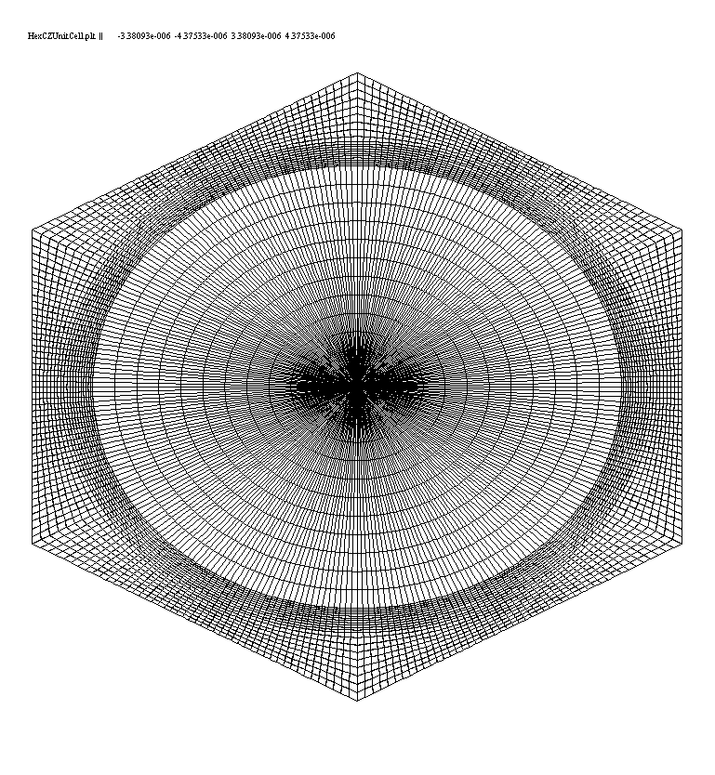

* Highly refined mesh
* Periodic boundary conditions imposed to create infinite array

❑

Direction of applied uniaxial load

**Continuum damage model**

Reduce moduli when strength exceeded

**Cohesive zone model**

Progressive opening per traction-separation law

Figure 1 Configuration

As both the normal and transverse strength of the cohesive zones were adjusted by a percent reduction, the error between the continuum damage model strength and the cohesive zone model strength also reduced. Figure 2 shows the relative error per each reduction.

Figure 2: Percent error as a function of percent reduction

The relative strengths of each model can also be compared through this iterative process. Figure 3 shows the variation of strength for the cohesive zone model as it approaches the desired value from the continuum damage model.

Figure 3: Evolution of strength for the Cohesive zone model at 0 degrees

A preliminary comparison of loading angle was also conducted with the adjusted cohesive zone strength parameters. Figure 4 shows this comparison between the two models.

Figure 4: Model Strengths through angles of loading

1. **CONCLUSIONS/ANALYSIS TO DATE**

Comparisons of predictions using continuum damage and cohesive zone models showed that for even a fairly simple problem, the predicted strengths are significantly different. Therefore, we decided to modify the normal and transverse strength parameters that are unique to the cohesive zone model to better match these strengths so that results from future predictions can be compared more accurately. The strength of the cohesive zone model now matches the strength of the continuum damage model to a very small error at 0 degrees of loading. However, as the models rotate the strengths begin to diverge. The next step in the comparison of the two models is to further explore the cause behind this separation and determine a method to overcome this lack of agreeance.

1. **WORK FORECAST AND PLANS**Collin Blake is planning to be at AFRL as an intern this summer. This will be an ideal opportunity for collaboration. In addition to the great educational opportunity for Collin, I expect our efforts in the fall to be guided by the interaction this summer. My personal efforts during the summer will focus on remote advising, collaboration with AFRL researchers, and developing strategic plans for the fall.