**AFRL Research Collaboration Program**

**Contract FA8650-13-C-5800**

**Effect of Constituents and Microstructure on Energy Dissipation Mechanisms During Damage Growth**

**University: Texas A&M University**

**REPORT COVERS PERIOD: 1-1-17 THRU 3-30-17**

1. **PROJECT TEAM MEMBERS**
2. **LEAD UNIVERSITY POC:** John Whitcomb, 979-845-4006, jdw@tamu.edu
3. **PROJECT TEAM MEMBERS:** John Whitcomb, Collin Blake
4. **AFRL TECHNICAL POC:** Craig Przybyla
5. **TECHNICAL DISCUSSION**
6. **CURRENT WORK**Development of the infrastructure to perform mesoscale analysis of 3D textile composites.

**Background**

In the past couple of years, another graduate student, Scott McQuien, explored the accuracy of the VTMS suite of tools in predicting stresses in plain weave composites. Although Scott discovered a number of issues with the software, the geometry modeling capabilities were quite promising. Early this quarter Keith Ballard developed techniques to use the geometry produced by VTMS and other modeling tools to develop a standard finite element model for a 3D textile composite. Based on Scott and Keith’s experience, we decided there was excellent potential for developing finite element models using the geometry engine. However, difficulties that Scott and Keith experienced convinced us that we needed to take a fresh look at the geometry creation component of VTMS and the subsequent finite element mesh generation. Accordingly, Collin spent the quarter learning to use VTMS for a simple textile composite and exploring a number of mesh generation programs. The following describes Collin’s activities during the quarter. I should point out that Keith Ballard is not supported by this contract, but does provide mentoring for Collin. Scott McQuien was supported last summer as an intern at AFRL, during which time he helped identify some errors in the VTMS coding.

**Approach**

Collin learned the basic process that VTMS uses to generate its geometries. VTMS creates this geometry by starting with an idealized approximation of fiber weave pattern. This approximation is then “fiberized” into smaller domains, which are then relaxed into a textile shape. Once the shape is clipped to an appropriate size, it is then converted to a surface geometry. The results of this process are shown in Figure 1.

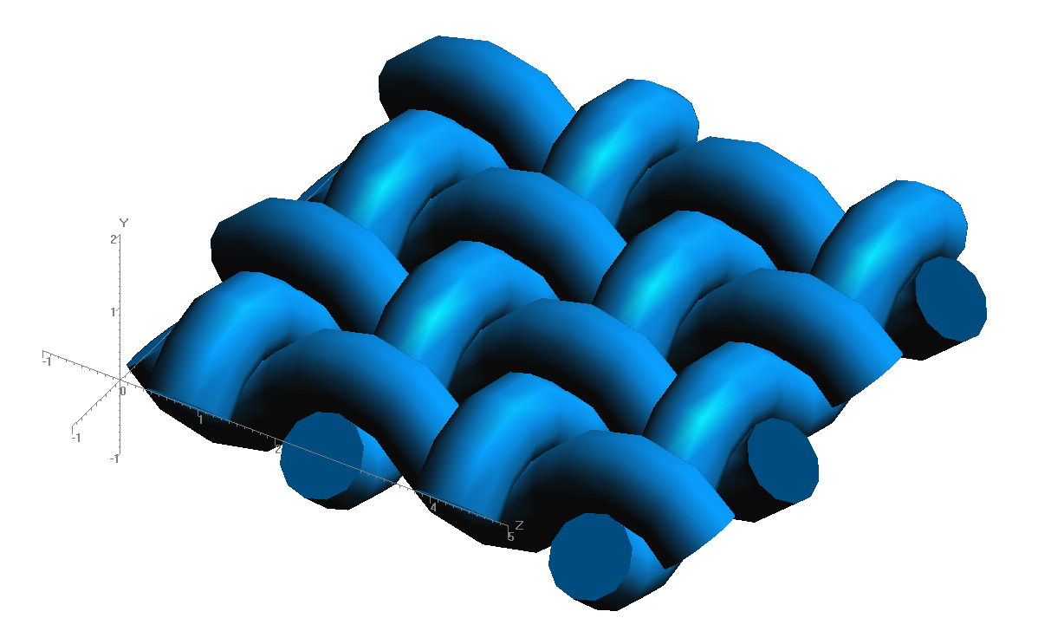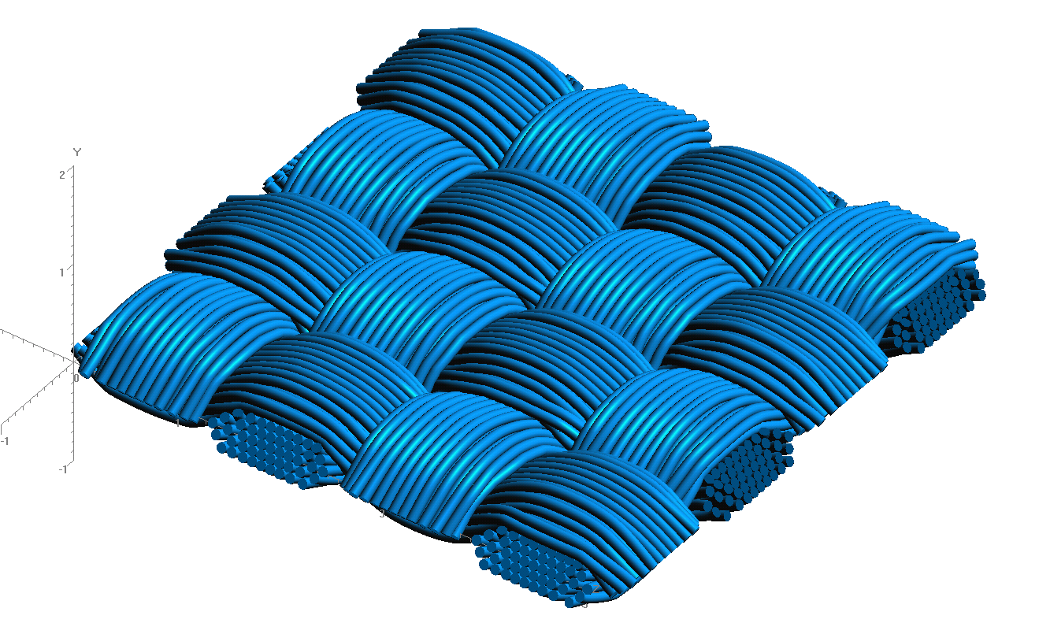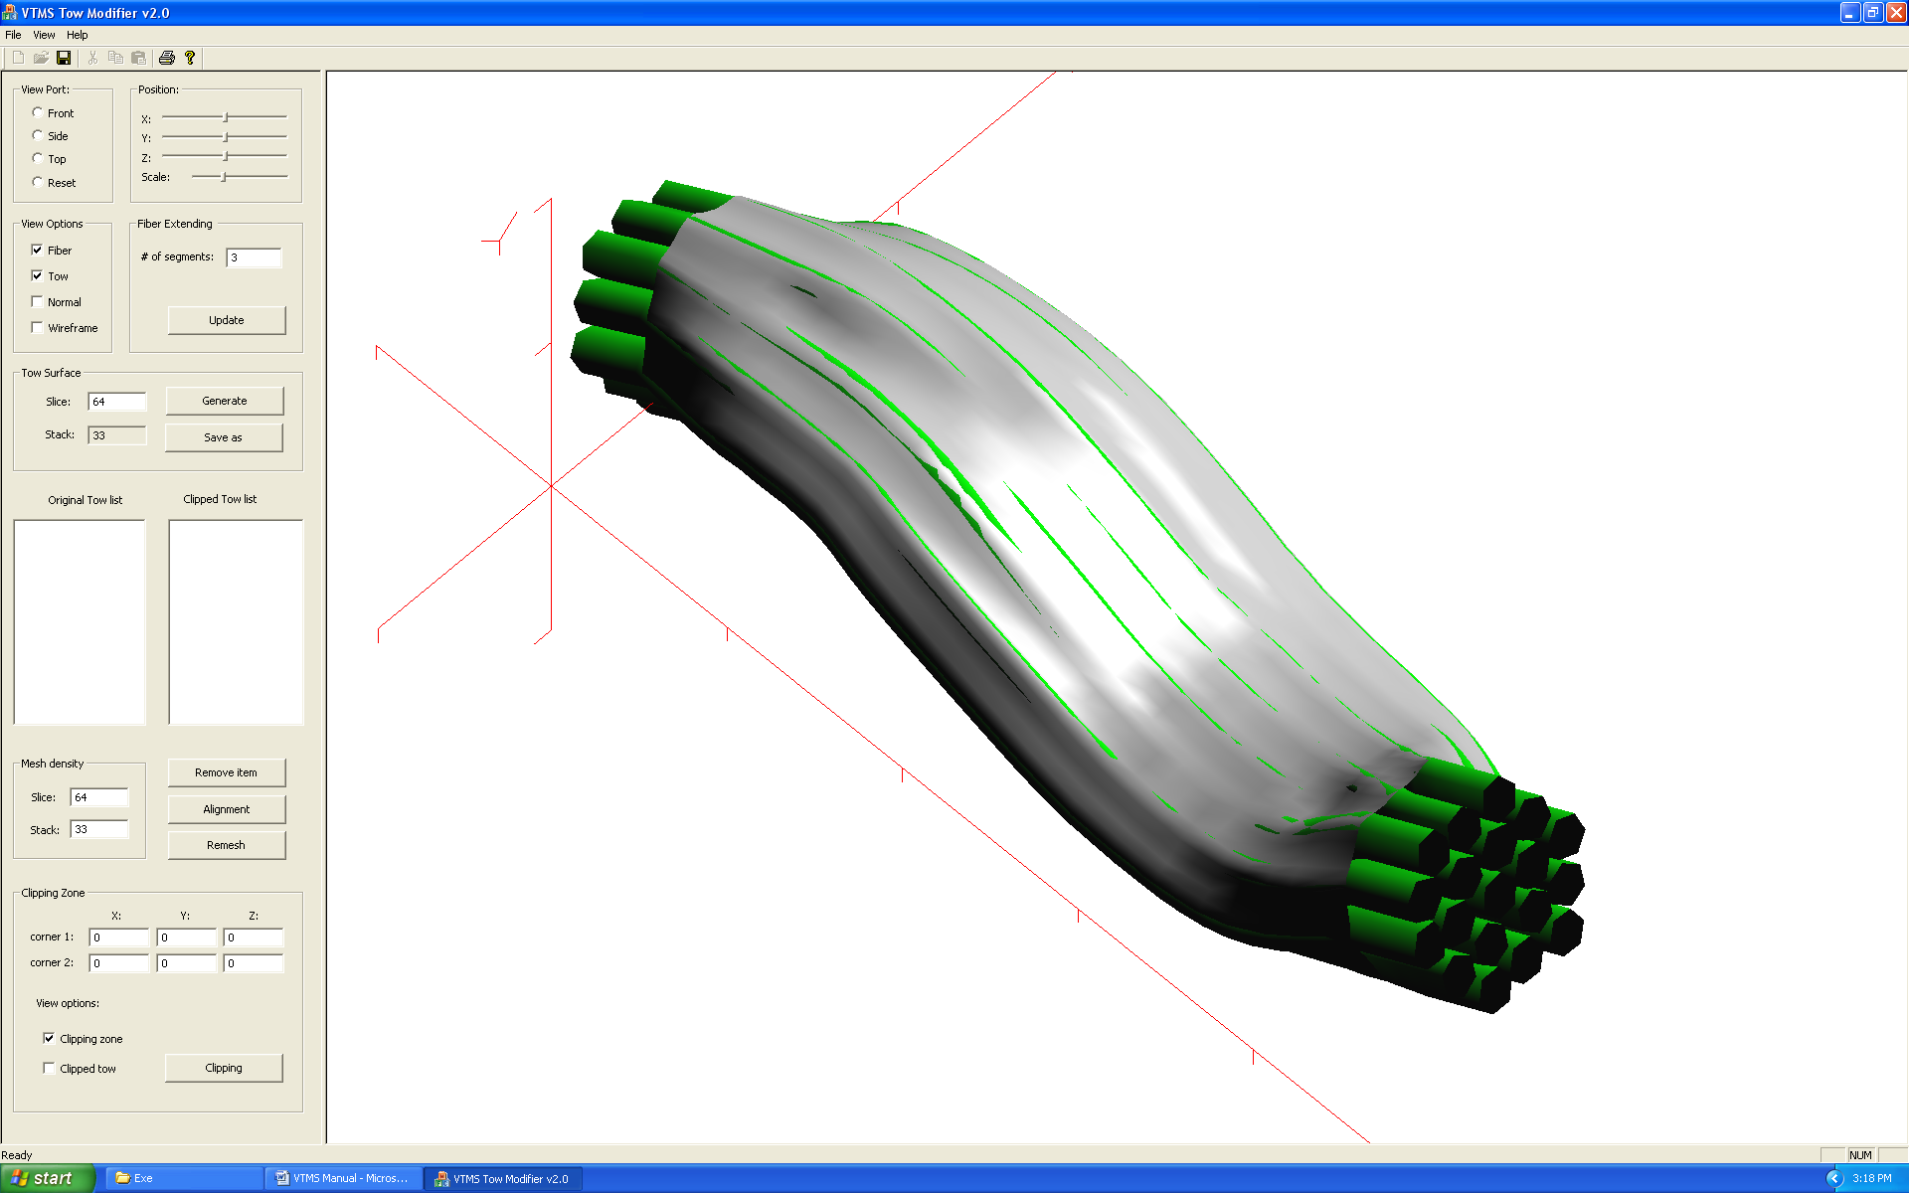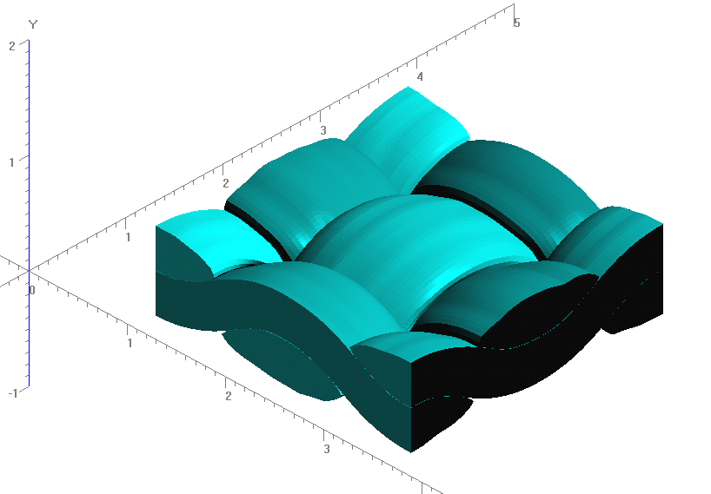

**Figure 1: Evolution of Weave Tow Geometry**

The process to produce these geometries is quite difficult. The relaxation process requires hundreds of “relaxation steps” that frequently result in the interpenetration of fibers, rendering the model useless. The relaxation itself requires constant monitoring and adjustment of factors, boundary conditions, and tension values that all affect the outcome. Sometimes the relaxation process becomes unstable. These instabilities can be fixed with some single-minded focus on these issues. VTMS is an impressive tool that we believe could benefit from further, focused development.

The geometries modeled are not without faults either. There have been multiple instances of interpenetrations of the tows that cause analysis difficulties after the fibers are made into a surface. The current solution is to shrink the tows until interpenetrations are removed. However, a more realistic, long term solution to this issue is desired and will be a point of focus in the coming months. If the issues related to relaxation and interpenetrations can be resolved, VTMS will be much more useful to the textile research community.

VTMS has its own mesh generation method, but it results in incompatible meshes that must be solved using the independent mesh method. Instead, we decided to create compatible meshes using the geometry resulting from VTMS. A large amount of time is spent on meshing these geometries. Geometries this complex require very robust meshing algorithms. Much of this quarter was spent researching and evaluating possible software to mesh these complex geometries with much less user intervention.

The first task was to evaluate a number of mesh generation programs to evaluate their potential for 3-D mesh generation. We are looking for software that can generate tetrahedral, quadrilateral, or hybrid meshes from geometry polygon data. If needed we can develop our own conversion scripts to the desired input of the software, but the mesh generation ability must be able to handle complex 3-D models. The following summarizes the evaluation.

Cubit/Trelis

This software suite is highly capable and complete. It comes with its own pre- and post- processing routines. However, it is under a costly license that is currently not sustainable under the current funding. Also, it has the same ability as the top candidate software (which is discussed later) but has a more polished user interface.

CGAL

This software is a collection of low-level routines and algorithms that require some development to run together. Currently some routines are being used within our own meshing routines. However, some of the newer routines could prove beneficial. CGAL is a backup to the more high-level commands we wish to use.

Gmsh

Based on previous experience with this software, the input files required are not conducive to complex geometries and require plugins for specific geometry files to be meshed. If a plugin were developed this software could also be useful, however we wish to avoid development time in this area if possible.

Abaqus

This highly used software suite has a very good scripting interface that makes meshing geometries very easy. However, an Abaqus license is required to run the software along with development to convert VTMS geometry into Abaqus geometry. This is also another option in case the primary software does not work out.

NetGen

This software is the primary software that we are pursuing. It is open source and still being developed by its designers, which means support is still available. It is also primarily written in C++, which helps in debugging and inclusion into our research code. Currently we are working on implementing its functionality on the scripting side instead of using its user interface. The next step will be to convert the VTMS geometry into NetGen’s preferred format.

1. **CONCLUSIONS/ANALYSIS TO DATE**

The creation of realistic, non-idealized tow geometry is possible with the VTMS software. The meshing of this geometry is very complex and requires development to minimize the amount of user input required to make the mesh viable. VTMS itself will also benefit from further development of its routines. The first area of evaluation will be the relaxation and interpenetration routines in the relaxation module.

1. **WORK FORECAST AND PLANS**Collin Blake is planning to be at AFRL as an intern this summer. His focus will be understanding the details of the geometry generation engine in VTMS. The goal is to identify the parts of the code that are causing major problems and to attempt to remedy these issues. Since the code was developed by a highly skilled analyst (Eric Zhou), it is recognized that this will be very challenging. The strategy is to collaborate with Eric and hopefully, by taking a fresh look at the algorithms, solutions can be developed.