**AFRL Research Collaboration Program**

**Contract FA8650-13-C-5800**

**Effect of Constituents and Microstructure on Energy Dissipation Mechanisms During Damage Growth**

**University: Texas A&M University**

**REPORT COVERS PERIOD: 7-1-18 THRU 9-30-18**

1. **PROJECT TEAM MEMBERS**
2. **LEAD UNIVERSITY POC:** John Whitcomb, 979-845-4006, jdw@tamu.edu
3. **PROJECT TEAM MEMBERS:** John Whitcomb, Collin Blake
4. **AFRL TECHNICAL POC:** Craig Przybyla
5. **TECHNICAL DISCUSSION**
6. **CURRENT WORK**Development of the infrastructure to perform mesoscale analysis of 3D textile composites.

**Approach**

The last report described some of the challenges in removing the interpenetrations between the tow surfaces as output by VTMS. For all of this quarter, the student, Collin Blake, had an internship in Houston that was unrelated to this effort. His unfunded part-time efforts and interactions with Collin revealed a major issue with describing the procedure proposed for removing the interpenetrations. This was critical for two reasons: First, the strategy involves many steps, is complicated, and is not completed. Finishing the implementation and debugging of the strategy requires a very clear description of the various steps. Secondly, Collin will need to write this up in his thesis. Since this report is required to be short, the following gives a concise, but hopefully clear, description of the steps (and the motivations for the steps) that have been implemented thus far. Additional figures and text have been drafted and are available upon request.

1. VTMS creates a surface model of the tows (surface mesh) that contains interpenetrations. This is because the contact algorithms in VTMS are not sufficiently robust.
2. These interpenetrations are not critical when using the mesh independent method.
3. These interpenetrations must be removed to use the surfaces for creating a traditional finite element model.
4. Several techniques were evaluated for potential integration into VTMS. These techniques were not sufficiently robust.
5. Removal of interpenetrating regions is a challenge in many disciplines, which has resulted in numerous techniques being developed and implemented for detecting interpenetrations.
6. The public domain library SISL, which is designed to identify interpenetrations was selected as a tool to help create valid tow surface meshes.
7. SISL creates a B-spine representation of the tow surfaces from a structured grid of surface points that are provided by the sequence of cross-section polygons that define the cross-section shape at various points along the tow path.
8. The output of SISL is a collection of B-spline curves that identify the intersections between tows.
9. These curves are not guaranteed to be unique or closed, which is required for the next step towards generating compatible surface meshes. Hence, the intersection curves are processed to assure that they are both unique and closed.
10. The next step also requires an initial surface mesh. This initial surface mesh is generated using the same sequence of cross-section polygons that define the cross-section shape at various points along the tow path that SISL used to define the B-spline representations. See figure.

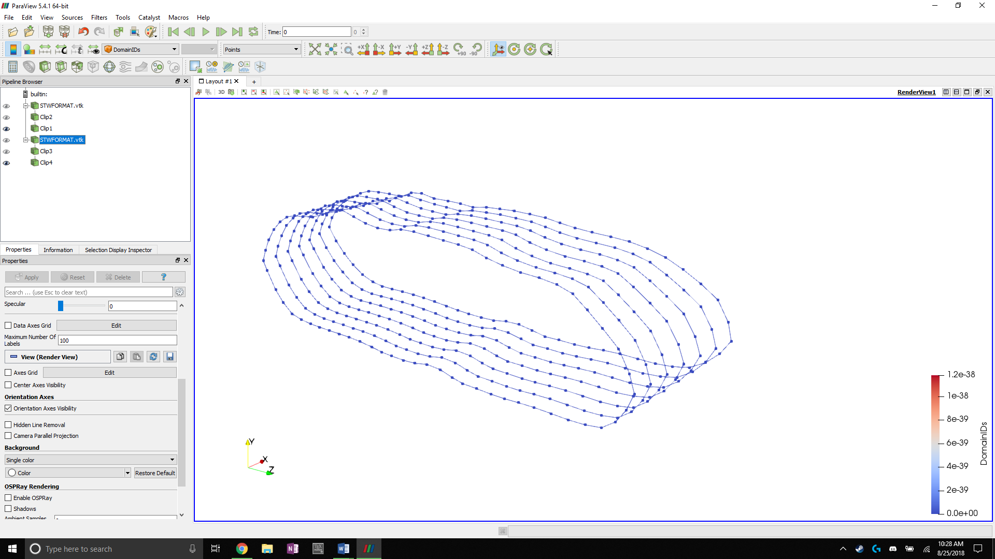

1. It is assumed that the intersecting volumes is small, so that the goal is to create a compatible mesh in the intersection zone and delete the interpenetrating volumes.
2. Creation of a compatible mesh requires he following
   1. Outlining the interpenetration zone on the surface mesh.  
      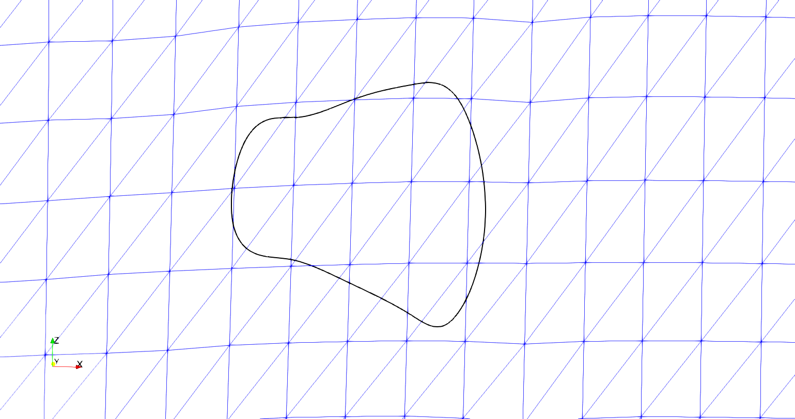
   2. Elimination of surface elements that are totally inside the interpenetration zone.
   3. When only a very small portion of an element is in the interpenetration zone or outside interpenetration zone, it is better to modify the surface mesh nodal coordinates such that the element is either totally in or totally out of the interpenetration zone. This helps avoid very small and distorted elements.
   4. Subdivision of elements that are partially in the interpenetration zone, such that the new elements are either all within or all outside of the interpenetration zone. (The “x” indicates the elements that would have been removed previously.)  
      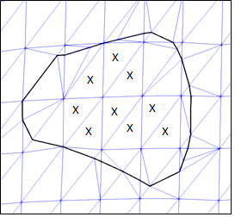
   5. Elimination of the new elements that are within the interpenetration zone. These are the shaded elements.  
      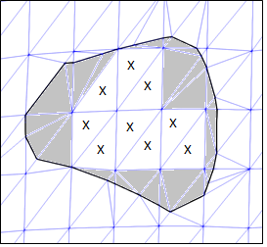
   6. Elimination of all elements interior to the interpenetration region, gives the following.

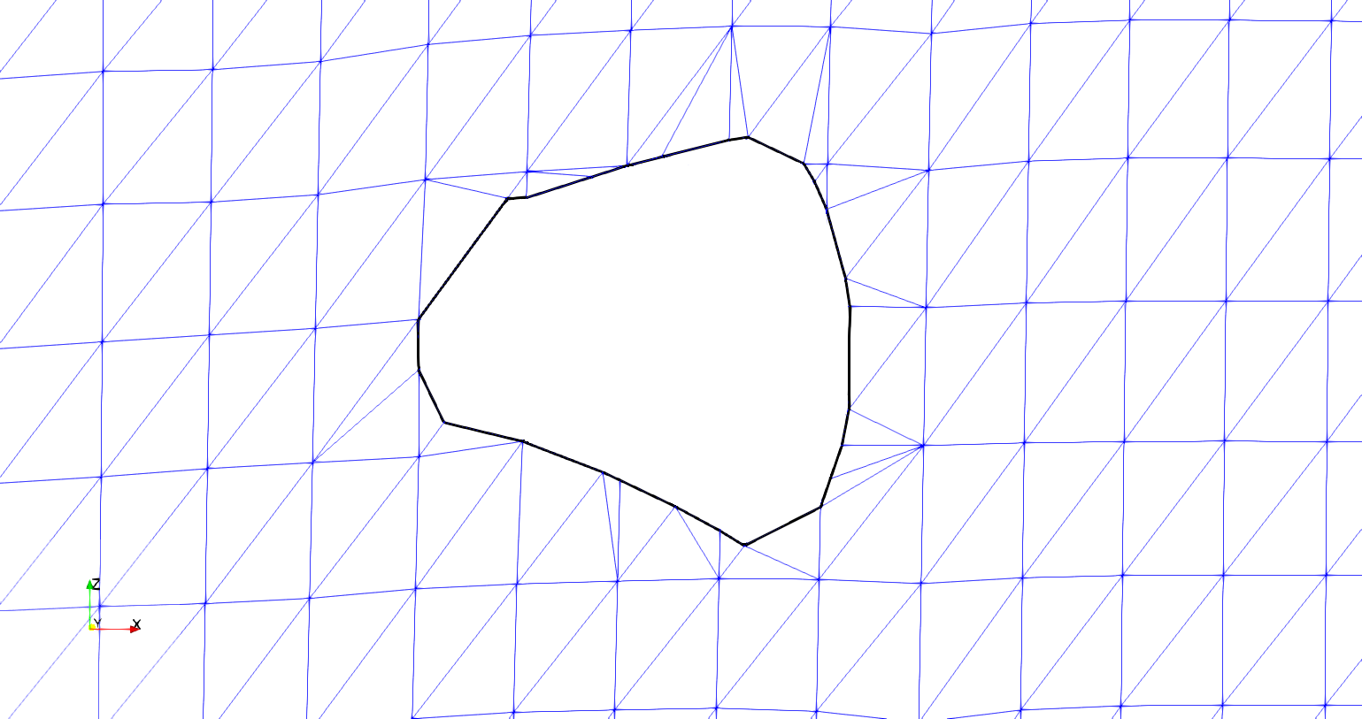

* 1. At this point, the surface mesh for one surface of the two interpenetrating surfaces has been modified. The nodes that define the interpenetration boundary are essential in guiding the required re-meshing of this region. When the other surface is considered, additional points will be added along the boundary such that compatibility is satisfied for both surfaces when the re-meshing is performed.
  2. Basically, the same strategy will be used to modify the other interpenetrating surface and the interpenetration boundary curve. Since the details have not been implemented yet, the outline of the remaining steps will not be given. In particular, there are often surprises that arise only during the implementation, so rather than possibly mislead, the details will be given in a subsequent report.

1. **CONCLUSIONS/ANALYSIS TO DATE**

The strategy appears to be robust thus far. A complete evaluation can only be performed when the “other surface” described above is processed.

**WORK FORECAST AND PLANS**The goal of the next quarter is to finish the algorithm for creation of compatible meshing between interpenetrating tows and evaluate its effectiveness.