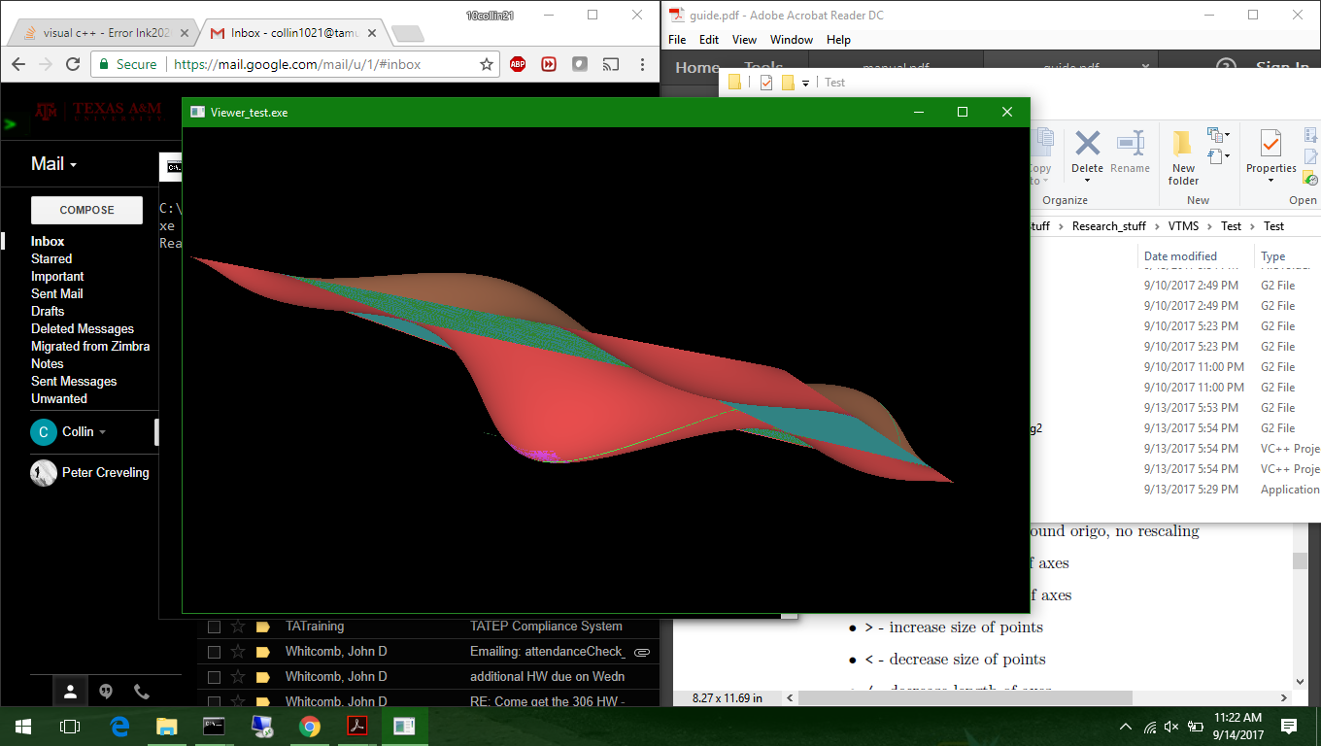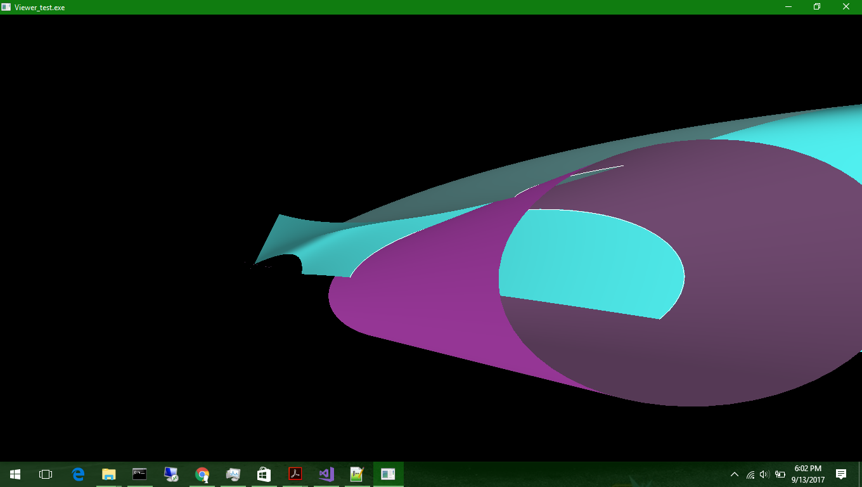

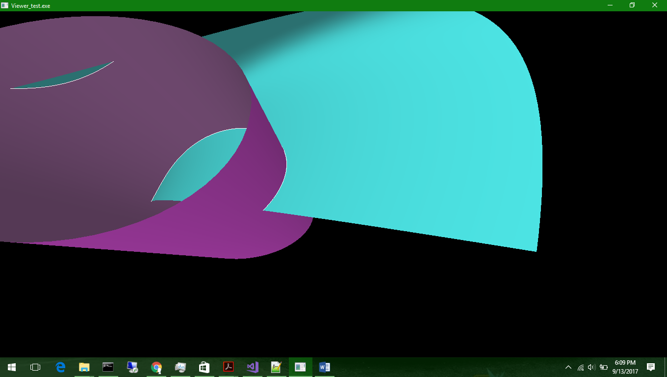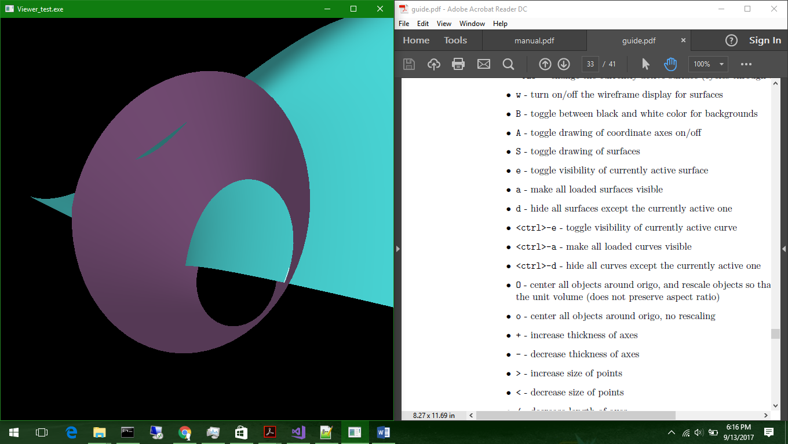

The first picture shows a simple, two surface diagram in the SISL library viewer. One is simply a flat plane while the other is a surface that undulates in two directions multiple times. This is simply to show that surfaces can be defined and readily portrayed without a significant amount of faceting.

The rest of the pictures show the particular interest we have in the library. The pictures show a cylinder with an elliptic cross-section intersecting with an arbitrarily defined surface. The pictures also show the intersection boundary that has been calculated using the SISL library.

These pictures show three things. The first is that we can view the surfaces via the in-library viewer. The second is that we can define both open and closed (meaning the continuity of the cylinder surface connects to itself with no discontinuity in slope) surfaces with the library. The third is surface intersection curves can be defined and displayed (the white lines where the curve intersects are the intersection curves, you can see the curves removed in the third picture). The intersection must be specifically calculated before it can be displayed. This is significant because a.) we cannot accurately view the intersection without calculating it, and b.) it shows the ability of the software to identify the intersection in 3-D space. The next step is to evaluate if it can detect closed loop penetrating curves where the entirety of the intersection is contained on the surfaces (think two spheres intersecting, resulting in a circular penetration curve). I will also continue on creating a surface for a realistic tow cross-section.