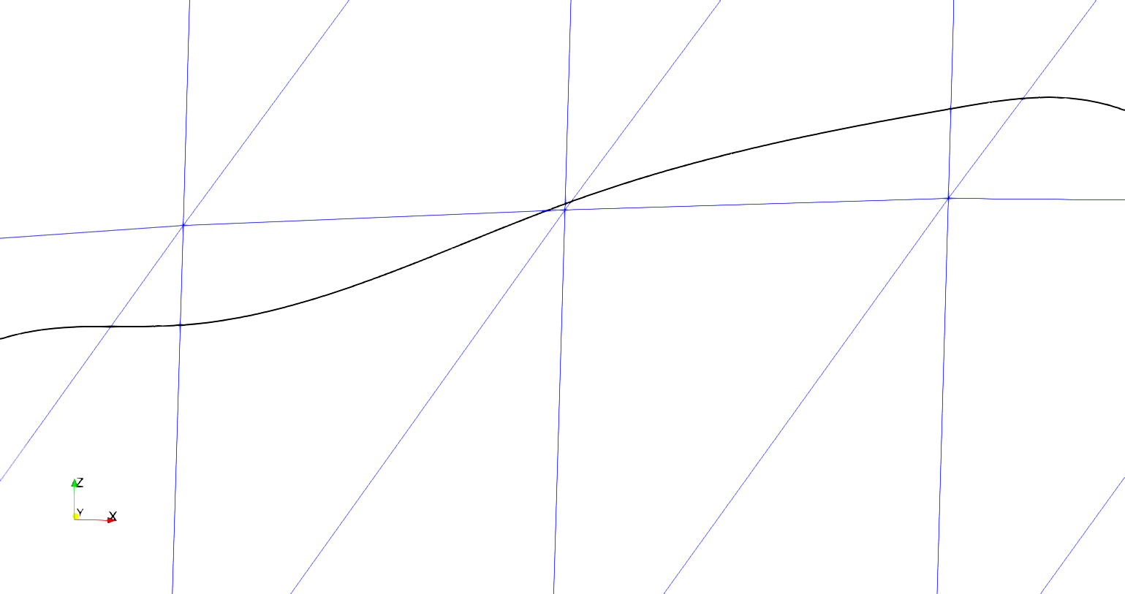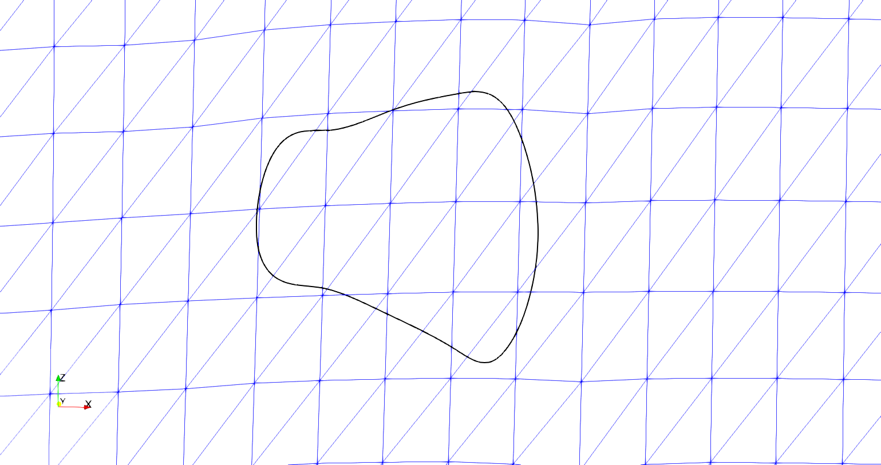

* This figure will be used to further show the reader that the boundary curve can come close to a node on the surface but not necessarily cross through the node itself
* I would also like to have a brief discussion on why the boundary curve next to a node is not good (i.e. causes high refinement compared to surface mesh, very high aspect ratio elements, etc.)
* This figure shows the initial conditions of both the boundary curve and the tow surface mesh around the boundary curve
* I will bring the readers attention to the places where the boundary curve is close to a surface mesh node, how the curve cuts the surface elements, and why we are bothering to change the surface mesh at all (which is to remove the elements that lie within the curve)

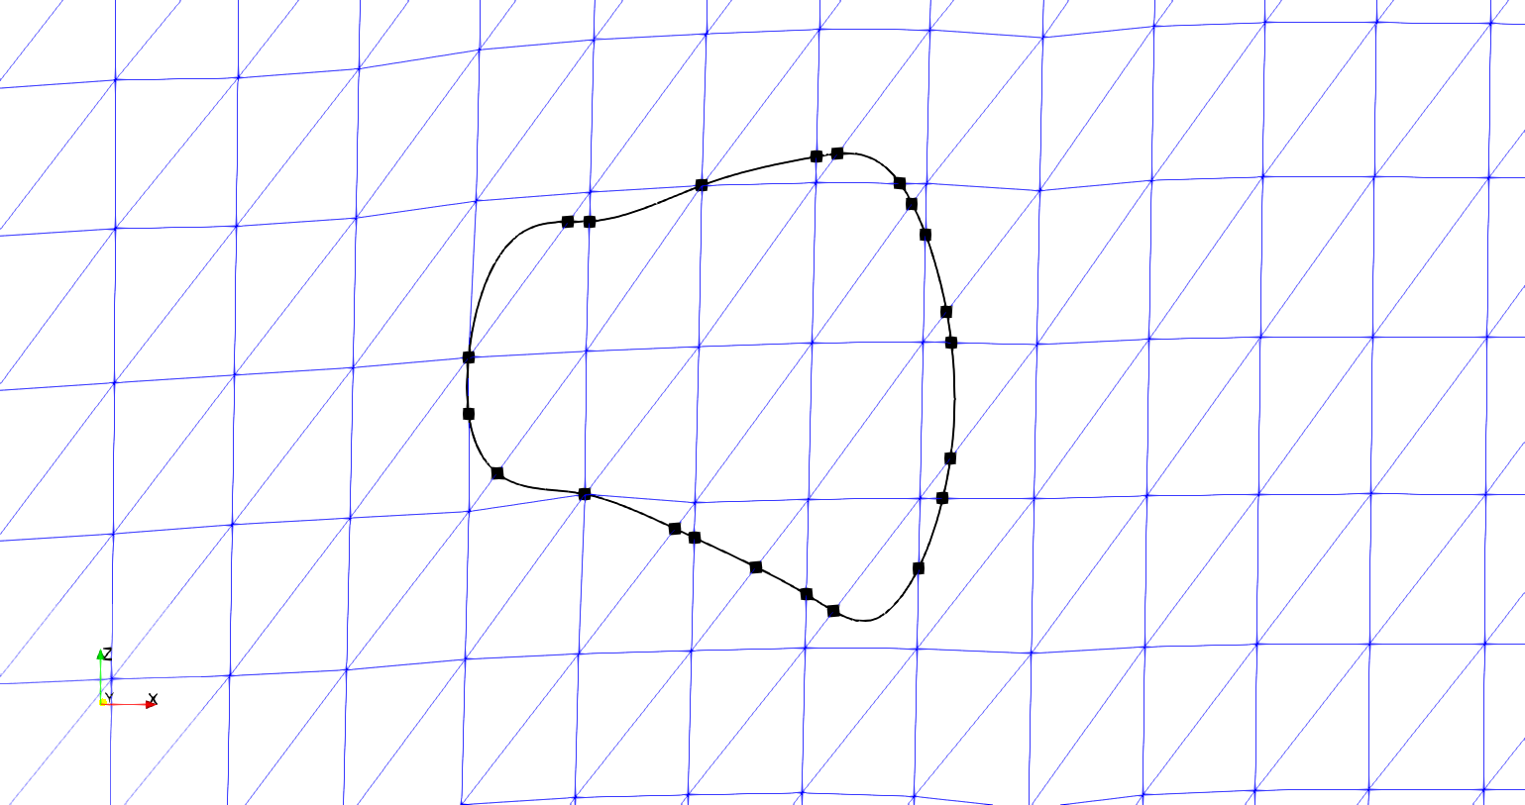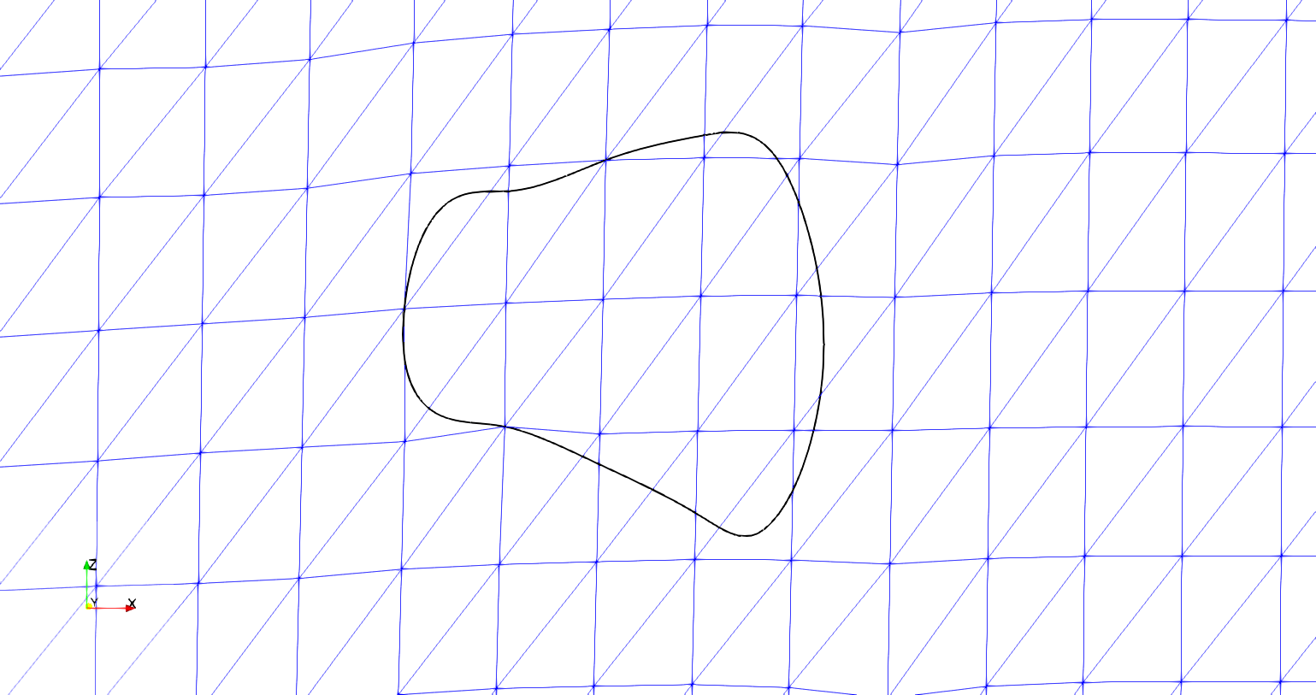

* I will use this figure to show where the boundary curve intersects the surface mesh
* This is where I will also discuss the methods used to detect intersections between the boundary curves and surface elements (Separating Axis Theorem, linear algebra equations for lines, etc)
* I will also talk about how we find the intersection points and why we need the intersection points
* This figure shows the surface mesh after the surface nodes have moved to the boundary curve
* I would like to add indicators to draw readers attention to nodes that have moved
* I will also discuss why moving the surface nodes is an acceptable change to the surface mesh as long as the change is not drastic, which is ensured by a set tolerance that is compared against the distance the surface node must travel to lie on the boundary curve

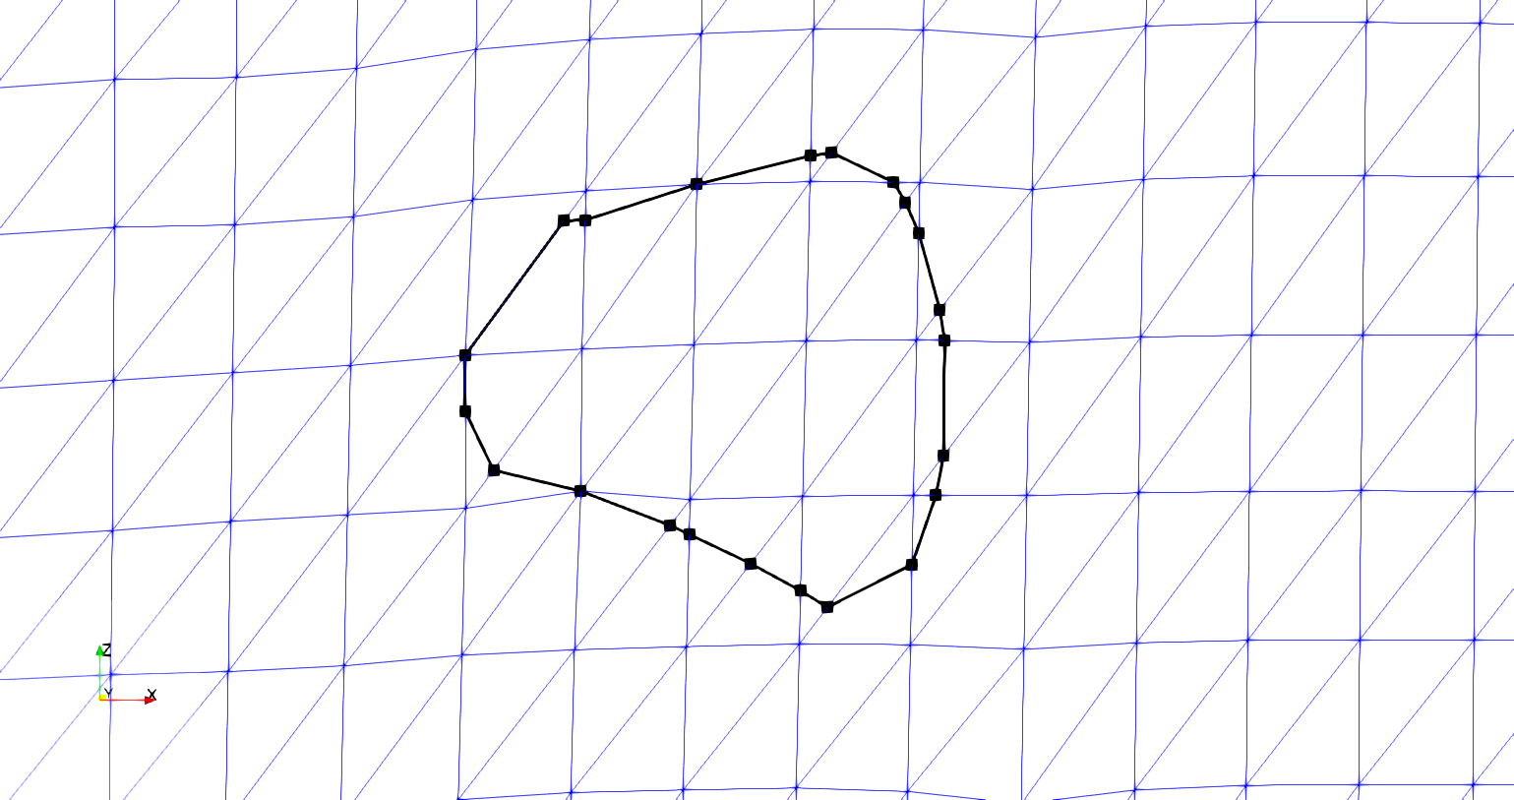

* This figure shows how the intersection points are used to coarsen the boundary curve into a curve we can use to divide the surface elements
* I’ll also talk about how the boundary curve is coarsened and why we made the decision to do so (the relative refinement of the curve to the surface is too high, resulting in an inadequate surface mesh)

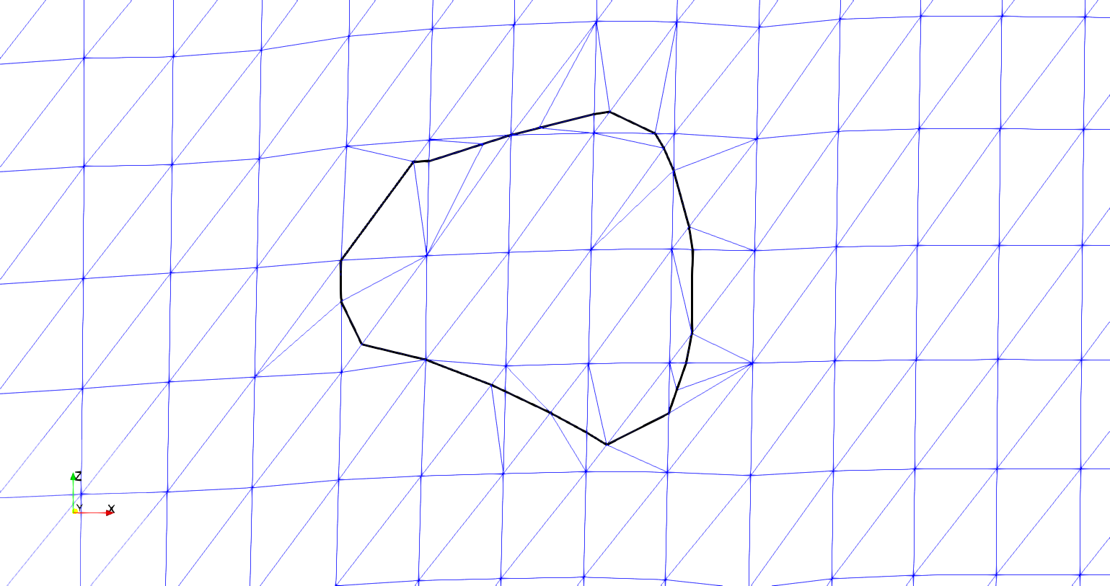

* This is the result of cutting and re-meshing the surface elements cut by the boundary curve
* Here I will elaborate on how the elements inside of the curve will be cut away from the mesh (or duplicated and inserted into the other surface mesh that it is interpenetrating, creating a compatible mesh)
* I will also discuss the methods of how we have to sub-divide surface element edges that are cut by the boundary curve and the process of determining the boundaries that the Triangle sub-meshing routine needs (with figures)

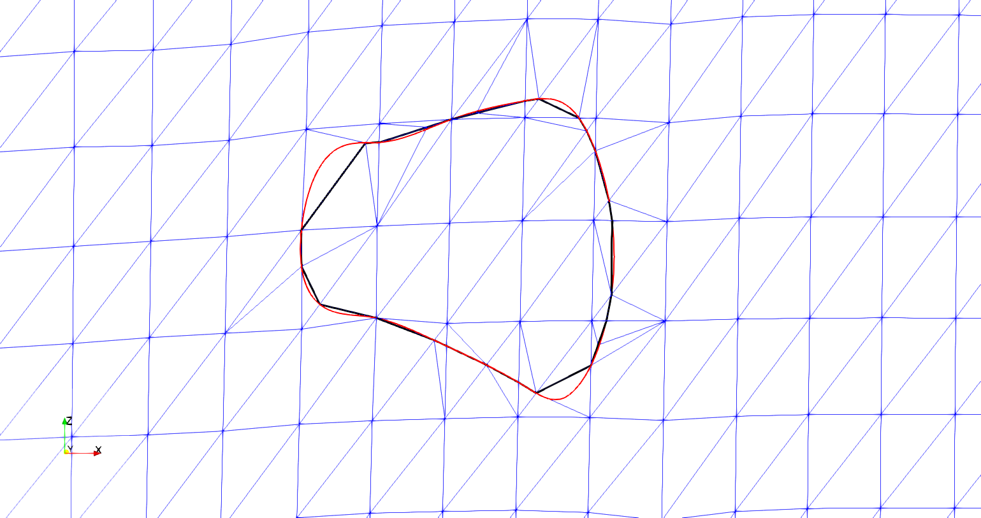

* This figure is simply a comparison between the original boundary curve and the resulting surface mesh after our algorithms are complete.
* I will discuss how the resulting sub-mesh captures the general shape of the interpenetration region without drastic changes the surface shape or boundary curve
* I will also discuss any simplifying assumptions made, how they affect the process of creating the new surface mesh, and why the assumptions are valid.
  + These include boundary curve refinement reduction, surface node movements, duplicate intersection point removal (during sub-meshing), and other assumptions we made.

After these figures I will have sections discussing what happens if the changes are not made (as we discussed). I will send these to you with bullets as well once I have some figures for it.