Towards Accurate Detection and Resolution of Interpenetrations of Woven Composite Surfaces

Collin Blake

# Introduction

The growing use of fiber-matrix composite materials as both a decorative and functional material has also increased the need to better understand these materials in all of their forms. From unidirectional ply composites to intricate woven textile composites, the need for understanding material properties and mechanics for these composites has never been higher. Research towards mechanical properties of these geometries in a physical testing environment is extensive. (reference) Many of these tests centered on the idea of discovering the different macroscopic properties and responses of composites. Complexity to understanding these macroscopic properties were further added with the introduction of woven fiber composites. These fabrics brought new challenges in the form of phenomena caused by the woven geometry that had previously not been explored. Attempts were made to understand these phenomena via in-situ analysis during physical testing. However, in-situ testing during this time was limited by the technology available and only a limited amount of insight was available. In order to gain a more intimate understanding of the mechanical response for these composites, research turned towards analytical models to represent the test data received from mechanical testing. These models were then used in computational models and simulations that were validated with experimental data. (reference) As these models became more accurate, understanding of both mechanical response and damage initiation increased. The use of computational models and analysis is now a fundamental aspect of most engineering and scientific research and can been seen in use as far as early undergraduate studies.

One aspect of computational research for composite analysis is the use of finite element models that can simulate material responses to mechanical loads. Finite element analysis is the discretization of a large, complex problem into smaller, simpler pieces. The result is a problem that is more easily solved mathematically in exchange for accuracy compared to the exact solution to the problem, which is rarely known. This method can be used in composite research by creating geometries that mimic the actual geometry of a composite and assigning the appropriate geometries accurate material properties. The model is then given certain boundary conditions and a result can be computed. These results can be insightful to stress concentrations, deformation responses, energy absorption and other attributes that may be of interest. These results are, among other things, affected by how accurately the geometry of the problem can be modeled. Although a finite element mesh (the discretized version of the physical geometry) is an approximation of a continuous geometry, remarkably accurate results can be achieved concerning macroscopic responses.

At first, composite fabric computational research using finite elements used simplified geometry models such as rectangles with rounded arcs on two sides and lenticular cross-sections (Figure 1) made by overlapping circles to define the cross-section of fiber bundles (also referred to as tows) along a tow path. These cross sections do not vary along the tow path. These geometries can be assigned anisotropic material properties defined by a coordinate system that runs along the tow path. These properties are generally reflective of both a fiber and matrix occupying the tow volume, generally with a high fiber volume fraction. These tows then represent pre-impregnated fiber bundles, and when the surrounding matrix is added to the model, a woven fabric composite. There have been multiple methods to create the homogenized tow geometries that revolve around simple geometries. These are usually referred to as idealized geometries as everything is known about their shape and structure. These geometries can be created to perfectly coexist with their woven counterparts, which is crucial to using traditional finite elements.

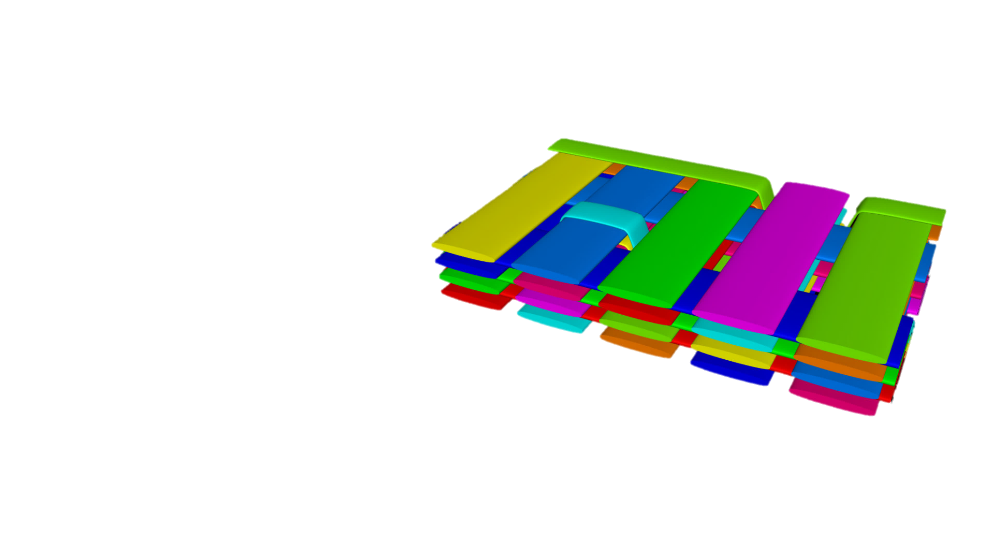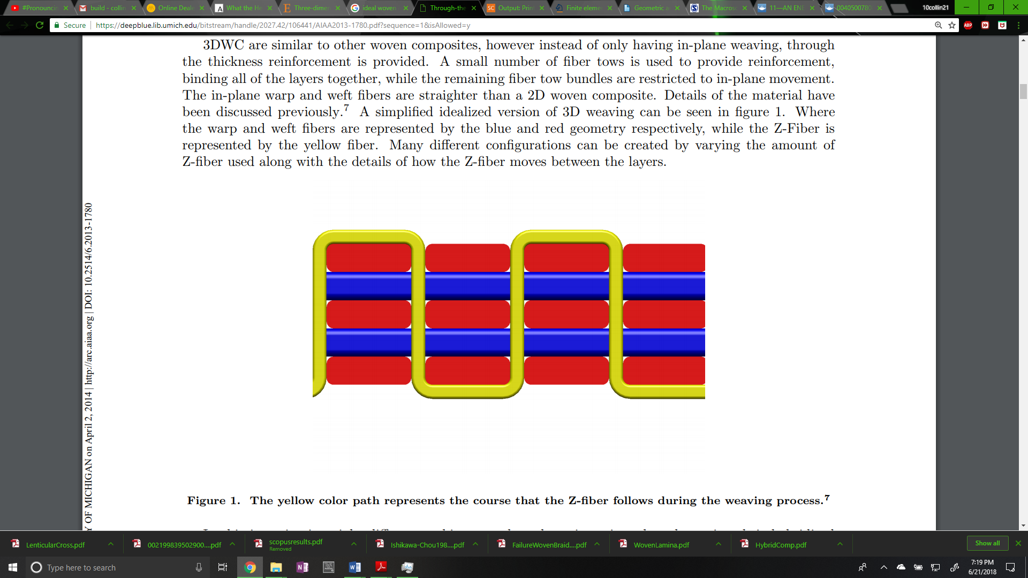

**Figure 1: Lenticular (left) and Simplified (right) woven cross sections**

Substantial experimental and computational research has been conducted on unidirectional ply composite as well as experimental research on textile woven composites. However, there is still a need for non-idealized textile composite geometries for computational analysis. Idealized geometries for woven fabrics can be great predictors of macroscopic properties and even yield acceptable results concerning interactions between tow geometries. Because these geometries match so well where tows interact, it is difficult to capture intricate interactions and stress concentrations that cause damage initiation between tow geometries. More realistic geometries may yield better results and can more closely resemble the geometry and response of realistic fabric composites.

One method to creating more realistic woven geometries is to simulate the process that manufactures employ to create the fabrics (Wang_Sun). The process begins by simulating bundles of fibers as "yarns". These yarns are made up of digital elements (cylindrical bars connected by friction-less pins) chained together. Each bar is given a stiffness in the longitudinal direction that amounts to a large value which eliminates yarn stretching. Then, a finite element style contact problem is solved where pins between two yarns can create contact forces between each other as well as friction forces. The result is realistic interactions between the digital chains. (Wang_Sun1)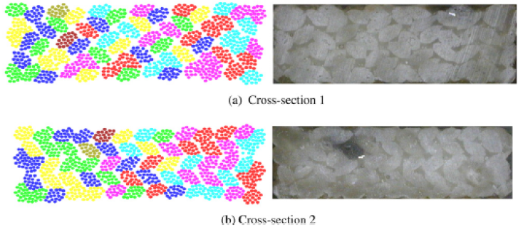 The result is fiber bundle cross sections that are similar to micro-CT scans from actual woven specimens, shown in Figure 2, from Wang_Sun1.

**Figure 2: Simulated vs. Actual Fiber Bundle Cross Sections**

While there is possibly other software that can accomplish this level of similarity between simulation and reality, only two were explored. The first is Digital Fabric Mechanics Analyzer (DFMA) from Kansas State, overseen by Youqi Wang and students. The other is Virtual Textile Morphology Suite (VTMS), developed by Eric Zhou at AFRL. It should be noted that Eric Zhou is a former student of Youqi Wang and is cited in a previous paper (Wang_Zhou1).

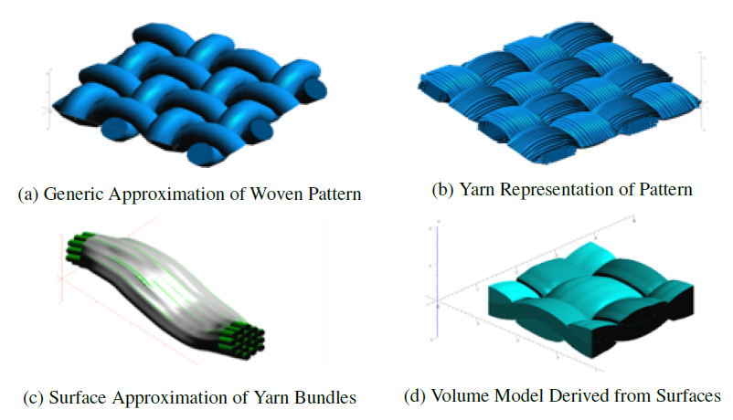

**Figure 3: Evolution of Weave Textile Geometry**

It is from VTMS that the base geometry and surface mesh that is used in this study originates. Figure 3 shows the process visually. The surface inter-penetrations come as a result from the geometries shown in Figure 3.d.

The reasoning behind creating surface and volume approximations (Figure 3.c and d) is that the computational cost of analyzing many bundles that represent woven fibers is very high. Instead, researchers currently are content with using a surface or volume approximation and applying material properties found in experiments.

1. **Transparent upper tow showing interpenetrations**
2. **Tows in close proximity**

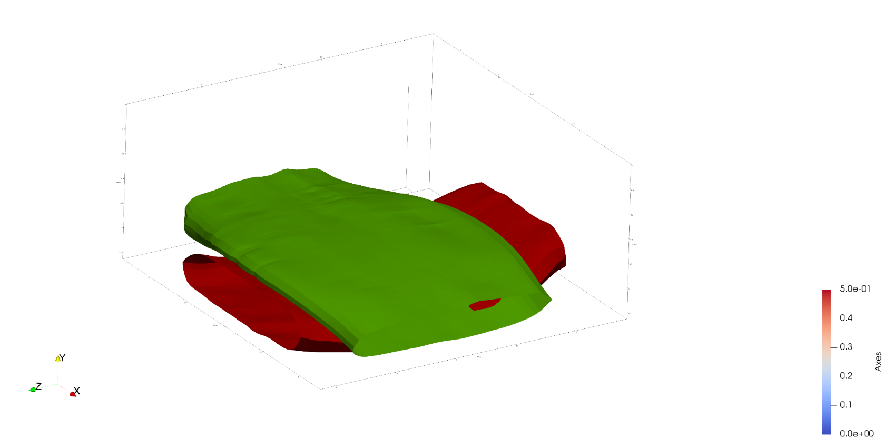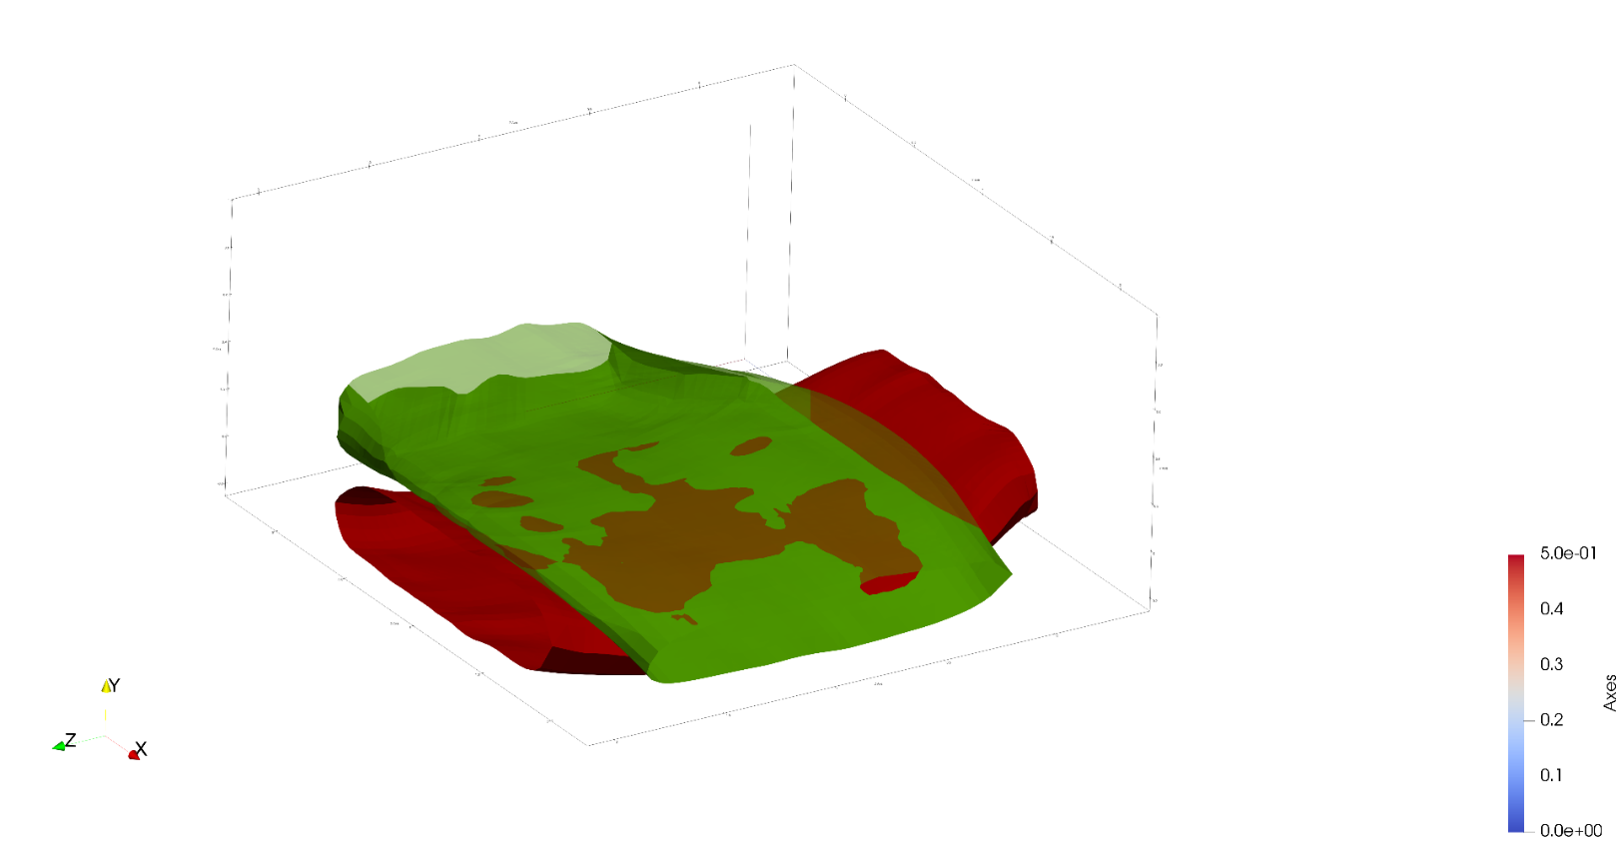

**Figure 4: Region of close tow geometries with interpenetrations**

Once a surface representation is created, surfaces in close proximity have the ability to penetrate into each other, as shown in Figure 4. The arrows in Figure 4.b indicate regions where one surface mesh is penetrating into the other. Physically, the two surfaces would come into contact and create some form of surface. This reaction is not represented here because the surfaces are created after the simulation process is done. These inter-penetrations represent the error in approximating the yarn bundles as a surface to apply homogenized properties to for analysis. Here in lies the focus of this study. Traditional finite element software requires that two geometries cannot occupy the same space and must have compatible meshes along any boundaries that they may share. These regions must be fixed if a traditional FEA is to be conducted.

# Literature Review

The idea of solving the penetration (also know as intersection) issue is one documented well in computer aided modelling. Various approaches have been used to detect whether two shapes, for both two and three-dimensional shapes, occupy the same space at any given point. Jimenez, Thomas, and Torras asserted that intersection scenarios can occur statically as well as be dependent on time. However, regardless of which scenario is occurring, a static intersection step must be calculated. For surfaces that are polyhedra (defined as having multiple flat faces), Dobkin and Kirkpatrick (source) state that hierarchical representation of the polyhedral can be used to reduce the computation time required to detect an intersection and that the representation of an intersection is embodied in the hierarchies of the two parent polyhedra. During this method, the minimum distance between the shapes is calculated, and said to be null if the shapes intersect. This framework is useful in that once a hierarchy is established for a shape, it can be used for every query involving the shape. Its limitation is that it requires the polyhedra to be convex.

Canny (source) discusses in his book a method for the more general case of a polyhedra with convex faces. He states that for these shapes two intersection cases exist, face-to-node contact (Type-A) and edge-edge (Type-B). By associating a predicate that is true or false for each case, a series of tests can be run on a polyhedra and if either predicate remains true at the end of the tests, the shapes are said to have intersected. This method is useful because it requires simple vector math to run the tests. The method itself does not directly identify the case of containment (one shape lying completely in another). However, a simple ray intersection algorithm can determine if containment is occurring.

The most general case for a polyhedral shape is a non-convex shape. For this case there are two trains of thought. The most popular response is to subdivide the domain it to convex sub-domains and then perform similar intersection operations that apply to convex polyhedra. Two popular methods are decomposition into smaller convex polyhedral (source) and decomposition of only the surface into convex surfaces (source). After a sub-division, the smaller, convex shapes can then use a multitude of intersection algorithms that apply to convex shapes. The main drawback to this sub-division method is the increase in number of operations and intersection checks required. The more complex and less used method is a direct approach to calculating the intersection. This usually involves a two-step process to identify edge-face intersections (source) involving a ray-intersection algorithm to determine if edge end points lie on opposing sides of a face of a polyhedron. By counting the number of intersection an edge has with faces on the polyhedron, it can be determined if the edge intersects with the polyhedron. Another method that does not require computing these intersection tests involves computing signs of the determinants of a set of linear equations that are formed from equating equations that calculate the location of certain polyhedron surface nodes. The equations are set up to quantitatively calculate the predicates mentioned previously (source). They can be assembled in matrix form and by calculating the sign of certain determinants it can be determined if a certain case of intersection occurs. In this way the method does not care about the convexity of the shape and can be applied to the most general of cases. The main drawback of this method is that it requires extensive setup of the shape vertex equations as well as the framework for solving the linear equations.

Although detection algorithms for discretized surfaces are well documented, they are not the only method for detection. There are a variety of methods to translate polyhedral surfaces into mathematical descriptions of these surfaces. With these surfaces there are also methods to detect intersections between surfaces of similar description type. Two common types of non-polygon surfaces are implicit surfaces and parametric surfaces. Implicit surfaces are in three-dimensional space and are defined by a function where when the function is evaluated at a point on the surface in three-dimensional space, the function is equal to zero. If the function is a polynomial in *x*, *y*, and *z*, it is considered algebraic (source). These functions may also be quadric, which are second degree polynomials in *x*, *y*, and *z*. The other typically used non-polygon surface is a parametric surface. These surfaces in three dimensions are described by functions that have two input parameters. As a result, they are generally not closed but easier to polygonalize and render. A special class labeled Non-Uniform Rational B-Spline (NURBS) have gained traction in computer aided design software (source) and possess some ideal properties that make them easier to use. For each of these non-polygon surfaces, there are algorithms for detecting intersections.

For implicit surfaces, the available algorithms are limited. Pentland and Williams (source) discuss the implementation of an “inside-outside” functions that use the object’s canonical frame (no rotation, centered on origin) and current location. Once the function is formed the surface to be tested has its points tested against another surfaces inside-outside functions. If a point is determined to be inside, it is intersecting. One main advantage of this algorithm over any polygon intersection detection algorithms is that it can obtain a good closed form solution that approximates interpenetration region depth, area, and shape. This is very valuable when the shapes are static and simply detecting intersections is not enough. However, this method is only applicable to implicit functions and has drawbacks in terms of robustness as it relies on point samples. Lin and Manocha (source) have discussed algorithms that extend their previously mentioned hierarchical representation algorithm that used curved models made of splines and algebraic surfaces, which work best on low degree curves.

Parametric surfaces have a larger set of explored algorithms for intersection detection. There are four main methods: lattice, subdivision, tracing, and analytic methods. This review will cover the latter three as they are the most relevant to this research. The first is the subdivision method which works by subdividing both surfaces in parallel. By recursively subdividing and testing for intersections of the subdomains, the domain of the intersection region can be approximated. In this way the intersected subdomains can be further subdivided to more accurately describe the intersection region (source). A method very similar to this is used by Drach et al (source) to determine if surface nodes interpenetrate a surface. They then use another technique to remove interpenetrating surface nodes until they are all corrected. The main drawbacks to this approach is that the desired level of refinement of the intersection region negatively affects the computation time quickly. As the desired level of refinement increases, so does the computation time.

A second method used is tracing. This method starts by first finding a known point of intersection, of which there are multiple methods to choose from (sources). Then, the intersection curve is traced along by starting at the previously calculated point of intersection and a moving along a determined vector by a set distance. The vector is found by intersecting the two tangent planes of the surfaces and calculating the direction of the line that defines the intersection. The distances along this vector is predetermined and is the determining factor in the amount of “refinement” the curve has. One issue the method faces is determining if a curve has reached its starting position. This is usually posed as a system of algebraic equations (source) or a differential equation problem (source). This method can yield very good results when trying to identify a boundary curve for the interpenetration regions.

A third method is the analytic method. Generally, one surface is made into an implicit representation of the surface (source) and creates a scalar function in the two parametric variables. The root locus of these functions in the parametric variable plane is the preimages of the intersection curve (sources). In other words, this method creates a series of algebraic equations that describe where one surface lies on another. In the case that they intersect, the equations can be solved and the result is a curve (in a given basis) that defines where and how the two surfaces intersect. This method can be difficult to implement as it requires knowledge of how to accomplish the parametric-implicit conversion as well as the frame work for multiplying polynomials and solving multi-basis functions.

Drach et al have used a couple of these techniques to solve a very similar problem to the one posed for this research (source). They have used a variety of software to produce realistic woven fabric geometries and have also encountered the tow interpenetration problem. Their first attempt was using a variation of the subdivision method where they create voxels (or bounding boxes) that collectively encompass the tow volume for the host tows. The tow being checked against the host is still in its polygon form and they check the host voxels against the surface nodes of the other tow. This allows them to quickly identify interpenetrating nodes. They then move the penetrating node in the mean normal direction of all the interpenetrating surface elements inside the host. When they detect no more interpenetrations they consider them fixed. In paper published shortly after, they updated their method to also account for edge-edge intersections as well. This method accomplishes the task of fixing interpenetrations however results in two tows not in contact. During the removal of interpenetrating nodes, the nodes are moved until they are a minimum distance away from the host tow. This allows for small matrix pockets that are not present in actual CT scans when tows are in contact which can cause minor yet important inaccuracies when observing the interaction between tows in proximity. It is the goal of this research to further reduce these possible inaccuracies.

There are a number of possible methods for detecting interpenetrations between polyhedral surface representations. Many use the same polygon representation that is similar to the standard output from VTMS while others depend on mathematical (parametric and implicit) representations. It is expectable that using a method that uses the polygon form will be quicker but less accurate than its mathematical counterparts, which should have a similar but inverted trade off. Both will be explored for their potential in solving this problem.

# Research Problems

The foreseeable issues to be solved during this research can be summarized into three main ideas. These issues will be discussed in terms of the goals to be accomplished when solving these issues, the possible method by which the issue will be solved, and the expected results from solving each issue. The goals of this research are:

1. Determine the data representation types that will best describe the geometries from VTMS.
2. Implement methods for each representation type that will accurately identify interpenetration regions.
3. Discuss and implement methods that resolve interpenetrations for each representation type.

To understand the reasoning for these goals, they will be discussed individually.

## Surface Representation Data Types

There are many types of computational analyses that can be used on computer models and geometries. Inherently, there are also many ways to describe this data. The first objective will be to explore possible representations of the data from VTMS and how they relate to the default types given from this software. This objective is a prerequisite to the remaining objectives as it is important to us the best suited data type for identifying and resolving interpenetration regions between surfaces.

The origin software VTMS is written in C++ and it is the goal of this research to create a set of software that can implemented in not just VTMS but other software as well. Therefore, the methods developed will be written in C++. Completion of this objective will allow for a easy to use software that can translate the representation of the geometries in VTMS to other representation types.

## Identification of Interpenetration Regions

The second objective will determine an accurate way to identify interpenetration regions for the representation types chosen in the first objective. It is important that the detection algorithm correctly identify the regions interpenetrating so that all incompatibilities may be fixed. The results of completing this objective will give all the information needed to correctly fix the interpenetrations for the respective representation type for the geometries.

## Resolution of Interpenetration Regions

The third objective is to identify a method that can resolve the issue of interpenetrations for each representation type identified in the first objective. Once the method is identified, it will be implemented if possible or the required data to solve the interpenetration will be given to the user. This will allow for multiple possible solutions to be implemented. It is conceivable that some solutions may be too complex to be implemented during this study.

# Research Plan

A short summary of methods and expected results are provided in Table 1 along with a tentative outline.

Table 1. ….

|  |  |  |  |
| --- | --- | --- | --- |
| **#** | **Task** | **Description** | **Time** |
| 1 | Determine best surface representation candidates | Analyze multiple surface data description types to determine one or more ideal candidates. An in-depth study will occur that resembles the previous literature review except that the ideal candidate(s) will be chosen based on their being previously used in successful attempts at identifying interpenetrations. The expected results are one or more representation types that show promise in solving interpenetrations. | 2 months |
| 2 | Identify the region of interpenetrations for representations chosen | Identify methods that can accurately identify the regions of interpenetration between the tow geometries. The ideal methods will not only identify interpenetration regions but also return data that will have the potential to be useful for solving the interpenetrations. This could include boundary curves, element sets, node sets, and other data that will be useful in solving the interpenetrations. | 3 months |
| 3 | Resolve the interpenetrations | Use the representations and methods previously identified to correct interpenetrations. Once the best method(s) are chosen, a resolution will be developed. It is expected that the resolution will result in a compatible (in terms of meshing) contact surface that a contact model can be enforced on. Ideally the surface would be an average of the interpenetrating region from each tow. However, it is more smart to start with a Boolean type mesh operation of selecting one region as the master. Other resolution types could prove useful with more research. | 5 months |

# References

To be added.