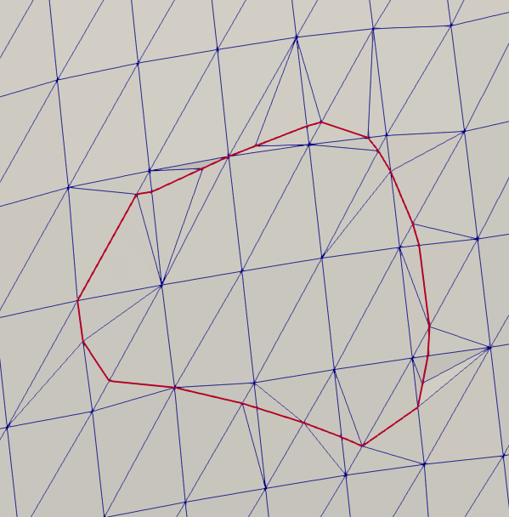

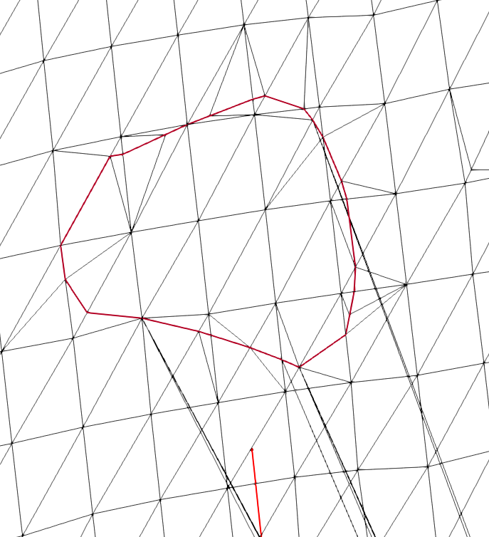This is what our reference curve looks like right now. This is the curve Keith was using to verify his method is working correctly. With the surface mesh not in wireframe view, the curve and sub-mesh looks correct. However, when the surface is switched to wireframe mode, it is obvious something is wrong.

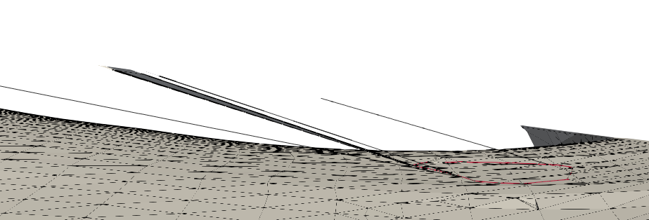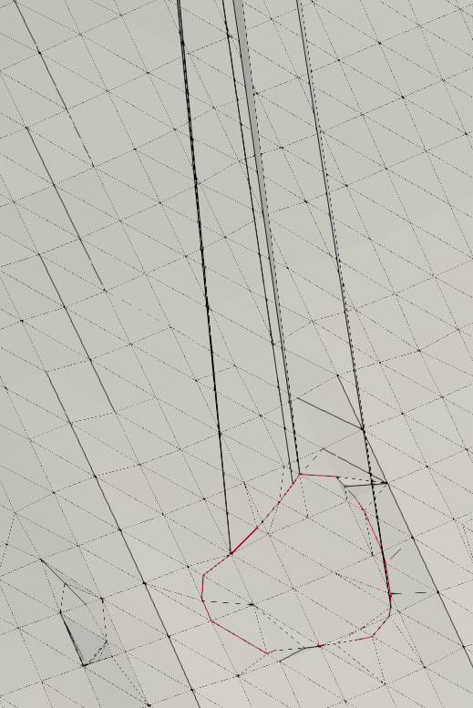You can see the underlying elements that are stretched and simply wrong. They are actually connecting to a separate boundary curve but in no apparent order or pattern. I should also mention that this didn’t occur when it was one curve but only when I start to try and loop over each curve and add them to the surface mesh (by sub-dividing elements and adding the sub-divided elements back into the surface mesh as we have discussed). This makes me think that something I changed to get the loop working is wrong (just stating the obvious here). I noticed this today when I tried to generate a surface with all of the curves for the report I sent to you. I am not sure what is going on yet but I am investigating tonight. Below is the reverse side of the curve where you can see the incorrect elements again.

Hopefully it is apparent that there is also some dimensionality to these incorrect elements as they do not lie flat on the surface. I will let you know what I find out.