Lab6 School ID : F74034091 Name : 許熙浩

1.

(1)T

(2)F , an is-a relationship is totally copy base-class’s thing.

(3)F , student should be an has-a relationship with faculty and course class. For the faculty’s ability is more than student.

(4)T

(5)T

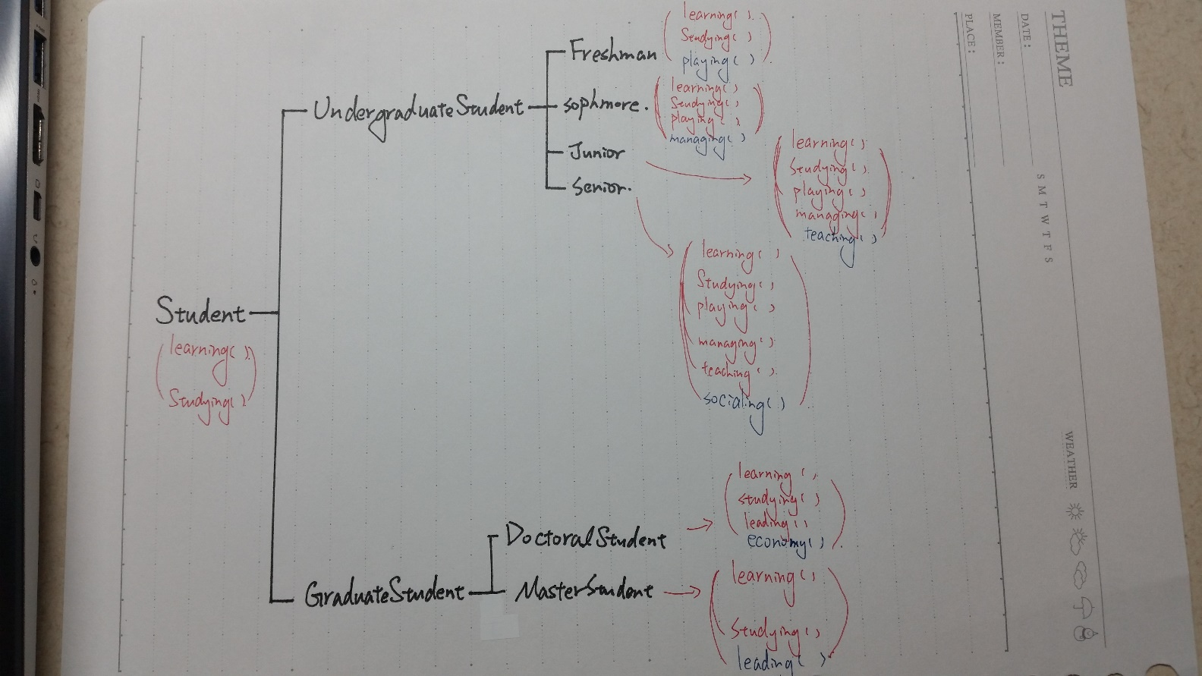2.