library(tidyverse)
## ── Attaching core tidyverse packages ──────────────────────── tidyverse 2.0.0 ──
## ✔ dplyr 1.2.1 ✔ readr 2.2.0
## ✔ forcats 1.0.1 ✔ stringr 1.6.0
## ✔ ggplot2 4.0.3 ✔ tibble 3.3.1
## ✔ lubridate 1.9.5 ✔ tidyr 1.3.2
## ✔ purrr 1.2.2
## ── Conflicts ────────────────────────────────────────── tidyverse_conflicts() ──
## ✖ dplyr::filter() masks stats::filter()
## ✖ dplyr::lag() masks stats::lag()
## ℹ Use the conflicted package (<http://conflicted.r-lib.org/>) to force all conflicts to become errors
library(ggplot2)
library(dplyr)
library(imager)
## Loading required package: magrittr
##
## Attaching package: 'magrittr'
##
## The following object is masked from 'package:purrr':
##
## set_names
##
## The following object is masked from 'package:tidyr':
##
## extract
##
##
## Attaching package: 'imager'
##
## The following object is masked from 'package:magrittr':
##
## add
##
## The following object is masked from 'package:stringr':
##
## boundary
##
## The following object is masked from 'package:dplyr':
##
## where
##
## The following object is masked from 'package:tidyr':
##
## fill
##
## The following objects are masked from 'package:stats':
##
## convolve, spectrum
##
## The following object is masked from 'package:graphics':
##
## frame
##
## The following object is masked from 'package:base':
##
## save.image
apple <-load.image("C:/Users/collin/Downloads/R images/WhatsApp Image 2026-10-27 at 18.50.60.jpeg" )
plot(apple)
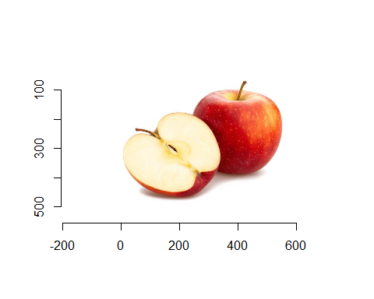
#applying grayscale
gray_apple<- grayscale(apple)
plot(gray_apple)
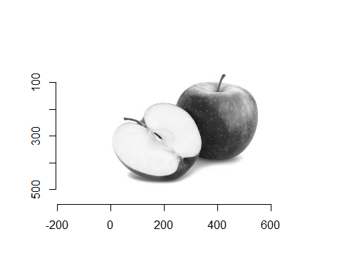
#Applying threshold
binary<-gray_apple>0.5
plot(binary)
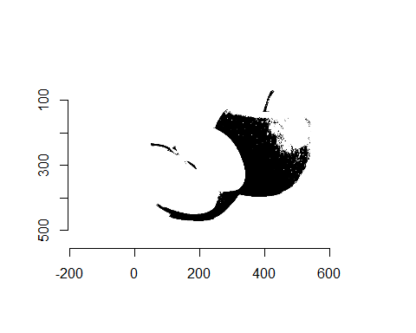
blur_apple <- isoblur(apple, sigma = 5)
plot(blur_apple)
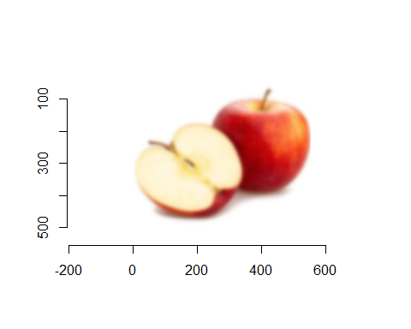
# 5.3 Face Detection and Recognition
library(image.libfacedetection)
library(opencv)
library(magick)
## Linking to ImageMagick 6.9.13.29
## Enabled features: cairo, freetype, fftw, ghostscript, heic, lcms, pango, raw, rsvg, webp
## Disabled features: fontconfig, x11
# Load photo
img <- image_read("C:/Users/collin/Downloads/R images/WhatsApp Image 2026-10-26 at 11.49.13.jpeg")
# Detect faces (extracts bounding box coordinates)
faces <- image_detect_faces(img)
# Display detection results dataframe in console
print(faces$detections)
## x y width height confidence landmark1_x landmark1_y landmark2_x
## 1 403 179 23 28 99 409 188 420
## 2 1047 129 25 40 98 1053 142 1069
## 3 765 180 22 27 98 769 189 779
## 4 845 187 26 33 98 856 200 867
## 5 716 184 22 30 98 720 195 728
## 6 512 200 23 28 97 520 210 530
## 7 359 186 24 28 97 367 195 377
## 8 664 200 22 25 96 672 210 681
## 9 991 161 29 39 93 1006 175 1017
## 10 579 203 20 25 92 584 212 592
## 11 466 192 21 25 90 472 201 482
## 12 623 196 22 29 90 628 207 637
## 13 909 184 25 34 89 923 196 931
## 14 295 176 24 30 83 305 188 315
## 15 253 178 24 28 49 264 191 274
## 16 175 153 28 37 42 186 165 198
## landmark2_y landmark3_x landmark3_y landmark4_x landmark4_y landmark5_x
## 1 189 415 193 410 199 419
## 2 143 1058 150 1054 158 1067
## 3 190 773 195 769 199 778
## 4 201 863 208 856 212 864
## 5 195 722 201 722 206 729
## 6 211 525 216 519 220 528
## 7 196 373 201 366 206 376
## 8 210 677 215 671 219 679
## 9 175 1015 182 1006 189 1014
## 10 212 587 216 583 220 590
## 11 201 476 205 472 210 480
## 12 207 631 213 628 217 636
## 13 196 931 202 924 208 931
## 14 189 311 194 304 198 312
## 15 190 271 197 265 200 272
## 16 164 195 171 187 179 198
## landmark5_y
## 1 199
## 2 158
## 3 200
## 4 213
## 5 205
## 6 221
## 7 206
## 8 219
## 9 190
## 10 221
## 11 210
## 12 218
## 13 208
## 14 199
## 15 200
## 16 179
# Plot photo with red boxes around detected faces
plot(faces, img, border = "red", lwd = 2)
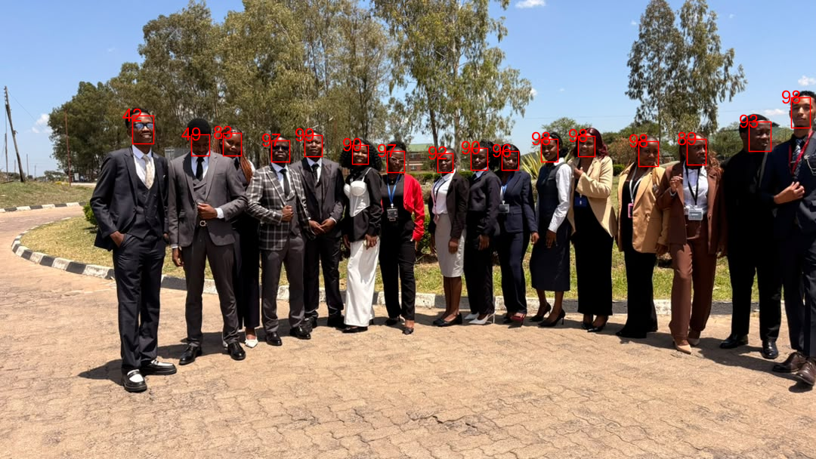
# Convert faces data frame coordinates to crop boxes
detections <- faces$detections
if (nrow(detections) > 0) {
# Loop through each detected face and crop it
for (i in 1:nrow(detections)) {
crop_geo <- sprintf("%dx%d+%d+%d",
detections$width[i],
detections$height[i],
detections$x[i],
detections$y[i])
face_crop <- image_crop(img, crop_geo)
# Save each cropped face
image_write(face_crop, sprintf("cropped_face_%d.jpg", i))
}
}
detections <- faces$detections
if (!is.null(detections) && nrow(detections) > 0) {
# Loop through each detected face, crop, save, and print
for (i in 1:nrow(detections)) {
crop_geo <- sprintf("%dx%d+%d+%d",
detections$width[i],
detections$height[i],
detections$x[i],
detections$y[i])
face_crop <- image_crop(img, crop_geo)
# Save cropped face to disk
image_write(face_crop, sprintf("cropped_face_%d.jpg", i))
# --- DISPLAY OUTPUT IN NOTEBOOK ---
print(face_crop) # Forces display of the cropped face image
}
} else {
print("No faces detected in the image.")
}
## # A tibble: 1 × 7
## format width height colorspace matte filesize density
## <chr> <int> <int> <chr> <lgl> <int> <chr>
## 1 JPEG 23 28 sRGB FALSE 0 72x72
## # A tibble: 1 × 7
## format width height colorspace matte filesize density
## <chr> <int> <int> <chr> <lgl> <int> <chr>
## 1 JPEG 25 40 sRGB FALSE 0 72x72
## # A tibble: 1 × 7
## format width height colorspace matte filesize density
## <chr> <int> <int> <chr> <lgl> <int> <chr>
## 1 JPEG 22 27 sRGB FALSE 0 72x72
## # A tibble: 1 × 7
## format width height colorspace matte filesize density
## <chr> <int> <int> <chr> <lgl> <int> <chr>
## 1 JPEG 26 33 sRGB FALSE 0 72x72
## # A tibble: 1 × 7
## format width height colorspace matte filesize density
## <chr> <int> <int> <chr> <lgl> <int> <chr>
## 1 JPEG 22 30 sRGB FALSE 0 72x72
## # A tibble: 1 × 7
## format width height colorspace matte filesize density
## <chr> <int> <int> <chr> <lgl> <int> <chr>
## 1 JPEG 23 28 sRGB FALSE 0 72x72
## # A tibble: 1 × 7
## format width height colorspace matte filesize density
## <chr> <int> <int> <chr> <lgl> <int> <chr>
## 1 JPEG 24 28 sRGB FALSE 0 72x72
## # A tibble: 1 × 7
## format width height colorspace matte filesize density
## <chr> <int> <int> <chr> <lgl> <int> <chr>
## 1 JPEG 22 25 sRGB FALSE 0 72x72
## # A tibble: 1 × 7
## format width height colorspace matte filesize density
## <chr> <int> <int> <chr> <lgl> <int> <chr>
## 1 JPEG 29 39 sRGB FALSE 0 72x72
## # A tibble: 1 × 7
## format width height colorspace matte filesize density
## <chr> <int> <int> <chr> <lgl> <int> <chr>
## 1 JPEG 20 25 sRGB FALSE 0 72x72
## # A tibble: 1 × 7
## format width height colorspace matte filesize density
## <chr> <int> <int> <chr> <lgl> <int> <chr>
## 1 JPEG 21 25 sRGB FALSE 0 72x72
## # A tibble: 1 × 7
## format width height colorspace matte filesize density
## <chr> <int> <int> <chr> <lgl> <int> <chr>
## 1 JPEG 22 29 sRGB FALSE 0 72x72
## # A tibble: 1 × 7
## format width height colorspace matte filesize density
## <chr> <int> <int> <chr> <lgl> <int> <chr>
## 1 JPEG 25 34 sRGB FALSE 0 72x72
## # A tibble: 1 × 7
## format width height colorspace matte filesize density
## <chr> <int> <int> <chr> <lgl> <int> <chr>
## 1 JPEG 24 30 sRGB FALSE 0 72x72
## # A tibble: 1 × 7
## format width height colorspace matte filesize density
## <chr> <int> <int> <chr> <lgl> <int> <chr>
## 1 JPEG 24 28 sRGB FALSE 0 72x72
## # A tibble: 1 × 7
## format width height colorspace matte filesize density
## <chr> <int> <int> <chr> <lgl> <int> <chr>
## 1 JPEG 28 37 sRGB FALSE 0 72x72
# Plot image first
img<- image_read("C:/Users/collin/Downloads/R images/WhatsApp Image 2026-10-26 at 11.49.13.jpeg")
plot(as.raster(img))
# Annotate each box with confidence percentage
if (nrow(detections) > 0) {
rect(detections$x, detections$y,
detections$x + detections$width,
detections$y + detections$height,
border = "red", lwd = 2)
# Add text labels above the bounding boxes
text(x = detections$x, y = detections$y - 10,
labels = paste0("Face: ", round(detections$confidence[i] * 100, 1), "%"),
col = "red", cex = 1.2, font = 2)
}
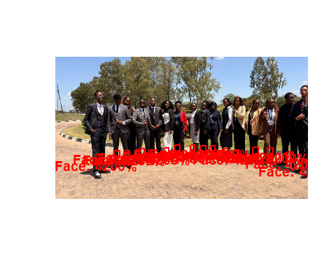
library(magick)
library(image.libfacedetection)
# Load image and detect faces
img <- image_read("C:/Users/collin/Downloads/R images/WhatsApp Image 2026-10-26 at 11.49.13.jpeg")
faces <- image_detect_faces(img)
detections <- faces$detections
if (nrow(detections) > 0) {
# Sort face bounding boxes by height
tallest_idx <- which.max(detections$height)
shortest_idx <- which.min(detections$height)
print(paste("Tallest/Largest Face Index:", tallest_idx, "with height:", detections$height[tallest_idx], "px"))
print(paste("Shortest/Smallest Face Index:", shortest_idx, "with height:", detections$height[shortest_idx], "px"))
# Highlight tallest face in green, shortest in blue
plot(faces, img, border = "red")
rect(detections$x[tallest_idx], detections$y[tallest_idx],
detections$x[tallest_idx] + detections$width[tallest_idx],
detections$y[tallest_idx] + detections$height[tallest_idx],
border = "green", lwd = 3)
rect(detections$x[shortest_idx], detections$y[shortest_idx],
detections$x[shortest_idx] + detections$width[shortest_idx],
detections$y[shortest_idx] + detections$height[shortest_idx],
border = "blue", lwd = 3)
}
## [1] "Tallest/Largest Face Index: 2 with height: 40 px"
## [1] "Shortest/Smallest Face Index: 8 with height: 25 px"

