**Collin McElroy**

**4/14/16**

**HW #2**

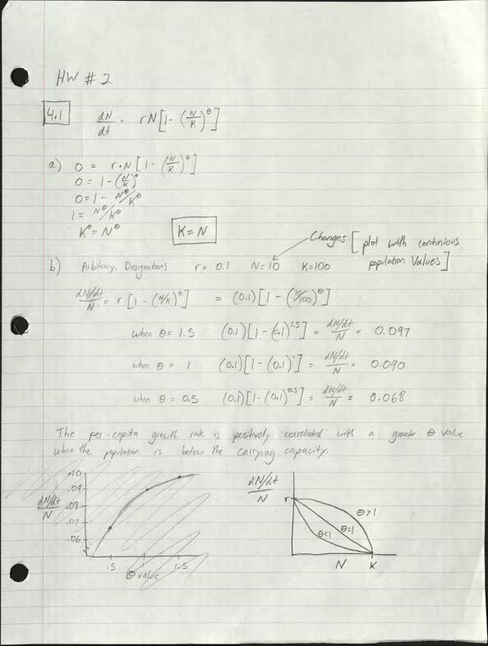





**2.a)**

log.growth <- function(t, y, p) {

N <- y[1]

with(as.list(p), {

dN.dt <- r * N * (1 - (N / K)^theta)

return(list(dN.dt))

})

}

N<-runif(1,min=0.01,max=0.1)

p<-c('r'=0.25,'K'=100,'theta'=1)

t<-1:100

y<-c('N'=N)

sim <- ode(y = y, times = t, func = log.growth, parms = p, method = 'lsoda')

sim <- as.data.frame(sim)

plot(N ~ t, data = sim, type = 'l', lwd = 3, bty = 'l', col = 'purple')

p2<-c('r'=0.25,'K'=50,'theta'=1)

sim2 <- ode(y = y, times = t, func = log.growth, parms = p2, method = 'lsoda')

sim2<-as.data.frame(sim2)

lines(N ~ t, data = sim2, type = 'l', lwd = 3, bty = 'l', col = 'red')

p3<-c('r'=0.25,'K'=25,'theta'=1)

sim3<-ode(y = y, times = t, func = log.growth, parms = p3, method = 'lsoda')

sim3<-as.data.frame(sim3)

lines(N ~ t, data = sim3, type = 'l', lwd = 3, bty = 'l', col = 'green')

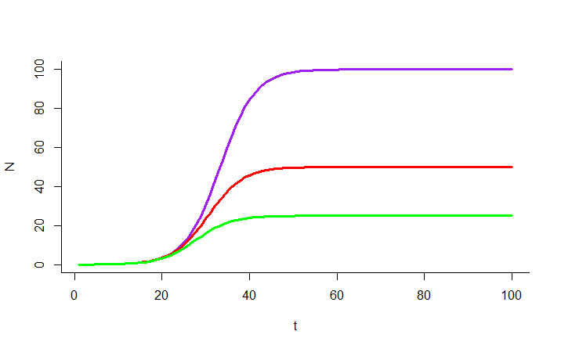

**2.b)**

sim$deriv<-c(diff(sim$N),NA)

plot(deriv ~ N, data = sim, type = 'l', lwd = 3 , col = 'purple', bty = 'l')

sim2$deriv<-c(diff(sim2$N),NA)

lines(deriv ~ N, data = sim2, type = 'l', lwd = 3 , col = 'red', bty = 'l')

sim3$deriv<-c(diff(sim3$N),NA)

lines(deriv ~ N, data = sim3, type = 'l', lwd = 3 , col = 'green', bty = 'l')

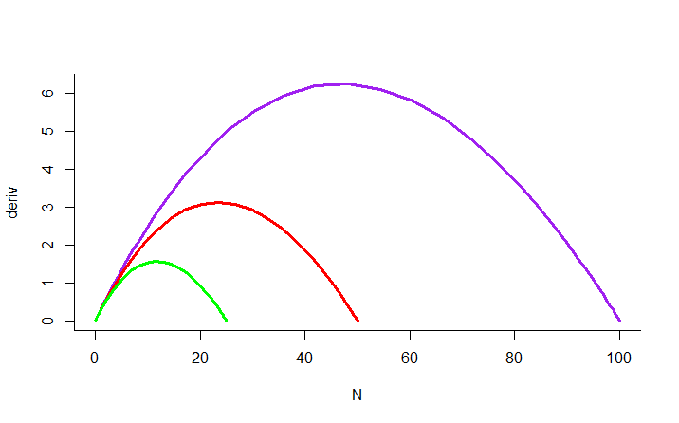

**2.c)**

Max.rate.1<-max(sim$deriv, na.rm = TRUE)

Max.rate.2<-max(sim2$deriv, na.rm = TRUE)

Max.rate.3<-max(sim3$deriv, na.rm = TRUE)

which(sim$deriv == max(sim$deriv, na.rm = TRUE))

which(sim2$deriv == max(sim2$deriv, na.rm = TRUE))

which(sim3$deriv == max(sim3$deriv, na.rm = TRUE))

install.packages('deSolve')

library(deSolve)

K/2

N.max.rate.1<-50

N.max.rate.2<-25

N.max.rate.3<-12.5

Population.half.of.K<-c(50,25,12.5)

Max.rate<-c(Max.rate.1,Max.rate.2,Max.rate.3)

plot(Population.half.of.K,Max.rate, col="blue",lwd=3,type='l')

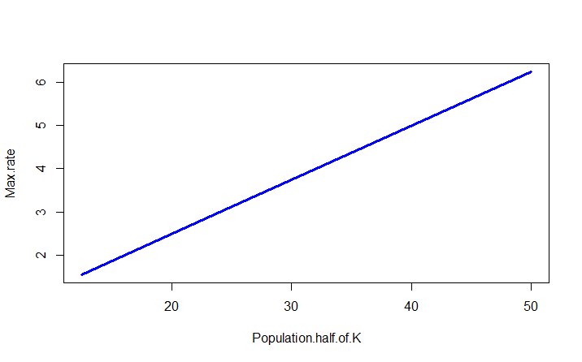

**3)**

log.growth.N <- function(t, y, p) {

N <- y[1]

with(as.list(p), {

dN.dt <- r * (1 - (N / K)^theta)

return(list(dN.dt))

})

}

r<-0.1

K<-100

N<-50

theta.A<-0.5

theta.B<-1.0

theta.C<-1.8

Rate.A<-(r*(1-(N/K)^(theta.A)))

Rate.B<-(r*(1-(N/K)^(theta.B)))

Rate.C<-(r*(1-(N/K)^(theta.C)))

Per.Capita.Growth.Rate<-c(Rate.A,Rate.B,Rate.C)

Theta.Value<-c(theta.A,theta.B,theta.C)

plot(Per.Capita.Growth.Rate~Theta.Value,col="purple",type='l',lwd=3)

Species 'C' will have the highest population abundance because

it has the highest growth rate.

