Order Status
Flow for what the customer sees on the order details screen, based on order status.
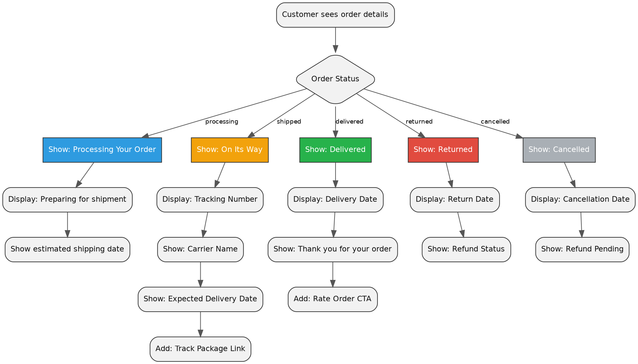

Overview
processing | shipped | delivered | returned | cancelled
1. Show: Processing Your Order  2. Display: Preparing for shipment  3. Show estimated shipping date | 1. Show: On Its Way  2. Display: Tracking Number  3. Show: Carrier Name  4. Show: Expected Delivery Date  5. Add: Track Package Link | 1. Show: Delivered  2. Display: Delivery Date  3. Show: Thank you for your order  4. Add: Rate Order CTA | 1. Show: Returned  2. Display: Return Date  3. Show: Refund Status | 1. Show: Cancelled  2. Display: Cancellation Date  3. Show: Refund Pending

