Gikomba Online
Software Requirements Specification Document

CMT 311
Group Members
1033993 Barbara Nanyingi
1033977 Diana Nyamai
1034876 Collins Kiprono

1. INTRODUCTION
1.1 PURPOSE
The purpose of this document is to build an online system to enables different users to buy and sell pre-owned Items .
1.2 DOCUMENT CONVENTIONS
This document uses the following conventions.
DB | Database
DDB | Distributed Database
ER | Entity Relationship
1.3 INTENDED AUDIENCE AND READING SUGGESTIONS
This project is a prototype for the e-Commerce website Gikosh.com which is an online platform to ease sale and purchase of various preowned market goods. This project intends to reach out to small scale market traders to enhance flow of goods for their business
1.4 PROJECT SCOPE
The purpose of the e-Commerce website is to ease the flow of goods from the seller to the buyer without the bustle of heading to the market place.
This project will deal with both large scale (Whole sale Goods) and small scale goods .

2. OVERALL DESCRIPTION
2.1 PRODUCT PERSPECTIVE
A distributed goods flow database system stores the following information.
- Goods for sale:
It includes goods posted by the various sellers that are available for purchase by the buyer
- Goods for Purchase:
It includes Goods that have been placed in the cart by the potential buyers within the system.
- Customer description:
It contains valid information useful for the delivery of the ordered goods
- Seller description:
It includes origin of the goods for sale
2.2 PRODUCT FEATURES
This product features a faster way for flow of goods from the seller to the buyer
2.3 OPERATING ENVIRONMENT
Operating environment for the Goods management system is as listed below. <<Include the details as per your application >>
- distributed database
- client/server system
- Operating system: Windows.
- database: sql+ database

2.4 DESIGN and IMPLEMENTATION CONSTRAINTS
- The global schema, fragmentation schema, and allocation schema.
- SQL commands for above queries/applications
- How the response for application 1 and 2 will be generated. Assuming these are global queries. Explain how various fragments will be combined to do so.
- Implement the database at least using a centralized database management system.

2.2 Product Functions:
OSS should support this use case:

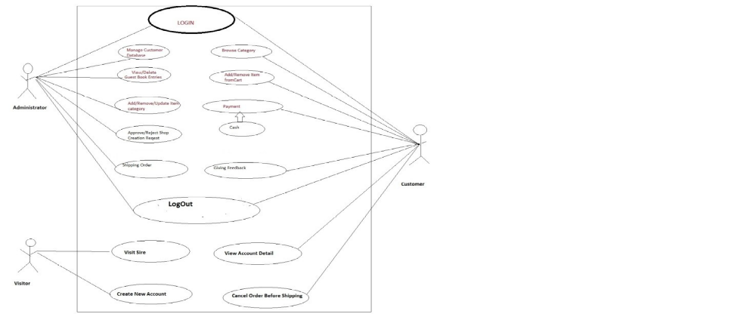

2.5 ASSUMPTION DEPENDENCIES
Let us assume that this is a distributed goods management system and it is used in the following application:
- goods sold and goods placed in the cart to be prepared for sale
- Calculation of prospective revenue for the traders
Assuming both the transactions are single transactions, we have designed a distributed database that is geographically dispersed at four cities Nairobi, Mombasa, Kisumu, and Nakuru

3. SYSTEM FEATURES
- DESCRIPTION and PRIORITY
The Website keeps track of goods in stock with the various sellers and the potential buyers, The system prioritizes on a steady flow of goods from various sellers to a steady customer base
- STIMULUS/RESPONSE SEQUENCES
  - Search for certain brands in stock
  - Displays a detailed list of available goods and move the item to cart once selected.
  - Complete Purchase order.
- FUNCTIONAL REQUIREMENTS
Other system features include:
DISTRIBUTED DATABASE:
Distributed database implies that a single application should be able to operate transparently on data that is spread across a variety of different databases and connected by a communication network.

CLIENT/SERVER SYSTEM
The term client/server refers primarily to an architecture or logical division of responsibilities, the client is the application (also known as the front-end), and the server is the DBMS (also known as the back-end).
A client/server system is a distributed system in which,
- Some sites are client sites and others are server sites.
- All the data resides at the server sites.
- All applications execute at the client sites.

4. EXTERNAL INTERFACE REQUIREMENTS
4.1 USER INTERFACES
- Front-end software: Reactjs Framework
- Back-end software: js
4.2 HARDWARE INTERFACES
- Windows.
- A browser which supports CGI, HTML & Javascript.
4.3 SOFTWARE INTERFACES
Following are the software used for the Goods management online application. <<Include the software details as per your project >>
Software used | Description
Operating system | We have chosen Windows operating system for its best support and user-friendliness.
Database | To save the seller records, buyer records we have chosen SQL+ database.
4.4 COMMUNICATION INTERFACES
This project supports all types of web browsers. We are using simple electronic forms for the reservation forms, ticket booking etc.

5. NONFUNCTIONAL REQUIREMENTS
5.1 PERFORMANCE REQUIREMENTS
The steps involved to perform the implementation of Goods Flow database are as listed below.
A) E-R DIAGRAM
The E-R Diagram constitutes a technique for representing the logical structure of a database in a pictorial manner. This analysis is then used to organize data as a relation, normalizing relation and finally obtaining a relation database.
- ENTITIES: Which specify distinct real-world items in an application.
- PROPERTIES/ATTRIBUTES: Which specify properties of an entity and relationships.
- RELATIONSHIPS: Which connect entities and represent meaningful dependencies between them.

B) NORMALIZATION:
The basic objective of normalization is to reduce redundancy which means that information is to be stored only once. Storing information several times leads to wastage of storage space and increase in the total size of the data stored.
If a database is not properly designed it can give rise to modification anomalies. Modification anomalies arise when data is added to, changed or deleted from a database table. Similarly, in traditional databases as wellimproperly designed relational databases, data redundancy can be a problem. These can be eliminated by normalizing a database.
Normalization is the process of breaking down a table into smaller tables. So that each table deals with a single theme. There are three different kinds of modifications of anomalies and formulated the first, second and third normal forms (3NF) is considered sufficient for most practical purposes. It should be considered only after a thorough analysis and complete understanding of its implications.
5.2 SAFETY REQUIREMENTS
If there is extensive damage to a wide portion of the database due to catastrophic failure, such as a disk crash, the recovery method restores a past copy of the database that was backed up to archival storage (typically tape) and reconstructs a more current state by reapplying or redoing the operations of committed transactions from the backed up log, up to the time of failure.
5.3 SECURITY REQUIREMENTS
Security systems need database storage just like many other applications. However, the special requirements of the security market mean that vendors must choose their database partner carefully.

5.4 SOFTWARE QUALITY ATTRIBUTES
- AVAILABILITY: The Ordered Goods should be available on the specified date and specified time as many customers are doing advance reservations.
- CORRECTNESS: The Sellers should reach start from correct start terminal and should reach the correct order
- MAINTAINABILITY: Sellers should update goods available in stock and show those sold out
- USABILITY: Available items should be real time for the buyers and sellers easier

