

Project Proposal

For consideration under

BACHELOR OF SCIENCE (BSc)  COMPUTER SCIENCE

PROJECT TITLE

CAMPUS CONTENT MANAGEMENT SYSTEM

(LIVE SUMMARY)

SUBMITTED BY :

Collins Kiprono

(Author)

MR WILLIAM MIRUGI

(Project Supervisor)

Mr Edward Kioko

(Head of Department Computer Science)

(Date of Submission)

This project is in partial fulfillment of the requirements for the award for BSc in Computer Science.

DECLARATION 

I, Collins Kiprono, do hereby declare that this Project Report is original and has not been published and/or submitted for any other degree award to any other university before.

Signed …………………..   Date…………………………..

COLLINS KIPRONO

APPROVAL

This project has been submitted for examination with the approval of the following supervisor.

Signed ……………..  Date …………………………

MR WILLIAM MIRUGI

DEDICATION

This research project is dedicated to my family who have been instrumental in the completion of this project.

I thank them for the advice, motivation and support both financially and physically. They have contributed a lot in my education and I pray that God may bless them abundantly and give them favor for the rest of their days.

ACKNOWLEDGMENTS

I would like to acknowledge the contributions of several people to this research; without whose help it

would not have been possible for me to carry out this research. First and foremost I would like to thank

my heavenly father who has kept me in good health all through the course of this project and reminded me of a principle of living a day at a time. I would also like to thank Mr Edward Kioko ,the Head of Department Computer Science , for his leadership during the duration of the four year program.

My supervisor William Mirugi, what can I say, you have been the greatest influence in this research.

Thank you for your guidance, insight and for believing in me and my prayer is for this working

relationship to go on even after the completion of this project.

I thank the management of the Catholic University of Eastern Africa, Nairobi for their support to do this work. Finally, my thanks to all the people who supported me to complete this research work directly or indirectly.

ABSTRACT

Content management is becoming the most basic necessities in any organization today. This can be attributed to the rise in digital content and the need to secure this content in various online platform for future reference and editing . This has been seen in many organizations coming up with articles which can be referred to b researchers and the general public . The spread of such content has led to the need to integrate content management systems to various levels in organizations. This project was conceptualized to try and bring down the use on content management systems in Learning Institutions to the students level thereby enabling them to get their Class content r.g notes and reference material in a digital format that can be accessed from different devices across the world .

This project is also set to try and reduce deforestation by reducing the reliance on pen and paper technology which is costly and environmentally unfriendly.

Various studies have come to the conclusion that over 90% of campus students have access to Digital devices which can be made useful in the learning process . The front-end part of this project will be developed using HTML css and java-script , the back-end will be developed using node js and the database using mongodb(mongoose). The final work to be delivered will be a functioning web application that can allow students to create their user account create sessions to take down notes during lectures , access already existing content and make edits to the content that is already on the system. This research will be of help to the students as a platform for sharing and collaborating on learning material.

Table of Contents

DECLARATION  2

DEDICATION 3

ACKNOWLEDGMENTS 4

ABSTRACT 5

CHAPTER ONE  8

CHAPTER ONE  8

1.1 INTRODUCTION  8

1.2 Motivation and Background of Research 8

1.3 Problem Statement 9

ACKNOWLEDGMENTS 10

1.4 Aim of Research 10

1.5 Objectives of the Research 11

1.6 Justification of the Research 11

1.6 Justification of the Research 11

1.7 Scope of Research 11

1.8 Research Organization 12

CHAPTER TWO 13

LITERATURE REVIEW 13

2.1 Introduction 13

2.2 History of the Research Topic 13

2.3 Review of related prototypes, systems [from local to global] 13

[2.3.1 Notion(Note Taking App) 13](#1%192.3.1_Notion(Note_Taking_App)%19C)

2.3.2 EverNote 14

2.4 Emerging Trends in this Field of Research 14

2.4.1 Psychology 14

2.4.2 Diversity 14

2.4.3 Technology 14

2.5 Research gap to be filed by your Research 14

2.6 Chapter Summary 14

CHAPTER THREE 15

RESEARCH METHODOLOGY 15

3.1 Introduction 15

3.2 Methodology for the Literature Review 15

3.3 Methodology for requirement specification, data collection an analysis techniques e.g Interviews, questionnaires 15

3.3.1 Data Collection 15

[3.4 Methodology for the System Analysis(current systems) DFD, Context Diagrams, Flow Charts 15](#1%193.4_Methodology_for_the_System_Analysis(current_systems)_DFD,_Context_Diagrams,_Flow_Charts%19C)

3.5 Methodology for System Implementation: Back-end, Front-end and Database Technologies to be used 15

3.6: Methodology for system testing, testing plan, testing techniques 15

3.7 Methodology For System Testing 15

3.7.1 Acceptance Testing 15

3.7.2 Unit Testing 15

3.8 Methodology for System Deployment 15

3.9 Chapter Summary 16

CHAPTER FOUR 17

SYSTEM ANALYSIS OF THE CURRENT SYSTEM 17

4.1 Introduction 17

4.2 Description of the Current System 17

4.3 Feasibility Study 17

4.3.1 Technical Feasibility 17

4.3.2 Economic Feasibility 17

4.3.3 Operational Feasibility 17

4.3.4 Schedule Feasibility 17

4.4 Data I/O Analysis 17

4.5 Process Logic Design of the current System 17

4.6 Chapter Summary 17

CHAPTER 5 18

SYSTEM DESIGN OF THE PROPOSED SYSTEM 18

5.1: Introduction 18

5.2 The Proposed System 18

5.3 Requirement Analysis 18

CHAPTER ONE 

1.1 INTRODUCTION

This research proposal will look into Content Management and delivery can be applied in the education system using mobile devices such as smartphones,  tablets, laptops e.t.c  . This introduction has been apportioned various parts as follows the first part is the background of the research the second is the problem statement, the third part is the major purpose of the research, fourth is the justification lastly is the aim and objective of the proposed research.

1.2 Motivation and Background of Research

Just like any other Content Management System(CMS) The main aim of this research is to integrate the CMS Model into the education sector. Normally in a School content management system the Teachers/ tutors would be at the admin view issuing the content and the student be at the user fronted viewing but not making any edits to the available content . This doesn’t prove to be interactive with the students while making the content for study.

Though rather effective, this approach isn’t useful for the student when taking short notes during the lecturers. The students would then rather write down their short notes on an exercise book or piece of paper rather than in a digital format as their tutors do. Often the students end up losing the short notes they wrote in class .

With the rise of use of information technology in the education system ,It would be rational to bring tits use to the student level . This approach would then encourage the students to work together on class projects and enable them to share learning material through a content management system of its kind.

This would aid students during the preparation for school examinations by helping them sort though the content that has been covered throughout the course .

With the rapid growth of devices , we see that young minds are more intrigued by a screen more than a book . This would encourage the Bring Your Own Device(B.Y.O.D) Culture among students . Its no lie using the same devices to take down classroom content isn’t such a bad idea .

1.3 Problem Statement

With the rise of Information Technology integration in the Education sector, we are still yet to see students typing up all the classwork during the lecture. Specifically looking at University level of education close to 99% of the students have access to a mobile device whether a smartphone , a tablet or laptop . Most of whom still use pen and paper to take down notes during lectures, this could be an issue since some if not most end up losing the content they wrote just before examination period . Another instance is when a student has to re-sit an examination they often don’t have the notes to study for the paper and end up failing due to that. This has been a great problem especially with the older students with pending units acting as a barrier to their graduation.

In recent times students usually have an issue when coordinating class group assignments and projects where they don't have the necessary platform to share the content required to complete the assignment and/or project .

During the exam period students usually have trouble finding the notes they wrote during lectures . This platform should be a one stop place for the students to get a last glimpse of the class content before sitting the exam paper .

1.4 Aim of Research

The purpose of this research project is to harness the power of Information technology in the day to day studies of students by using a content management system to manage their class notes, and personalized short notes. This would also heavily involve the use of personal digital devices in the learning process.

1.5 Objectives of the Research

General Objectives

* Live Summary will be designed to give student an open platform to write, Read , share and edit academic content .(Collaborate in making class content)
* Allow students to practice their typing skills by taking notes down using a personal device , as fast typing has become a requirement for some of the positions in the job market (Data Entry, Software Engineering e.t.c)
* Create both client and server side and use web services for data transfer communication for students with different content access rights . Admins should be able to write or edit content that will be accessed by other students

1.6 Justification of the Research

Here are some reasons why that make this research very relevant to the smoothing out the students study. According to recent survey, up to 50% of students don’t get to the pass mark and this has been attributed to the following reasons

* Lack of reading material to prepare adequately for the examination ; This has been brought about by students losing their class notes and often do not have the material to prepare for the examination .
* Lack of a proper collaboration tool to conduct class group work and class discussions ;This leaves the students with little to no understanding of the content in the course work .
* Poor methods of backing up school work ; Students tend not to have their class work properly backed up for future use and most of the time end up losing the notes they wrote up .

1.7 Scope of Research

This project aims to :

* To develop a web based application for the sole purpose of enhancing content management in Universities and colleges.
* Able to integrate within the app various tools to aid students during exam preparation as it will enable them to store a backup of their class notes .

1.8 Research Organization

The organization of this research leverages the power of the internet to acquire information. The target sources that provided the information that contribute to the analysis of this topic include:

* Google
* Information from Students

In chapter two, we seek to resolve our research problem through data gathering using a variety of techniques. We will also provide an interpretation of data gathered and afterwards draw conclusions from our research data. The research methods that we will use will lay down the foundation of our research.

In chapter three, we will be concerned with reviewing previous studies that are related to our research problem. This will include goals, discussion and findings of previous work done in regards to our research problem. This will include goals, discussion and findings of previous work done in regards to our research problem .

In chapter four, which is the system analysis, we are set to examine our research problem with the purpose of developing a system solution to our problem. This project will require analysis to gather requirements and create blueprints for how the web application system will be built .

In chapter five, which is system design is set to defining elements for our web application system such as modules architecture components and their interfaces and data for the system based on specific requirements. Here we will use modeling languages to express the information and knowledge in the structure of our system.

In chapter six, we have implementation and testing and this will entail defining how we will build our system while ensuring the system is operational and meets the quality standard. Testing will also be done to validate the complete and fully operational software. This is done to evaluate that the end-to-end system specifications are well done.

In chapter seven, is set to give conclusions and will also interpret the findings and results of our research. Afterwards, we will give our own recommendations which are our opinions supported by the research. This will finally form the debrief of our project.

Conclusion

CHAPTER TWO

LITERATURE REVIEW

2.1 Introduction

Review of related work refers to a detailed study of existing literature related to a topic of a thesis or dissertation. This chapter will identify the finding of Live Summary. We will highlight various gaps in the notes taking in the life of a campus student .

2.2 History of the Research Topic

2.3 Review of related prototypes, systems [from local to global]

2.3.1 Notion(Note Taking App)

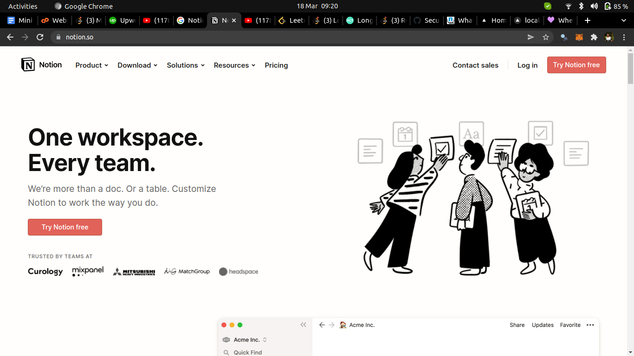

2.3.2 EverNote

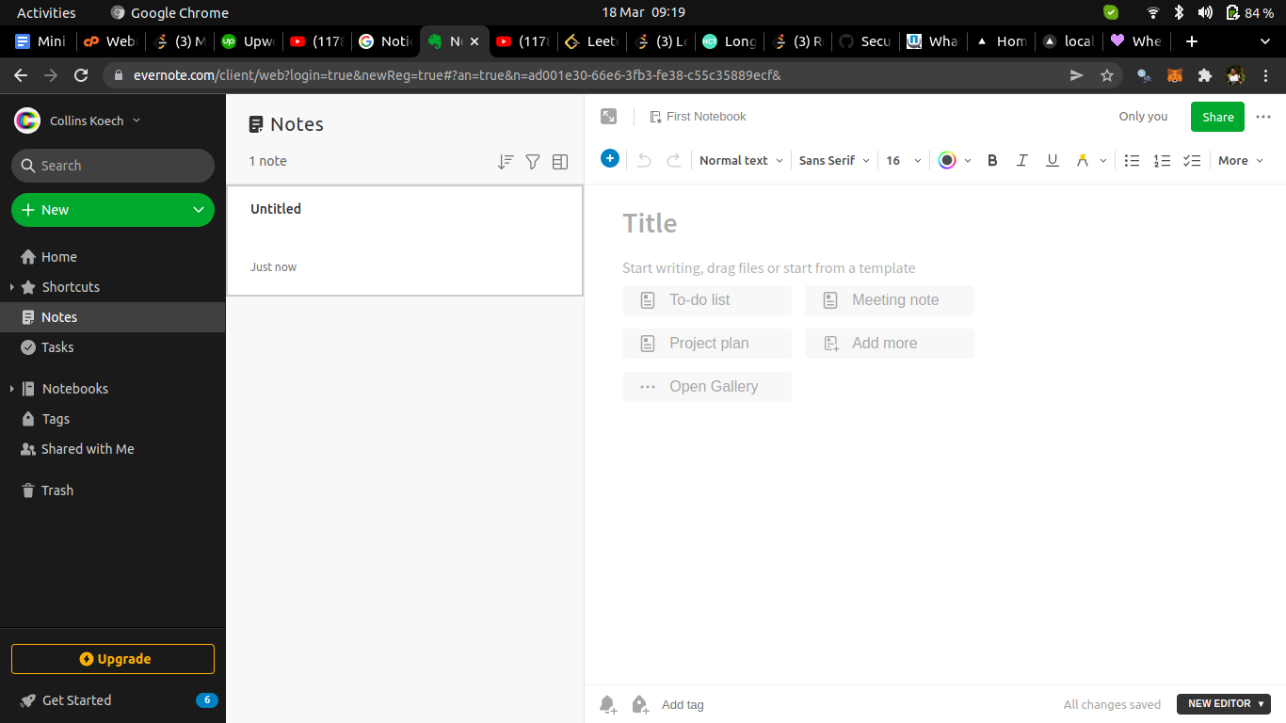

2.4 Emerging Trends in this Field of Research

2.4.1 Psychology

2.4.2 Diversity

2.4.3 Technology

2.5 Research gap to be filed by your Research

2.6 Chapter Summary

CHAPTER THREE

RESEARCH METHODOLOGY

3.1 Introduction

3.2 Methodology for the Literature Review

3.3 Methodology for requirement specification, data collection an analysis techniques e.g Interviews, questionnaires

3.3.1 Data Collection

Interviews

Conducting interviews is one of the most common methods of data collection. It may be defined as a two-way systematic conversation between an investigator and an informant, initiated for obtaining information relevant to a specific study. It involves not only a conversation, but also learning from the respondents gestures, facial expressions and pauses, and his environment. The interviews are done both physically and some through phone.

Questionnaires

In this approach. Printed questionnaires were given to some students, lecturers and coordinators to fill in the answers to the questions. An online google forms link was posted on various social media platforms in order to get the relevant feedback, without getting access to the information about the user filling in the form .

Sample questions included :

* Have you ever tried taking notes on a mobile device
* How many notes taking apps have you tried
* Which of the note taking app was the most efficient in its use
* Which was the most striking feature
* Would you consider using a notes app in the future

3.4 Methodology for the System Analysis(current systems) DFD, Context Diagrams, Flow Charts

3.5 Methodology for System Implementation: Back-end, Front-end and Database Technologies to be used

3.6: Methodology for system testing, testing plan, testing techniques

The tools used for in the project are as follows :

* LocalHost : LAMP
* Code Editor: Visual Studio Code
* Database: MySQL
* Data diagram designs: Lucid chart

Techniques used:

* Front-end Design and Implementation: HTML, CSS, Javascript
* Back-end : PHP
* Database: MySQL , phpmyadmin

Resources Needed:

* Processor: intel celeron/AMD E1 & above
* HDD: 150 GB Minimum
* RAM: 2GB or higher

3.7 Methodology For System Testing

3.7.1 Acceptance Testing

3.7.2 Unit Testing

3.8 Methodology for System Deployment

3.9 Chapter Summary

CHAPTER FOUR

SYSTEM ANALYSIS OF THE CURRENT SYSTEM

4.1 Introduction

System Analysis is the process of collecting facts, interpreting facts, problem identification and decomposing a system into smaller fragments.

It specifies what the system should do and it provides a variety of design methods, analytical tools and it evaluates the techniques.

Main purpose of conducting system analysis is to be able to study a system and its parts to identify its objectives. System analysis is a problem solving technique as it improves the system and it ensures that every component in the system is working efficiently to accomplish its purpose.

4.2 Description of the Current System

The current System could be outlined as follows :

Strengths:

1. The current system is that students have to write study notes manually using pen and paper during their period of study at their respective institution.
2. The system requires that information be kept in hard copy form which can be hard to share or produce copies .

Weaknesses:

1. The current system does not allow for efficient manipulation of the available information
2. The current system does not allow students to access their study material Anytime Anywhere
3. The current system does not ensure students can easily share study material for efficient learning
4. The current system does not allow students to easily have access to study material from other students to enhance a coordinated learning environment

4.3 Feasibility Study

4.3.1 Technical Feasibility

The campus students would comfortably adapt to the new system as there is enough resources (In Terms of personal devices such as smart phones & Personal Laptops) to set up and use the system .

The Stone age method of taking down notes on paper(books) proves to e inefficient in terms of reusing the content ( If need be )

The lecturers can have direct access to the notes His/her Students are taking down during lectures and give further instruction on any correction or misleading information written down by the students .

4.3.2 Economic Feasibility

The Live Summary (Content Management System) will allow students to make incredible savings as there will no-longer be a need to purchase Exercise books every semester. This will also ensure that student make good use of the available school WiFi in their day to day activities . This is a perk that the school offers and needs to be taken to good use in classroom activities.

This will also ensure that the student can backup their notes for future reference in a safe & secure server.

4.3.3 Operational Feasibility

This research will come up with a user friendly platform that is fit to assist both the lecturers and Mainly the Students as a quick reference platform before End of semester Examinations or Continuous Assessment tests . The students can also make reference to the notes from students from past years (Alumni) and make good use of otherwise stale content.

4.3.4 Schedule Feasibility

The project implementation should take 6 months as allocated by the School faculty. The project is divided into two phases including; The initialization Phase, The implementation phase. This is to ensure a smooth transition from one phase to another.

The initialization phase involves gathering pf requirements for the system and designing of the system , coding, testing of the system and the finally Implementation and maintenance of the system .

The implementation should take precisely the time allocated to it

4.4 Data I/O Analysis

The current method of managing class notes includes

1. Students buying an exercise book for each unit
2. Students writes during each lecture
3. If need for sharing the content arises they have to take a photo of the book(often unclear photos)
4. Locating where he/she placed the book when need for revising arises

The student has to buy and keep track of the whereabouts of the various books for each unit over the four year period. This often means that the student may lose the invaluable notes taken down during the lectures .

The students have to share revision questions by word of mouth and may end up forgetting the most valuable bits of info

4.5 Process Logic Design of the current System

Data Flow Diagram

UML diagram showing the current system processes

4.6 Chapter Summary

This chapter focuses on how the system will work, The strengths and weaknesses of the system while also explaining how data is circulated within the system: who is in charge of the information, who can access or make changes to the information available in the system . With the help of the data flow diagram and the UML Diagram we can see the students relate to what data in the system

CHAPTER 5

SYSTEM DESIGN OF THE PROPOSED SYSTEM

5.1: Introduction

5.2 The Proposed System

Advantages of The proposed System

* Allows students to easily share study material among themselves .
* Allows students to store a secure backup of the notes they take down during lectures to make sure they can access it later on .
* Allows students to be reminded of upcoming assignments with relation to their course .
* Allows students to share past papers for specific units .

Disadvantages of The proposed System

* Will require each student intending to write notes on the system to carry their personal device for classes not taken in a computer lab .
* In case school WiFi is down(which rarely happens) the students might have to purchase their own internet bundles to access the server with the notes and update them.

5.3 Requirement Analysis

Refferences