STATE OFFICE OF EDUCATION
NETWORK DESIGN PROPOSAL

TABLE OF CONTENTS
I. FEASIBILITY STUDY
II. NETWORK NEEDS ANAYLSIS
III. HIGH-LEVEL NETWORK DESIGN
IV. DETAILED DESIGN DOCUMENTATION
V. COST-BENEFIT ANALYSIS

FEASIBILITY STUDY
Situation in which the Project Exists: This proposal is for a data communication network to serve the public education system. The legislature recently approved funding sufficient to pay for the development of this proposal. Pending proposal acceptance by the Maryland State Public Education Office of Technology (a department within the state Office of Education), funding will be sought to implement the proposal.
Network Scope: The proposed network is designed to serve the state Office of Education and two of its school district offices. The state office, located in Kenzington, contains five departments to be served by this network. Each district office contains four departments to be served. The is located in Ricksville, 25 miles from the state office. The is located in Albanton, about 40 miles from the state office. Note that this network does not serve instructional needs of students; other resources have been allocated for that purpose. This network is for administrative purposes and is specifically designed to be independent of student computing facilities.
Objectives of the Network. The network is designed to achieve several specific business/operational objectives:
1. Secure Service: The main objective of this network is to provide secure administrative computing service to the State Office and two districts. It is designed to be functionally and physically isolated from access by people not employed by the public education system so as to minimize the risk of unauthorized use.
2. Integration and Update: Presently there are many LANs in the public education system, but much of the equipment is out of date, many of the LANs are incompatible with each other, and not connected in a system-wide network. This proposal describes a WAN that integrates and updates these LANs to support productive collaboration across the system.
3. Versatile Information Processing: The network will enable users to retrieve, process, and store ASCII and non-ASCII text, still graphics, audio, and video from any connected computer.
4. Collaboration: The network will combine the power and capabilities of diverse equipment across the state to provide a collaborative medium that helps users combine their skills regardless of their physical location. A network for this educational community will enable people to share information and ideas easily so they can work more efficiently and productively.
5. Scalability: The design is scaleable so that more district offices can be added as funding becomes available without having to redo the installed network.
Intended Users. The primary users of the network at the state level will be the three administrators, three secretaries, ten members of the Curriculum Department, eight members of the Human Resource Department, six members of the Finance/Accounting Department, and three members of the Computer Services Department. At the district level the primary users will be four administrators, four secretaries, four members of the Computer Services Department, sixteen members of the Human Resource Department, and two members of the Finance/Accounting Department. Parents, pre-service teachers, teachers, and the public are secondary users of the network in that they will receive information produced on the network, but they will not directly use the network.
Design Assumptions. This design assumes the following:
1. The State Education Network has a firewall that protects all information coming and going from the network.
2. Internet service is provided by the State Education Network, which is subsidized by the state government.

NETWORK NEEDS ANALYSIS
Data Types. The types of data served by the network will be reports, bulletins, accounting information, personnel profiles, and web pages. The majority of the data will be text (ASCII and non-ASCII), but there will be some still graphics and possibly a small amount of voice and video (primarily for PC-based teleconferencing).
Data Sources. Data will be created and used at all end stations on the network. The data will be produced by software applications in Windows 2000, primarily Dream Weaver and Office 2000 Professional (Word, Excel, Access, PowerPoint, and Outlook). Other data sources to be supported on at least a limited basis will Windows 2000 Accessories (Paint, Notepad, etc.), NetMeeting, Media Player, and PhotoShop. Note that the network will be not be accessible from outside…
Numbers of Users and Priority Levels. At the state level, the users will be administrators, secretaries, and members of four departments. At the district levels, the users will be administrators, secretaries, and members of three departments. The maximum estimated number of users on the network at any given time is 100: 33 regular users in the State Office, 30 regular users in the North District Office, 30 regular users in the South District Office, and seven otherwise unanticipated users.
Three priority levels will be supported: management (top priority), user (medium priority), and background (low priority). Note that these designations do not correspond to administrative levels in the public education system; rather, they are network service levels. Network management processes will receive top-priority service; most network processes will receive medium-priority service; a few processes (e.g., e-mail transfers, backup, etc.) will be given low-priority service. It should be noted that network management will usually consume a small amount of the available bandwidth; this means that management and user processes will usually enjoy identical support. Background processes will also usually receive more than adequate service, but they will be delayed as needed to maintain support for management and user services.
Transmission Speed Requirements. The network is to be transparent to the users. Thus, remotely executed applications, file transfers, and so forth should ideally appear to operate as quickly as processes executed within an end-station. Interviews with users to ascertain their needs and expectations indicate that an average throughput of 20 mbps per user within each LAN and 10 mbps per user between LANs will more than support the needed performance in most cases (teleconferencing being the possible exception).
Load Variation Estimates. Interviews with users and observation of LAN use at the three locations yielded data on hourly average and peak loads from January to March, 2001. The data are tabulated in the appendix. The data indicate that the highest average traffic volume will occur from to , Monday through Friday. The peak network traffic volume is expected at two times during the day: and At night and on weekends the network traffic is minimal except for the daily backups of the PCs to the LAN servers in the districts and several batch data transfers anticipated from the districts to the State Office. The data indicate the following network design parameters:
• The average required throughput on any LAN during work hours () will be only about 0.2 mbps.
• The average required throughput on the WAN during work hours () will be only 0.04 mbps.
• The peak expected traffic load on any LAN will be about 10.4 mbps.
• The peak expected traffic load on the WAN will be about 6.4 mbps.
Of course, to avoid user complaints, the network is designed for the peak traffic loads, not the average throughput.
Storage Requirements. Storage requirements need to be large enough to store all student, teacher, and state data (note: student data are data about students, not data generated by students). Interviews and observations of users’ present and anticipated storage requirements indicate that each user will need an average of 100 MB of server space (in addition to secondary storage on local PCs); the maximum estimated server-side storage requirement per user is about 1 GB. Additionally, the network operating system will occupy about 500 MB on each LAN server. Taking price-performance issues into account, each PC will have a minimum storage capacity of 10 GB, each LAN server will have a minimum storage capacity of 20 GB. A main data server in the State Office will have a 36 GB capacity.
Reliability Requirements. In keeping with user expectations and industry standards, both the LANs and the WAN are expected to operate at 99.9% uptime and an undiscovered error rate of .001%.
Security Requirements. A firewall will be used so unauthorized users will be restricted. Part of the security will be Users accounts and passwords that will give limited access. There will be different access capabilities for network managers and users.
Existing Network. There is no existing network.

HIGH-LEVEL NETWORK DESIGN

Top-Level Network Diagram

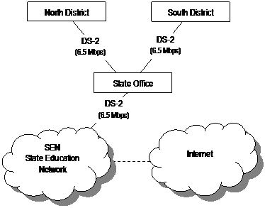

State Office Network Diagram
(LAN cabling is 100BaseT CAT5)

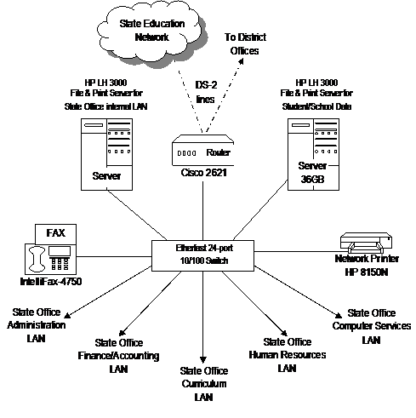

State Office Network Sub-Diagram
Administration LAN
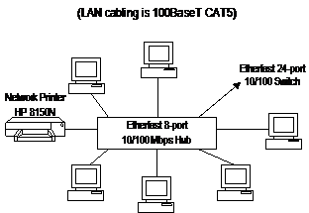

State Office Network Sub-Diagram
Finance/Accounting LAN

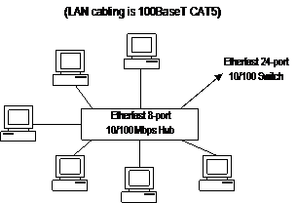

State Office Network Sub-Diagram
Curriculum LAN

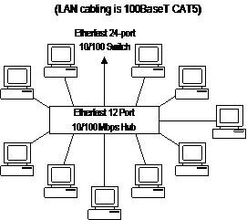

State Office Network Sub-Diagram
Human Resources LAN
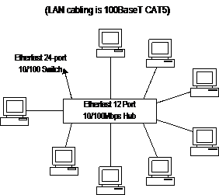

State Office Network Sub-Diagram
Computer Services LAN

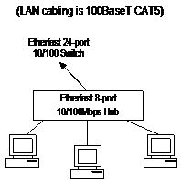

North District Network Diagram
(LAN cabling is 100BaseT CAT5)

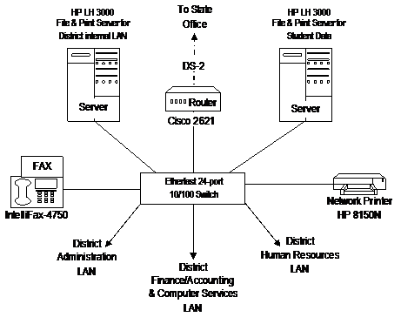

North District Network Sub-Diagram
Administration LAN
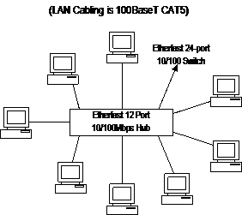

North District Network Sub-Diagram
Finance/Accounting & Computer Services LAN

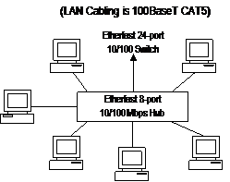

North District Network Sub-Diagram
Human Resources LAN

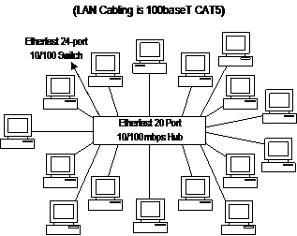

South District Network Diagram
(LAN cabling is 100BaseT CAT5)

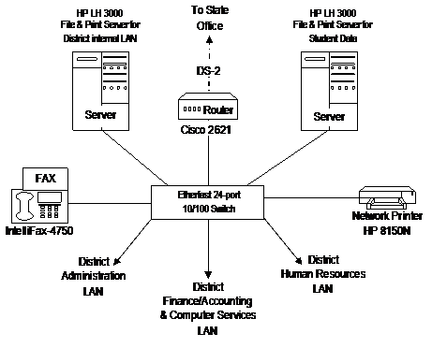

South District Network Sub-Diagram
Administration LAN

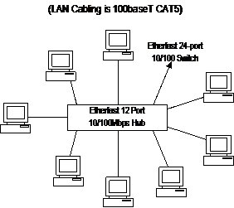

South District Network Sub-Diagram
Finance/Accounting & Computer Services LAN

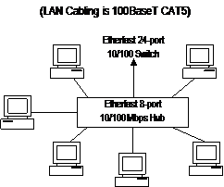

South District Network Sub-Diagram
Human Resources LAN

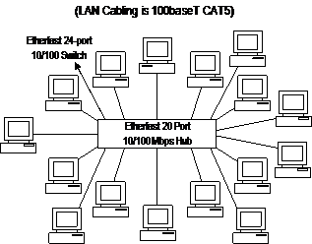

DETAILED DESIGN DOCUMENTATION
Key for Lists = Product
- Cost
- Availability
- Performance
- Maintainability
HP File/Print Server LH 3000
- $4,089.00
- Available/In Stock
- P3 866MHz, 128 MB/4GB RAM, 256KB L2, 32X CD
- 3 Year Warranty and Maintained by Computer Services as needed
HP NetServer Hard Drive
- Ksh379.95
- Available/In Stock
- 9.1 GB SCSI3 7200 RPM LVD, LC2000/LH3 Compatibility
- Maintained by Computer Services as needed
IntelliFax-4750 Commercial Laser Fax
- $499.95
- Available/In Stock
- 250-sheet Universal Paper Cassette, 4 MB, Dual Access Memory (upgradeable to 12 MB or 20 MB), Up to 50 page Auto Document Feeder, Stores up to 270 pages, 14.4 Kbps fax modem
- Maintained by Computer Services as needed
HP Laser Jet 8150N Series
- $2,469.95
- Available/In Stock
- 1200 dpi, 32 MB memory expandable to 192 MB, Network ready 10/100 Base-TX, 2 open EIO Slots, 3/100 (Number of trays/capacity)
- Maintained by Computer Services as needed
Windows 2000 Server
- $819.95
- Available/In Stock
- 5 Licenses included, Full Version
- Maintained by Computer Services as needed
Compaq DeskPro EN P3/600
- $999.00
- Available/In Stock
- 10 GB, 128 MB, 40X CD ROM, NIC DT Win 00; with Windows 2000 OS
- 3 Year Parts and Labor Warranty and Maintained by Computer Services as needed
CAT 5 Cable
• $145.99
• Available/In Stock
• 4 pair solid PVC; 1000 feet
• Maintained by Computer Services as needed
SmartPro 1400
- $454.99
- Available/In Stock
- 6 outlets +LAN
- Maintained by Computer Services as needed
EtherFast 8-Port 10/100 Desktop Hub
- $79.99
- Available/In Stock
- True 10/100 auto-sensing ports, Internal store-and-forward switching segment, built-in data collision and frame re-timing
- Manufacturer’s 5 year limited warranty and Maintained by Computer Services as needed
EtherFast 12-Port 10/100 Desktop Hub
- $129.99
- Available/In Stock
- True 10/100 auto-sensing ports, Internal store-and-forward switching segment, built-in data collision and frame re-timing
- Manufacturer’s 5 year limited warranty and Maintained by Computer Services as needed
EtherFast 20-Port 10/100 Desktop Hub
- $199.99
- Available/In Stock
- True 10/100 auto-sensing ports, Internal store-and-forward switching segment, built-in data collision and frame re-timing
- Manufacturer’s 5 year limited warranty and Maintained by Computer Services as needed
EtherFast II 24-Port 10/100 Switch
- $449.99
- Available/In Stock
- True 10/100 auto-sensing ports, Internal store-and-forward intelligent switching segment, built-in data collision and frame re-timing
- Manufacturer’s 5 year limited warranty and Maintained by Computer Services as needed
CISCO 2621 Ethernet Router 2 10/100
- $2,319.00
- Available/In Stock
- Provides remote access and WAN integrations, supports extranet VPN access and multiple modules, two 10/100 RJ45 ports, two WAN slots, one network module slot, one AIM slot
- Maintained by Computer Services as needed
Firewall I Internet Gateway V4.1 100 Nodes ONL
- $6,000.00
- Available/In Stock
- Full Version
- Maintained by Computer Services as needed
DS-2 Connection
- $650.00
- Available
- 1 month, exclusive rights
- Maintained by Quest Communications

