HCI-US-B Assignment IV – Video prototyping

**SmartHome – SmartMap**

(Jonas Witt, Georgios Mastoras)

Smart Home technology has enabled users to interact with home appliances through digital interfaces. Similarly, users themselves have become part of intelligent frameworks. Their presence and interaction preferences are learned in order to autonomously adapt the world around them.

However, very little information on how users navigate through their homes and move around their yards has been captured in this process. We consider this source of information to be crucial to a more fine-tuned smart home experience tailored to individual consumers. Services based on location tracking are capable of further extending smart home interaction to the ubiquitous realm.

Starting with chapters I. – II. we describe preliminary user-system interaction. Here we elaborate on the necessary information sources in order to set up the system. Chapters III. – V. describe possible applications of this technology.

The SmartMap app allows users to self-build maps of their home which will then be synced to location information gathered by users’ phones. Therefore, SmartMap combines the intuition of how users perceive their home with the precision of coordinate based location services. Services will be able to adapt to users’ needs based on how users navigate through their homes.

1. **Build now**

First, users create a digital approximation of their home and property via a simple drag and drop interface. Standard building blocks, such as garden area, kitchen and bedroom, come preconfigured. Customized building blocks can be created. Users will construct both indoor and outdoor maps.

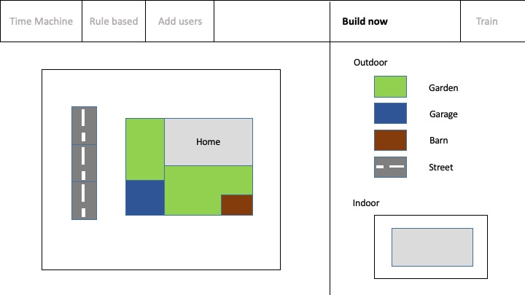 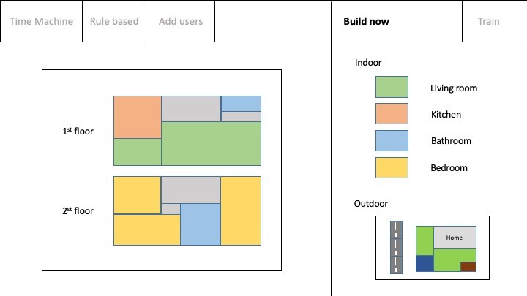

1. **Train**

Users are asked to move between several map points in order for the system to learn the equivalent coordinates. Based on the geometric outlines of rooms/buildings the system will quickly generalize a complete coordinate space from only a few practice runs.

For each practice run users are asked to move to a starting location. They will then press the start icon on the left. The system registers the user’s location and assigns it to the starting point in the mapping. As users start moving towards the second location marked as the target, the system will track their path and describe certain attributes to it. This includes but is not limited to continuity, speed and linearity.

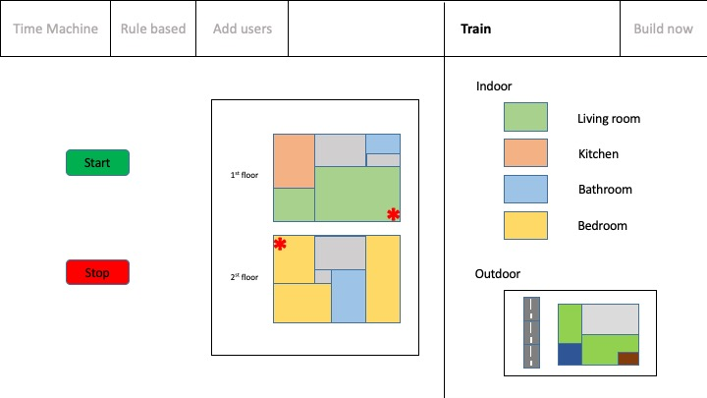

The system has now matched the user’s building block structure onto a coordinate framework. Coordinate based location data can easily be converted and communicated to users using their self-built visualizations. Based on this groundwork many different scenarios are plausible, three of which will be highlighted in the next paragraphs.

1. **Time Machine**

In time machine mode users can access their location history. By adjusting a slider, users can go back in time and choose specific time frames whose location data they would like to have shown to them. Visualization takes place in one of two different ways. Firstly, location data might be presented on the user’s self-built outdoor and indoor maps. Secondly, location data might be mapped into the user’s camera feed. Simply by rotating the camera, available track records will be mapped onto the user’s screen. In both cases pathways will be highlighted as dashed lines, whereas standpoints will be marked as dots – their size corresponding to the time a user has spent at this location. Pathways and standpoints appear increasingly faded as they date back longer in time.

A popular use case might be the search for misplaced items. A user searching for their wallet can go back in time to when he was last in possession of the wallet and retrace his pathway to this location.

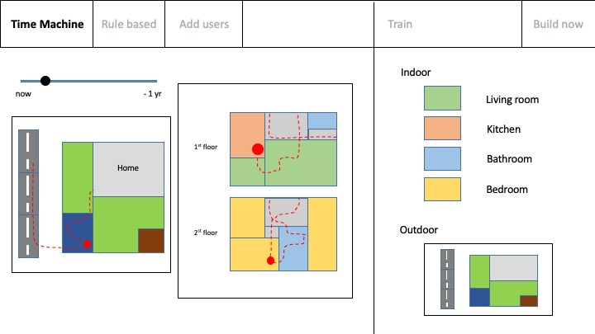 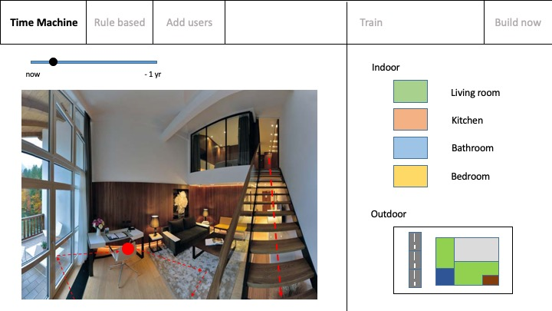

1. **Rule based**

Time machine mode sets the groundwork for the second application of SmartMap. Once pathways and standpoints are intuitively communicated to users they are invited to attach rules to location patterns. Whenever pathways or standpoints which fulfill a predefined set of attributes are detected any assigned actuators are triggered.

A possible use case might be dinner. When the user Alice returns home from work, she changes into comfortable clothes in her bedroom and then heads into the kitchen for dinner. The system will text Bob to let him know dinner will be ready soon. The lighting is dimmed automatically.

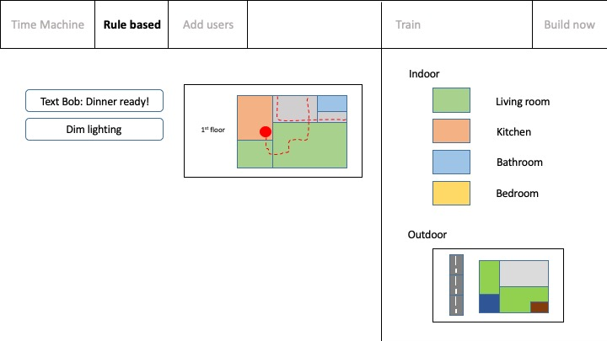

1. **Add users**

Finally, many more users might be added to SmartMap. All maps will be available to these users. Location data will be colored to distinguish different users.

A possible use case might be a collaborated search party. All users will be able to track their companions. This way they follow along which areas have already been searched and what areas have not been covered yet.

