# AMM Liquidity Pool Hedging Analysis

## 1. Impermanent Loss Over Time

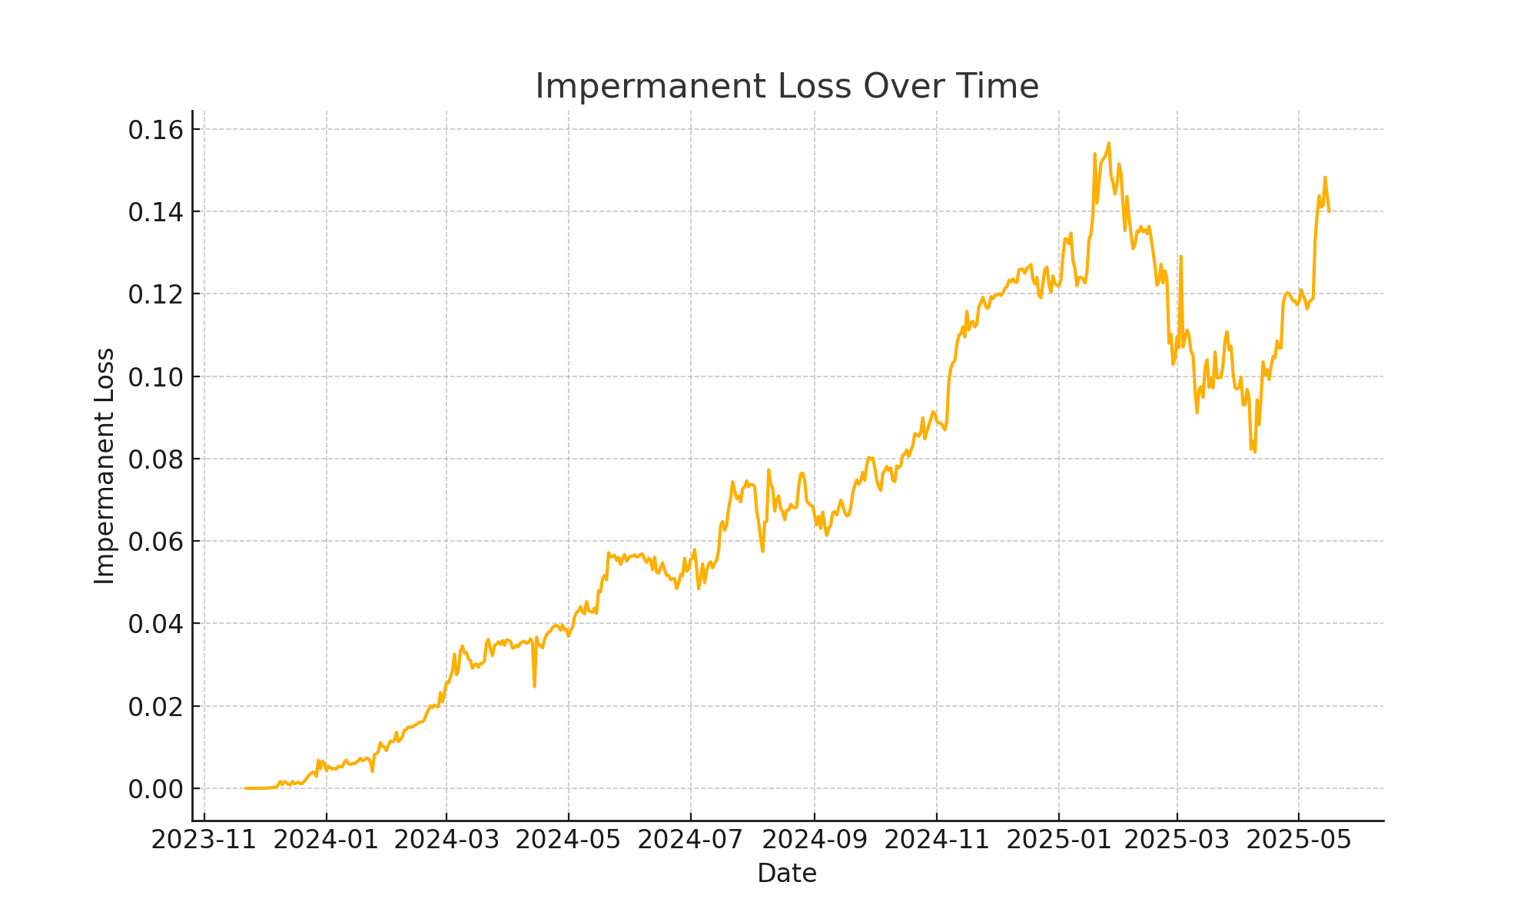

## 2. Cumulative Fees Earned Over Time

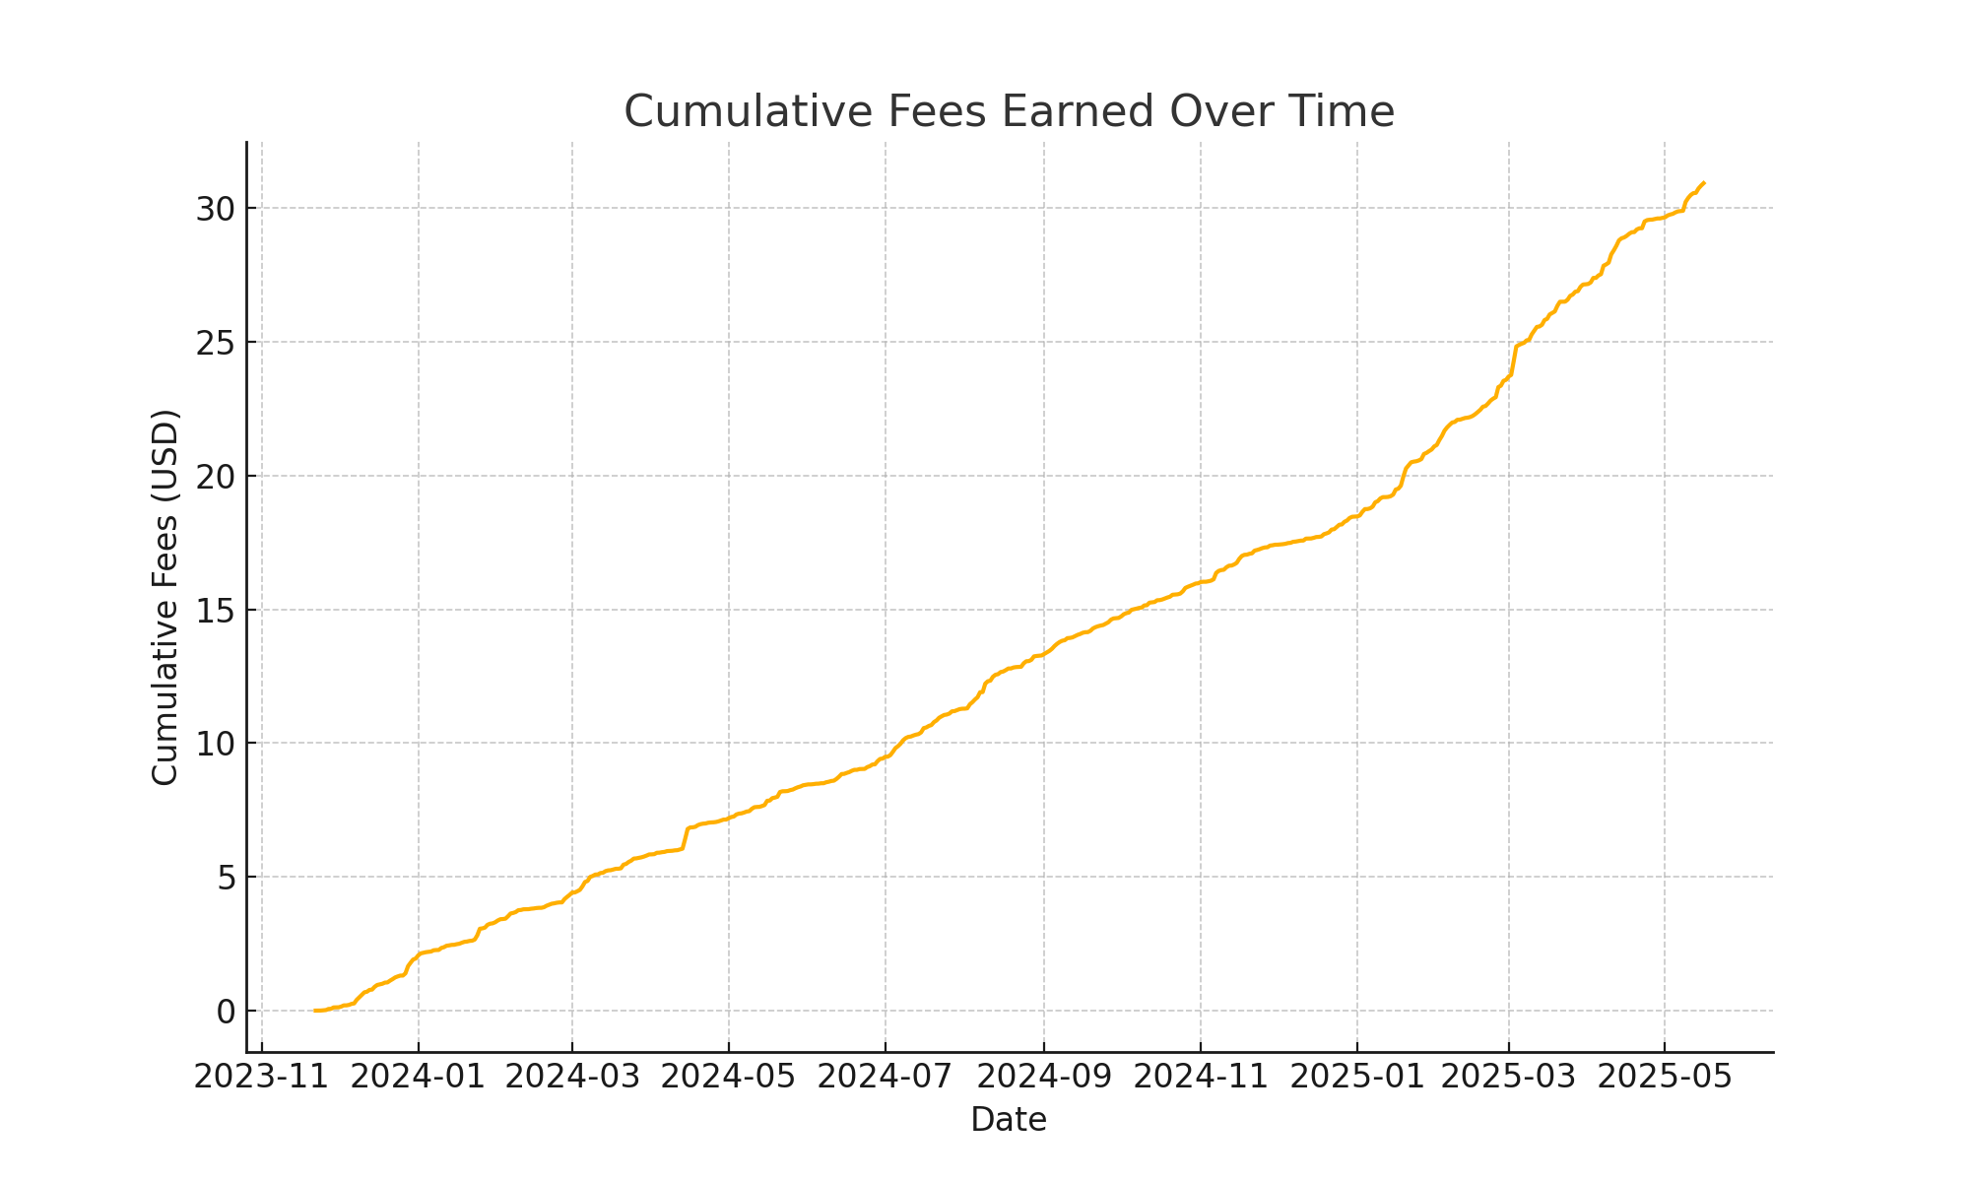

## 3. Net PnL: LP vs HODL

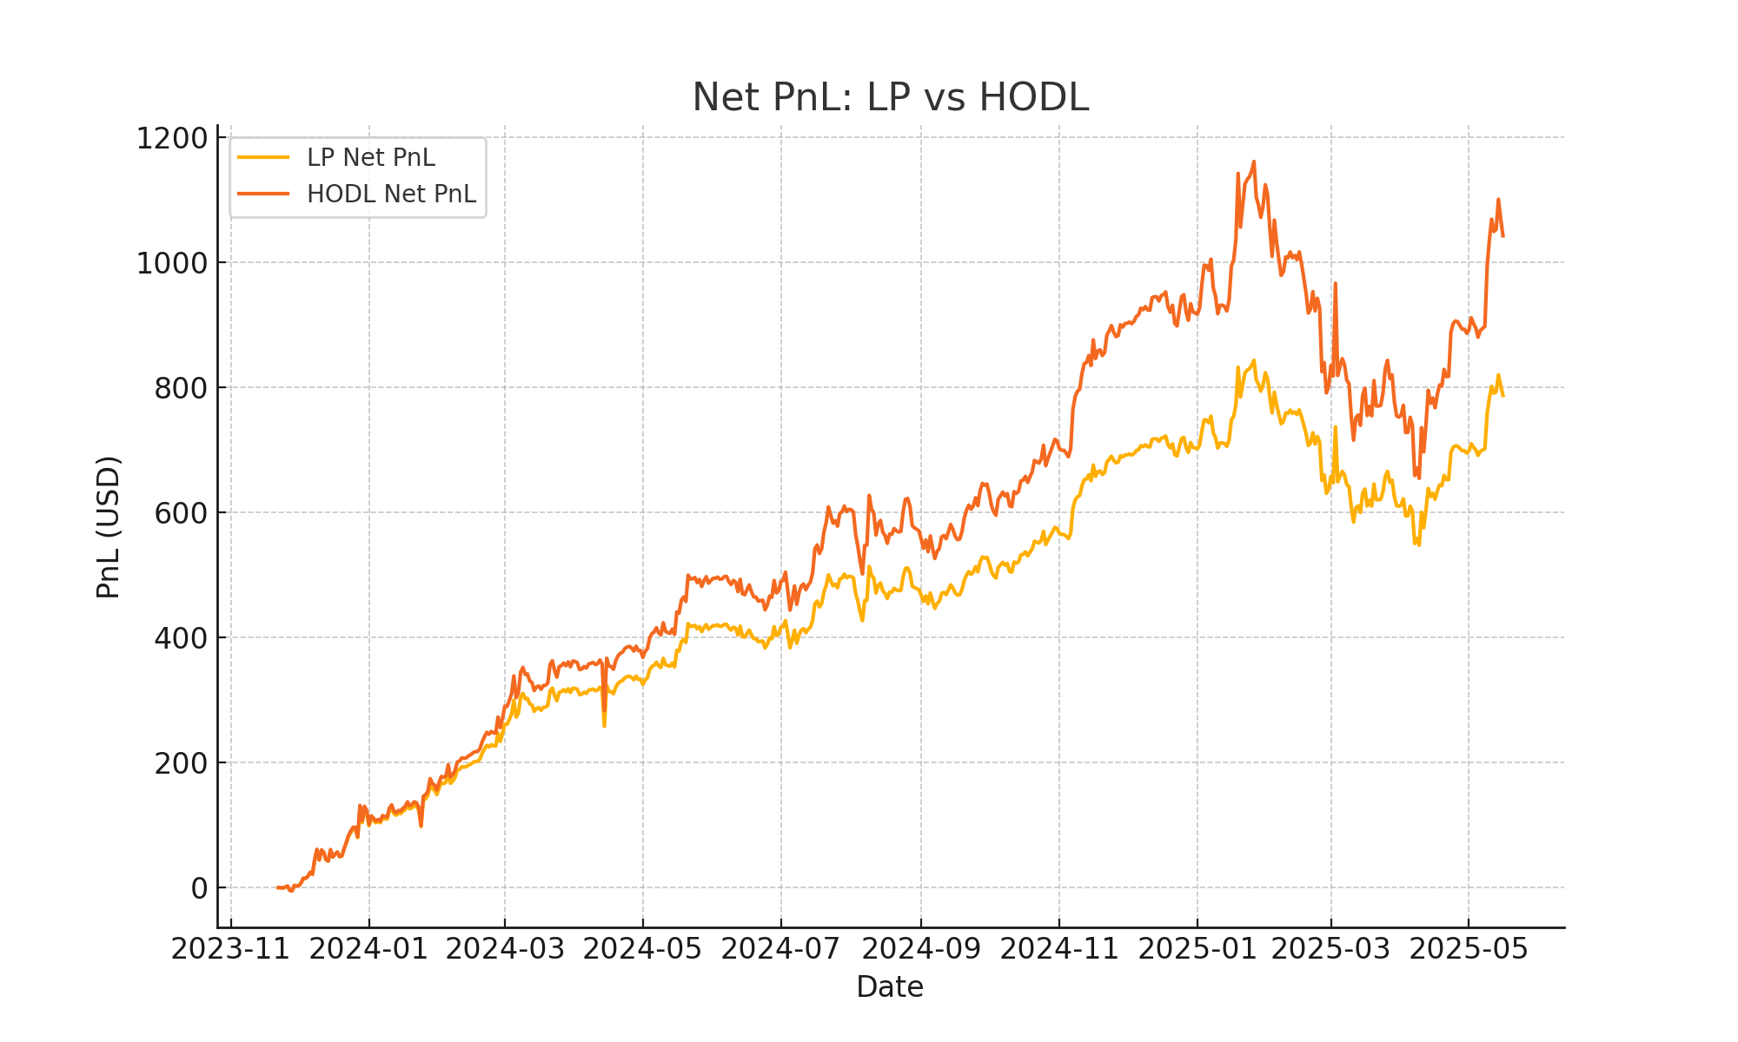

## Key Takeaways

• Impermanent Loss (IL) climbs as price diverges from the initial peg, reaching ~15% at peak.

• Cumulative fees (~$30 USD) partially offset IL, narrowing the gap versus HODL.

• LP net PnL underperforms HODL but benefits significantly from accrued fees.

## Next Steps

1. Calibrate the volume proxy α using real DEX trading volumes.

2. Perform sensitivity analysis: vary fee rates and volume factors.

3. Extend the simulation to Fartcoin and SOL for cross-asset comparison.

4. Incorporate price-impact models for large trade slippage.