CAP 4730 Raytracer Report – Collin Williams

1. Camera Behavior

For perspective and orthographic cameras, the implementation is similar enough that a lot of code is shared between the two. For both, the following constants are defined:

Viewpoint  LookAt  UpVec  ViewW  ViewH | a vector representing the camera origin  the direction the camera is looking  orthogonal to LookAt, controls rotation along the LookAt axis  the width of the viewing window  the height of the viewing window

(All vectors in this report are bolded, and scalars are italicized)

Additionally, a ProjDist scalar is defined for perspective mode, along with a DoPerspective Boolean that allows switching between orthographic and perspective. Given the above definitions, the basis can be calculated:

e = Viewpoint
w = -LookAt
v = UpVec
u = v × w

Now, for every pixel (x, y) on the screen, we need to find the corresponding ray equation for the raytracer. To start, every (x, y) mapped to a vector ranging from (-0.5, -0.5), corresponding to the top-left, and (0.5, 0.5), corresponding to the top-right. These are then transformed into scalar u and v quantities using ViewW and viewH:

u = (x / width – 0.5) * viewW
v = (y / height – 0.5) * viewH

The mapping is done in this way so the center of the screen is mapped to (0, 0), and the width / height between the endpoints matches viewW and viewH. Now, when calculating the S and D for the ray equation R(t) = S + tD, the perspective and orthogonal cameras have different implemen-tations. For the perspective camera, the S vector is always e, and the D vector varies based on (u, v). For the orthogonal camera, the S vector varies based on (u, v), and the D vector is always -w.

Perspective:
S = e
D = -w * ProjDist + u * u + v * v
Orthogonal:
S = e + u * u + v * v
D = -w

Also, the D vector is normalized to simplify calculations later on.

While the program is running, the P key can be used to toggle between perspective and orthographic. Additionally, the WASD keys move the camera parallel to the ground, SPACE moves it up, and SHIFT moves it down. E and R rotate the camera around the y-axis. The images below show a comparison of perspective and orthographic cameras:

Perspective:

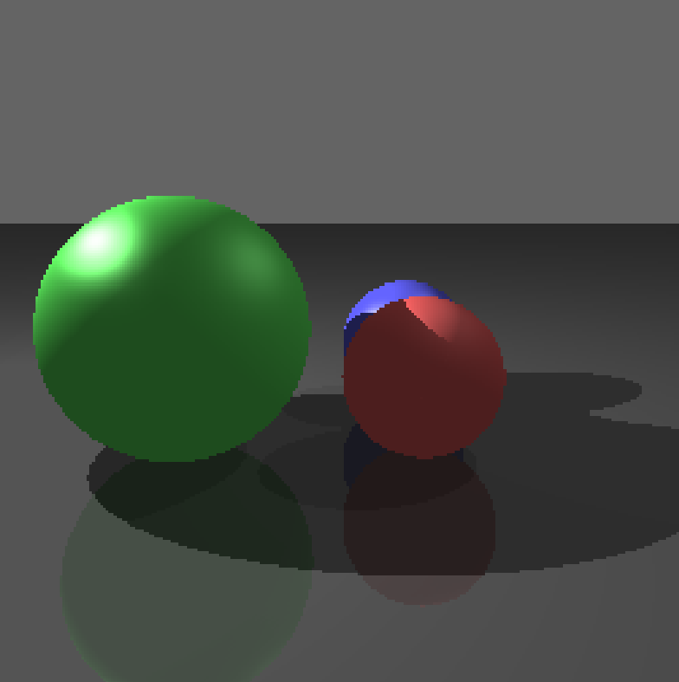

Orthogonal:

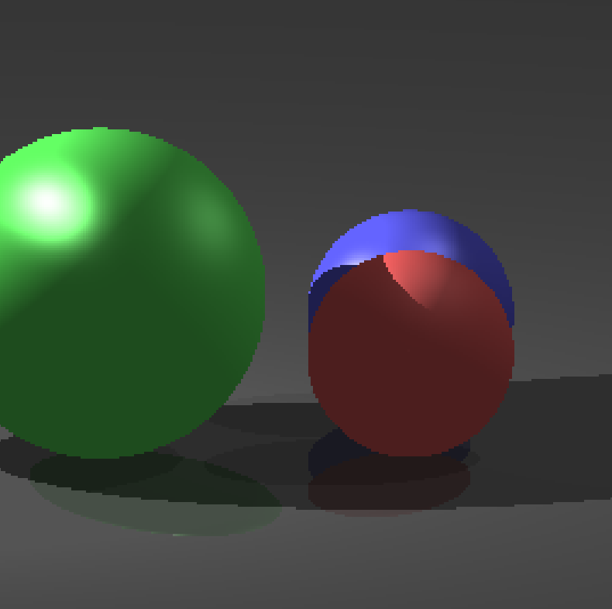
2. Camera Behavior

