Steepl

Derek Lundy and Collin Willis

Capstone Project Proposal

Grand Canyon University

Instructor: Professor Mark Reha

Revision: 4

Date: 4/14/22

|  |
| --- |
| History and Signoff Sheet |

**Change Record**

|  |  |  |
| --- | --- | --- |
| **Date** | **Author** | **Revision Notes** |
| 9/16/21 | Derek + Collin | Initial draft for review/discussion |
| 9/23/21 | Derek | Initial Draft Revision 1 |
| 9/26/21 | Derek + Collin | Initial Draft Revision 2 |
| 4/14/22 | Derek + Collin | Final Version Revision 1:  - Overview and Project Objectives adjusted for app name change that occurred shortly after initial draft revision 3 and more clear objectives listed.  - New item listed in benefits and opportunities.  - Adjustments in project scope to replace ambiguous terminology to be clearer.  - Project Success Measures adjusted to remove "for example" parenthesis info.  - Solution reworded to be accurate to the structure of final product.  - Social comments moved to out of scope where it should have been based off above wording. |

|  |
| --- |
| **Overall Instructor Feedback/Comments** |

|  |
| --- |
| **Overall Instructor Feedback/Comments** |

**Integrated Instructor Feedback into Project Documentation**

Yes  No

**Project Approval**

Professor Mark Reha

**TABLE OF CONTENTS**

Project Overview and Project Objectives 4

Project Scope 5

Project Success Measures 6

Project High-Level Solution 7

Project Controls 8

Project Overview and Project Objectives

Steepl is being done because there is no good online church experience available yet. There are Bible apps and other religious text reviewing apps, but no apps that provide a full church-like experience online exist yet.

Steepl will also provide a way for people who are introverted or do not like the typical church-going format to experience a personalized and comfortable church experience unlike any other, where instead of going to church and hearing what the pastor felt like preaching with their perspective and interpretation of the Bible, a user can hear many sermons from many pastors about what the user wants to hear.

With the world experiencing the Covid-19 pandemic, not everyone was able to attend or partake in church the same way people did before March 2020. Steepl would provide a constant connection for everyone to be able to attend church from anywhere for free.

Finally, Steepl’s content and categorization will cater to the non-Christian to provide a meaningful, useful, and self-driven introduction to what Christianity is like, the beliefs, and what Christianity has to offer.

**Christian Worldview**

The Christian worldview teaches that isolation is inherently harmful and that community, worship, and a cultivated relationship with God are essential. This project fully embraces the Christian worldview as this project will provide a spiritual, social, and ethical good for the community to have a constant connection to church, God, and other Christians. This project would be difficult to approach from any perspective other than a Christian worldview. This project is being built for anyone to use, including people who do not have a Christian worldview. Knowing the user base may come from many different worldviews, this project will be designed to be such a personalized (but guided/curated) church-experience that non-religious users could think of the application as a therapy and community app.

**Project Objectives**

This project’s success metrics will be number of topics and number of interactions within each topic because the content being available is a more accurate depiction of the project’s success rather than just how many people download and use the application.

**Challenges**

* Some team members have never used React Native before.
* The size of the project may be too large (care must be taken when defining the in-scope and out-of-scope features).

**Benefits and Opportunities**

* Gives people who do not like local church to still be connected.
* Gives people opportunity to hear a specific desired teaching.
* Allows people to stay connected spiritually from anywhere anytime, specifically helping those who are sick or cannot be out in public.
* Gives people an opportunity to connect with others about a specific problem they are having to get advice or guidance from others who have experienced similar problems or have insight.
* Provides a meaningful, useful, and self-driven introduction to Christianity to non-Christians.

Project Scope

The scope of this project is to develop a dynamic mobile application that can be used to distribute church-related content via predefined and curated topics categorized by mental states. Any feature that does not satisfy the scope, such as the social media elements and pastor users, are to be considered out of scope.

In-Scope:

* + Register
  + Login
  + “How are you feeling” process to find content
  + Verses for topics
  + Videos for topics
  + Stories for topics
  + Ability to look through a topics’, verses, videos, and stories
  + View all topics

Out-of-Scope:

* + Community tab
  + Pastor Users + Pastor Insertion Proposal System
  + Comments for topics, verses, videos, and stories

|  |  |  |  |  |  |  |  |  |  |  |
| --- | --- | --- | --- | --- | --- | --- | --- | --- | --- | --- |
| Work Breakdown Structure | | | | | | | | | | |
| ID | Task | Dependencies | Status | Estimated Effort Hours | Cost | Start Date | Planned Completion | Estimate to Completion | Actual Completion | Resource |
| 1 | Database | Google | Planned | 5 | (Free Student) | TBD | TBD | TBD | N/A | Firestore |
| 2 | Front End | React | Planned | 20 | TBD | TBD | TBD | TBD | N/A | Native |
| 3 | Back End | React | Planned | 20 | TBD | TBD | TBD | TBD | N/A | Native |

Project Success Measures

The number of topics and interactions within a topic will be used to measure project success.

|  |
| --- |
| Project Completion Criteria |
| 10 Topics are available |
| 5 interactions are available for each topic |

|  |  |  |  |  |  |
| --- | --- | --- | --- | --- | --- |
| Assumptions and Constraints | | | | | |
| ID | Description | Comments | Type | Status | Date Entered |
| 1 | Team members that don’t know React Native can learn it. | This is an assumption but is a strong educated guess. | Assumption | W.I.P. | 9/21/21 |
| 2 | Time Constraint. Due date: 12/19/21 | The due date should not be an issue. | Constraint | Addressed | 9/21/21 |

Project High-Level Solution

**Introduction**

The nature of this project is to deliver organized church content relating to a developed list of topics to anyone with a smartphone and internet connection for free. The objective is to create a mobile application to house and distribute the organized church content.

**Solution**

The challenge of this project is to create a dynamic mobile application using React Native and Component/View design pattern to display data and source files from a database hosted in the cloud with Google Firestore.

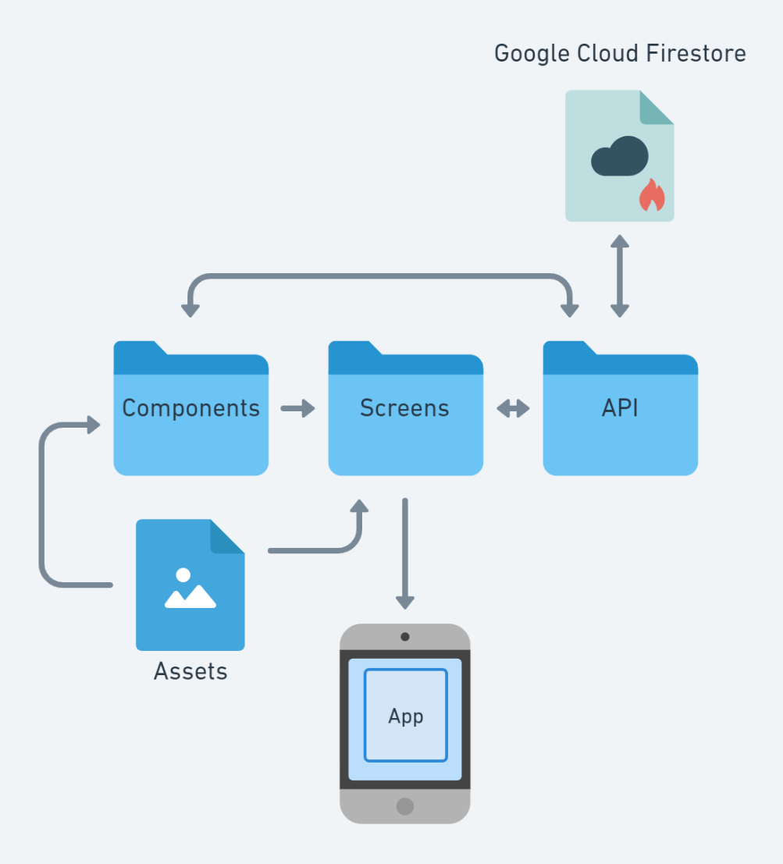

Project Controls

|  |  |  |  |  |
| --- | --- | --- | --- | --- |
| Risk Management | | | | |
|  | **Risk Probability** | **Risk Impact** |  |  |
| **Event Risk** | **(high, medium, low)** | **Risk Mitigation** | **Contingency Plan** |
| Some team members are unfamiliar with React Native. | low | Project will not be able to be accomplished. | Learn React native within a set time constraint. | Switch To another language. |
| Not finishing by due date. | medium | Project will be incomplete. | Plan out all tasks, schedule them to be completed in set time constraints. | Finish project after due date. |

|  |  |  |  |  |  |  |  |  |
| --- | --- | --- | --- | --- | --- | --- | --- | --- |
| Issues Log | | | | | | | | |
| **ID** | **Description** | **Project Impact** | **Action Plan/**  **Resolution** | **Owner** | **Importance** | **Date Entered** | **Date to Review** | **Date Resolved** |
| 1 | Topic circle spacing algorithm takes too long to complete, and eventually crashes the application. | Medium – needs to be addressed and approach needs change | List circles linearly in a horizontal fashion | Collin | *Medium* | *1/16/22* | *1/18/22* | *1/21/22* |