Steepl

Collin Willis & Derek Lundy

Capstone Project Requirements Document

Grand Canyon University

Instructor: Professor Mark Reha

Revision: 2

April 14, 2022

**ABSTRACT**

|  |
| --- |
| History and Signoff Sheet |

Steepl is a dynamic mobile app that gives a user access to vast amounts of organized Christian content. The content will be organized by topic categorized by mental states. The content will consist of videos, verses, stories. The app will have a feature called the How Are You Feeling (HAYF) function that will prompt the user on a happy scale how they are currently feeling and then will list topics associated with the selected mood. The HAYF filter will greatly assist a user in finding the most beneficial and relevant content quickly. Steepl will allow a user to register and login to use the application. Steepl will allow a user to favorite content which can be later viewed in a profile page. Steepl will be supported on IOS and Android devices. The Steepl application will be created with the React Native framework and the content will live in a cloud stored database (Google Firestore). Steepl will be designed with the Container/View design pattern.

**Change Record**

|  |  |  |
| --- | --- | --- |
| **Date** | **Author** | **Revision Notes** |
| 10/22/21 | Collin Willis & Derek Lundy | Initial draft for review/discussion |
| 4/14/22 | Derek Lundy & Collin Willis | Final revision:  Project name throughout document changed to final project name  Accuracy adjustments and more details added in abstract  Functional Requirements links replaced the "in excel sheet" notes  Updated Wireframes to reflect final design |

|  |
| --- |
| **Overall Instructor Feedback/Comments** |

|  |
| --- |
| **Overall Instructor Feedback/Comments** |

**Integrated Instructor Feedback into Project Documentation**

Yes  No

**TABLE OF CONTENTS**

Functional Requirements 4

Non-Functional Requirements 5

Technical Requirements 6

Logical System Design 7

User Interface Design 8

Reports Design 9

Functional Requirements

<https://github.com/collinwillis/Steepl_Homepage/blob/main/Assets/Steepl_user_stories.xls>

**Non-Functional Requirements**

<https://github.com/collinwillis/Steepl_Homepage/blob/main/Assets/Steepl_user_stories.xls>

**Technical Requirements**

|  |  |
| --- | --- |
| **Technology or Tool** | **Justification** |
| **React Native v0.66** | **React Native compiles the same code natively on both iPhone and Android. This makes it so only one developer team is needed.** |
| **Google Cloud Firestore Database** | **Connects seamlessly with react native. Offers a completely free plan. Stores all data on Google’s cloud.** |
| **Material UI Library v5.0.4** | **Provides a UI library to make great looking user-friendly interfaces.** |
| **Visual Studio Code v1.6.1** | **Open sources code editor that provides many extensions created by the community that can be very helpful during the development process.** |
| **Android Studio Emulator v2021.1.1** | **Provides emulators for many Android devices. This allows testing of the application on Android.** |
| **XCode iPhone Simulator v13.0** | **Provides an iPhone simulator that the application can be tested on. The simulator can be changed to any version of the iPhone that is on the market.** |
| **Jira v8.20** | **Allows scrum planning and progress tracking for the development process of the application. This helps the team plan and stay on track.** |

**Logical System Design**

Steepl is a mobile application that stores all user data and content in a Google Firestore database, which is in the cloud.

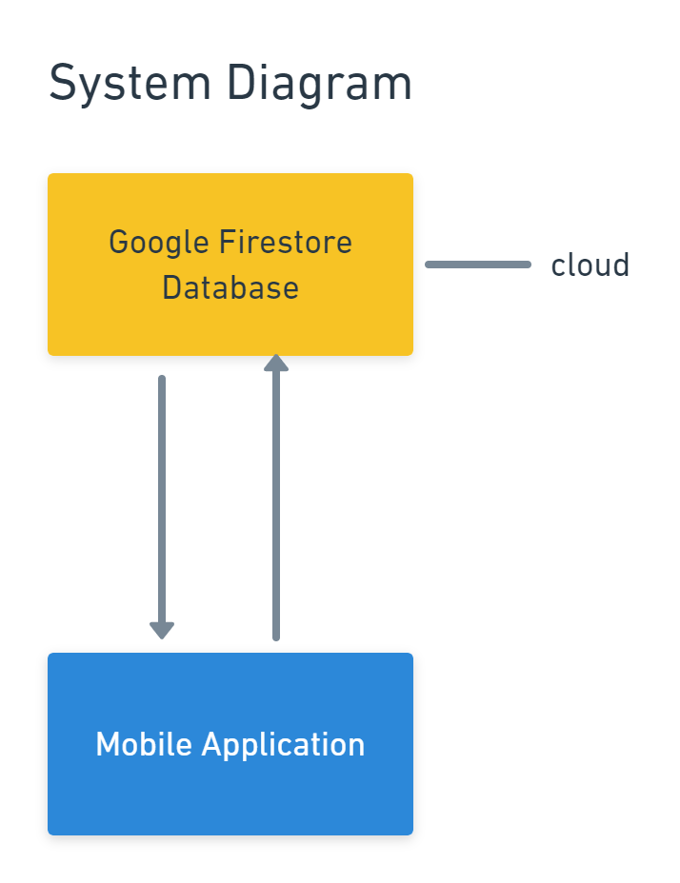

User Interface Design

Landing Page

Login and Register Wireframes

Topic Selection Wireframe

Topic of the Day and Topic View Wireframes

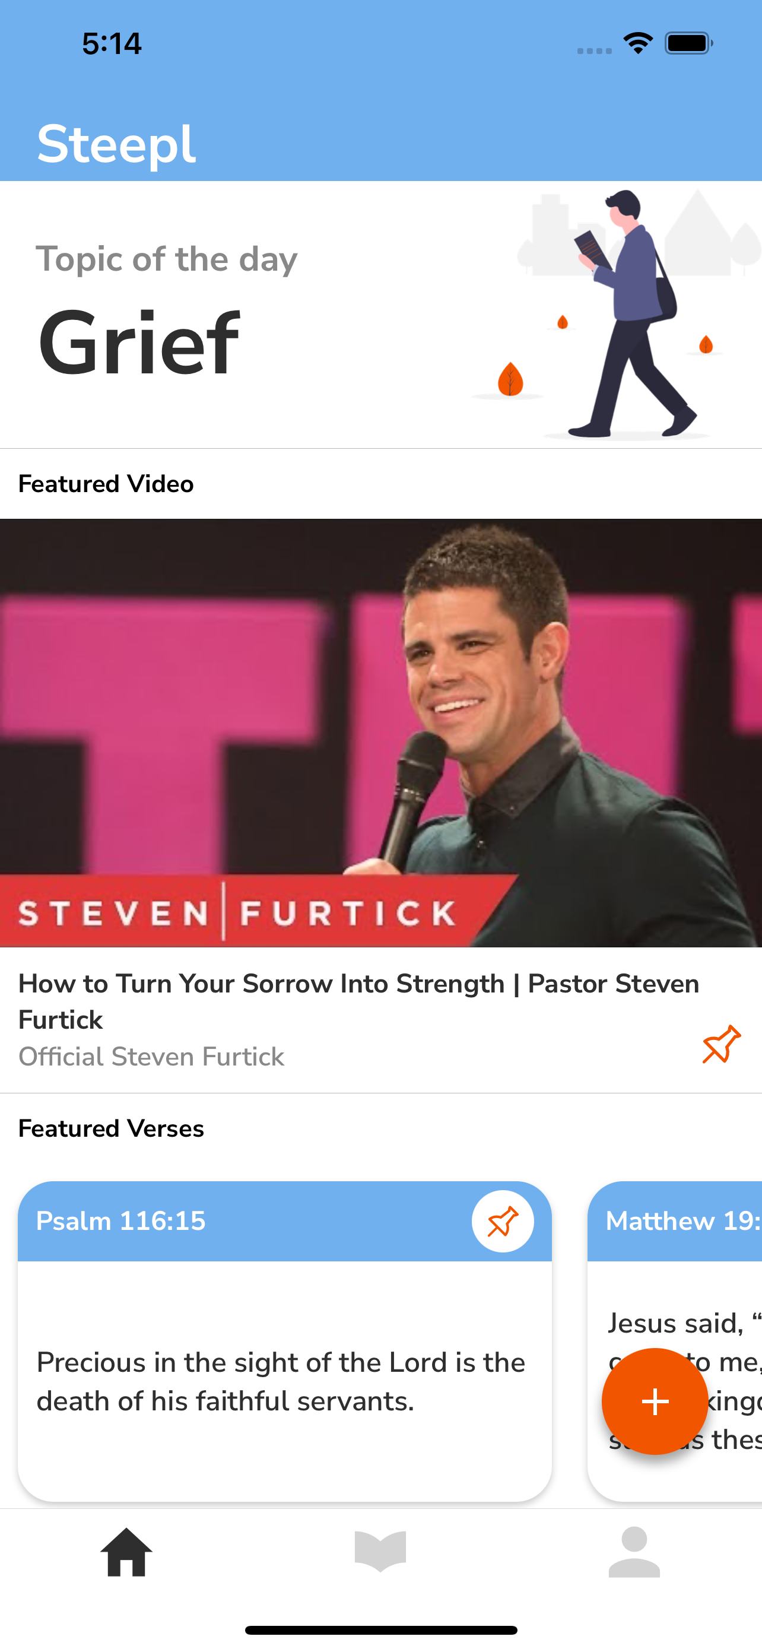

Add Testimony Wireframe

Profile and Profile Edit Wireframes

