STRATEGIC OBJECTIVE | Delivering High Quality Digital Services

WELL-BEING OF FUTURE GENERATIONS ACT | A healthier Wales
If more than one standard applies, please list below:

DHCW QUALITY STANDARDS | ISO 9001
If more than one standard applies, please list below:
ISO 9001
ISO 27001

DUTY OF QUALITY ENABLER | Leadership
DOMAIN OF QUALITY | Effective
If more than one enabler / domain applies, please list below:

EQUALITY IMPACT ASSESSMENT STATEMENT | Date of submission:
Choose an item. | Outcome:
Statement:
This guidance supports best practice published in our Software development handbook. This best practice was subject to an equality impact assessment.

APPROVAL / SCRUTINY ROUTE:
Person/Committee/Group who have received or considered this paper
COMMITTEE OR GROUP |  | DATE | OUTCOME
Lead Software Developers’ Group |  | 12/12/22 | Approved
Application Architecture Assurance Group |  | 09/12/22 | Approved
Technical Design Assurance Group |  | 06/02/24 | Approved
IMPACT ASSESSMENT
QUALITY AND SAFETY  IMPLICATIONS / IMPACT | No, there are no specific quality and safety implications related to the activity outlined in this report.
LEGAL  IMPLICATIONS / IMPACT | No, there are no specific legal implications related to the activity outlined in this report.
FINANCIAL  IMPLICATIONS / IMPACT | No, there are no specific financial implication related to the activity outlined in this report
WORKFORCE  IMPLICATIONS / IMPACT | No, there is no direct impact on resources as a result of the activity outlined in this report.
SOCIO ECONOMIC  IMPLICATIONS / IMPACT | No. there are no specific socio-economic implications related to the activity outlined in this report
RESEARCH AND INNOVATION  IMPLICATIONS / IMPACT | No, there are no specific research and innovation implications relating to the activity outlined within this report.

TABLE OF CONTENTS
1 PURPOSE 4
2 SCOPE 4
3 REFERENCES 4
4 CONVENTIONS 4
5 THE NEED FOR GUIDANCE 5
6 STANDARDS 5
6.1 ORGANISE YOUR SOLUTION TO ACCORD WITH OUR CONVENTIONS 5
6.2 USE PHYSICAL FOLDERS 6
6.3 CREATE A ROOT FOLDER FOR YOUR SOLUTION (./<ROOTFOLDERNAME>) 7
6.4 PROVIDE A README FILE (,/<ROOTFOLDERNAME>/README.MD) 7
6.5 CREATE A .EDITORCONFIG FILE 7
6.6 CREATE A SOURCE FOLDER (./<ROOTFOLDERNAME>/SRC) 7
6.7 USE ADDITIONAL SUB-FOLDERS FOR DEPENDENCY LAYERS (/SRC/<DEPENDENCYLAYER>) 8
6.8 USE SUB-FOLDERS WITHIN VISUAL STUDIO PROJECTS 8
6.9 USE EXISTING CONVENTIONS FOR PROJECT TYPES 8
6.10 CREATE A SPECIFICATION FOLDER (./<ROOTFOLDERNAME>/SPECS) 9
6.11 PROVIDE A TEST FOLDER (./<ROOTFOLDERNAME>/SPECS/TEST) 9
6.12 PROVIDE A DOCUMENTS FOLDER (./<ROOTFOLDERNAME>/SPECS/DOCS) 10
6.13 PROVIDE A BUILD FOLDER (./<ROOTFOLDERNAME>/BUILD) 10
6.14 PROVIDE A SCRIPTS FOLDER (./<ROOTFOLDERNAME>/BUILD/SCRIPTS) 11
6.15 PROVIDE A DEPLOY FOLDER (./<ROOTFOLDERNAME>/DEPLOY) 11
6.16 PROVIDE AN EXAMPLES FOLDER (./<ROOTFOLDERNAME>/EXAMPLES) 11
7 EXCEPTIONS PROVE THE RULE 12
8 GOOD PRACTICE CHECKLISTS 13
8.1 FOLDER STRUCTURE GOOD PRACTICE 13

PURPOSE
Describes the Application Development and Support Directorate’s standard for organising your software solution.

SCOPE
Software Developers have a responsibility to follow this guide.
Developers targeting frameworks other than .NET may need to make sensible adjustments where necessary.

REFERENCES

INDEX NUMBER | DOCUMENT NAME
SDS-GDN-1 | General Coding Standard

CONVENTIONS
The key words "MUST", "MUST NOT", "REQUIRED", "SHALL", "SHALL NOT", "SHOULD", "SHOULD NOT", "RECOMMENDED", "MAY", and "OPTIONAL" in this document are to be interpreted as described in RFC 2119.
 | Practical tips

 | Examples of good practice…
 | …and practices to avoid

 | Links to further guides, information and work instructions  Note that all links to Microsoft Learn© may default to Azure DevOps Services. Use its version selector to tailor the website for Azure DevOps Server.

THE NEED FOR GUIDANCE
Modern programming practices expect us to prove that our code meets functional requirements and can be reliably built and deployed.
This requires a little forethought when creating a solution that others will use (often without the originating developer present.) So, it’s critical we create software solutions that are:
- Clear and explicit
- Understandable by developers of all abilities
- Safely extensible & well documented
The following sections provide guidance on how we can achieve this.

STANDARDS

ORGANISE YOUR SOLUTION TO ACCORD WITH OUR CONVENTIONS
You SHOULD organise your solution according to our standards. They follow those used by many language ecosystems, including the .NET source code itself. Note that they differ from the typical Visual Studio File New defaults.
There are two choices, as shown below. This document describes the first, which suits a Behavioural Driven Development [BDD] approach. But they are very similar and equally valid.
└──{RootFolderName}/ # Root folder for your entire software solution
├── deploy/ # Any infrastructure provisioning scripts
├── build/ # Any published build outputs
│ └── scripts/ # Build scripts and CI scripts not required in the root
├── examples/ # Samples and demos on how to build or consume your app
├── specs/ # Container folder for tests and documentation
│ ├── docs/ # Diagrams, specifications and documentation
│ └── test/ # Automated tests and feature files
├── src/ # Source code separated by dependency layer subfolders
├── README.md # Starting point for anyone building or using your software
├── .editorconfig # Enforces a consistent coding style for your project
└── {SolutionName}.sln # Solution file
Organizing your software solution - option #1 (suits a BDD approach)
└──{RootFolderName}/ # Root folder for your entire software solution
├── deploy/ # Any infrastructure provisioning scripts
├── build/ # Any published build outputs
│ └── scripts/ # Build scripts and CI scripts not required in the root
├── docs/ # Diagrams, specifications and documentation
├── examples/ # Samples and demos on how to build or consume your app
├── src/ # Source code separated by dependency layer subfolders
├── test/ # Automated tests
├── README.md # Starting point for anyone building or using your software
├── .editorconfig # Enforces a consistent coding style for your project
└── {SolutionName}.sln # Solution file

Organizing your software project - option #2
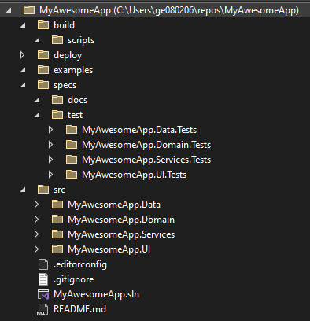
An Example .Net Solution which follows our conventions

- Use the approach that best matches your needs
- In later versions of .NET use C:\> dotnet new gitignore to generate a .gitignore file
- Clone our example project structure from the Software Development Standards project in Azure DevOps.

An Opinionated Approach to ASP.NET Core - Scott Allen - YouTube
.NET Core Opinion #1 - Structuring a Repository (odetocode.com)
.NET Core Opinion #2 - Managing a Repository Structure (odetocode.com)
.NET Core Opinion #3 - Other Folders to Include in the Source Repository (odetocode.com)
Create .NET Projects Using Standard Practices | Toptal
Common web application architectures | Microsoft Learn
Behaviour-Driven Development - Cucumber Documentation
.NET project structure · GitHub
GitHub - github/gitignore: A collection of useful .gitignore templates

USE PHYSICAL FOLDERS
Typically, a legacy .NET application relies on visual studio solution folders. These virtual folders don’t represent the physical structure on disk.
With no folders to look at, the reader is reliant on our understanding of the project names without opening the solution. To overcome this, you SHOULD follow our first convention and use physical folders and folder names.

CREATE A ROOT FOLDER FOR YOUR SOLUTION (./<ROOTFOLDERNAME>)
You SHOULD place your solution file in a root folder. Doing so makes it easy for others to clone a repo and open the file to get started. The rest of the software project lives within this root folder.
Provide a sensible name, using the name of the git repo or the solution file.
If the RootFolderName does not describe the project, replace it with something more accurate and understandable.
Do this before you commit to source control. In doing so you avoid the need for communicating a change and making source control work overtime after the initial commit.

PROVIDE A README FILE (,/<ROOTFOLDERNAME>/README.MD)
You SHOULD provide a README file in the root folder as a common way of helping others learn about your software.
As a minimum, it SHOULD instruct others on how to build and deploy your software. Typically, you SHOULD also include guidelines on how to contribute to your project – how to fix bugs or correct typos, for example.
- Use Microsoft’s Writing Style Guide to maintain a consistent and familiar style
- Using Markdown makes it easier to format text and include links & images
- Describe your assurance processes (such as code reviews or gated check-ins) in a separate CONTRIBUTING.md file, saved to the root folder
- Consider your audience. What would others find useful?

Create a readme for your Git repo - Azure Repos | Microsoft Learn
About READMEs - GitHub Docs
Welcome - Microsoft Style Guide | Microsoft Learn

CREATE A .EDITORCONFIG FILE
You SHOULD share your configuration by adding an. editorconfig file to the root of your solution, making sure to add it to source control. For more details, see our ‘General coding standard’ (v4 or later).

CREATE A SOURCE FOLDER (./<ROOTFOLDERNAME>/SRC)
You SHOULD store all projects that have a definable output release (for example, web, desktop, mobile or general library projects) in a source folder, named src.

USE ADDITIONAL SUB-FOLDERS FOR DEPENDENCY LAYERS (/SRC/<DEPENDENCYLAYER>)
You SHOULD create immediate sub-folders to separate the dependency layers of your solution, such as data access, user interface, domain logic or service layers. This reminds you that the layers exist and to test them.
Including the parent’s name in the sub folder name may appear repetitive, but it adds context. And it can prove useful when referencing it from another location or when searching for a file or folder.
We leave naming the sub folders underneath src and test to your discretion but you SHOULD :-
- use Pascal casing when naming folders.
- Follow Microsoft’s naming advice when developing for Windows systems.
You SHOULD NOT use special characters or abbreviations longer than two letters in folder names.
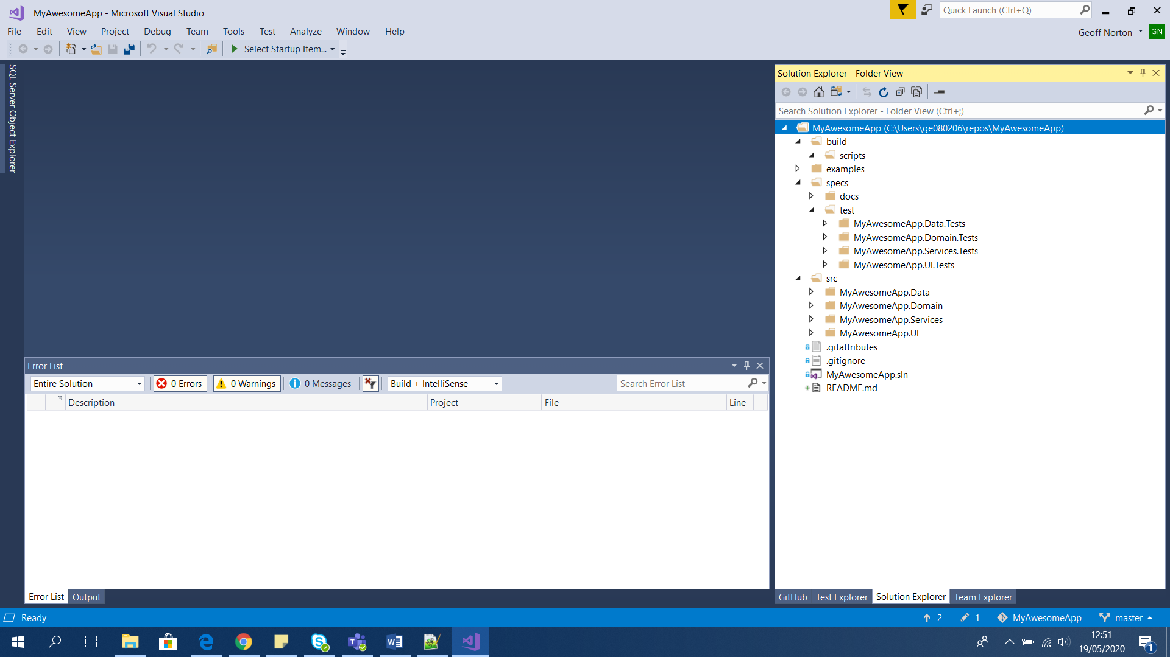
Figure 1 An example.NET Solution with dependency layers

Naming Files, Paths, and Namespaces - Win32 apps | Microsoft Learn

USE SUB-FOLDERS WITHIN VISUAL STUDIO PROJECTS
You SHOULD use sub-folders within each project to reflect namespacing and separate dependency layers. Doing so helps remind you that the solution is becoming more complex as this tree grows. And proves useful when refactoring or extending the project.
You SHOULD use parent names in solution subfolder names.
Follow SOLID principles to refactor out exposed complexities. This helps to reduce each project to its simplest form.

USE EXISTING CONVENTIONS FOR PROJECT TYPES
Some project types require you to work with a different convention. Typically, these include web projects, MVC, web forms, APIs, or razor pages. For example, MVC structures projects for path conventions, whereas razor pages use folder hierarchy.
However, the project type determines this - not the software team. And you SHOULD follow the namespace convention described above for any additional folders you add to these project types.

CREATE A SPECIFICATION FOLDER (./<ROOTFOLDERNAME>/SPECS)
You SHOULD store test projects and any specifications you consider valuable in a specification (‘specs’) folder. Keeping them together helps link your documentation to tests.
You SHOULD clearly indicate the expected behaviours, functionality and actual integration with consumers of the code. This may include data extracts from other systems or software.

PROVIDE A TEST FOLDER (./<ROOTFOLDERNAME>/SPECS/TEST)
As the name suggests, this is where you SHOULD store your tests. As with the src folder, you SHOULD place test projects in sub folders, mapping the name of the sub folder to the name of the project.
Names SHOULD correspond to those of your dependency layers, with the .Tests suffix added.
When writing the tests, you SHOULD:-
- Prioritise output testing over testing that assures modules.
- Adopt Behavioural Driven Development as your approach.
- Balance the benefits and drawbacks of adding extensive testing to your solution.
- Consider You Aren’t Gonna Need It (YAGNI) rules when deciding what to test.
- Consider the testing requirements described in your Definition of Done (DOD).
Figure 2 An example.NET Solution with tests
Consider wider assurance needs when deciding what tests to write. Integration and smoke tests often provide the greatest benefit
Consider You Aren’t Gonna Need It [YAGNI] and carefully balance the time and effort of an extensive testing approach with the benefit it provides

Selective Unit Testing – Costs and Benefits (stevensanderson.com)

PROVIDE A DOCUMENTS FOLDER (./<ROOTFOLDERNAME>/SPECS/DOCS)
You SHOULD keep documentation you consider valuable (including diagrams, specifications and documents relevant to build output) in a documents (‘docs’) folder. This is particularly useful if there’s no Solutions Architecture Design document [SAD] or Software Requirements Specification [SRS].
While most documents MAY be stored in our document management system, not all will reflect the current state of the solution. For example, a SAD or SRS may include planned work or perhaps even obsolete design decisions. Maintaining a docs folder is an important step in addressing any drift between design and build.
You SHOULD NOT let documentation become stale or out-of-step with the build output or use the docs folder as a replacement for the corporate document management system.
- Use automation. For example, generate .pdf files from the repo’s markdown files and include OpenAPI documentation.
- Take care when linking to other documents. Links are only relevant while they are maintained and may be resolvable only from within our domain.
- Encourage testers and business analysts to use. feature files to record changes to requirements. Link your docs folder to those. feature files
- Use a tool like Grammarly: Free Online Writing Assistant to help you make your content clear
Writing good documentation is a skill. Use these links to help you write high quality documentation.
Doing Visual Studio and .NET Code Documentation Right -- Visual Studio Magazine
How to write plain English
Writing checklist (sharepoint.com)

PROVIDE A BUILD FOLDER (./<ROOTFOLDERNAME>/BUILD)
You SHOULD store the latest output from publish commands, though not necessarily each build event, in a build folder.
Place your outputs in sub folders, named appropriately, with a suffix to indicate output type and a prefix for the solution name. And take care to indicate the last build date.

PROVIDE A SCRIPTS FOLDER (./<ROOTFOLDERNAME>/BUILD/SCRIPTS)
You SHOULD store any scripts needed to assist with the build, by placing them in a ‘scripts’ subfolder. This offers a standard location for any others wishing to build your solution.
As well as build scripts, use the folder to store artefacts related to your continuous integration [CI] processes. While some CI systems require you place build artefacts in the root, placing other supporting files in the scripts folder avoids excessive cluttering.
When storing scripts, you SHOULD keep your scripts clean and with comments.
You SHOULD prefer using scripted solutions over build events whenever possible.
You SHOULD NOT break published conventions without considering how this impacts others.

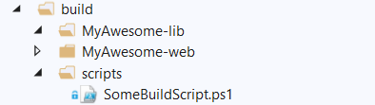
Figure 3 An example.NET Solution with a build and scripts folder

.NET Core Opinion #4 - Increase Productivity with Dev Scripts (odetocode.com)
.NET Core Opinion #5 - Deployment Scripts and Templates (odetocode.com)

PROVIDE A DEPLOY FOLDER (./<ROOTFOLDERNAME>/DEPLOY)
You SHOULD store any infrastructure provisioning scripts in a deploy folder. These could be Azure Resource Management (ARM) templates or Bicep scripts and associated parameter files, but it is RECOMMENDED that you use Terraform scripts.

PROVIDE AN EXAMPLES FOLDER (./<ROOTFOLDERNAME>/EXAMPLES)
It is RECOMMENDED that you provide examples to show others how to use your published outputs. Developers will thank you for it!
SQL outputs, scripted languages, or configurations such as yaml, will likely be single files. For complex outputs, store each demo project in its own sub-folder.
When doing so you SHOULD:
- Make sure examples work as expected.
- Demonstrate typical use cases, capabilities and support queries.
- Consider using automation for each example output.
You SHOULD NOT let examples become stale and out-of-date.
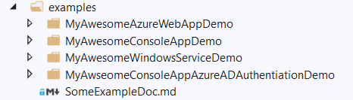
Figure 4 An example.NET Solution with example

EXCEPTIONS PROVE THE RULE
As with most standards, there are occasions when it’s unwise to follow “hard and fast” rules.
Principal and Lead software developers have discretion to do so but this should be the exception rather than the rule.

GOOD PRACTICE CHECKLISTS
Use this checklist to demonstrate you follow our coding standards.
We cross-reference each checklist item to a relevant section in our standards and guides; Exceptions are noted where they may apply.

FOLDER STRUCTURE GOOD PRACTICE
Item |  |  | Guide or standard | Exceptions
1 | You use physical folders to separate logical areas of your software solution | ☐ | Use physical folders
2 | You include a README markdown file, instructing others on how to build and deploy your software solution | ☐ | Provide a README file
3 | You include a .editorconfig to allow your code style rules to be shared | ☐ | Provide a .editorconfig file
4 | You include a source folder | ☐ | Include a source folder
5 | You create subfolders to separate dependency layers | ☐ | Use additional subfolders for dependency layers
6 | You include a documents folder | ☐ | Include a documents folder
7 | You include folder for coded tests | ☐ | Include a test folder
8 | You include a builds folder | ☐ | Include a build folder
9 | You include a deploy folder | ☐ | Include a deploy folder | May only be required if deploying to cloud
10 | You provide examples with your solution | ☐ | Include an examples folder

For example, if you are building on published specs – such HL7 FHIR.
.exe, .ps1 .sql and .cmd files for example.

