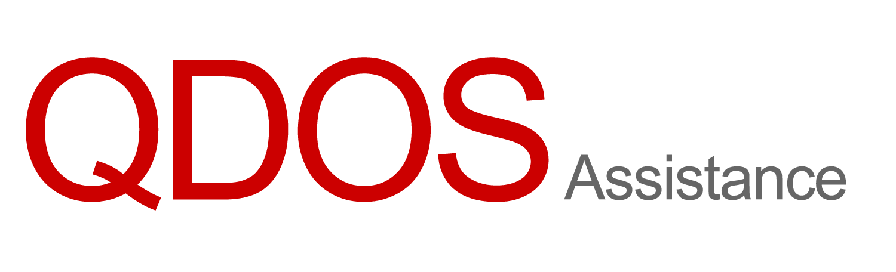

Collision Engineers Ltd
77-79 Hoylake Road
Moreton
Wirral
CH49 6LH

Our Ref: REB/47066/1
Date: 21 July 2026

Dear Sirs

Our Client: Mr Abdulrahman Ibrahim
Our Client’s Vehicle: NISSAN NOTE N-TEC
Registration: LX10XTJ
Date of Accident: 19 July 2026

Triage Only Request

Please find attached our client’s images.

Please will you provide an initial assessment to confirm if this vehicle is roadworthy and repairable as soon as possible. We will forward the official inspection instruction as soon as we are able.

Accident Circumstances: | Our client's vehicle was parked and unattended just off of Normanby Road, Middlesborough, outside the Southbank Mosque. Your insured collided into the front nearside of our client's vehicle, as shown on cctv footage provided by the Mosque.
Damage Description: | Front Nearside: Moderate, Nearside: Moderate both doors dented and scratched more damage to front
Driveable: | Yes

Yours faithfully

