EVA Setup Guide

To set up a job in EVA, you will need:

• An offline copy of the email with the job request
• The Instruction (usually attached in the email as a .pdf or .docx)
• Images of the damaged vehicle

Make sure you have downloaded all three of the above. Once you have these, you can begin to setup the job in EVA for the engineers to complete.

If any of these are missing, immediately pause and locate them. If you have difficulty locating anything, just ask for help.

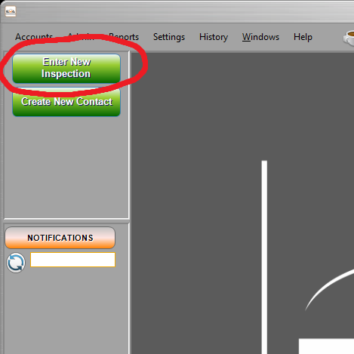
1) Begin Setup

Open The Instruction so you can reference it – it contains key details that you will copy.

In EVA, click "Create New Inspection" to open the Inspection Setup Tool. The Inspection Setup Tool will go page-by-page and prompt you to fill in fields to create the database entry. We only use a small number of the available fields while leaving many of them empty, so it's important to pay attention to which fields need filling in.

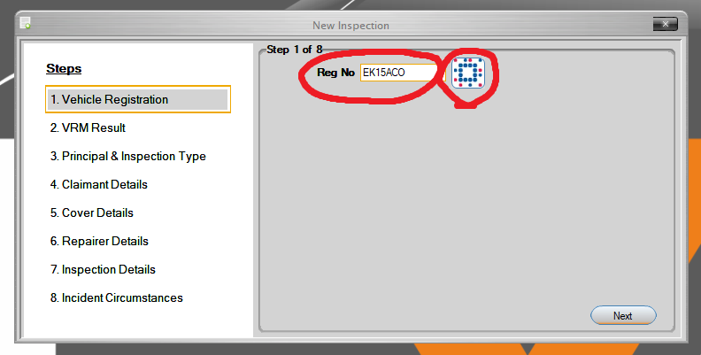
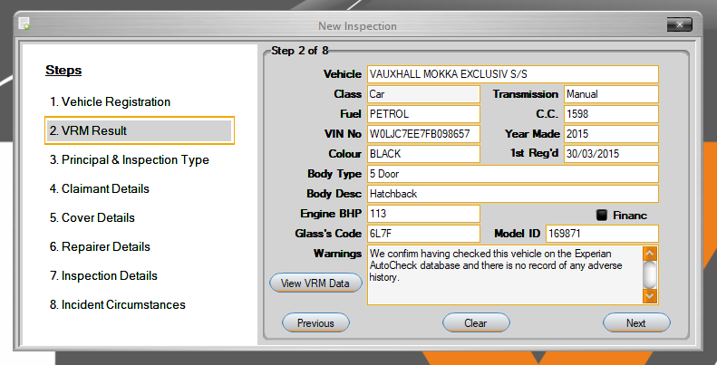

2) Go Through Setup

Page 1)

• "Reg No" Input the vehicle registration here.

• Afterwards, click the Experian logo to load information about the vehicle.

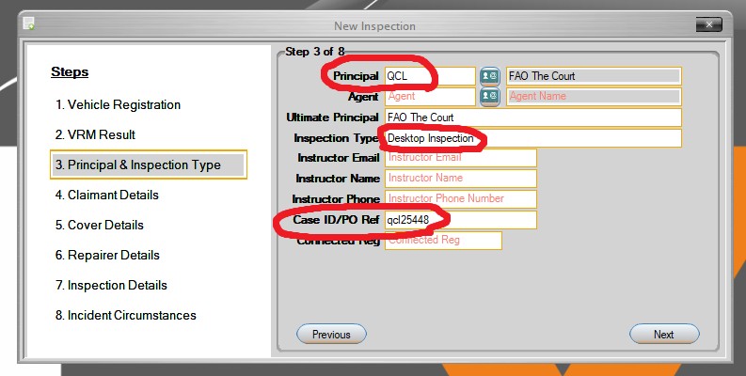
Page 3)

• "Principal:" Enter the code related to the principal in this field (e.g. PCH, QDOS, BA).

• "Inspection Type:" Select "Desktop Inspection" from the dropdown list.

• "Case ID/PO:" Enter our internal reference for the job (e.g. qcl25448). To figure out what reference to use, simply find the last job from the same principal and count upwards by one. If you look at the table below, you will see that the last QCL job completed in our database had the reference “qcl25447”, therefore the next job will be “qcl25448”.

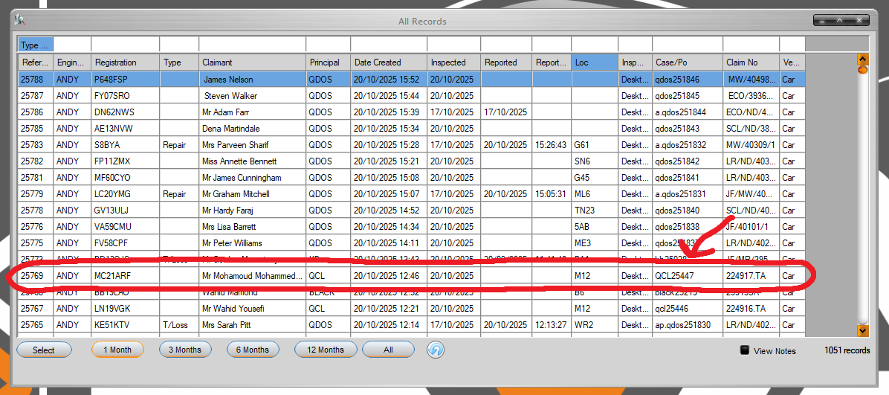

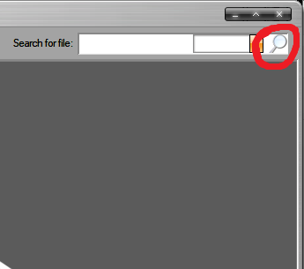
To check the database at any time, simply click the magnifying glass in the top-right corner of EVA. To make things easier, you can always filter the database by clicking in the top row of cells and typing to perform a search.

It’s at this point that you might want to make a folder on Box and name it the internal reference for the job (in this example, you would name the Box folder “QCL25448”).

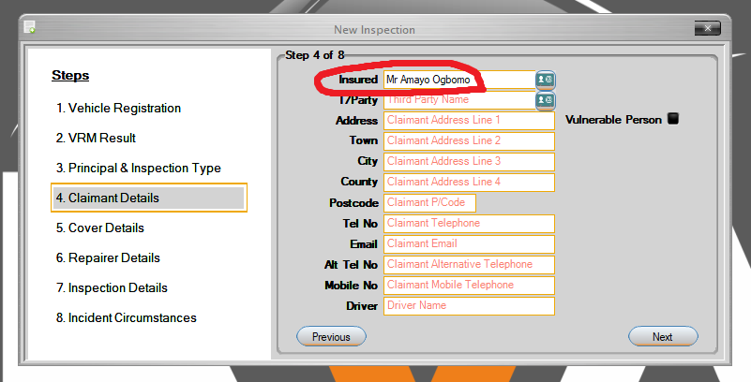

Page 4)

• "Insured:" Enter the client/vehicle owner’s name.

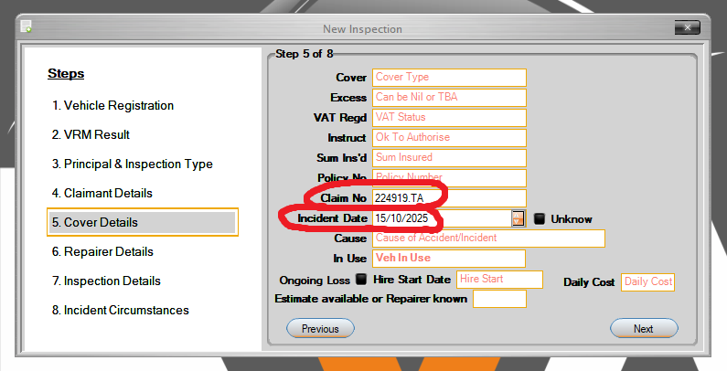

Page 5)

• “Claim No:” Enter the external reference (the one the principal uses to refer to the job).

• “Incident Date:” Enter the date of the accident.

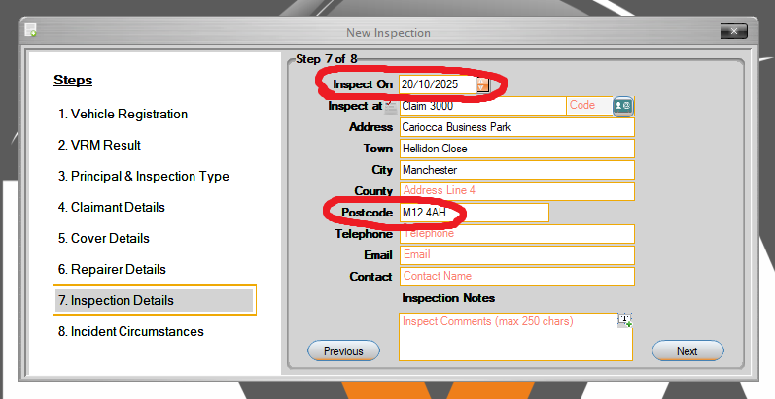
Page 7)

• “Inspected On:” Enter the current date.

• “Inspect at:” Enter either the address where the images were taken, or “Image-based Assessment”. There are a lot of different factors that affect which decision you make here. If you’re unable to work out the address, always choose “Image-based Assessment”. There are notes on the most common addresses for each principal to help confirm the address. Sometimes, the address is the client’s home address. It’s important to note that whenever we name an address, there is an implication that Andy may have visited the address to inspect the vehicle, and therefore the images need to be checked to make sure that it isn’t obvious that the photographer isn’t Andy. When we choose “Image-based Assessment”, we are making it clear that we haven’t inspected the vehicle in person. For example, if there is a reflection of the photographer in one of the images and it doesn’t look like Andy, and we have also noted the inspection address, then this image needs to be cropped to remove the reflection - and if this isn’t possible then the image should be discarded. If all the images are full of reflections and can’t be cropped, then just choose “Image-based Assessment”

4) Complete Remaining Fields

Now the initial setup is complete, but you still need to make some changes to the database entry.

Overview Tab:

• “Request” Change this to the date we received the email in our inbox for the job.
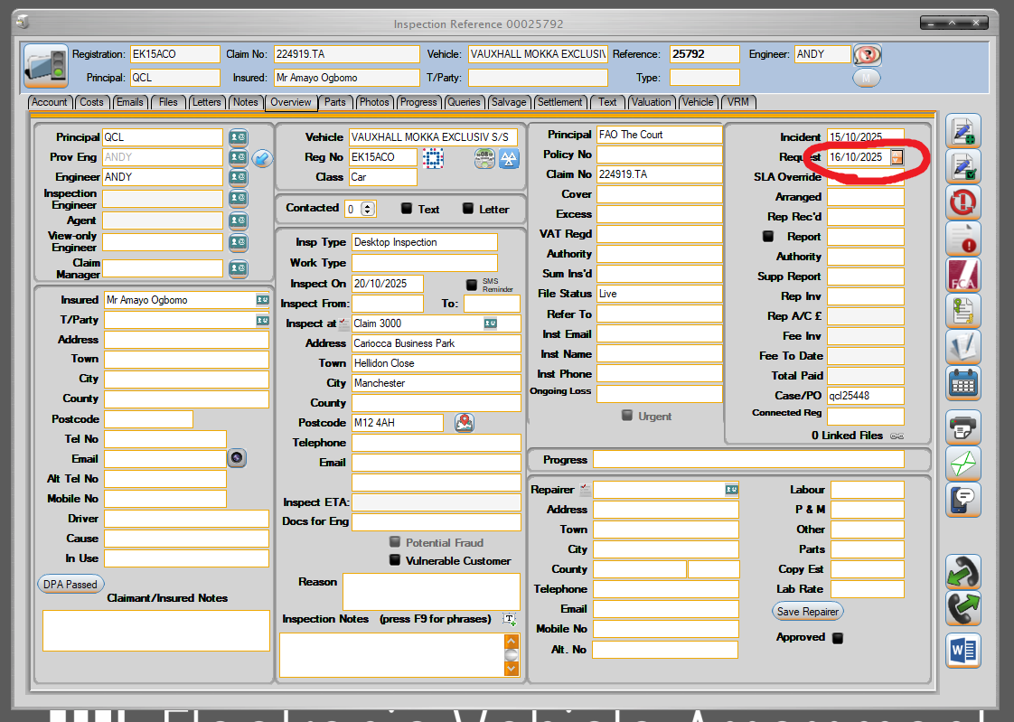

Vehicle Tab:

• “Speedo” Enter the mileage of the vehicle. If this is present in one of the images of the vehicle, then copy what the dashboards says in the image. If this is not present in any of the images, you can get an estimate of the mileage on Percayso by entering the VRM and accident date.

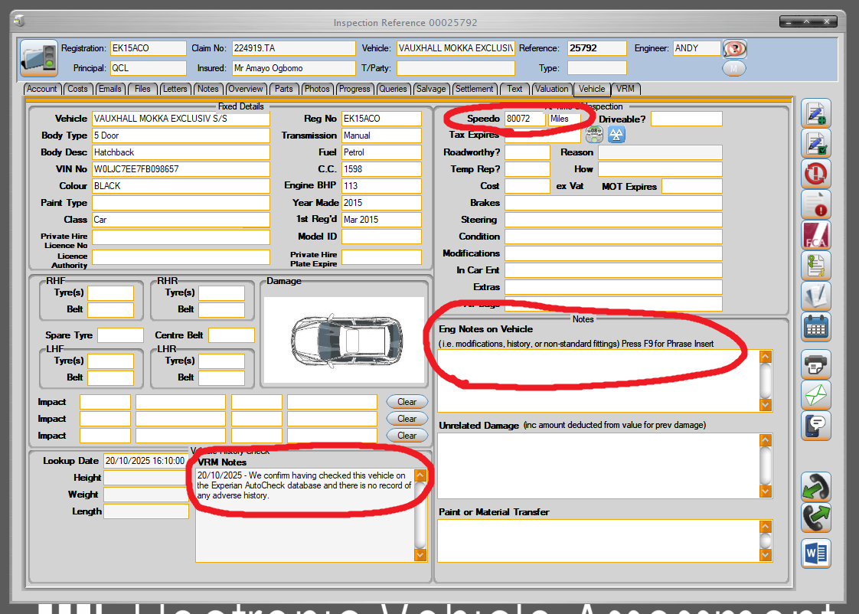

• “Eng Notes on Vehicle” You can press F9 in this field to access a list of presets. You only need to enter info in this field if:

- The vehicle is a previous total loss. To verify this, you need to read the “VRM Notes”. If the vehicle is a previous total loss, you need to verify that the date of the total loss is not the same (or very similar to) the date of the accident, as this would indicate that the VRM Notes are for the current case, not a previous case.

- The mileage (in the “Speedo” field) has been estimated based on MOT data, rather than being verified by reading it from an image of the dashboard.

Valuation Tab:

• Glass’s “Retail” and “Trade” Enter an estimate of the vehicle’s retail and trade value in these two fields in the top half of the page. To get these estimates, enter the VRM, mileage and incident date on Glasses.

• Percayso “Retail” and “Trade” Enter an estimate of the vehicle’s retail and trade value in these two fields in the top half of the page. To get these estimates, enter the VRM, mileage and incident date on Percayso.

• “Retail”, “Trade” and “Engineer Value” Look which estimate method provided the highest single value and then carry down that pair of values into the below fields. You then also need to input the highest single value into the “Engineer Value” field.

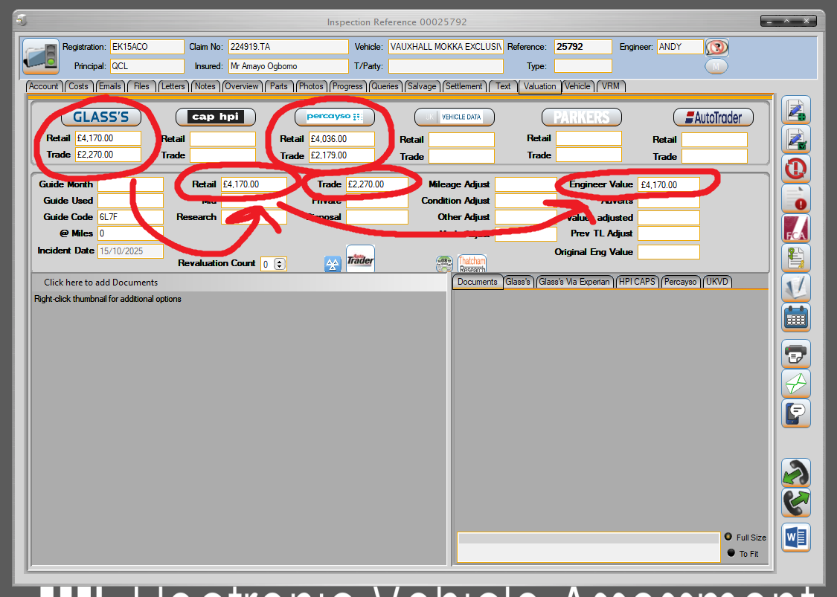

Photos Tab:

Finally, you need to upload the vehicle damage images into the photos tab. There is an important order in which the images need to be uploaded:
- The first two images you upload are handled separately by EVA. The first two images should be one image of the overall vehicle showing the reg, and a closeup image of the damaged area.
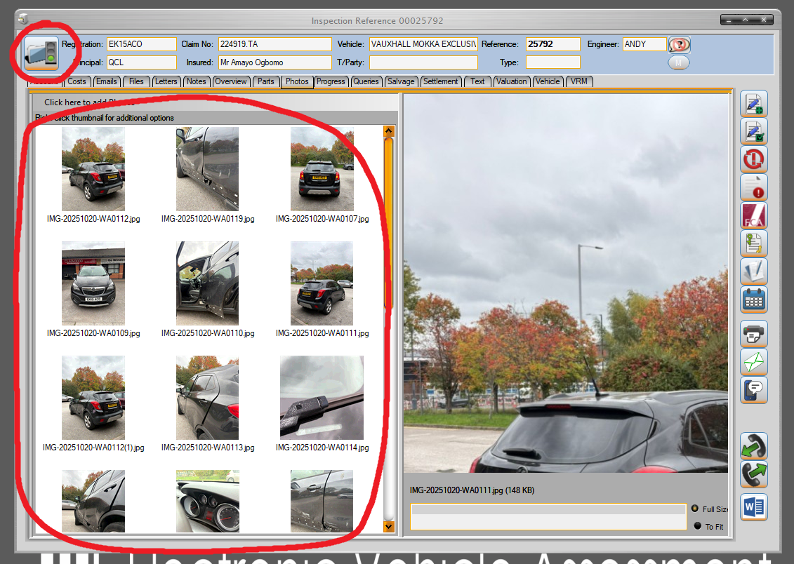
- After you have uploaded the first two images, you then need to drag in ALL of the images (including the two you just uploaded). This may seem counterintuitive, but it’s important that the first two images are duplicated.

5) Save and Complete Box upload

You have now completed the setup process in EVA! To save your changes, you need to click the traffic light symbol in the top right corner. After moving on, make sure you have everything uploaded to the Box folder for the engineer to access. Remember, you need:
• An offline copy of the email with the job request
• The Instruction (usually attached in the email as a .pdf or .docx)
• Images of the damaged vehicle

You can also carry forward any notes for the engineer needed to help them complete the job in the form of boxnotes.

