

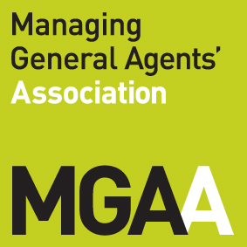
Collision Engineers Ltd
Proud Members Of
QDOS Accident Assistance Ltd are a claims management company.
Registered in England and Wales: Company Registration Number 5179995
Registered Office: Higsons Chartered Accountants – Offices 1 and 2, 1A King Street, Farnworth, Bolton, BL4 7AB
Call us today on
0800 093 0982
enquiries@qdosassist.co.uk
77-79 Hoylake Road
Moreton
Wirral
CH49 6LH

Our Ref: SAB/46591/1
Date: 13 July 2026

Dear Sirs

Our Client: Mr Michael Deakin
Our Client’s Vehicle: MINI JOHN COOPER WORKS AUTO
Registration: AY15EWU
Date of Accident: 1 July 2026
ENGINEER NOTIFICATION (REPORT + AUDIT REPORT)

CLIENT DETAILS
Mr Michael Deakin  15 Hampshire Road  Camberley  GU15 4DW |  | Vehicle Details
 |  | Client’s Vehicle: | MINI JOHN COOPER WORKS AUTO
 |  | Vehicle Registration: | AY15EWU
 |  | Accident Date: | 01/07/2026
Home Tel:
Work Tel:
Mobile: | 07534403797

REPAIRER DETAILS
Tel:
Fax:
Email:
Engineer to Estimate | Unknown

We would be obliged if you could contact the repairing garage and/or the client as appropriate and agree figures with the repairer – do not authorise repairs. Please do not agree a contract repair in excess of 80% of the vehicle value. All contract repairs must be fully itemised.

Please confirm if the vehicle is un-roadworthy and/or illegal to drive.

Vehicle Status – Undriveable

Please could you check the damage for consistency with the following accident circumstances?

Our client's vehicle was parked and unattended for a few minutes opposite the Co-op on Upper College Ride, Camberley. This is a single lane residential road for travel in both directions with allocated parking bays outside the shop. Your insured, parked in one of the bays outside the Co-op failed to reverse safely out of their bay and collided into the rear offside of our client's vehicle. Our client didn't see the damage until they were home, therefore they proceeded back to the Co-op and obtained your insured's registration from their CCTV footage. Our client then proceeded to look for a vehicle matching your insured's vehicle description in the local area and found it.

Damage Area – Offside: Moderate offside door and rear panel scratches and dented
Pre-existing Damage: | none
TP Vehicle: | NISSAN QASHQAI ACENTA PREMIUM DIG-T
TP Registration: | YT70HZD
TP Representative Name: | U K I (Formerly Direct Line)

If you need any further information please contact us on 0800 093 0982 selecting option 2.

Yours faithfully

