数字图像处理程序设计报告

题目： 机读卡识别

姓名： 张心妍

学号： 19160132

目录

一、程序介绍

二、工作流程

三、测试结果

四、程序代码

一、程序介绍
功能：可以识别答题卡，并根据提供的答案文档进行批改，显示最终成绩
环境：jdk1.8.0 + opencv4.0.1
二、工作流程
- 进入主界面
- 选择答案文件
- 选择答题卡图片所在文件夹
- 确认后程序进行批改操作，切换到结果显示界面
批改规则：
单选题正确得全分，错误得零分
多选题部分正确得1分，完全正确得全分，含错误选项得零分
答案文档中没有的题目不批改，不计分
三、测试结果
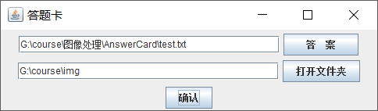
主界面
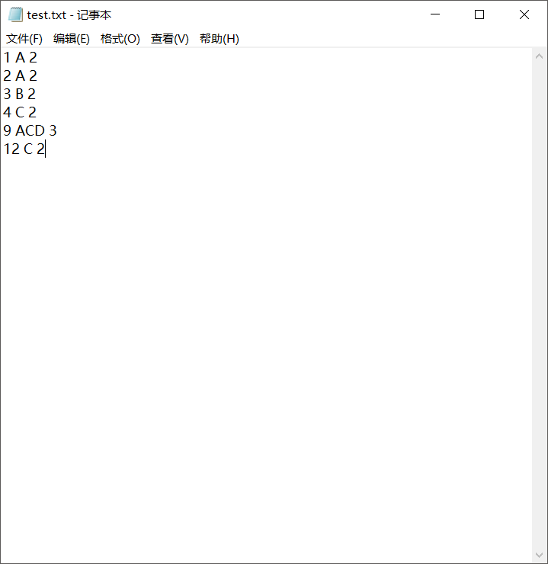
答案文档
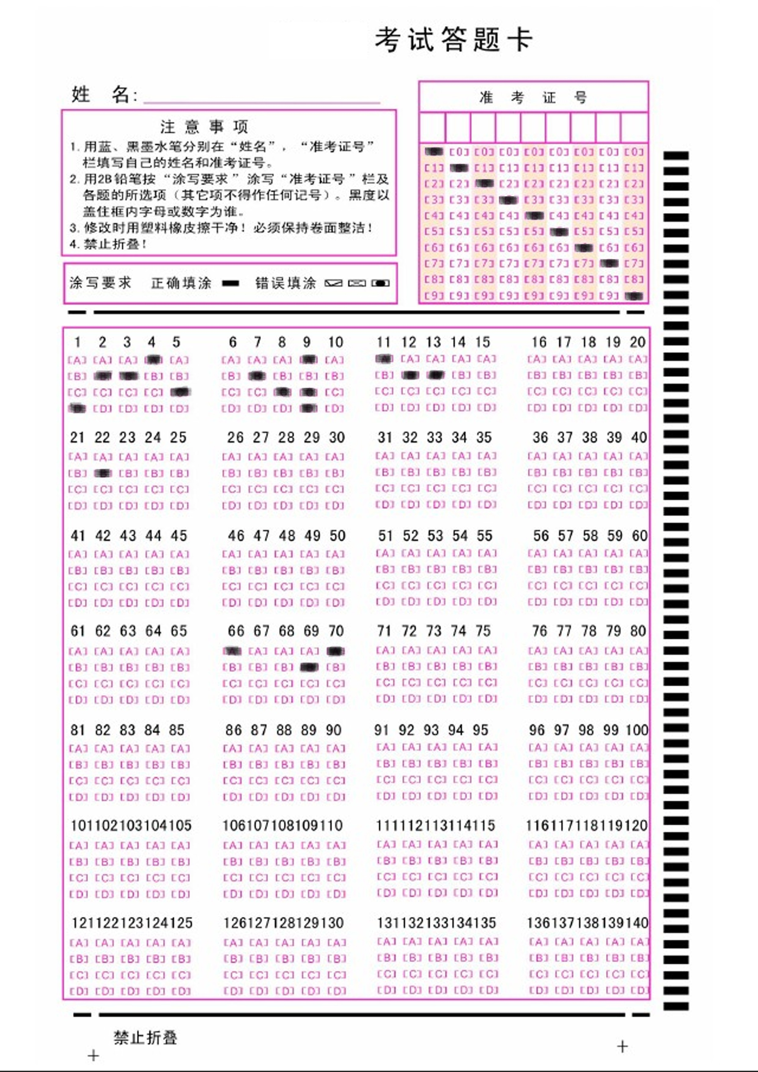
测试用例1
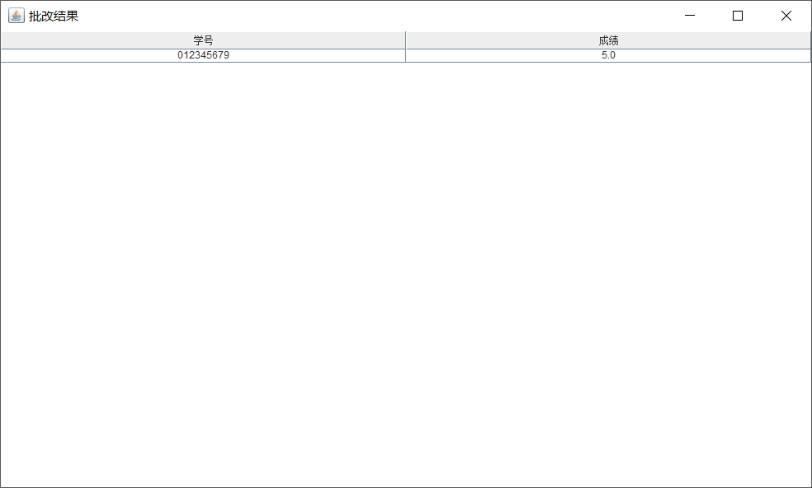
测试结果1
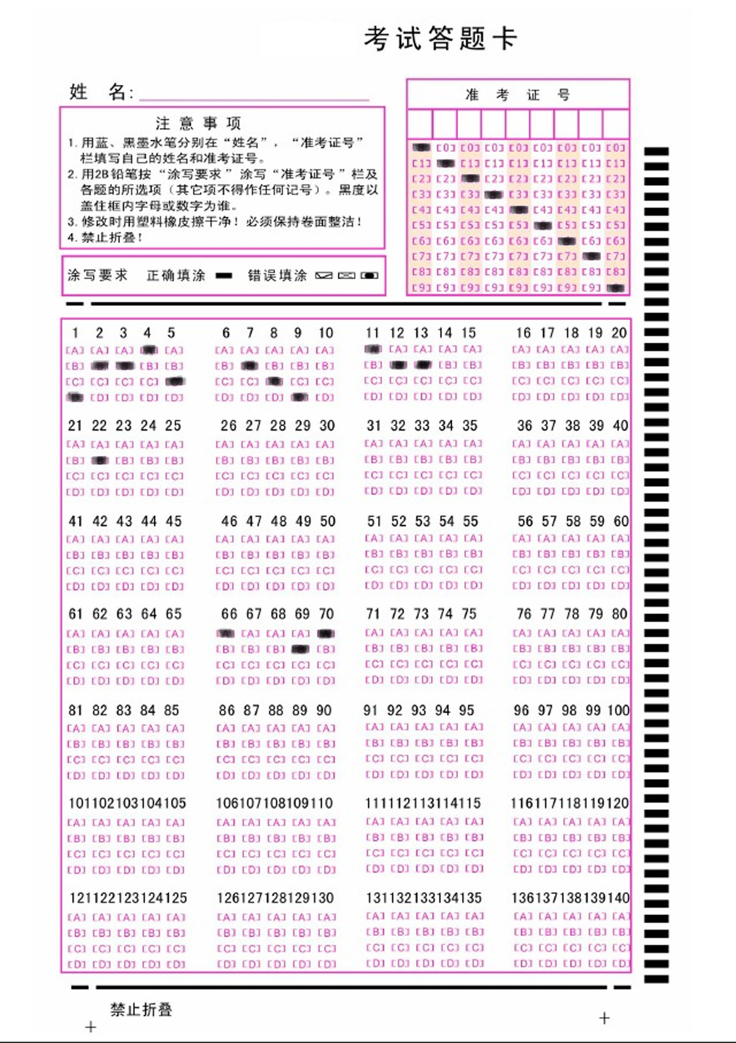
测试用例2
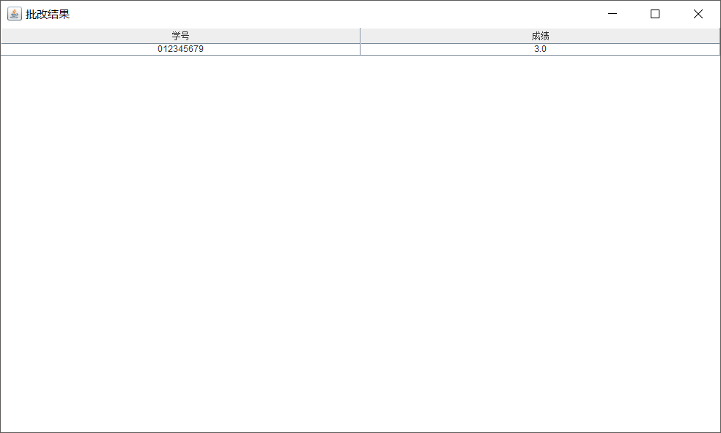
测试结果2
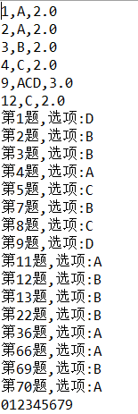
用例2程序读取结果
四、程序代码
1、主页面
import static org.opencv.imgproc.Imgproc.MORPH_RECT;

import java.awt.GridLayout;
import java.awt.event.ActionEvent;
import java.awt.event.ActionListener;
import java.io.*;
import java.util.*;

import javax.swing.*;

import org.opencv.core.Core;
import org.opencv.core.Mat;
import org.opencv.core.Size;
import org.opencv.imgcodecs.Imgcodecs;
import org.opencv.imgproc.Imgproc;

public class MainWin {

static void show_win() throws Exception {
JFrame jf_img=new JFrame("答题卡");
jf_img.setLayout(new GridLayout(3, 1));

//open dir
JPanel jp_text=new JPanel();
JTextField jtf=new JTextField(30);
JButton jb_text=new JButton(" 答 案 ");
jp_text.add(jtf);
jp_text.add(jb_text);

JPanel jp_dir=new JPanel();
JTextField jtf_dir=new JTextField(30);
JButton jb_dir=new JButton("打开文件夹");
jp_dir.add(jtf_dir);
jp_dir.add(jb_dir);

JPanel jp_bt=new JPanel();
JButton jb_ok=new JButton("确认");
jp_bt.add(jb_ok);

Vector<Object> result=new Vector<Object>();

Vector<Ques> data=new Vector<Ques>();

jb_text.addActionListener(new ActionListener() {

@Override
public void actionPerformed(ActionEvent e) {
// TODO Auto-generated method stub
JFileChooser jfc=new JFileChooser();
jfc.setFileSelectionMode(JFileChooser.FILES_AND_DIRECTORIES);
jfc.showDialog(new JLabel(), "选择");
File result=jfc.getSelectedFile();
try {
BufferedReader bf=new BufferedReader(new FileReader(result));
String fn=result.getAbsoluteFile().toString();
jtf.setText(fn);

if(result.exists()&&result.isFile()){
if(fn.substring(fn.lastIndexOf('.')+1).equals("txt")){
String textLine=new String();
while((textLine=bf.readLine())!=null){
String[] temp=textLine.split(" ");
int no=Integer.parseInt(temp[0]);
String answer=temp[1];
float point=Float.parseFloat(temp[2]);
System.out.println(no+","+answer+","+point);
Ques q=new Ques(no,answer);
q.point=point;
data.add(q);
}
}
}
bf.close();
} catch (Exception e1) {
// TODO Auto-generated catch block
e1.printStackTrace();
}

}
});

jb_dir.addActionListener(new ActionListener() {

@Override
public void actionPerformed(ActionEvent e) {
// TODO Auto-generated method stub
JFileChooser jfc=new JFileChooser();
jfc.setFileSelectionMode(JFileChooser.DIRECTORIES_ONLY);
jfc.showDialog(new JLabel(), "选择");
File dir=jfc.getSelectedFile();
String fn=dir.getAbsoluteFile().toString();
jtf_dir.setText(fn);
if(dir.exists()&&dir.isDirectory()){
result.clear();
String[] files=dir.list();
// System.out.println(fn);
for(String file:files){
int flag=file.lastIndexOf('.');
if(!(file.substring(flag+1).equals("gif")||file.substring(flag+1).equals("jpg")||file.substring(flag+1).equals("png")))continue;
String img_route=fn+"\\"+file;
// System.out.println(img_route);

Mat img=Imgcodecs.imread(img_route);
Mat srcImage2 = new Mat();
Mat srcImage3 = new Mat();
Mat srcImage4 = new Mat();
Mat srcImage5 = new Mat();

//图片变成灰度图片
Imgproc.cvtColor(img, srcImage2, Imgproc.COLOR_RGB2GRAY);
//图片二值化
Imgproc.adaptiveThreshold(srcImage2, srcImage3, 255, Imgproc.ADAPTIVE_THRESH_MEAN_C, Imgproc.THRESH_BINARY_INV, 255, 1);
//确定腐蚀和膨胀核的大小
Mat element = Imgproc.getStructuringElement(MORPH_RECT, new Size(1, 6));
//腐蚀操作
Imgproc.erode(srcImage3, srcImage4, element);
//膨胀操作
Imgproc.dilate(srcImage4, srcImage5, element);

Vector<Ques> answer=OpenCv.get_answer(srcImage4);
String sno=OpenCv.get_sno(srcImage4);
// System.out.println(sno+","+answer.size());
float score=0;

for(int i=0;i<answer.size();i++){
Ques temp=check(answer.elementAt(i), data);
answer.set(i, temp);
score+=temp.point;
}
// System.out.println(sno+","+score);
result.add(sno); result.add(score);
}
}
}
});

jb_ok.addActionListener(new ActionListener() {

@Override
public void actionPerformed(ActionEvent e) {
// TODO Auto-generated method stub
new ResultWin(result);
}
});

jf_img.getContentPane().add(jp_text);
jf_img.getContentPane().add(jp_dir);
jf_img.getContentPane().add(jp_bt);
jf_img.setSize(500, 150);
jf_img.setVisible(true);
jf_img.setExtendedState(JFrame.NORMAL);
jf_img.setLocationRelativeTo(null);
}

public static Ques check(Ques q,Vector<Ques> data){
for(int i=0;i<data.size();i++){
Ques temp=data.elementAt(i);
if(temp.no==q.no){
if(temp.answer.equals(q.answer))
q.point=data.elementAt(i).point;
else if(temp.answer.length()>1){
for(int j=0;j<temp.answer.length();j++){
if(q.answer.indexOf(temp.answer.charAt(j))!=-1)
q.point=1;
}
for(int j=0;j<q.answer.length();j++){
if(temp.answer.indexOf(q.answer.charAt(j))==-1)
q.point=0;
}
}
// System.out.println(q.no+","+q.point);
return q;
}
}
return q;
}

public static void main(String[] args) throws Exception {
// TODO Auto-generated method stub
System.loadLibrary(Core.NATIVE_LIBRARY_NAME);
show_win();
}

}
2、结果显示界面
import java.awt.BorderLayout;
import java.util.Vector;

import javax.swing.*;
import javax.swing.table.DefaultTableCellRenderer;

public class ResultWin {

public ResultWin(Vector<Object> result) {
// TODO Auto-generated constructor stub
JFrame jf=new JFrame("批改结果");

String[] colName={"学号","成绩"};
JPanel jp=new JPanel(new BorderLayout());

System.out.println("size"+result.size());
Object[][] rowData=new Object[result.size()/2][2];
for(int i=0;i<result.size();i++){
rowData[i/2][i%2]=result.elementAt(i);
System.out.println(result.elementAt(i));
}

JTable jt=new JTable(rowData, colName);
DefaultTableCellRenderer r=new DefaultTableCellRenderer();
r.setHorizontalAlignment(JLabel.CENTER);
jt.setDefaultRenderer(Object.class, r);
JScrollPane sp=new JScrollPane(jt);
jp.add(jt.getTableHeader(), BorderLayout.NORTH);
jp.add(jt, BorderLayout.CENTER);

jf.getContentPane().add(sp, BorderLayout.CENTER);
jf.setContentPane(jp);
jf.pack();
jf.setSize(1000, 600);
jf.setLocationRelativeTo(null);
jf.setVisible(true);
}
}
3、图片处理

import org.opencv.core.*;
import org.opencv.imgcodecs.Imgcodecs;
import org.opencv.imgproc.Imgproc;

import java.util.*;

import static org.opencv.core.CvType.CV_8U;
import static org.opencv.imgproc.Imgproc.MORPH_RECT;

public class OpenCv {
static {
System.loadLibrary(Core.NATIVE_LIBRARY_NAME);
}

public static void main(String []args) {
String sheet = "img//A4.jpg";

//A4 二值化膨胀后生成的图片路径
String results = "img//result.jpg";
String msg = rowsAndCols(sheet, results);
System.out.println(msg);
}

public static void Canny(String oriImg, int threshold) {
//装载图片
Mat img = Imgcodecs.imread(oriImg);
Mat srcImage2 = new Mat();
Mat srcImage3 = new Mat();
Mat srcImage4 = new Mat();
Mat srcImage5 = new Mat();

//图片变成灰度图片
Imgproc.cvtColor(img, srcImage2, Imgproc.COLOR_RGB2GRAY);
//图片二值化
Imgproc.adaptiveThreshold(srcImage2, srcImage3, 255, Imgproc.ADAPTIVE_THRESH_MEAN_C, Imgproc.THRESH_BINARY_INV, 255, 1);
//确定腐蚀和膨胀核的大小
Mat element = Imgproc.getStructuringElement(MORPH_RECT, new Size(1, 6));
//腐蚀操作
Imgproc.erode(srcImage3, srcImage4, element);
//膨胀操作
Imgproc.dilate(srcImage4, srcImage5, element);
}

public static Vector<Ques> get_answer(Mat srcImage){
//答案的ROI区域
Mat imag_ch1 = srcImage.submat(new Rect(200, 1065, 1930, 2210));

//识别所有轮廓
Vector<MatOfPoint> chapter1 = new Vector<>();
Imgproc.findContours(imag_ch1, chapter1, new Mat(), 2, 3);
Mat result = new Mat(imag_ch1.size(), CV_8U, new Scalar(255));
Imgproc.drawContours(result, chapter1, -1, new Scalar(0), 2);

Imgcodecs.imwrite("img//result.jpg", result);

//new一个 矩形集合 用来装 轮廓
List<RectComp> RectCompList = new ArrayList<>();
for (int i = 0; i < chapter1.size(); i++) {
Rect rm = Imgproc.boundingRect(chapter1.get(i));
RectComp ti = new RectComp(rm);
//把轮廓宽度区间在 50 - 80 范围内的轮廓装进矩形集合
if (ti.rm.width > 60 && ti.rm.width < 85) {
RectCompList.add(ti);
}
}

//new一个 map 用来存储答题卡上填的答案 (A\B\C\D)
TreeMap<Integer, String> listenAnswer = new TreeMap<>();
//按 X轴 对listenAnswer进行排序
RectCompList.sort((o1, o2) -> {
if (o1.rm.x > o2.rm.x) {
return 1;
}
if (o1.rm.x == o2.rm.x) {
return 0;
}
if (o1.rm.x < o2.rm.x) {
return -1;
}
return -1;
});

//根据 Y轴 确定被选择答案 (A\B\C\D)
for (RectComp rc : RectCompList) {
flag:
for (int h = 0; h < 7; h++) {
for(int w = 0; w < 4 ; w++){
for(int i=0;i<5;i++){
String answer=new String();
if(rc.rm.contains(new Point(55 + (80*i) + (500 * w), 115 + (320 * h))))
answer+='A';
if(rc.rm.contains(new Point(55 + (80*i) + (500 * w), 165 + (320 * h))))
answer+='B';
if(rc.rm.contains(new Point(55 + (80*i) + (500 * w), 220 + (320 * h))))
answer+='C';
if(rc.rm.contains(new Point(55 + (80*i) + (500 * w), 275 + (320 * h))))
answer+='D';
if(!answer.isEmpty() && !listenAnswer.containsKey(i + 1 + (20 * h) + (5 * w))){
listenAnswer.put(i + 1 + (20 * h) + (5 * w), answer);
break flag;
}else if(!answer.isEmpty() && listenAnswer.containsKey(i + 1 + (20 * h) + (5 * w))){
answer+=listenAnswer.get(i + 1 + (20 * h) + (5 * w));
listenAnswer.put(i + 1 + (20 * h) + (5 * w), answer);
break flag;
}
}
}
}
}

Vector<Ques> answer=new Vector<>();
Iterator iter = listenAnswer.entrySet().iterator();
while (iter.hasNext()) {
Map.Entry entry = (Map.Entry) iter.next();
Object key = entry.getKey();
Object val = entry.getValue();
Ques q=new Ques((Integer)key,(String)val);
answer.add(q);
System.out.println("第" + key + "题,选项:" + val);
}

return answer;
}

public static String get_sno(Mat srcImage){
//准考证号的ROI区域
Mat imag_ch2 = srcImage.submat(new Rect(1370, 470, 750, 525));

Vector<MatOfPoint> chapter2 = new Vector<>();
Imgproc.findContours(imag_ch2, chapter2, new Mat(), 2, 3);
Mat num = new Mat(imag_ch2.size(), CV_8U, new Scalar(255));
Imgproc.drawContours(num, chapter2, -1, new Scalar(0), 2);

Imgcodecs.imwrite("img//num.jpg", num);

List<RectComp> RectCompList_num = new ArrayList<>();
for (int i = 0; i < chapter2.size(); i++) {
Rect rm = Imgproc.boundingRect(chapter2.get(i));
RectComp ti = new RectComp(rm);
if (ti.rm.width > 60 && ti.rm.width < 85) {
RectCompList_num.add(ti);
}
}

TreeMap<Integer, Integer> listenNum = new TreeMap<>();
//按 X轴 对listenAnswer进行排序
RectCompList_num.sort((o1, o2) -> {
if (o1.rm.x > o2.rm.x) {
return 1;
}
if (o1.rm.x == o2.rm.x) {
return 0;
}
if (o1.rm.x < o2.rm.x) {
return -1;
}
return -1;
});

for(RectComp rc : RectCompList_num){
for (int h = 0; h < 10; h++) {
for (int w = 0; w < 9; w++) {
if (rc.rm.contains(new Point(55 + (80 * w), 25 + (53 * h)))) {
listenNum.put(1 + w, h);
}
}
}
}

String sno=new String();
Iterator iter_num = listenNum.entrySet().iterator();
while (iter_num.hasNext()) {
Map.Entry entry = (Map.Entry) iter_num.next();
Object key = entry.getKey();
Object val = entry.getValue();
sno+=val;
}
System.out.println(sno);

return sno;
}
}
5、Ques类
public class Ques {

int no;
String answer;
float point;
Ques(int no,String answer){
this.no=no;
this.answer=answer;
}
}
6、RectComp类
import org.opencv.core.Rect;

public class RectComp {
Rect rm ;

public RectComp(Rect rms) {
super();
this.rm = rms;
}
public Rect getRm() {
return rm;
}
public void setRm(Rect rm) {
this.rm = rm;
}
public boolean operator(RectComp ti) {
return rm.x < ti.rm.x;
}

}

