supporting documents

Colm O’Neill

This material details some of my recent work in fabrication laboratories, maker spaces, educational practices and projects related to new technologies.

Research statement
My name is Colm O’Neill, I am a freelance researcher, graphic designer, web developer and teacher. My research ranges from photography to web / graphic design and digital literacy with a particular interest in the design of “frontal aesthetics” (including graphic design and interface design) in comparison to the background systems they mediate.

In my research I am concerned with how graphic design and interfaces can disempower users of certain technologies, often making them reliant on closed-down systems such as the adobe systems or even the google suite. I believe that the visual language which mediates powerful computing functions rarely reflects the background processes in action. An example of this would be popup messages through which websites attempt to get users to allow notifications from their site. This request has multiple detrimental hidden effects, but is proposed to the user as an extra handy feature. I believe this is a strategy often employed to mislead users, which enhances a user's reliance on an interface designed for “ease of use” or “intuitive use”; my research questions the effects of these interfaces.

In attempting to tackle these issues I work in various capacities as a researcher, teacher, developer and designer; with electronics, printing, computer aided design and fabrication laboratory practices. I aim to create learning and teaching situations rooted in experiences, and to empower students and users of technology through open source technologies and more broadly, digital literacy. It is my hope that the questions these learning moments raise, enable individuals to develop critical capacities to navigate our complex digital environments.

I completed a Master in Media Design and Communications at the Piet Zwart Institute in 2017, presenting my thesis on the topic of Tangible Tools (http://tangible.tools) a critique of digital design tools focused on their various attempts at efficiency versus efficacy. My graduation project is titled Adversarial Interfaces (http://adversarial.interfaces.site/) which collects and develops projects of interface or interfacing resistance through adversarial practices.

Working with BeMaker – A Brussles-based digital fabrication laboratory
I am currently education lead for an organisation called beMaker. The group (http://bemaker.eu) is a non-profit organisation from Brussels that is focused on introducing fablab-like practices to students between the ages of 10 and 16. It’s main mission is to demystify what are understood as new technologies. Specifically, beMaker has built two food truck-like vans to fully function as mobile fablabs. This allows us to work in schools directly with children, taking time to introduce them to what a fablab may be and to give various workshops introducing children to programming, basic electronics and design methods.

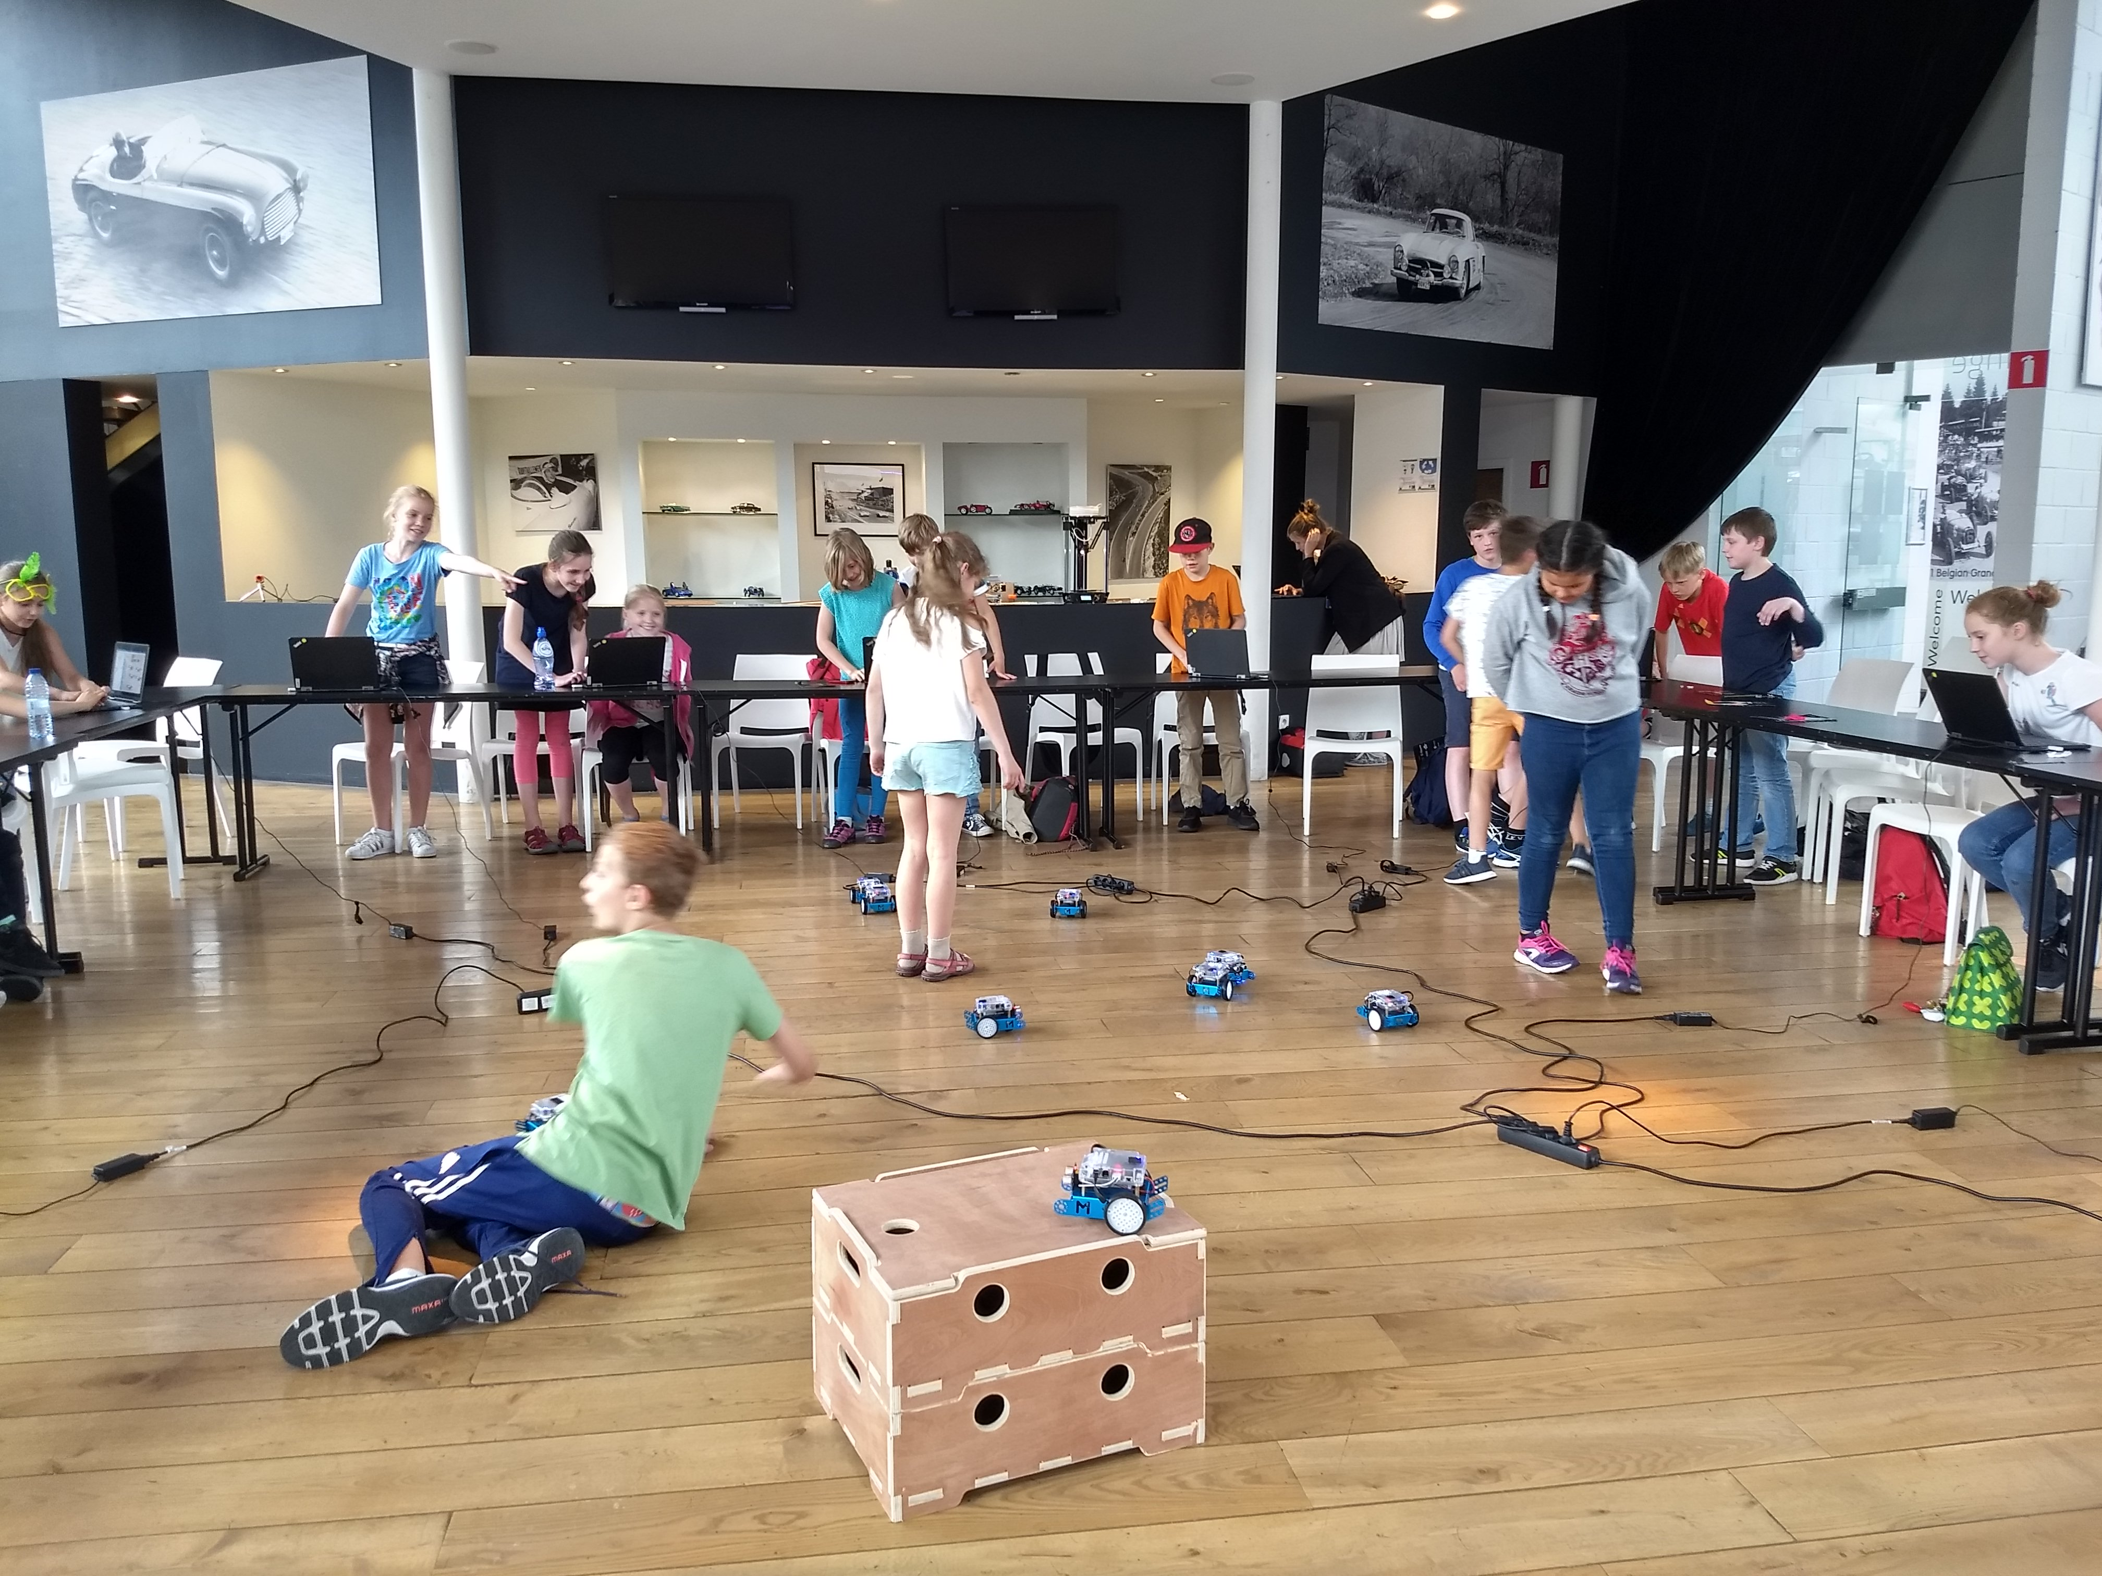
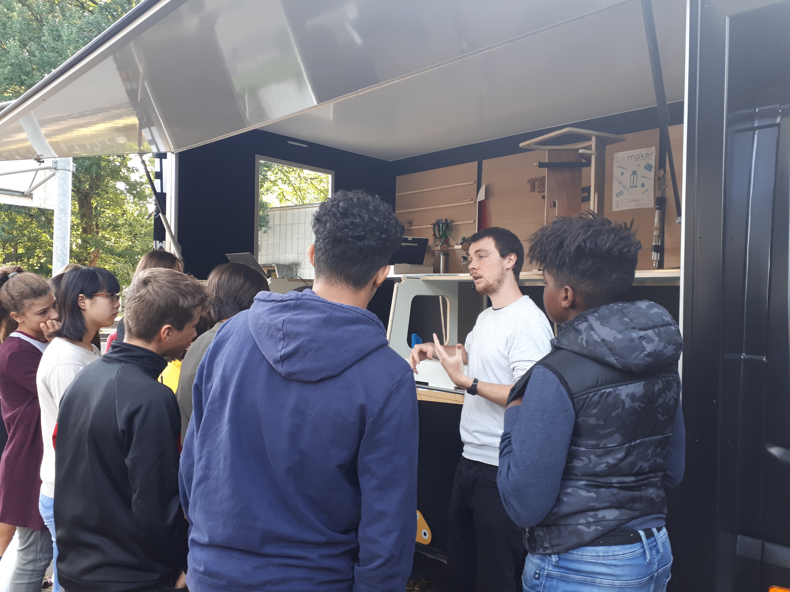
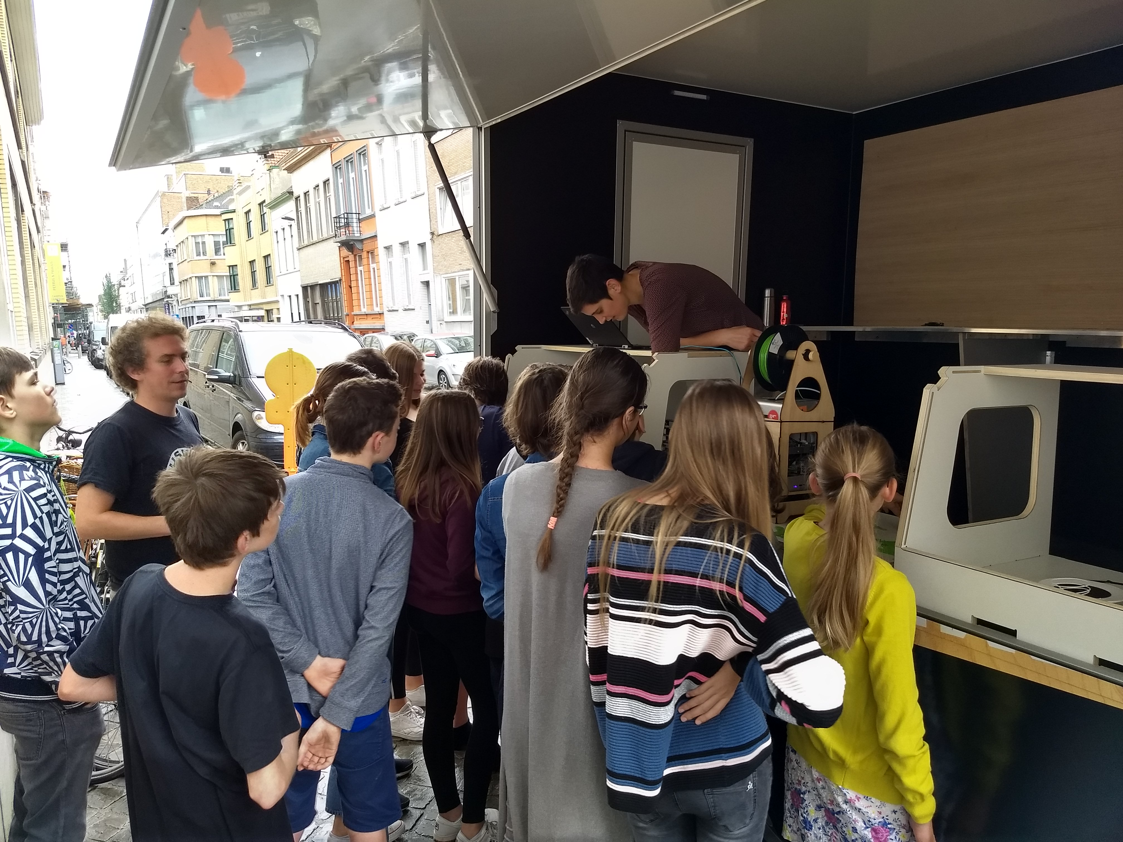
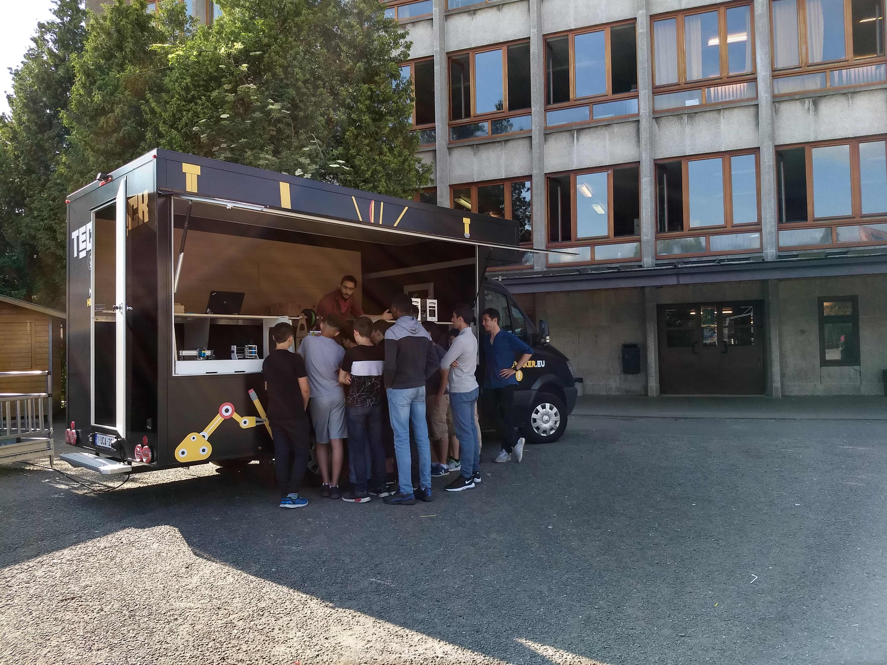
These pictures show the mobile fablabs in use in various school contexts. The general introduction we give takes between 30 and 50 minutes, depending on the specific interests of each group.

Lengthened workshops with beMaker

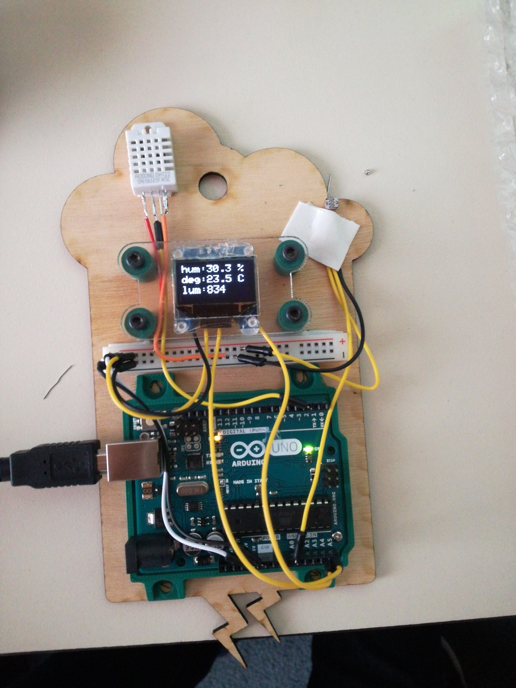
Alongside the basic introductory workshops we also deliver longer projects. In one of these workshops we developed a small weather station. The station aims to teach the students to measure and display humidity levels, current temperature, brightness and other sensors. Later, this micro weather station can be updated to receive a digital communication module to log the readings from each sensor. This project was designed to integrate with other subjects in a school's course curriculum.

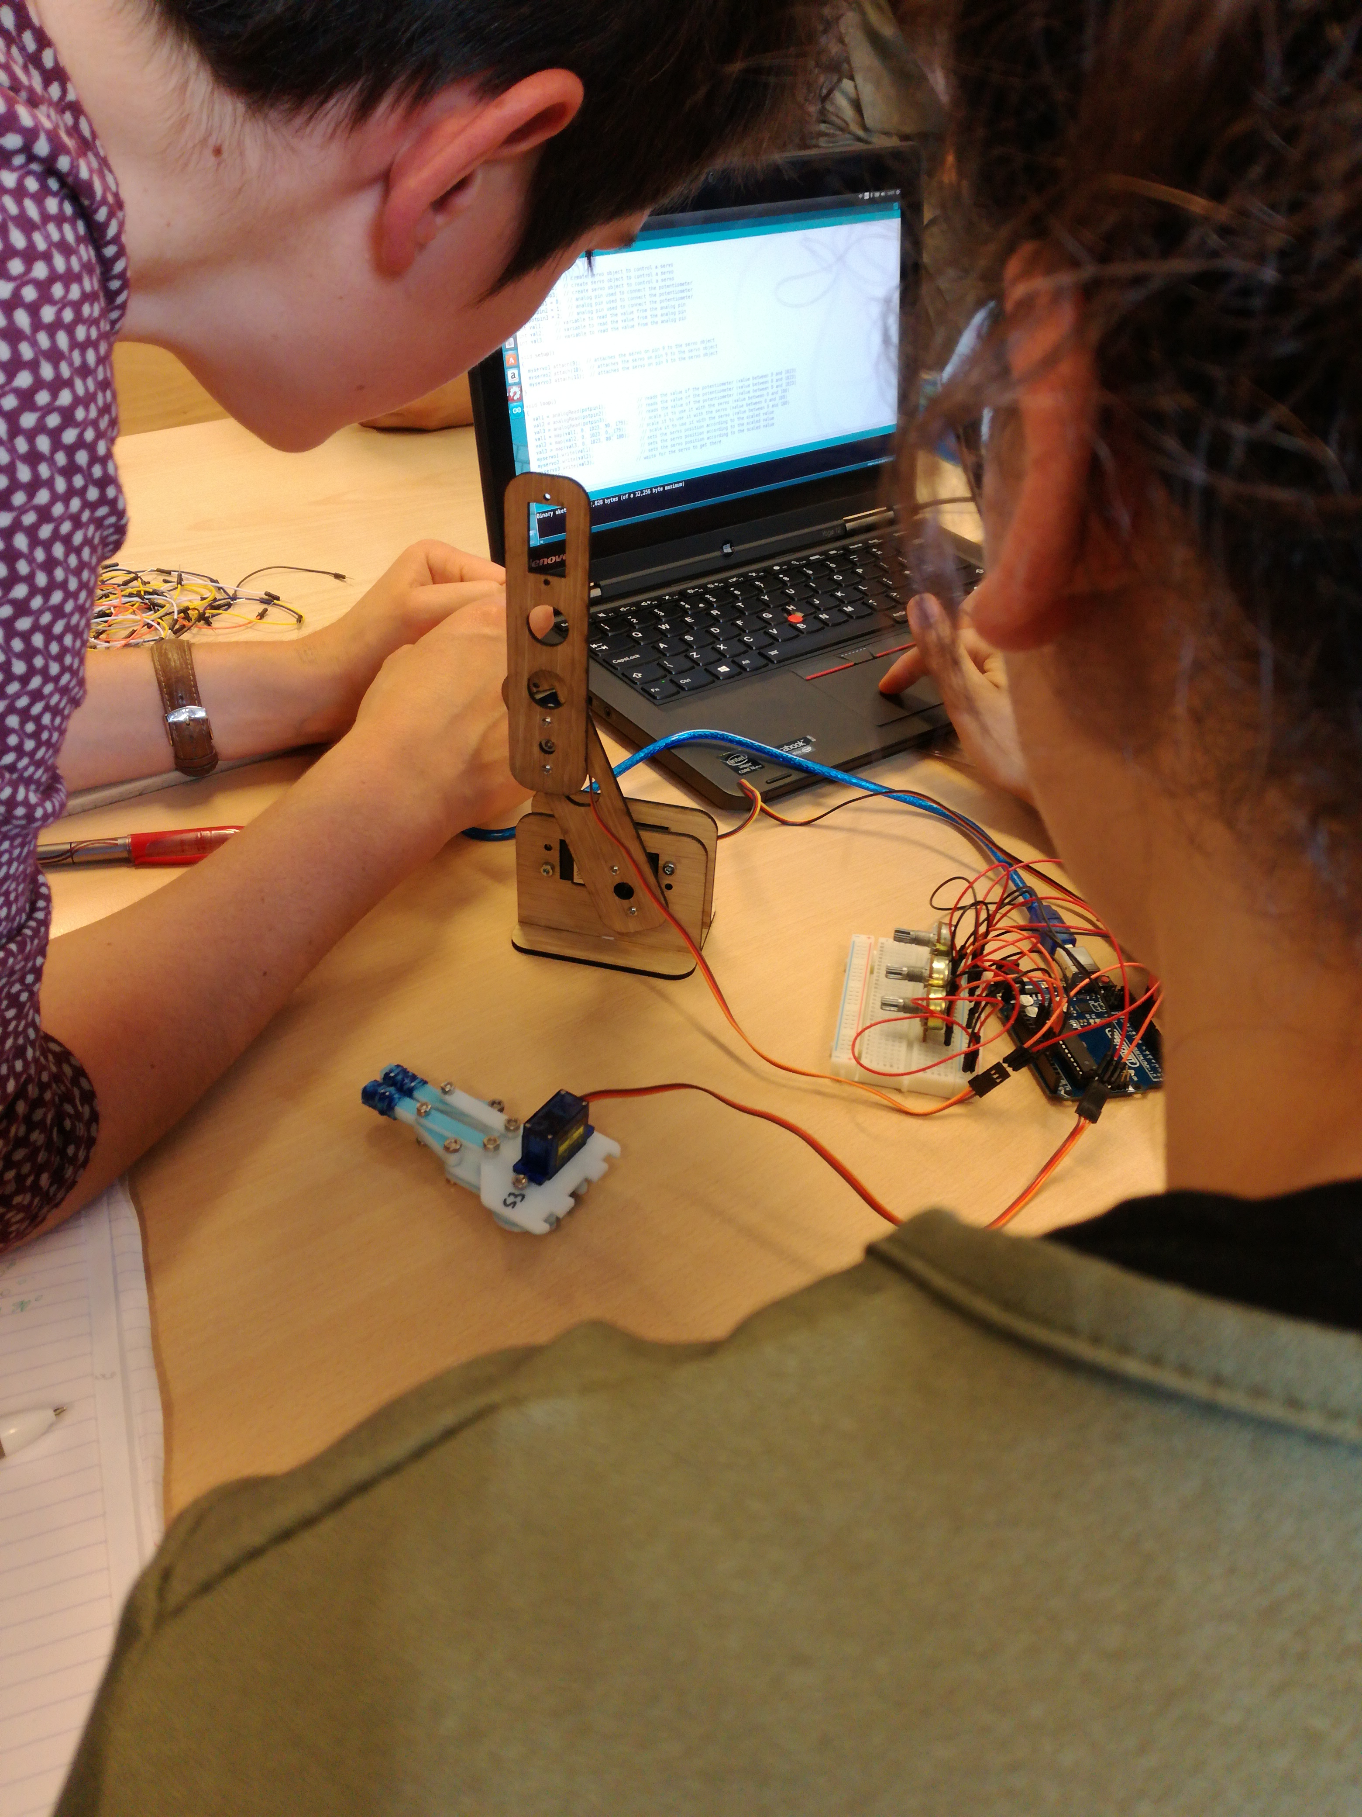

A second extensive workshop uses the idea of articulated arms, displaying to the students how a tri- or quad-angled robot arm works theoretically. When deployed, this project requires less programming involvement, but needs more parts designing in order to make the robotic arm usable.

Production add-ons for the beMaker truck
Below are images of some of beMakers internal projets / productions, these are a collection of little add-ons or creations we had to build to facilitate the workings of the mobile fablab.

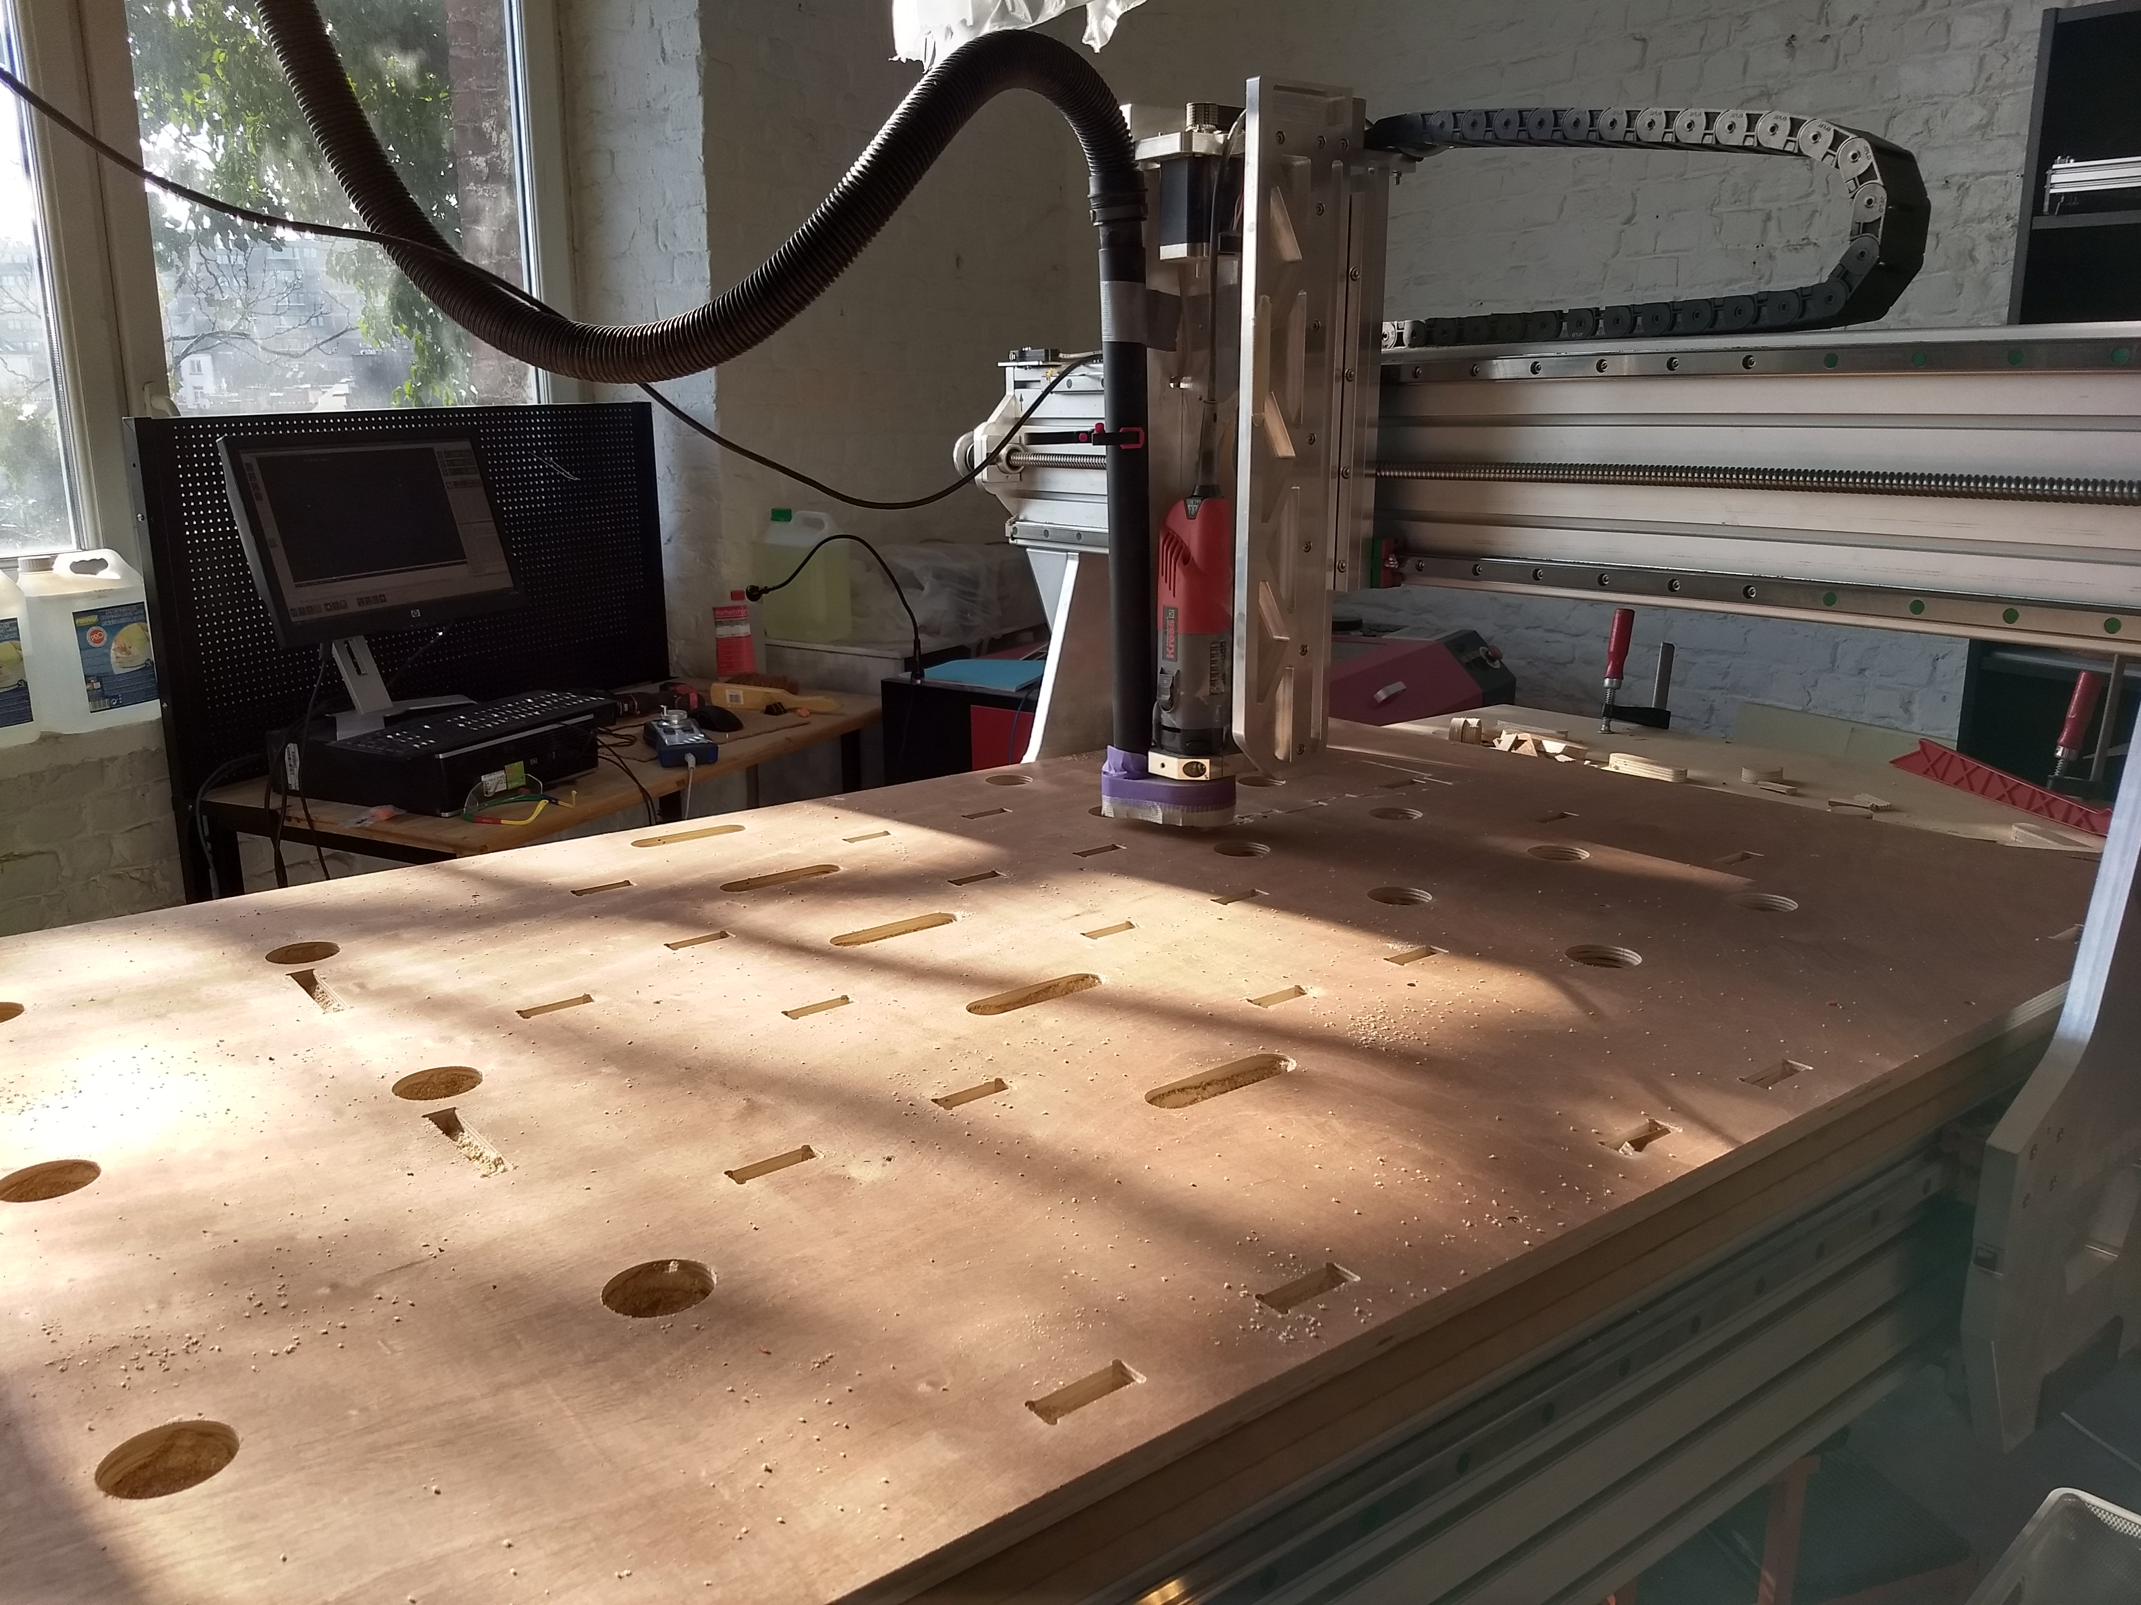
One of the main issues with making a fablab mobile is storage and security while driving the van between school locations. All of the workbenches and furniture has been custom built for the project using our own fablab machinery and programmes. This image shows our storage and transport box before assembly.

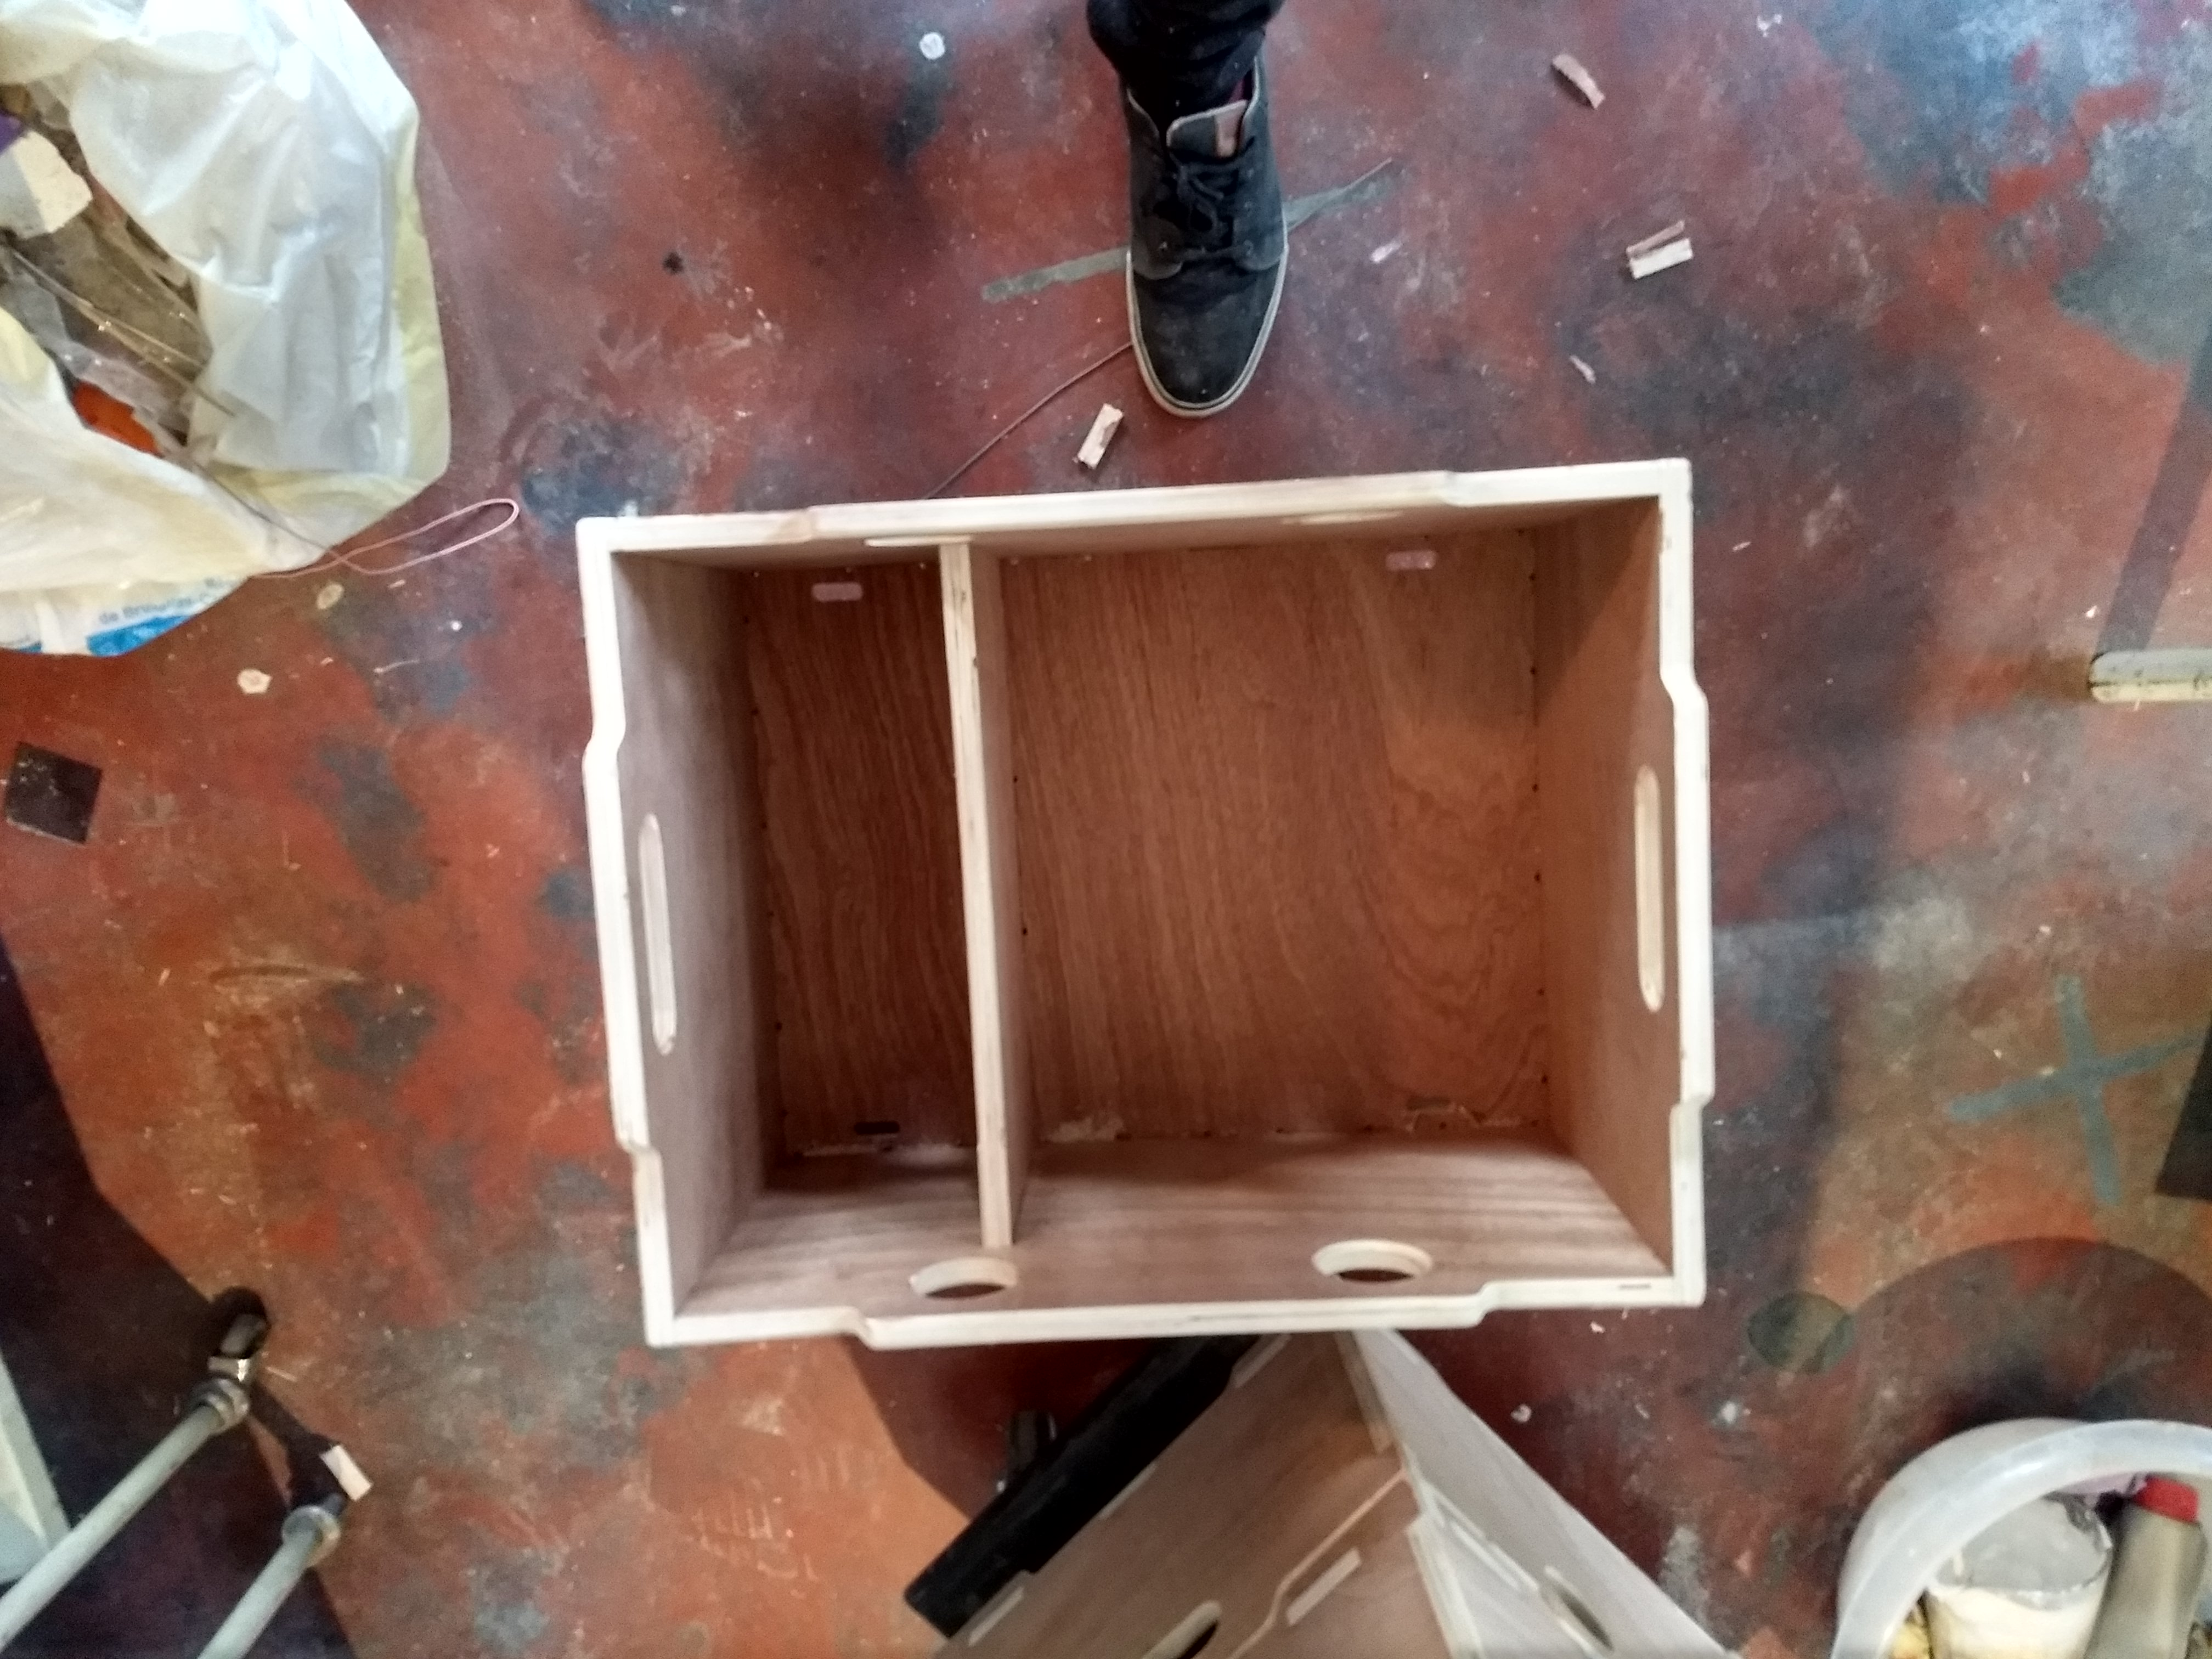
The boxes are purpose built to carry specific equipment. This box is meant to hold 6 laptops, and their chargers in the smaller compartment. We later laser cut thick packing foam to protect and space out the laptops safely.

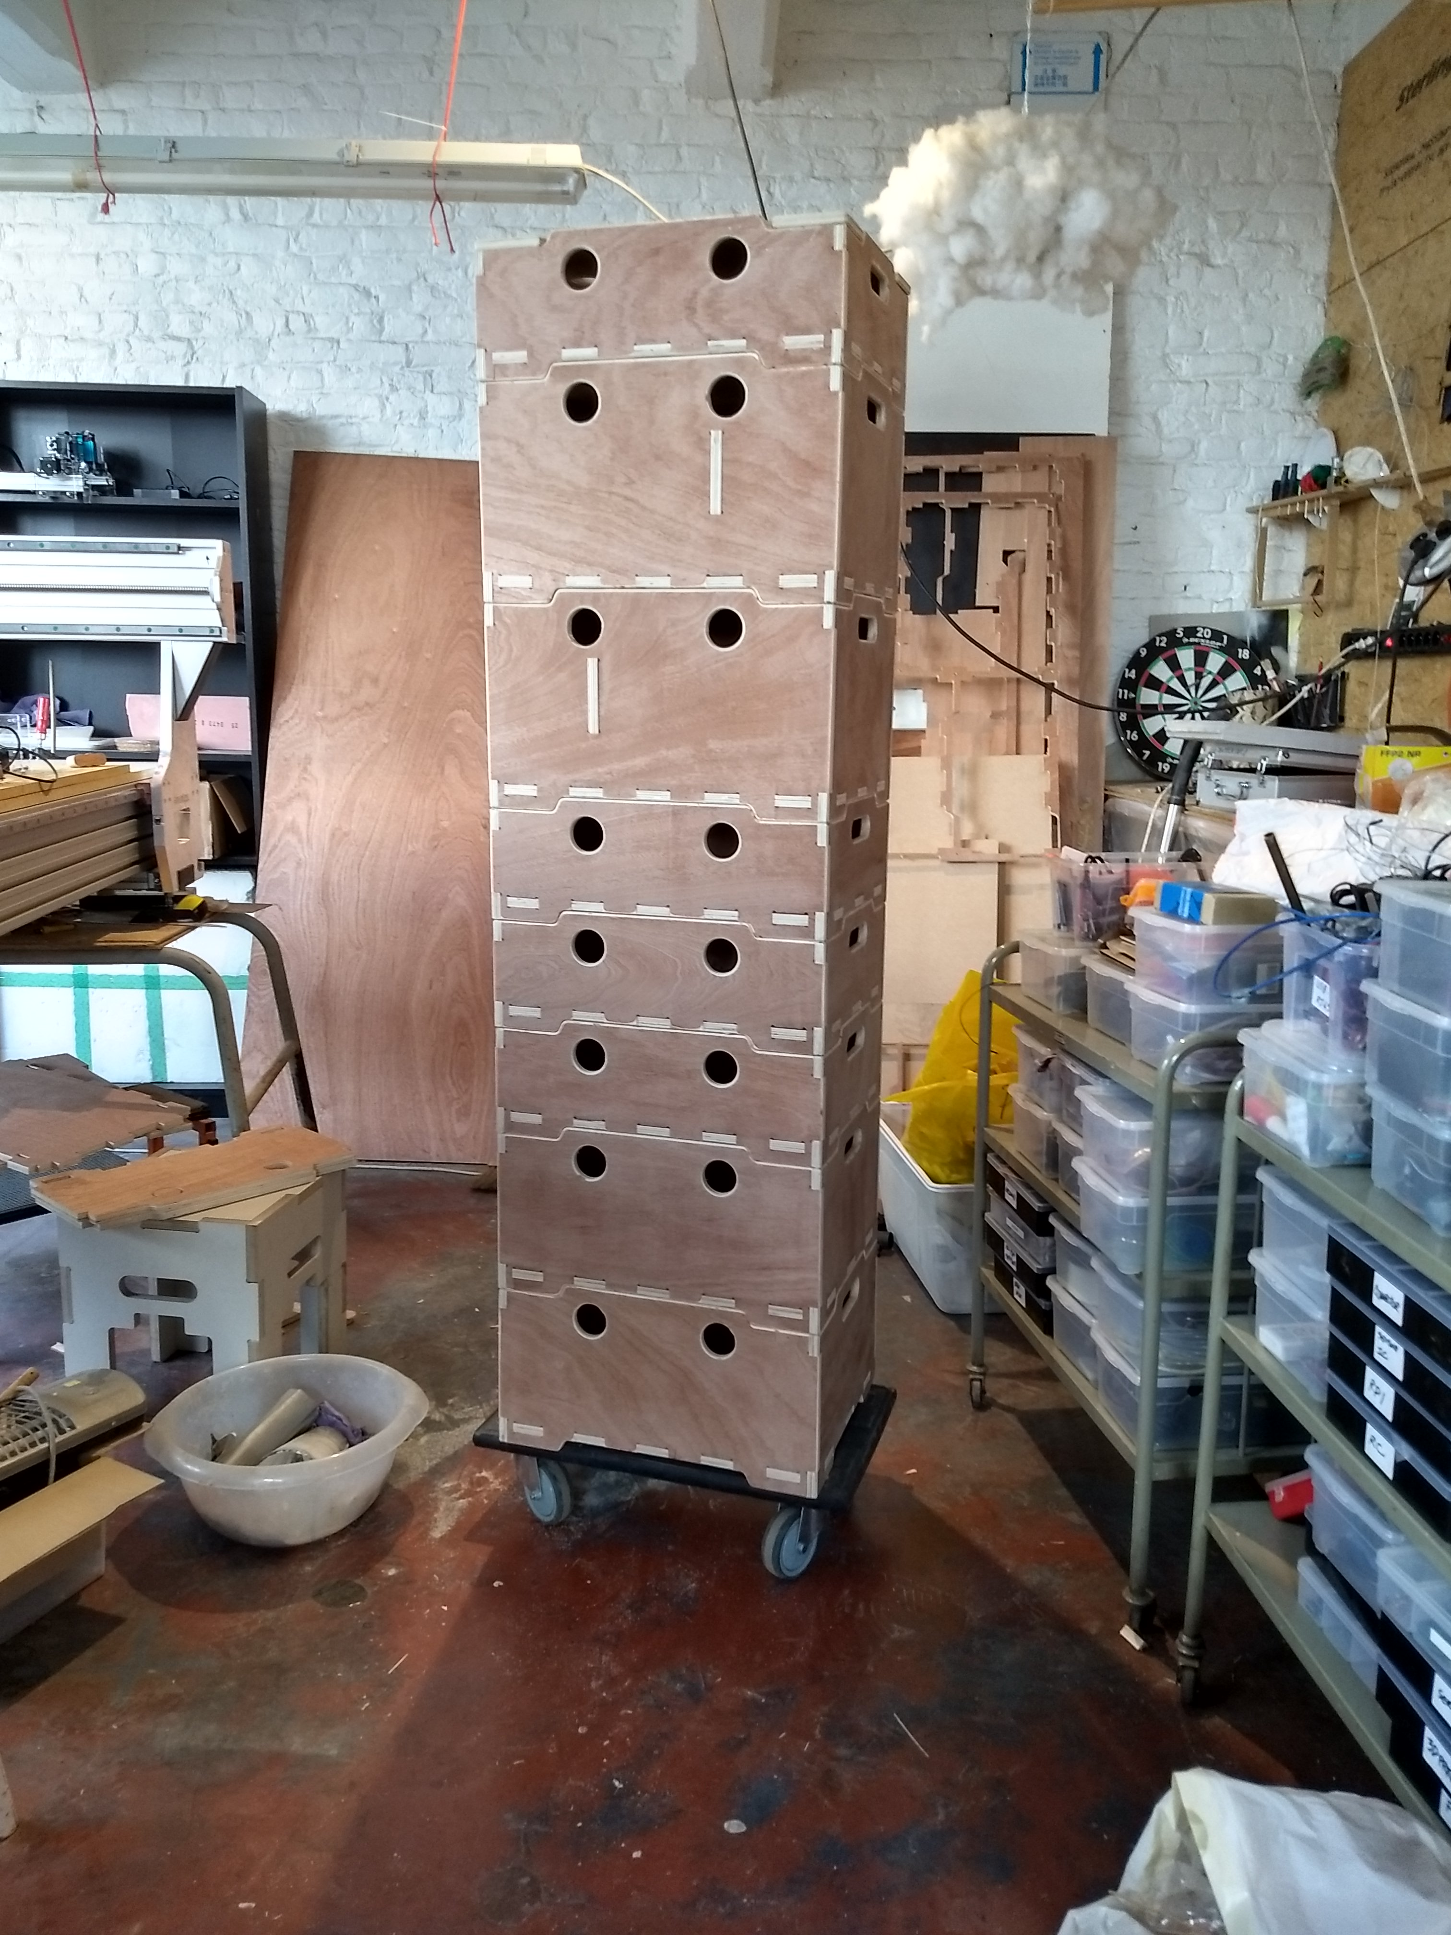
All the boxes are also designed to stack atop one another. This facilitates safe transport in and outside of the vans.

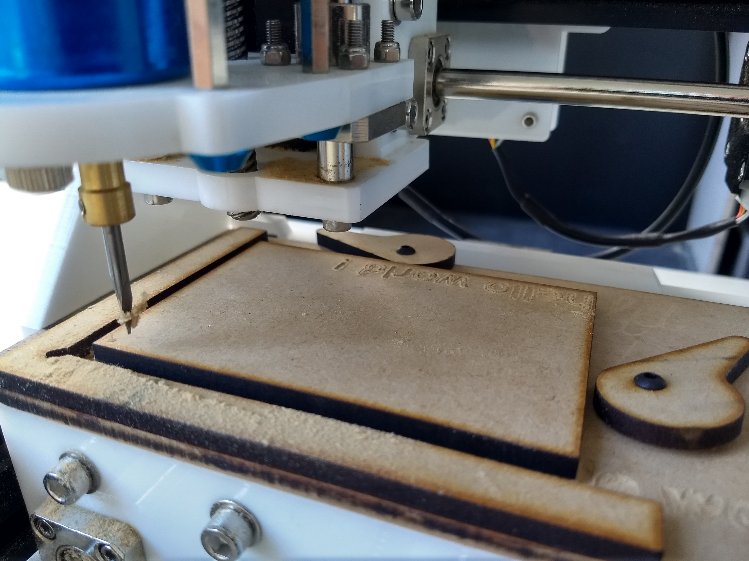
As this small CNC mill serves mostly for demonstrations, we added a speed clamping system, allowing the moblile fablab staff to quickly and easily change the demonstration cutting cards.

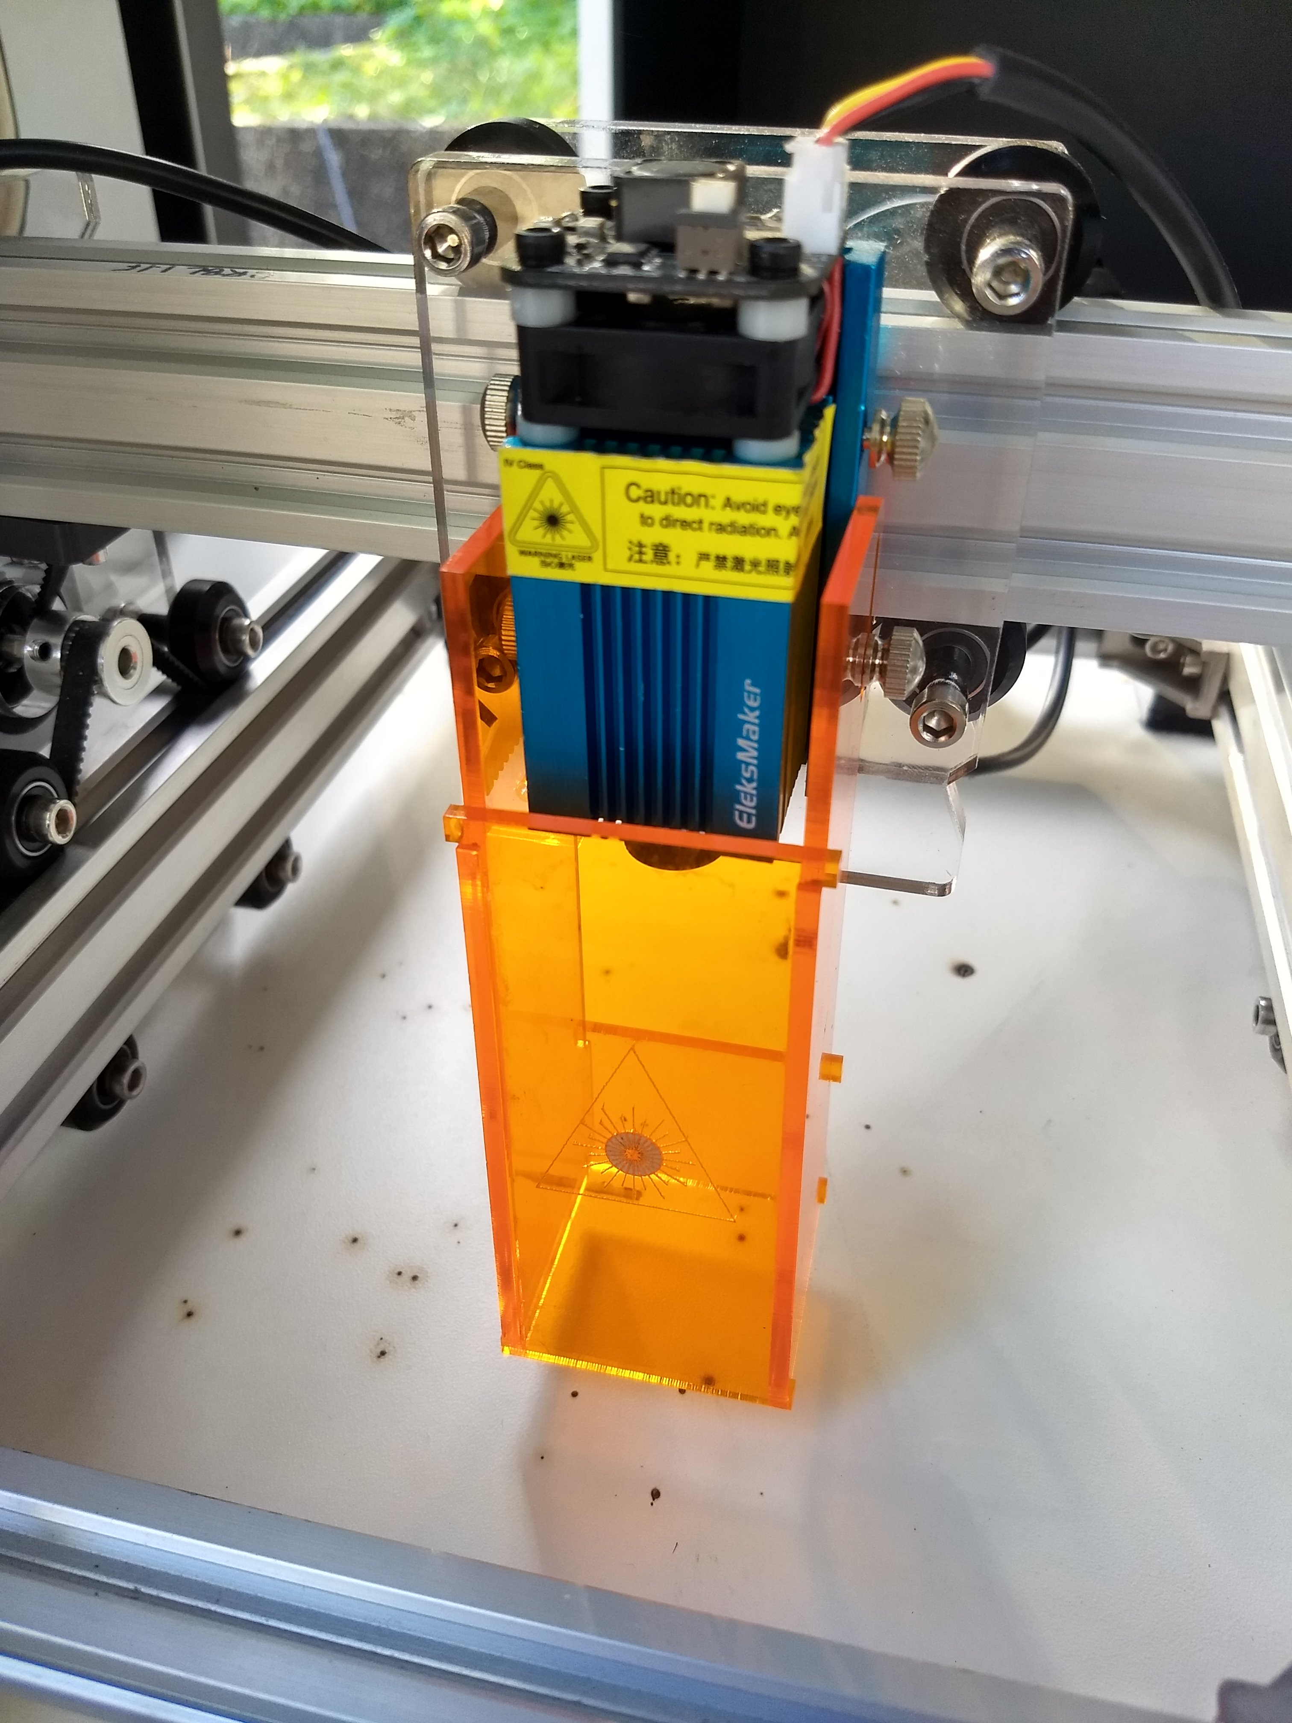
This laser cutter is small and ideal for demonstrating the tools ability to children. However, unlike larger laser cutters, it does not come with eye protection. We designed and built these UV filtering boxes to add around the lasers protecting all observers eyes. In addition to this, we hand out protective eyeware (also UV filtering) to guarantee no injuries can happen.

Pen plotters and Open Source Publishing
In my practice as a graphic designer I am a member of the design collective Open Source Publishing (http://osp.kitchen). As a collective we question copyrighting systems. OSP has an educational motivation, most of our members are active teachers. One of our ongoing interests is the use of penplotters a penplotter is a drafting machine that appeared about thirty years ago. It was mostly used by architects or professions needing to reproduce technical drawings. As part of OSP my interest in the plotter comes from it’s foregrounding of typographic gestures over contrasted shapes, drawing letters from within rather then drawing the outershape.
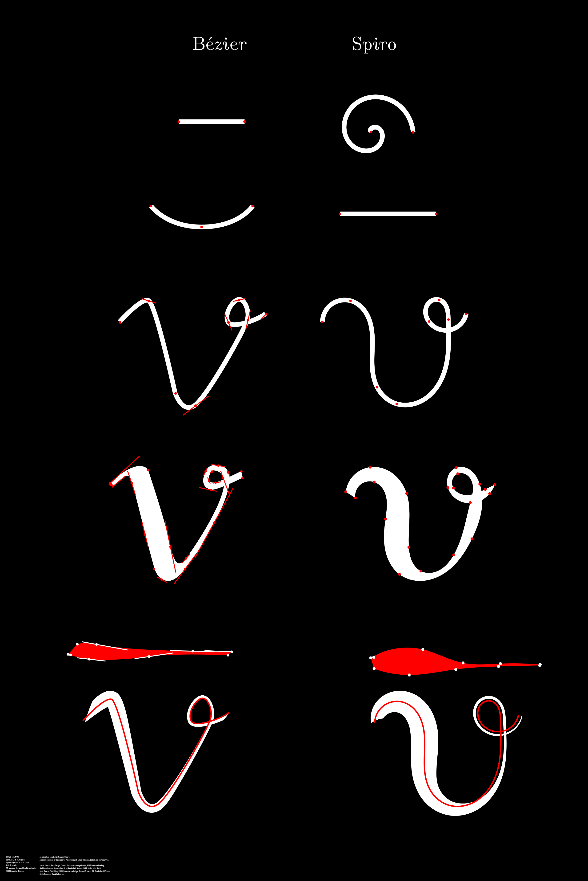
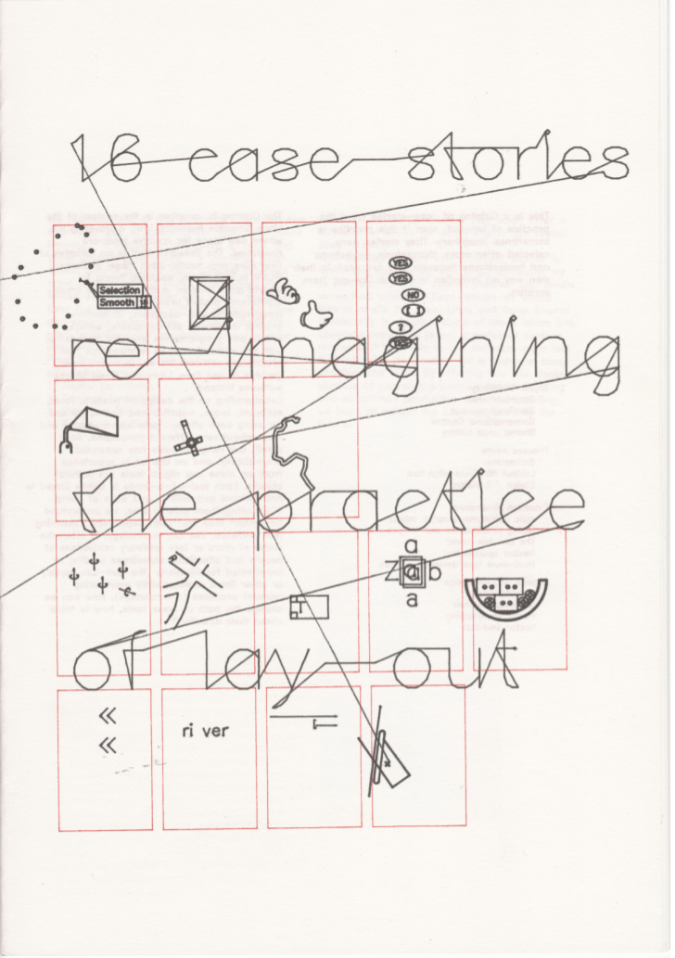
Bezier side by side with Spiro, one of the first posters I made with OSP.
16 case stories, co-position LGRU (Libre Graphics Research Unit) catalogue design. 2012, Print, 24 page booklet, Risograph print and flatbed pen plotter cover.Design with Pierre Huyghebaert.https://gitlab.constantvzw.org/lgru/co-position-catalog/blob/master/facsimile/digital-catalog.pdf

This booklet used the pen plotter in some of it’s basic function to print a research outcome booket questionning the practices of page layout.
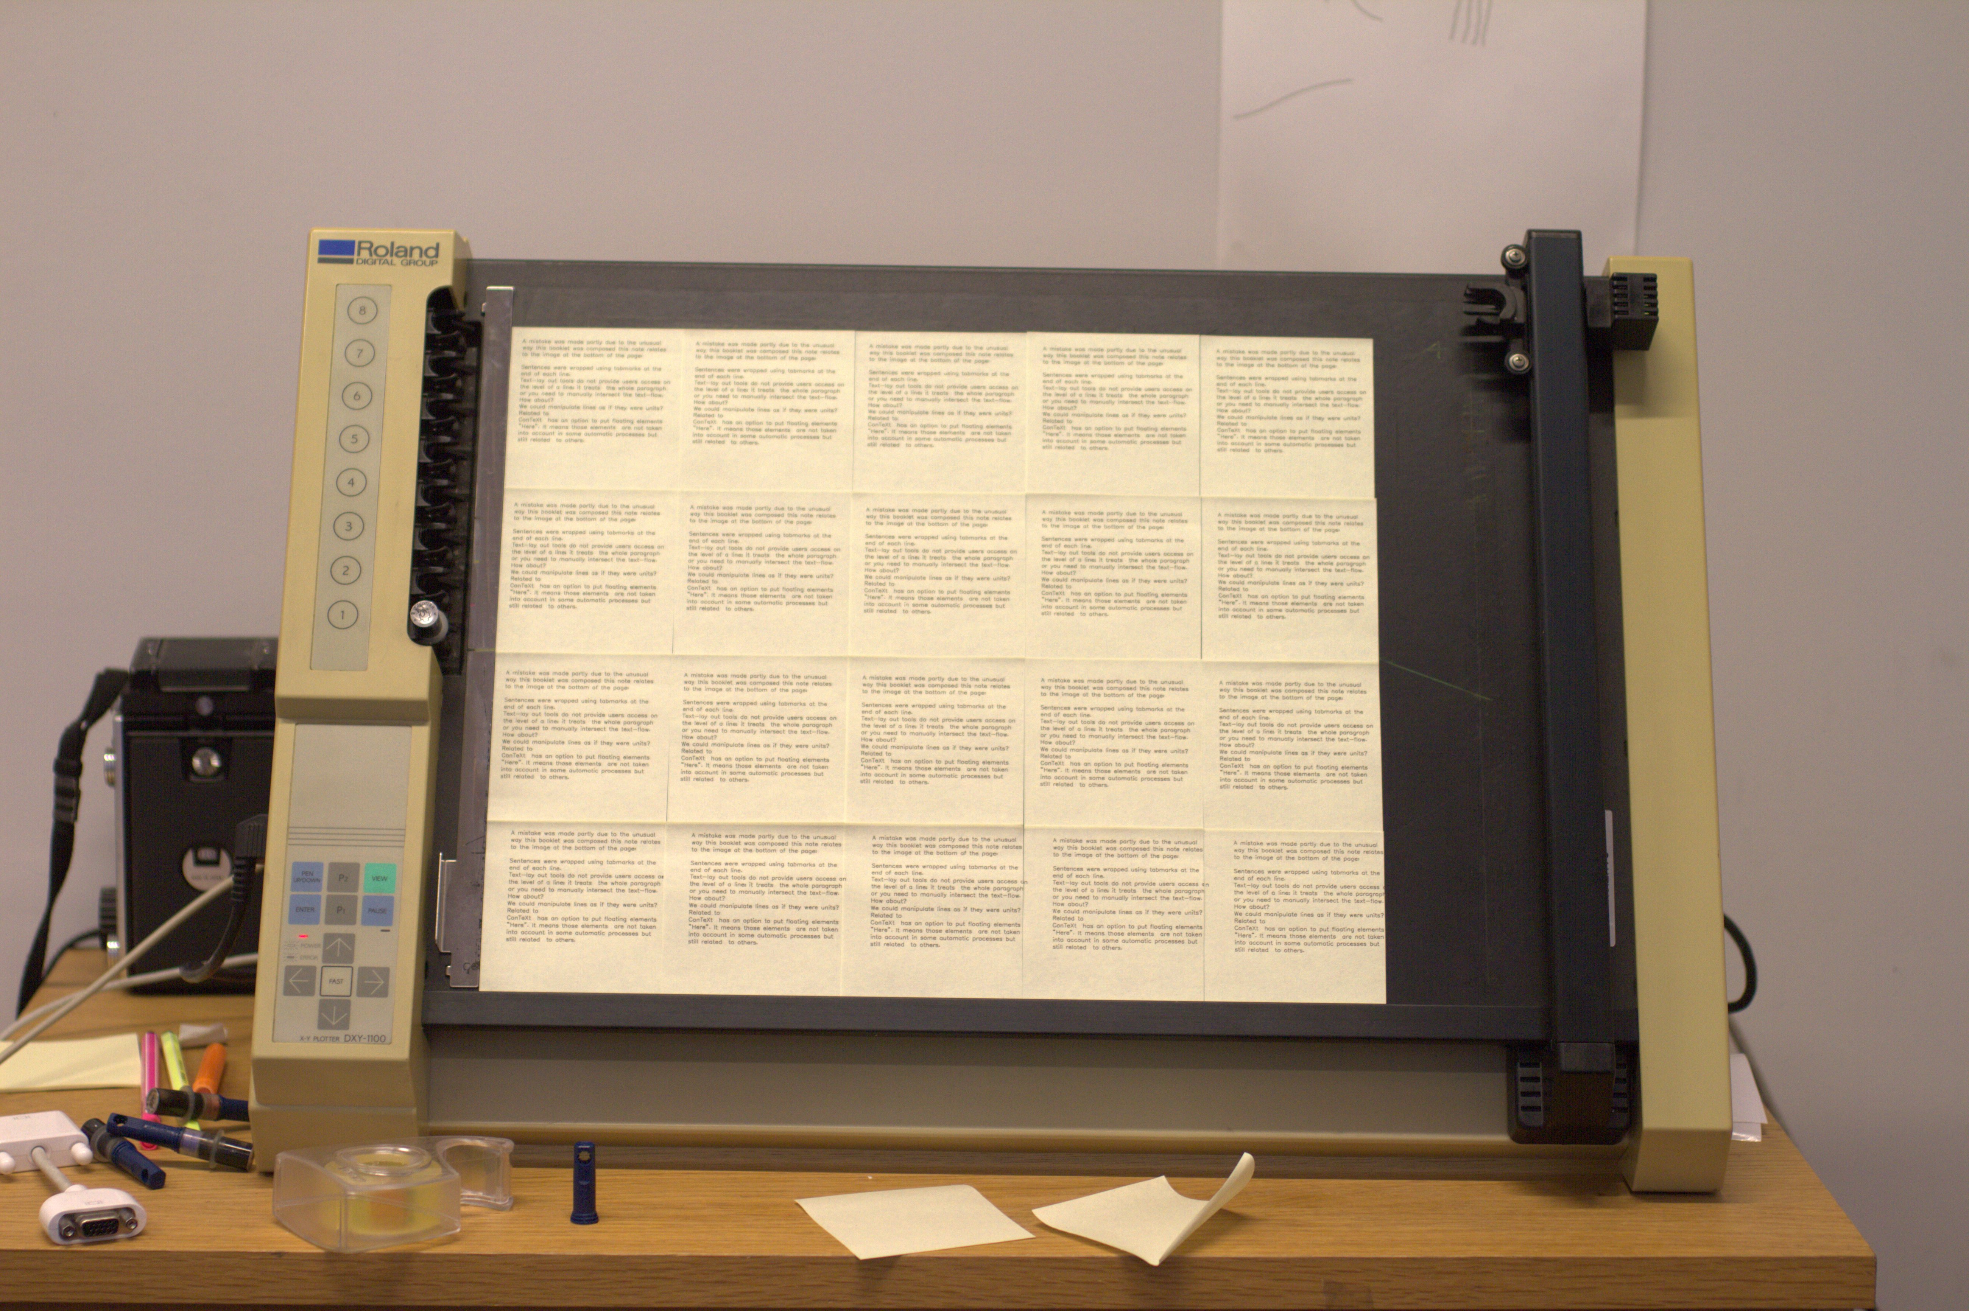
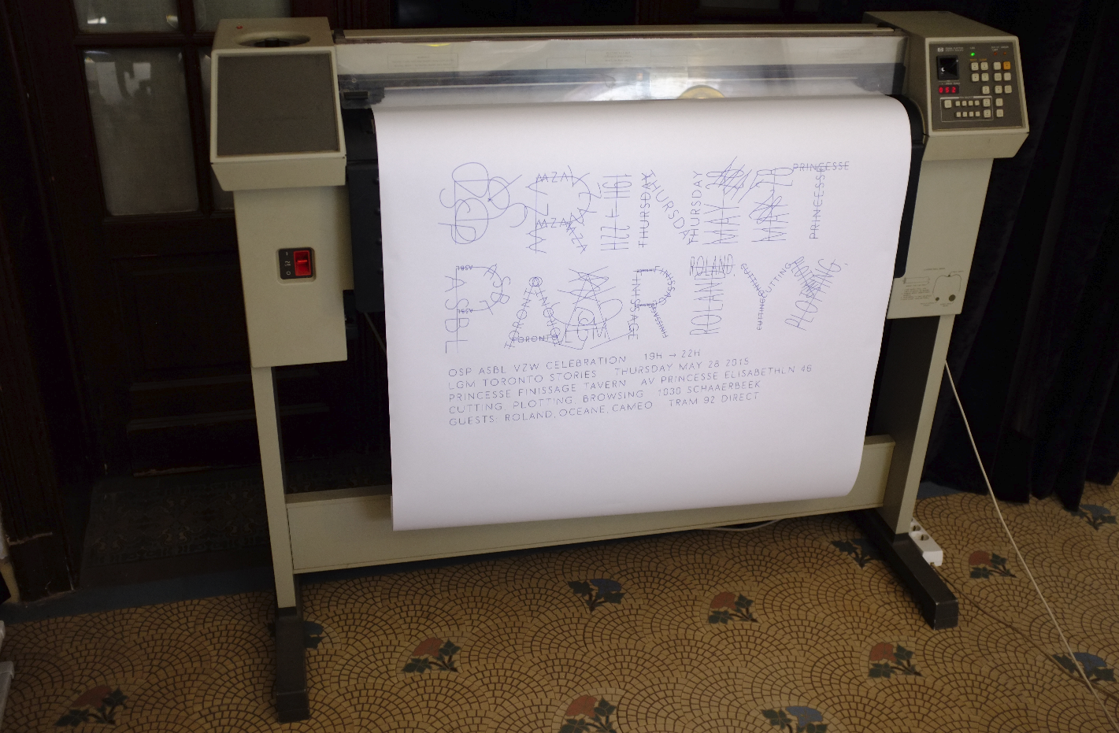

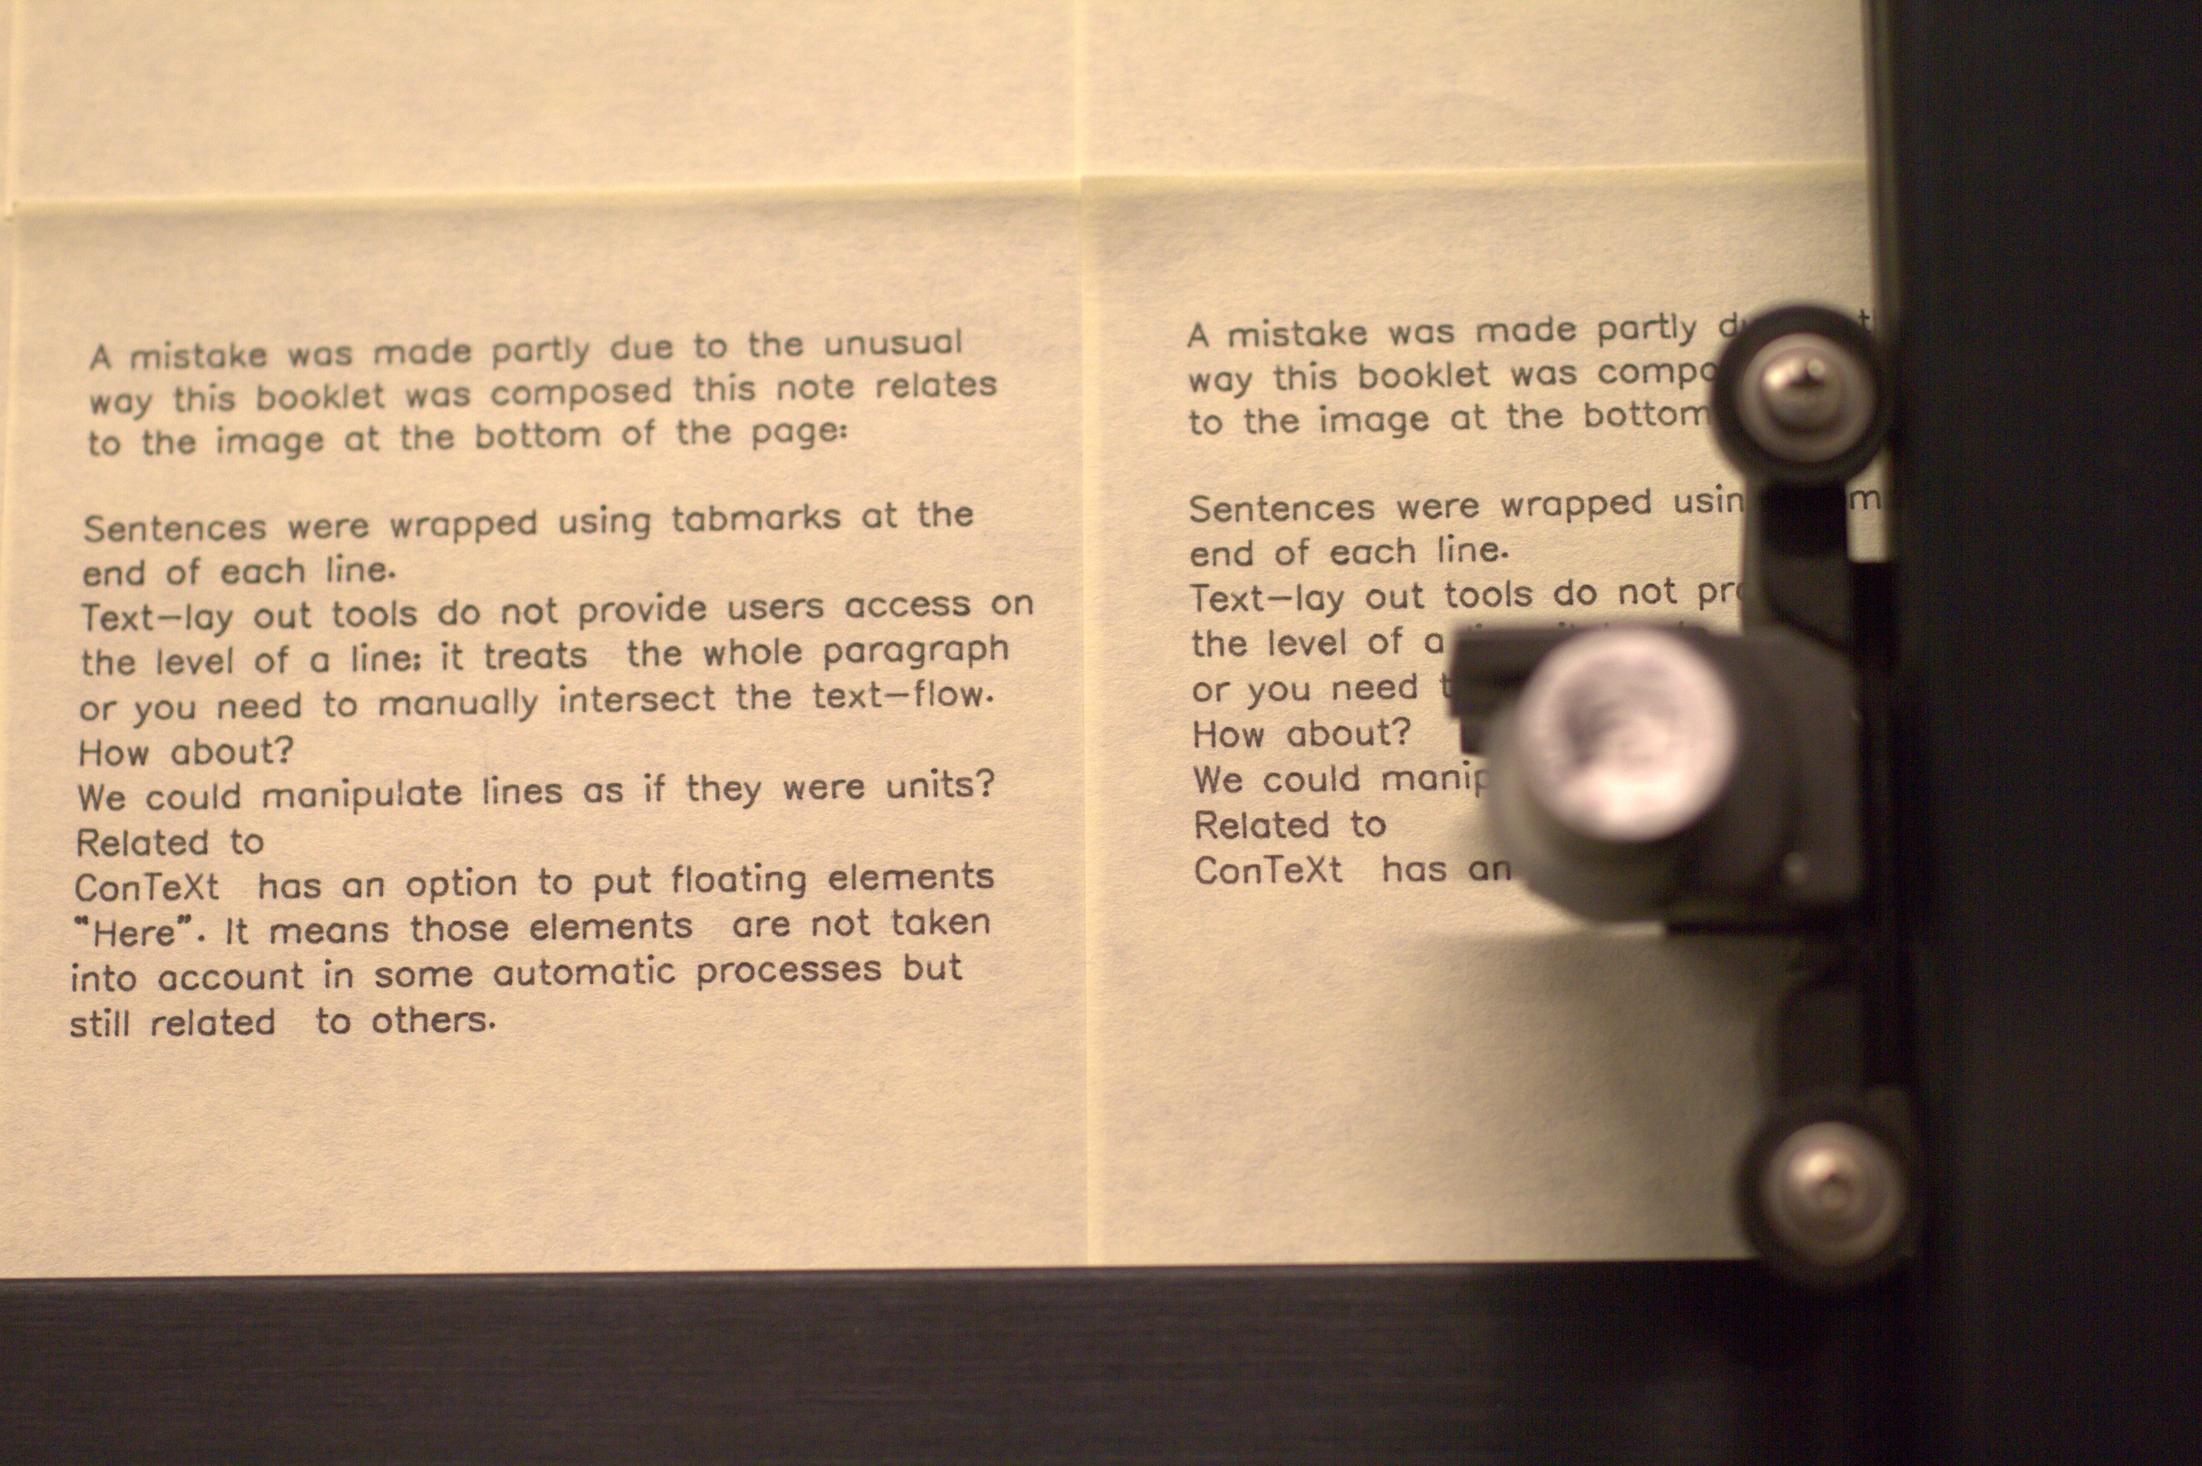

From the “16 case stories” research spawned a more speculative writing research project called Drawing Curved, concerned with the nature of curvature.

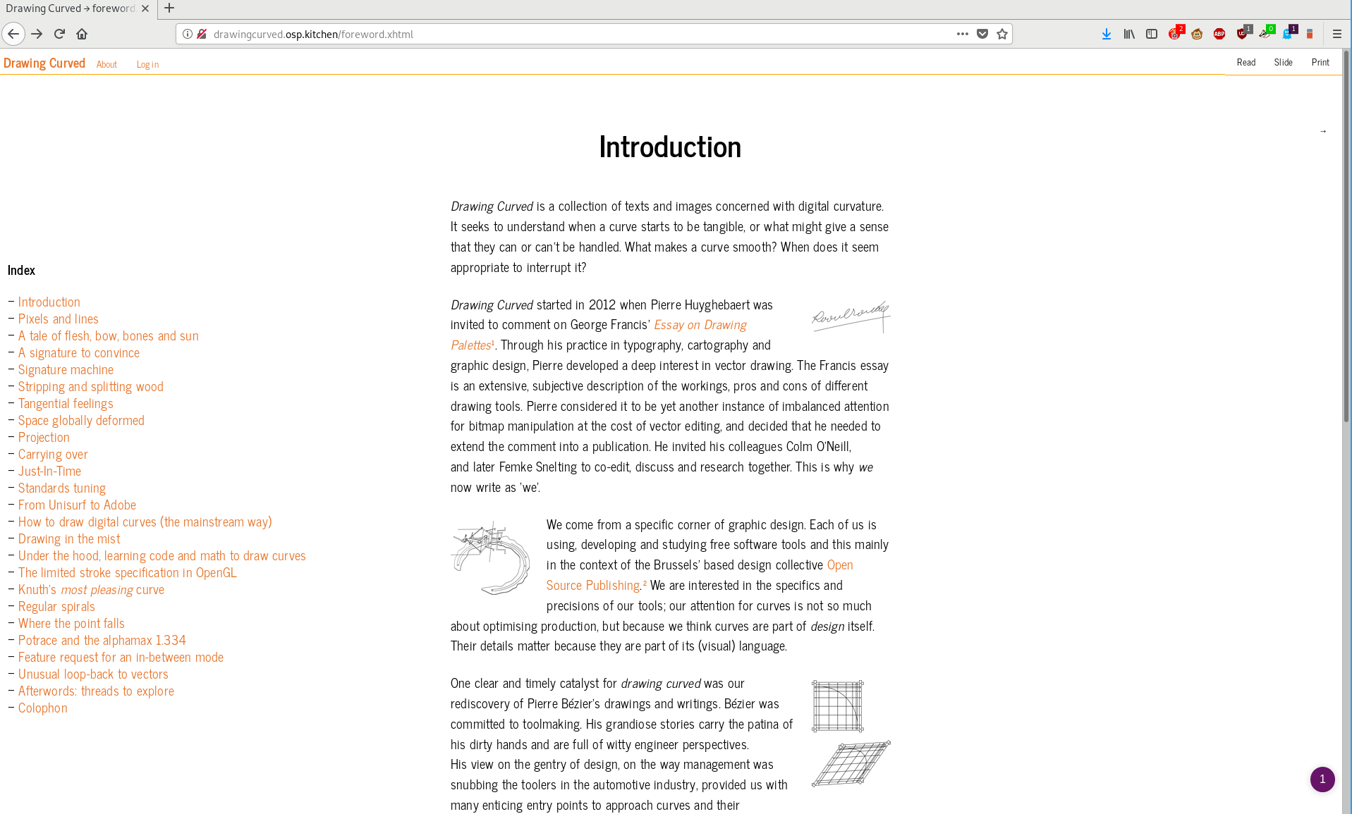
Drawing Curved is a research text on the topic of computed curves, co written with Pierre Huyghebaert, 2012 — 2017
“ Drawing Curved is a collection of texts and images concerned with digital curvature. It seeks to understand when a curve starts to be tangible, or what might give a sense that they can or can't be handled. What makes a curve smooth? When does it seem appropriate to interrupt it? ”
http://drawingcurved.osp.kitchen

Relearn – an experimental Open Source Software Summer school
I have been a participant and organiser of Relearn Summer School in Brussels and Rotterdam in 3 iterations of the project, years 1, 2 and 5. “Relearn is a collective learning experiment with as many teachers as it has participants. It is motivated by the possibility to displace parameters of/for research, studying and learning. During the week of Relearn, we work with a set of case-studies, observations, questions or stacks of study material that we call”tracks“. Relearn outlines the idea of resetting thinking modes, for a diverse set of approaches that we can reconsider, that come out of the development of our cultures towards and through digital entities. While Relearn is an experiment in collective learning, it grows from an interest in Free / Libre Open Source Software culture and practices as a way to address and acknowledge the production processes and frameworks involving technology and culture.”
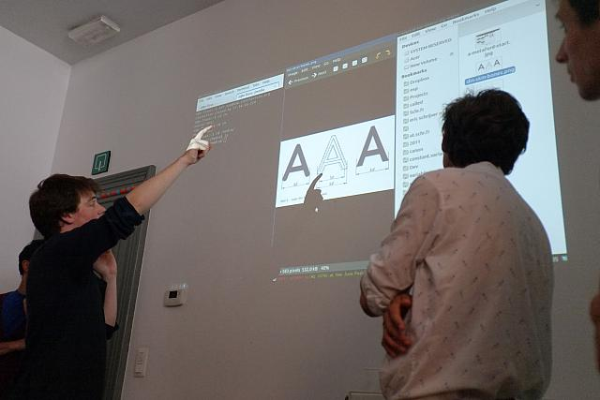
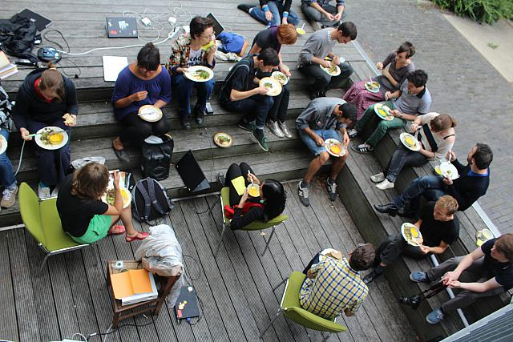
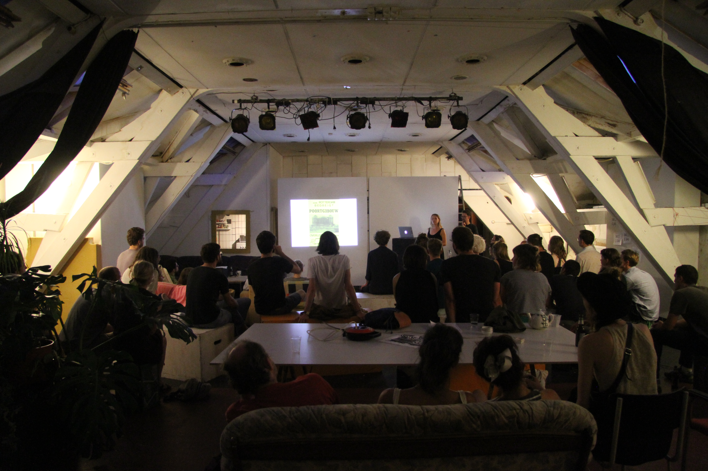

http://relearn.be project archives and
repository: https://gitlab.com/relearn

breadfellows.school
A website, online publication space, pedagogical tool and archive made in collaboration with Clare Breen, September 2017 – present.
“ The design of this online space has been developed with the ethos of the Breadfellows' Chats methodology in mind. As a web designer […] I focused on making the inner-workings of the sites I design freely accessible, sharing all source code; the entire framework of the website is free for any person to access, study and duplicate.
Educational methods are (thankfully) rarely considered to be intellectual property however, documentation material, publications, artworks or media too easily gets bound, closed and made essentially unusable through copyright. This means that (outside of the academic frame) it is hard to use and publish research and methodological source materials in support of new educational research. As the focus of Breadfellows.school is to share and disseminate neoteric educational practices, we publish the written content, the visual material, the supporting audio, video media and the code developed specifically for this site under a copyleft license. This is a statement of where the research positions itself socially. Copyright and licensing issues were not initial interest in the Breadfellows Chats project, but through our collaboration on this platform we put forward the potential space for education and free information to exist.
[...]
The breadfellows.school repository is available for you to consult, study, modify and reuse at gitlab.com/breadfellows/breadfellows.school. ”

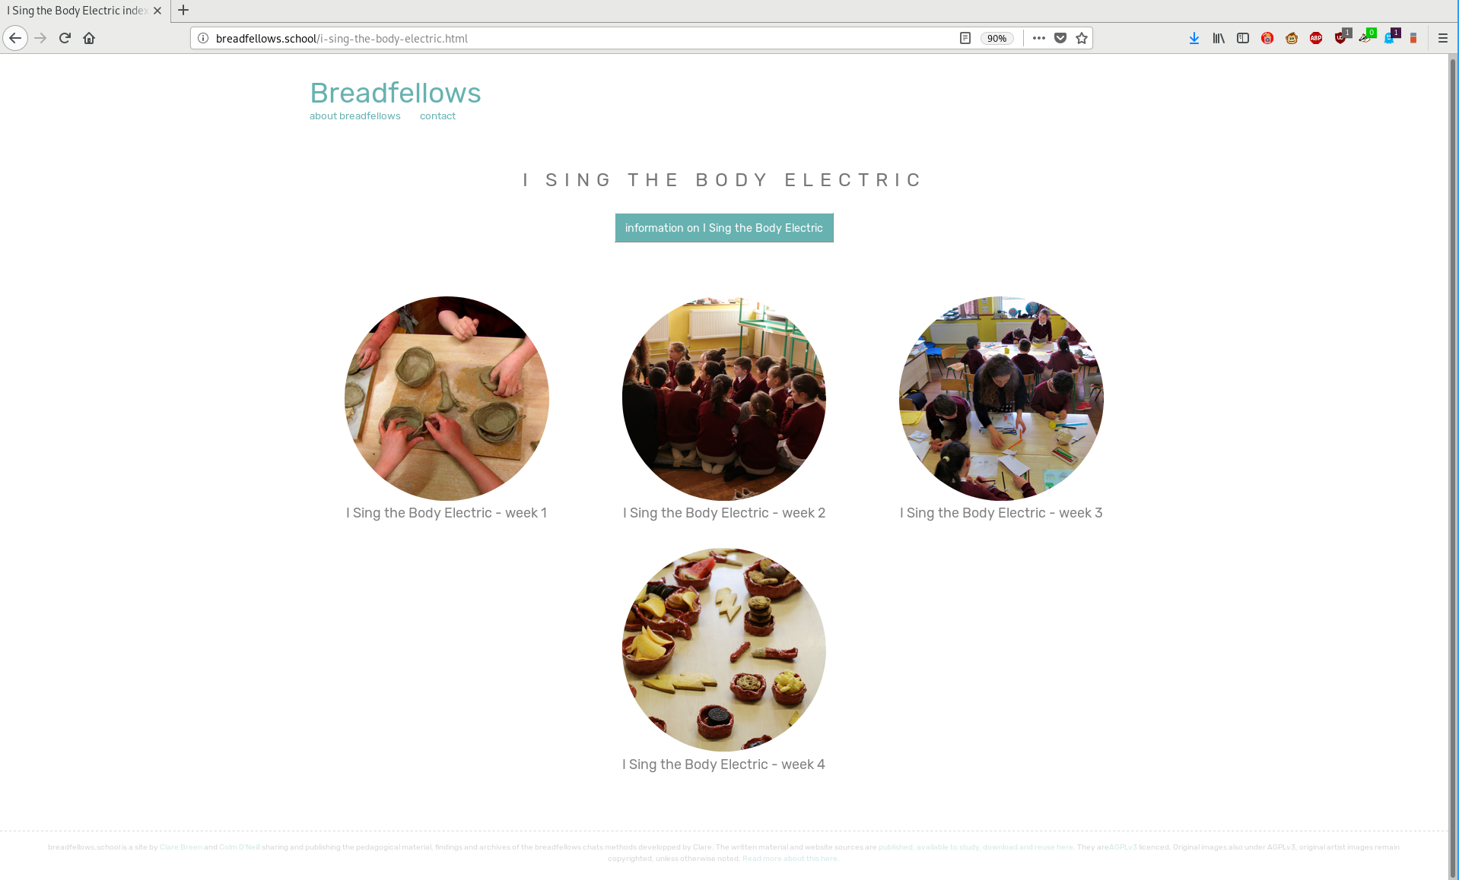
http://breadfellows.school

