supporting documents

Colm O’Neill
This material detail some of my recent practice in the sphere of fabrication laboratories, maker spaces, fablabs all revolving around educational practices and projects.

Research statement
My name is Colm O’Neill, I am a freelance researcher, graphic designer, web developer and teacher. My study and research path has brought me from photography to web design through the intermediate of graphic design, which is the profession I identify with most. As my practice of design and website making grows from frontal aesthetics to background systems, I continuously come across rifts in vocabulary between my practices and the audiences they aim to involve. I take concern with how graphic design and interfacing languages can enable a particular and potentially detrimental mode of address. I believe that the visual language in which powerful computing functions are given access through do not appropriately reflect the background processes in action. With enough occurrences I feel this can mislead users / people to an individual disconnect between their digital doings and the secondary or hidden effects these click input actions may have. My research is still focused on the question of the effects and affects of the interfaces. Meanwhile, my attempts to tackle the issues I am speaking of are greatly helped by physical expressions (electronics, printing, computer aided design, fabrication laboratories practices) of what we might mean by the word technology. Learning, teaching and education methods come as great tools to untangle the rifts created by the fast paced graphical interfaces I am critical of. I aim to create learning and teaching situations rooted in experiences. I seek this in the hope that the questions these moments may raise enable individuals to develop critical vocabulary to navigate the almost unavoidable digital functions of our environments.

Working with BeMaker
My current professional function is education lead for an organisation called beMaker. The group (http://bemaker.eu) is a non profit organisation from Brussels that is focused on introducing fablab-like practices to students between the ages of 10 and 16. It’s main vocation is to demystify what are understood as new technologies. Specifically, beMaker has built two food truck-like vans to fully function as mobile fablabs. This allows us to work on school sites directly with children, taking time to, firstly introduce them to what a fablab may be, secondly to give varied length workshops introducing the children to programming, basic electronics and design methods.

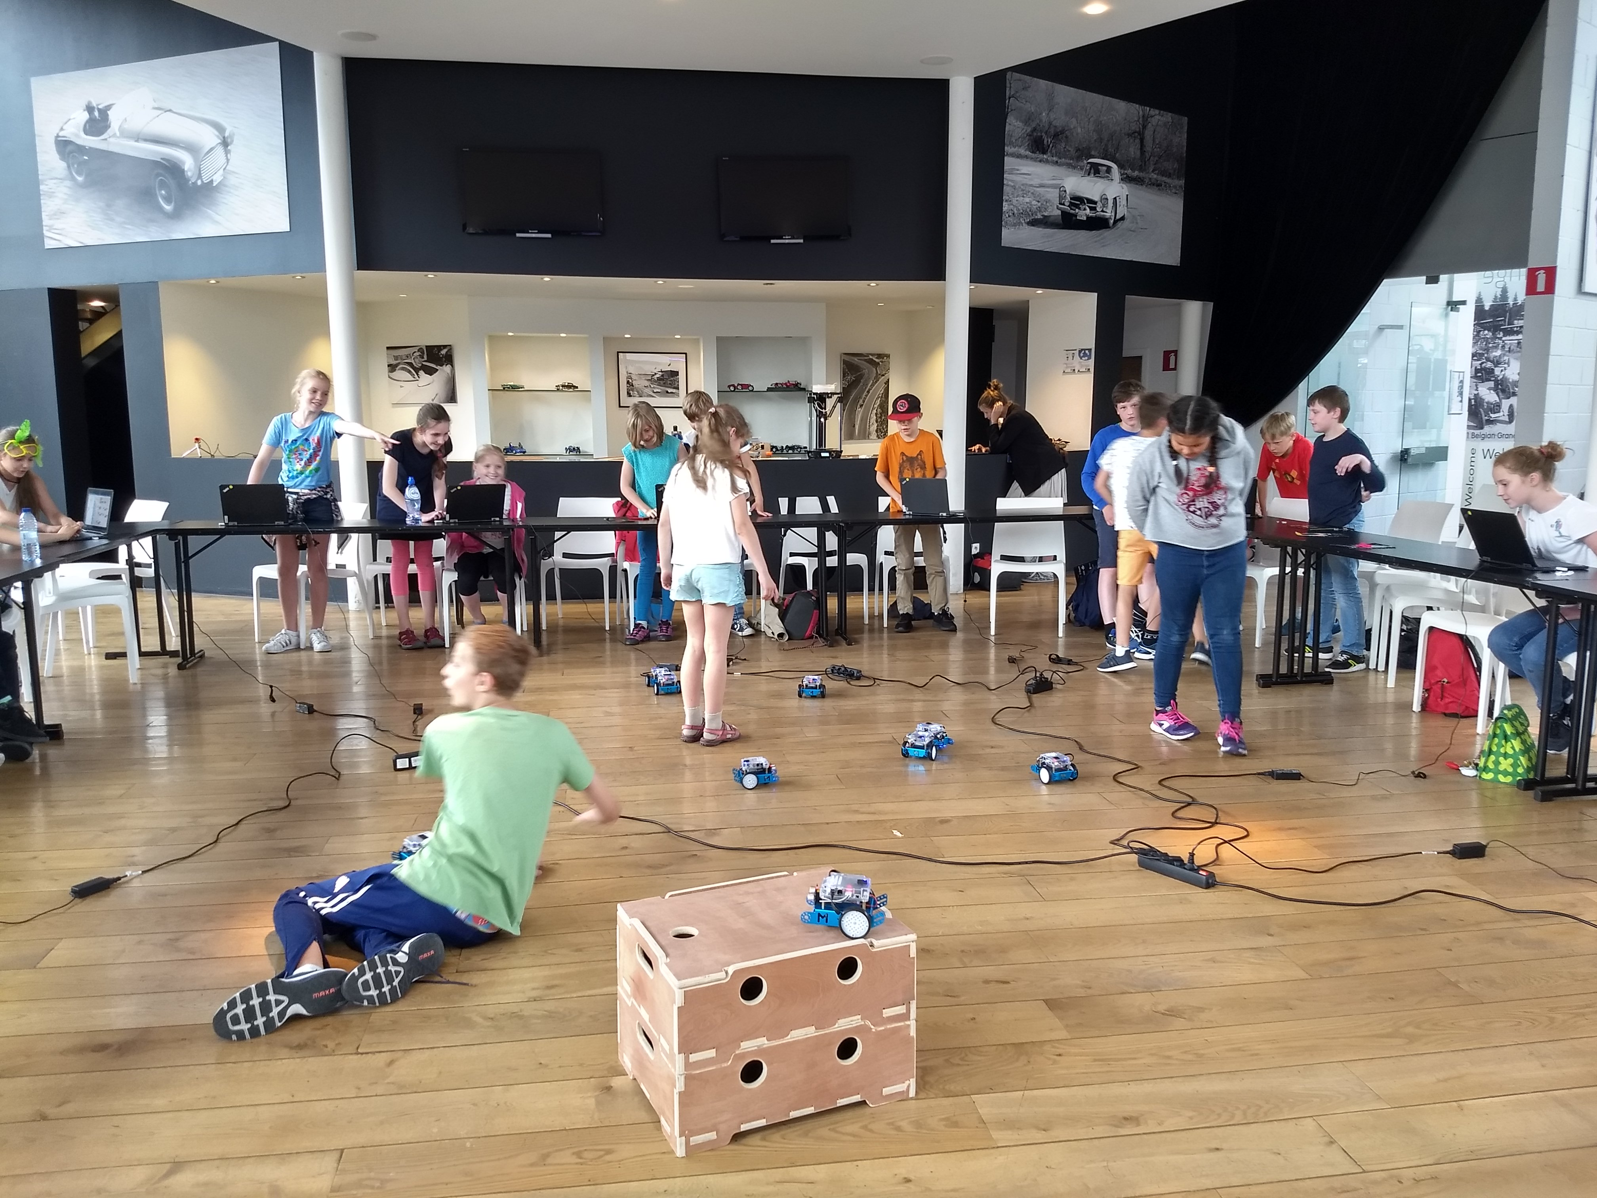
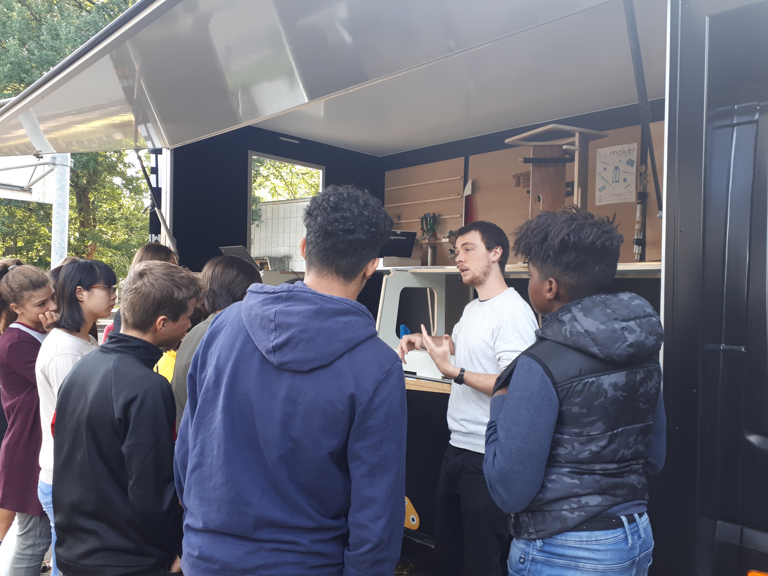
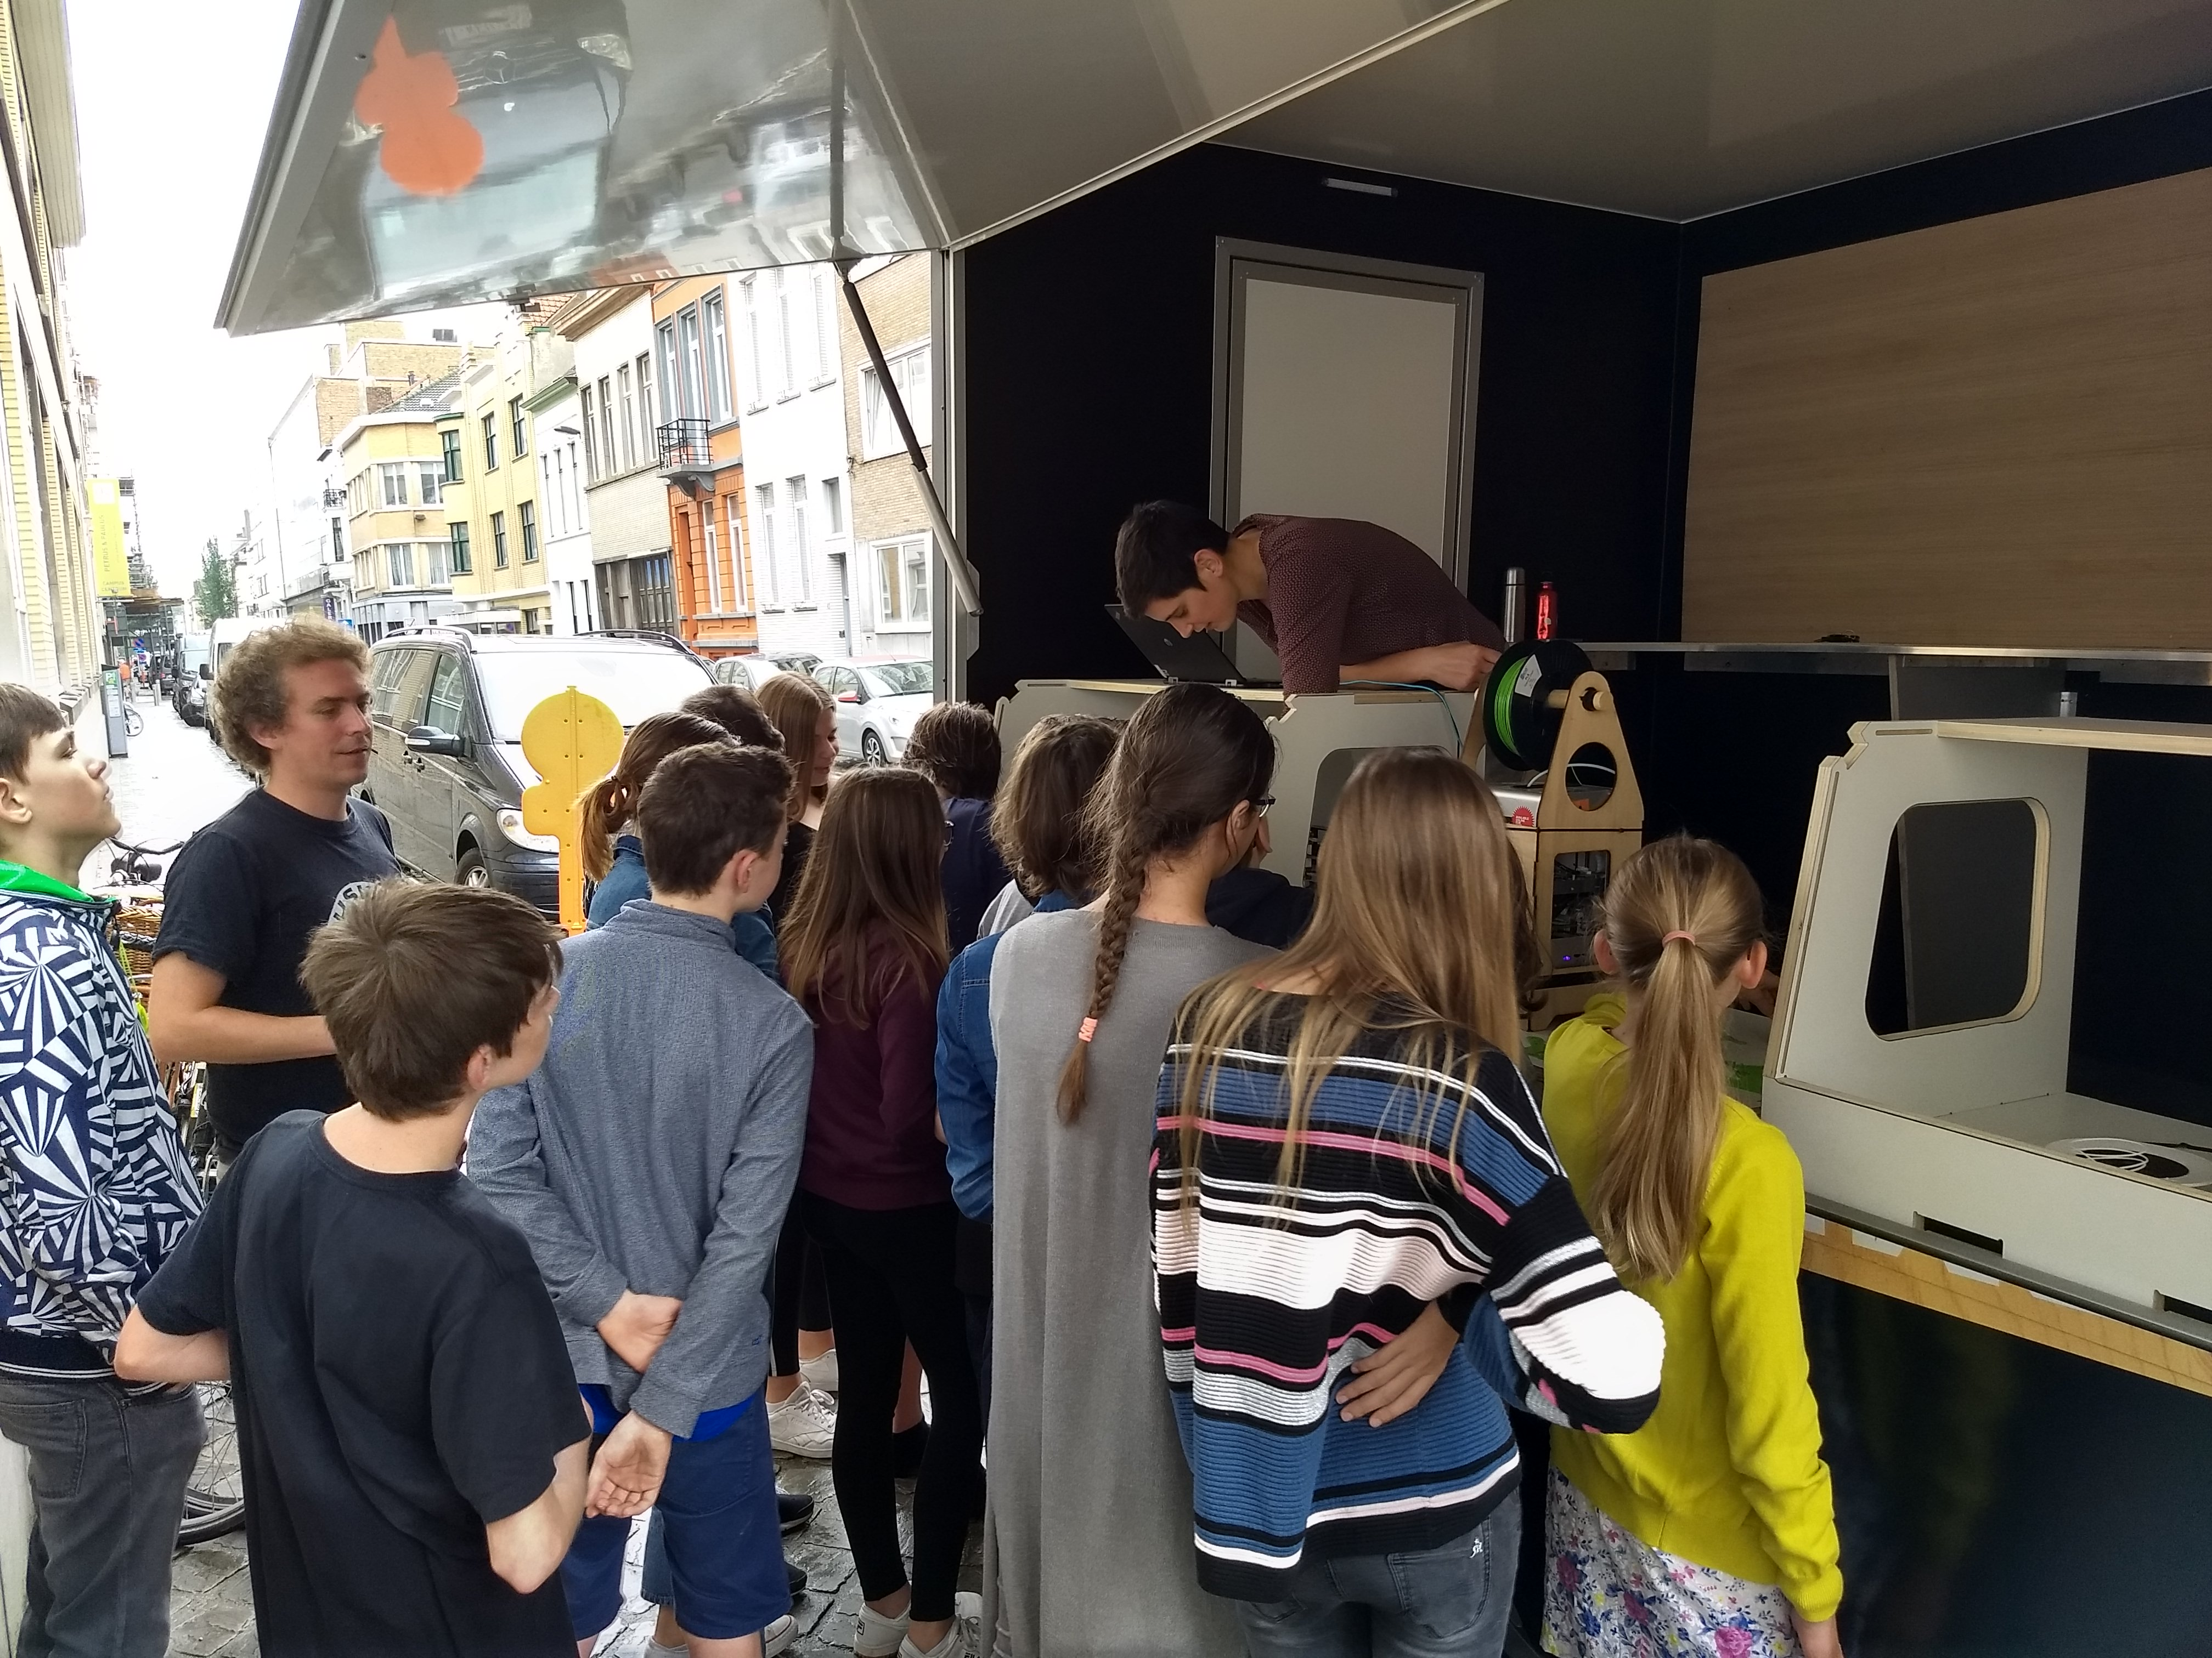
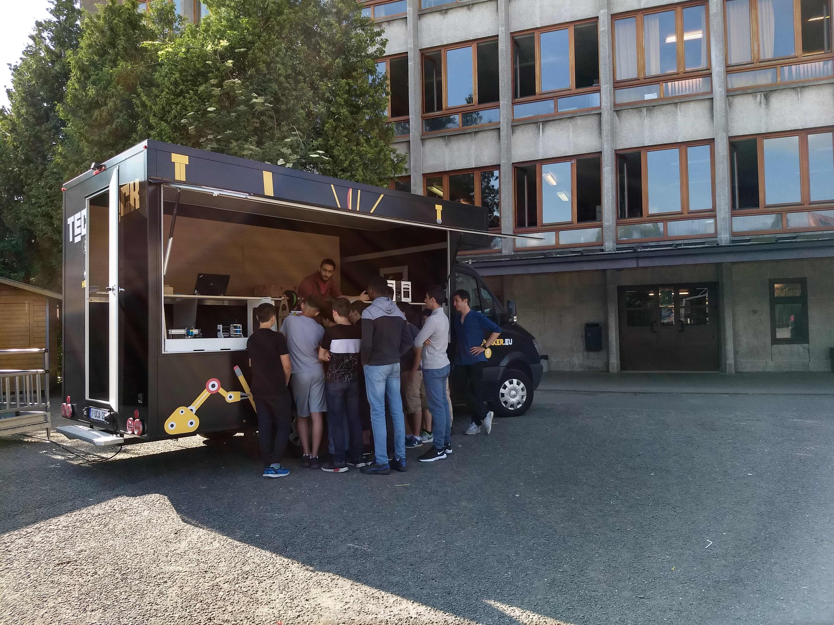
These pictures show the mobile fablabs in use in various school contexts. The general introduction we give takes between 30 and 50 minutes, depending on the specific interests of each group.

Lengthened workshops

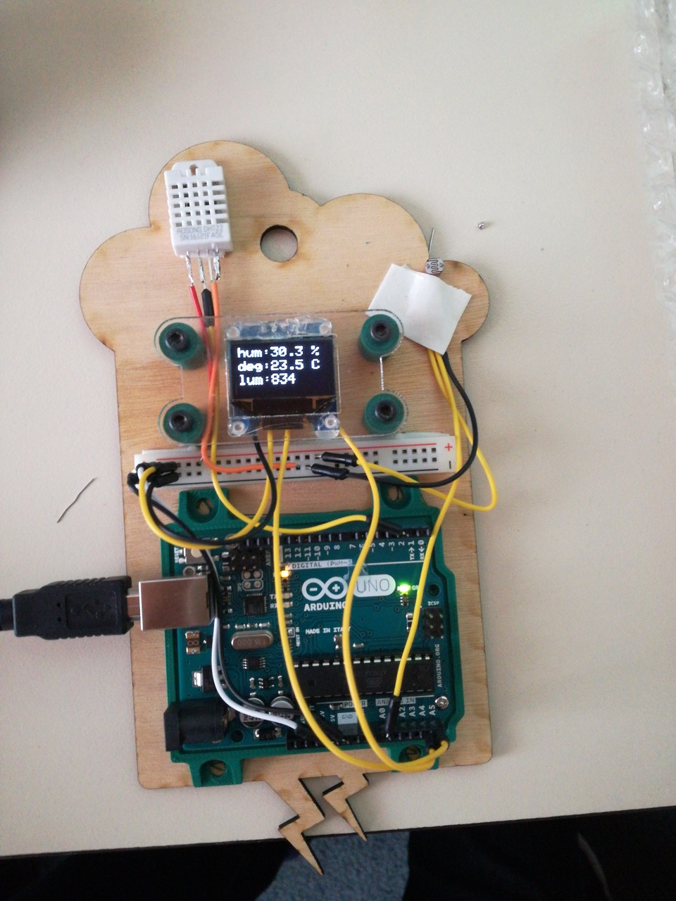
One of the small weather station built as part of a more extensive set of workshops. The station aims to teach the students to measure and display humidity levels, current temperature and amount of brightness, but also use other sensors. Later, this micro weather station can be updated to receive a digital communication module to log the readings from each sensor for better studying.

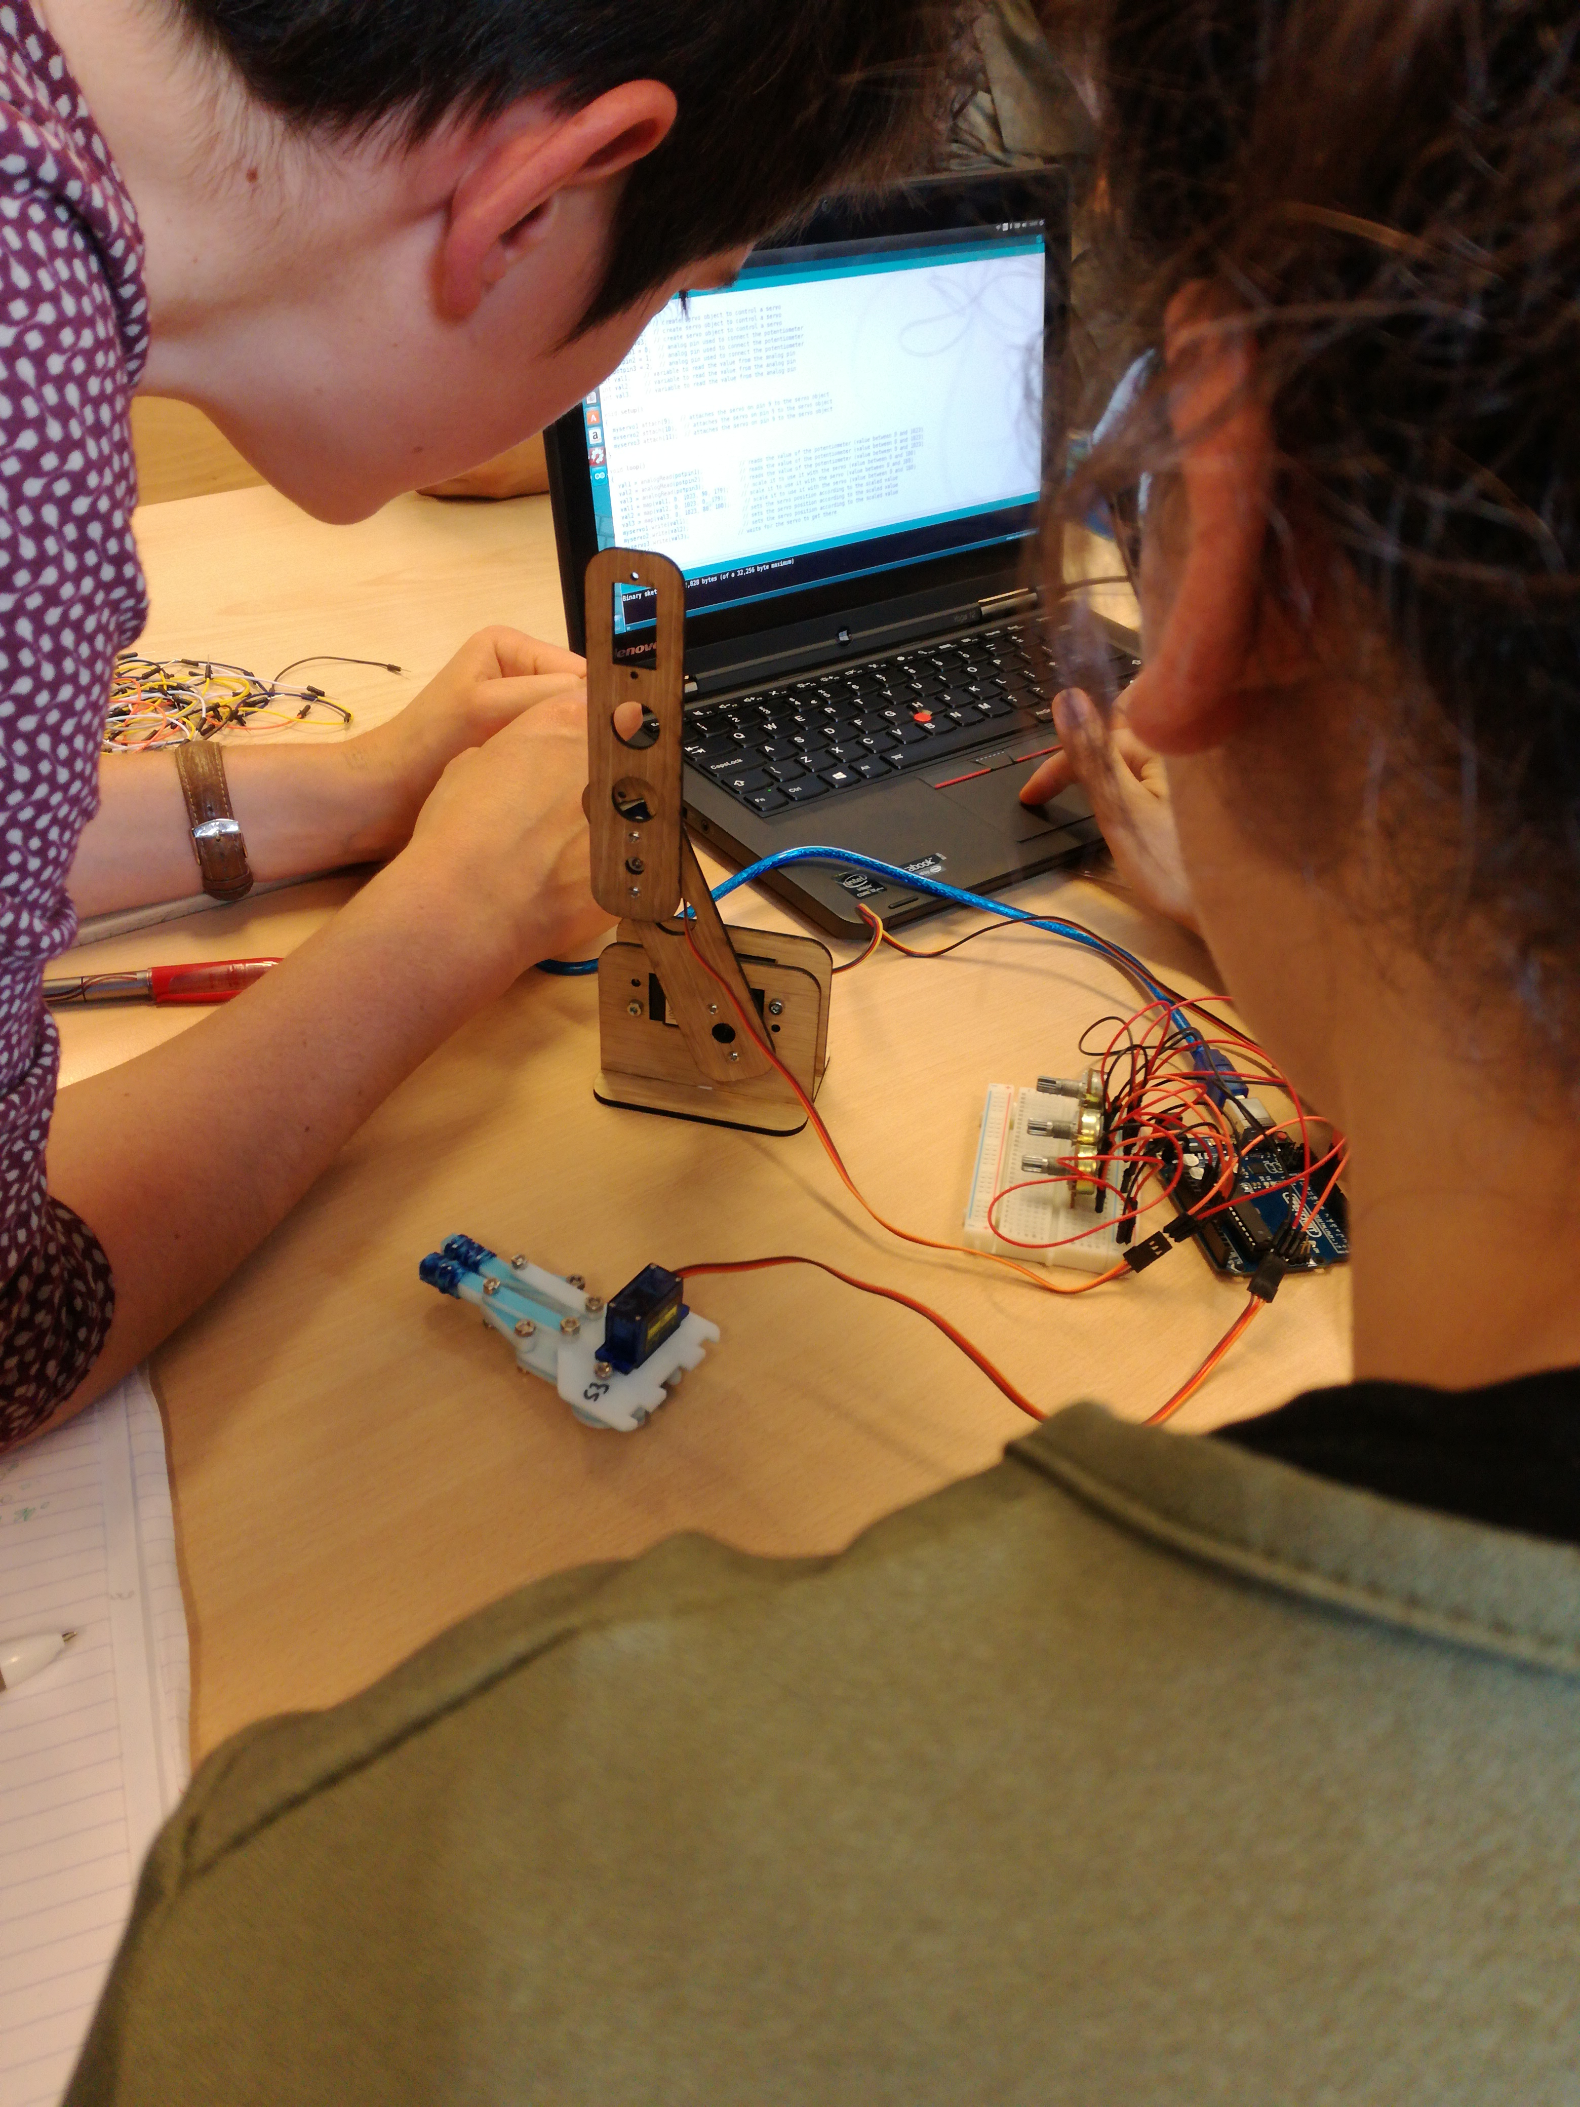
A second extensive workshop uses the idea of articulated arms, displaying to the students how a tri- or quad-angled robot arm works theoretically. When deployed, this project requires less programming involvement, but needs more parts designing in order to make the robotic arm usable.

Production add-on
Below are images of some of beMakers internal projets / productions, these are a collection of little add-ons or creations we had to build to facilitate the workings of the mobile fablab.

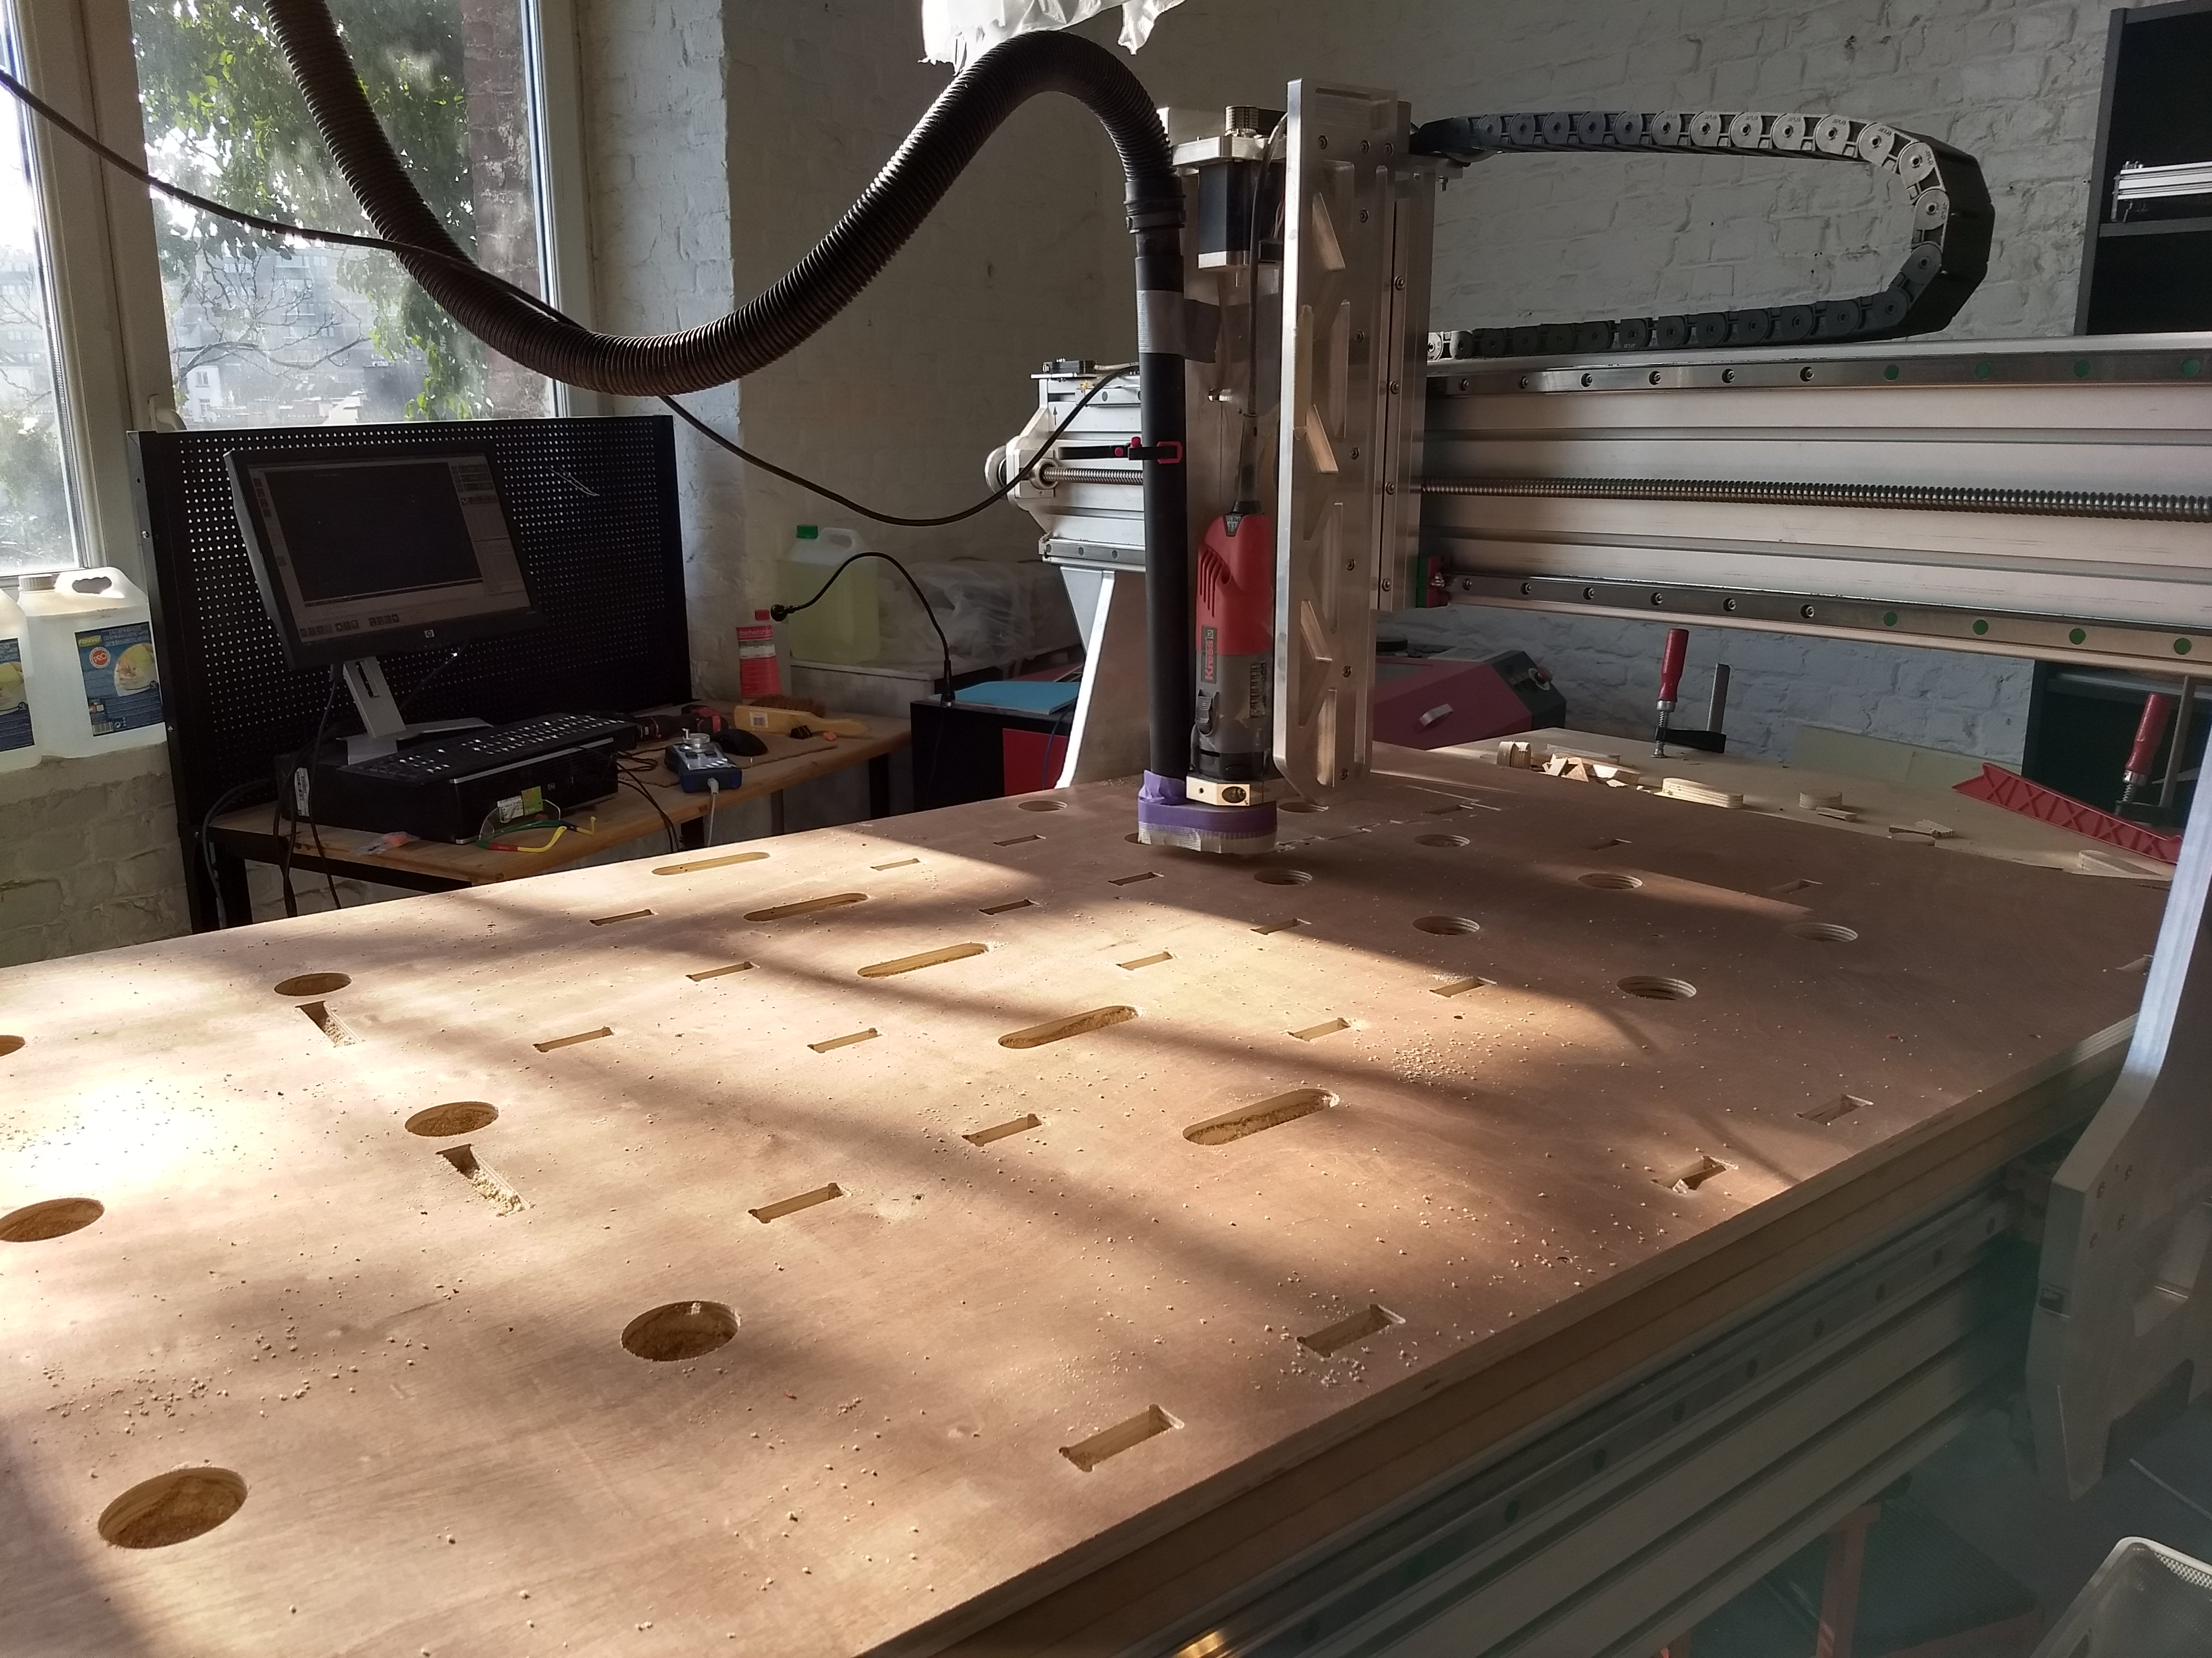
One of the main issues with making a fablab mobile is storage and security while driving the van between school locations. All of the workbenches and furniture has been custom built for the project. This image shows our storage and transport box before assembly.

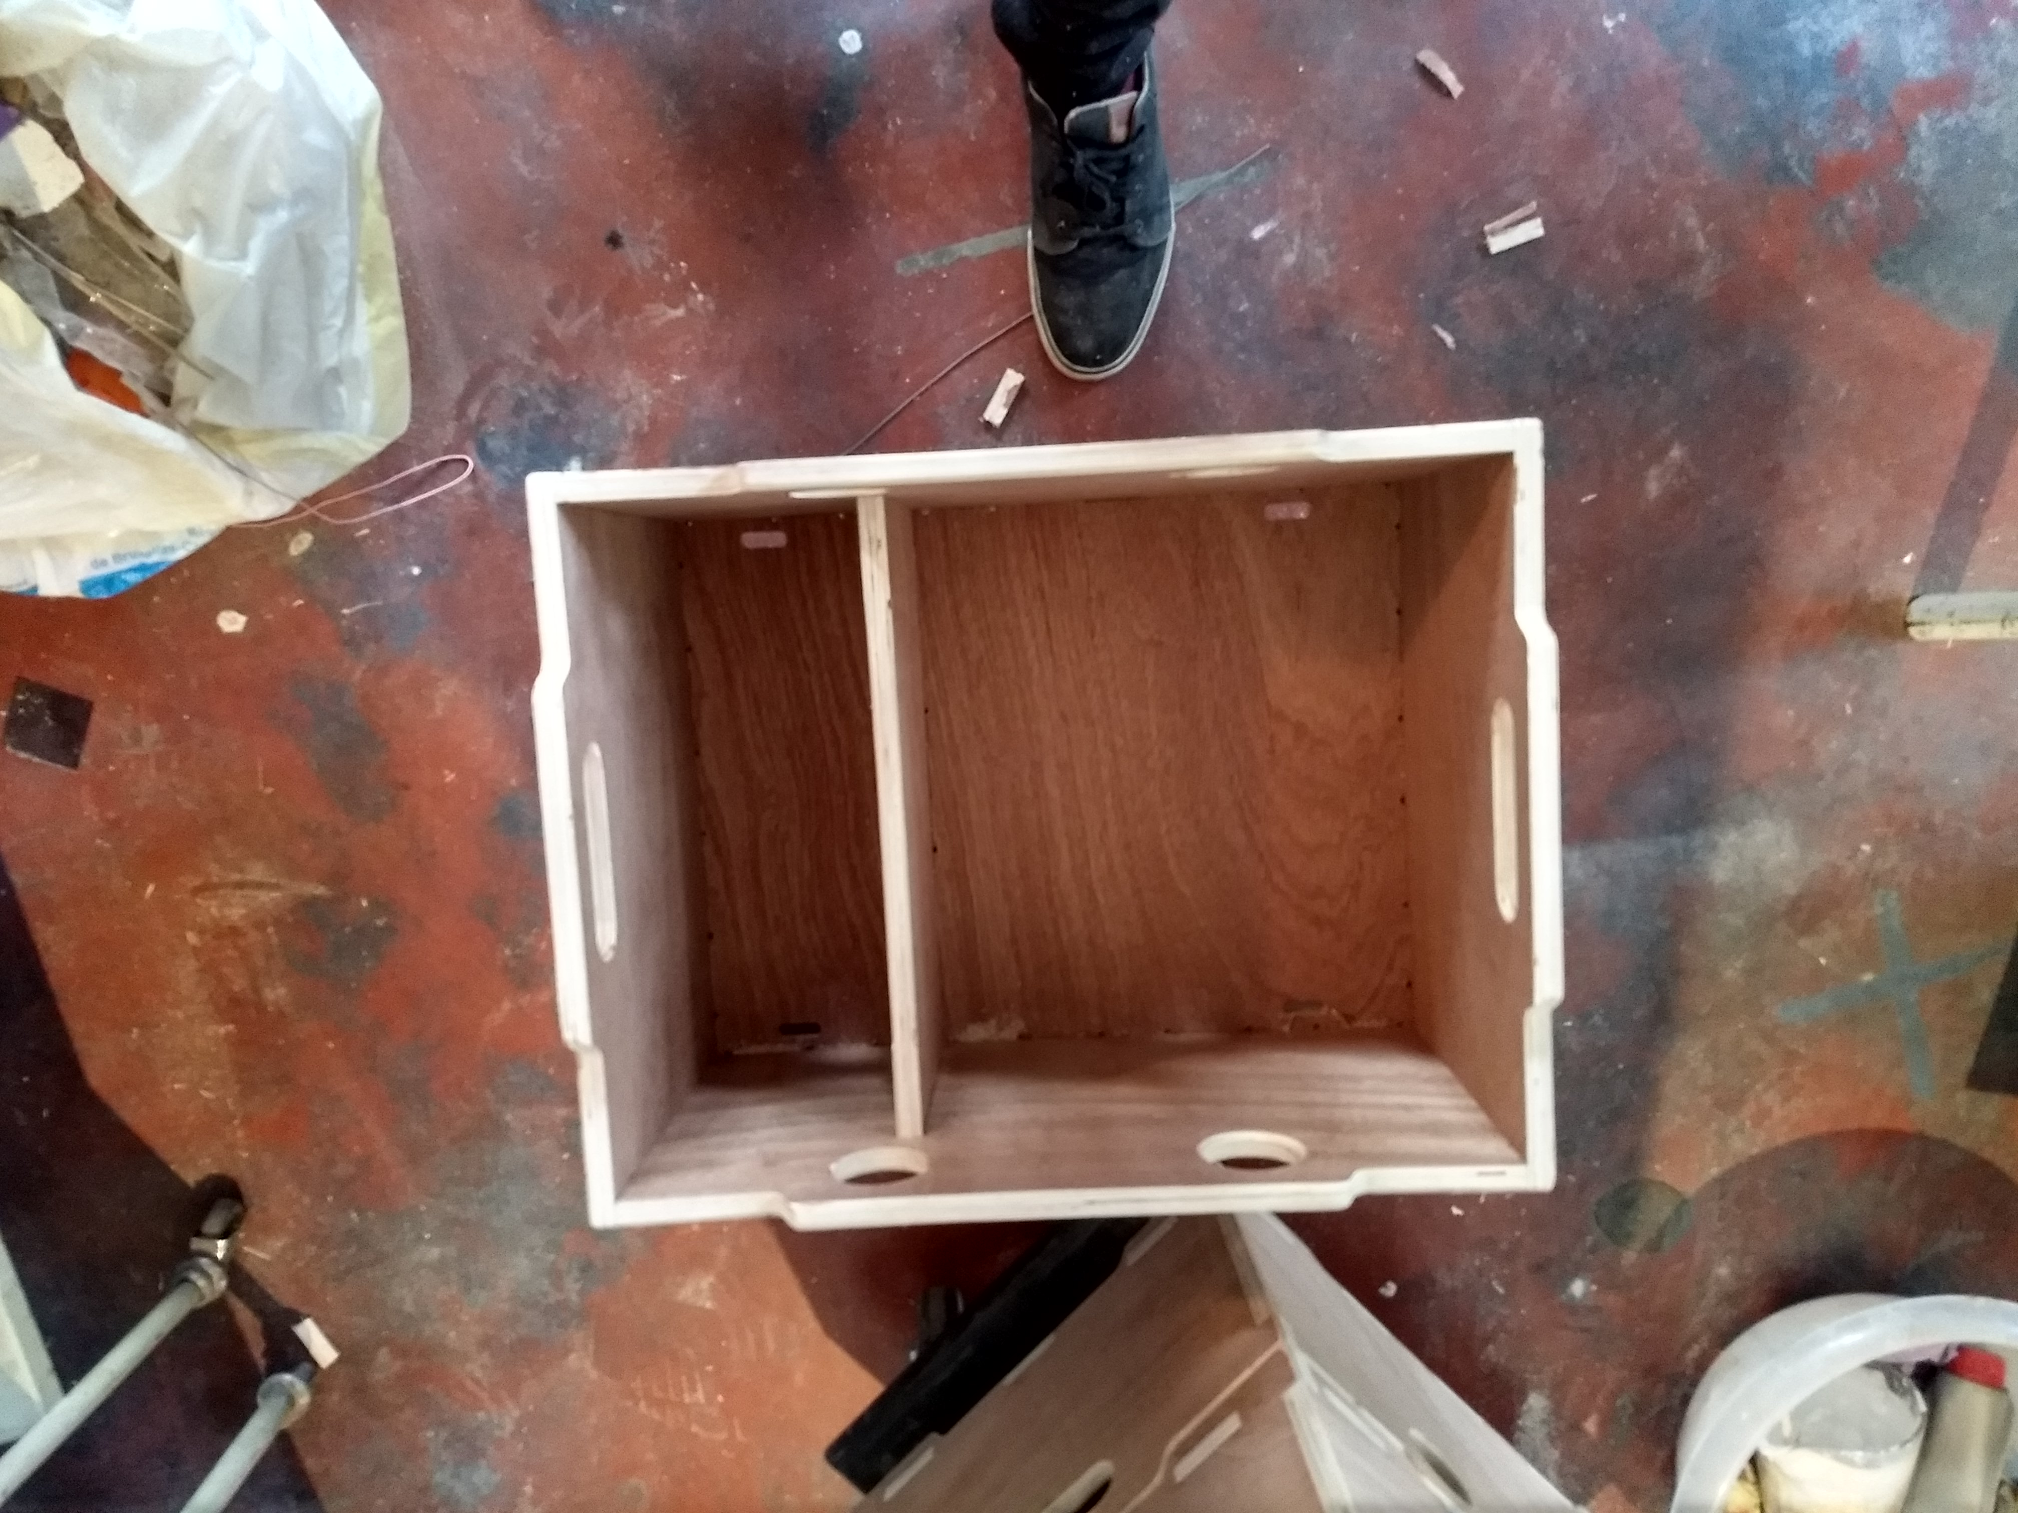
The boxes are purpose built to carry specific equipment. This box is meant to hold 6 laptops, and their chargers in the smaller compartment. We later laser cut thick packing foam to protect and space out the laptops safely.

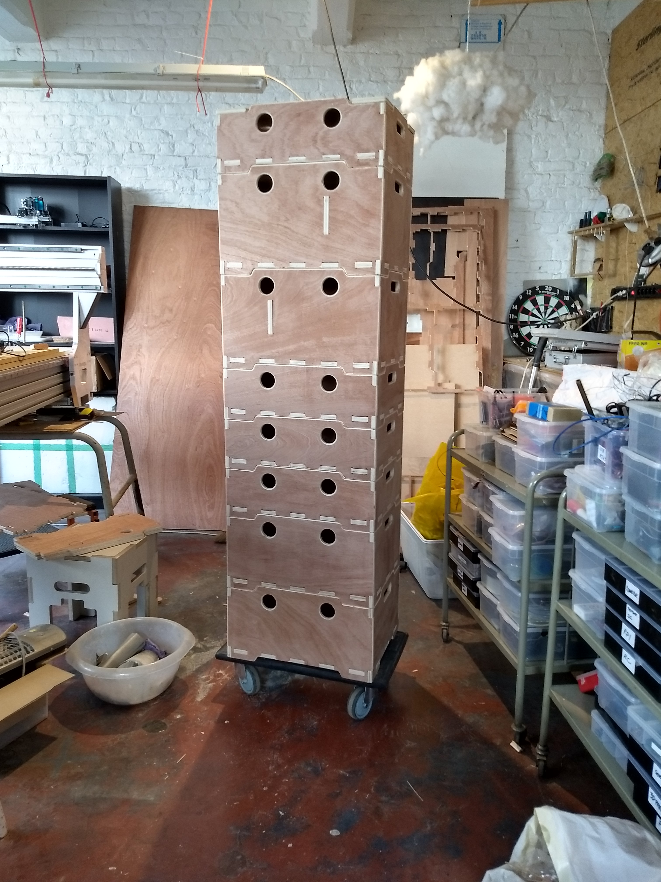
All the boxes are also designed to stack atop one another. This facilitates safe transport in and outside of the vans.

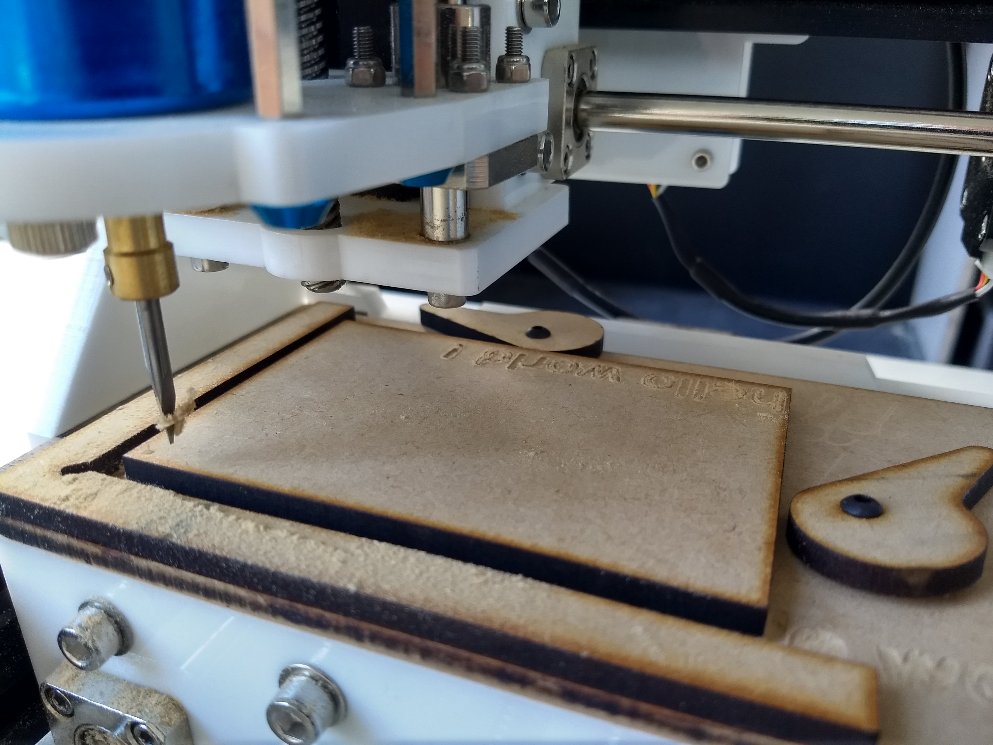
As this small CNC mill serves mostly for demonstrations, we added a speed clamping system, allowing the moblile fablab staff to quickly and easily change the demonstration cutting cards.

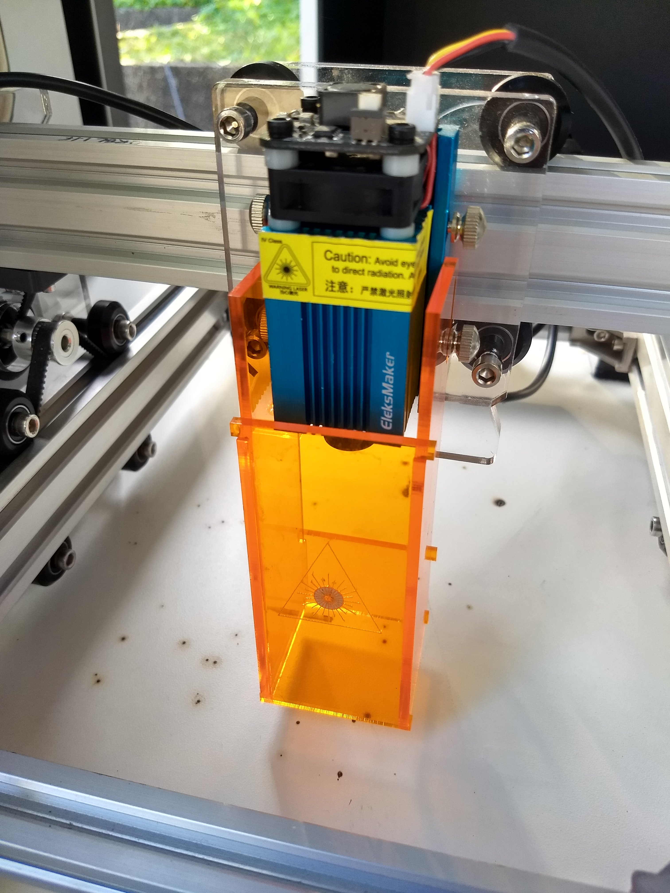
This laser cutter is small and ideal for demonstrating the tools ability to children. However, unlike larger laser cutters, it does not come with eye protection. We designed and built these UV filtering boxes to add around the lasers protecting all observers eyes. In addition to this, we hand out protective eyeware (also UV filtering) to guarantee no injuries can happen.

Pen plotters and Open Source Publishing
Gesture, ductus and machinic gestures have been an important focuses for my research as a graphic designer and as a member of the design collective Open Source Publishing (http://osp.kitchen). As a collective we question the necessities and boundaries of the copyrighting systems. OSP always had an educational motivation, most of our members being active teachers. Among our many parallel research tracks, machine tinkering with mid 80s pen plotters quickly became an interest.
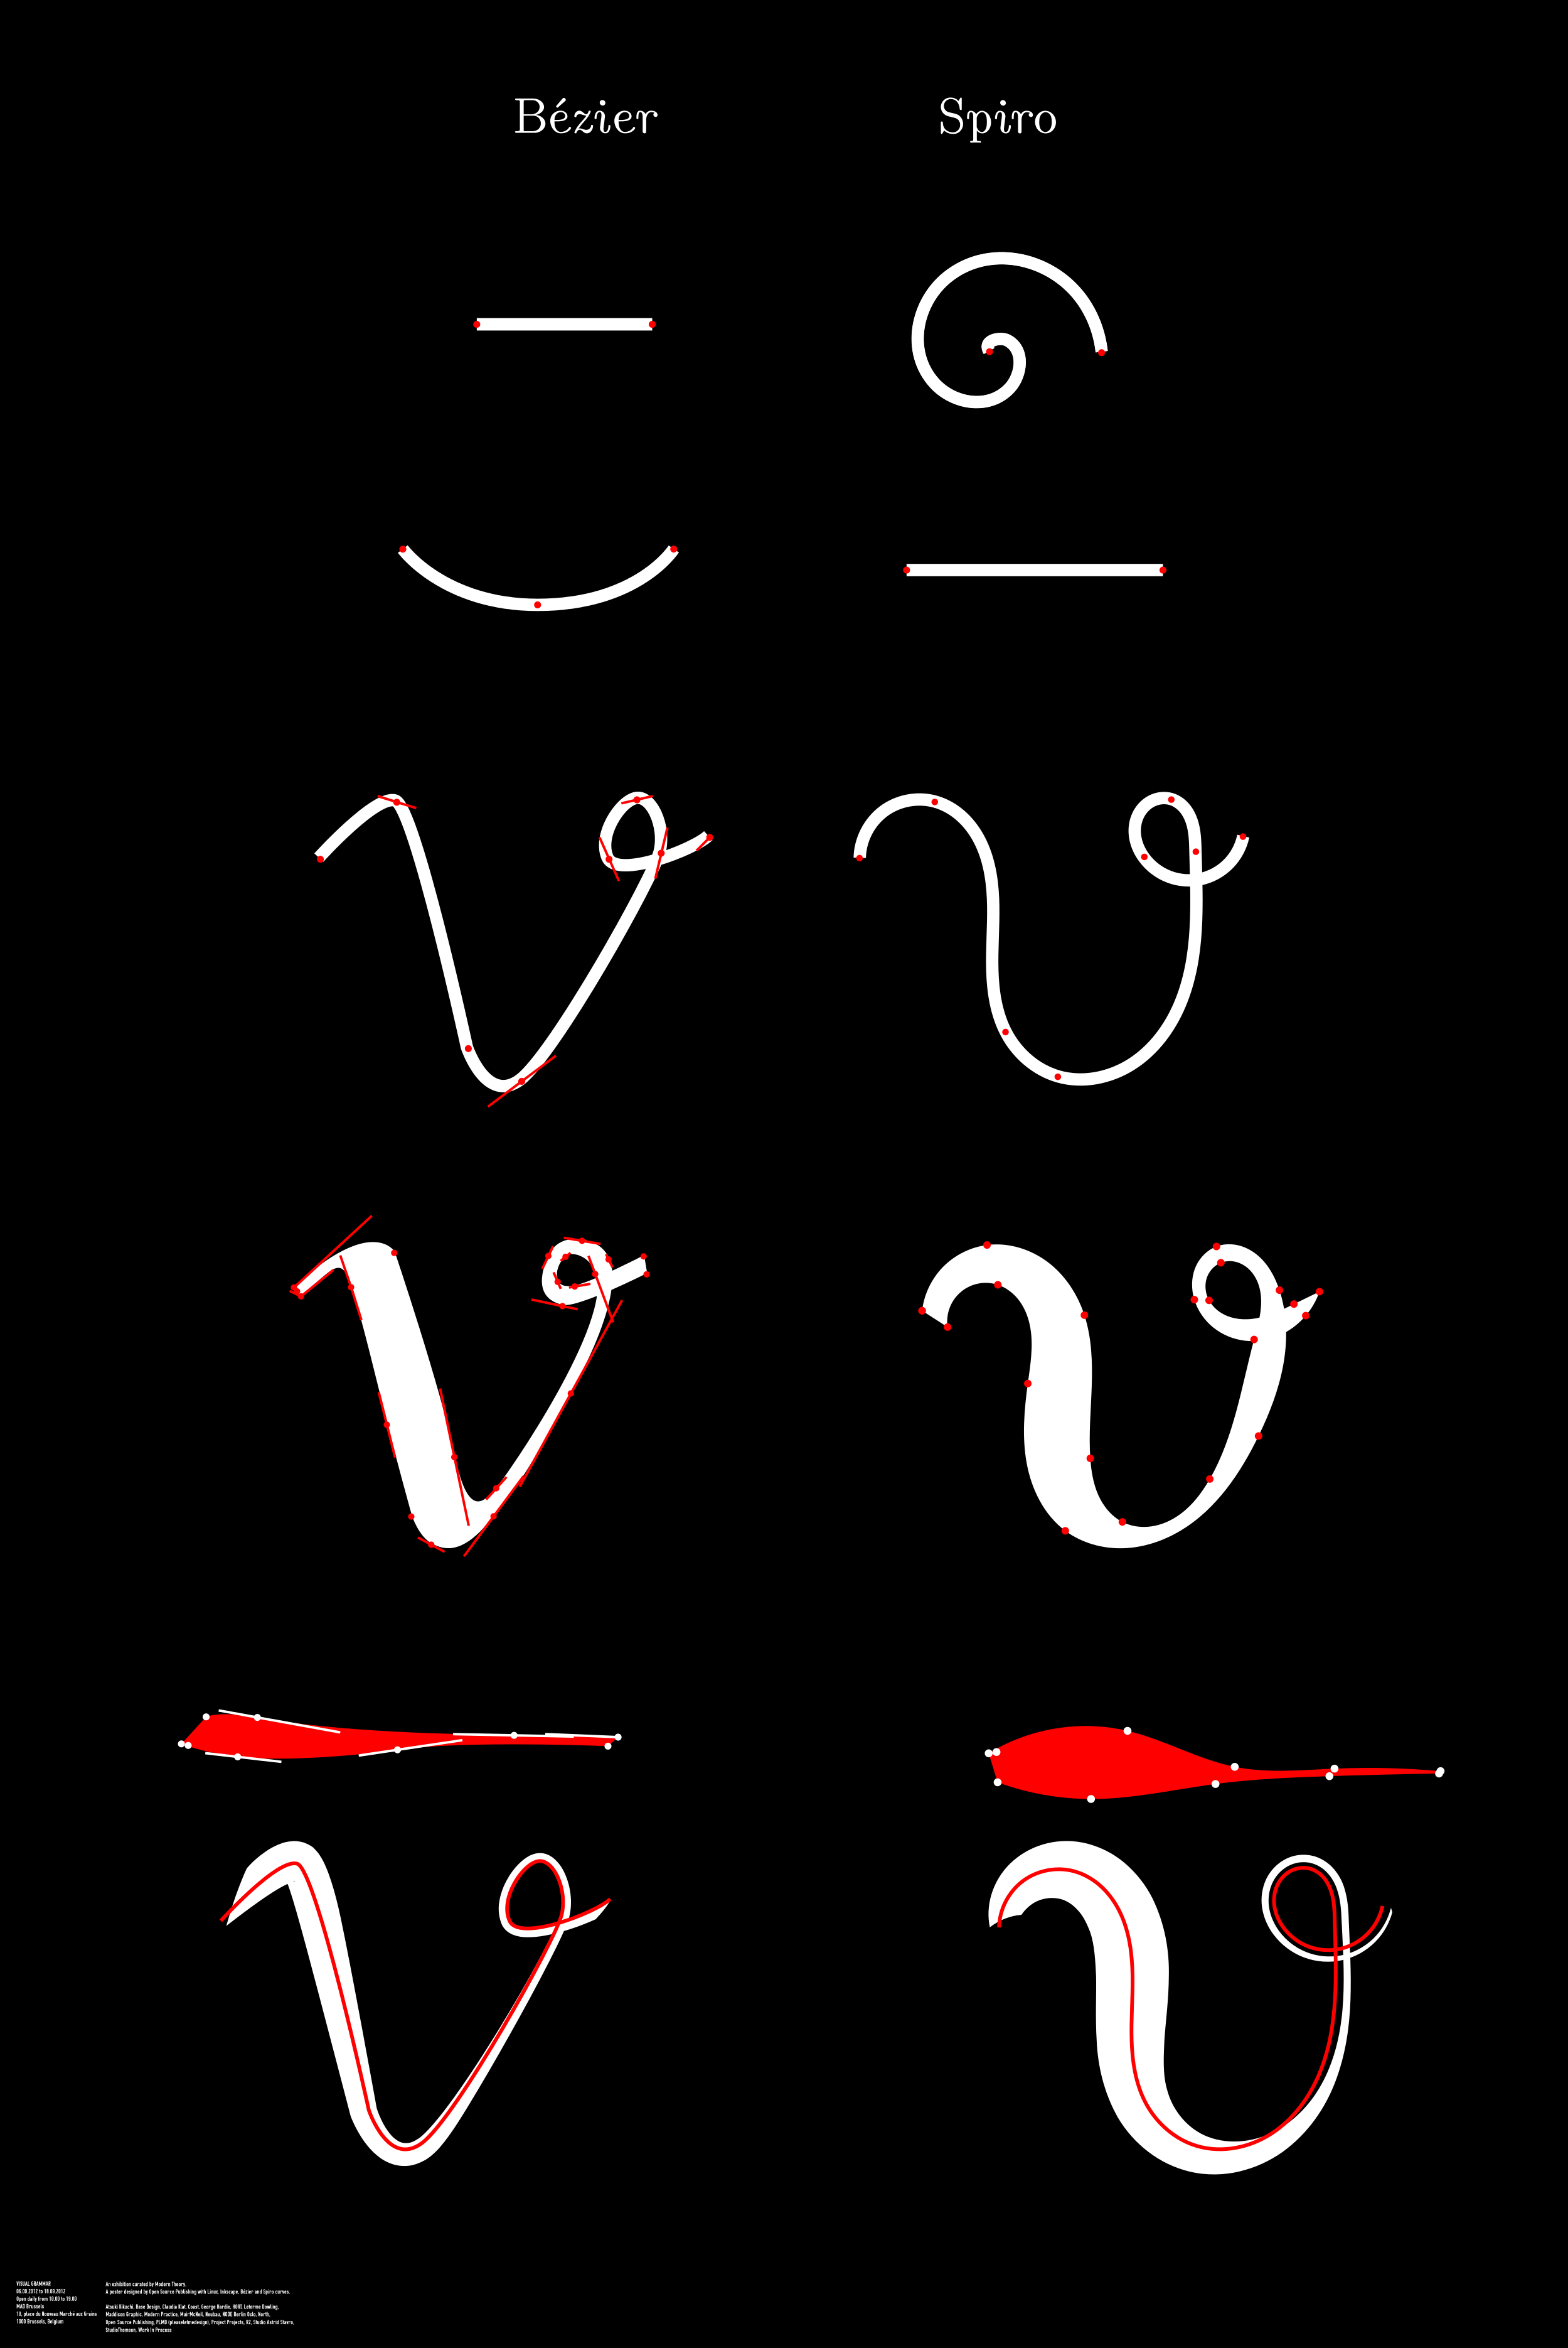
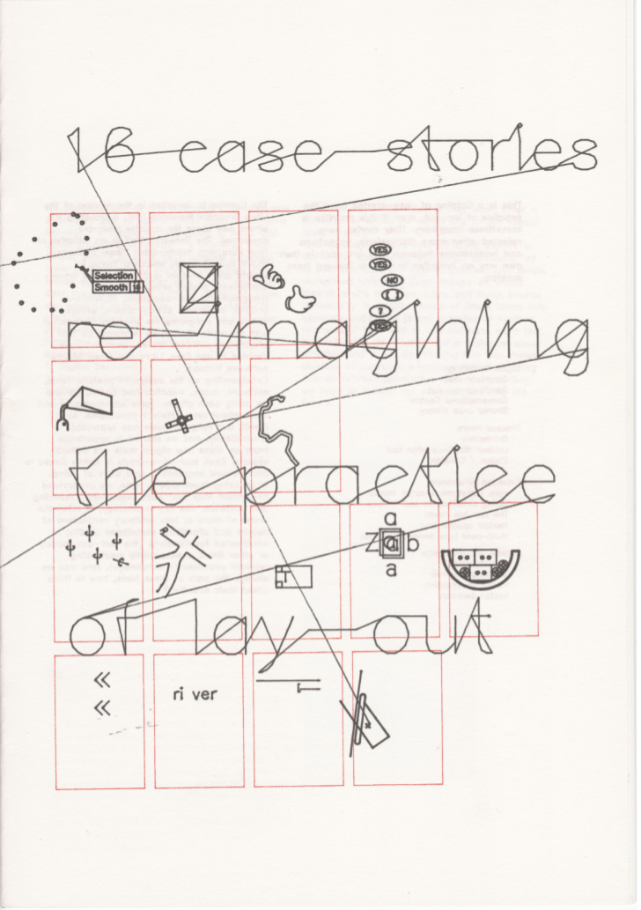
Bezier side by side with Spiro, one of the first posters I made with OSP.
16 case stories, co-position LGRU (Libre Graphics Research Unit) catalogue design. 2012, Print, 24 page booklet, Risograph print and flatbed pen plotter cover.Design with Pierre Huyghebaert.https://gitlab.constantvzw.org/lgru/co-position-catalog/blob/master/facsimile/digital-catalog.pdf

This booklet used the pen plotter in some of it’s basic function to print a research outcome booket questionning the practices of page layout.
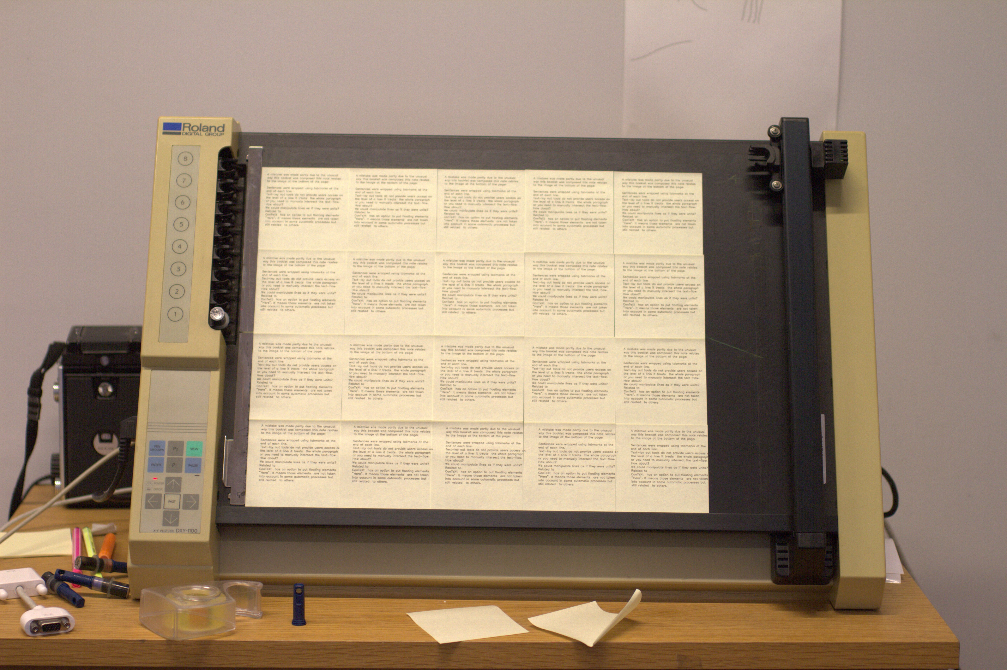
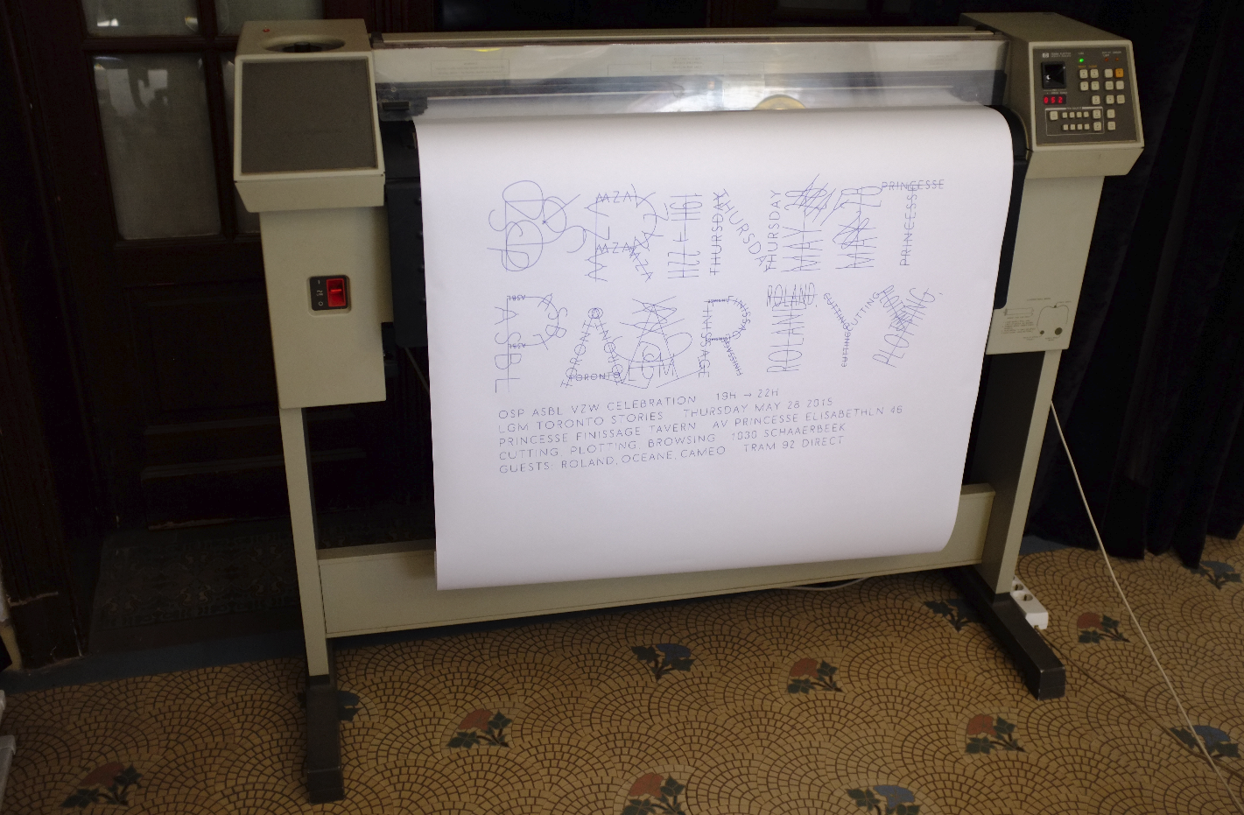

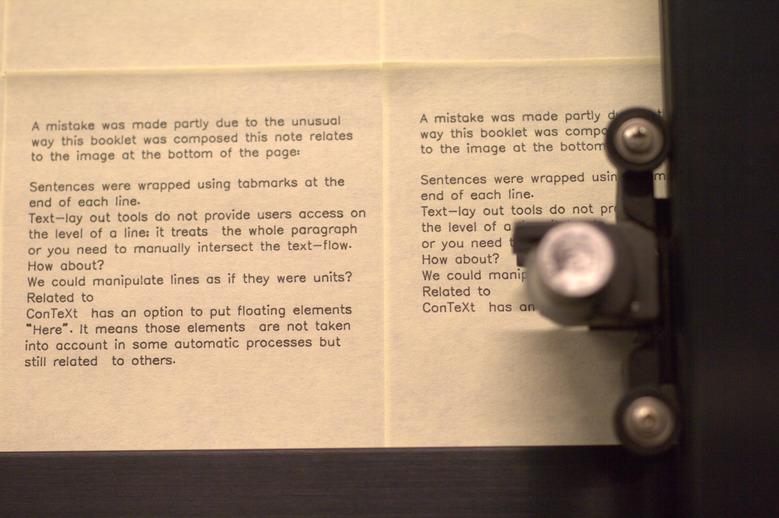

From the “16 case stories” research spawned a more speculative writing research project called Drawing Curved, concerned with the nature of curvature.

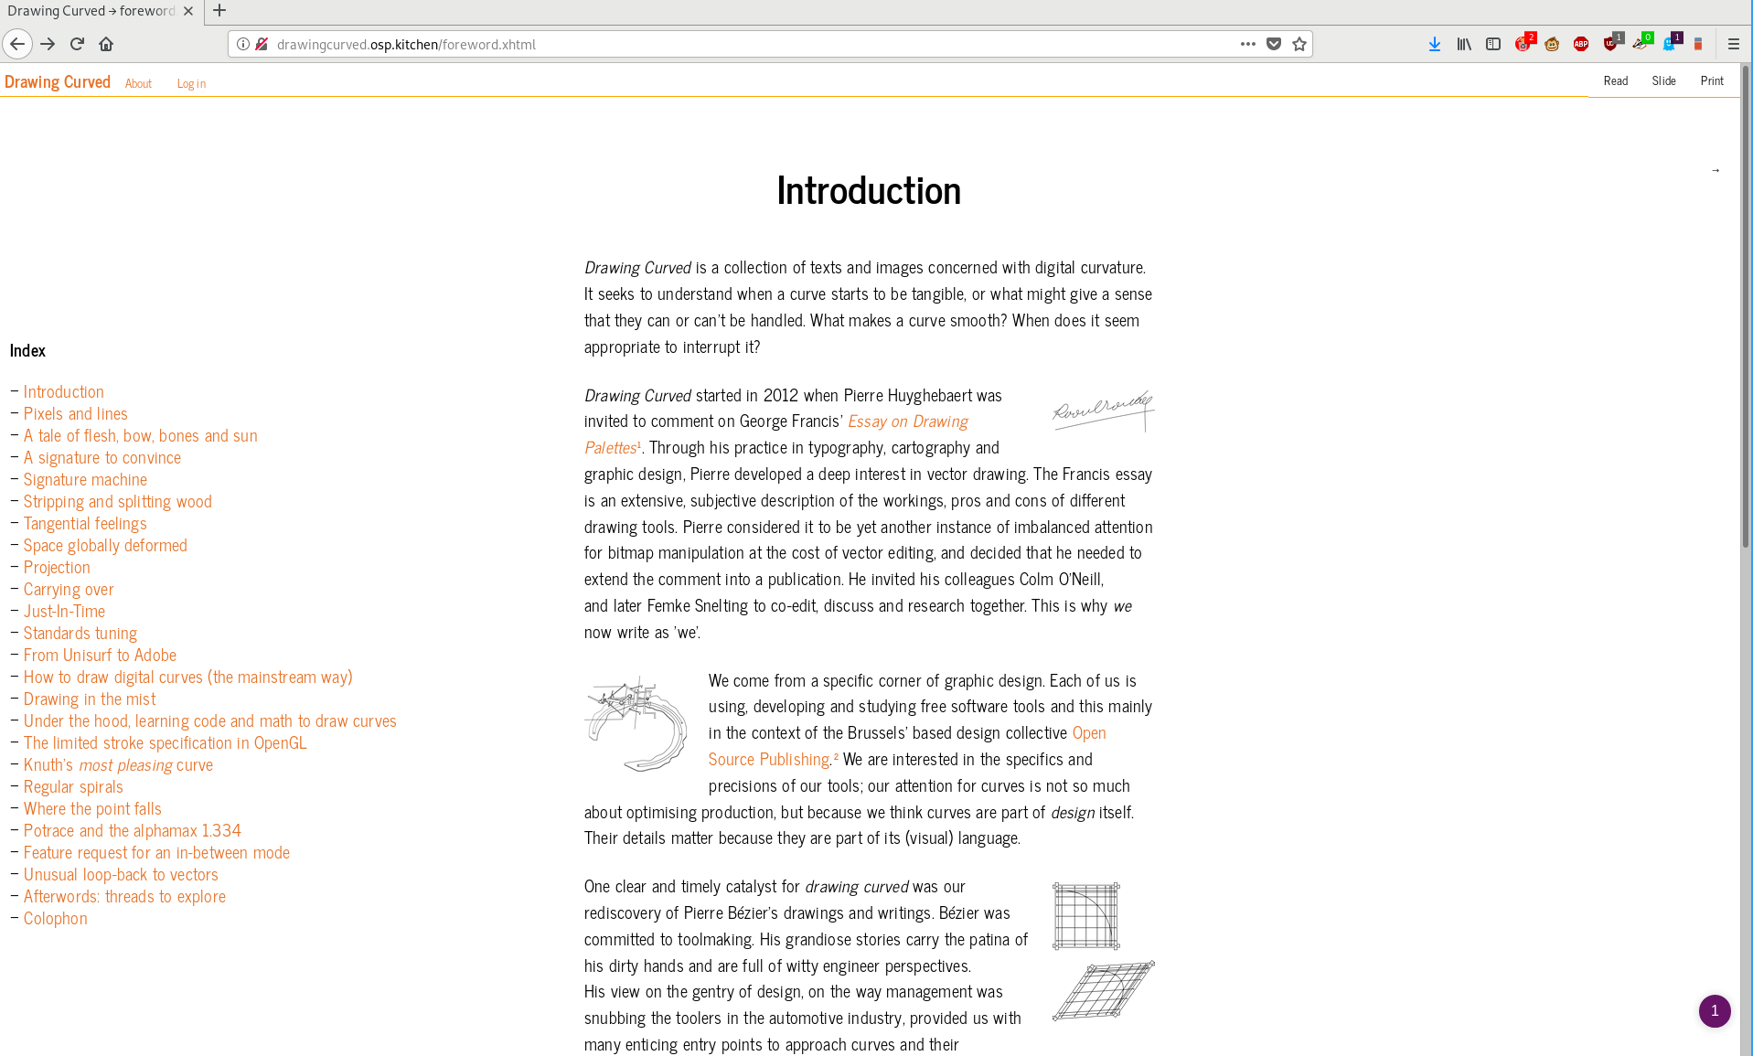
“ We come from a specific corner of graphic design. Each of us is using, developing and studying free software tools and this mainly in the context of the Brussels' based design collective Open Source Publishing. We are interested in the specifics and precisions of our tools; our attention for curves is not so much about optimising production, but because we think curves are part of design itself. Their details matter because they are part of its (visual) language. ”
http://drawingcurved.osp.kitchen

Relearn
“Relearn is a collective learning experiment with as many teachers as it has participants. It is motivated by the possibility to displace parameters of/for research, studying and learning. During the week of Relearn, we work with a set of case-studies, observations, questions or stacks of study material that we call”tracks“. Relearn outlines the idea of resetting thinking modes, for a diverse set of approaches that we can reconsider, that come out of the development of our cultures towards and through digital entities. While Relearn is an experiment in collective learning, it grows from an interest in Free / Libre Open Source Software culture and practices as a way to address and acknowledge the production processes and frameworks involving technology and culture.”
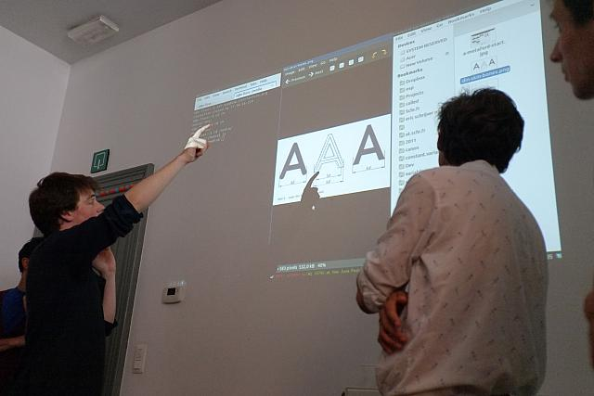
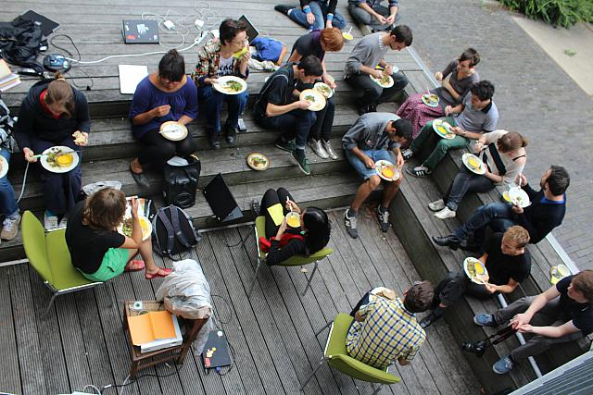
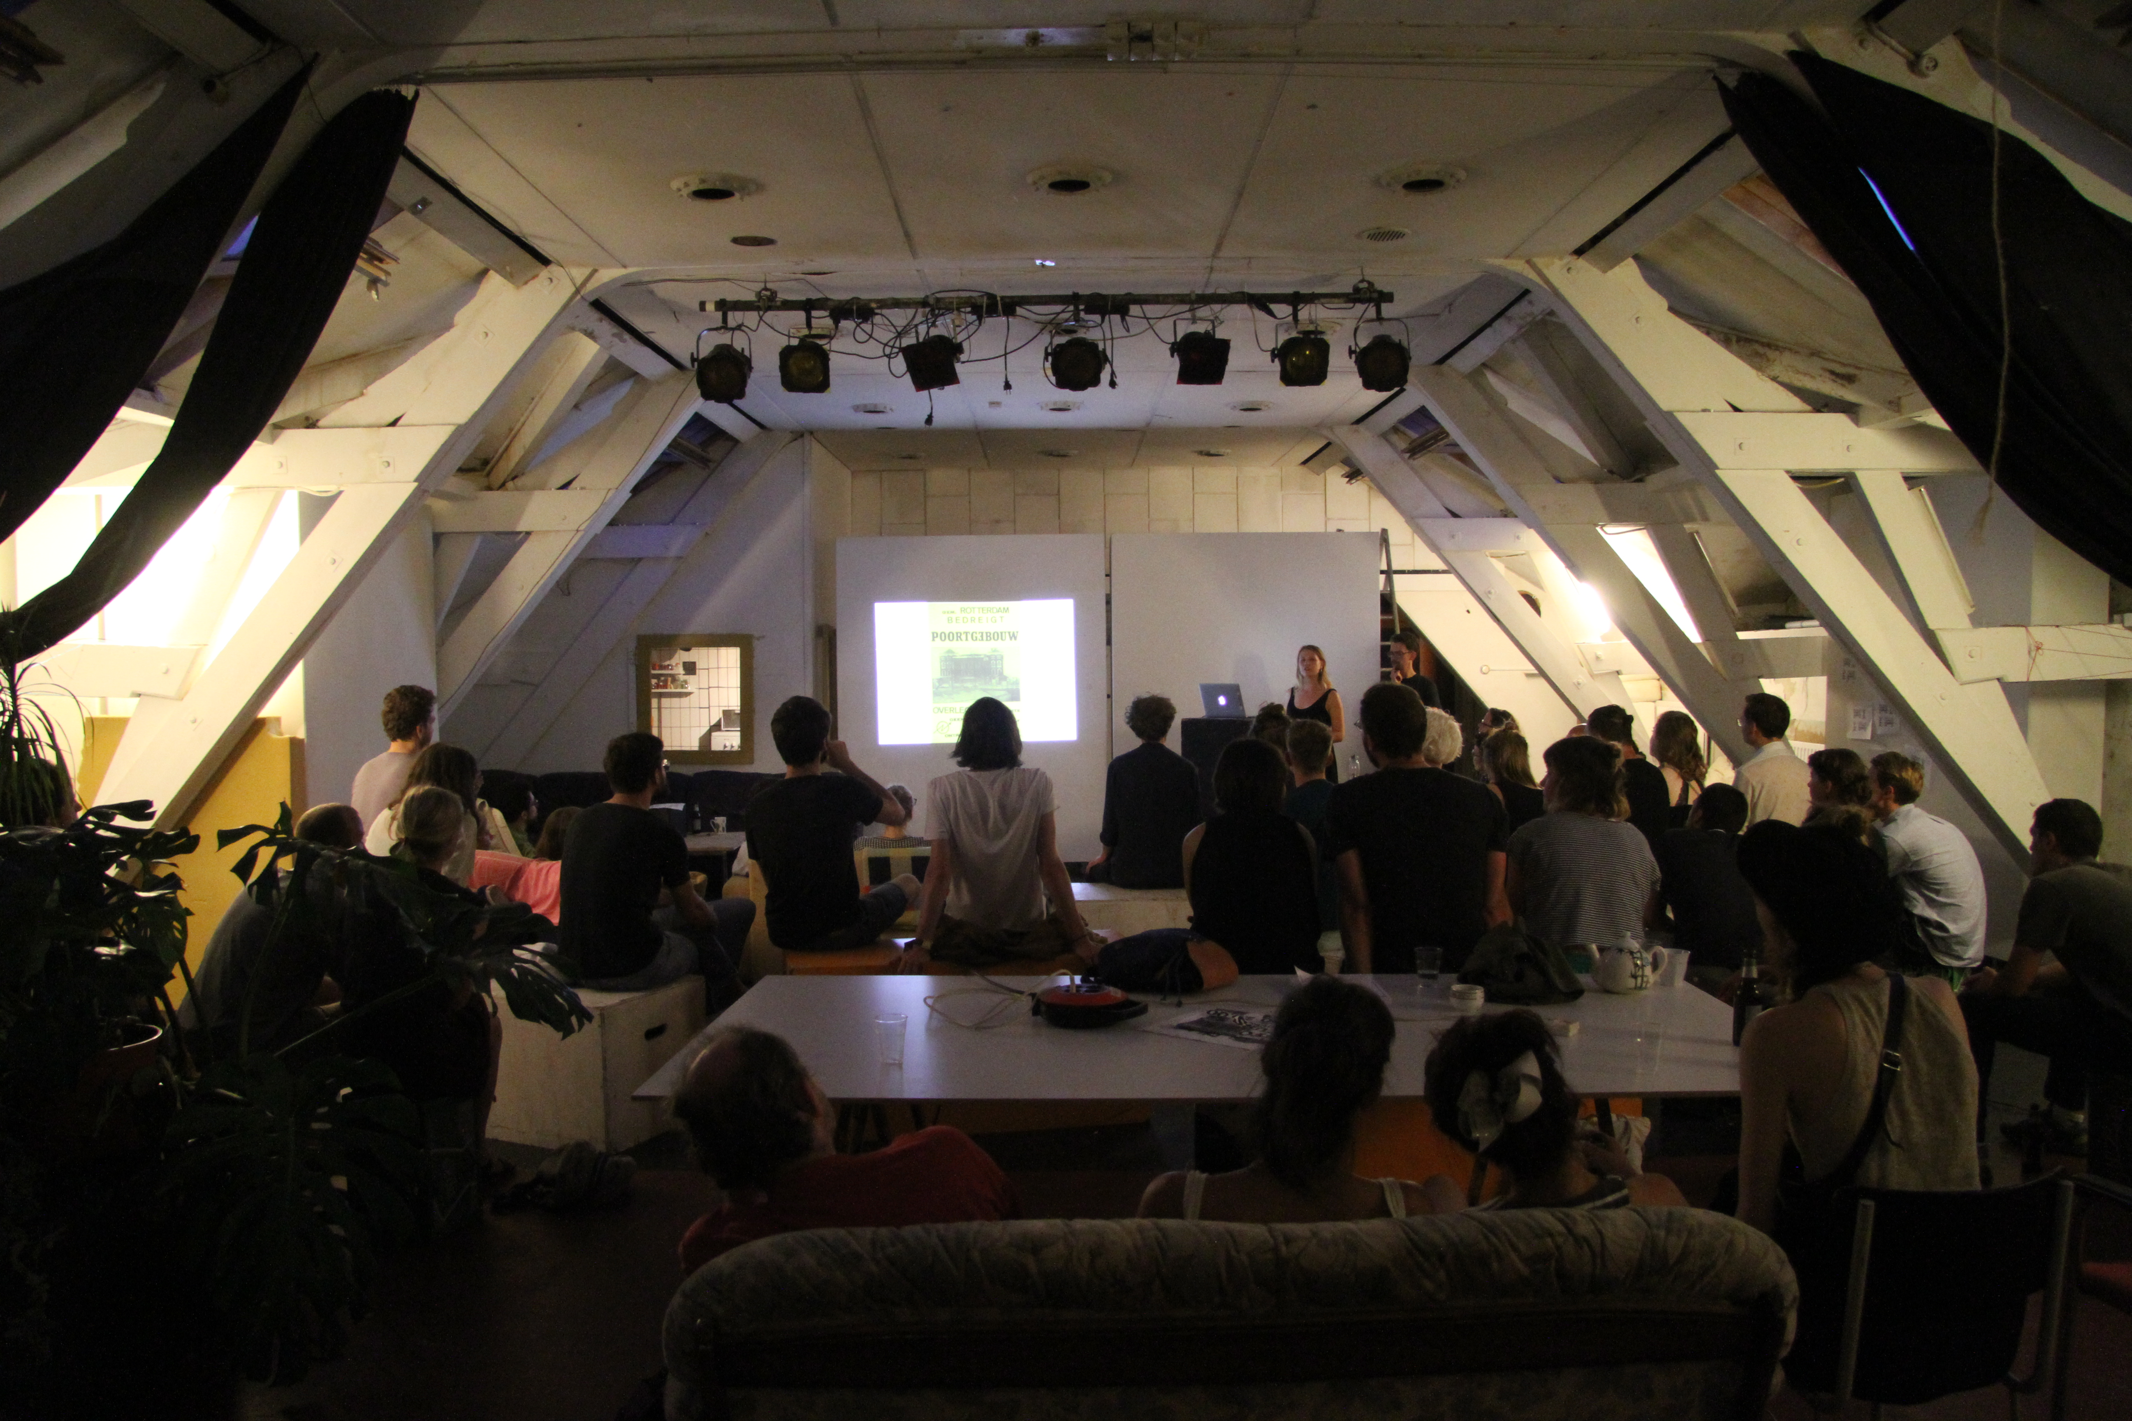

http://relearn.be project archives and repository: https://gitlab.com/relearn

breadfellows.school

A website, online publication space, pedagogical tool and archive made in collaboration with Clare Breen, September 2017 – present.
“ The design of this online space has been developed with the ethos of the Breadfellows' Chats methodology in mind. As a web designer […] (ndlr; I) focused on making the innerworkings of the sites he designs freely accessible, sharing all source code; the entire framework of the website is free for any person to access, study and duplicate.
Educational methods are (thankfully) rarely considered to be intellectual property however, documentation material, publications, artworks or media too easily gets bound, closed and made essentially unusable through copyright. This means that (outside of the academic frame) it is hard to use and publish research and methodological source materials in support of new educational research. As the focus of Breadfellows.school is to share and disseminate neoteric educational practices, we publish the written content, the visual material, the supporting audio, video media and the code developed specifically for this site under a copyleft licence. This is a statement of where the research positions itself socially. Copyright and licencing issues were not initial interest in the Breadfellows chat project, but through our collaboration on this platform we put forwards the potential space for education and free information to exist especially within the artistic fields.
The collaboration on this project has functioned on several levels. Ideologically, the attitude of publishing this content freely (as in speech) technically and legally echo the aims the Breadfellow chats. Meanwhile, this has also been an attempt at demystifying some of the technical or structural aspects necessary to build and publish a website. By using the exact same repository, by thinking about what visible and invisible interfaces both content writer and web designer have to use, we hope to establish a larger vocabulary for exchanging and building this website-publication-project. The goal is not to learn/teach all the skills necessary to build this site, but simply by making them visible, by documenting them, we make the system tangible for ourselves, and hopefully somewhat tangible to you too.
The breadfellows.school repository is available for you to consult, study, modify and reuse at gitlab.com/breadfellows/breadfellows.school. ”



