Supporting Documents: C.O’NEILL

Open Source Publishing and restored pen plotters
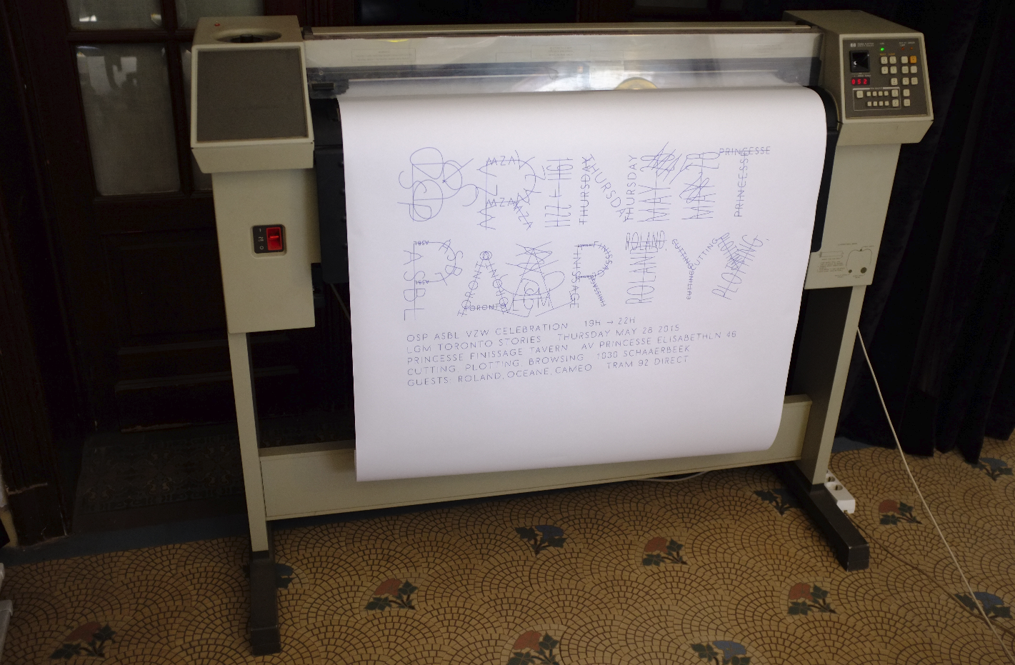
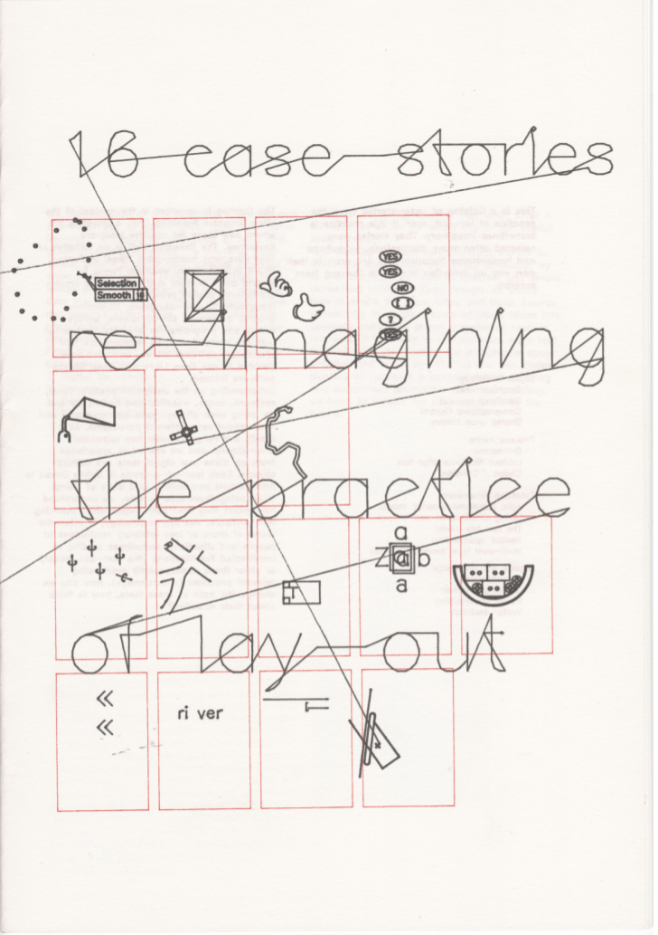
16 case stories, co-position LGRU (Libre Graphics Research Unit) catalogue design. 2012, Print, 24 page booklet, Risograph print and flatbed pen plotter cover.Design with Pierre Huyghebaert.https://gitlab.constantvzw.org/lgru/co-position-catalog/blob/master/facsimile/digital-catalog.pdf
This booklet used the pen plotter in some of it’s basic function to print a research outcome booket questionning the practices of page layout.
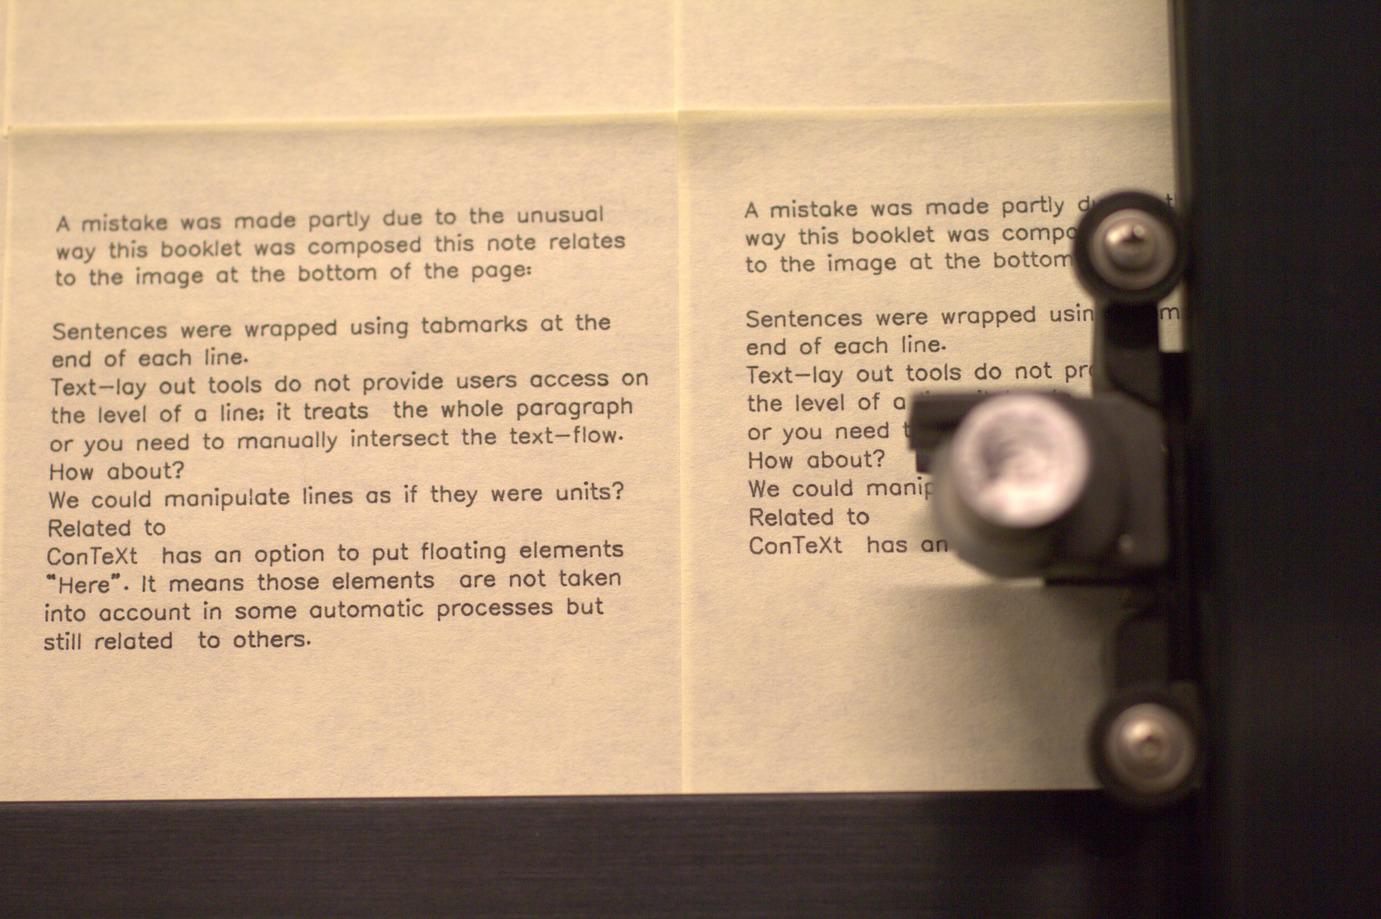
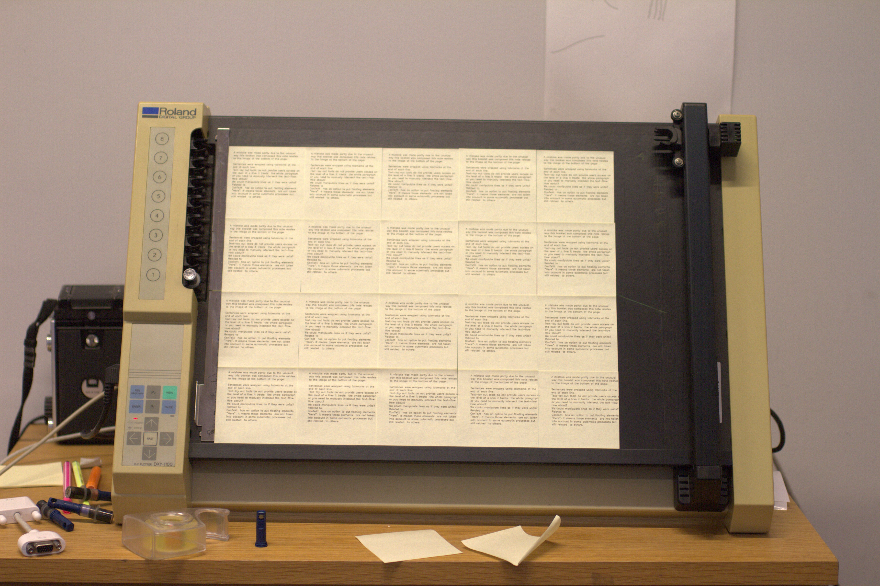

workshops and performances with pen plotters
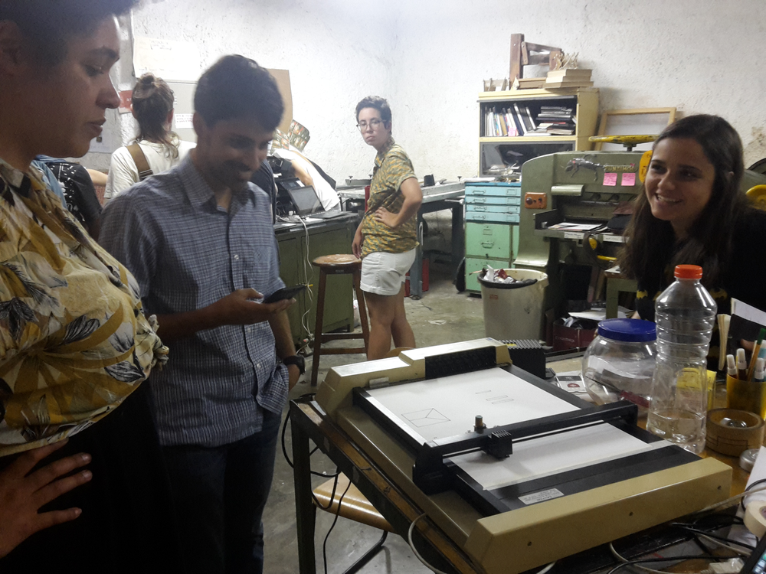
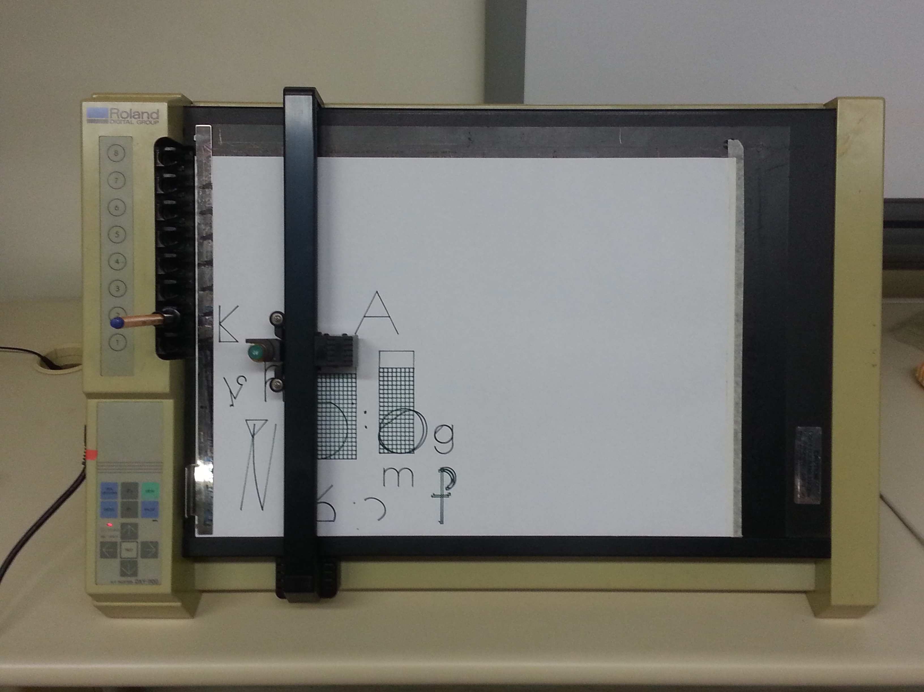
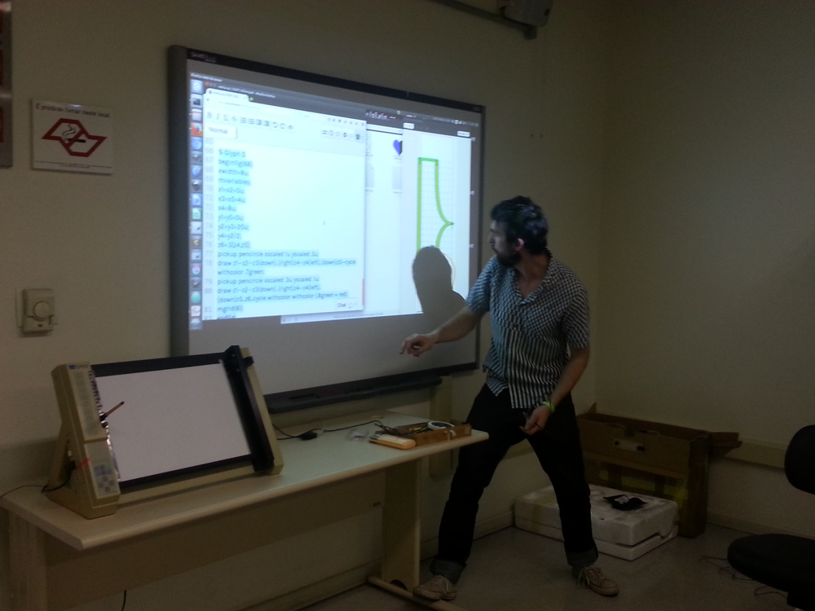

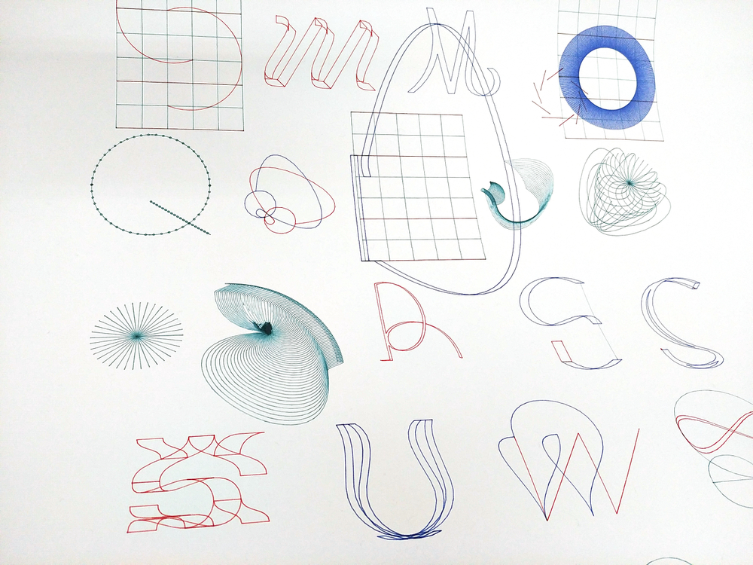

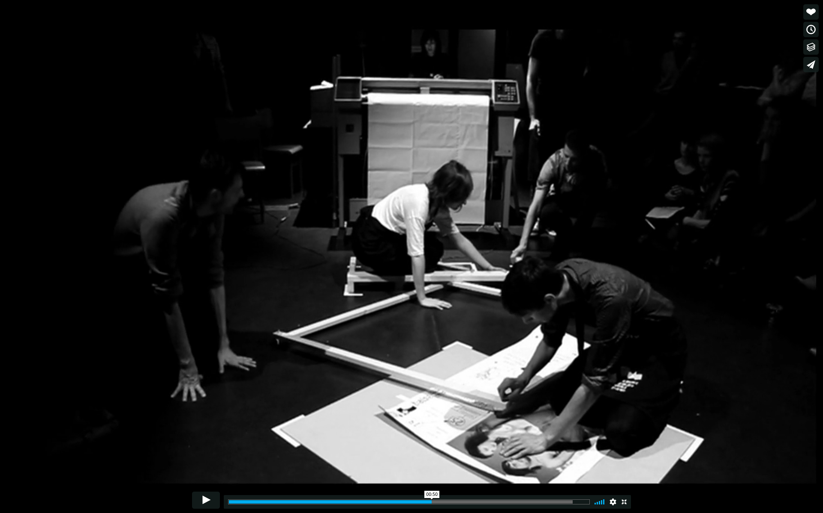
First four images : OSP woskshop on HPGL language, Metapost and Metafonts in Port-Au-Prince, Rio de Janeiro, and Liège. http://osp.kitchen/workshop/
Last image : Bootstrap IV, Print party performance with OSP in Théâtre Balsamine, Schaerbeek Brussels https://vimeo.com/64151382

beMaker

Until the end of 2018 I was education lead for an organisation called beMaker. The group (http://bemaker.eu) is a non-profit organisation from Brussels that is focused on introducing fablab-like practices to students between the ages of 8 and 16. It’s main mission is to demystify what are understood as new technologies. Specifically, beMaker has built two food truck-like vans to fully function as mobile fablabs. This allows us to work in schools directly with children, taking time to introduce them to what a fablab may be and to give various workshops introducing children to programming, basic electronics and design methods.

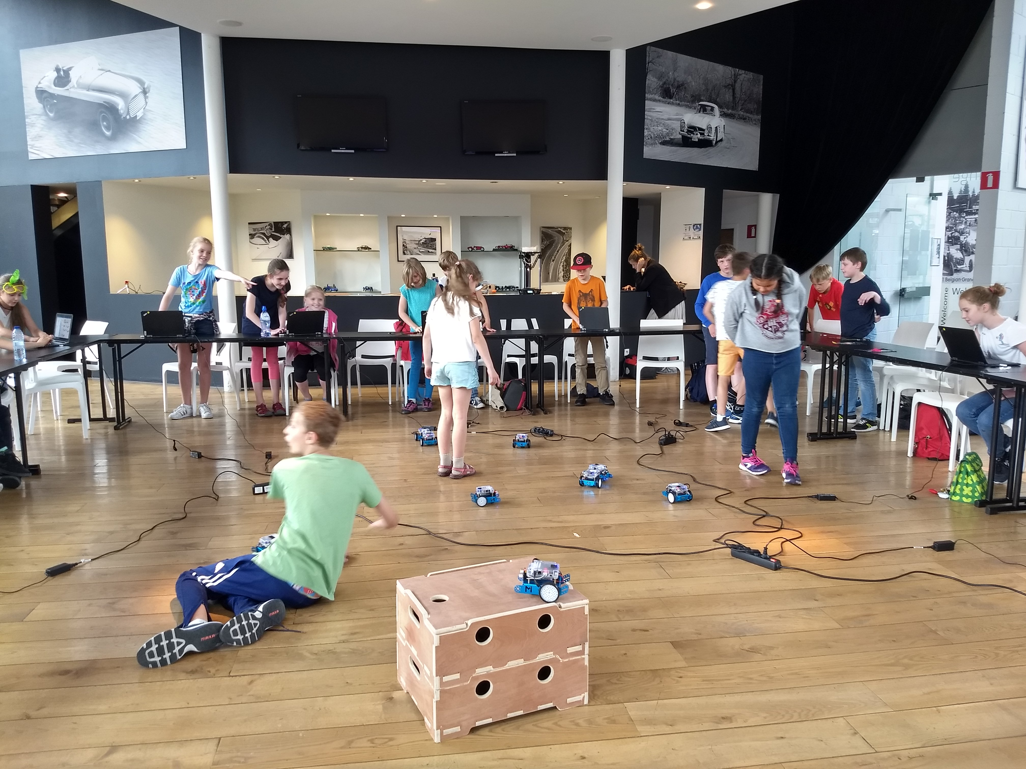
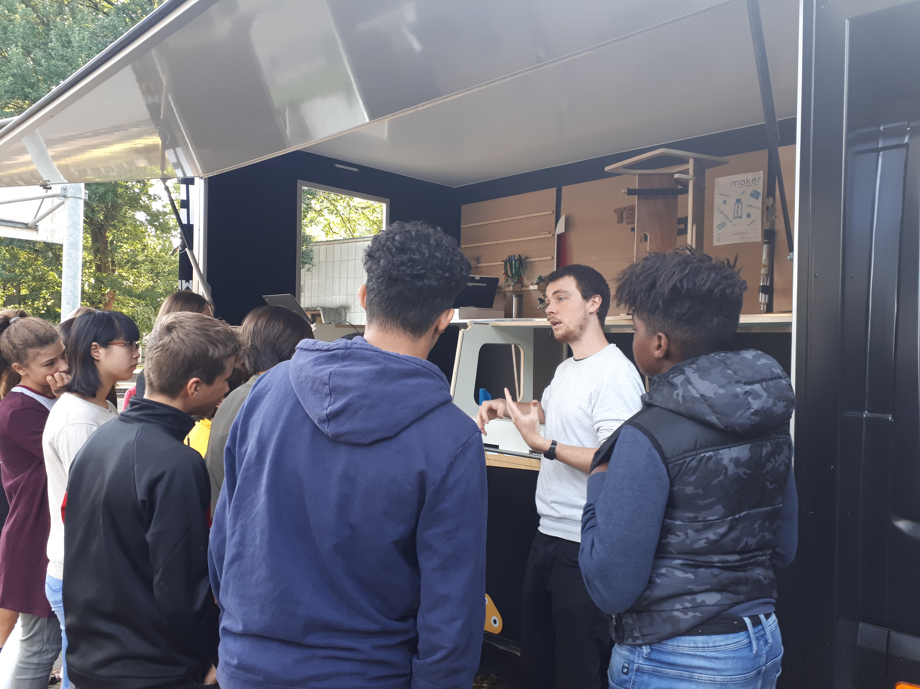
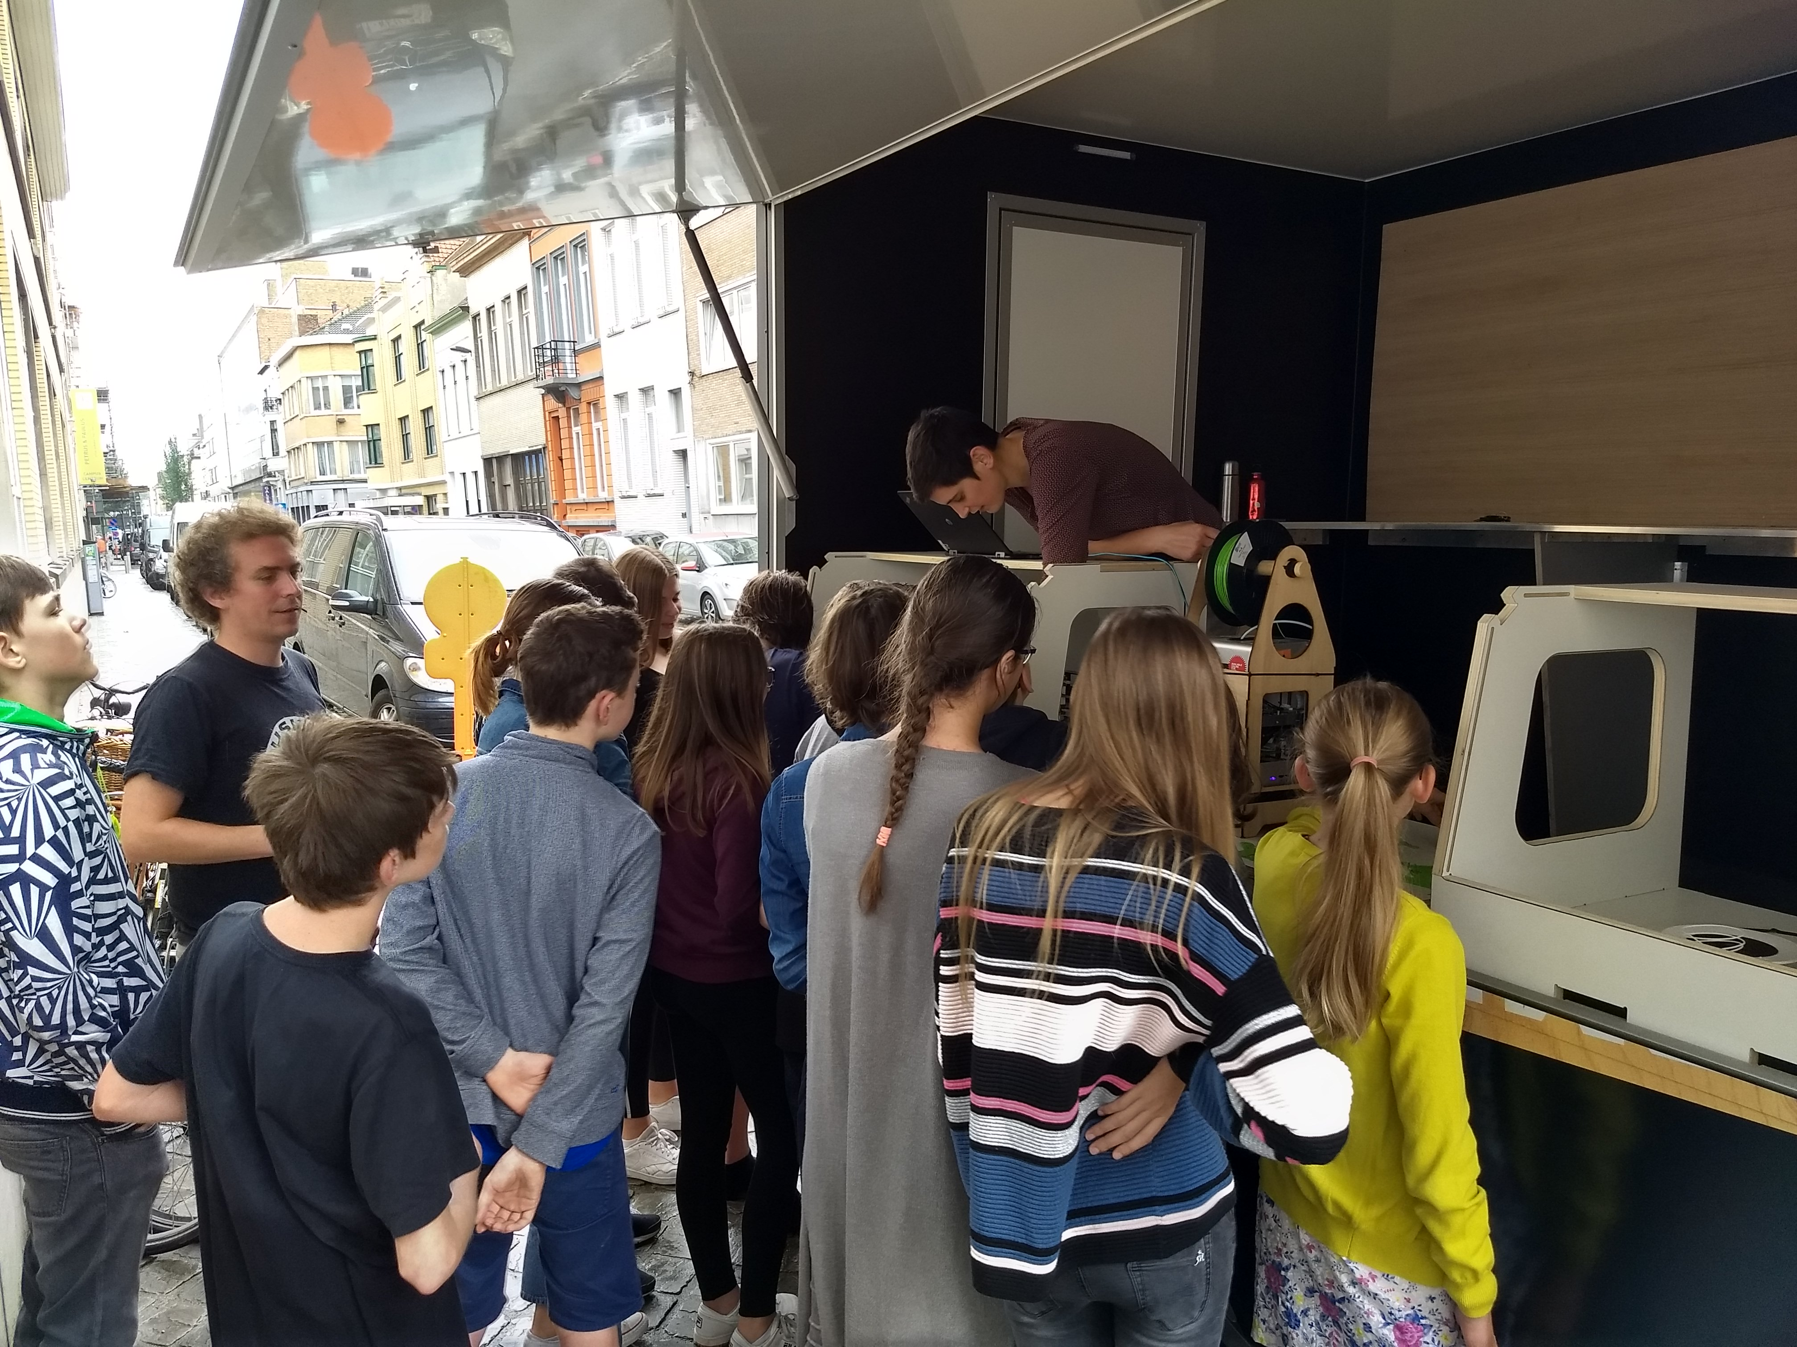
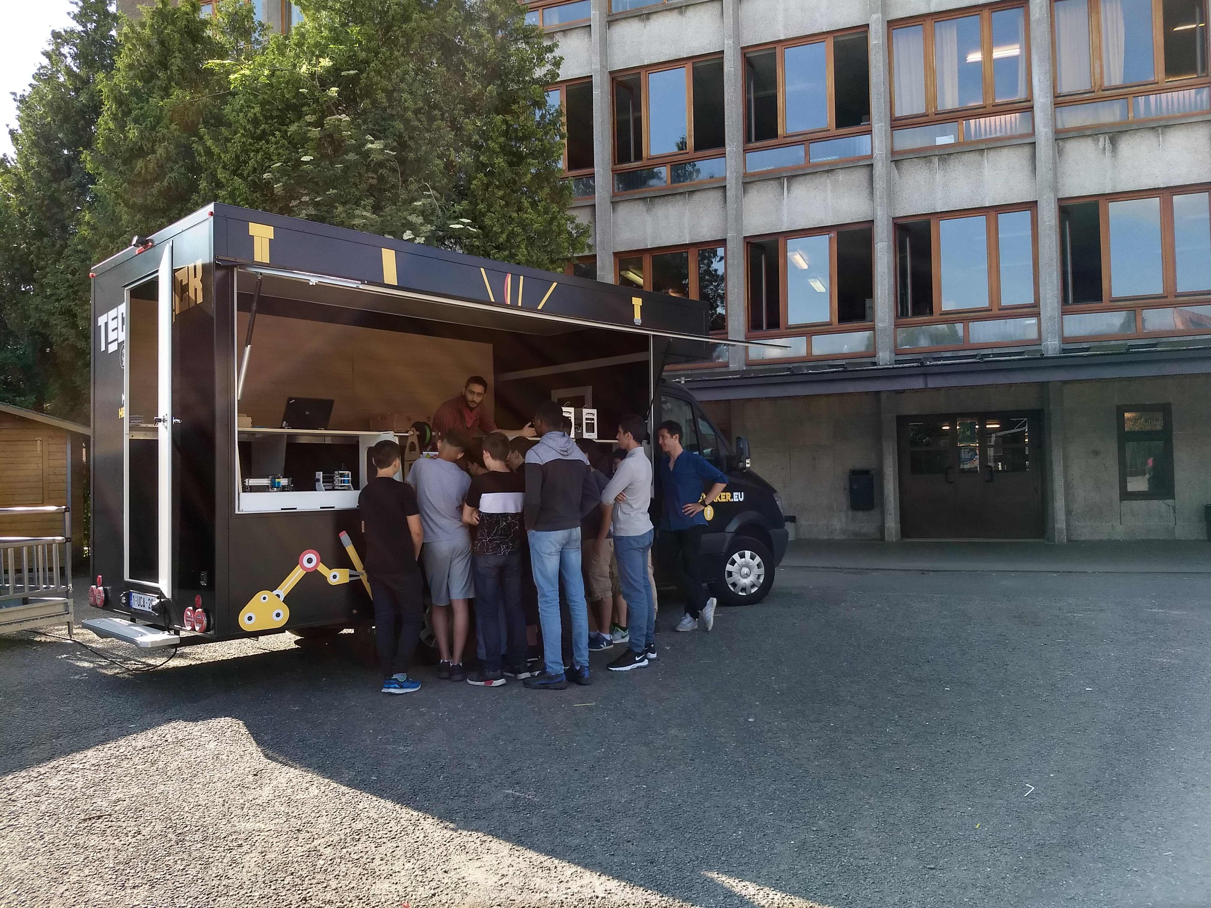

Relearn – an experimental Open Source Software Summer school
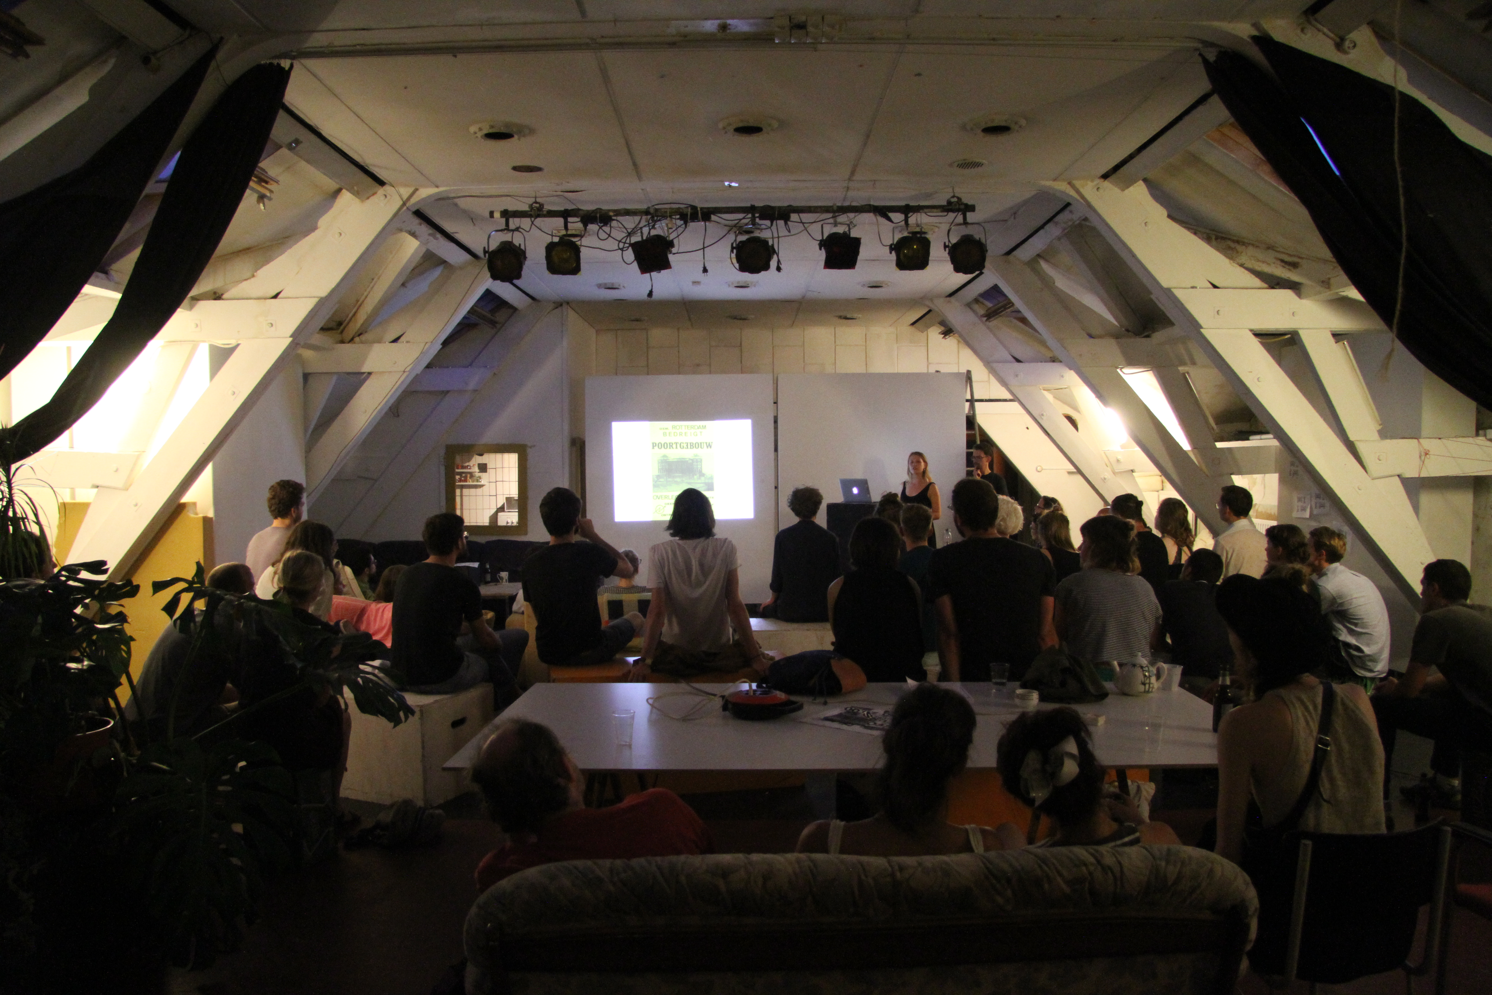
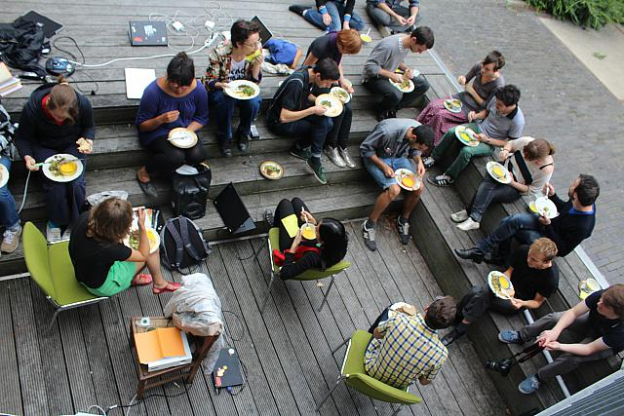
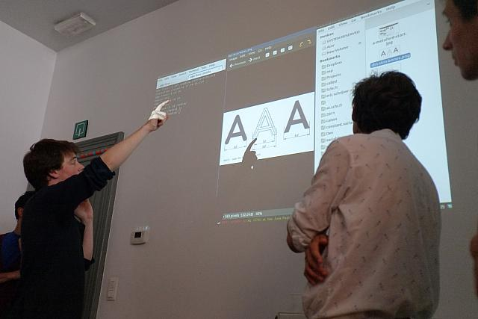

“Relearn is a collective learning experiment with as many teachers as it has participants. It is motivated by the possibility to displace parameters of/for research, studying and learning. During the week of Relearn, we work with a set of case-studies, observations, questions or stacks of study material that we call”tracks“. Relearn outlines the idea of resetting thinking modes, for a diverse set of approaches that we can reconsider, that come out of the development of our cultures towards and through digital entities. While Relearn is an experiment in collective learning, it grows from an interest in Free / Libre Open Source Software culture and practices as a way to address and acknowledge the production processes and frameworks involving technology and culture.”
http://relearn.be project archives and repository: https://gitlab.com/relearn

Maps drawn with plotters
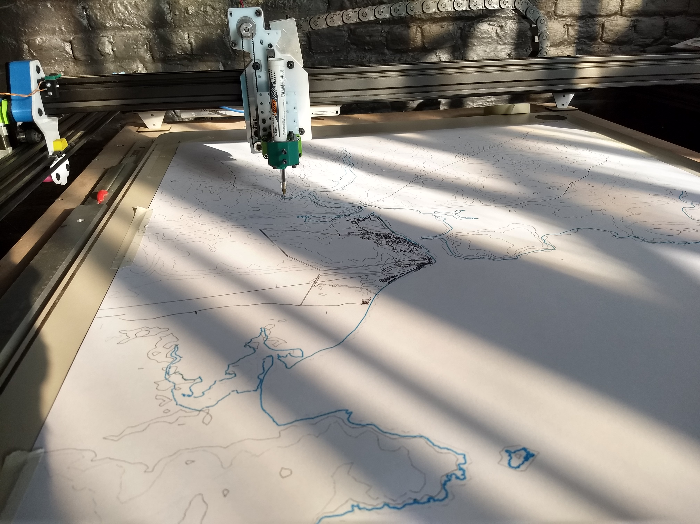
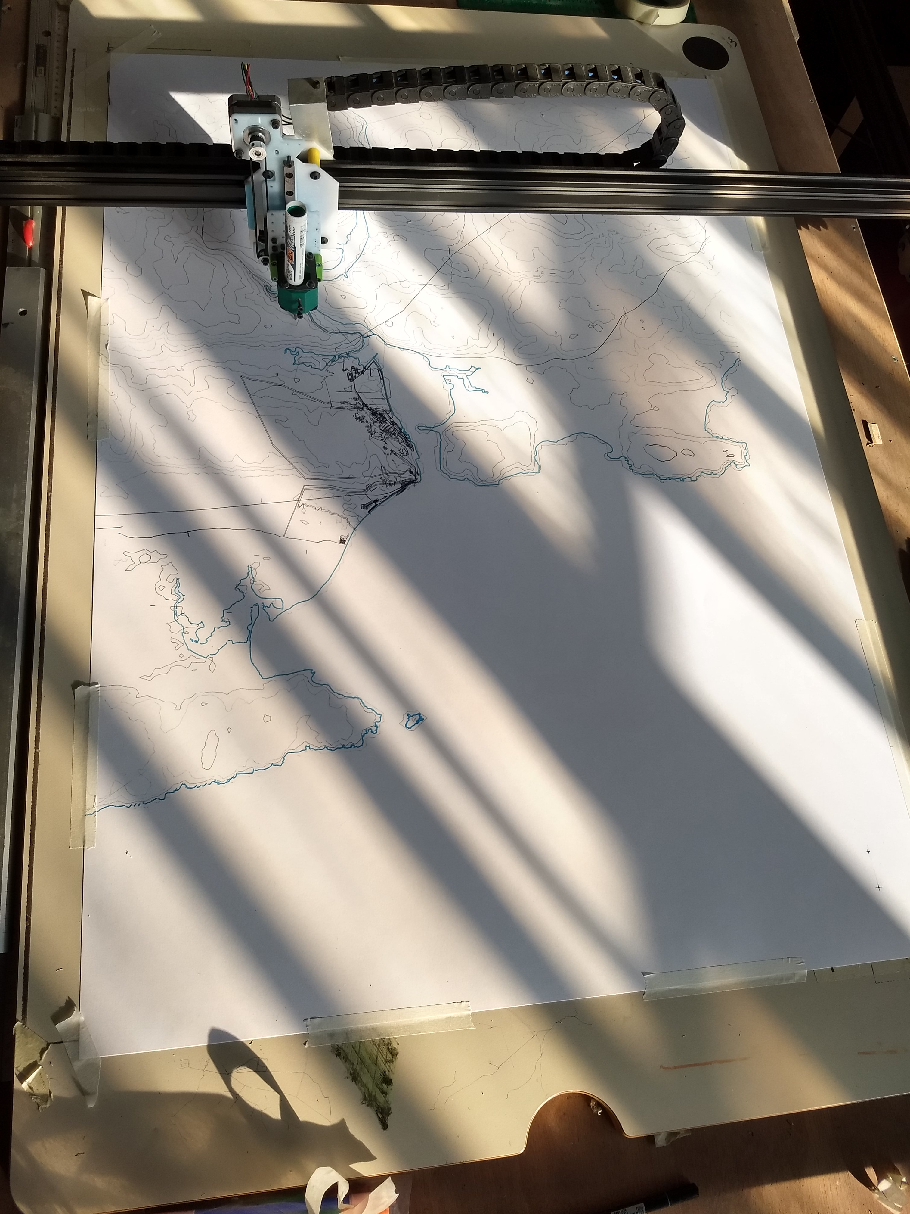
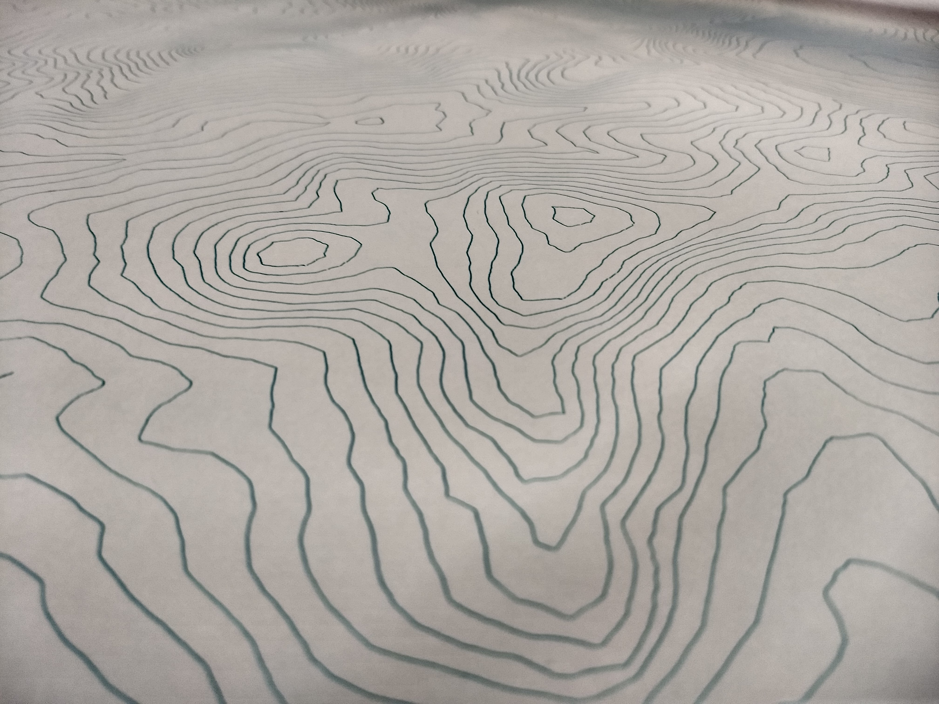
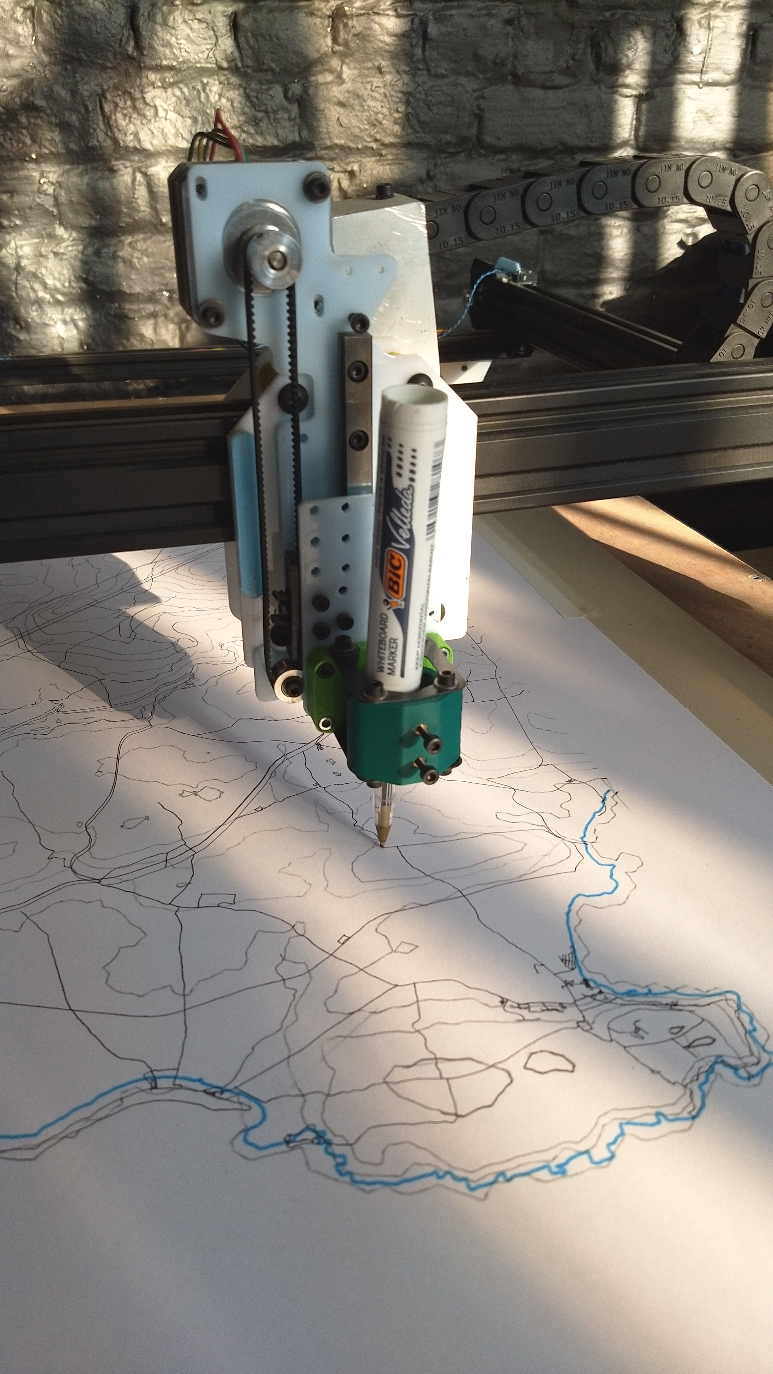

Static and animated schematics
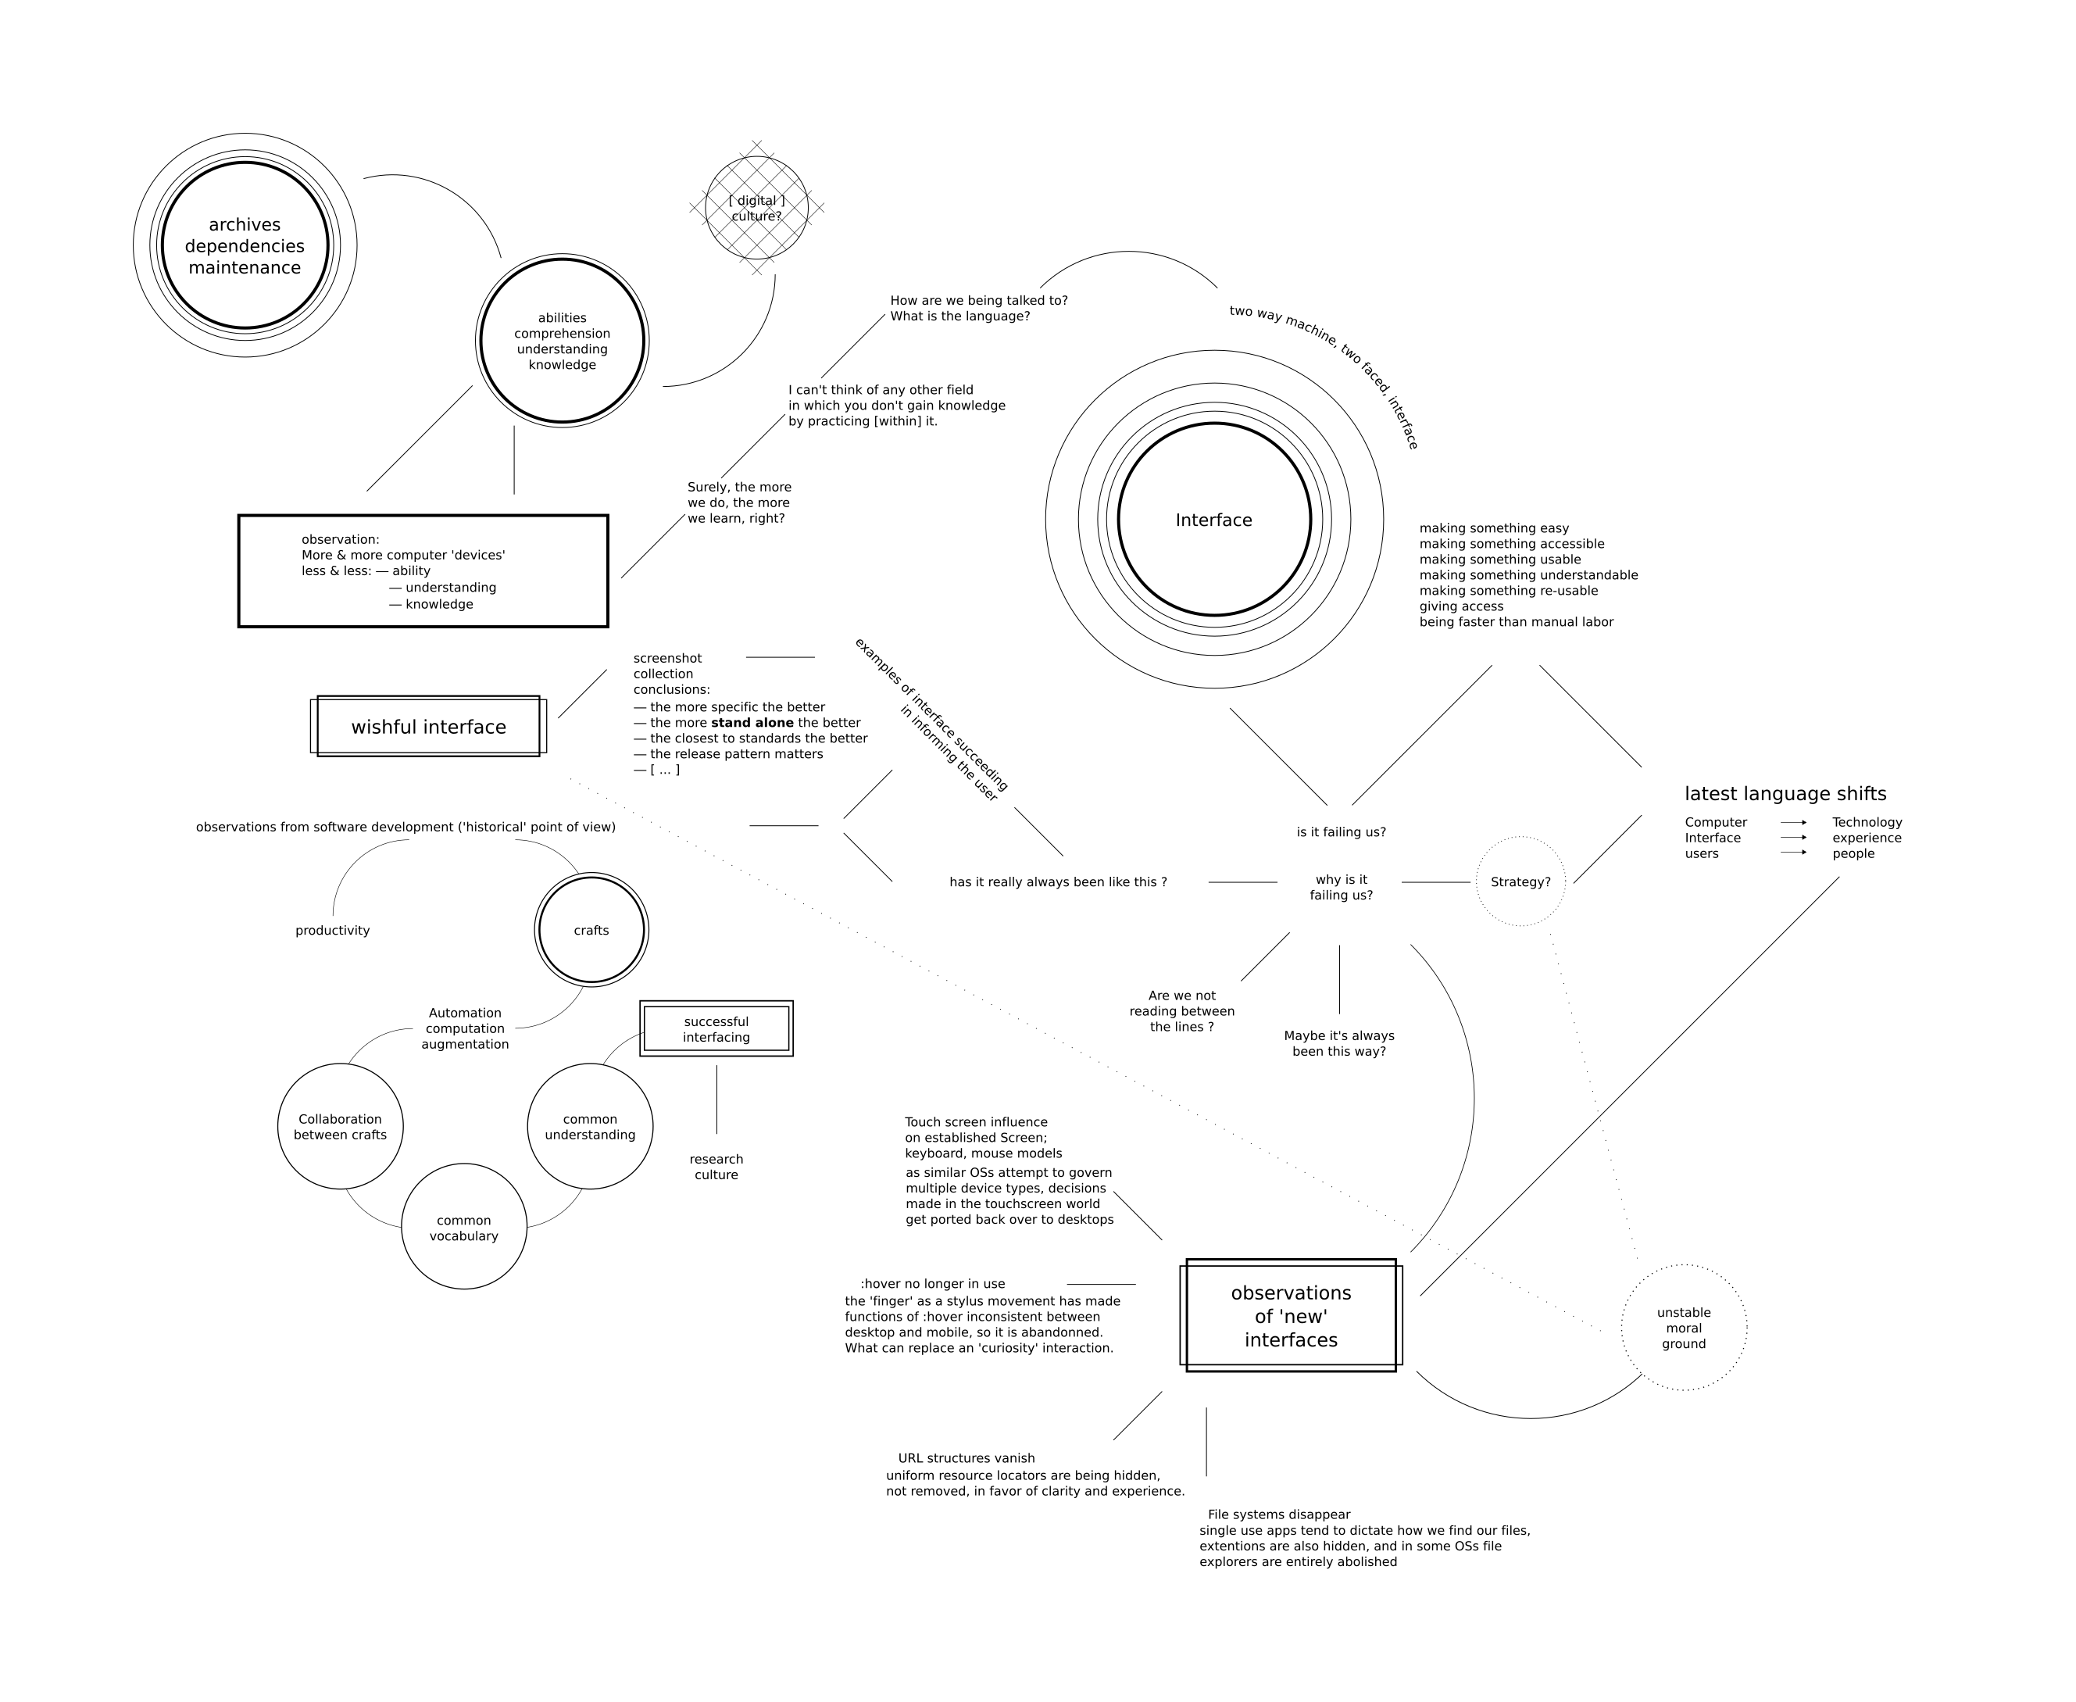
Example of static schematic used to document and explain a body of research
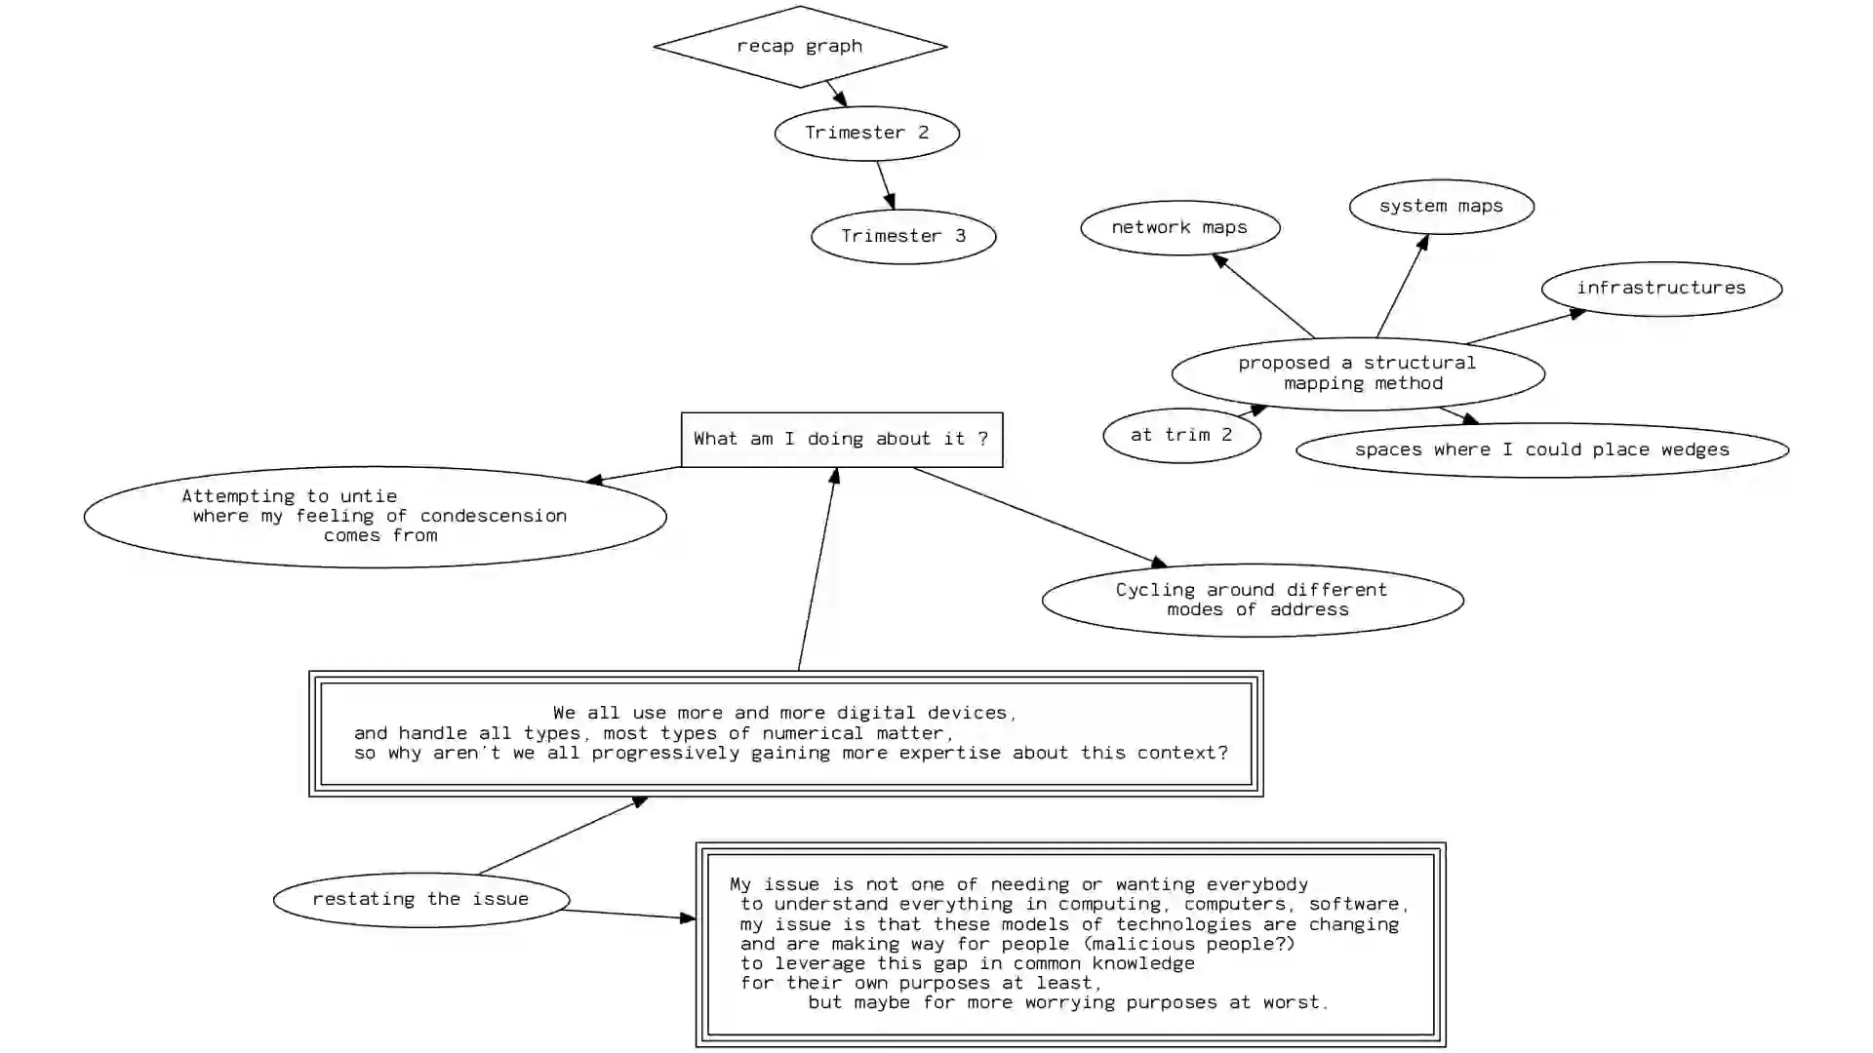

Example of animated schematic visible at http://pzwart1.wdka.hro.nl/~colm/out-8faster.webm

Drawing curved

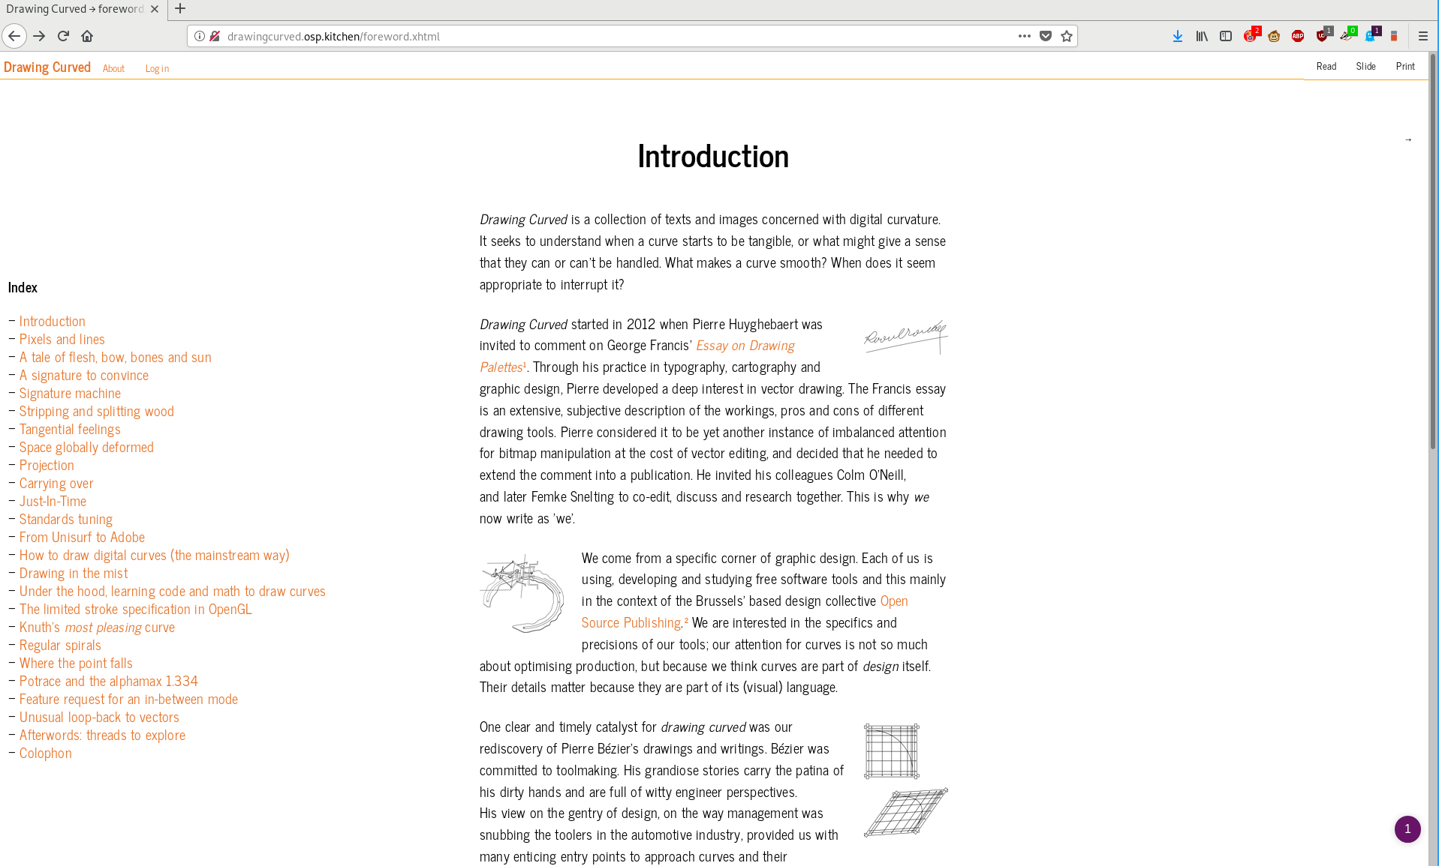
Drawing Curved is a research text on the topic of computed curves, co written with Pierre Huyghebaert, 2012 — 2017
“ Drawing Curved is a collection of texts and images concerned with digital curvature. It seeks to understand when a curve starts to be tangible, or what might give a sense that they can or can't be handled. What makes a curve smooth? When does it seem appropriate to interrupt it? ”
http://drawingcurved.osp.kitchen


