Drawing curved
An essay of a visual collection
on drawing curved vectors
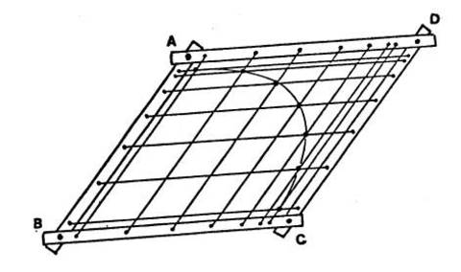
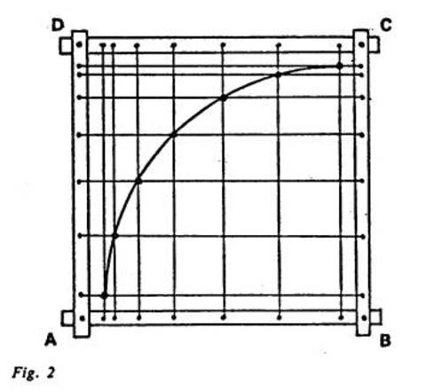
Just before to die, Pierre Bezier wrote to a researcher on his work :
"My contribution could be summarized by this somewhat strange idea : instead of modifying the shape of a curve, or of a family of curves, it is better to have the space into which we put them globally deformed.
The straight line is not... and so on.
Best wishes,
P. Bézier"

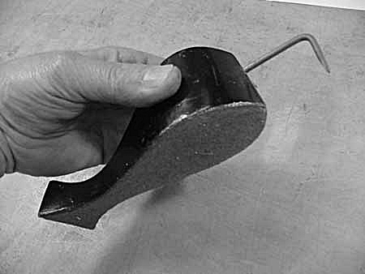
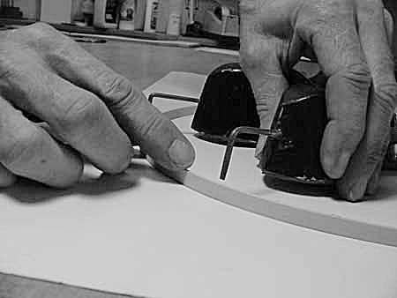
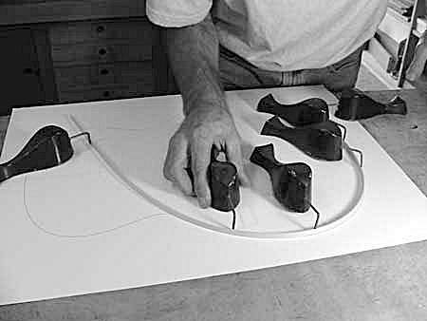
To draw perfect curves, boats architects and music instruments makers ticks lead weights on a thin strip of perfectly clear grain wood, bends it to the shape, and holds it in place with the weights.
The exact dimensions of the wood aren't significant, although it must be consistent in thickness and width, and bend easily to the curves desired, several thicknesses are used for different radius curves.
The guitar maker Ed Claxton of Santa Cruz repeat the gestures of everyone who has to design
or build irregularly curved objects such as boats, planes, cars, or complex roofs. In fact any objects that has to play nicely with flows. They go by various names depending on who's using them,
in cars curves are spline and weights are ducks , roofers who lay out "eyebrow" shingled roofs just use a straight strip of plywood and a couple of nails. Under Ed fingers, “just like magic, the wood strip springs out or in just a teeny bit to smooth out the curve. A couple of trips around the curve, and it comes out perfectly aligned. For sure, this is a trick that works so well, it is really not possible to describe adequately. You really should see it in action. Working a section at a time, he gets each curve just right. Of course, it's no trick at all to draw a pencil line along this strip.

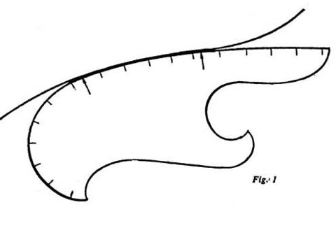
Trouver une portion sur un étalon pré-existant.
Comment étaient produits les gammes de pistolets?

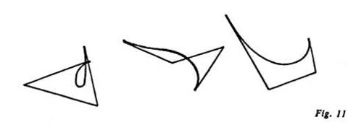
Exercice : can you list different physical processes that describe in other way the process Bezier produces

(idem) Pantographe - changement d'échelle (?)

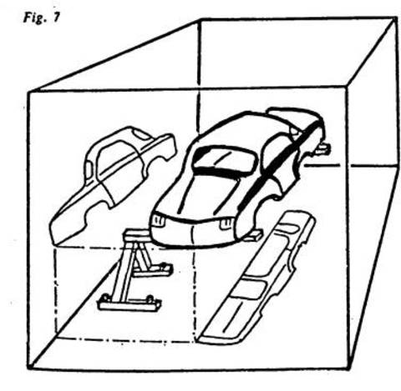
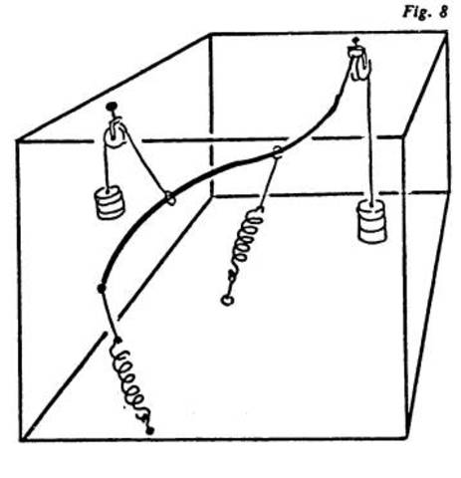
Vieilles techniques de reproduction, utiles chez Renault

"By the mid-1950s, Toyota Motor Corporation of Japan began to explore a more fluid production model. Without the massive warehouse spaces available to store inventories required for an Assembly-Line, Toyota developed the Just-In-Time production model and inverted the stakes of manufacturing. By exploiting and implementing a fluid communications infrastructure along the supply line of parts, manufacturers, labor and customers, Toyota could maintain smaller inventories and make rapid adjustments. A quicker response time was now possible and products could be made when they were needed. All of the work could be handled by a wider number of less-specialized workers and design revisions could be made on-the-fly without shutting down production and re-tooling. The result was an immediate surplus of cash (due to reduced inventories) and a sustainable, responsive design and production system—smaller warehouses, faster communications networks, responsive and iterative design revision and products made as they are needed: Just-In-Time."
Link with the car industry →Bezier - Modules... Logiciel... Retooling - ce n'est pas pour rien que les courbes de béziers ont été créees par un outilleur de l'industrie automobile). Position ingrate, doivent inventer des outils mais sans réellement savoir l'application.

Capture d'écrans de logiciels de 2D/3D montrant des voitures. - Les belles courbes

Customizing - hot rods – Ford T - standards

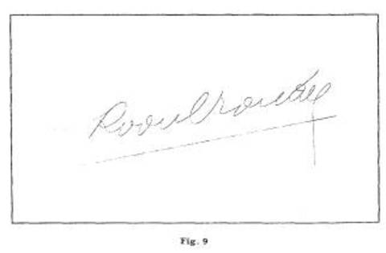
Pour convaincre les dirigeants de Renault, ils reproduisent l'écriture: signature du trésorier de la Banque de France, imprimée sur tous les billets de l'époque - Rapport à l'écriture/typographie
le geste est la forme la plus libre qui soit,
rapport à la copie: faire aussi bien que l'original
"With any new palette you encounter, try to execute your signature. If it comes out looking half-way decent, then the pencil is being splined" http://new.math.uiuc.edu/netgeom/advice/palettes.html
signature = trace du corps

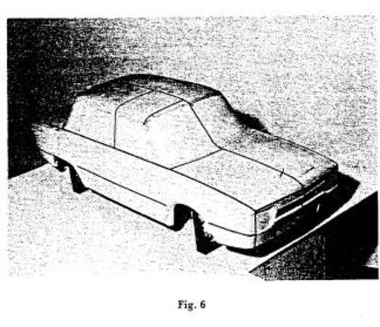
Manuel d'Unisurf
Essayer le visual basic
http://www-gmm.insa-toulouse.fr/~rabut/bezier/
extra/mono-basic 2.10-3 - Mono Visual Basic.NET compiler

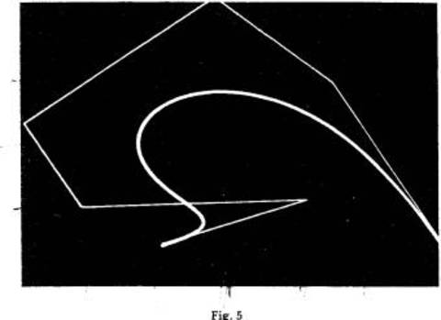
http://www.jstor.org/discover/10.2307/77846?uid=3737592&uid=2&uid=4&sid=21102269602281
(demander à Lilly)
À creuser. Chercher des gens chez Renault qui connaissent Unisurf.
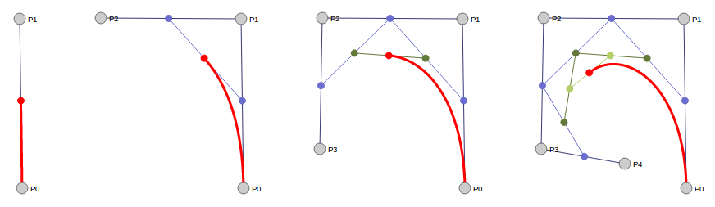
Re-read how manuals try to describe this distorsion - Comment on apprend à dessiner les courbes Bézier - Adobe

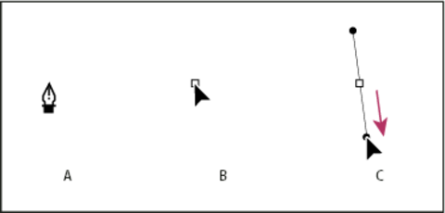
Drawing the first point in a curve
A. Positioning Pen tool
B. Starting to drag (mouse button pressed)
C. Dragging to extend direction lines

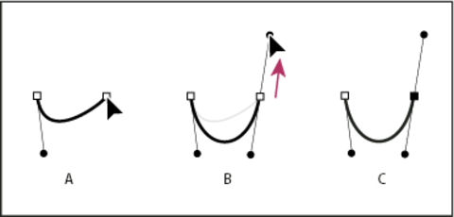
Position the Pen tool where you want the curve segment to end, and do one of the following:
To create a C-shaped curve, drag in a direction opposite to the previous direction line. Then release the mouse button.

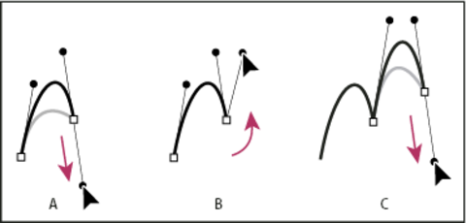
Drawing the second point in a curve
A. Starting to drag second smooth point
B. Dragging away from previous direction line, creating a C curve
C. Result after releasing mouse button

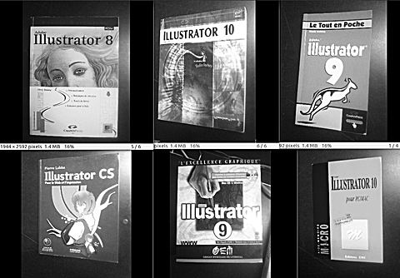
Relire comment les manuels décrivent le dessin en Bezier pour chaque logiciel - Le tout en poche
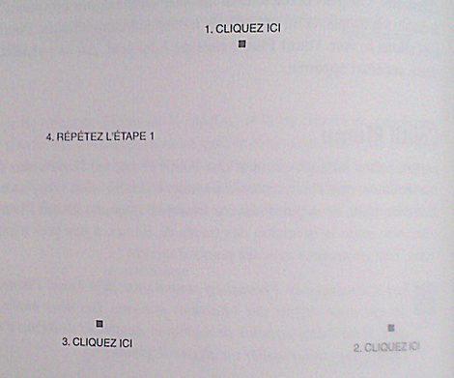
Is drawing curves is drawing in the mist?

Point-and-click - selection systems
mécanismes de sélections
Question de la représentation des points, des sélections, des courbes

LisaDraw
Xerox Star
http://www.youtube.com/watch?v=ODZBL80JPqw

Xerox Alto with Bravo
http://bitsavers.informatik.uni-stuttgart.de/pdf/xerox/alto/BravoXMan.pdf
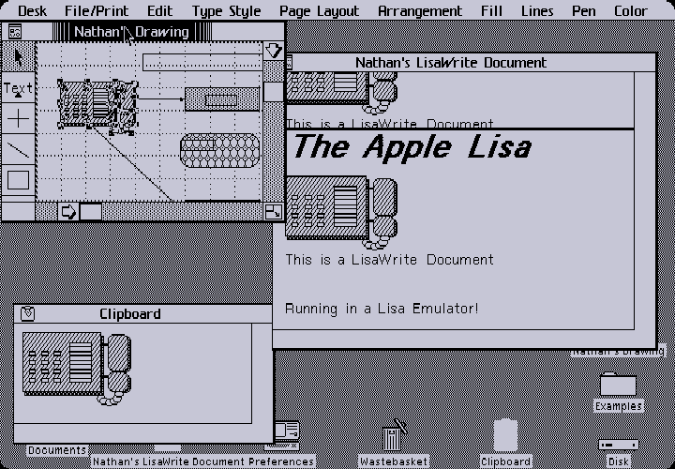
SIL and Draw
http://history-computer.com/Library/AltoUsersHandbook.pdf

MacDraw
Sodipodi -no manual?
Inkscape
KSEG
FontForge
FontLab
Freehand - http://www.adobe.com/products/freehand/productinfo/features/
http://www.adobe.com/support/freehand/vectors/using_pen_tool/using_pen_tool03.html

FontStudio Letrastudio
http://designarchives.aiga.org/#/entries/%2Bid%3A4034/_/detail/relevance/asc/0/7/4034/letraset-package-systemletrastudio/1

Photoshop > Illustrator
SK1
LibreOffice
Gimp
Scribus
CorelDraw
Fontographer
Blender
SketchUp
Paint
Jpicedt
http://typism.appspot.com
http://fontclod.meteor.com/

Robofont
http://support.xara.com/ : no manual svgedit (editeur de fontes en ligne)
http://typism.appspot.com
Kalliculator: http://www.kalliculator.com/
font constructor: http://www.fontconstructor.com
rounding ufo: http://roundingufo.typemytype.com
ufo stretch: http://ufostretch.typemytype.com/
superpolator: http://superpolator.com/

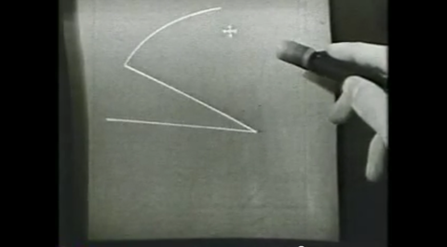
Spiro
https://github.com/monkeyiq/fontforge

Speculations

tester sur un dessin canonique et noter chaque différence précise. Tenter de relater une expérience du dessin
- Use the Tiger example
http://en.wikipedia.org/wiki/Comparison_of_vector_graphics_editors

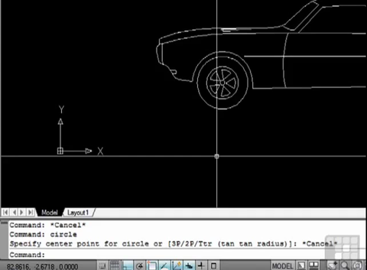
Graphical Shell prototype
lien avec le GSp dans la mesure où on édite le tool on the spot
AutoCAD Command line and Dynamic Input
http://new.math.uiuc.edu/netgeom/advice/palettes.html

Pierre: Bitmap: photoshop/gimp
parler du manque apparent entre les deux parties (dessin, géometrie)
disparition/disparité

Alan Kay on OOP: http://marcusdenker.de/AlanKayOOP.html

A few pictures of a future font editor with history interface

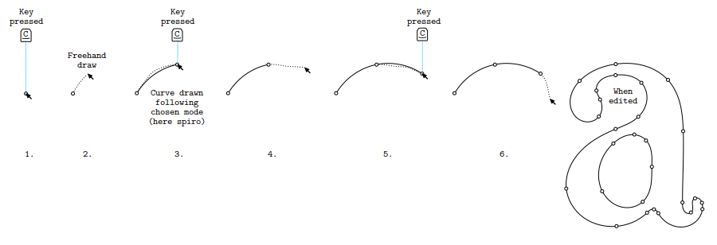
Multi-level type design interfaces
Type design is an iterative process of refining design directions. Starting from a better understanding of what happens when you design a font, we worked on a type design environment that moves more fluently between different scales of design: From single glyphs to letter-pairs and textblocks but also to move between different versions of both digital and hand-drawn sketches. Some of these features can be already discovered in Fontmatrix: http://oep-h.com/fontmatrix

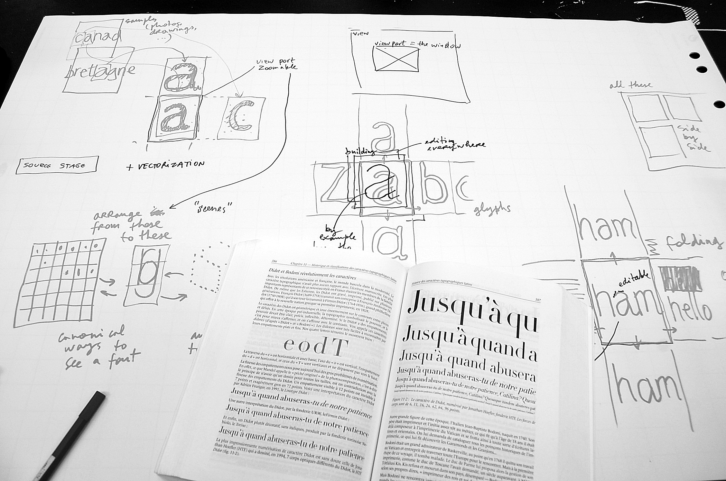
Essai visuel: dessiner une courbe de bézier.
bezier fontographer

8< - - -
"L'aventure de Pierre Bézier aurait pu s'arrêter là. Mais, à l'autre bout du monde, des années plus tard, un groupe de développeurs liés à Apple créa un langage adapté à la future imprimante laser conçue pour le Mac. Il s'agissait de trouver un moyen de définir mathématiquement une courbe, comme le tracé d'un caractère, avant de l'envoyer à l'imprimante...

L'un de ces développeurs, John Warnock, connaissait le travail du Français. Tout naturellement, il choisit les courbes de Bézier comme base du langage PostScript et fonda la société Adobe. On sait comment le PostScript fit la fortune de cette start-up devenue multinationale. Et comment le nom de Pierre Bézier fut popularisé par un autre best-seller d'Adobe, le logiciel de dessin Illustrator. Aujourd'hui, les graphistes et designers utilisent l'outil Plume et tracent des courbes de Bézier sans avoir la moindre idée de leur origine, un peu comme monsieur Jourdain faisait de la prose sans le savoir..."
- - - >8
http://rocbo.lautre.net/bezier/pb-indus.htm

Femke's restitution of co-position LGRU session
http://blogs.lgru.net/ft/theme/co-position/100-idees

http://git.constantvzw.org/?p=lgru.reader.drawing-curved.git;a=blob_plain;f=ill_sdw_edit_closed_shape.png
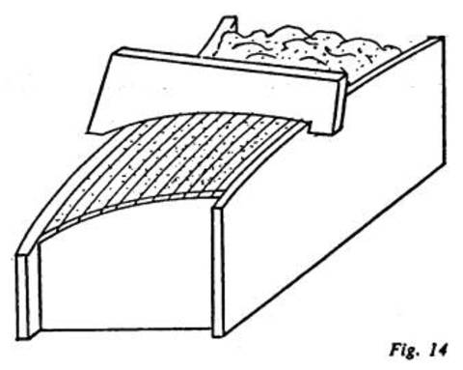
Question of time in the way of drawing - pauses - relationship wth the stroke and the time of the drawing of the stroke
what happened when you want to pause your pen?
Expliquer les différents types de points
sur un "d" - avec des tensions variables

2D/3D rabbatement sans contrainte, opposé à rencontre avec une surface = contrainte
photo d'ombre de sein sur le sable + dessin d'un sein sur le sable
?
rapport skin-bone typographie, trait - approche par le bord, ocr

vector comme 'peau' de la matière = trace d'un mouvement ou d'une tension
baguette = tension principale dans un sens = ligne
spline

compression video qui utilise la vectorisation + interpolation
description de la matière par sa limite avec la lumière

-----------------

Some quotes
"And each has a different palette (a.k.a. drawing toolbar) reflecting a different philosophy of what constitutes a minimal set of drawing tools."

"Not every fat-bits tool since works the way it did in MacPaint."

"(on Ipaint palette) But the spline tool takes some getting used to, and it helps to know how Bezier splines work." [...] "Circles are special ellipses. Most surprisingly, circles don't have a center or radius. You have to guess." [...] If it matters how your figures look, use proper geometry drawing tools, many of which are also free.

(on vector graphics) "the figure on the screen can re-addressed with a picking tool, and edited. For example, it can be deleted. The document stores only the data needed for the Bresenham line to be drawn."

(on word's whiteboard) "Curiously, the Whiteboard uses an advanced feature more proper to advanced tools, like Photoshop, namely so-called layers . This permits a level of interactivity of several users which is not typical of blackboard, or real whiteboards. This makes its use non-intuitive."

(on KSEG) "KSEG creates new points with the right mouse, and that is where geometry begins, with points! Everything else is a construction. " [...] "Suppose you specify three points (hold the shift key as you select three already constructed points), what do they specifiy geometrically speaking? The options that are available. Thus you can click the segment (you get a polygon), the lines (you get a tri-lateral), the arc (you get an arc). But why not circle. Because you should construct your circle from more primitive constructions. Baran is a minimimalist, in many ways."

projects / lgru.reader.drawing-curved.git / tree
"On pourrait résumer mon apport par cette idée un peu bizarre : au lieu de déformer une courbe, ou une famille de courbes, il vaut mieux faire subir une distorsion générale à l'espace dans lequel on les a incluses. La ligne droite n'est pas... etc. Bien cordialement, P. Bézier"
http://www.frets.com/FretsPages/Luthier/TipsTricks/DraftingWeights/draftweights.html
http://www.dextersinister.org/index.html?id=3
http://help.adobe.com/en_US/illustrator/cs/using/WS3f28b00cc50711d9-2cf89fa2133b344d448-8000.html#WS55B8A5DC-5496-494d-ADA8-FFE0FA5DAEA1

