**LAB 04 – RDS & DYNAMODB**

**Họ tên: Nguyễn Tấn Lộc**

**MSSV: 21059391**

1. **RDS**

* Create database

* Set public access, port

* Set username, password

* Create database

* Set rule Security Groups

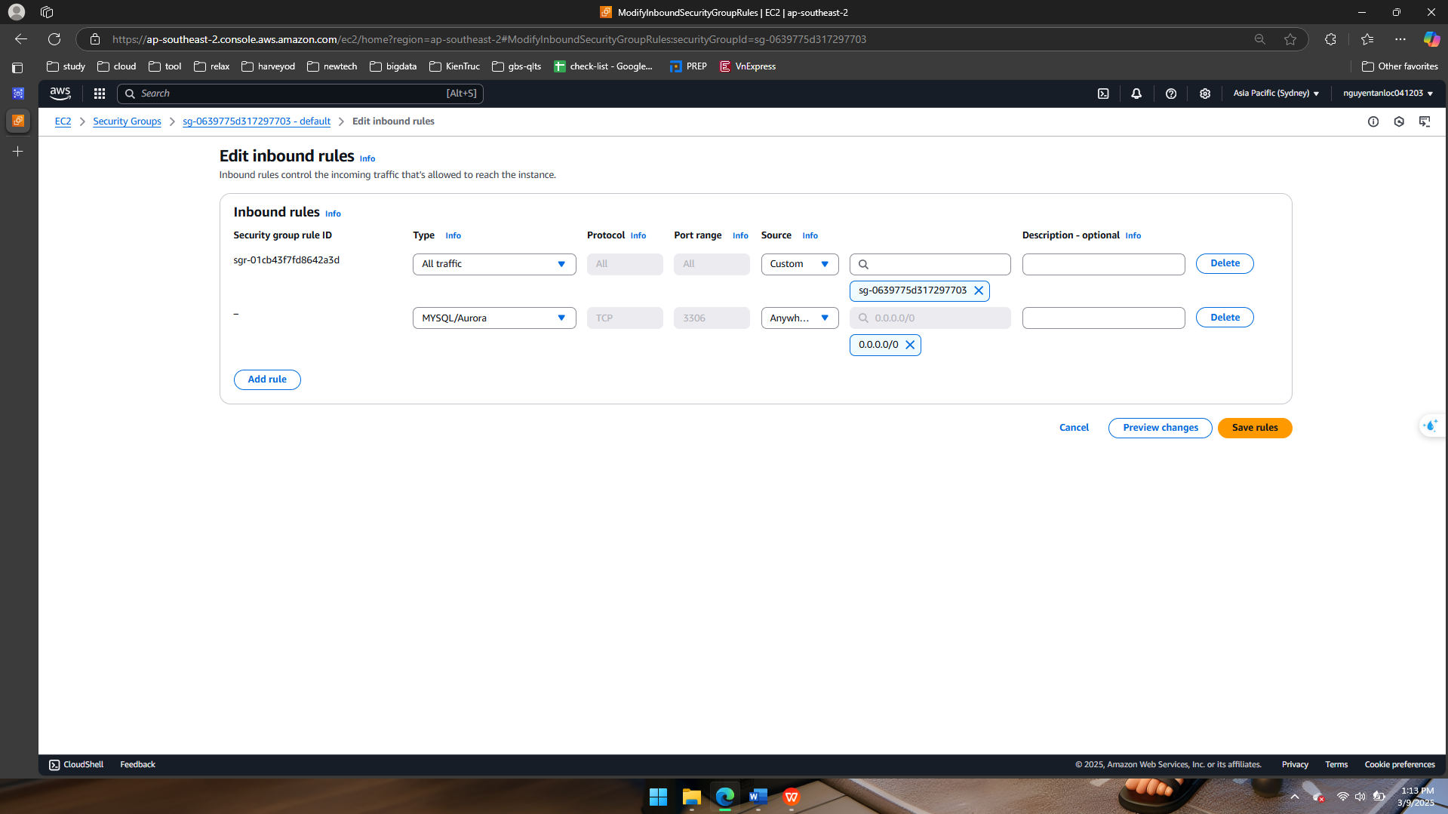

* Connect MySQL

1. **DYNAMODB**

* Create Table

* Create item in table

* Result

