- Update trang index.js

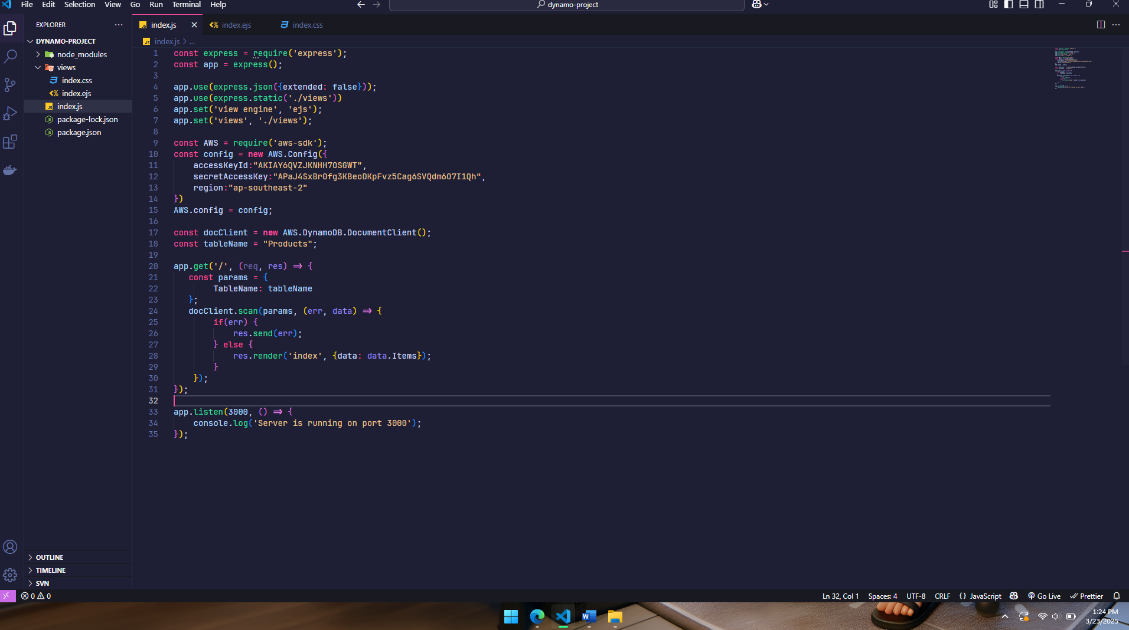

- Update file css

- Update file ejs

- DynamoDB

- Màn hình localhost:3000

- Cập nhật file index sau khi cài multer

- Update web có form nhập, thêm mới

- Test thêm mới data

- Update render data sort theo id

- Api delete item

- View delete item

