# Explanation

**Image Retrieval**

Getting the images from the text files was the first challenge we encountered. After looking over the image sets I found out that all the digits images were no more than 20 pixels high and 28 pixels wide and the face images were no more than 70 pixels high and 60 pixels wide. While scanning a text file with digit images the program will ignore whitespace until it encounters a line with something in it besides whitespace and then grab the next 20 lines and convert it into a boolean 2D array that I call the pixels matrix. This method didn’t exactly work for faces because the images were split up evenly every 70 lines. So grabbing face images just meant I had to convert every 70 lines into a 70 x 60 pixel matrix. Once the program grabs all the images it must also grab the associated labels which can easily be extracted line by line. I bundled the true label and pixels of an image together into my own Image object. The raw pixels of an image are the features we are using for classification. The classification algorithms use 2 ArrayLists of image objects corresponding to the training and testing sets. The classification algorithms also use an ArrayList of LabelData objects to hold important data on each label. So if you want to classify faces there will be 2 LabelData objects you need to work with, one for face and one for not-face.

**Naive Bayes**

To classify an image with NaiveBayes you must first create a NaiveBayes object which will train on the given training set. It trains in the initialize(...) method by iterating through all the training images keeping track of how many times each pixel is true for each label. This information is held in a 2D int array called trueFeatures which is a field of the LabelData object. Each label will have its own trueFeatures matrix whose size is the same as the pixel matrix. So for the sake of clarity, each element of the trueFeatures matrix indicates how many times the corresponding pixel is true for a particular label. The trueFeatures matrix of each label makes a lot of the necessary calculations easier. To classify an image the program must determine the most likely label for the image by iterating through each possible label and determining which one has the highest probability. I got how to determine the probability of a label from the berkeley resource the professor posted. The equation for the probability of label y can be written as log(P(Y)) + summation[i:m] {log (P(fi | y) )} where P(Y) is the “prior distribution” of label y and P(fi | y) is the probability of feature fi given the label y. The prior distribution for a label is easy to compute since it is the the number of times the label shows up in the training images divided by the total number of training images. The probability of feature fi given label y can be computed by dividing the [number of times fi takes on the value it does in the image for each image in training set labeled as y] by [the number of times label y appears in the training data]. So to determine the error of classifying with naive bayes the program iterates through all the testing images, choosing the most likely label and incrementing a counter every time the classification is wrong. After iterating through all the images the number of failed classifications over the total number of training images is the percent error.

**Perceptron**

We implemented the Perceptron algorithm, computing the class with highest score as the predicted label for that data instance with \begin{displaymath}
\mbox{score}(f,y) = \sum_i f_i w^y_i
\end{displaymath}. Using a weight matrix to give weight to each feature, given a feature list f, the perceptron computes the class y whose weight vector is most similar to the input vector f. We scan over the data, one instance at a time. When we come to an instance (f,y), we find the label with highest score:

\begin{displaymath}
y' = \textmd{arg max}_{y''} score(f,y'')
\end{displaymath}. We then compare it to the true label, if equivalent we do nothing; if it is not equal we update the matrices accordingly w=w+f, w=w-f. This trains our data to prevent error in the future. To determine the error of classifying with Perceptron the program iterates through all the testing images, choosing the most likely label and incrementing a counter every time the classification is wrong. After iterating through all the images the number of failed classifications over the total number of training images is the percent error.

**MIRA**

The MIRA classification algorithm is very similar to the Perceptron algorithm, where We scan over the data, one instance at a time. When we come to an instance (f,y), we find the label with highest score:

\begin{displaymath}
y' = \textmd{arg max}_{y''} score(f,y'')
\end{displaymath}. We then compare it to the true label, if equivalent we do nothing; if it is not equal we update the matrices (this is where MIRA classification differs) according to the function 

where . Every time we run through our training images, we alter our weight Matrix according to these algorithms to better classify future images. To determine the error of classifying with MIRA the program iterates through all the testing images, choosing the most likely label and incrementing a counter every time the classification is wrong. After iterating through all the images the number of failed classifications over the total number of training images is the percent error. The training times of MIRA and Perceptron are very similar because they both have the same time limit on updates.

# Performance

*This is the data of the time needed for training on face images with the Naïve Bayes Algorithm. I did 3 trials for each group of data points.*

|  |  |
| --- | --- |
| Data Points | Training Time (seconds) |
| 45 | 0.004 |
| 45 | 0.004 |
| 45 | 0.004 |
| 90 | 0.007 |
| 90 | 0.005 |
| 90 | 0.004 |
| 135 | 0.005 |
| 135 | 0.005 |
| 135 | 0.005 |
| 180 | 0.007 |
| 180 | 0.008 |
| 180 | 0.006 |
| 225 | 0.008 |
| 225 | 0.01 |
| 225 | 0.006 |
| 270 | 0.008 |
| 270 | 0.011 |
| 270 | 0.008 |
| 315 | 0.011 |
| 315 | 0.011 |
| 315 | 0.012 |
| 360 | 0.016 |
| 360 | 0.017 |
| 360 | 0.013 |
| 405 | 0.016 |
| 405 | 0.013 |
| 405 | 0.013 |
| 451 | 0.015 |
| 451 | 0.015 |
| 451 | 0.012 |

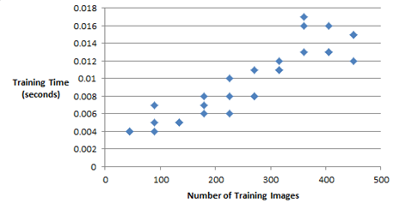

*This is the data for the prediction error on faces in relation to the number of data points used.*

|  |  |
| --- | --- |
| Data Points | error |
| 45 | 0.307 |
| 45 | 0.227 |
| 45 | 0.293 |
| 90 | 0.147 |
| 90 | 0.153 |
| 90 | 0.186 |
| 135 | 0.147 |
| 135 | 0.133 |
| 135 | 0.16 |
| 180 | 0.147 |
| 180 | 0.147 |
| 180 | 0.133 |
| 225 | 0.14 |
| 225 | 0.147 |
| 225 | 0.12 |
| 270 | 0.127 |
| 270 | 0.127 |
| 270 | 0.12 |
| 315 | 0.113 |
| 315 | 0.12 |
| 315 | 0.153 |
| 360 | 0.127 |
| 360 | 0.127 |
| 360 | 0.106 |
| 405 | 0.087 |
| 405 | 0.1 |
| 405 | 0.107 |
| 451 | 0.093 |
| 451 | 0.093 |
| 451 | 0.093 |

*The standard deviation is 0.051774267*

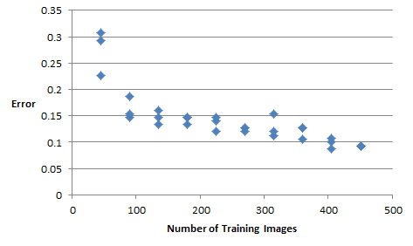

*This is the data for the time needed to train on digit images with the Naïve Bayes Algorithm. I did 3 trials for each group of data points.*

|  |  |
| --- | --- |
| Data Points | Training Time (seconds) |
| 500 | 0.004 |
| 500 | 0.006 |
| 500 | 0.005 |
| 1000 | 0.009 |
| 1000 | 0.008 |
| 1000 | 0.007 |
| 1500 | 0.012 |
| 1500 | 0.013 |
| 1500 | 0.01 |
| 2000 | 0.017 |
| 2000 | 0.013 |
| 2000 | 0.015 |
| 2500 | 0.017 |
| 2500 | 0.016 |
| 2500 | 0.016 |
| 3000 | 0.019 |
| 3000 | 0.016 |
| 3000 | 0.014 |
| 3500 | 0.018 |
| 3500 | 0.025 |
| 3500 | 0.017 |
| 4000 | 0.027 |
| 4000 | 0.029 |
| 4000 | 0.022 |
| 4500 | 0.026 |
| 4500 | 0.021 |
| 4500 | 0.018 |
| 5000 | 0.028 |
| 5000 | 0.03 |
| 5000 | 0.021 |

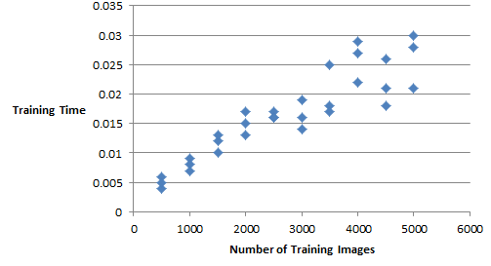

*This is the data for the prediction error on digits in relation to the number of data points used.*

|  |  |
| --- | --- |
| Data Points | error |
| 500 | 0.25 |
| 500 | 0.245 |
| 500 | 0.26 |
| 1000 | 0.241 |
| 1000 | 0.232 |
| 1000 | 0.24 |
| 1500 | 0.246 |
| 1500 | 0.222 |
| 1500 | 0.245 |
| 2000 | 0.242 |
| 2000 | 0.232 |
| 2000 | 0.236 |
| 2500 | 0.243 |
| 2500 | 0.233 |
| 2500 | 0.243 |
| 3000 | 0.24 |
| 3000 | 0.23 |
| 3000 | 0.236 |
| 3500 | 0.237 |
| 3500 | 0.239 |
| 3500 | 0.238 |
| 4000 | 0.246 |
| 4000 | 0.239 |
| 4000 | 0.244 |
| 4500 | 0.239 |
| 4500 | 0.243 |
| 4500 | 0.237 |
| 5000 | 0.238 |
| 5000 | 0.238 |
| 5000 | 0.238 |

*The standard deviation was 0.006792152*

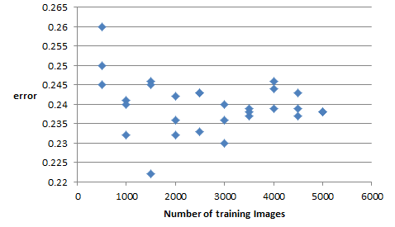

Training Times & Accuracy of Perceptron-Faces

|  |  |  |
| --- | --- | --- |
| *Perceptron-Faces*  **Data Points** | **Training Time (s)** | **Accuracy/**  **Prediction Error**  **@5s an update** |
| 45 | 180s | .303 |
| 90 | 360s | .314 |
| 135 | 540s | .487 |
| 180 | 720s | .387 |
| 225 | 901s | .114 |
| 270 | 1080s | .387 |
| 315 | 1260s | .143 |
| 360 | 1440s | .287 |
| 405 | 1620s | .274 |
| 451 | 1805s | .285 |

Mean Accuracy of 70.19% across data sets or error of .2981

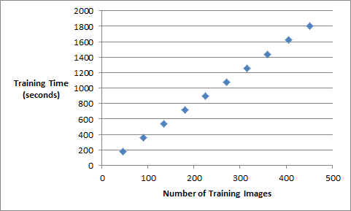

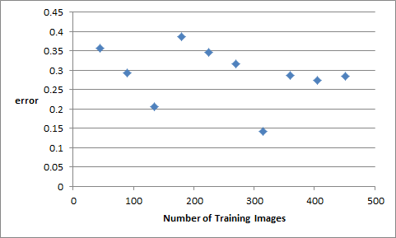

Training Times & Accuracy of Perceptron-Digits

|  |  |  |
| --- | --- | --- |
| *Perceptron-Digits*  **Data Points** | **Training Time (s)** | **Accuracy/**  **Prediction Error @5s an update** |
| 500 | 2500s | .461 |
| 1000 | 5002s | .3 |
| 1500 | 7504s | .314 |
| 2000 | 10006s | .338 |
| 2500 | 12515s | .303 |
| 3000 | 51298s | .291 |
| 3500 | 17500 | .267 |
| 4000 | 20020s | .27 |
| 4500 | 22550s | .134 |
| 5000 | 25008s | .114 |

Mean Accuracy of 72.08% across data sets or error of .2792

Training Times & Accuracy of Mira-Faces

|  |  |  |
| --- | --- | --- |
| *MIRA-Faces*  **Data Points** | **Training Time(s)** | **Accuracy/**  **Prediction Error @5s an update** |
| 45 | 190s | .487 |
| 90 | 400s | .387 |
| 135 | 540s | .36 |
| 180 | 750s | .387 |
| 225 | 931s | .134 |
| 270 | 1180s | .387 |
| 315 | 1360s | .35 |
| 360 | 1480s | .114 |
| 405 | 1635s | .187 |
| 451 | 1895s | .16 |

Mean Accuracy of 70.47% across data sets or error of .2953

Training Times & Accuracy of MIRA-Digits

|  |  |  |
| --- | --- | --- |
| *MIRA-Digits*  **Data Points** | **Training Time(s)** | **Accuracy/**  **Prediction Error @10s an update** |
| 500 | 2550s | .487 |
| 1000 | 5102s | .314 |
| 1500 | 7574s | .238 |
| 2000 | 10106s | .32 |
| 2500 | 12564s | .314 |
| 3000 | 53298s | .287 |
| 3500 | 17500 | .134 |
| 4000 | 20020s | .36 |
| 4500 | 22550s | .187 |
| 5000 | 25008s | .134 |

Mean Accuracy of 72.2% across data sets or error of .278