**AINAK**

**(APP FOR VISUALLY IMPAIRED PERSONS)**

**PROJECT SYNOPSIS**

OF

MINOR PROJECT

**BACHELOR OF TECHNOLOGY**

COMPUTER SCIENCE & ENGINEERING

SUBMITTED BY

CHIRAG PATEL

September 2022

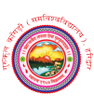

Faculty of Engineering and Technology

Gurukula Kangri (Deemed to be University)

Haridwar, Uttarakhand.