Semester Project
By Viannys Colon and Oskar Sierzega
Databases with Dr. Alex Pezewski
12/8/2025

Project Part I: Adapting a Relational Model to a NoSQL Implementation

Summary of the Relational Implementation
Briefly describe the structure of your original relational model and the queries used to answer Lab 3 questions 3 - 9.
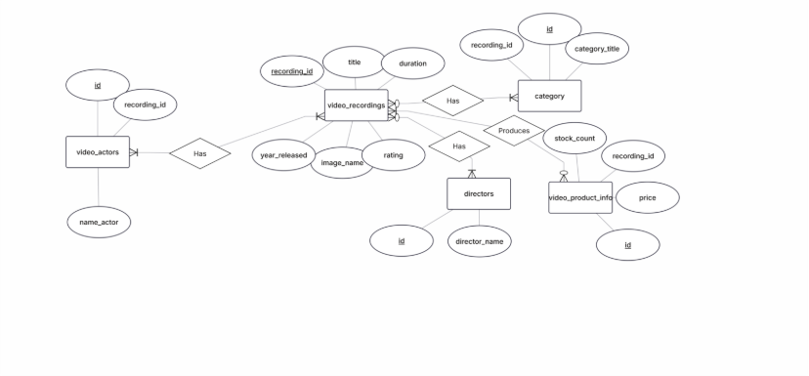
3. SELECT category_title, COUNT(*) AS num_videos FROM recordings GROUP BY category_title;
4. SELECT r.category_title, COUNT(*) AS num_videos FROM recordings r JOIN product_info p ON p.recording_id = r.recording_id WHERE p.stock_count != 0 GROUP BY category_title;
5. SELECT r.category_title, a.name_actor FROM recordings r JOIN actors a ON r.recording_id = a.recording_id;
6. SELECT a.name_actor FROM actors a JOIN recordings r ON a.recording_id = r.recording_id GROUP BY a.name_actor HAVING COUNT(DISTINCT r.category_title) > 1;
7. SELECT a.name_actor FROM actors a JOIN recordings r ON a.recording_id = r.recording_id WHERE r.category_title != '"Comedy"'
8. SELECT a.name_actor FROM actors a JOIN recordings r ON a.recording_id = r.recording_id WHERE r.category_title IN ('"Comedy"', '"Action & Adventure"') GROUP BY a.name_actor HAVING COUNT(DISTINCT r.category_title) = 2;
- 9. SELECT c.category_title, MAX(p.price) AS highest_price FROM product_info p JOIN recordings r ON p.recording_id = r.recording_id JOIN categories c ON r.category_title = c.category_title GROUP BY c.category_title;
9.SELECT r.title, c.category, e.rating FROM video_recordings r INNER JOIN video_categories c ON r.category_id = c.id INNER JOIN video_ratings e ON r.rating_id = e.id
WHERE e.rating NOT LIKE '%R%';

NoSQL Implementation Overview
Explain how you adapted the relational schema to a NoSQL model, using at most three collections.
-video recordings {
_id
Title
Duration
Year_released
Image_name
Rating
Director_id
Category
Price
Stock_count
Actors: [
_id
]
}
-video actors {
_id
Actor_name
}
-video directors {
_id
Director_name
}

Justify your design decisions — for example, document structures, embedded versus referenced data, and key indexing strategies.
We decided to go with a simplified version (like the way the original data set was structured in lab 3) because we felt this worked best document structures. One of the design the decisions we made that supports this is the list of actors that is in video recordings. That lists acts like a forgien key list that stores all the actors in that video by their id. Then in the video_actors collection, we have their id and name. This decision was made to prevent user mistakes like entering their name incorrectly. Since it a list of keys it both an embedded and refenced data structure since it is own list but references a different collection.
We decided not to use key indexing strategies as we wanted to see how the queries would behave with just plain document structures.

Query Execution and Results
Recreate queries used to answer questions 3 - 9 from Lab 3 using your NoSQL model.
For each query, include the resulting output and a brief explanation of your method, code, or approach.
- List the number of videos for each video category
Output:
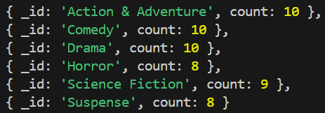
To get this result we selected with an aggregate function to group by category.
- List the number of videos for each video category where the inventory is non-zero
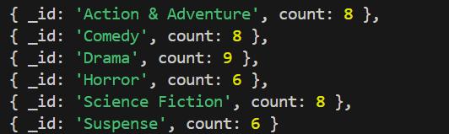
Same method as above, except we filtered based on stock_count $gt 0.
- For each actor, list the video categories that actor has appeared in
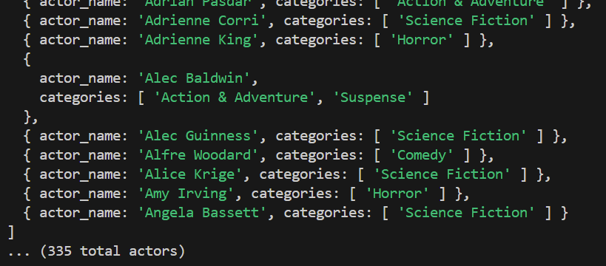
For this we first queried all actors. Then we looped through each actor and queried all the recordings they were apart of, and then returned the unique values for category from those recordings.
- Which actors have appeared in movies in different video categories
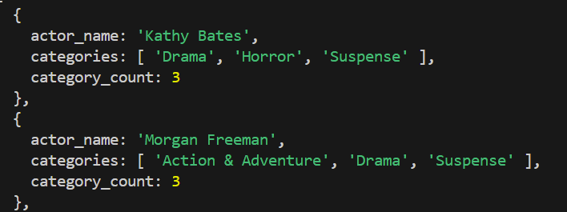
25 total actors were returned. Since we already had the actors and categories data from the previous query, we just used that and filtered with # of categories $gt 1.
- Which actors have not appeared in a comedy
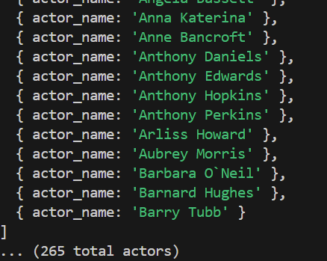
Again, using the data from query three we filtered for all actors where the list of categories did not contain “Comedy”.
- Which actors have appeared in both a comedy and an action-adventure movie
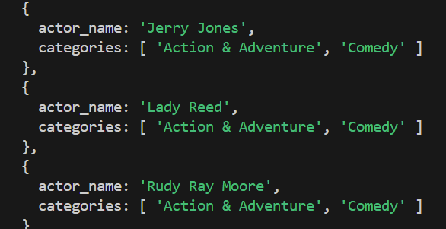
Again, using the data from query three we filtered for all actors where the list of categories contained both “Comedy” and “Action & Adventure”
- Highest price in each category
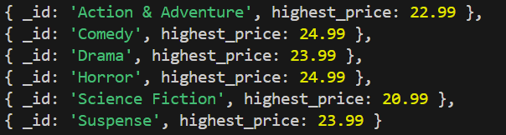
For this query we used an aggregate to group all the recordings by price, and then used the $max function to find the highest price for each category.
- Title, Category, and rating for every video recording NOT rated R?
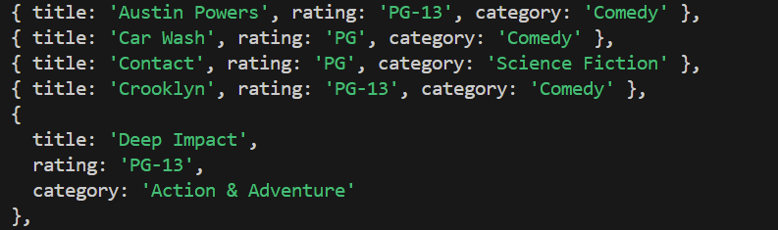
For this we used a simple filter to remove all movies rated R. Then we also used a projection to only retrieve the title, rating, and category.

Comparative Analysis
Provide a concise evaluation of the advantages and disadvantages of using a NoSQL database (e.g., MongoDB) versus a traditional relational database for this dataset.
- One advantage of the NoSQL database was it was really easy to load the data in since we didn’t have to do much transformation from the text files to the json documents. One disadvantage was that we had a lot of duplicate data which led to some inefficiencies, such as storing each rating on the video_recording rather than in its own video_ratings collection.
Which do you prefer using, Relation or Non Relational models? And why?
- I think for this project in particular, we preferred relational models more. The complex queries for grouping by and summation were easier in SQL, maybe because we have more experience with it already.

Project Part II: Original NoSQL Application Design

Data Model and Collections
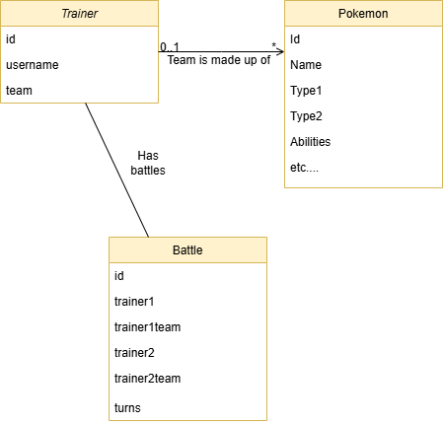
Each of the yellow highlighted boxes is a collection we utilized in the project.
Here is the actual code of the models we used, in the form of typescript interfaces:
export interface Pokemon {
_id: string;
Id: string;
Name: string;
Type1: string;
Type2: string | null;
Abilities: string[];
Category: string;
HeightFt: string;
HeightM: string;
WeightLbs: string;
WeightKg: string;
CaptureRate: string;
EggSteps: string;
ExpGroup: string;
Total: string;
HP: string;
Attack: string;
Defense: string;
SpAttack: string;
SpDefense: string;
Speed: string;
Moves: Record<string, Move>;
}

export interface Move {
Type: string;
Level: string;
Power: string;
Accuracy: string;
PP: string;
EffectPercent: string;
Description: string;
}

export interface Trainer {
username: string;
team: Pokemon[];
}

export type BattleStatus =
| "new"
| "trainer1turn"
| "trainer2turn"
| "trainer1win"
| "trainer2win"
| "cancelled";

export interface PokemonStatus {
hp: number;
}

export interface BattleTurn {
turnNumber: number;
movingTrainer: 1 | 2; // 1 for trainer1, 2 for trainer2
moveUsed: string | null; // move used by the active pokemon, null on first or switch out pokemon
pokemon1: number; // index of pokemon in trainer1team
pokemon2: number; // index of pokemon in trainer2team
team1status: PokemonStatus[]; // status of all pokemon in trainer1team
team2status: PokemonStatus[]; // status of all pokemon in trainer2team
}

export interface Battle {
_id: string;
status: BattleStatus;
trainer1: string;
trainer1team: Pokemon[];
trainer2: string;
trainer2team: Pokemon[];
turns: BattleTurn[];
}

Complex queries
- Connecting 6 pokemon to be on a trainers team
This would be an insert/update on the teams table that would also have to join on the trainers table to get the necessary information. Picture below, users are able to create/customize their team on the Trainer page
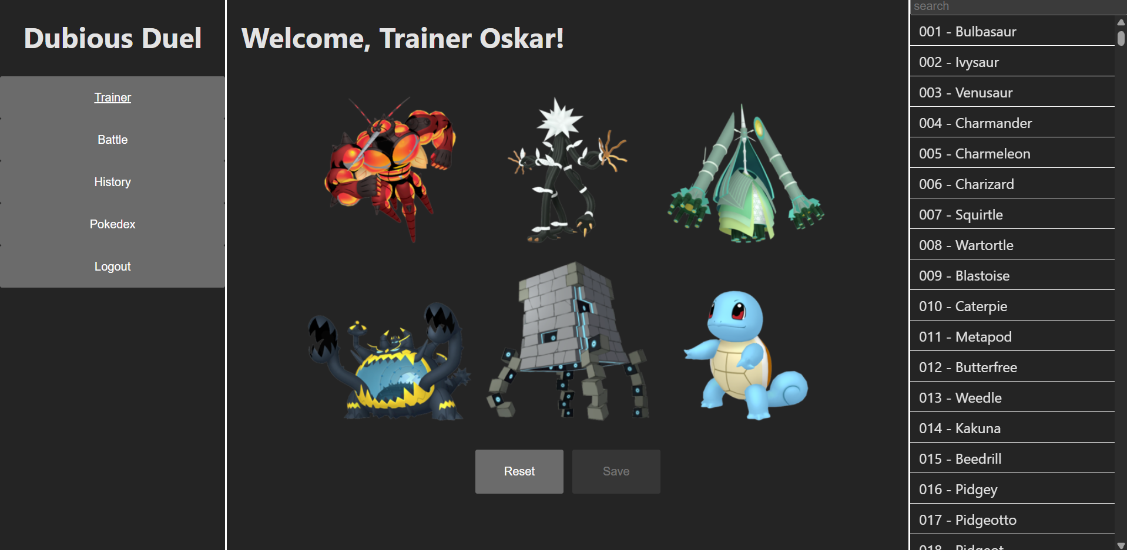
- Removing and adding pokemon to a trainers team and saving
This would also be an insert/update on the teams table that would also have to join on the trainers table to get the necessary information.
- Creating a new open battle
This would be an insert on the battles table that would also have to join on the trainers and teams table to get the necessary information. Picture below, the “Start New Battle” button is clicked to create a new battle
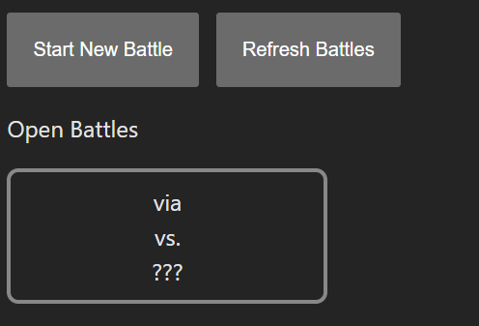
- Entering a battle with another trainer
This would be an update on the battles table that would also have to join on the trainers and teams table to get the necessary information. Picture below, modal that allows trainers to inspect the other team before deciding whether to accept the battle.
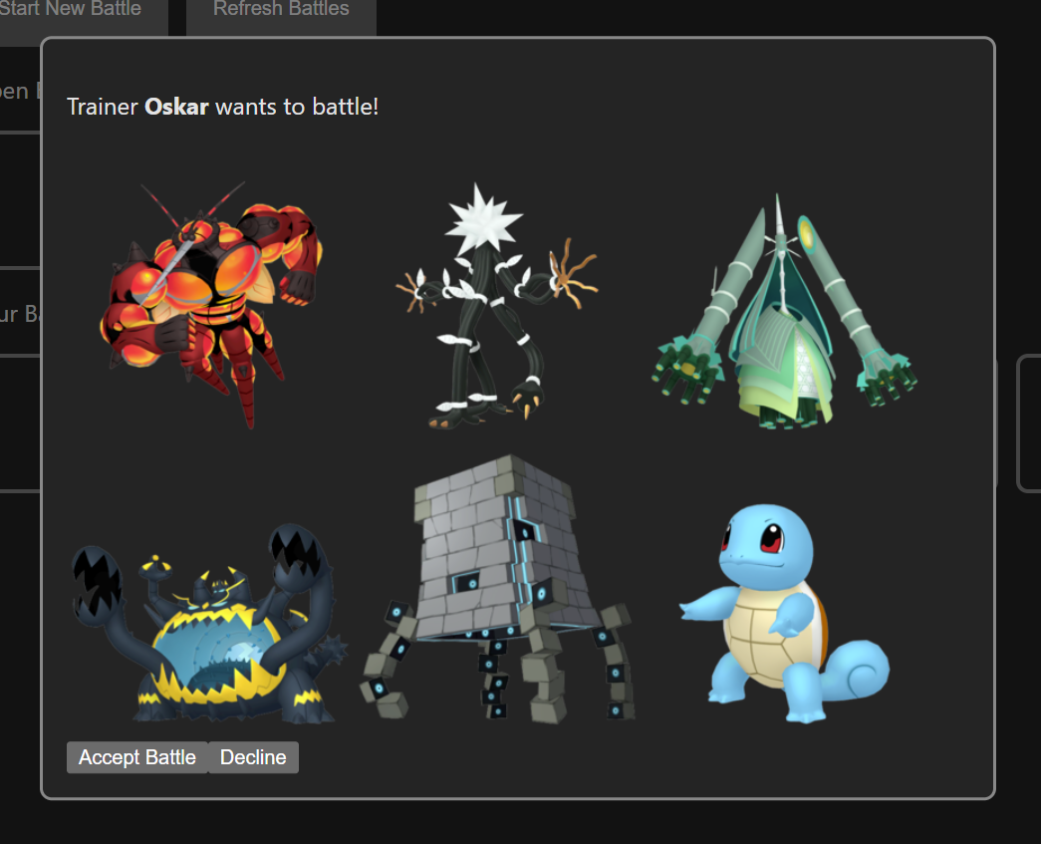
- Updating a battle with a turn
This would have been multiple inserts and complex where logic into the BattleTurns table, while also referencing other tables to get information and performing many validation checks. Below is the code for this query, a lot of it is just calculation and validation but it is still very long:
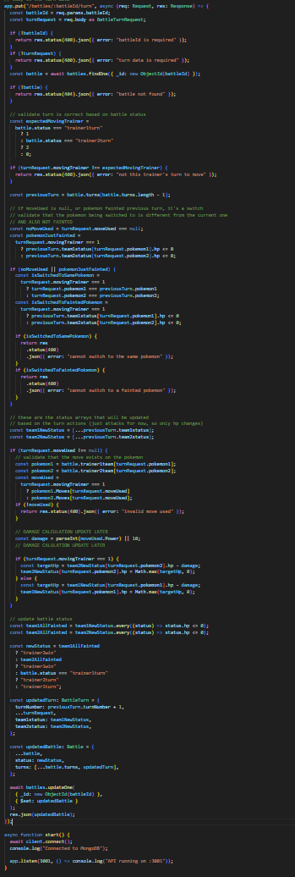
- Getting all pokemon with all data and moves
If we were to be doing this in a relational database, we would need to do multiple conditional joins on Pokemon table, Moves table, and PokemonMoves table.
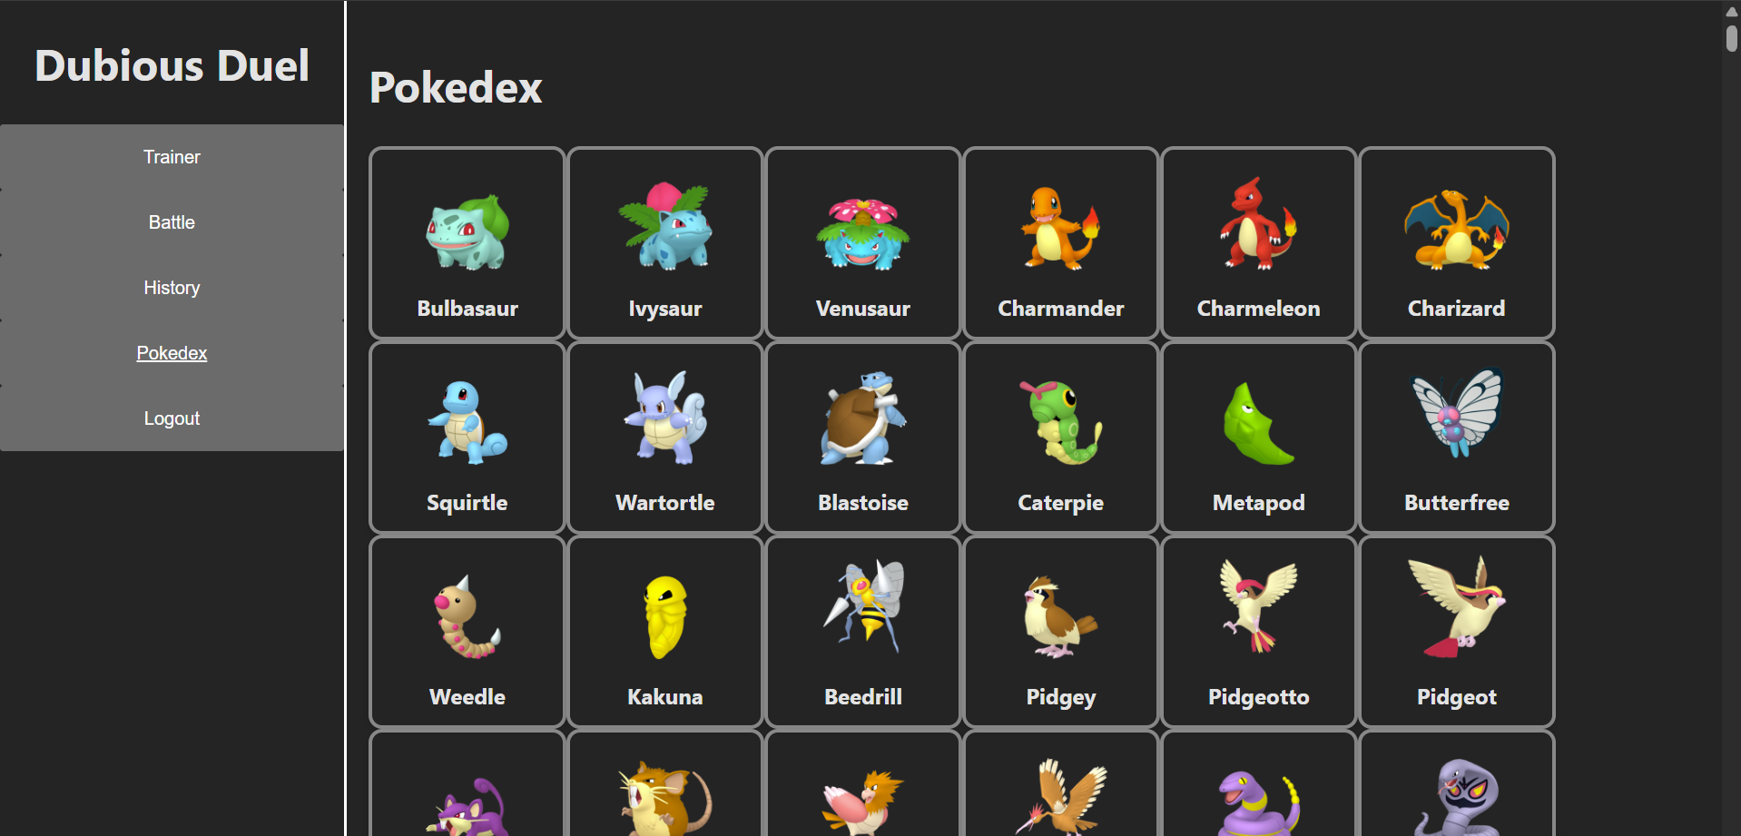

AI Use
Throughout the project there was pieces of work that were made easier through AI – an example of this is the CSS pages. Styling and layout can get tricky especially if you CSS is a little rusty.
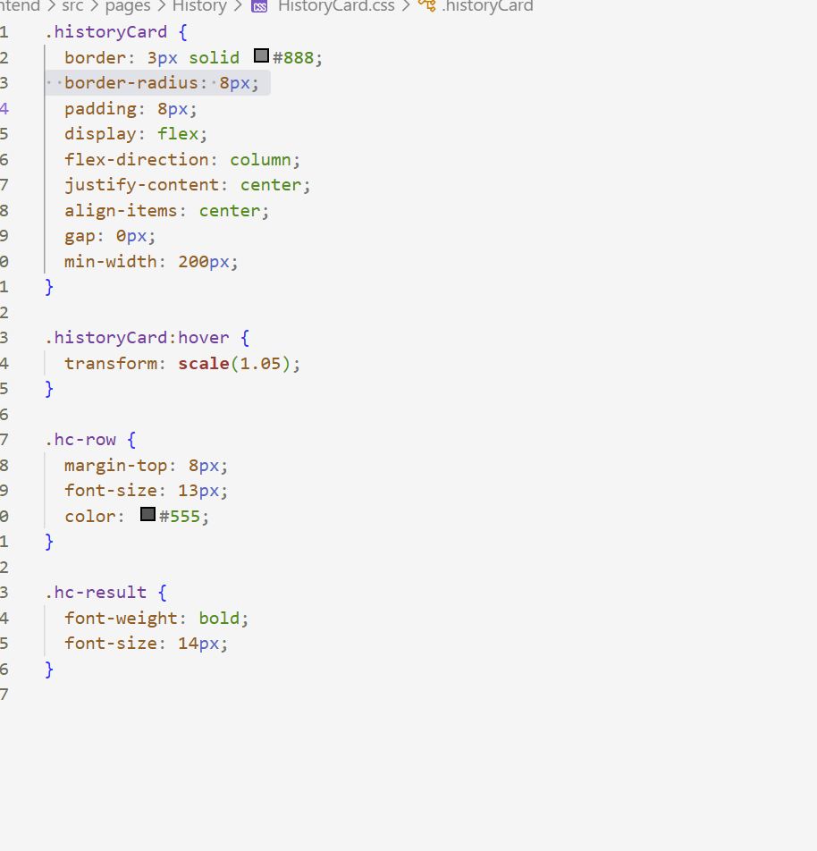

This also goes for certain aspects of the layout
Here I was unsure of how to put the Pokémon image on the left and have the status on the right. Since the page was getting long, I also used AI to add a scroll bar.
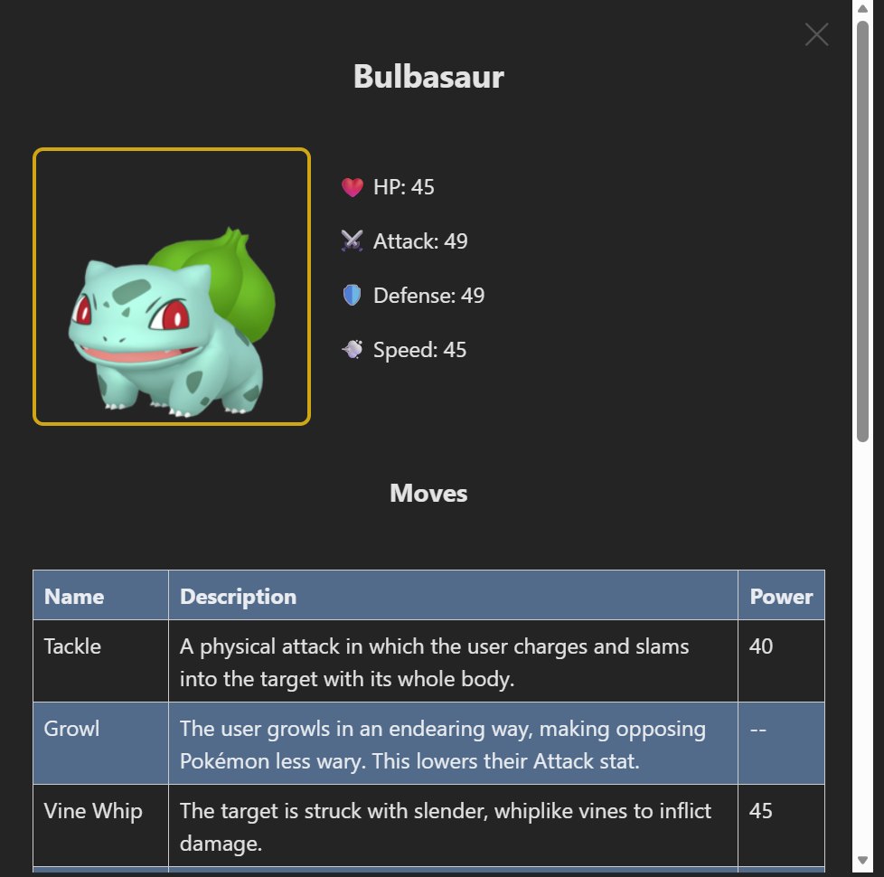
A lot of these stylistic features can be time consuming and have diminishing returns when done by hand, so I saw these as prime candidates to use AI for.

