So you’ve gotten yourself a Twoolhead (pronounced twoooooooolhead). Awesome! Most experts agree that printing two things at once is at least twice as great as regular boring old only-one-thing-at-a-time printing. Let’s get started!

You should have the twoolhead itself, a right-side wiper pad holder as well as a 2nd feed tube holder. You’ll also need a the metric hex wrench set that came with your TAZ as well as a computer connected to both the TAZ and the internets.

Step 1: Check out your sweet new Twoolhead.

Pull everything out of the box if you haven’t already, and take a minute to check out the Twoolhead, front and back. The purple and black ABS parts were made using a Twoolhead on a TAZ 6 using Chroma Strand Labs ABS filament extruded up in Loveland, CO which is pretty cool. Here are some of the important features of the Twoolhead that you should be aware of:

Nozzle leveling bits:

There’s a brace that links the 2 extruders together at the fan ducts, as well as a brace linking the tops of the 2 extruders together. Both of these braces are adjustable to allow you to make sure both nozzles are at the same height above the bed, and for adjustment both of the screws mounting the lower brace and the 2 screws with oversize washers on the upper brace need to be loose.

(Pic 1: Top/front showing braces)

On the back of the twoolhead there are 4 mounting screws, one of them a rounded button-head. With both the braces and this button-head screw just slightly loose, you should be able to adjust the height of the right nozzle. Holding the motor of the right extruder, you should be able to tilt that extruder slightly by moving it towards or away from the center of the Twoolhead. This slight pivoting is what will allow you to make sure that both nozzles are at the same height, which will be critical.

(Pic 2: back of Twoolhead)

X-endstop hitter:

Also on the back of the extruder you’ll see a purple curved bit attached to the right side. This is used to adjust the twoolhead’s position relative to the bed once it’s on the printer.

Step 2: Get it on.

- Power off the printer
- Carefully unplug the black toolhead connector
- Unscrew the M3 screw holding the toolhead in place
- Carefully lift the standard toolhead out of the mount and throw it in the trash, your days of only printing one thing at once are over :)
- Place the twoolhead in the extruder mount on the printer and press down gently on the top of the backplate to make sure that the mount is fully seated.
- Secure the twoolhead in place with the same mounting screw used for the standard extruder.
- Wrap the twoolhead harness around the main harness up to the top of the frame and plug the 2nd extruder harness from the twoolhead into the extruder 2 port on the back of the TAZ electronics case (top of the box for the TAZ 5).
- If you’re installing on a TAZ 6, attach the right side wiper pad by sliding it between the bed plate and aluminum bed mount.

Step 3: Reconfigurate the firmwares and machine settings
In order to convince the printer to work with the twoolhead you’ll need to mix up some of it’s bits and bytes. Luckily it’s pretty easy to do that these days.

- Start by downloading the Twoolhead repository. This will contain all the firmware, print profiles and source material for the twoolhead. It’ll be a zipped archive, so use whatever program you like to extract the files.
- Open up Cura LulzBot Edition. If you don’t have it installed yet, the latest and greatest can be gotten directly from LulzBot(R).
- Under the “machine” tab in the top taskbar, select Add new machine…
- Select which machine you have (TAZ 5 or 6) and a standard extruder
- Change the machine width to 140mm
- Change the name of the machine to Twoolhead-TAZ or anything that will help you remember that this is the machine to select if you’re ready to reallly get making.
- Delete the start and end gcodes and replace them with the ones listed at the bottom of this guide. Make sure to use the right start / end gcode for your generation of printer.
- Click OK
- Plug the machine back in and turn it on; connect the printer to the computer by USB.
- Under the machine tab in the taskbar, select install custom firmware…
- Select the TAZ 5 or TAZ 6 hex file from the firmware folder in the twoolhead repo you downloaded and click Open. It will flash the new firmware any the machine will be set to go!
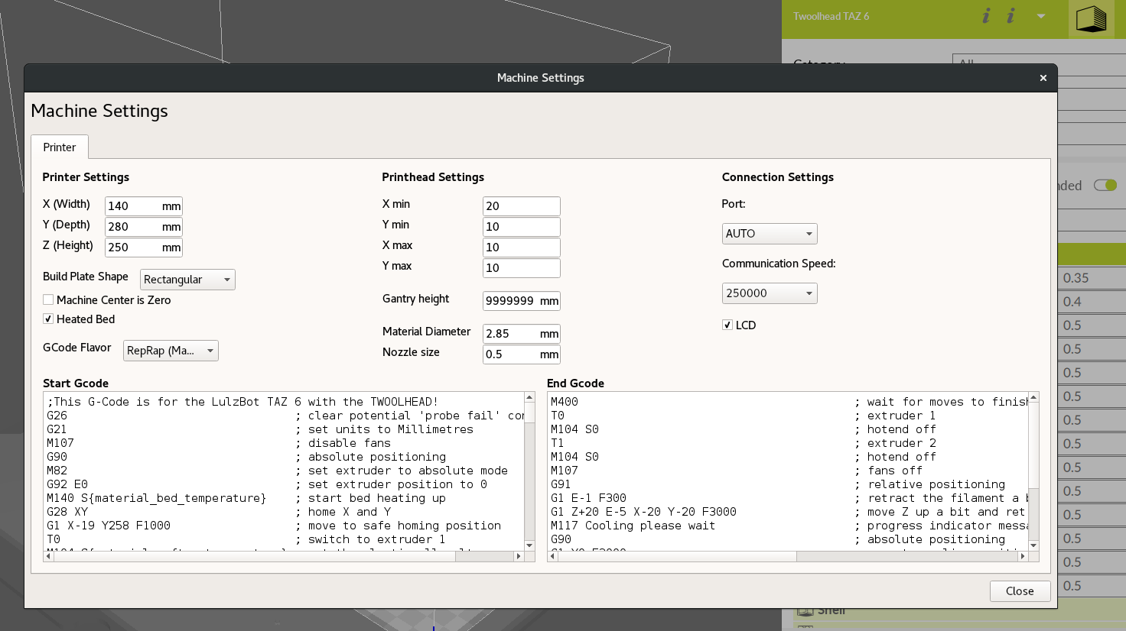
The machine settings tab should look like this when you’re done.

Step 4: Adjust the x endstop hitter
After updating the firmware the next step is to fine tune the x endstop to your printer. The Twoolhead has an adjustable endstop hitter on the side of the left extruder. You can loosen and adjust this until the printer homes in the right place. For the TAZ 6 this is in the center of the z-min button on the back left side of the bed plate. For the TAZ 5 the left nozzle should be just inside the edge of the bed when resting on the endstop switch. Adjust as necessary so that the left nozzle hits the center of the button, this will make sure it hits the wiper pads and leveling washers correctly.

Step 5: Adjust the height of the right extruder.

- First make sure that the x axis is level to the bed by using a spacer to make sure there is the same gap between the lower x-rail and the bed on either side of the twoolhead.
- With the buttonhead screw on the back of the twoolhead and the upper and lower braces loose, the right extruder should be able to rotate slightly, bringing it’s nozzle up and down. Start with the nozzle lifted as high as it will go.
- Home the printer and then use the LCD controller to move the z axis downward until the left nozzle is just above the surface of the bed.
- Carefully lower the right extruders nozzle by pulling it to the right by the stepper motor or the extruder body that the motor is bolted to. Using a sheet of paper folded in half as a gauge, make sure that the right nozzle is the same height above the surface of the bed as the left nozzle.
- Secure the right extruder at the correct level by first tightening the upper brace, then tightening the button-head screw on the far right side of the back of the twoolhead and the lower heatsink fan brace.
- Verify that the heights of the nozzles above the bed are the same, if not then repeat until they are.

You’re ready to print! Have fun making twice as much awesome stuff

