So you’ve gotten yourself a Twoolhead (pronounced twoooooooolhead). Awesome! Most experts agree that printing two things at once is at least twice as great as regular boring old only-one-thing-at-a-time printing. Let’s get started!

You should have the twoolhead itself, a right-side wiper pad holder and 3 or 4 zip ties. You’ll also need a 3mm wrench for adjusting height of the right nozzle to match the left.

Step 1: Uninstall boring lame regular toolhead (or whatever accessory is currently in place)
- Power off the printer
- Carefully unplug the black toolhead connector
- Unscrew the M3 screw holding the toolhead in place
- Carefully lift the standard toolhead out of the mount and throw it in the trash, your days of only printing one thing at once are over :)

Step 2: Install super-awesome-new-two-things-printing-at-once Twoolhead
- Start by making sure that the right side extruder can rotate up and down a bit, this will be used to level the 2 extruders.
  - If the right side extruder seems fixed in place, loosen both of the blue screws on the back of the twoolhead mount and then snug them just barely finger tight. The extruder should be able to pivot around the inner screw but shouldn’t just be flopping around.
- Place the twoolhead in the extruder mount on the printer and press down gently on the top of the backplate to make sure that the mount is fully seated.
- Secure the twoolhead in place with the same mounting screw used for the standard extruder.
- Plug the 2nd extruder harness from the twoolhead into the extruder 2 port on the back of the TAZ electronics case (top of the box for the TAZ 5).
- Zip tie the twoolhead harness to the main toolhead harness so they stay together and out of the way.
  - You can also just wrap the twoolhead harness around the main harness if you plan on switching between toolheads often.
- If you’re installing on a TAZ 6, attach the right side wiper pad by sliding it between the bed plate and aluminum bed mount.

Step 3: Reconfigurate the firmwares and machine settings
In order to convince the printer to work with the twoolhead you’ll need to mix up some of it’s bits and bytes. Luckily it’s pretty easy to do that these days.

- Start by downloading the twoolhead repository (link). This will contain all the firmware, print profiles and source material for the twoolhead. It’ll be a zipped archive, so use whatever program you like to extract the files.
- Open up Cura LulzBot edition. If you don’t have it installed yet, the latest and greatest can be gotten from this internet place (link).
- Under the “machine” tab in the top taskbar, select Add new machine…
- Select which machine you have and a standard extruder.
- Change the number of extruders to 2 and the machine width to 140
- Change the name of the machine to Twoolhead-TAZ or anything that will help you remember that this is the machine to select if you’re ready to reallly get making.
- Click OK
- Plug the machine back in and turn it on; connect the printer to the computer by USB.
- Under the machine tab in the taskbar, select install custom firmware…
- Select the TAZ 5 or TAZ 6 hex file from the firmware folder in the twoolhead repo you downloaded and click Open. It will flash the new firmware any the machine will be set to go!
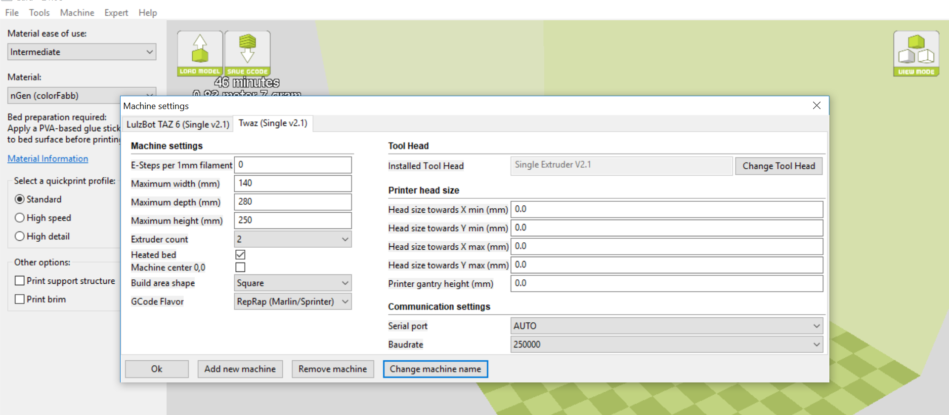
The machine settings tab should look like this when you’re done.

Step 4: Adjust the x endstop
After updating the firmware the next step is to fine tune the x endstop to your printer. The Twoolhead has an adjustable endstop hitter on the side of the left extruder. You can loosen and adjust this until the printer homes in the right place. For the TAZ 6 this is in the center of the z-min button on the back left side of the bed plate. Loosen and adjust as necessary so that the left nozzle hits the center of the button, this will make sure it hits the wiper pads and leveling washers correctly.

Step 5: Adjust the height of the right extruder.

- First make sure that the x axis is level to the bed by using a spacer to make sure there is the same gap between the lower x-rail and the bed on either side of the twoolhead.
- The right extruder can lift up and down by rotating around the left screw. Start with the nozzle lifted as high as it will go.
- Home the printer and then use the LCD controller to move the z axis downward until the left nozzle is just above the surface of the bed.
- Twist the right extruder clockwise to lower it’s nozzle until it’s nozzle is the same height above the surface of the bed as the left nozzle.
- Secure the right extruder at the correct level by tightening the button-head screw on the far right side of the back of the twoolhead.
- Verify that the heights of the nozzles above the bed are the same, repeat until they are.

You’re ready to print! Have fun making twice as much awesome stuff :)
Pics yo.
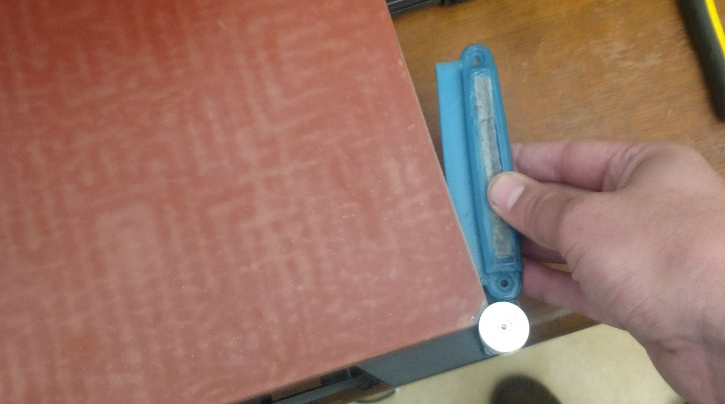
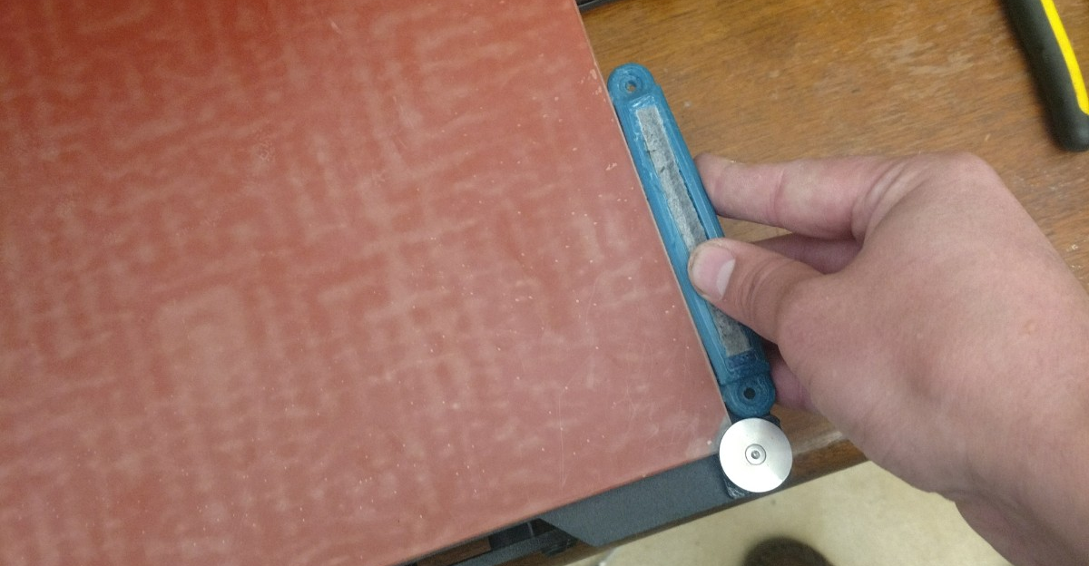
The right side wiper just slides in between the metal bed plate and the glass bed surface.

The wiper pad holder needs to be flush with the glass plate and the rubber bed corner piece.
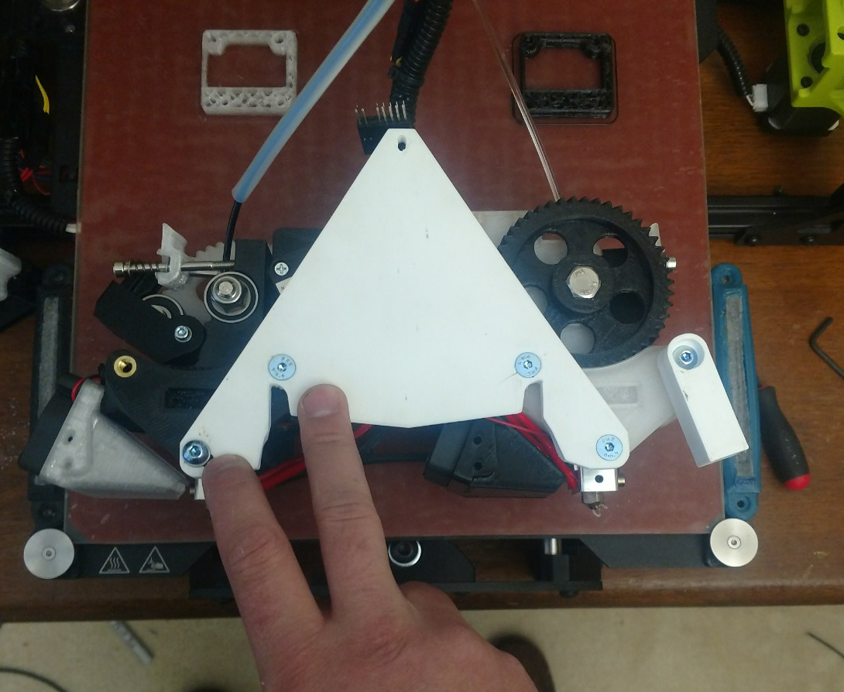
Make sure these 2 screws are just finger tight before installing on the printer, the far left screw needs to be able to slide a bit in order to level the two shnozzles.

