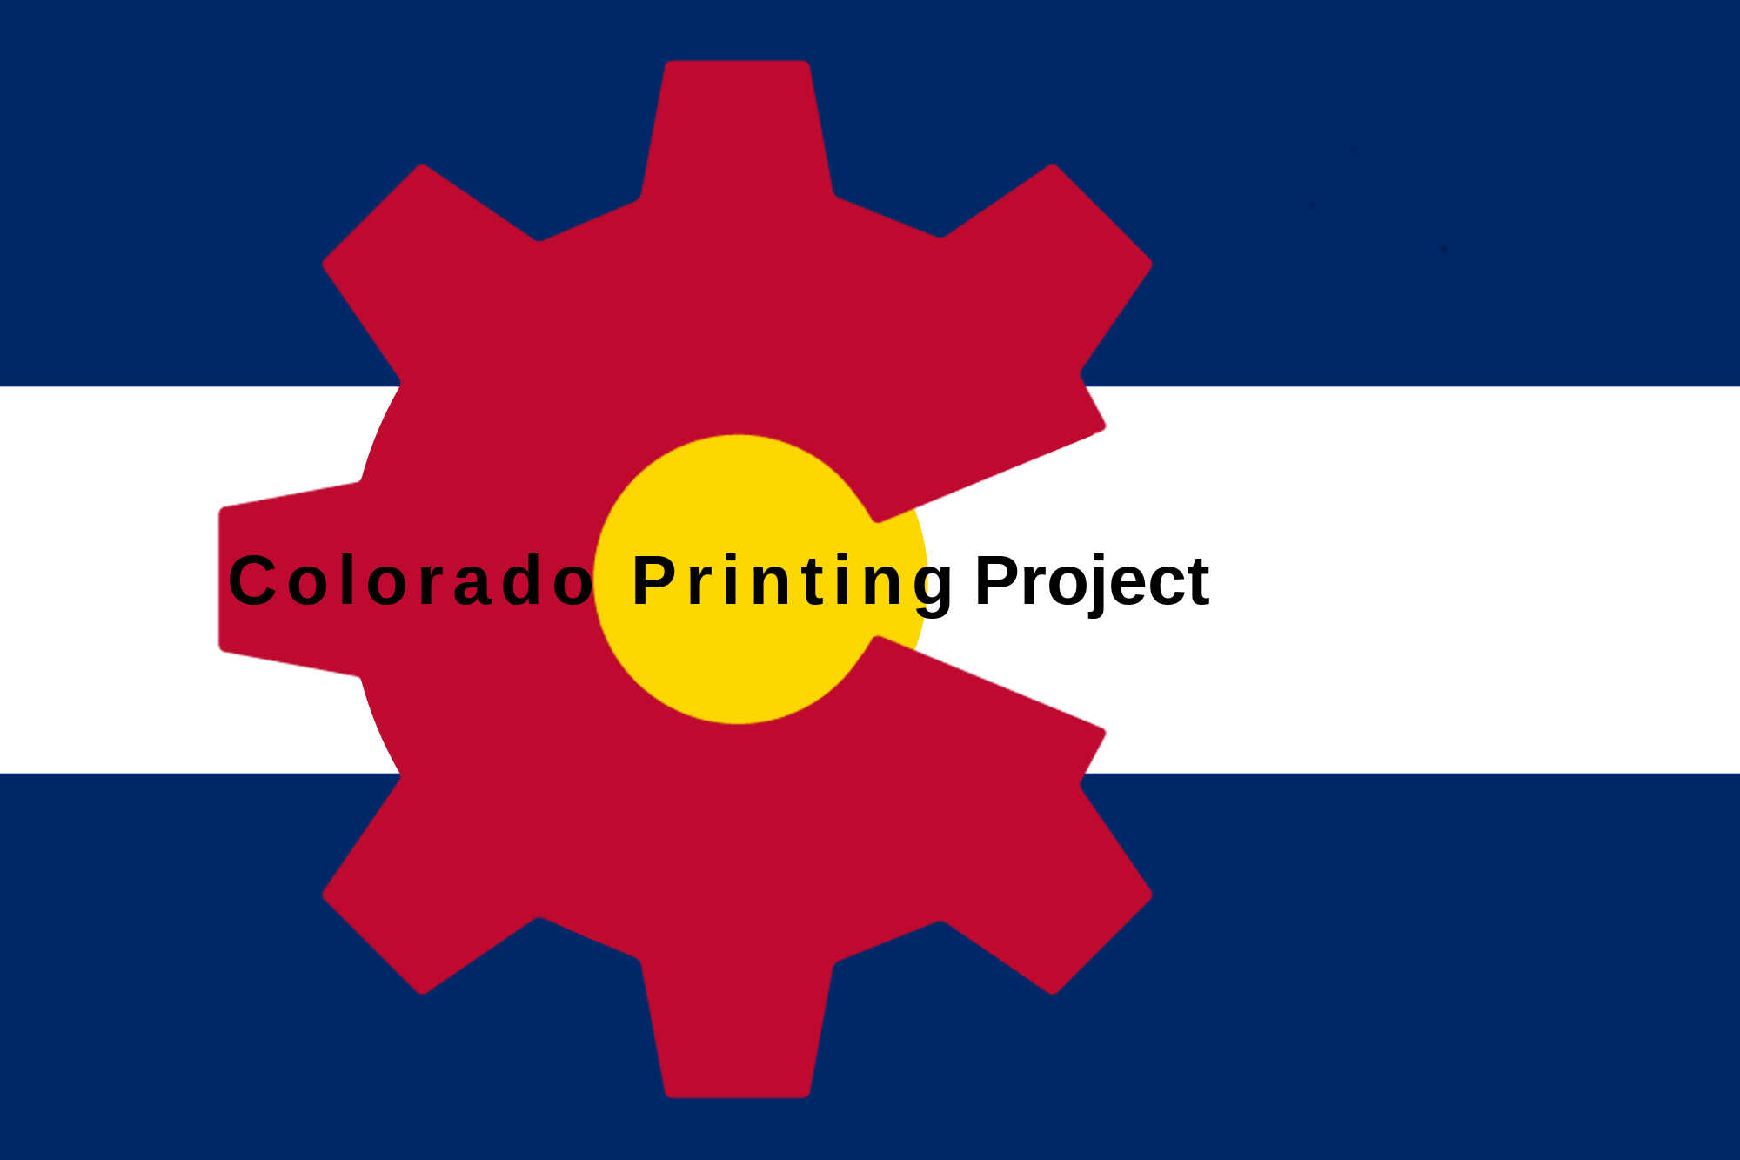

Thank you for purchasing the Twoolhead, and for supporting the development being done by the Colorado Printing Project.

To get started, please download the Twoolhead source from Github by navigating to the link below and clicking on the green “clone or download” button. This will include a complete startup guide in the getting_started folder, along with the part files, bill of materials and all other source materials created during development.

https://github.com/coloradoprintingproject/twoolhead

The Twoolhead will work with pretty much any slicing software, but needs custom start and end gcode.

If you have any questions or difficulties getting started, please get in touch with me directly at bam@coloradoprintingproject.org.

Again, thank you for your support of the Colorado Printing Project

-Brent MacKenzie (bam)
Founder
Colorado Printing Project, Ltd.

