So you’ve gotten yourself a Twoolhead (pronounced twoooooooolhead). Awesome! Most experts agree that printing two things at once is at least twice as great as regular boring old only-one-thing-at-a-time printing. Let’s get started!

You should have the twoolhead itself, a right-side wiper pad holder as well as a 2nd feed tube holder. You’ll also need a the metric hex wrench set that came with your TAZ as well as a computer connected to both the TAZ and the internets.

Step 1: Check out your sweet new Twoolhead.

Pull everything out of the box if you haven’t already, and take a minute to check out the Twoolhead, front and back. The purple and black ABS parts were made using a Twoolhead on a TAZ 6 using Chroma Strand Labs ABS filament extruded up in Loveland, CO which is pretty cool. Here are some of the important features of the Twoolhead that you should be aware of:

Nozzle leveling bits:

There’s a brace that links the 2 extruders together at the fan ducts, as well as a brace linking the tops of the 2 extruders together. Both of these braces are adjustable to allow you to make sure both nozzles are at the same height above the bed, and for adjustment both of the screws mounting the lower brace and the 2 screws with oversize washers on the upper brace need to be loose.

(Pic 1: Top/front showing braces)

On the back of the twoolhead there are 4 mounting screws, one of them a rounded button-head. With both the braces and this button-head screw just slightly loose, you should be able to adjust the height of the right nozzle. Holding the motor of the right extruder, you should be able to tilt that extruder slightly by moving it towards or away from the center of the Twoolhead. This slight pivoting is what will allow you to make sure that both nozzles are at the same height, which will be critical.

(Pic 2: back of Twoolhead)

X-endstop hitter:

Also on the back of the extruder you’ll see a purple curved bit attached to the right side. This is used to adjust the twoolhead’s X home position once it’s on the printer.

Step 2: Get it on.

- Power off the printer
- Carefully unplug the black toolhead connector
- Unscrew the M3 screw holding the toolhead in place
- Carefully lift the standard toolhead out of the mount and throw it in the trash, your days of only printing one thing at once are over :)
- Place the twoolhead in the extruder mount on the printer and press down gently on the top of the backplate to make sure that the mount is fully seated.
- Secure the twoolhead in place with the same mounting screw used for the standard extruder.
- Press the long harness into the empty harness holderrap the twoolhead harness around the main harness up to the top of the frame and plug the 2nd extruder harness from the twoolhead into the extruder 2 port on the back of the TAZ electronics case (top of the box for the TAZ 5).
- If you’re installing on a TAZ 6, attach the right side wiper pad by sliding it between the bed plate and aluminum bed mount.

Step 3: Reconfigurate the firmwares and machine settings
In order to convince the printer to work with the twoolhead you’ll need to mix up some of it’s bits and bytes. Luckily it’s pretty easy to do that these days.

- Start by downloading the Twoolhead repository. This will contain all the firmware, print profiles and source material for the twoolhead. It’ll be a zipped archive, so use whatever program you like to extract the files.
- Open up Cura LulzBot Edition. If you don’t have it installed yet, the latest and greatest can be gotten directly from LulzBot(R).
- Under the “machine” tab in the top taskbar, select Add new machine…
- Select which machine you have (TAZ 5 or 6) and a standard extruder
- Change the machine width to 140mm
- Change the name of the machine to Twoolhead-TAZ or anything that will help you remember that this is the machine to select if you’re ready to reallly get making.
- Delete the start and end gcodes and replace them with the ones listed at the bottom of this guide. Make sure to use the right start / end gcode for your generation of printer.
- Click OK
- Plug the machine back in and turn it on; connect the printer to the computer by USB.
- Under the machine tab in the taskbar, select install custom firmware…
- Select the TAZ 5 or TAZ 6 hex file from the firmware folder in the twoolhead repo you downloaded and click Open. It will flash the new firmware any the machine will be set to go!
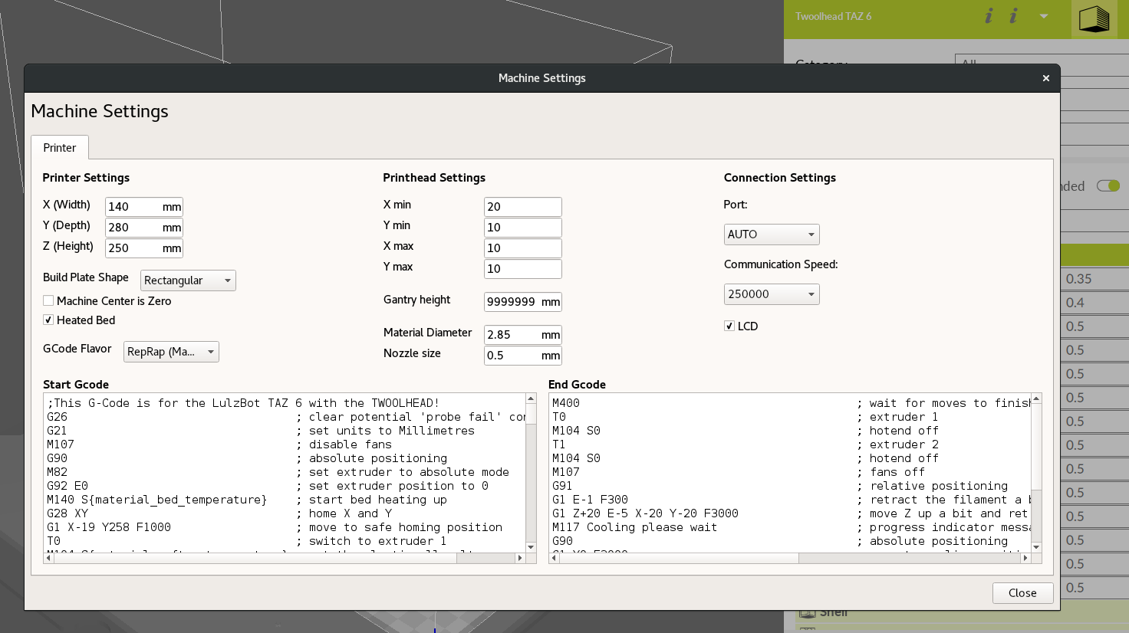
The machine settings tab should look like this when you’re done.

Step 4: Adjust the x endstop hitter
After updating the firmware the next step is to fine tune the x endstop to your printer. The Twoolhead has an adjustable endstop hitter on the side of the left extruder. You can loosen and adjust this until the printer homes in the right place. For the TAZ 6 this is in the center of the z-min button on the back left side of the bed plate. For the TAZ 5 the left nozzle should be just inside the edge of the bed when resting on the endstop switch. Adjust as necessary so that the left nozzle hits the center of the button, this will make sure it hits the wiper pads and leveling washers correctly.

Step 5: Adjust the height of the right extruder.

- First make sure that the x axis is level to the bed by using a spacer to make sure there is the same gap between the lower x-rail and the bed on either side of the twoolhead.
- With the buttonhead screw on the back of the twoolhead and the upper and lower braces loose, the right extruder should be able to rotate slightly, bringing it’s nozzle up and down. Start with the nozzle lifted as high as it will go.
- Home the printer and then use the LCD controller to move the z axis downward until the left nozzle is just above the surface of the bed.
- Carefully lower the right extruders nozzle by pulling it to the right by the stepper motor or the extruder body that the motor is bolted to. Using a sheet of paper folded in half as a gauge, make sure that the right nozzle is the same height above the surface of the bed as the left nozzle.
- Secure the right extruder at the correct level by first tightening the upper brace, then tightening the button-head screw on the far right side of the back of the twoolhead and the lower heatsink fan brace.
- Verify that the heights of the nozzles above the bed are the same, if not then repeat until they are.

You’re ready to print! Have fun making twice as much awesome stuff

Start and end gcodes:

Cura LulzBot Edition (latest version):
Start:
;This G-Code is for the LulzBot TAZ 6 with the TWOOLHEAD!
G26 ; clear potential 'probe fail' condition
G21 ; set units to Millimetres
M107 ; disable fans
G90 ; absolute positioning
M82 ; set extruder to absolute mode
G92 E0 ; set extruder position to 0
M140 S{material_bed_temperature} ; start bed heating up
G28 XY ; home X and Y
G1 X-19 Y258 F1000 ; move to safe homing position
T0 ; switch to extruder 1
M104 S{material_soften_temperature} ; get the plastic all melty
T1 ; switch to extruder 2
M109 R{material_soften_temperature} ; soften filament before homing Z
G28 Z ; home Z
T0 ; switch to extruder 1
M104 S{material_wipe_temperature} ; set temp but don't wait
T1 ; switch to extruder 2
M109 R{material_wipe_temperature} ; wait for extruder to reach wiping temp
G92 E0 ; set extruder location to 0
G1 E-30 F100 ; retract filament
G1 X-15 Y100 F3000 ; move above wiper pad
G1 Z0.5 ; push nozzle into wiper
G1 X-17 Y95 F1000 ; slow wipe
G1 X-17 Y90 F1000 ; slow wipe
G1 X-17 Y85 F1000 ; slow wipe
G1 X-15 Y90 F1000 ; slow wipe
G1 X-17 Y80 F1000 ; slow wipe
G1 X-15 Y95 F1000 ; slow wipe
G1 X-17 Y75 F2000 ; fast wipe
G1 X-15 Y65 F2000 ; fast wipe
G1 X-17 Y70 F2000 ; fast wipe
G1 X-15 Y60 F2000 ; fast wipe
G1 X-17 Y55 F2000 ; fast wipe
G1 X-15 Y50 F2000 ; fast wipe
G1 X-17 Y40 F2000 ; fast wipe
G1 X-15 Y45 F2000 ; fast wipe
G1 X-17 Y35 F2000 ; fast wipe
G1 X-15 Y40 F2000 ; fast wipe
G1 X-17 Y70 F2000 ; fast wipe
G1 X-15 Y30 Z2 F2000 ; fast wipe
G1 X-17 Y35 F2000 ; fast wipe
G1 X-15 Y25 F2000 ; fast wipe
G1 X-17 Y30 F2000 ; fast wipe
G1 X-15 Y25 Z1.5 F1000 ; slow wipe
G1 X-17 Y23 F1000 ; slow wipe
G1 Z10 ; raise extruder
G1 X155 Y95 F3000 ; move above other wiper
G1 Z0.5 ; move down into wiper pad
G1 X155 Y90 F1000 ; slow wipe
G1 X155 Y85 F1000 ; slow wipe
G1 X153 Y90 F1000 ; slow wipe
G1 X155 Y80 F1000 ; slow wipe
G1 X153 Y95 F1000 ; slow wipe
G1 X155 Y75 F2000 ; fast wipe
G1 X153 Y65 F2000 ; fast wipe
G1 X155 Y70 F2000 ; fast wipe
G1 X153 Y60 F2000 ; fast wipe
G1 X155 Y55 F2000 ; fast wipe
G1 X153 Y50 F2000 ; fast wipe
G1 X155 Y40 F2000 ; fast wipe
G1 X153 Y45 F2000 ; fast wipe
G1 X155 Y35 F2000 ; fast wipe
G1 X153 Y40 F2000 ; fast wipe
G1 X155 Y70 F2000 ; fast wipe
G1 X153 Y30 F2000 ; fast wipe
G1 X155 Y35 F2000 ; fast wipe
G1 X153 Y25 F2000 ; fast wipe
G1 X155 Y30 F2000 ; fast wipe
G1 X153 Y25 F1000 ; slow wipe
G1 X155 Y23 F1000 ; slow wipe
G1 Z15 ; raise extruder
T0 ; switch extruder
M104 S{material_probe_temperature} ; set but don't wait
T1 ; switch extruder
M109 R{material_probe_temperature} ; wait for extruder to reach probe temp
G28 XY ; home X and Y
M204 S100 ; set probing acceleration
G29 ; start auto-leveling sequence
M204 S350 ; restore standard acceleration
G1 Z15 F5000 ; move up off last probe point
G4 S1 ; pause
M400 ; wait for moves to finish
M117 Heating... ; progress indicator message on LCD
T0 ; switch to extruder 1
M104 S{material_print_temperature} ; set but don't wait
T1 ; switch to extruder 2
M109 R{material_print_temperature} ; wait for extruder to reach printing temp
M190 S{material_bed_temperature} ; wait for bed to reach printing temp
G1 Z2 E0 F75 ; prime tiny bit of filment into the nozzle
M117 TWAZ 6 Printing... ; progress indicator message on LCD

End:
M400 ; wait for moves to finish
T0 ; extruder 1
M104 S0 ; hotend off
T1 ; extruder 2 ; Extruder 2
M104 S0 ; hotend off
M107 ; fans off
G91 ; relative positioning
G1 E-1 F300 ; retract the filament a bit before lifting the nozzle, to release some of the pressure
G1 Z+20 E-5 X-20 Y-20 F3000 ; move Z up a bit and retract filament even more
M117 Cooling please wait ; progress indicator message
G90 ; absolute positioning
G1 Y0 F3000 ; move to cooling position
M117 Cooling please wait ; progress indicator message on LCD
M190 R{material_part_removal_temperature} ; set bed to cool off
G1 Y280 F3000 ; present finished print
M84 ; steppers off
G90 ; absolute positioning
M117 Print complete ; progress indicator message

