**Control and Breakthrough: The Construction of Female Images**

**in Makeup Video Titles within the Context of Post-Feminism**

Jiale Zheng, Siting Liu, Tianqing Lu, Dongyuan Zhu, and Yan Lei

Department of AI and Digital Media, Hong Kong Baptist University

AIDM 7340: AI for Digital Media

Dr. Xinzhi Zhang

May 14, 2023

**Control and Breakthrough: The Construction of Female Images**

**in Makeup Video Titles within the Context of Post-Feminism**

**Abstract**

This study explores the construction of female images and femininity in makeup videos and their impact on the audience from a gender perspective, focusing on the Chinese young generation's femininity. The study first describes the femininity and images indicated by the titles of 1000 female makeup videos on Bilibili, exploring the femininity behind the different region-based makeup styles. The study then generalizes the themes of comments under makeup videos better to understand the impact of female makeup videos on fans. The study reveals that the "girl" female image dominates among the various female images, with "purity," "cute," "chunyu," and "gentle" being the most represented sub-fields of femininity. Meanwhile, "elegant," "confident," and "sweet and depressed" are the least represented sub-fields. The study also demonstrates that makeup videos can reinforce traditional gender roles and provide opportunities for women's self-empowerment and aesthetics diversification in the globalization and Internet era. Overall, this study contributes to a better understanding of the role of makeup videos in promoting femininity and female images in the internet era, the impact of global aesthetic mutual influence on the diversity of femininity, and the critical understanding of the role of makeup videos in feminism.

**Keywords***: femininity, objectification, self-empowerment, Post-Feminism, makeup video titles*

**Introduction**

Makeup videos are a type of video that focuses on makeup and covers product reviews, skincare knowledge, makeup techniques, creative marketing, and lifestyle sharing. With the advancement of media technology, makeup has gradually transitioned from a private behavior behind closed doors to being showcased on the Internet. On the one hand, makeup videos encourage women to use makeup to achieve the femininity highlighted in the title and make themselves look refreshed; on the other hand, the framework of femininity set in beauty videos limits the audience's self-imagination and implies that women put themselves under the gaze of others by modifying their appearance.

Based on this, this study focuses on how women present themselves and what kind of femininity they possess in makeup videos. What is the femininity behind the region-based makeup styles? What impact does femininity in makeup videos have on the audience? These questions still need further research. This research explores the construction of femininity and images in makeup videos and their impact on the audience from a gender perspective, which can help us better understand the popular femininity and images in the internet era, the impact of global aesthetic mutual influence on the diversity of femininity, the impact of makeup videos on the audience's self-awareness, and the critical understanding of the role of makeup videos in feminism.

To address these questions, this study first describes the femininity and image indicated by the titles of 1000 female makeup videos on Bilibili. Previous studies have focused more on traditional texts, such as television and advertisements (McNeil, 1975; Plakoyiannaki & Zotos, 2009) and less on the title texts of self-published makeup videos. Next, this study explores the association between femininity and region. Finally, by generalizing the themes of comments under makeup videos, we can better understand the impact of female makeup videos on fans.

**Literature Review**

**Makeup Videos and Objectification**

Objectification theory is a social psychological framework that seeks to explain the impact of objectification on gendered experiences, particularly those of women (Fredrickson & Roberts, 1997). In a seminal paper, according to Fredrickson and Roberts (1997), objectification takes place when someone is regarded more like an object or instrument than like a whole person with thought, emotions, and desires. They suggest this experience is ubiquitous for women, who are often viewed as sexual objects rather than fully formed individuals. Building on that work, Moradi and Huang (2008) suggest that objectification can take many forms, including physical objectification (whereby individuals are reduced to their physical appearance), self-objectification (whereby individuals internalize objectifying attitudes and view themselves as objects), and interpersonal objectification (whereby individuals are treated as objects by others).

Objectification in media refers to how media representations of individuals can reduce them to mere objects for consumption rather than complex human beings with thoughts, feelings, and agency. Textual descriptions and visual presentations that overemphasize the body and appearance are two common ways that the media objectify humans. One common way that media objectifies individuals is through textual descriptions. For instance, the headlines of women's health publications often use objectifying language to emphasize getting the body you want or avoiding having a body you don't like (Aubrey, 2010). In addition, close-up video shots of body parts that draw the viewer's attention to a body part rather than focusing on a person similarly embody objectification (Tiggemann & Zaccardo, 2018).

Objectification in the media can take many different forms, including commodification, sexual objectification and stereotyping. Commodification in media refers to transforming people, ideas, and experiences into commodities that can be bought and sold through media. For instance, beauty gurus commercialize and sell themselves as a brand. Their style, image, and personality become part of their brand identity, which can be monetized through sponsorships, collaborations, and advertising deals (Marwick, 2015). Besides, stereotyping in media refers to how media representations can reinforce existing prejudices and biases about certain groups of people. For example, the media often portrays women in stereotypical roles, perpetuating harmful myths and stereotypes about female groups (Dill & Thill, 2007). That can contribute to a culture of discrimination and inequality. Finally, One prominent example of objectification in the media is the sexualization of women's bodies. According to research, women are frequently represented in the media as the objects of male sexual desire, emphasizing their bodies over other aspects of their identity (Fredrickson & Roberts, 1997). That can lead to harmful consequences, such as increased body dissatisfaction and negative self-image among women (Aubrey, 2006).

For a long time, makeup has been associated with femininity and beauty, often used to enhance one's appearance. However, some scholars believe that when makeup becomes a tool for women's body reconstruction, allowing their body parts to comply with various social or patriarchal norms, it will promote women's sexualization (Wang&Bao, 2020). Meanwhile,  makeup videos often promote specific beauty standards and practices, providing step-by-step guidance for women to transform their bodies. Within the framework of sexual objectification, by promoting specific beauty standards and strengthening traditional gender roles, makeup videos may promote women's objectification and sexualization (Wang&Bao, 2020). Moreover, some scholars believe that makeup may lead to a negative body image and physical dissatisfaction, which can enhance the appearance self-esteem of females, but will lower their physical self-esteem (Tran&Rosales, 2020).

**Makeup Videos and Empowerment**

Although women in makeup videos can still not escape the constraints of commercial capital and power structure, it also provides possibilities for women's self-empowerment in the "post-feminism" period. According to Gill (2007), "post-feminism" refers to a cultural shift away from second-wave feminism's emphasis on collective action and towards individualism and consumerism. This shift is reflected in media representations of women as empowered agents who can achieve success through their efforts rather than relying on collective action or government intervention. Post-feminist studies suggest that makeup empowers women by giving them control over their bodies, guiding them in constructing a desirable image and pursuing their ideal selves. This shift is from "pleasing others with one's appearance" to "pleasing oneself with one's appearance (Banet-Weiser, 2017)". Many beauty bloggers have engaged in critical reflection on this issue. A beauty blogger named "My Pale Skin" posted a video titled "YOU LOOK DISGUSTING," which talks about her pale skin and acne problems and shows the cyberbully she has received. She believes that women who have had similar experiences are beautiful and should believe in, affirm, and accept themselves while criticizing cultural expectations about female self-presentation (2015).

Meanwhile, some scholars argue that rather than claiming makeup itself is empowering, feminist blogs demonstrate that makeup can become part of the language of feminism (White, 2018). Through makeup, women renegotiate their status as objects and bodies. For example, feminist scholar Alison Bartlett argues that applying lipstick is a claim that women demand to speak with their lips (Bartlett, 1993). Additionally, red is often seen as violent and sexual, not suitable for displaying passive feminine qualities (Bartlett, 1993). Thus, women who use red lipstick emphasize their sexual characteristics rather than maintaining caution and obeying the male summons. Beauty blogger Tadelesmith also suggests that her eyeliner and other applications are forms of resistance (Tadelesmith, 2013). Another beauty blogger, Rodriguez's makeup aesthetic, has a sharp visual structure, which is inconsistent with appropriate feminine qualities, rejecting the feminization of intimacy (White, 2018). These feminist makeup tutorials disprove the assertions of certain feminists that cosmetics are a necessary component of an objectifying system that creates and normalizes women. They show how feminism and beauty advice can serve as critical feminist language.

One the one hand, patriarchal hegemony objectives may be mixed with ideas of femininity, self-esteem, and female image in makeup videos (Merskin, 2007). When women present their bodies and identities to society, they can become entangled in idealized femininity prescribed by patriarchal norms. On the other hand, makeup videos give women the right to recreate their bodies and choose to be who they are, symbolizing the critical thinking of post-feminism. Previous studies have attempted to gain insight into the construction of femininity through lipstick names (Merskin, 2007). However, few studies have focused on this topic through the titles of makeup videos. Therefore, this research theme is explorable.

**The Impact of Makeup and Social Videos on Audience**

Currently, there is limited research on the effects of makeup on women's self-perception. One study conducted an experimental investigation into the self-perception of women who use makeup. The study (Cash et al., 1989) involved 38 American female university students who brought their commonly used makeup products into a laboratory. Participants were first asked questions about their use of makeup after applying it. Then researchers asked them to remove their makeup and undergo further body image measurements. The researchers found that women who applied cosmetics had greater levels of facial satisfaction, appearance satisfaction, and body attractiveness. That suggests that women's self-perception and their perception of how others evaluate them may be affected by wearing makeup regularly. Another study (Anchieta et al., 2021) compared the differences in self-perception between women in simulated and actual makeup stages. Women in the simulated stage believed they were more feminine and healthier. They had more self-esteem when wearing makeup than when not wearing it. These scores were higher in the actual makeup stage than in the simulated stage. There was no difference between appearance satisfaction and attractiveness ratings in the simulated and actual makeup stages, which were higher than those without makeup. Therefore, actual modifications to one's appearance and expectations of it can affect specific domains of self-perception differently.

Many studies also explore the role of social media platforms in self-perception. For instance, numerous studies focused on Instagram, which primarily features image posts. For instance, research has explored the effects of fitness bloggers' posts on fans' body perception, confirming that viewers gain objectifying cues from images and focus on their bodies rather than health or fitness-related goals (Murashka & Peng, 2021). Girls who were exposed to the modified photographs suffered detrimental effects, especially those with higher social comparison tendencies (Kleemans et al., 2018).

**The Research Context**

Research chose Bilibili as the research platform in this study. Bilibili is a Chinese video-sharing platform with a high concentration of cultural communities and video websites for the young generation in China. After more than 10 years of growth, Bilibili has created an ecosystem centered on users, creators, and content that consistently generates high-quality material. Users can upload or watch videos in animation, games, makeup, etc. Users can also comment on the various content below the video.

Bilibili has a solid community-driven culture, with a special section for "makeup" and many makeup videos and related discussions. These texts can represent the interpretation of makeup and the construction of female images by the young generation in China. Therefore, This study captured nearly six years of videos and comments on "makeup" on Bilibili for analysis, trying to find out what characteristics of the young Chinese generation's femininity that makeup videos construct.

**The Research Questions**

According to previous studies, one reason for the popularity of makeup is that it enhances people's attractiveness and femininity (Batres et al., 2018). Women may choose different styles and degrees of makeup, and different femininity will convey different information through vision and give people different impressions. However, women's choices often depend on the attractiveness or competitiveness they have perceived as required by the environment (Wagstaff, 2018). The majority of sexualization and objectification research concentrate on how people perceive information visually and connect it to sexualized bodies that occur in popular culture (Ward, 2016). This study aims to answer the following two questions through captured video titles, which are helpful for us to explore what is the preference for femininity and female images in the young Chinese generation.

**RQ1:** *How many kinds of female images and femininity is in makeup videos of Bilibili?*

**RQ2:** *What is the distribution of female images and femininity in makeup videos of Bilibili?*

A particular region has its makeup style, communicating worldwide and impacting other countries' trending femininity and female images. By analyzing the femininity behind the region-based makeup styles, this research can determine the impact of global aesthetic mutual influence on femininity. Besides, the study can infer the social reasons behind the popularity of femininity through these characteristics and the social environment. Therefore, the study puts forward the following question.

**RQ3:** *What are female images and femininity reflected by representative makeup styles in regions?*

Considering that the audience's feedback on the displayed femininity can indicate the public's acceptance of femininity, this research added the following questions to explore how people react when discussing makeup.

**RQ4:** *What are the topics discussed in the comments?*

**Method**

**Data Collection**

This study gathered data using web scraping techniques based on Python language and relevant libraries, combined with Bilibili's API interface, with the search keyword "makeup," "makeup style," and so on as the condition to obtain video and comment information published on Bilibili. The video section includes the title, release time, and author name. In contrast, the comment section includes comments on various videos.

This study scraped all 4492 videos displayed on the web page. After manual review, the following types of makeup videos that do not meet the scope of this study were removed：(1) The male makeup videos; (2) Functional makeup tutorials on how to apply makeup, how to use makeup tools and so on; (3) The title text does not point to confident femininity. The final sample includes 1000 valid data for coding.

This study performed pre-processing steps like cleaning, removing duplicates, and filtering the collected data to improve accuracy and ensure data quality. Then the cleaned data was stored in CSV format for analysis and visualization. Challenges during the data collection process, such as IP bans, anti-scraping mechanisms, and non-standard formats, were tackled using techniques like proxy IPs, user agent settings, and regular expressions.

**Coding Procedures**

This study first categorizes femininity and female images based on the "makeup style" words from titles of makeup videos. As few studies analyze the portrayal of female images and femininity in makeup videos, this study refers to research on femininity and female images in advertisements to construct categories. According to previous studies (Schippers, 2007; Plakoyiannaki & Zotos, 2009; Roca-Sales & Lopez-Garcia, 2017), female images can be categorized as traditional roles (subordinate to men or dependent on their protection), decorative roles (sexual objects with a sexual appeal to men), or non-traditional females (career-oriented or engaged in activities outside of the home). Based on previous research and the text characteristics of this study, the primary category focuses on female images. In contrast, the secondary category focuses on femininity. Videos are classified based on core words in titles pointing to femininity and female images. If multiple femininity is mentioned in the title, the most prominent one is chosen as the representative category. Next, research encodes the "representative regions of the makeup style" based on the region, celebrities or the makeup imitation target mentioned in the title of the makeup video.

Of 1000 valid data, 79 were published in 2018, 120 in 2019, 187 in 2020, 298 in 2021, 196 in 2022, and 120 in 2023. Prior to formal coding, the four coders receive training. After settling all differences and discussing how to improve the coding approach, the four coders coded 50 videos selected from the final sample via convenient sampling and achieved dependable inter-coder reliability  (average Cohen's Kappa of female images, femininity, and region = 0.89, 0.81, 0.84).  Subsequently, the four coders code 250 makeup videos out of 1,000. The coding book is shown in the appendix A.

**Text Mining**

In order to reveal the most discussion comment topics under makeup videos on Bilibili, we conducted an unsupervised topic modeling analysis on comments generated by users who watched makeup videos in our sample.

This study used The Biterm Topic Model (BTM) for unsupervised topic modeling analysis. The Biterm Topic Model (BTM) is a statistical model designed to analyze short text data and identify latent topics (Yan et al., 2013). The BTM is unique because it considers word pairs (biterms) co-occurrence in short texts instead of individual words or longer phrases. By analyzing these biterms, the model can capture the semantic relationships between words and better represent the nuances of short texts (Yan et al., 2013). That makes it particularly useful for analyzing social media posts, consumer comments, and other user-generated content that are typically brief and lack context.

To determine the best number of topics, this study used perplexity (Blei et al., 2003) to model 2-10 topics and calculate their respective perplexity values. The results showed local minimum perplexity values when k was equal to 3, 5, and 8, while the global minimum perplexity value was observed when k was equal to 10. However, since having ten topics resulted in topic redundancy and an excessive number of topics, we compared the quality of the topics. We ultimately chose the topic classification with k=3.

**Result**

RQ1: **How many kinds of female images and femininity are reflected in makeup videos of Bilibili?**

According to our coding sheet, we have divided the female image into three categories, namely, "woman" female image, "girl" female image and "other" female image.

Each female image has a variety of femininity sub-fields. The "woman" female image includes nine sub-fields mature, noble, qinglen, sexy, gaolen, rich, daqi, confident and elegant. The "girl" female image includes five sub-fields: purity, cute, chunyu, gentle and girlish. The "other" female image includes seven sub-fields: rebellious, natural, sweet and spicy, sweet and cool, delicate, neutral, and sweet and depressed.

**RQ2: What is the distribution of female images and femininity reflected in makeup videos of Bilibili?**

After manually coding the female beauty video titles mined by Python, 1000 valid coding records were obtained. Among these 1000 coded records, the female image field of this study can be roughly divided into the following three categories: 543 female image codes of "girl"  (54.3%), 248 female image codes of "other" (24.8%), and 209 female image codes of "woman" (20.9%). The result is presented in Figure 1. From the specific data tables and charts, it can be seen that the female image field of the "girl" dominates. At the same time, the female image field of the "woman" and "other" types also occupy an important part, which indicates that the female beauty style of the girl image is more popular among the female beauty styles on the Bilibili platform.

**Figure 1**

*Distribution of Different Female Images*

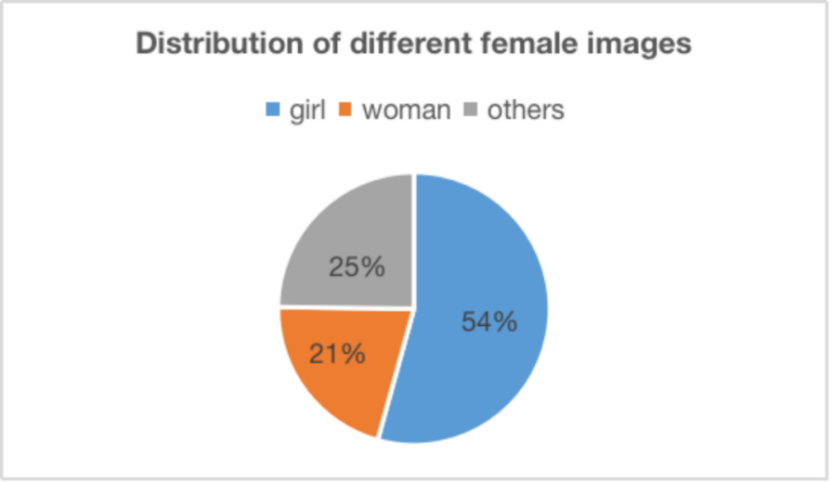

In the overall distribution of 21 sub-fields of femininity in all female images, purity, cute, chunyu and gentle is the dominant femininity, while elegant, confident, sweet and depressed are the least represented sub-fields. The result is presented in Figure 2.

**Figure 2**

*Distribution of Different Femininity*

**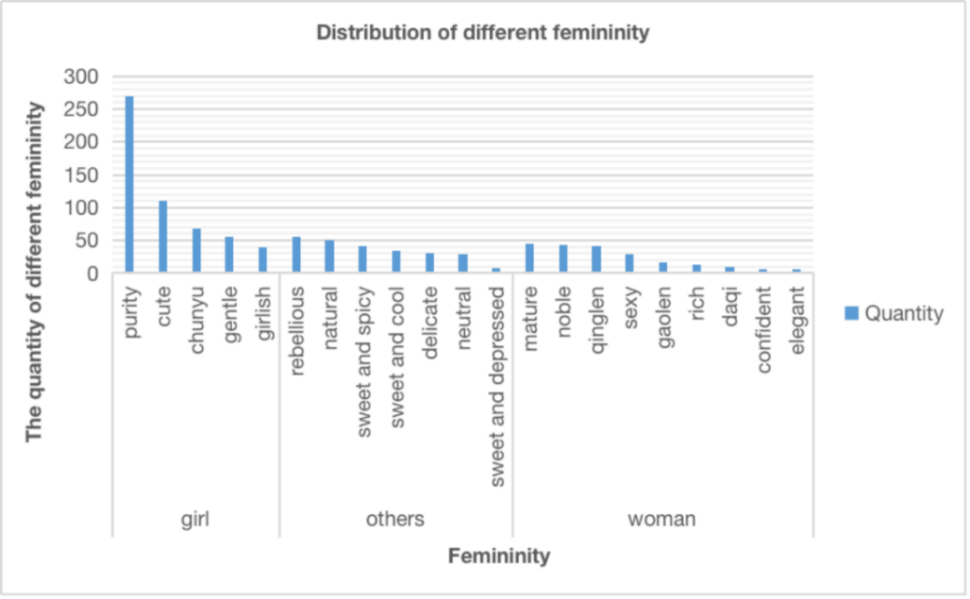**

This study also focuses on the distribution of femininity types in every female image. "Girl" type contains five femininity, including purity, cute, chunyu, gentle, and girlish, with data and percentages of 270(49.7%), 110(20.2%), 68(12.5%), 56(10.3%), and 39(7.1%). It can be seen from Figure 3 that among the femininity of "girl," purity femininity has the highest percentage, followed by cute, chunyu, gentle, and girlish.

**Figure 3**

*The Distribution of Different Femininity in the Female Image of "Girl"*

"Woman" female image includes mature, noble, qinglen, sexy, gaolen, rich, daqi, confident, and elegant femininity; the data and proportion are 45(21.5%), 44(21.0%), 42(20.0%), 29(13.8%), 17(8.1%), 14(6.6%), 10( 4.7%), 6(2.8%), 2(0.9%). Figure 4 shows mature femininity accounts for the highest proportion in the "woman" female image, followed by noble, qinglen, sexy, gaolen, rich, daqi, confident, and elegant.

**Figure 4**

*The Distribution of Different Femininity in the Female Image of "Woman"*

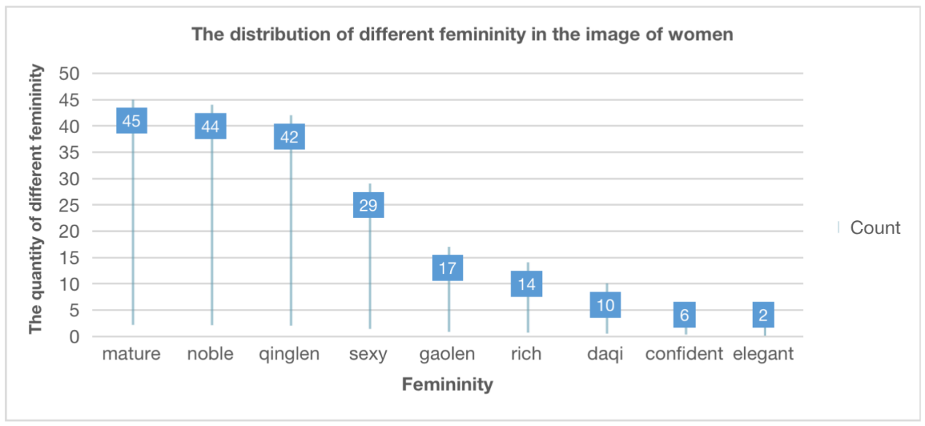

Figure 5 shows that in "other" female image, there is seven femininity, including rebellious, natural, sweet and spicy, sweet and cool, delicate, neutral, sweet and depressed. The data and proportions are 55(22.1%), 50(20.1%), 42(16.9%), 34(13.7%), 31(12.5%), 29(11.6%), 7(2.8%). Rebellious femininity has the highest proportion in "other" female image, followed by natural, sweet and spicy, sweet and cool, delicate, neutral, sweet and depressed.

**Figure 5**

*The Distribution of Different Femininity in the Female Image of "Other"*

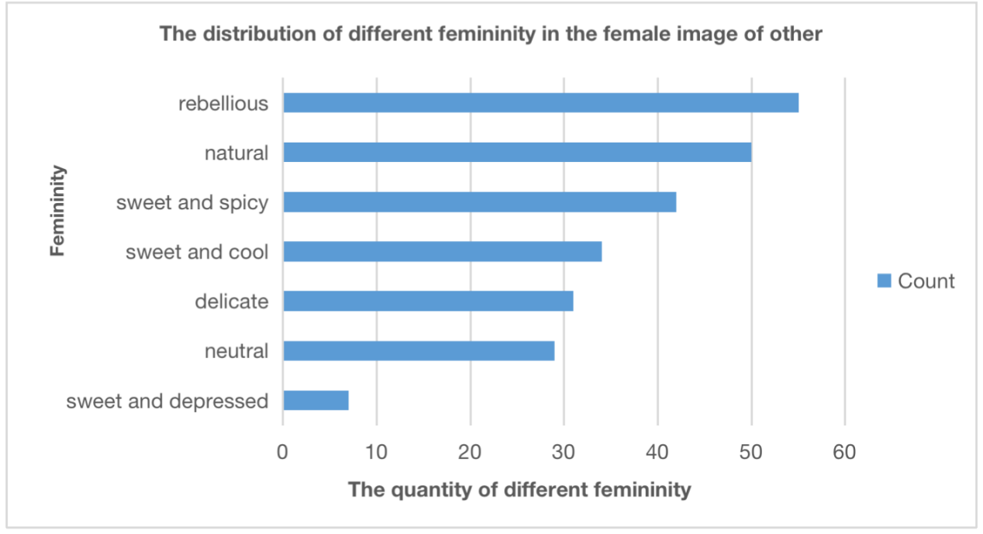

**RQ3: What are female images and femininity reflected by representative makeup styles in regions?**

In order to analyze the relationship between female images/femininity and regions, research calculates the number of female images/femininity belonging to different regions. Due to the few Hong Kong and Thailand regions, these two areas do not need to be considered. At the same time, Japan, China, South Korea, Europe and America were selected for analysis. The distribution result is presented in Figure 6.

**Figure 6**

*Distribution of Different Region-Based Makeup Styles*

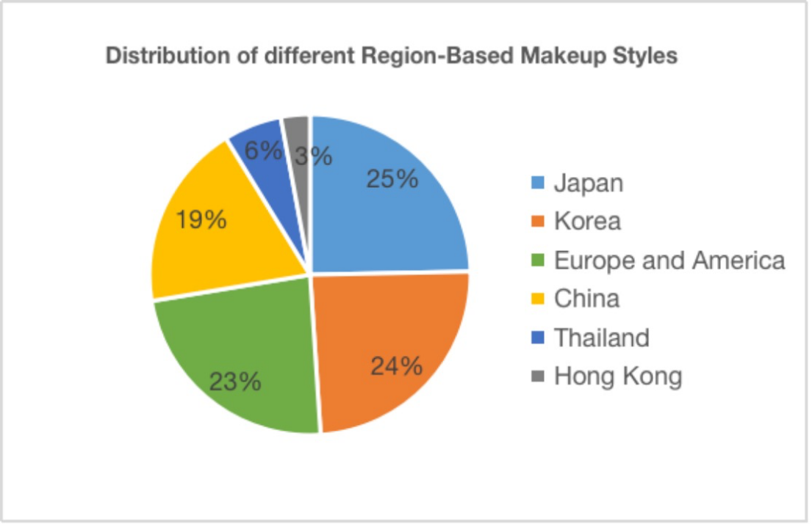

"Woman" female image dominates Chinese-style makeup videos, followed by female images of "girl" and "others." In contrast, "other" female image accounts for a small proportion. "Girl" female image dominates Japanese-style makeup videos, and "woman" female image accounts for the least amount. Like Japan, "girl" female image dominates Korean-style makeup videos, with "woman" female image accounting for the least amount. Unlike Japan and South Korea, the "others" female image dominates makeup videos of Europe and America style and the "girl" female image accounts for the minor proportion of female images. Overall, the distribution of three types of Europe and America style is relatively balanced. The distribution result is presented in Figure 7.

**Figure 7**

*Differences in the Female Images of Region-Based Makeup Styles*

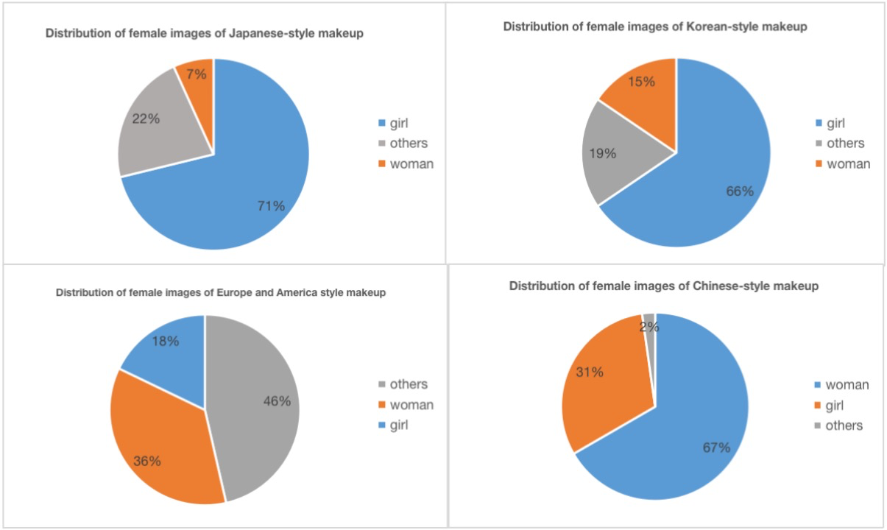

From the perspective of femininity, purity and cute femininity dominate Korean-style and Japanese-style makeup videos. Besides, the polarized femininity distribution of Korea and Japan reflects purity and cute have become their main makeup styles. Sweet and spicy femininity dominates the makeup videos of Europe and America style. Noble femininity mainly dominates the Chinese style, and the distribution of femininity is relatively scattered and balanced. That means the Chinese makeup style is still in an open and pluralistic environment.

**Figure 8**

*Differences in the Femininity of Region-Based Makeup Styles*

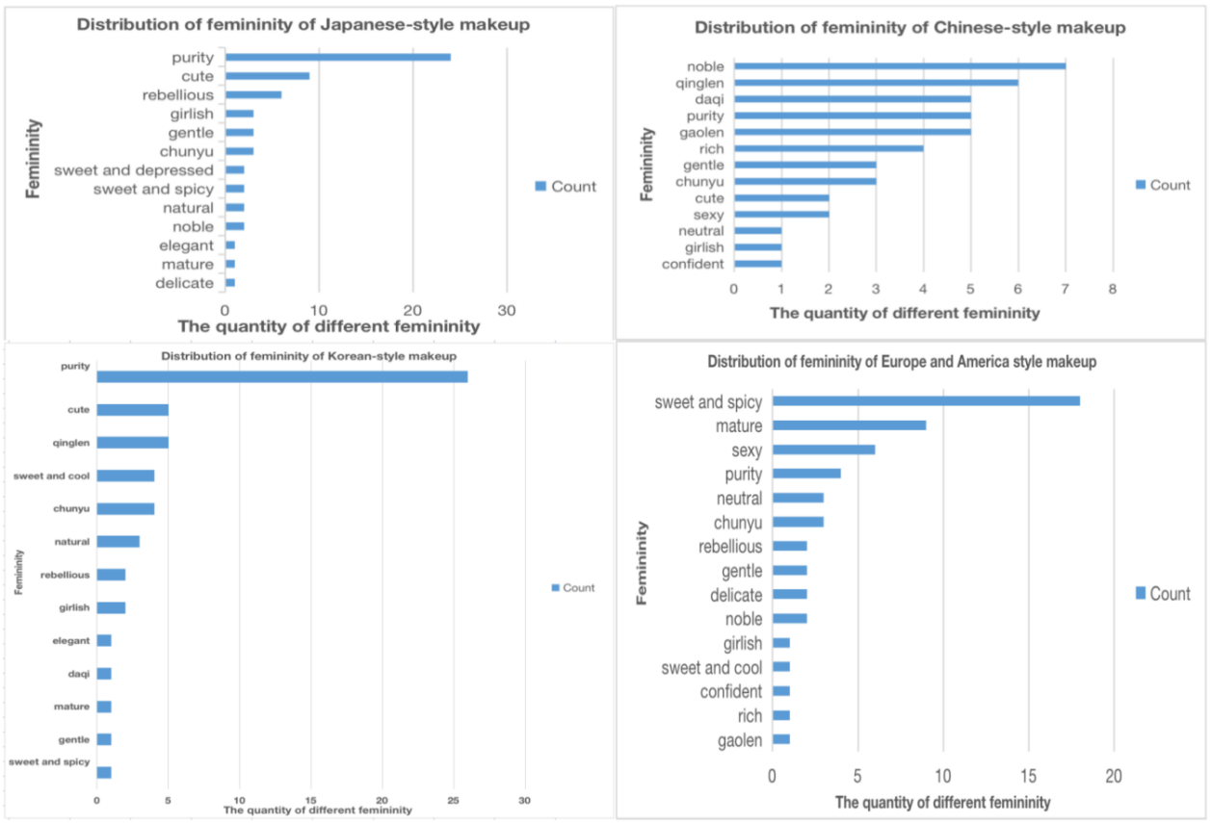

RQ4：What are the topics discussed in the comments?

**Table 1**

*Topic Clusters and Examples for Makeup-Related Comments using BTM Topic Model*

|  |  |  |
| --- | --- | --- |
| Topic | Highest-ranking terms in the topic | Examples |
| Topic 1:  Tool-related  (86.7%) | Eye Shadow, Glasses, Makeup, Eyeliner, Eyelashes, Makeup Style, Powder Blusher, Sister, Lipstick, Eyes, Wife, Liquid Foundation, Eyebrow Pencil, Foundation, Skin, Eyebrows, Tutorial, Eye Black, Brand, Color, Color Number, Brush, Sisters, Facial Features, Beauty. | -What is the brand of blogger's eye shadow palette and facelift?  -What brand of contact lenses are they?  -Ask eyeliner pen!!  -May I ask what brand eyelash curlers are? They are so curly. |
| Topic 2:  Anti-hater-related  (10.8%) | Makeup, Sister, Beauty, Bullet Screen, Comment, Blogger, Skin, Makeup style, Technology, Speechless, Style, Fans, Smile, Eyes, Problems, Nosebleeds, Advertising, Voice, Experience, Teacher, Trolling, Girl, Original Face, Time, Plain Face. | -Take a look at the haters that look ugly in the bullet screen.  - Comments are also very harsh.  - Speechless, why are there so many haters?  - Plain looks are all very beautiful. |
| Topic 3:  Praise-related  (2.5%) | Wife, Lesbian, Shoulders, Snacks, Clothes, Things, Screens, Involution, Streets, Big Fish, Airships, Haunted Houses, Palms, Targets, Mists, Taxis, Slings, Mobile Phones, Bad Things, Collarbones, Subways, Balloons, Limbs, Feet, Rivers. | -The blogger looks like my next wife.  -First of all, I'm not a lesbian. Honey hugging me  -Go to 49 haunted houses... hang 41 slings.  - Wife! (... elongate limbs, bend limbs) |

The three main themes identified in the corpus of comments can be summarized as (1) Tool-related, (2) Anti-hater-related, and (3) Praise-related. Table 1 shows that Tool-related topic accounts for 86.7% of comments on female makeup videos, mainly related to inquiries about the brands and types of makeup tools used by blogger or makeup tutorials. This topic is represented by the terms such as "eyeshadow," "glasses," and "eyeliner" (Table 1). The study also identified the presence of the Anti-hater-related topic in comments, accounting for 10.8% of comments on female makeup videos. A closer investigation of the most relevant keywords and texts revealed that the discussion mainly focused on condemning haters occurring in comments or bullet screens and expressing support for the blogger's original appearance before makeup. In addition to these two topics, a third Praise-related theme was identified, accounting for 2.5% of comments on female makeup videos. This theme typically reflected the audience's extreme admiration for the blogger. An analysis of the text found that many female viewers would refer to the blogger as their "wife" while explicitly stating that they were not lesbians to praise the blogger's charm.

**Discussion**

**The Rise of the Looking-Level Economy**

Over the past decades, the institutional breakdown caused by various economic and political developments has gradually emerged. The group occupying more societal resources can quickly suppress the other groups participating in the competition, making women's life opportunities more challenging and vulnerable. So many young women place their hopes of creating income and gaining fame on their appearance, as the economic return brought by appearance is equal to that brought by qualifications. They regard physical appearance as a substitute for other relevant qualifications (such as education and family conditions) in pursuing economic and social status (Dippner, 2018; Hakim, 2011). As Foucault said, people pay attention not to the body itself, but to "body politics" and regard it as material factors and technologies that serve the power and knowledge relations as weapons, repeaters, transmission paths, and support means (Michel, 2010).

At the same time, anxiety is generated as people are increasingly unable to meet the imperative of boundless modeling of their lives through free and rational choices (Salecl, 2005). The incidence of "appearance anxiety" among young people has increased along with the growth of the looking-level economy.

**The Formation of Homogenous Aesthetics**

Under the neoliberal discourse, everyone must accept that resisting or protecting themselves from various difficulties is almost impossible. Everyone must learn how to adapt to the favorable conditions in the social environment by embracing insecurity through their efforts and careful choice (Chandler & Reid, 2016). Women are under tremendous pressure to adhere to rigidly defined criteria, such as having lovely, homogeneous looks, out of fear of being rejected by social norms (Dippner, 2018). The data we captured confirmed this statement. The dominant types of femininity are closely related to the female image of "girl."

In contrast, the proportion of other femininity related to "sister" is tiny, completely unable to compete with the data of "girl" related femininity, which indicates that the requirements of the current social, aesthetic norms for women are "immature." A particular female image and its corresponding femininity tend to prevail in society. However, there are a few cases where multiple images and temperament are equally popular at the same time.

Even if not everyone has precisely the same aesthetic, under the influence of social opinion and network environment, once the existence of a particular point of view is default, the different aesthetics will often be regarded as outlandish. Therefore, some people who attach too much importance to appearance are straightforward to be "kidnapped" by this single aesthetic (Dai, 2021). These single images and temperament represent a seemingly perfect life and a perfect appearance, which has aroused widespread public attention and the following of many fans. Many women are eager to learn how to make themselves perfect and make their striking appearance conform to mainstream beauty ideals as much as possible (Dippner, 2018).

**The Prevalence of Juvenile Aesthetics**

The invasion of capital and the spread of foreign aesthetic culture have simultaneously produced the aesthetic mainstream and the new era's fashion standard. With the introduction of the Japanese and Korean idol trends, it has had a significant influence on the local Chinese aesthetic concept. From the entertainment industry to ordinary girls, it is widely followed by the pursuit of "big eyes, small face, small mouth, and fair skin," which is a broad and traditional Asian beauty ideal (zhang, 2012）, which, in turn, brings with it a high requirement for appearance. The data we captured confirmed that makeup style with Japanese and Korean characteristics is the most popular in China. In contrast, Japanese and Korean aesthetics are more inclined to "purity," and their portrayal of female images is more inclined to "girl." That exposes a male-dominated aesthetic, the underlying logic of which is that people prefer what appears to be a safer option, a younger age, a weaker body, and a more humanly harmless face, which removes risk and leaves only harmless and child-friendly. So while it may seem that women are choosing their appearance type, men are colonizing women's appearances (Wijsbek, 2000).

According to feminist beauty experts, genetics is not the primary determinant of beauty but rather its construction by history and society (Banner, 1983). Therefore, Chinese women's aesthetic appreciation is closely related to the gender culture of the Asian cultural circle. Since ancient times, Asia has taken male supremacy as the primary aesthetic value and advocated girlish feelings. People often use the sexual appearance of women as a direct indication of women's sexual interests and behaviors. Although this suggestion is often inaccurate, women with sexual temperaments are often more likely to be sexualized and regarded as immoral, promiscuous, and unclean, which is inconsistent with the historical requirements of male women in Asian cultural circles. Although these views gradually fade with the progress of social spirit, their influence is still deeply rooted in the subculture circle. Even though many women subconsciously understand that this kind of juvenile aesthetic is a kind of deformed aesthetic, they will still be forced to comply with it under various pressures.

**Female Aesthetic Awakening and Counterattack**

It is important to note that although it is frequently believed that men are the ones who start the objectification of women, both men and women do it. It is just that the ways and why may vary. When males concentrate on a woman's physical appearance, their sexual ambitions become more apparent, which may be related to how men objectify women. Women's objectification of women, on the other hand, might be more closely linked to the notion that sexualized women are active and competitive in the mate market. In some cases, women who self-sexualize to highlight their physical attractiveness can get psychological benefits from feeling that their bodies are valued. Women who self-sexualize may feel pleasurable, liberated, and empowered by appearing more sexually attractive (Kellie et al., 2021). Therefore, some women paying more attention to their feelings emerge. Although they are keen to self-sexualize through makeup, they do not serve social norms but show their favorite temperament to please themselves.

However, consumerist culture distorts the concept of feminism. Women's economic freedom becomes a standard based on purchasing power, and the quest of the ideal self constrains the self-determination promoted by feminism (Faludi, 2009). More and more women are realizing this and starting to make changes. According to the 2021 New Trends in Women's Lives report, a new generation of women is beginning to advocate for diverse beauty, have beauty standards, and accept their true and imperfect selves (China Women's Daily et al., 2021). In resolving facial anxiety, the issue of "reconciliation with no makeup" has emerged. People are encouraged to post photos or videos of themselves without makeup, which implies accepting imperfections and flaws and accepting themselves. In the world of the Internet, where beauty is all the rage, there is no doubt that such an act has a back-to-basic symbolism. At the same time, women who wear makeup also have more choices regarding their self-image, which is confirmed by the data we captured. Several women have deviated from the traditional "Girl" image and are keen on some unconventional, highly distinctive femininity. Take "sweet and spicy" as an example. The "sweet and spicy" style combines the advantages of the two styles of sweet and sexy. It is attractive and sexy, with a charm between "Girl" and "Women." These unconventional temperaments undoubtedly reflect that women began actively fighting for their aesthetic discourse power.

**"Girls Help Girls."**

From the three themes summarized in our text analysis, it is not difficult to see that women are trying to escape the social objectification through mutual assistance. Female competition has long been one of the hottest topics in Asian culture. Female competition is the superposition of various soft powers. Being physically superior to peers is an essential part of these soft powers. Now more and more women realize that women help women, which is the only way for all women to improve their social status, have more choices in life, and control their destinies. "Girls help girls" is a typical example of a female help movement gaining more attention on online social media. If we refuse female competition, stand together with other women, and jointly demand equality, justice, freedom, and respect, we can improve the reality that women are still objectified today.

From the first theme, many comments on makeup-related posts are related to tools. On the one hand, it shows that after women find the makeup they like, they will be eager to imitate others to achieve and enjoy the same beauty. Women will actively pursue their favorite makeup, although objectification may accompany it. On the other hand, it also reflects that the discussion about makeup on the Internet is very open. Many women are very willing to share their makeup skills with other women. They are enthusiastic to reply and help more women find their favorite style.

According to the second and third topics, there was a significant interaction between women's self-objectification level and the idealized body after viewing the idealized image, which increased participants’ body shame (Monro & Huon, 2005). Even so, most women were very willing to appreciate and praise the beauty of other women. When a blogger receives negative, aggressive feedback, other women tend to defend the blogger and attack the negative feedback, which shows that more and more women are no longer silent, but speaking up, not only for other women but also for their appearance initiative.

**Conclusion**

In conclusion, this study explored the female images and femininity portrayed in makeup videos on the Bilibili platform. The dominant female image was found to be that of a "girl," with the femininity types of "purity," "cute," "chunyu," and "gentle" being the most prevalent. The rise of the looking-level economy, the formation of homogenous aesthetics and Asian traditional aesthetics were significant factors controlling women's beauty standards. However, there are signs of change, with a new generation of women advocating for diverse beauty and rejecting objectification. Overall, this study sheds light on the complexities of female beauty standards in the digital age and the potential for women to challenge and transform these standards.

**References**

Anchieta, N. M., Mafra, A. L., Hokama, R. T., Varella, M. A. C., Melo, J. D. A., da Silva, L. O., ... & Valentova, J. V. (2021). Makeup and its application simulation affect women's self-perceptions. Archives of Sexual Behavior, 50(8), 3777-3784.

Aubrey, J. S. (2006). Effects of sexually objectifying media on self-objectification and body surveillance in undergraduates: Results of a 2-year panel study. Journal of Communication, 56(2), 366–386.

Aubrey, J. S. (2010). Looking good versus feeling good: An investigation of media frames of health advice and their effects on women's bodyrelated self-perceptions. Sex Roles, 63(1–2), pp. 50–63. https://doi.org/10. 1007/s11199-010-9768-4

Batres, C., Russell, R., Simpson, J. A., Campbell, L., Hansen, A. M., & Cronk, L. (2018). Evidence that makeup is a false signal of sociosexuality. Personality and Individual Differences, pp. 122, 148–154. https://doi.org/10.1016/j.paid.2017.10.023

Bartlett, A. (1993). Let's talk about lips. LiNQ, 20(2), 51–52.

Banner, L.W. (1983). American beauty. New York: Knopf.

Blei, D. M., Ng, A. Y., & Jordan, M. I. (2003). Latent Dirichlet Allocation. Journal of Machine Learning Research, 3, 993–1022.

Banet-Weiser, S. (2017). 'I'm beautiful the way I am': Empowerment, beauty, and aesthetic labour. Aesthetic labour: Rethinking beauty politics in neoliberalism, 265-282.

Batres, C., Russell, R., Simpson, J. A., Campbell, L., Hansen, A. M., & Cronk, L. (2018). Evidence that makeup is a false signal of sociosexuality. Personality and Individual Differences, pp. 122, 148–154. <https://doi.org/10.1016/j.paid.2017.10.023>

Cash, T. F., Dawson, K., Davis, P., Bowen, M., & Galumbeck, C. (1989). Effects of cosmetics use on the physical attractiveness and body image of American college women. The Journal of social psychology, 129(3), 349-355.

China Women's Daily, China Women's Network and xiaohongshu. (2021, March 4). 2021 New trends in women’s lives. The Paper. https://m.thepaper.cn/baijiahao\_11550400

Chandler, D., & Reid, J. (2016). The neoliberal subject: Resilience, adaptation and vulnerability. Rowman & Littlefield.

Dill, K. E., & Thill, K. P. (2007). Video game characters and the socialization of gender roles: Young people's perceptions mirror sexist media depictions. Sex Roles, 57(11-12), pp. 851–864.

Dippner, A. (2018). Social media celebrities and neoliberal body politics in China. KFG WorNing paper Series.

Faludi, S. (2009). Backlash: The undeclared war against American women. Crown.

Foucoult, M. (1975). Discipline and punish. A. Sheridan, Tr., Paris, FR, Gallimard.

Dai Chen.(2021). The cultural differences behind the popular aesthetic standards of "appearance anxiety". Study Abroad (02),67-69. doi:CNKI:SUN:LIUX.0.2021-02-019.

Fredrickson, B. L., & Roberts, T. A. (1997). Objectification theory: Toward understanding women's lived experiences and mental health risks. Psychology of Women Quarterly, 21(2), 173-206.

Gill, R. (2007). Post-feminist media culture: Elements of a sensibility. European Journal of Cultural Studies, 10(2), 147–166.

Hakim, C. (2011). Attractive Wins and Ugly Loses in Today's Rat Race. Evening Standard, p. 22.

Kellie, D. J., Blake, K. R., & Brooks, R. C. (2021). Behind the makeup: The effects of cosmetics on women's self‐objectification, and their objectification by others. European Journal of Social Psychology, 51(4-5), pp. 703–721.

Keum, H. J. (2006). The influences of entertainment television use on social comparison and life satisfaction-focusing on individuals' economic situations and romantic relationships. Korean J Broadcast Telecommun Stud, 21(2), 98-137.

Kleemans, M., Daalmans, S., Carbaat, I., & Anschütz, D. (2018). Picture perfect: The direct effect of manipulated Instagram photos on body image in adolescent girls. Media Psychology, 21(1), 93-110.

Marwick, A. E. (2015). Instafame: Luxury selfies in the attention economy. Public Culture, 27(1), 137–160.

McNeil, J. C. (1975). Feminism, femininity, and the television series: A content analysis. Journal of Broadcasting & Electronic Media, 19(3), 259–271.

Merskin, D. (2007). Truly Toffee and Raisin Hell: A Textual Analysis of Lipstick Names. Sex Roles, 56(9-10), pp. 591–600.

Moradi, B., & Huang, Y. P. (2008). Objectification theory and psychology of women: A decade of advances and future directions. Psychology of Women Quarterly, 32(4), 377-398.

Monro, F., & Huon, G. (2005). Media‐portrayed idealized images, body shame, and appearance anxiety. International Journal of Eating Disorders, 38(1), 85-90.

Myers, T. A., & Crowther, J. H. (2009). Social comparison as a predictor of body dissatisfaction: A meta-analytic review. Journal of abnormal psychology, 118(4), 683.

Murashka, V., Liu, J., & Peng, Y. (2021). Fitspiration on Instagram: Identifying topic clusters in user comments to posts with objectification features. Health Communication, 36(12), 1537-1548.

My Pale Skin. (2015, July 1). YOU LOOK DISGUSTING. YouTube. https://www.youtube.com/watch?v=WWTRwj9t-vU.

Plakoyiannaki, E., & Zotos, Y. (2009). Female role stereotypes in print advertising: Identifying associations with magazine and product categories. European Journal of Marketing, 43(11/12), 1411-1434.

Prichard, I., McLachlan, A., Lavis, T., & Tiggemann, M. (2018). The impact

Of different forms of# fitspiration imagery on body image, mood, and

self-objectification among young women. Sex Roles, 78(11–12), 789–798.

https://doi.org/10.1007/s11199-017-0830-3

Roca-Sales, M., & Lopez-Garcia, G. (2017). Contemporary portrayals of women and femininity. A case study of lifestyle blogs in the US. Journal of Research in Gender Studies, 7(2), 186-210.

Salecl, R. (2005). On Anxiety. London: Routledge.

Schippers, M. (2007). Recovering the feminine other: Masculinity, femininity, and gender hegemony. Theory and society, 36, 85-102.

TadeleSmith. (2013, January 13). Feminist Makeup Tutorial (PARODY). YouTube. https://www.youtube.com/watch?v=lET-WXTsSwc

Tran, A., Rosales, R., & Copes, L. (2020). Paint a better mood? Effects of makeup use on YouTube beauty influencers' Self-esteem. Sage Open, 10(2), 2158244020933591.

Ward, L. M. (2016). Media and sexualization: State of empirical research, 1995–2015. The Journal of Sex Research, pp. 53, 560–577. DOI: <https://doi.org/10.1080/00224499.2016.1142496>

Wagstaff, D. (2018). Comparing Mating Motivations, Social Processes, and Personality as Predictors of Women's Cosmetics Use. Evolutionary Behavioral Sciences, 12(4), 367–380. https://doi.org/10.1037/ebs0000119

Wang, N., & Bao, H. (2020). Double control of patriarchy and capital: Pathological female image shaping in beauty videos. Media Criticism, (1), 144-156.

Wagstaff, D. (2018). Comparing Mating Motivations, Social Processes, and Personality as Predictors of Women's Cosmetics Use. Evolutionary Behavioral Sciences, 12(4), 367–380. <https://doi.org/10.1037/ebs0000119>

White, M. (2018). Beauty as an "act of political warfare" Feminist Makeup Tutorials and Masquerades on YouTube. Women's Studies Quarterly, 46(1/2), 139–156.

Wijsbek, H. (2000). The pursuit of beauty: the enforcement of aesthetics or a freely adopted lifestyle?. Journal of medical ethics, 26(6), 454–458.

Wijsbek, H. (2000). The pursuit of beauty: the enforcement of aesthetics or a freely adopted lifestyle?. Journal of medical ethics, 26(6), 454–458.

Yan, X., Guo, J., Lan, Y., & Cheng, X. (2013, May). A biterm topic model for short texts. In Proceedings of the 22nd international conference on World Wide Web (pp. 1445-1456).

Zhang, M. (2012). A Chinese beauty story: How college women in China negotiate beauty, body image, and mass media. Chinese Journal of Communication, 5(4), 437–454.

**Appendix A**

**Table A1**

*Coding book for the style of makeup videos on Bilibili platform*

|  |  |  |  |  |
| --- | --- | --- | --- | --- |
| **Primary Category** | **Definition of Primary Category** | **Secondary Category** | **Definition of Secondary Category** | **Keyword Examples** |
| woman | The individual displays traits of maturity, independence, distant feeling, confidence, and fearlessness of exhibiting their sexual allure. | mature | a well-developed femininity. | yujie, nongyan, cool |
| confident | a femininity full of self-assurance in one's own abilities. | queen, qichang, baqi |
| sexy | a femininity of fearlessness of exhibiting their sexual allure. | charm, mei, yan, yaoyan, feminine |
| dayi | a dignified, steady and extraordinary femininity. | daqi |
| rich | a rich femininity. | rich, guiqi |
| gaolen | a femininity of cool and distant. | gaolen, cool, cold, yanxi, normcore |
| noble | a femininity of wealth and distance. | noble, socialite, qianjin, a sense of sophistication |
| qinglen | a literary and distant femininity. | qinglen, moonlight |
| elegant | a beautiful and graceful femininity. | elegant, quietly elegant |
| girl | The individual is perceived as sweet, pure, and approachable, which may evoke a sense of protectiveness from others. Additionally, the person may be hesitant to display overt sexual attractiveness. | girlish | a young-looking femininity. | girlish, childlike, age reduction |
| purity | a clean and pure femininity. | fragile sense, VC sense, first love, air sense, innocent, pure |
| cute | a cute femininity. | sweet, cute, energetic |
| gentle | a tame and gentle femininity. | gentle, cute and clever |
| chenyu | a pure and cute femininity, with subtly sexual attraction. | slightly drunk, chunyu, milky drunk, American boiled water, teasing a man, green tea |
| others | Other  female images including mixture temperaments  with multiple incompatible femininity, non-mainstream style, neutral temperament and so on. | sweet and spicy | a sweet femininity, with openly sexual attractiveness. | Asian spicy girl, human computer, American sweetheart, American boiled water |
| sweet and depressed | a femininity of girlishness with a rebellious feeling. | sweet and depressed、peach flower and world-weary |
| sweet and cool | a femininity of girlishness with a neutral feeling. | sweet and cool, milky and cool, sweet and salty |
| rebellious | a femininity of not following the mainstream. | doomsday wasteland, Y2K, worldliness, dark black, decadence, bad, sick, punk |
| neutral | a mixture temperament of masculinity and femininity. | neutral style, youthful, handsome,  aggressive, super A, cool |
| natural | a femininity of pursuing authenticity without modification. | relaxed, natural, danyan, makeup-free, pseudo pure face,, light, and nude makeup |
| delicate | a meticulously embellished and unrealistic femininity due to the pursuit of extremely perfect facial features in makeup. | doll, internet sensation, barbie, internet celebrity sensation, plastic surgery style |

Coding protocols:

1. Videos are classified based on core words in the titles pointing to femininity.
2. Male makeup videos and words not describing makeup styles, such as atmosphere, daily life, texture are not considered.
3. If multiple femininity is mentioned in the title, the most prominent one is chosen as the representative category.

**Table A2**

*Coding book for the region of origin of makeup videos on Bilibili platform*

|  |  |  |
| --- | --- | --- |
| **Category** | **Description** | **Keyword Examples** |
| China | Words about China and related celebrities and makeup imitation targets. | ancient times, ancient style, Liu Yifei. |
| Europe and America | Words about Europe and America and related celebrities and makeup imitation targets. | light European and American style, Asian-Americans |
| Japan | Words about Japan and related celebrities and makeup imitation targets. | Yu Aoi, Komatsu Nana |
| Korea | Words about Korea and related celebrities and makeup imitation targets. | Korean female high school students, Kim Tae Hee |
| Thailand | Words about Thailand and related celebrities and makeup imitation targets. | light Thai style |
| Hong Kong | Words about Hong Kong and related celebrities and makeup imitation targets. | Hong Kong style |

Coding protocols:

1. If the title does not involve keywords of makeup style, this title does not need to be labeled by region and is directly treated as invalid data.

2. If the title includes a makeup imitation's name, you can consider this person's name as a keyword, such as Yu Aoi and code the person's region. But if the word is the blogger's name, the title will be ignored.

**Appendix B**

**School of Communication, Hong Kong Baptist University**

**Statements on Research Ethics Consideration for Digital Research**

**for AIDM7340 AI for Digital Media**

**Updated: 10-Apr-2023**

Group members: Jiale Zheng, Siting Liu, Tianqing Lu, Dongyuan Zhu, and Yan Lei

Date: 13-Apr-2023

# Roles & responsibilities

This project explores the construction of femininity and female images in makeup videos and their impact on the audience from a gender perspective, with the titles and user comments of 1000 female makeup videos from 2018 to 2023 on Bilibili. This project plans to start from April 1 to May 14.

The proposed methods include web scraping,manually review,pre-processing and text mining in comments.This study first describes the femininity and images indicated by the titles of 1000 female makeup videos on Bilibili. In addition, this study focuses on the femininity behind the different region-based makeup styles and the discussion topics in the user comments. By carefully analyzing the user comments under makeup videos, we can better understand the impact of makeup videos on their followers.

This project is no funded. The data is collected as a part of the course project of AIDM7340 AI for Digital Media. The course supervisor is Dr. Xinzhi ZHANG. The data will be used for academic purposes ONLY.

# Data creation & collection

The data is collected through Bilibili's API. The code uses the requests library to send requests to the API link and sets the User-Agent in the header to simulate a browser to avoid being blocked by the website. Specifically, the Bilibili API allows users to obtain various types of data such as videos, pop-ups, comments, and user information. Among them, comment data can be obtained through the following interface:

https://api.bilibili.com/x/v2/reply?pn={page}&type=1&oid={video\_id}

where pn indicates the number of pages of comments to get (up to 20 comments per page), type indicates the type of comments (1 for normal comments, 2 for popular comments), and oid indicates the ID of the video.

When using the Bilibili API, developers need to comply with certain restrictions, including the following:

* request frequency: For certain API interfaces, Bilibili limits the request frequency, for example, the commenting interface can only initiate a maximum of 80 requests per minute.
* Data volume limit: For some API interfaces, Bilibili limits the amount of data returned, for example, the comment interface can only return a maximum of 20 comments per page.
* Authorization and authentication: For some API interfaces, Bilibili requires users to be authorized and authenticated before they can access them, for example, the user information interface requires users to be logged in before they can access it.

# Data management, storage & retention

We store data in CSV files because it is a common, easy-to-use format and can be easily imported into many different data processing tools. To ensure easy and secure sharing, we will upload CSV files to a password-protected shared cloud drive (Google Drive) and authorize it only to the team.

To ensure data integrity and traceability, we will also consider using GitHub to record data file changes and updates.

Long-term storage plans are important because we may need to access past data at any time. To address this, we back up data to local disks or remote servers, and make regular backups to ensure that data is not lost for any reason.

Concerning copyright, we will first determine ownership of the data to ensure the right to share it. If we do not have full ownership, we will obtain permission from others or sign a contract.

Finally, if we need to comply with a funder's policy, we consult the funder's guidelines for information about long-term retention terms and other rules.

# Data usage and reporting of the results

This study scraped all 4492 videos displayed on the web page. After manual review, the following types of makeup videos that do not meet the scope of this study were removed.The final sample includes 1000 valid data for coding.

Based on previous research and the text characteristics of this study, the primary category focuses on female images while the secondary category focuses on femininity. Videos are classified based on core words in the titles pointing to femininity. If multiple femininity is mentioned in the title, the most prominent one is chosen as the representative category. Next, research encodes the "country of origin of the makeup style" based on the country, celebrities or the makeup imitation target mentioned in the title of the makeup video.After resolving all disagreements and refining the coding strategy through discussion, the four coders coded 50 videos selected from the final sample via convenient sampling and achieved dependable inter-coder reliability.

For text mining, this study used The Biterm Topic Model (BTM) for unsupervised topic modeling analysis. And in order to determine the optimal number of topics, this study used perplexity (Blei et al, 2003) to model 2-10 topics and calculate their respective perplexity values.

We report the data analysis according to the academic standard and we don’t report and share any private data openly or any other means violating fair use, etc.

# 

# Data security, private protection

This research will not disclose users' personal information publicly, and will only crawl and analyze the public information of the platform under study. The information will not be shared with third parties outside of HKBU or used for non-academic purposes, etc.

**The HKBU’s University’s Privacy Policy Statement and Personal Information Collection Statement([https://bupdpo.hkbu.edu.hk/policies-and-procedures/pps-pics/](https://bupdpo.hkbu.edu.hk/policies-and-procedures/pps-pics/" \t "_blank" \o "https://bupdpo.hkbu.edu.hk/policies-and-procedures/pps-pics/)) are also applicable to the collecting and handling of data for this project.**