Unversity of Arkansas
Department of computer science and computer engineering
CSCE 3513 Software Engineering
Spring 2010
Team Project Report

Team 02
Restaurant Organization and Floor Layout
Restaurant Automation

Adam Higgins
Andrew Jones
Tejeshwar Sangameswaran
Kellen Zantow

May 4, 2010

TABLE OF CONTENTS

1. Customer Statement and requirement 1
2. Individual Contributions Breakdown 4
2.1 Requirement Specification 4
2.2 Software Design 4
2.3 Coding 4
2.4 Debugging 5
2.5 Report Preparation 5
2.6 Demo and Presentation Preparation 5
2.7 Individual Contributation Overall 6
3. Glossary of Terms 7
Busboy 7
Cook 7
Host 7
Manager 7
Order 7
Payment 7
ROFL 8
Table 8
Waiter 8
4. Functional Requirements Specification 9
4.1 Actors and Goals 9
4.1.1 Manager 9
4.1.2 Waiter 9
4.1.3 Host 9
4.1.4 Busboy 9
4.1.5 Cooks 10
4.2 Use Cases 10
4.2.1 Casual Description 10
4.2.2 Fully-Dressed Description 11
4.2.3 Use Case Diagram 14
4.3 System Sequence Diagram 16
4.3.1 Seat Customer 16
4.3.2 Place Order 17
4.3.3 Prepare Food 18
4.3.4 Clean Table 19
5. Class diagram and interface specification 20
6. System Architecture and system 21
6.1 Architecture Syles 21
6.2 Persistent Data Storage 21
6.3 Network Protocol 21
7. Algorithms and data structures 22
8. user interface design and implementation 23
8.1 Navigational path 23
8.2 User Effort Estimation 23
8.2.1 Click Analysis 24
9. Implemenation statistics 26
9.1 Development Summary 26
9.1.1 The Programming Languages 26
9.1.2 The leveraged libraries 26
9.1.3 The supported platforms 26
9.1.4 Line count 26
9.1.5 Man Hours 26
9.2 SVN Repository 27
9.3 Done and Incomplete 27
9.3.1 Done 27
9.3.2 Incomplete 28
10. Conclusions 29
10.1 Technical challenges 29
10.2 Application of class lectures 30
10.3 Other applied knowledge 31
10.4 Future work 31
References 33
Appendix A. New features 34

LIST OF FIGURES

Figure 1: Use Case Diagram: Main 14
Figure 2: Use Case Diagram: Manage Users 15
Figure 3: Sequence Diagram: Seat Customer 16
Figure 4: Sequence Diagram: Place Order 17
Figure 5: Sequence Diagram: Prepare Food 18
Figure 6: Sequence Diagram: Clean Table 19
Figure 7: Class Diagram 20

1. Customer Statement and requirement
In general, this system is designed to minimize the amount effort required on the part restaurant employees. Instead of interacting with each other in person and through paper, they can simply log in and type a short description on a console and have it electronically entered into the network.
The actors in this system correspond to the different employee types (ie. host, waiter, cook, bus boy, and manager). Each employee has its own privileges in the system, appropriate for his or her tasks. When an employee logs into the system, he or she will see a start up screen with a menu unique to that employee type.
When a waiter logs into a terminal, he can see the layout of the floor and tables. The tables are colored in such a way that they indicate their status (green for available, yellow for occupied, red for dirty). He can then select a table to view its tab and is presented with a hierarchy. He can select a category of dishes and then select a particular food to add to the tab. He can also delete a dish from the tab. After he's done, he can go back to the main menu and choose another option, or he can just log off. This benefits him so that he doesn't have to walk to the back room to give the cooks a piece of paper and walk back to find another table, and changing the order is as easy as a click of a button instead of having to erase or start over.
When a manager logs in, he's greeted with an administrative control panel, wherein he can access, create, or modify employee profiles. He can use it to keep track of any information available, such as inventory info and sales analysis. He can also act as any other employee type in the system, so the manager type is like a subclass of all other types.
The cook screen, which should typically be open at all times, initially has a large gray area. When clicked, a new order attaches itself to the page. Each order has a unique number, with a list of entrees, appetizers, and desserts associated with that order. He can say when the order is complete and it will remove itself from the page and the others will re-organize themselves in sorted order.
One issue to deal with is whether to have the computer terminals stationary or wireless, hand-held devices. If stationary consoles are used exclusively, the waiters would still have to use paper to write things down before they can get to a terminal. On the other hand, hand-held devices would be expensive. Also, fixed devices aren't likely to be lost, unlike wireless devices. For now, assume the system uses only stationary consoles.
Another problem is, there will most likely be more people on the staff than there are consoles. As a result, a user will have to log in, make the change, and log back out to free up the computer for someone else to use. To minimize the usage time of the consoles, when a user logs in, he's immediately updated on information relevant to his user type. For example, a waiter could log in and be told what orders have become ready to serve since he last logged on. Then he can log off directly after reading that information and go retrieve the food. Some users will remain logged on indefinitely (ie. the host and kitchen staff), since their consoles will be located in areas mostly exclusive to their types, and thus won't have to worry about logging out for another user type.
One of the functions of this system needs to be a floor layout manager. When designing the layout for a specific restaurant, we can arrange the walls and tables so that they match up with the physical layout of the building. The manager will be able to edit the floor layout at any time, as tables are added, removed, or relocated, or even if some construction is done on the walls. There's a default layout of walls and tables that is satisfactory for demonstration purposes.
The system is designed to automatically handle a large range of statistics processing and perform other tasks. It keeps track of employee hours, revenue for a given period, number of each dish sold, etc. and also processes information based on collected data, such as taxes, compensation owed, and so on. Automation is good because your typical human isn't very good at calculations.
In keeping with the requirement of efficiency, the system is designed to function on a minimal amount of clicks and keystrokes.

2. Individual Contributions Breakdown

2.1 Requirement Specification
- Kellen Zantow
  - Contribution - 25%
  - Gave specifications for cook screen, host screen.
- Andrew Jones
  - Contribution - 25%
  - Gave specifications for menu editor, waiter screen.
- Adam Higgins
  - Contribution - 25%
  - Gave specification for database schema, login infrastructure.
- Tejeshwar Sangameswaran
  - Contribution - 25%
  - Gave specification for manager screen and general GUI.

2.2 Software Design
This pertains to building the software architecture and project planning.

- Adam Higgins
  - Contribution - 50%
    - Built application framework
- Tejeshwar Sangameswaran
  - Contribution - 50%
    - Built abstract classes.

2.3 Coding
- Adam Higgins
  - Contribution - 30%
    - Database adapters
    - Floor layout editor
    - Core functionality modules
- Tejeshwar Sangameswaran
  - Contribution - 30%
    - Manager interface
    - Floor layout editor
    - Animation Library
- Kellen Zantow
  - Contribution 20%
    - Cook Screen
    - Cook Panel Design
- Andrew Jones
  - Contribution 20%
    - Waiter screen
    - Busboy screen

2.4 Debugging
- Adam Higgins
  - Contribution - 50%
    - Debugged database refresh issues
- Tejeshwar Sangameswaran
  - Contribution - 50%
    - Debugged threading issues

2.5 Report Preparation
- Kellen Zantow
  - Contribution - 25%
    - User Interface Design and implementation
- Andrew Jones
  - Contribution - 25%
    - Customer Statement of Requirements
- Adam Higgins
  - Contribution - 25%
    - Functionality and requirements specification
    - Use Case diagrams
    - Sequence Diagrams
- Tejeshwar Sangameswaran
  - Contribution - 25%
    - Case diagrams.
    - Interface specification
    - Rich Client Interface

2.6 Demo and Presentation Preparation
- Adam Higgins
  - Contribution - 50%
    - Presented and demoed.
- Tejeshwar Sangameswaran
  - Contribution - 50%
    - Presented and demoed.

2.7 Individual Contributation Overall
- Adam Higgins
- Tejeshwar Sangameswaran
- Andrew Jones
- Kellen Zantow

3. Glossary of Terms

Busboy
A busboy is a restaurant user who is responsible for cleaning dirty tables.

Cook
A cook is a restaurant user who is responsible for preparing orders.

Host
A host is a restaurant user who is responsible for placing customers at tables.

Manager
A manager is a restaurant user with complete system access. A manager can do all other users tasks, as well as changing master data in the system.

Order
An order is a list of items ordered by customers that is input by a waiter, tells cooks what to prepare, and how much the customer owes.

Payment
A payment is a monetary amount put against the value of an order. A payment may be cash or credit.

ROFL
ROFL is an acronym for Restaurant Oraganization and Floor Layout.

Table
A table is a location in a restaurant that is served by a waiter, cleaned by a busboy, and has an order tied to it when the table is occupied.

Waiter
A waiter is a restaurant user who is responsible for taking customer orders, delivering food, and handling payments.

4. Functional Requirements Specification

4.1 Actors and Goals

4.1.1 Manager
The goals of the manager are to manage table layouts, system users, waiter schedules, and menu items and to analyze data for trends to improve restaurant profits. Managers are initiating and participating actors.

4.1.2 Waiter
The goals of the waiter are to take the customers order and enter it into the system, to receive notification of orders being ready and to deliver the orders to the customers, to handle payments, and to mark tables as dirty when customers leave. Waiters are initiating and participating actors.

4.1.3 Host
The goal of the host is to place customers at available tables when the customers arrive or when a table becomes available. Hosts are initiating and participating actors.

4.1.4 Busboy
The goal of the busboy is to receive notification of dirty tables, to clean the tables, and to mark the tables as available. Busboys are initiating and participating actors.

4.1.5 Cooks
The goal of the cook is to receive the orders from other users, to prepare the food, and to mark the orders as ready. Cooks are initiating and participating actors.

4.2 Use Cases

4.2.1 Casual Description

4.2.1.1 Deliver Order
The system alerts the waiter when a cook has finished preparing an order. The waiter takes the food to the customer and marks the order as delivered.

4.2.1.2 Handle Payment
The waiter takes the payment method from the user and inputs the payment information into the system against an order.

4.2.1.3 Manage Users
A manager can add, change, and delete users in the system.

4.2.1.4 Manage Menu Items
A manager can add, change, and delete menu items in the system.

4.2.1.5 Manage Layout
A manager can add, change, and delete different types of tables and walls to the floor layout.

4.2.1.6 Seat Customer
Hosts and managers mark tables as occupied to represent customers siting at a table.

4.2.1.7 Place Order
Waiters and managers place an order against a table. They may add multiple menu items to the order.

4.2.1.8 Prepare Food
Cooks and managers can mark which orders have been prepared in the kitchen.

4.2.1.9 Clean Table
Busboys and managers mark which dirty tables have been cleaned.

4.2.1.10 Mark Table Dirty
Waiters and managers can mark tables as dirty when customers leave.

4.2.1.11 Assign Waiters to Tables
Managers can specify which waiter server which tables.

4.2.2 Fully-Dressed Description

4.2.2.1 Seat Customer
Actor: Host, Manager
Preconditions:
- The user is registered in the system.
- The table to be occupied is open.

Scenario:
- The user logs into the system.
- The user navigates to the floor manager.
- The user selects the table to be occupied and clicks "Set Table Occupied."
- The user logs out.

Exceptions:
Step 3: If no table is open, the user must wait for one to become available.

4.2.2.2 Place Order
Actor: Waiter, Manager
Preconditions:
- The user is registered in the system.
- The table for the order is marked as occupied.

Scenario:
- The user logs into the system.
- The user navigates to the floor manager.
- The user selects the table to have an order and clicks "Create Order."
- The user selects a menu item to add to the order.
- The user saves the order.
- The user logs out.

Exceptions:
Step 3: If no tables are occupied, the user cannot create an order.
Extension:
4a. Multiple menu items can be added to an order.

4.2.2.3 Prepare Food
Actor: Cook, Manager
Preconditions:
- The user is registered in the system.
- The order to be prepared is in the system.

Scenario:
- The user logs into the system.
- The user navigates to the cook screen.
- The user marks the prepared order as "Completed."
- The user logs out of the system.

Exceptions:
Step 3: If there are no active orders in the system, the user cannot select an order as "Completed."
Extensions:
3a. The user may mark multiple orders as completed at one time.

4.2.2.4 Clean Table
Actor: Busboy, Manager
Preconditions:
- The user is registered in the system.
- The table to be cleaned is marked as dirty.

Scenario:
- The user logs into the system.
- The user navigates to the floor manager.
- The user selects the table and clicks "Set Table Open."
- The user logs out of the system.

Exceptions:
Step 3: If no tables are dirty, the user cannot mark any table as open.

4.2.3 Use Case Diagram
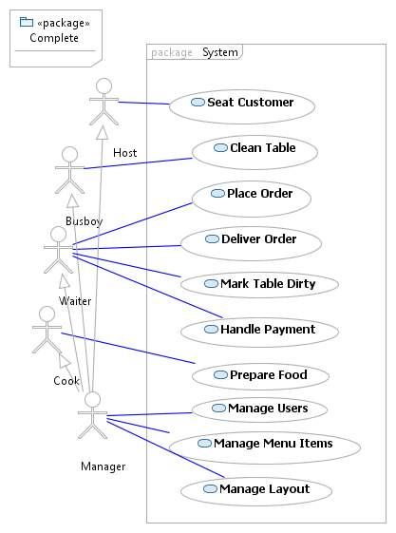
Figure 1: Use Case Diagram: Main
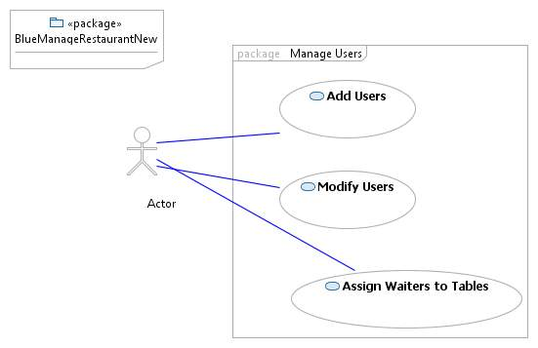
Figure 2: Use Case Diagram: Manage Users

4.3 System Sequence Diagram

4.3.1 Seat Customer
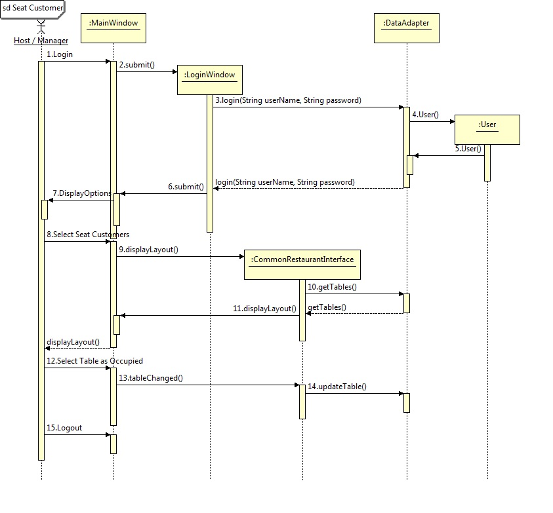
Figure 3: Sequence Diagram: Seat Customer

4.3.2 Place Order
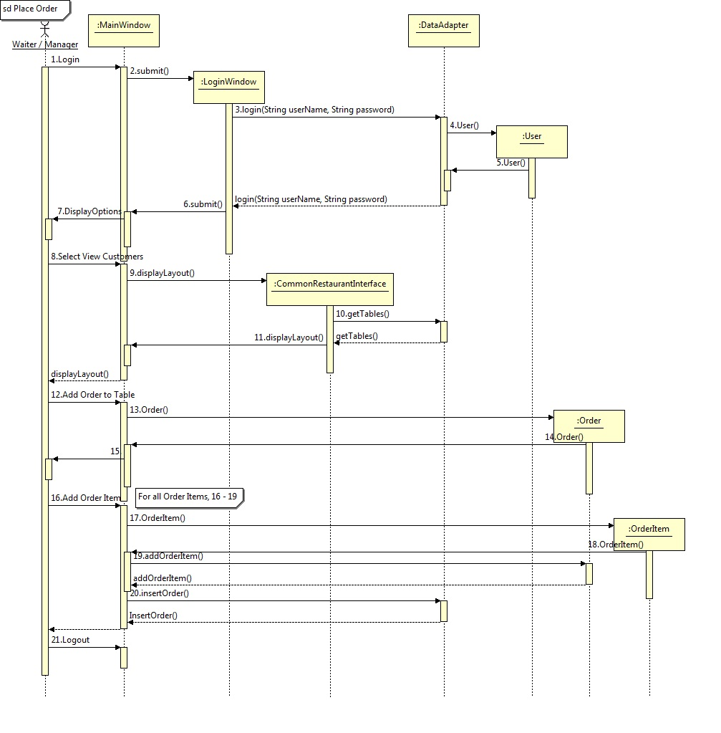
Figure 4: Sequence Diagram: Place Order

4.3.3 Prepare Food
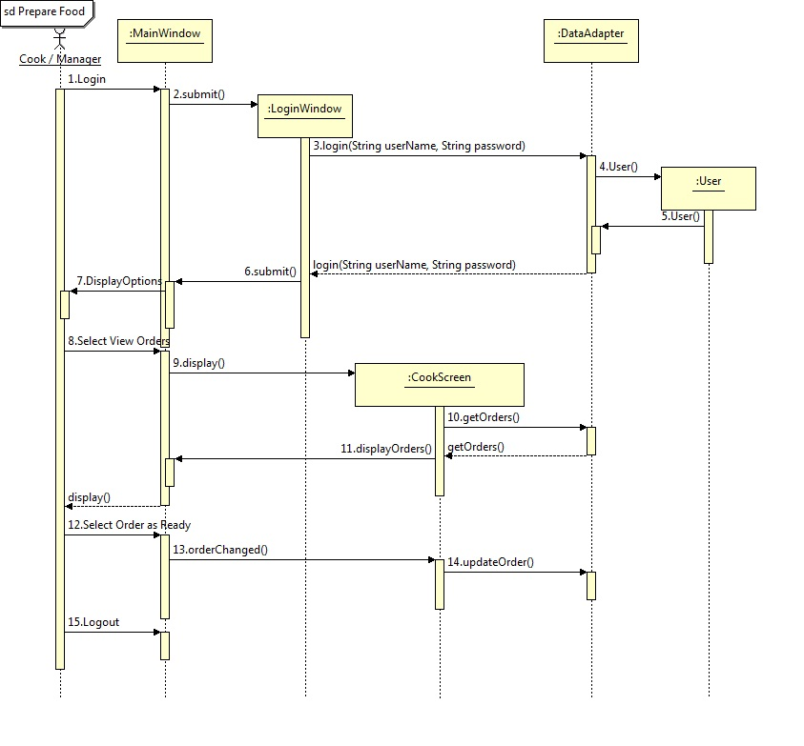
Figure 5: Sequence Diagram: Prepare Food

4.3.4 Clean Table
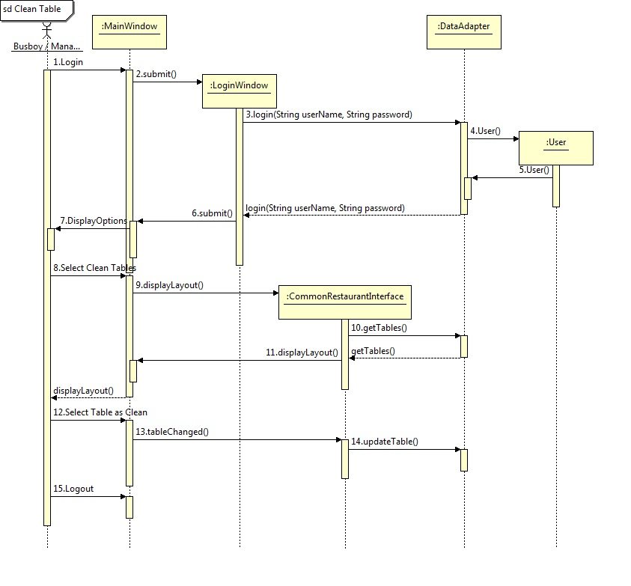
Figure 6: Sequence Diagram: Clean Table

5. Class diagram and interface specification
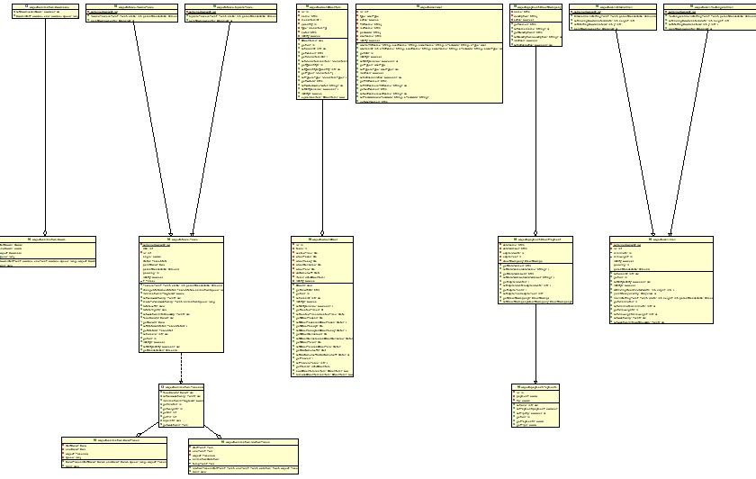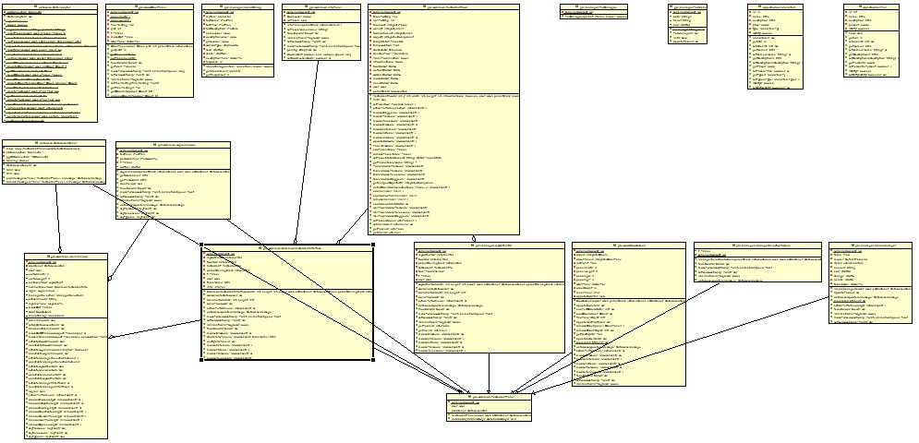
Figure 7: Class Diagram
Note: Class diagram is managed with an Eclipse plug-in, AmaterasUML, and can be viewed in high resolution from the repository using this plug-in.

6. System Architecture and system

6.1 Architecture Syles
The final completed program is built with client-server architecture. The same program, or client, can be deployed on several different machines. They are all kept in sync with each other through the central database, the server. Each executable can logon as a single username and perform actions which will be cascaded onto all the other nodes.

6.2 Persistent Data Storage
Restaurant Organization and Layout Manager uses Postgresql, a relational database to persist data. The database persists users, tables, orders, order items, menu items, payments, adjustment masters, adjustments, taxes, scheduling, and credit companies, as well as the following relationships: orders to tables, order items to orders, menu items to order items, payments to orders, adjustments to adjustment masters, adjustments to orders, taxes to menu items, and credit companies to credit payments. Java JDBC is the connection protocol of choice because of the ease of use. It requires only a database management system installed on the server instead of an additional server program.

6.3 Network Protocol
Networking is managed by JDBC.

7. Algorithms and data structures
No complex algorithms or data structures were used in the making of this program.

8. user interface design and implementation

8.1 Navigational path
Users will begin by inputing their credentials into the login screen. From this point, hosts, waiters, and busboys will be taken to the floor management screen, where they can complete their tasks. The application routes cooks to the cook order management screen. Managers get a view to select what functionality they wish to use: Manage Floor, Floor Layout, or Menu Editor. The Manage Floor screen is similar to the screen for hosts, waiters, and busboys. The Floor Layout resembles the Manage Floor screen but with the ability to add, to modify, and to delete tables and walls. The Menu Editor allows managers to select adding a menu item, which brings up a dialog to add the information, such as name and price, about the item. It also brings up a dialog to modify information when clicking change. Finally, clicking delete removes the selected item from the list.

8.2 User Effort Estimation
A lot of effort was put into the project to avoid program crashed due to malformated input and redundant data. The GUI is "fool-proof."
The user has the power to add and remove walls and tables. But to make sure that the user does not give in an invalid input, the user's mouse movements are locked within the restaurant floor layout. This prevents them from giving in co-ordinates which are out of bounds.

We have also implemented an advanced heuristics based collision detection system. This system automatically detects collision and prevents users placing tables on top of each other and on walls. This implementation is highly optimized to be spatially aware; which means it detects collisions closer to it first than the ones which are far away.

8.2.1 Click Analysis
8.2.1.1 Login:
1 Click

8.2.1.2 Seat Customers
From host screen:
Worst Case: 3 clicks.
Best Case: 2 clicks.

8.2.1.3 Clean Table
From busboy screen:
Worst Case: 3 clicks.
Best Case: 2 clicks.

8.2.1.4 Place Order
From waiter screen:
Worst Case: 3 clicks + (n Clicks for n Orders).
Best Case: 2 clicks + (n Clicks for n Orders).

8.2.1.5 Deliver Order
From waiter screen:
1 click

8.2.1.6 Mark Table Dirty
From Waiter Screen:
Worst Case: 3 clicks.
Best Case: 2 clicks.

8.2.1.7 Prepare Food
From Cook Screen:
1 Click

8.2.1.8 Manage User Item
From manager screen:
1 Click + n Clicks for n modifications.
8.2.1.9 Manage Layout
From manager screen:
1 Click + n Clicks for n modifications.

9. Implemenation statistics

9.1 Development Summary

9.1.1 The Programming Languages
Java, SQL

9.1.2 The leveraged libraries
Substance Library (Look and Feel)
PostgreSQL JDBC drivers
Java Libraries (Swing, Util, etc.)

9.1.3 The supported platforms
Client – Any platform that can run JRE
Server – Any platform the can run PostgreSQL

9.1.4 Line count
Java – 4990, including embedded SQL
SQL – 150 for creating database

9.1.5 Man Hours
Lower bound – 156 hours (Three two hour meetings with three people per week since 2/22)
Estimate – 200 hours

9.2 SVN Repository
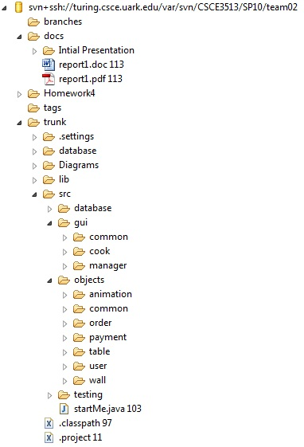
Final Version Number: 152

9.3 Done and Incomplete

9.3.1 Done
- Seat Customers
- Take Orders
- Make Orders
- Deliver Orders
- Manage Tables
- Edit Floor Layout
- Animation Framework

9.3.2 Incomplete
- Manage Users
  - Adding/Removing Users
  - Scheduling Waiters
- Statistical Reports
- Advanced Payment Options
Features were not completed due to time constraints.

10. Conclusions

10.1 Technical challenges
There were a lot of technical difficulties faced in this project. Our project is composed of different modules. Each module contributes a specific functionality to the whole application. The Layout Manager module was by far the hardest of them all. The layout manager is basically a free to draw canvas where the user can come in and create their restaurant layout. It’s very flexible and has a drag and drop design where users can draw tables and walls. The layout can be easy moified by dragging the components around. The layout manager also has intuitive features like Collission detection and intuitive user feedback. The collission detection engine runs inside the layout manager and constnatly checks for overlapping components and prevents that. This allows it to always maintain a valid layout. The intuitive feedback engine constnatly checks and gives visual feedback about the controls currently on the screen. For example, if the user tries to place a table on top of another one, the viusal feedback engine interrupts and switches the color of the table to grey to indicate that the action is forbidden.

Another majaor technical challenge faced was the database synhronization. All clients take the responsibility of synronizing themselves with the database. To simplify this process we used built in notification function of PostgreSQL. This function allows database update events to automatically cascade down to all the connected clients. Getting this feature to work was a huge ordeal.
Last but not least, the final challenge was building the Animation framework. This framework is heavily relied upon by the user feedback engine and for providing the users with a rich interface. The animation library can perform zoom, color tween and motion tween animations. Getting the animations to run smoothly, timing issues, buffering issues and threading issues were faced during the development of the project.

10.2 Application of class lectures
All the problems faced above were solvable only because the valuable information learnt from this class. We’ve learn about the MVC design paradigm which focuses on keeping the business logic away from the front end. We’ve heavily relied upon this to build our modules.

Also from this class we’ve learnt how to test our applications. We’ve learnt the importance of test based design and how to implement unit tests. All our database modules have unit tests and are thorougly tested over varied test cases to give a bug free database communication layer.

Concepts of specificaiton handling and requirement translation leart in the class were essential in translating the needs and wants of the project in something code-tangible. Following the concepts of data abstraction discusses in class we were able to create an abstracted version of our software before we implemented our functions. This allowed us to get a hollistic view of the software architecture.

10.3 Other applied knowledge
We were able to apply several other design patterns which were also vital to this program. Our program has a main window and all the modules are seprate forms which can be plugged into the main window. This was a perfect oppertunity to use the decorated design patter which allowd for easy component resuse with minimal code rewritting.

We have implemented the database modules in the project based on our existing experinece with database programming. We were able to apply database architecture and normalization paradigms onto our project. Thus we were able to create a solid foundation to our application.

Aside from the technical impedimenta, we were also able to work as a team and get our task accomplished. We’ve learnt how to respect each other’s ideas and learnt the importance of team discussions.

Overall this has project has been a very enlightening experience.

10.4 Future work
The application is very open ended, there is a lot of room for improvement. The checkout GUI can be implemented. This will allow users to check out and pay the pill. The database functionaly currently exists, so it would only be a matter of creating the GUI and linking. The statistics have not yet been implemented. This module would pull all the data stored in our database and build graphs. This statistical analysis module would be a great enhacement to our project.

We would also like to work on a more intricate user management system, where the manager can login to manage the users of the restaurant. The manager would also be able to tender salaries and promotions.

References
No references.

Appendix A. New features
No additional features were added after the final presentation.

