**WORKSTATION SETUP**

**[http://sdk.rethinkrobotics.com/wiki/Workstation\_Setup#Step\_3:\_Create\_Baxter\_Development\_Workspace](http://sdk.rethinkrobotics.com/wiki/Workstation_Setup" \l "Step_3:_Create_Baxter_Development_Workspace)**

* Create ROS Workspace
  + $ mkdir -p ~/ros\_ws/src
  + $ cd ~/ros\_ws
  + $ catkin\_make
  + $ catkin\_make install
* Install Baxter SDK Dependencies
  + $ sudo apt-get update
  + $ sudo apt-get install git-core python-argparse python-wstool python-vcstools python-rosdep ros-kinetic-control-msgs ros-kinetic-joystick-drivers
* Install Baxter Research Robot SDK
  + $ cd ~/ros\_ws/src
  + $ wstool init .
  + $ wstool merge https://raw.githubusercontent.com/RethinkRobotics/baxter/master/baxter\_sdk.rosinstall
  + $ wstool update
* Build and Install
  + $ cd ~/ros\_ws
  + $ catkin\_make
  + $ catkin\_make install
* Configure Baxter Communication/ROS Workspace
  + $ wget https://github.com/RethinkRobotics/baxter/raw/master/baxter.sh
  + $ chmod u+x baxter.sh
* Customize the baxter.sh script (example script is uploaded to drive)
  + $ cd ~/ros\_ws
  + $ gedit baxter.sh
  + Edit the ‘baxter\_hostname’ field
  + Edit the ‘your\_ip’ field
  + Verify ‘ros\_version’ field

**HELLO BAXTER**

**Remark :** Make sure that you are connected to one of the COLORS wireless networks.

**Remark :** Prefer to use bash instead of zsh, fish, etc. since the baxter.sh script includes some commands that could only be run using bash.

* **$ cd ~/ros\_ws**
* **$ . baxter.sh**
* **$ env | grep ROS\_MASTER\_URI →** ROS\_MASTER\_URI=http://011607P0027.local:11311
* **$ ping 011607P0027.local**
* **Verify Development Workstation Ping (Depending on the setting of baxter.sh)**
  + env | grep ROS\_IP
  + env | grep ROS\_HOSTNAME → ROS\_HOSTNAME=serkan.local
* **SSH To Baxter**
  + **ssh ruser@011607P0027.local (password is rethink)**
  + After ssh connection make sure that we are able to ping back to the development PC.
    - $ ping 192.168.101.99
    - ping serkan.local
* **Enable the Robot**
  + **Remark:** SSH connection is not required for enabling the robot.
  + $ rosrun baxter\_tools enable\_robot.py -e → Enable the robot.
  + $ rosrun baxter\_tools enable\_robot.py -d → Disable the robot.

**ROBOT FACE APPLICATION**

* $ SSH To Baxter
* $ cd ros\_ws
* $ ./ff\_baxter.sh → will run the application
* rostopic pub /display\_chatter std\_msgs/String confused → change the face of the robot to given type.
* **Java Application:** 
  + Make sure that Java 8 installed on your system.
    - $ java -version

openjdk version "1.8.0\_191"

OpenJDK Runtime Environment (build 1.8.0\_191-8u191-b12-2ubuntu0.16.04.1-b12)

OpenJDK 64-Bit Server VM (build 25.191-b12, mixed mode)

* + Execute the application → java -jar baxter\_nope\_app.jar (jar is located in the google drive -- CoLoRs Lab Docs - robots - baxter)
  + Run the server → ./ff\_baxter.sh
  + Input port (8080) and ip fields. Get the ip by **ping 011607P0027.local**
  + Connect.

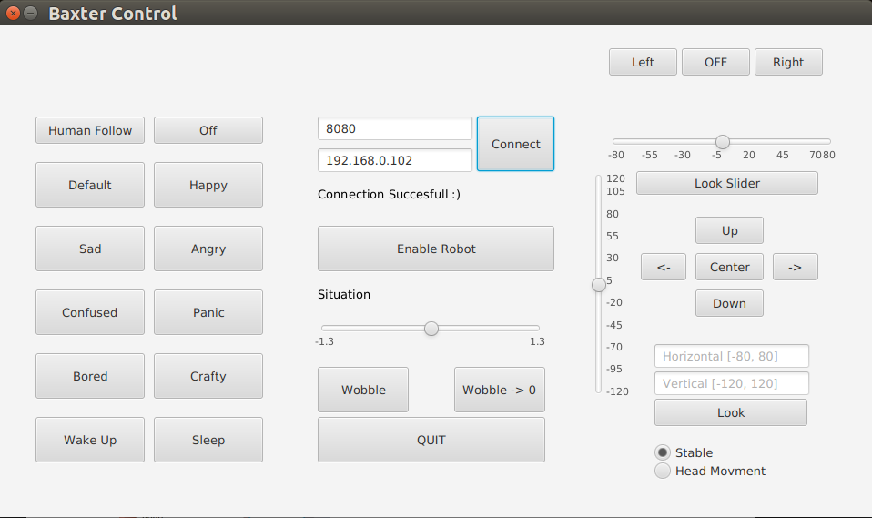

**Face Types**

default, happy, angry, confused, sad, panic, bored, crafty