OmniDebugger Game Project Readme

('*' means that this part is not very imortant)

Game play note*

Your goal in game *
OmniDebugger is a simple game in which you control the character to avoid the bullets shot out from the 4 badass.
There's no end, you'll try your best to survive longer and let the bullet kill themselves. After your death, the system will tell you how long have you survived and how many you kill ( well actually, how many they've killed their companions).

Control
In the startup tuto page, simply click the mouse to start.
In game:
use 'A' to go left;
use 'S' to go down;
use 'D' to go right;
use 'W' to go up;
In score page, click Ali (the red fox) to restart.

Game design note*

Game design startpoint and goal*
The idea come from the movie Total Recall, the hero was once surrounded by many enemies, and they shoot together. I was thinking, why they didn't hurt their companions? Then my start point is to develop a game in which you try to avoid and let our enemy kill each other.

But this turns out to be not so easy, you die so quick that you don't have time to think but just to avoid, so I add the time in score.
You can just ignore the reason why the game was called OmniDebugger! It was nonsense.

Rebalance*
It's a simple game, but very difficult. Later it can be rebalanced though these ways:
1.collision, actually there's a collision detection bug, that the bullet hit you more often than it look. Solution is to fix this bug (I'll mentioned later), and resize the player radius.
2.enemy movement speed, in game the enemy moves faster and faster if they didn't die.
3. shoot rate, respawn rate: I planned to let the enemy shoot and respawn quicker while time grows, but didn't do that, for balance issues (To tell you the truth, I didn't have the time)
4. enemy AI: which is the most funny part. currently there's AI at all, they just shoot at you one by one. We can add Ai to the enemy to predict your path(and even add AI to the bullet to do that).

Development Note

Development goal*
The goal is to develop a simple runnable game quickly, which is the requirement of the homework. However, I've added a goal that is to try how to work Cpp and AS3 together using Flascc.

Project overview
The project was separated by mainly two part, the logic and the view.
Logic part was written in C++, handle the work of logic like character movements, collision detection and bullets spawn. It was put in the folder .\OmniDebuggerSWC\
View part was written in ActionScript, handle the display, sound and input. Put in the folder .\OmniDebuggerRender\.

How to build
You'll need Flascc sdk ( newest version which contains the cygwin) and java to build the logic part.
1. edit .\OmniDebuggerSWC\Makefile.common set the
FLASCC:=/cygdrive/F/FlasCC/sdk
FLEX:=/cygdrive/F/AdobeFlashBuilder4.6/sdks/4.6.0
according to your related path.

2. run run.bat in your flascc sdk, redirect to .\OmniDebuggerSWC\
type the command "make"
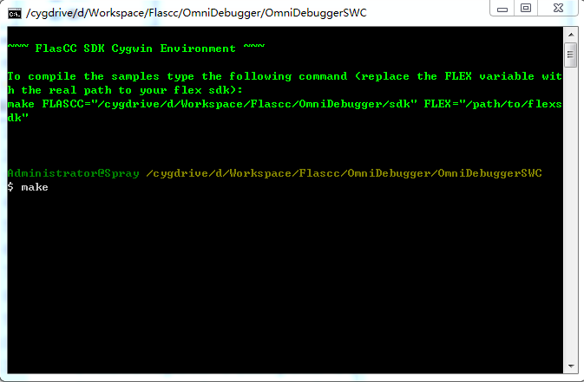
Check .\OmniDebuggerSWC\Makefile for more details.
The result ODGameLib.swc should be already there.

For the View part, was the .\ OmniDebuggerRender folder, you'd better have Flashbuilder (or flex) to build that.
Make sure he logic module ODGameLib.swc was imported in the Flashbuilder project, you simply need to click Debug/Run in eclipse.
Or just find the game in \OmniDebuggerRender\bin-debug\OmniDebuggerRender.swf

Logic module code
Term: C++, VS2010, Flascc, Swig, swc
The logic part was put in \OmniDebuggerSWC
All the .cpp source code and .h was put in \OmniDebuggerSWC\source
All the code was written in C++, using VisualStudio 2010 to edit, and flascc(g++) to compile. Flascc will use swig.i to generate ODGameLib_wrapper.cpp to expose all Cpp functionality (you want to expose) Actionscript3, and park everything into the ODGameLib.swc.
In this part I use no 3rd party libs except rand(), NULL define and vector<> in the standard library.
The overall structure:
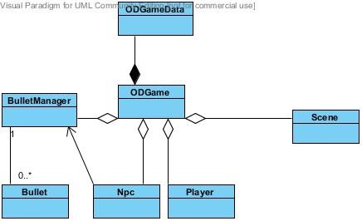
ODGame: is the main game structure, used to update everything, and refresh the data to feed to AS3 code.
ODGameData: is the interface for AS3, it contains a set of struct, encapsulate all the information like player position, bullet position, npc live or dead and so on. It was updated in ODgame every frame.
Scene doesn't do much, it's a singleton used to provide the scene information like scene width.
Player: is used to receive command and update player movement, detect player can bullet collision
NPC: there're 4 of them used to update NPC position, and count down for fire, death and respawn.
BulletManager: is a singleton to keep the info of a set of Bullets, Npc use it to spawn a bullet.
Bullet: to update the bullet spawn, movement and collision.

View module code
Term: FlashBuilder, Actionscript3, flascc
Folder .\OmniDebuggerRender
source code, only the \OmniDebuggerRender\src\OmniDebuggerRender.as
The project import the ODGameLib.swc, use it to do all the logic stuff.
It do:
1. keep a timer and tell to logic part to update
m_odgame.Update(delta/1000);
2. receive and pass key event to logic
3. manager all resource, I embed all .png and .mp3 into the swf, all of them was handled here
4. render: it act like a buffer, clear the stage each frame and add sprite according to the information provided by ODGameData received from ODGameLib.swc

Resources *
All resource was in OmniDebuggerRender\assets folder and was embed to the .swf output.
Most of the images came from internet, I draw or edit them using Photoshop;
Sound resources was exported from other games: Skyrim, LOL and Civ5

Possible improvements*
Even considered as a mini game, it's far from finish.
There's some rebalance work to fit the design goal.
There's a collision bug, that in logic, I calculate the collision supposing that all entity's axis was calculated in the center, but in the Flash, it was displayed from the upleft.
It need to be optimized, removing all sprites and readd them each frame is not so efficient.
We can add some more smarter AI for NPCs.
...

