Практическая работа №8

Цель работы:
Познакомиться с перегрузкой и использованием магических методов классов в Python.
Ход работы:
Часть 1:
Создайте класс Date, который будет представлять дату (год, месяц и день) и перегружать методы для сравнения дат (<, >. <=, >=, ==, !=).
class Data:
def __init__(self, year, month, day):
self.year=year
self.month=month
self.day=day
print(f"Дата создана {self.year}.{self.month}.{self.day}")
def __del__(self):
print("Удаление даты")
def __str__(self):
return f"{self.year}.{self.month}.{self.day}"
def __lt__(a, b):
if a.year<=b.year:
if a.month<=b.month:
if a.day<b.day:
return True
elif a.month<b.month:
return True
elif a.year<b.year:
return True
return False
def __le__(a,b):
if a.year<=b.year and a.month<=b.month and a.day<=b.day:
return True
return False
def __eq__(a,b):
if a.year==b.year and a.month == b.month and a.day==b.day:
return True
return False
def __ne__(a,b):
if a.year!=b.year or a.month != b.month or a.day != b.day:
return True
return False
def __ge__(a,b):
if a.year>=b.year and a.month >= b.month and a.day >= b.day:
return True
return False
def __gt__(a,b):
if a.year>=b.year:
if a.month>=b.month:
if a.day>b.day:
return True
elif a.month>b.month:
return True
elif a.year>b.year:
return True
return False
def func(data1, data2, data3, data4, data5):

print(f"data1<data2 | {data1}<{data2}: {data1<data2}")
print(f"data1<data3 | {data1}<{data3}: {data1<data3}")
print(f"data1<data4 | {data1}<{data4}: {data1<data4}")
print(f"data1<data5 | {data1}<{data5}: {data1<data5}")
print(f"data2<data1 | {data1}<{data5}: {data2<data1}")
print(f"data3<data1 | {data3}<{data1}: {data3<data1}")
print(f"data4<data1 | {data4}<{data1}: {data4<data1}")
print(f"data5<data1 | {data5}<{data1}: {data5<data1}")

print("\n")

print(f"data1<=data2 | {data1}<={data2}: {data1<=data2}")
print(f"data1<=data3 | {data1}<={data3}: {data1<=data3}")
print(f"data1<=data4 | {data1}<={data4}: {data1<=data4}")
print(f"data1<=data5 | {data1}<={data5}: {data1<=data5}")
print(f"data2<=data1 | {data1}<={data5}: {data2<=data1}")
print(f"data3<=data1 | {data3}<={data1}: {data3<=data1}")
print(f"data4<=data1 | {data4}<={data1}: {data4<=data1}")
print(f"data5<=data1 | {data5}<={data1}: {data5<=data1}")

print("\n")

print(f"data1==data2 | {data1}=={data2}: {data1==data2}")
print(f"data1==data3 | {data1}=={data3}: {data1==data3}")
print(f"data1==data4 | {data1}=={data4}: {data1==data4}")
print(f"data1==data5 | {data1}=={data5}: {data1==data5}")
print(f"data2==data1 | {data1}=={data5}: {data2==data1}")
print(f"data3==data1 | {data3}=={data1}: {data3==data1}")
print(f"data4==data1 | {data4}=={data1}: {data4==data1}")
print(f"data5==data1 | {data5}=={data1}: {data5==data1}")

print("\n")

print(f"data1!=data2 | {data1}!={data2}: {data1!=data2}")
print(f"data1!=data3 | {data1}!={data3}: {data1!=data3}")
print(f"data1!=data4 | {data1}!={data4}: {data1!=data4}")
print(f"data1!=data5 | {data1}!={data5}: {data1!=data5}")
print(f"data2!=data1 | {data1}!={data5}: {data2!=data1}")
print(f"data3!=data1 | {data3}!={data1}: {data3!=data1}")
print(f"data4!=data1 | {data4}!={data1}: {data4!=data1}")
print(f"data5!=data1 | {data5}!={data1}: {data5!=data1}")

print("\n")

print(f"data1>=data2 | {data1}>={data2}: {data1>=data2}")
print(f"data1>=data3 | {data1}>={data3}: {data1>=data3}")
print(f"data1>=data4 | {data1}>={data4}: {data1>=data4}")
print(f"data1>=data5 | {data1}>={data5}: {data1>=data5}")
print(f"data2>=data1 | {data1}>={data5}: {data2>=data1}")
print(f"data3>=data1 | {data3}>={data1}: {data3>=data1}")
print(f"data4>=data1 | {data4}>={data1}: {data4>=data1}")
print(f"data5>=data1 | {data5}>={data1}: {data5>=data1}")

print("\n")

print(f"data1>data2 | {data1}>{data2}: {data1>data2}")
print(f"data1>data3 | {data1}>{data3}: {data1>data3}")
print(f"data1>data4 | {data1}>{data4}: {data1>data4}")
print(f"data1>data5 | {data1}>{data5}: {data1>data5}")
print(f"data2>data1 | {data1}>{data5}: {data2>data1}")
print(f"data3>data1 | {data3}>{data1}: {data3>data1}")
print(f"data4>data1 | {data4}>{data1}: {data4>data1}")
print(f"data5>data1 | {data5}>{data1}: {data5>data1}")

if __name__=="__main__":

data1=Data(1999,1,1)
data2=Data(2000,1,1)
data3=Data(1999,2,1)
data4=Data(1999,1,2)
data5=Data(1999,1,1)
func(data1, data2, data3, data4, data5)
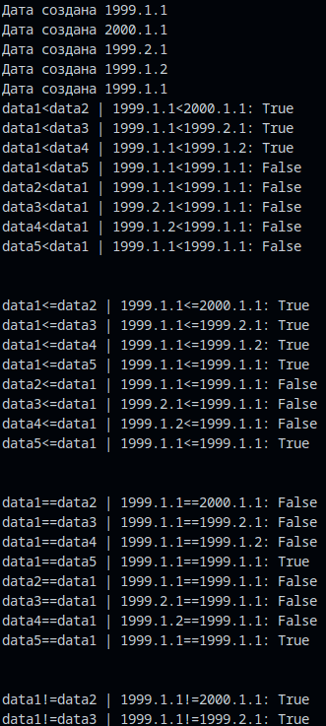
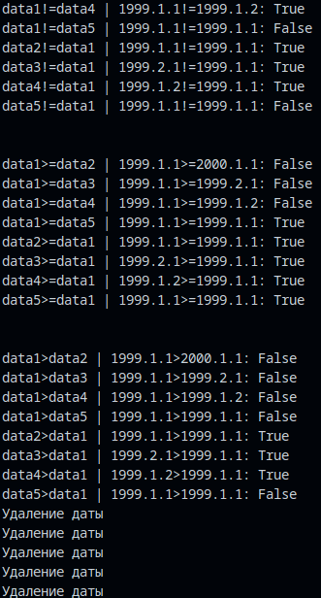
Рисунок 1 – Вывод в терминал.
Часть 2:
Создайте класс-декоратор Logger, который будет записывать логи выполнения декорируемой Функции. При вызове декорированной Функции необходимо выводить в терминал лог с информацией о времени выполнения и аргументах функции.
import time
def Logger(func):
def output_func(*args, **kwargs):
print("\nАргументы функции:", ", ".join(map(str, args)))
print("Начало работы функции\n")
start_time=time.time()
result=func(*args, **kwargs)
end_time=time.time()
print(f"\nКонец выполнения функции, время выполнения = {end_time-start_time}\n")
return result
return output_func

class Data:
def __init__(self, year, month, day):
self.year=year
self.month=month
self.day=day
print(f"Дата создана {self.year}.{self.month}.{self.day}")
def __del__(self):
print("Удаление даты")
def __str__(self):
return f"{self.year}.{self.month}.{self.day}"
def __lt__(a, b):
if a.year<=b.year:
if a.month<=b.month:
if a.day<b.day:
return True
elif a.month<b.month:
return True
elif a.year<b.year:
return True
return False
def __le__(a,b):
if a.year<=b.year and a.month<=b.month and a.day<=b.day:
return True
return False
def __eq__(a,b):
if a.year==b.year and a.month == b.month and a.day==b.day:
return True
return False
def __ne__(a,b):
if a.year!=b.year or a.month != b.month or a.day != b.day:
return True
return False
def __ge__(a,b):
if a.year>=b.year and a.month >= b.month and a.day >= b.day:
return True
return False
def __gt__(a,b):
if a.year>=b.year:
if a.month>=b.month:
if a.day>b.day:
return True
elif a.month>b.month:
return True
elif a.year>b.year:
return True
return False
@Logger
def func(data1, data2, data3, data4, data5):
print(f"data1<data2 | {data1}<{data2}: {data1<data2}")
print(f"data1<data3 | {data1}<{data3}: {data1<data3}")
print(f"data1<data4 | {data1}<{data4}: {data1<data4}")
print(f"data1<data5 | {data1}<{data5}: {data1<data5}")
print(f"data2<data1 | {data1}<{data5}: {data2<data1}")
print(f"data3<data1 | {data3}<{data1}: {data3<data1}")
print(f"data4<data1 | {data4}<{data1}: {data4<data1}")
print(f"data5<data1 | {data5}<{data1}: {data5<data1}")
print("\n")
print(f"data1<=data2 | {data1}<={data2}: {data1<=data2}")
print(f"data1<=data3 | {data1}<={data3}: {data1<=data3}")
print(f"data1<=data4 | {data1}<={data4}: {data1<=data4}")
print(f"data1<=data5 | {data1}<={data5}: {data1<=data5}")
print(f"data2<=data1 | {data1}<={data5}: {data2<=data1}")
print(f"data3<=data1 | {data3}<={data1}: {data3<=data1}")
print(f"data4<=data1 | {data4}<={data1}: {data4<=data1}")
print(f"data5<=data1 | {data5}<={data1}: {data5<=data1}")
print("\n")
print(f"data1==data2 | {data1}=={data2}: {data1==data2}")
print(f"data1==data3 | {data1}=={data3}: {data1==data3}")
print(f"data1==data4 | {data1}=={data4}: {data1==data4}")
print(f"data1==data5 | {data1}=={data5}: {data1==data5}")
print(f"data2==data1 | {data1}=={data5}: {data2==data1}")
print(f"data3==data1 | {data3}=={data1}: {data3==data1}")
print(f"data4==data1 | {data4}=={data1}: {data4==data1}")
print(f"data5==data1 | {data5}=={data1}: {data5==data1}")
print("\n")
print(f"data1!=data2 | {data1}!={data2}: {data1!=data2}")
print(f"data1!=data3 | {data1}!={data3}: {data1!=data3}")
print(f"data1!=data4 | {data1}!={data4}: {data1!=data4}")
print(f"data1!=data5 | {data1}!={data5}: {data1!=data5}")
print(f"data2!=data1 | {data1}!={data5}: {data2!=data1}")
print(f"data3!=data1 | {data3}!={data1}: {data3!=data1}")
print(f"data4!=data1 | {data4}!={data1}: {data4!=data1}")
print(f"data5!=data1 | {data5}!={data1}: {data5!=data1}")
print("\n")
print(f"data1>=data2 | {data1}>={data2}: {data1>=data2}")
print(f"data1>=data3 | {data1}>={data3}: {data1>=data3}")
print(f"data1>=data4 | {data1}>={data4}: {data1>=data4}")
print(f"data1>=data5 | {data1}>={data5}: {data1>=data5}")
print(f"data2>=data1 | {data1}>={data5}: {data2>=data1}")
print(f"data3>=data1 | {data3}>={data1}: {data3>=data1}")
print(f"data4>=data1 | {data4}>={data1}: {data4>=data1}")
print(f"data5>=data1 | {data5}>={data1}: {data5>=data1}")
print("\n")
print(f"data1>data2 | {data1}>{data2}: {data1>data2}")
print(f"data1>data3 | {data1}>{data3}: {data1>data3}")
print(f"data1>data4 | {data1}>{data4}: {data1>data4}")
print(f"data1>data5 | {data1}>{data5}: {data1>data5}")
print(f"data2>data1 | {data1}>{data5}: {data2>data1}")
print(f"data3>data1 | {data3}>{data1}: {data3>data1}")
print(f"data4>data1 | {data4}>{data1}: {data4>data1}")
print(f"data5>data1 | {data5}>{data1}: {data5>data1}")
if __name__=="__main__":
data1=Data(1999,1,1)
data2=Data(2000,1,1)
data3=Data(1999,2,1)
data4=Data(1999,1,2)
data5=Data(1999,1,1)
func(data1, data2, data3, data4, data5)
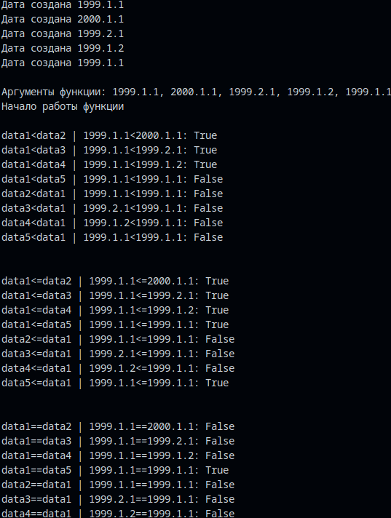
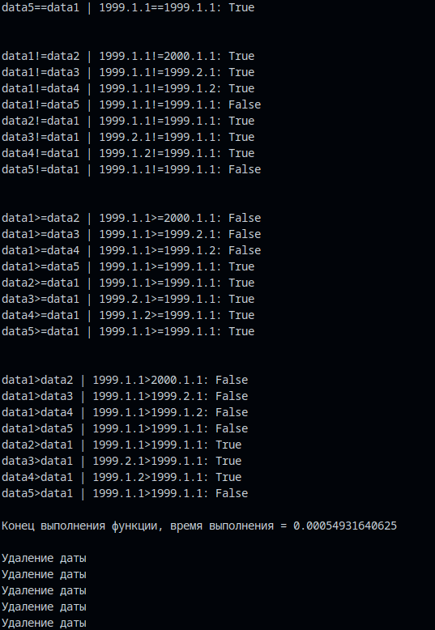
Рисунок 2 – Вывод в терминал.

Вывод: познакомился с основными способами объявления и использования генераторов в Python.

