**Milestone 3 README**

**Team Name: FatPet**

**Proposed Level of Achievement:** Apollo 11

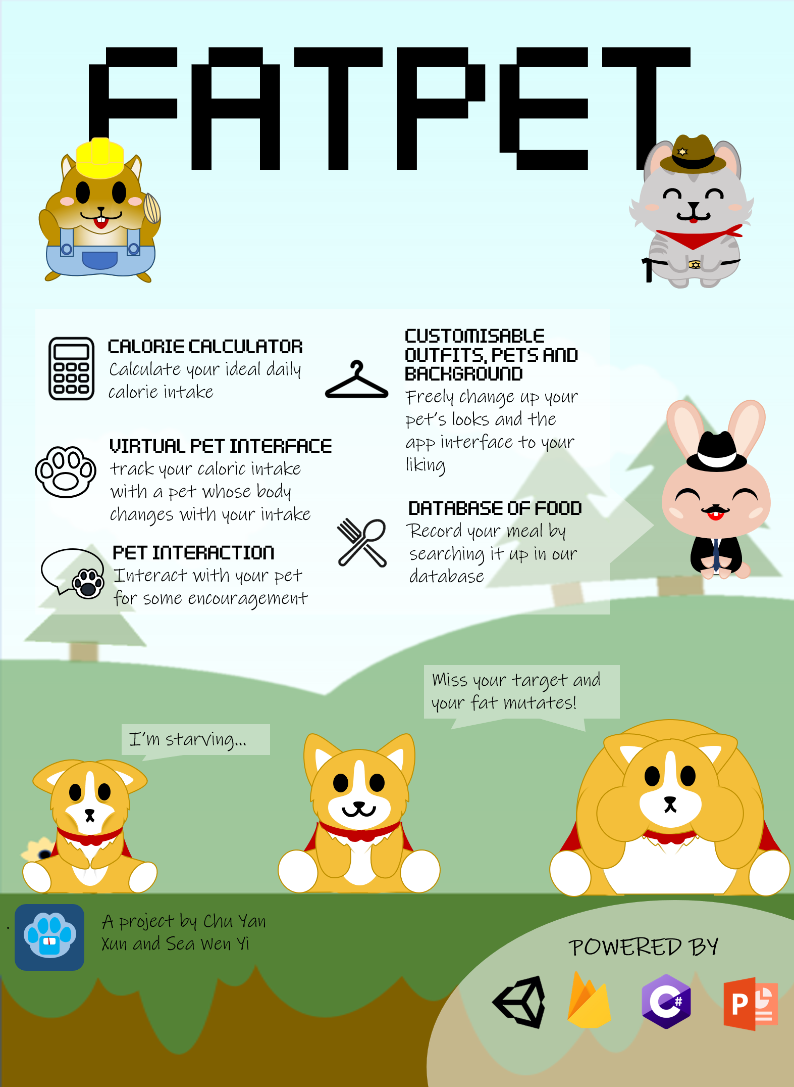

# **Motivation**

You want to track the amount of calories you are taking in, but do not know how much you need to achieve your desirable weight? Or are there no fun elements in the calculators already available to motivate you to continue using them?

More often than not, you have the motivation to do something about your weight but you do not know how to, or the applications available are too boring and keeping track of your intake just slips your mind. Therefore, many would have given up on achieving their ideal weight, which can result in lower confidence due to body image and possibly picking up unhealthy consumption habits which can be detrimental in the long run.

So now one might ask, why is there no application in the market that is not only able to allow users to effortlessly keep track of their weight, but also allow them to enjoy and have fun at the same time?

# **Project Scope**

We aim to provide a platform for our users to be able to easily keep track of their daily calorie intake in a fun manner so that they can achieve their desirable weight and at the same time stay healthy.

The calorie calculator will perform the fundamental purpose of the application, which is to utilise the user’s personal details to formulate their ideal daily calorie intake. All the user has to do is to key in their calorie intake everytime and the system will keep track of their intake for them.

According to a study supported by American Health Association, the gamification of a calorie tracker is more able to encourage users to achieve their ideal weight. The negative portrayal of a mutated pet when the user is “not eating right” leads to the user being more likely to stop eating food that is preventing them from attaining their ideal daily calorie intake, allowing users to attain their goals more easily. (Louisiana State University, 2018) Hence, we decided to implement a fun element to our application by having a virtual pet interface.

The virtual pet interface will serve as a representation of the user: mutating when the user eats too much; starving when the user eats too little; and jumping for joy when the user stays within or achieves their target. The user will be guided to choose their pet at the start of using the application, and will be able to play with it to add a fun element to the application.

# **User Stories**

Firstly, the user will be asked to indicate their (1) name, (2) age, (3) gender, (4) height, (5) weight, (6) weekly activity level and (7) weight goal. The user’s target daily calorie intake will be calculated, and a virtual pet of the user’s choice will be instantiated in the application.

1. For someone that wants to lose weight, the virtual pet will track the maximum amount of calories he/she can take in. If the user overeats, the pet will mutate bigger. If the user overeats again, the pet will not be able to withstand another mutation and explode, indicating that the user has failed to not only keep to his/her diet, but also to take care of his/her virtual pet.
2. For someone that wants to gain weight, his/her virtual pet will track the minimum amount of calories he/she needs to take in. If the user undereats, the pet will starve and shrivel up. If the user undereats again, the pet will starve to death.
3. For someone that wants to maintain his/her current weight, the virtual pet will track the desired caloric range that he/she needs to keep within (±250). Let's take a user’s ideal caloric intake to be 2500 for example. If the user overeats (>2750) or undereats (<2250), the pet will mutate bigger or starve and shrivel up respectively, eventually dying if the user repeats his/her mistake.
4. For someone who made their pet starve to death/explode, a game over interface will be presented and a warning message is shown. Following, the user will be guided to restart the process as he wishes.

# 

# **Core Features**

## **Calorie Calculator**

The calculator is based on the Mifflin-St. Jeor equation, a formula that numerous studies have shown to be an accurate way of estimating calorie needs (Frankenfield, Roth-Yousey & Compher, 2005). It calculates the required caloric intake based on a person’s Basal Metabolic Rate (BMR) and takes into account the person's Age, Gender, Height, Weight, Activity Level and Weight Goal.

Height, Weight, Activity Level and Weight Goal can be updated again in the future according to the user’s needs.

As a general rule, people need a minimum of 1200 calories daily to stay healthy. Therefore, if a user’s caloric intake is below 1200, it will be set to 1200 so that they will not harm their body.

**Software used:** Unity and C#

## **Virtual Pet Interface**

A virtual pet will add a fun element to motivate users to commit to their diet plan.

**Sub features Include:**

1. **Calorie Tracking:** The state of the pet will be linked to the user’s daily caloric intake, helping the user keep track of their caloric intake daily. If a user overeats/undereats, the pet will mutate/starve accordingly (refer to user stories).
2. **Choice of pet, outfit, and background:** There will be different pets, outfits and backgrounds for our users to choose from.
3. **Tapping interaction:** Tapping the pet multiple times will be equivalent to petting it, bringing joy to the pet and triggering cute animations.
4. **Sound Effects:** Interacting with the pet or buttons will trigger different sound effects.

Point B, C and D will provide a sense of ownership over the pet and thus bring more enjoyment to the user while he/she utilises the application.

1. **Encouragement:** Provide encouragement to the user from time to time to motivate the user to press on with their diet plan. Emotional support has proven to be essential in encouraging one to stay motivated when working towards their goal. Hence, we plan to set encouraging reminders occasionally through the application to support them in achieving their ideal weight.

**Software used:** Microsoft Powerpoint for designing, Unity and C# for application related features.

**Demo:** [Calorie Calculator and Virtual Pet Interface.mp4](https://drive.google.com/file/d/1UibKawrirfb99z7NSI8VxpDN9vpNlrN3/view?usp=sharing) (view in 720p)

## **Database interface**

A database of commonly eaten food and their respective calorie count will be available for users to retrieve. This is so that our users need not have to check online for the calorie count of their meal every time. Instead, the user can search for the calorie count on the application itself to support greater convenience in tracking.

Authentication will be required to access this feature, which will be prompted at the beginning of application utilisation.

**Software used:** Google Firebase

**Demo:** [Database interface.mp4](https://drive.google.com/file/d/1fHcEroWmj3EToExKWA0IXEunRsMcWvj3/view?usp=sharing) (view in 720p)

# **Program Flow**

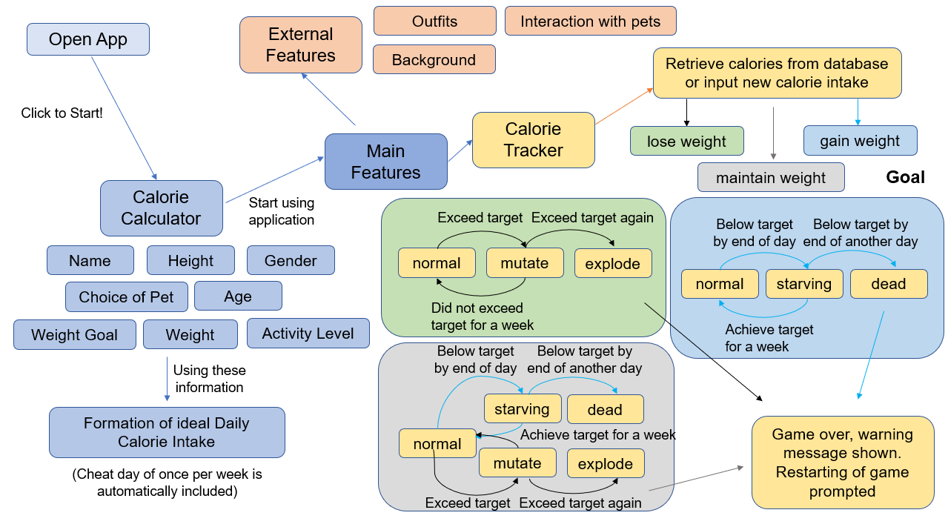

# **Development Progress**

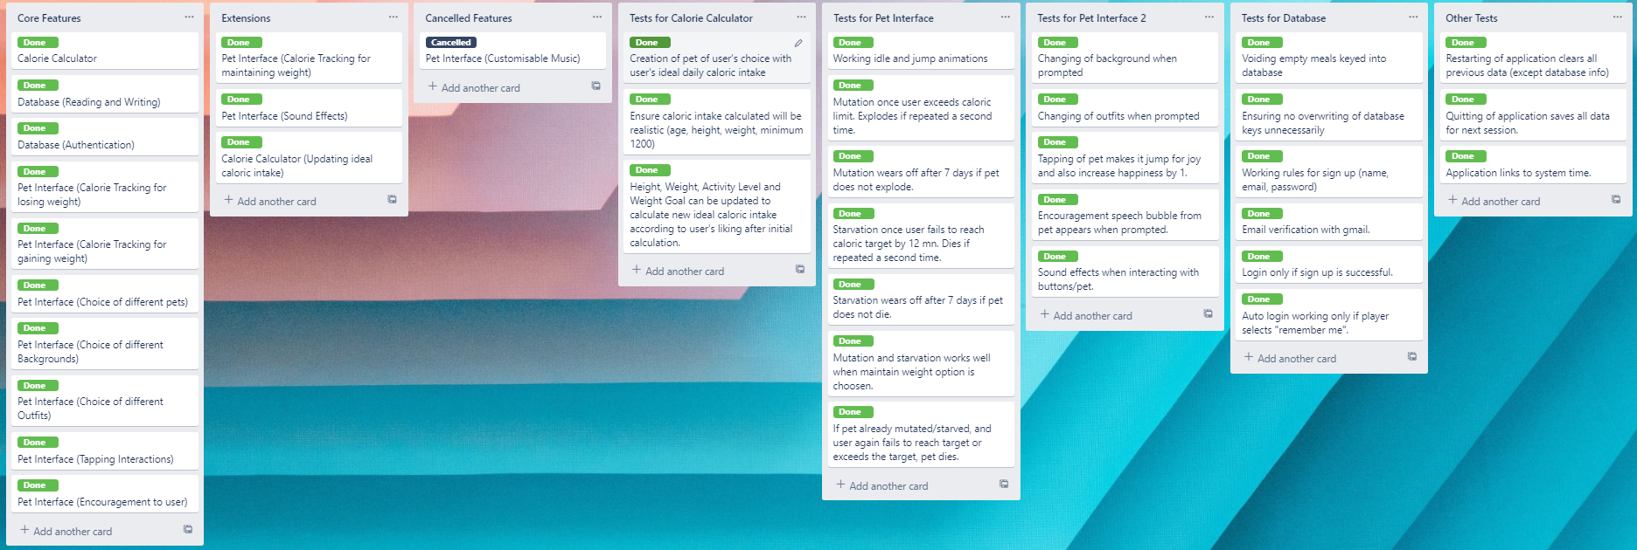

We have decided to adopt the Kanban method as we believe that its software engineering principle best aligns with what we do. We can constantly evaluate on our app and continuously upgrade it in order to suit our crowd and align it with their needs. Visualisation of our work and progress was clear with the Kanban board which enabled us to stay on task and visually check on our progress. Its flexibility and fluidity also allowed us to easily incorporate more exciting features into our app to make it more enticing.

* **Features that was completed by the mid of June:**
* Working calorie calculator interface. ✔
* Calorie tracking using virtual pet interface. ✔
* Different choice of pets, outfits and backgrounds for users. ✔
* Database of commonly eaten food and their respective calorie count using firebase. ✔
* **Features to be completed by the mid of July:**
* Encouragement to the user. ✔
* Authentication for database interface. ✔
  + **Extension Features that we also wish to implement by the mid of July to improve user experience:**
    - Sound effects such as clicking when the user is using the app. ✔
* Option for users to maintain weight: After attaining their weight, users can still continue to use our application to maintain their weight using the maintain weight option, which will calculate a new ideal daily caloric intake range for them to keep within. ✔
* Allows users to update their ideal caloric intake by updating their weight goal, activity level, height and weight after initial calculation. ✔

# 

# **Unit Testing**

Based on constant testing and running of our application, we have found and managed to resolve the following tail cases:

| Description of bug | Status (fixed/not fixed) | Remarks |
| --- | --- | --- |
| Range of age, height and weight was too broad and unrealistic | fixed | Researched on the height, weight and appropriate age of people worldwide and set the range of these features accordingly in our application. Unrealistic values are rejected. |
| Our research highlighted that a person requires a minimum of 1200 calories a day to stay healthy, but our calorie calculator may allocate a limit less than 1200 if the person wants to go for extreme weight loss. | fixed | If a person is allocated a target/limit of less than 1200, they will be required to set their target/limit to 1200. |
| Panels for each features overlapped each other | fixed | Each panel is placed to cover the icon, avoiding double clicking of different features. |
| Database requires authentication to be utilised. | fixed |  |
| Encouragement speech bubbles of the pet overlapped one another | fixed | Set each with a timer and disappear when the user clicks for another interaction with the pet. |
| Displaying of health bar for maintain weight was ambiguous | fixed | Preferred caloric range was shown clearly for users to take note of. |

# 

# **User Testing**

We have conducted a survey on our side to understand how users are finding our app. The app is deployed to 30 people and we have gathered the following comments and feedback:

* **General comments**

Users are generally happy with our application and managed to use it easily. People are found to enjoy the pet outfits and background the most due to the fresh concept not found in other applications.

* **Useful feedback**

Some users have highlighted that the restarting of our app was not ideal as once the pet explodes/shrivels, the user is prompted to restart the app and directed to the login page. It is mentioned that it is rather inconvenient hence we have instead directed the users to the weight goal page for the users to reevaluate their decision and make a more achievable goal.

# 

# **How are we different from similar platforms?**

* **Online calorie calculators**

Our application not only helps to calculate the ideal calorie intake, but also helps users to keep track of it and ensure they commit to it for a long period of time.

* **Other calorie tracking applications**

Our application provides a fun element to calorie tracking by introducing a virtual pet interface whereby users have to keep track of their calories to take good care of their pet. This provides a sense of ownership within users and will encourage them to be more committed to keeping track of their calories to keep their pet happy.

* **Other pet simulation applications**

Our application incorporated the calorie tracker to make the game more meaningful as taking care of the pet comes hand in hand with keeping track of the user’s caloric intake to not only be more confident in his/her own body but also to ensure their health is taken care of.

# **Tech Stack**

## **Front-End**

### **Unity with C#**

### Used to build the FatPet application, which includes the calorie calculator and pet interface. It was selected because:

### It is an easy platform for beginners to start on game development.

### It allows one to easily switch their game between ios, android and windows builds to cater to different platforms.

### It allows easy access to Google Firebase to implement a database interface.

### **Microsoft Powerpoint**

Used for designing pets, outfits and backgrounds. Even though Photoshop would be better for designing as it can look into smaller details in our designs, we did not have it at our disposal as it was not free of charge. Microsoft Powerpoint was free of charge and provided sufficient designing tools that were easy to use, making it a better option.

## **Back-End**

### **Google Firebase**

Used to include a database of meals with their respective calories for users to easily retrieve from and input into. It was selected because it was a free of charge software that does not require complicated implementation, easy for beginners to utilise. Furthermore, it can be easily accessed using Unity,

# 

# **How to access our application**

For Android: [FatPet.apk](https://drive.google.com/file/d/1AfojAH7OmhrERMpFtWYKShUefgtzJS9q/view?usp=sharing)

For Windows: [FatPet Setup.exe](https://drive.google.com/file/d/1FI-u_E9U985LrOTHCbaciB2TZ3wjPeRf/view?usp=sharing)

# **References**

Frankenfield, D., Roth-Yousey, L., & Compher, C. (2005). Comparison of predictive equations for resting metabolic rate in healthy nonobese and obese adults: a systematic review. *Journal of the American Dietetic Association*, *105*(5), 775–789. https://doi.org/10.1016/j.jada.2005.02.005

Louisiana State University. (2018, July 20). New study shows certain video games can improve health in children with obesity. *ScienceDaily*. Retrieved June 26, 2020 from [www.sciencedaily.com/releases/2018/07/180720092501.htm](http://www.sciencedaily.com/releases/2018/07/180720092501.htm)

# **Appendix**

1. **Calculation of daily calorie intake**

Ideal Daily Caloric Intake= [ 10**W** + 6.25**H** - 5**A** + 5 ***(if Male)*** - 161 ***(if Female)*** ] x **AF**

***W*** *= weight in kg*

***H*** *= height in cm*

***A*** *= age in years*

***AF*** *= activity factor*

| **Activity Level** | **Activity Factor** |
| --- | --- |
| Little to no exercise | 1.2 |
| Light exercise (1-3 days per week) | 1.375 |
| Moderate exercise (3-5 days per week) | 1.55 |
| Heavy exercise (6-7 days per week) | 1.725 |
| Very heavy exercise (twice per day, extra heavy workouts) | 1.9 |

~0.5kg equates to approximately 3500 calories, so reducing daily caloric intake by ~500 calories per day will theoretically result in a loss of 0.5kg per week.

| **Weight Goal** | **Estimated Ideal Daily Caloric Intake** |
| --- | --- |
| Heavy loss (-1kg/week) | Ideal Daily Caloric Intake - 1000 |
| Moderate loss (-0.5kg/week) | Ideal Daily Caloric Intake - 500 |
| Mild loss (-0.25kg/week) | Ideal Daily Caloric Intake - 250 |
| Maintain | Ideal Daily Caloric Intake |
| Mild gain (+0.25kg/week) | Ideal Daily Caloric Intake + 250 |
| Moderate gain (+0.5kg/week) | Ideal Daily Caloric Intake + 500 |
| Heavy gain (+1kg/week) | Ideal Daily Caloric Intake + 1000 |