Colouring Cities Configuration
  - Mike Simpson, Research Software Engineer, Newcastle University

As part of the transition from the Colouring London prototype to the expanding Colouring Cities Research Programme (CCRP), we have decided to implement some changes to make it easier for other projects to create and customise their own Colouring Cities platform.
The first stage of this process has been the addition of a new config file, used to specify certain elements of the Colouring Cities interface. These changes have now been deployed on the new 'colouring-core' and 'colouring-london' repositories.

Using CC-Config
To customise the site, you will need to edit the file “app/src/cc-config.json” and modify the text strings (red in the example below) and the values (shown in green below) to customise the Colouring Cities interface.
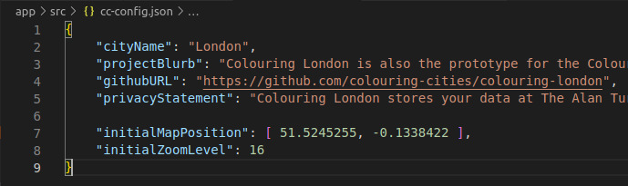
For example, changing the "cityName" from "London" to "[Your City Name]" will replace the logo and other properties across the entire site to use your city name instead of London.
You are also encouraged to update your githubURL to refer to your specific version of the project on GitHub. Also, please update the privacyStatement to inform users how their data will be stored (and what safeguards are in place).

More Features/Documentation Coming Soon
We will add new features and more information to the Colouring Cities Core Platform repository documentation as soon as possible. You can find this here:
https://github.com/colouring-cities/colouring-core
If you have any questions, comments or suggestions about this feature, feel free to use the discussion facilities available on GitHub.

Using/Modifying CC-Config in your Colouring Cities Code
For Developers, Software Engineers and advanced users, here is a more detailed overview of how the CC-Config features work.
The CCConfig code is defined in app/src/cc-config.ts and contains all of the variables that can be used in your code.
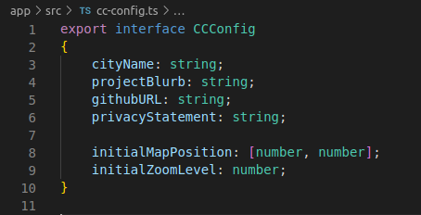
The value of these variables are defined in JSON format in app/src/cc-config.json
And to use the cc-config parameters in your code, you will need to import the files using the following lines of code
import { CCConfig } from '../../cc-config';
let config: CCConfig = require('../../cc-config.json')

