Limits of Task-Set Reduction in SWE-bench Verified: A Temporal Study of Leaderboard Ranking Reliability

Abstract
Coding-agent leaderboards make task reduction attractive, but a subset is useful only if it preserves the ranking of later systems. We test this time-forward requirement in two 500-task panels: open submissions from 2024 to 2025 (51 earlier and 78 later systems) and standardized Bash-only submissions from 2025 to 2026 (27 and 11 systems). Earlier outcomes select tasks at 13 budgets using uniform random, repository-stratified random, entropy, and a frozen temporal core-set procedure. We measure held-out fidelity with Kendall’s τ_{b}, a tie-aware top-k Jaccard diagnostic, and the all-systems and cluster-latest scopes. A harmonized curve bootstrap resamples held-out system clusters for every method and redraws tasks for stochastic procedures. Later cohorts had higher mean solve rates; entropy declined clearly only in the standardized panel. Under the protocol-defined pointwise policy, the common procedure budgets were 500, 500, 500, and 475 tasks, respectively. A post hoc joint max-t sensitivity retained these budgets only with standardized bands and scope-specific retraining; fixed selection required all 500 tasks. An unstandardized raw-deviation band forced all four to 500. Entropy was also non-monotone, passing at 150–300 tasks but failing at 400–475 in one scope. Task identities varied across scope-trained selectors, so a common budget does not denote one fixed public subset. Thus, no procedure supported more than a 5% reduction under the primary policy, and even that saving was not a fixed deployable set. Maintainers should validate selection procedures on later systems, model-related submissions, and report curve-wise selection uncertainty rather than assume fidelity increases with budget.
Keywords: coding agents; benchmark reduction; leaderboard reliability; SWE-bench Verified; temporal validation; ranking uncertainty

1 Introduction
Repository-level coding agents are commonly compared by the fraction of benchmark tasks they resolve. SWE-bench made this evaluation setting concrete by connecting real GitHub issues to repository snapshots, pull requests, and executable tests (Jimenez et al. 2024). SWE-bench Verified subsequently retained 500 tasks after human review of problem statements and test adequacy (OpenAI 2024). Public leaderboards then accumulated many submissions that differed in models, scaffolds, dates, and execution conventions.
Executing fewer tasks is an appealing way to reduce evaluation burden. The idea resembles test-suite reduction: retain a smaller set that preserves the property needed by the user (Harrold et al. 1993; Yoo and Harman 2012). For a leaderboard, however, the relevant property is not merely task coverage or fault detection. A reduced set must preserve comparative conclusions among systems. Benchmark-task choice alone can alter the relative performance of methods (Dehghani et al. 2021), so agreement on the systems already observed is not enough evidence that the same subset will rank later systems reliably. A subset can also appear stable when a leaderboard contains many closely related variants of the same agent or model provider.
This creates a temporal measurement problem. Suppose task outcomes from an earlier period are used to choose a subset. The subset is then applied to later systems, and its induced ranking is compared with the ranking produced by all 500 tasks. The key question is not whether one can fit the observed leaderboard, but whether the compressed measurement transfers forward. This distinction matters because data-generating processes can drift over time (Gama et al. 2014), because software tools and benchmark configurations evolve (Golmohammadi et al. 2026), and because benchmark conclusions can depend on uncontrolled sources of variation (Bouthillier et al. 2021). Out-of-sample validation and transparent reporting also remain uneven in empirical software engineering (Destefanis et al. 2026).
The need for maintenance has become more explicit since the data snapshot used in this study. In February 2026, OpenAI reported that SWE-bench Verified no longer provided a suitable signal for frontier coding capabilities because of residual task flaws and contamination, and recommended moving to newer evaluations (OpenAI 2026). Our study does not dispute or repair those construct-validity problems. Instead, it treats the frozen public leaderboard as a historical measurement system and asks a narrower methodological question: within that system, how much task reduction preserves later rankings? The distinction between outcome correctness and ranking fidelity is essential. Work such as SWE-Bench+ and UTBoost examines whether benchmark tasks and tests correctly accept solutions (Aleithan et al. 2024; Yu et al. 2025); we examine whether a subset of the recorded outcomes preserves system ordering.
We make four contributions.
1. We instantiate ranking-preserving benchmark reduction for coding agents as a time-forward evaluation, complementing general benchmark-compression work rather than claiming the first study of subset selection.
2. We construct two non-pooled temporal panels from frozen official sources, reconcile included matrices to public scores, and distinguish all systems from the latest system in each related family or provider cluster.
3. We evaluate four selection procedures over 13 budgets with task- and system-side uncertainty, curve-wise resampling, tie-aware diagnostics, threshold sensitivity, and a mandatory 500-task positive control.
4. We report a limitation finding and disclose its analysis provenance: a 475-task procedure-level result under the protocol-defined pointwise rule is evaluated using subsequent post hoc robustness analyses rather than described as a confirmatory result.
The practical implication is procedural rather than algorithmic. A task subset should be versioned and revalidated as a benchmark population changes. The validation must use future systems where possible, account for related submissions, and avoid monotonicity assumptions that the observed fidelity curves do not support. This maintenance stance is consistent with broader calls to document dataset lineage and to treat benchmark design as an ongoing measurement responsibility rather than a one-time release (Paullada et al. 2021; Raji et al. 2021).

2 Background and Related Work

2.1 Coding-agent benchmarks, task validity, and maintenance
SWE-bench evaluates whether a model or agent can modify a real repository to resolve a GitHub issue (Jimenez et al. 2024). The original benchmark contained 2,294 problems across 12 Python repositories. SWE-bench Verified was built after professional developers reviewed 1,699 tasks; 500 were selected as a human-validated subset (OpenAI 2024). These sources establish the benchmark's construction; they do not establish that every task remains valid indefinitely.
Subsequent studies identify distinct validity risks. SWE-Bench+ reports solution leakage, weak tests, and contamination concerns (Aleithan et al. 2024). UTBoost augments tests, identifies patches that had been incorrectly accepted, and shows that corrected outcomes can change leaderboard positions (Yu et al. 2025). OpenAI's later audit reports residual test-design problems and evidence of contamination among frontier models (OpenAI 2026). These works concern whether recorded task outcomes measure the intended capability. Our study assumes a frozen, quality-checked outcome matrix and asks a different question: whether selecting fewer columns preserves the full-matrix ordering of later systems. Perfect subset fidelity would not validate a flawed task, and a corrected task suite could still be too small to preserve rankings.
The submission ecosystem is also heterogeneous. Martinez and Franch (2026) document substantial variation in participants, products, model choices, and openness among SWE-bench leaderboard entries. We therefore do not treat leaderboard rows as interchangeable independent systems. The open-submission and standardized Bash-only formats are analyzed separately, and related-system sensitivity is reported rather than pooling every row into one analysis.

2.2 Test-suite reduction and benchmark compression
Software-testing research distinguishes test-suite minimization, regression test selection, and test-case prioritization (Yoo and Harman 2012). Early minimization work sought a representative subset that retained specified test requirements (Harrold et al. 1993), while prioritization studies evaluated whether ordering could improve the rate of fault detection (Elbaum et al. 2002). These objectives are property-specific: a smaller suite is defensible only relative to the coverage, change relevance, or fault-detection property that it preserves. Microbenchmark prioritization likewise shows that benefits and overhead vary across suites and parameterizations (Laaber et al. 2021).
Benchmark compression replaces testing requirements with evaluation requirements. Dehghani et al. (2021) show that changing benchmark tasks can alter the relative performance of machine-learning methods. Gusev and Zaytsev (2026) directly optimize dataset selection for model-rank preservation and show that gains over random selection depend on the benchmark regime and task representation. EssenceBench combines redundancy analysis, score reconstruction, and subset search for language-model evaluation and reports large reductions on several natural-language benchmarks (Wang et al. 2025). Our estimand is narrower than general compression: a selection procedure must transfer from earlier coding-agent systems to later ones, under two dependence scopes, while retaining a 500-task positive control. We do not propose a generally superior selector.

2.3 Ranking preservation and leaderboard reliability
Leaderboard reliability is not exhausted by a point estimate. Benchmark comparisons can change when data sampling, initialization, and hyperparameter choices are incorporated into the uncertainty analysis (Bouthillier et al. 2021). Model-comparison work similarly argues for comparing performance distributions rather than isolated scores (Dror et al. 2019). These findings motivate reporting task-selection and held-out-system uncertainty separately before adding a harmonized sensitivity.
Rank correlation is appropriate when the target is comparative order rather than absolute score. Kendall's τ_{b} explicitly handles tied ranks (Kendall 1945), which are common when systems resolve the same number of tasks. We supplement τ_{b} with a tie-inclusive top-k Jaccard diagnostic, pairwise direction agreement, calibrated score error, and repository coverage. The top-k measure is a decision diagnostic, not a replacement for the global ordering metric. This distinction follows broader critiques that a leaderboard score may not capture the dimensions of utility that matter to a particular user (Ethayarajh and Jurafsky 2020).
Benchmark design also defines what later work is incentivized to optimize. Bowman and Dahl (2021) argue that benchmark usefulness depends on dataset quality, reliability, size, and the intended capability, while Raji et al. (2021) caution against treating a small set of prominent benchmarks as general measures of progress. Our claim is correspondingly bounded: we evaluate the reliability of one historical ranking procedure, not general software-engineering capability.

2.4 Temporal validation and benchmark evolution
Time-forward validation treats the relation learned from an earlier cohort as potentially unstable. Concept-drift research formalizes the broader problem of data-generating relationships changing over time (Gama et al. 2014). We do not claim that the observed SWE-bench changes satisfy a particular drift model; the literature supplies the reason to test transfer rather than assume stationarity.
Software-engineering evidence makes the risk concrete. Golmohammadi et al. (2026) show that parameter-tuning conclusions in search-based software engineering can require periodic re-evaluation as tools and benchmarks evolve. Kaltenecker et al. (2023) find that relative performance rankings across configurable-system releases are often stable but have consequential exceptions. Baltes and Ralph (2022) further show that sampling and representativeness require explicit justification in software-engineering studies. Our response is to freeze sources, preserve temporal order, keep the two execution panels separate, and label the earlier open panel as developmental because its held-out period informed study refinement.

2.5 Dependence, resampling, and selection over budgets
Repeated submissions from one agent family or provider create a clustered observation structure. Resampling whole clusters is a standard way to retain within-cluster dependence, although the validity and stability of cluster bootstraps depend on the data structure and become fragile with few clusters (Field and Welsh 2007; Cameron et al. 2008). We therefore report both all-systems and cluster-latest scopes, publish the cluster mapping, and examine alternative cluster definitions rather than claiming that one provider label fully identifies statistical dependence.
The uncertainty problem also spans 13 searched budgets. Pointwise intervals do not provide simultaneous protection over a family of inspected decisions. Simultaneous-inference and resampling literature motivates max-type adjustments when many comparisons are considered together (Westfall and Young 1993; Hothorn et al. 2008). More generally, inference after a data-driven choice can require wider protection than inference for a prespecified target (Berk et al. 2013). Our joint max-t band is a post hoc, custom empirical diagnostic informed by that literature; it is not presented as a new general procedure with theoretical coverage guarantees.

2.6 Reproducibility and citation of research objects
Computational reproducibility requires more than a prose description. Version control, automated checks, and executable workflows reduce avoidable errors in scientific software (Wilson et al. 2014). The software-citation principles treat software as a citable research product and emphasize specificity, persistence, accessibility, and credit (Smith et al. 2016); the data-citation principles make analogous demands for datasets (Data Citation Synthesis Group 2014). ACM SIGSOFT's empirical standards likewise frame transparent reporting and replication materials as part of the evidence for software-engineering studies (Ralph 2021).
Accordingly, this study separates scholarly citations from reproduction identifiers. Dataset papers, software repositories, and archived releases are cited as research objects. Commit identifiers and SHA-256 digests identify exact bytes and versions, but they are recorded in a reproduction manifest rather than treated as substitutes for references. A persistent archive and version-specific identifier are required for the released replication package.

3 Research Questions
RQ1 - Temporal measurement shift. How do task solve rates, task entropy, and task-difficulty ordering change between the earlier and later periods of each execution panel?
RQ2 - Time-forward ranking fidelity. When task sets are selected only from earlier-period outcomes, how faithfully do the resulting selection procedures reproduce the full 500-task ranking of later systems across budgets, panels, and dependence scopes?
RQ3 - Reliable procedure budgets. What is the smallest single task count at which each selection procedure meets the protocol-defined reliability policy in both temporal panels and both dependence scopes? The estimand is a procedure budget; task identities may differ across cells.
The study does not hypothesize that the entropy selector or temporal core set must win. The temporal core set is a frozen exploratory heuristic retained to test whether a more structured earlier-period selector transfers forward.

4 Study Design

4.1 Frozen sources and unit of observation
The unit of observation is one public submission-task outcome. Canonical task identifiers come from the official SWE-bench Verified dataset (Jimenez et al. 2024; OpenAI 2024). Outcome matrices come from the official SWE-bench experiments repository, while public scores and submission metadata come from the official leaderboard website repository (SWE-bench Team 2026a, 2026b). All sources are pinned rather than read from moving branch heads.
The analysis uses experiments commit 1faa91c and website commit f42505b. Full commit identifiers, retrieval URLs, filenames, exclusions, collection times, and SHA-256 checksums are reported in Online Resource 2 (PDF, "Reproduction manifest"; a machine-readable Markdown source is also provided) and source_manifest.json. Commit and digest strings identify frozen versions; the dataset paper and software references identify the research objects themselves, following software- and data-citation guidance (Data Citation Synthesis Group 2014; Smith et al. 2016).

4.2 Inclusion and data-quality rules
For the classic source, a submission must have a valid date, be present in the official leaderboard metadata, expose a canonical resolved-task list, and reconcile exactly to its published score. Of 134 discovered directories, 133 were usable; one unlisted directory was excluded.
For the standardized Bash-only source, a result file must contain explicit Boolean outcomes for exactly the 500 canonical tasks. Seven of 47 discovered directories lacked a valid full matrix, and two more exceeded the protocol-defined 0.15 percentage-point reconciliation tolerance. The remaining 38 were usable. The maximum included difference from a published score was 0.13 percentage points. No included classic row had a score mismatch.
The pipeline verifies unique canonical identifiers, absence of duplicated system signatures within each panel period, and completeness of the positive control. All protocol-defined data-quality checks succeeded. Table 1 summarizes the source audit.
Table 1. Source inclusion and data-quality summary.
Source format | Discovered directories | Usable matrices | Main exclusions | Maximum included score difference
Open/classic | 134 | 133 | 1 unlisted submission | 0.00 pp
Standardized Bash-only | 47 | 38 | 7 missing/invalid full matrices; 2 score mismatches | 0.13 pp

4.3 Temporal panels
The panels represent different execution conventions and are never pooled for inferential claims.
Open-submission panel. Task selection uses 51 systems submitted in 2024; evaluation uses 78 systems submitted in 2025. Agent-family metadata defines 28 training-period and 51 held-out clusters. Because 2025 outcomes were inspected during pilot development, this panel is treated as developmental evidence. The top-k diagnostic uses k=10.
Standardized Bash-only panel. Task selection uses 27 systems from 2025; evaluation uses 11 systems from 2026. Model-provider metadata defines 10 and 7 clusters. The result files share the standardized mini-SWE-agent Bash-only format and explicitly report all 500 task outcomes. This heterogeneous panel provides time-external validation rather than a same-environment replication. The top-k diagnostic uses k=5.
The primary cluster labels are normalized official agent labels for the open panel and model providers for the standardized panel. The replication package publishes the system-level mapping and latest-row indicator. Sensitivity analyses repeat the cluster-latest evaluation with agent lineage, displayed model family, and provider labels while holding the all-system-selected task set fixed. Agent lineage is uninformative for the standardized panel because all 2026 rows share the mini-SWE-agent label; that alternative is reported as unavailable rather than treated as independent systems.
Table 2. Temporal panel design.
Panel | Earlier period | Later period | Systems | Cluster field | Clusters | Top-k
Open-submission | 2024 | 2025 | 51 → 78 | Agent family | 28 → 51 | 10
Standardized Bash-only | 2025 | 2026 | 27 → 11 | Model provider | 10 → 7 | 5

4.4 Task-selection methods
All selectors use only earlier-period outcomes. In the main cell-specific analysis, deterministic selectors are retrained separately for each panel and scope. Therefore an equal budget can identify different tasks. A separate fixed-selection sensitivity trains once on the all-system scope of each panel and evaluates that same set in both scopes.
Uniform random sampling draws tasks without replacement and serves as a descriptive baseline.
Repository-stratified random sampling allocates a budget proportionally across the 12 task repositories using largest remainders, then samples without replacement within each repository. This is the primary stochastic baseline because repository coverage is a basic structural constraint.
Training-period entropy ranks tasks by binary entropy of their earlier- period solve rate, with canonical task identifier as the deterministic tie breaker. It selects tasks closest to a 50% solve rate, which are maximally uncertain for that earlier cohort.
Temporal core set is a frozen exploratory selector. It stratifies by repository and one of five earlier-period difficulty bins, allocates the budget proportionally, and greedily combines three signals: discrimination 4p(1-p), stability between the first and second halves of the earlier period, and Hamming diversity of task outcome signatures. Discrimination and stability receive 75% of the score and signature diversity 25%. The heuristic is not claimed as a novel or successful algorithm.

4.5 Budgets, scopes, and outcomes
We evaluate 13 budgets: 25, 50, 75, 100, 125, 150, 200, 250, 300, 400, 450, 475, and 500 tasks. The 500-task endpoint must reproduce the full ranking exactly and is a mandatory positive control.
Every panel is evaluated in two scopes. The all-systems scope retains all eligible leaderboard rows. The cluster-latest scope retains only the latest eligible system in each agent-family or model-provider cluster, reducing the influence of closely related variants. Clustering is an approximation, not a claim that all within-cluster systems are statistically exchangeable.
The primary outcome is Kendall’s τ_{b} between later-period aggregate scores on the full 500 tasks and on the selected subset. Tau-b is tie-aware (Kendall 1945). For the top-k diagnostic, every system tied at the kth full or reduced score is included; overlap is the Jaccard similarity of the two resulting sets. This definition avoids breaking a boundary tie by system name. Other secondary outcomes are pairwise direction agreement, calibrated score mean absolute error, repository coverage, and the percentile of a deterministic selector relative to repository-stratified random sampling.

4.6 Repetition and uncertainty
The original pointwise analysis intentionally separates two uncertainty sources. Uniform and repository-stratified random sampling use 500 deterministic-seed repetitions per budget, panel, and scope; their empirical 2.5th and 97.5th percentiles describe task-selection variation with the system cohort fixed.
Entropy and temporal core-set selection are deterministic for a fixed earlier cohort. For these methods, we bootstrap later systems by their related-system cluster 1,000 times and recompute τ_{b}. Resampling whole clusters preserves the observed within-cluster grouping rather than treating member rows as independent (Field and Welsh 2007). RQ1 changes in solve rate and entropy use 2,000 repository-cluster bootstrap repetitions over tasks, where the repository is the resampling cluster.
Because those intervals are not directly comparable, a subsequent post hoc sensitivity uses a harmonized curve bootstrap. Five independent seeds contribute 2,000 replicates each (10,000 pooled replicates). Within a panel and replicate, held-out system clusters are drawn once and reused for both scopes, preserving their dependence; the two panels are sampled independently and paired by replicate index. Each stochastic procedure draws one random task ordering per panel-replicate and evaluates nested prefixes at all 13 budgets. Deterministic procedures retain the task set selected from the earlier cohort within each scope.
We report four lower-bound definitions. The first is the empirical pointwise 2.5th percentile. The second uses a raw-deviation sensitivity: within each cell, one additive correction is the 2.5th percentile of the replicate minimum deviation across budgets. Because low-budget, high-variance points can dominate that correction, it is interpreted only as an intentionally conservative diagnostic. The third standardizes deviations by the budget-specific bootstrap standard deviation and takes a cell-wise max-t critical value. The fourth takes the maximum standardized shortfall across the complete four-cell-by-13-budget family for each procedure, producing the decision-family joint max-t lower band. Zero-variance endpoints, notably the exact 500-task positive control, remain at their point estimate. At 500 tasks, the reduced and full score vectors are identical, so fidelity is set to 1 by construction even when a degenerate cluster resample contains no comparable system pair. We report the budget driving each correction, per-seed ranges, and 95% Wilson Monte Carlo intervals conditional on the empirical resampling scheme for budget-selection probabilities (Wilson 1927). These intervals quantify finite simulation error, not coverage of an external system population. An additional 2,000-replicate sensitivity redraws random task sets independently at each budget to compare independent-by-budget coupling with the nested-prefix estimand. The implementation follows standard bootstrap guidance on empirical intervals, dependent data, and Monte Carlo calculation (Efron and Tibshirani 1985; Davison and Hinkley 1997; Field and Welsh 2007). Max-type statistics are motivated by simultaneous-inference and resampling work (Westfall and Young 1993; Hothorn et al. 2008), and the need for curve-wise protection follows the general warning that data-driven selection changes the target of inference (Berk et al. 2013). Nevertheless, the four-cell max-t construction here is a custom empirical application whose coverage is assessed diagnostically rather than assumed.
Formally, let τ̂(c,m,b) be the observed tau-b for cell c, method m, and budget b; let τʳ(c,m,b) be replicate r; and let s(c,m,b) be the across-replicate standard deviation. The raw cell-wise correction is the 2.5th percentile of the minimum, over budgets b, of [τʳ(c,m,b) − τ̂(c,m,b)]. For the standardized joint band, each replicate takes M(r,m) as the maximum, over cells c and budgets b, of [{the replicate mean of τʳ(c,m,b)} − τʳ(c,m,b)] / s(c,m,b), excluding zero-variance points. If q(m) is the 97.5th percentile of M(r,m), the joint lower band is L(c,m,b) = τ̂(c,m,b) − q(m)s(c,m,b). The cell-wise max-t band uses the same expression with the maximum and critical value calculated separately within each cell.
For RQ1, a 500-replicate two-way sensitivity independently resamples task repositories and training/held-out system clusters. For the seven-cluster standardized scope, lower bounds are rerun with five seeds at 1,000 and 5,000 replicates. All intervals are empirical percentile intervals or bands, not population-identification claims for the self-selected leaderboard.

4.7 Reliability policies and exact procedure budgets
Under the protocol-defined pointwise policy, either random procedure passes when mean held-out τ_{b} is at least 0.90 and its task-sampling 2.5th percentile is at least 0.85. A deterministic procedure passes when τ_{b} is at least 0.90 and its system-cluster-bootstrap 2.5th percentile is at least 0.80. These different lower bounds are retained only as the original policy, not as a fair test of method superiority. The harmonized sensitivity applies a common 0.80 lower bound threshold to every procedure, using pointwise, raw cell-wise, cell-wise max-t, or decision-family joint max-t curve-bootstrap bounds.
The thresholds are governance choices, not natural constants, because the utility of a leaderboard decision depends on its user's purpose (Ethayarajh and Jurafsky 2020). In the tie-free case, Kendall's tau equals one minus twice the discordant-pair fraction, so tau values of 0.90 and 0.80 correspond to approximately 5% and 10% discordant pairs. Tau-b adjusts this relation for ties, but the comparison still gives an operational interpretation: the primary rule targets a public leaderboard with few pairwise reversals, whereas the lenient rule is more appropriate for internal screening.
The reported common reliable procedure budget is the smallest single task count that passes every panel-scope cell. It does not denote one fixed public task subset: scope-trained selectors can choose different tasks at that count. The algorithm scans exact budgets in ascending order and does not take the maximum of cell-specific minima. That shortcut would require monotone pass/fail status, which the observed curves contradict.
Two sensitivity policies are also fixed. The lenient policy uses mean τ_{b} 0.85, stochastic lower bound 0.80, and deterministic lower bound 0.75. The strict policy uses 0.95, 0.90, and 0.85. These policies assess threshold dependence; they are not selected to obtain a favorable budget.

4.8 Analysis provenance
This study was not externally registered. An initial analysis examined the 2025 open-submission outcomes, so that panel is treated as developmental. The reliability thresholds were fixed before the two-panel analysis. Inspection of the resulting non-monotone budget paths revealed that the initial aggregation implementation incorrectly assumed monotone pass/fail status; the aggregation was corrected to evaluate each exact budget across all required cells. The harmonized bootstrap, raw-deviation band, standardized max-t bands, and coupling sensitivity were specified subsequently and are reported as post hoc robustness analyses. This sequence separates the fixed thresholds from the corrected aggregation and later sensitivity analyses.

4.9 Use of generative AI
OpenAI Codex assisted with implementing analysis code, checking calculations, and drafting and copyediting the manuscript. The human authors verified the code, results, citations, claims, and final text and remain accountable for the work; the system is not an author.

5 Results

5.1 RQ1: Later cohorts had higher mean solve rates, but entropy changed differently
Mean task solve rate increased in both panels (Table 3 and Fig. 1). In the open-submission panel, the increase was 0.236 with a repository-bootstrap 95% interval from 0.213 to 0.261. Mean task entropy decreased by 0.049, but its interval (-0.096 to 0.029) crossed zero. We therefore do not interpret the open panel as showing a clear entropy decline.
The two-way sensitivity, which also resamples system clusters, widens the open solve-rate interval to [0.171, 0.301] and the entropy interval to [-0.121, 0.044]. For the standardized panel, the corresponding intervals are [0.085, 0.239] and [-0.414, -0.153]. Thus the directional RQ1 interpretation is unchanged, but Table 3 should be read as task-side descriptive uncertainty.
In the standardized Bash-only panel, mean solve rate increased by 0.158 (0.125 to 0.175), while entropy decreased by 0.292 (-0.332 to -0.203). The later standardized systems solved more tasks on average, but a larger share of tasks became weakly discriminative or nearly saturated. The τ_{b} correlation between earlier- and later-period task difficulty was 0.791 in the open panel and 0.713 in the standardized panel, indicating substantial but incomplete stability of task ordering.
Table 3. Later-minus-earlier temporal changes.
Panel | Systems (earlier → later) | Solve-rate change [95% interval] | Entropy change [95% interval] | Task-difficulty τ_{b}
Open | 51 → 78 | +0.236 [+0.213, +0.261] | -0.049 [-0.096, +0.029] | 0.791
Standardized | 27 → 11 | +0.158 [+0.125, +0.175] | -0.292 [-0.332, -0.203] | 0.713

Fig. 1 Temporal changes in mean task solve rate and binary entropy
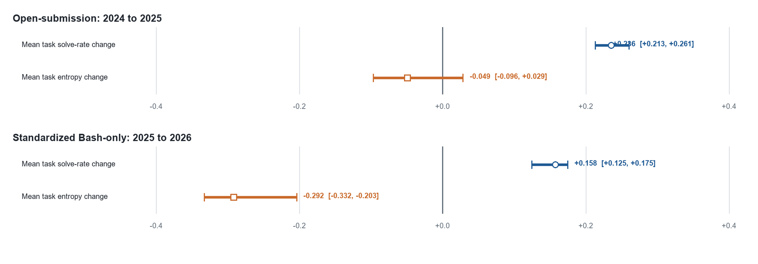
Answer to RQ1. Both held-out cohorts solved more tasks on average. A clear loss of task entropy was observed only in the standardized panel, and task difficulty ordering retained τ_{b}=0.791 in the open panel and 0.713 in the standardized panel. The incomplete stability makes earlier-period task selection a non-trivial transfer problem.

5.2 RQ2: In-panel fidelity does not imply later-cohort reliability
Figure 2 shows held-out ranking fidelity for all four procedures. The developmental open panel gives an optimistic picture. In the all-system scope, the first passing budgets are 200 tasks for uniform random, 150 for repository-stratified random, 400 for entropy, and 150 for the temporal core set. The standardized panel is markedly more demanding: corresponding all-system budgets are 450, 450, 100, and 475 tasks.
The divergent entropy budgets illustrate why a single-panel result is not a general recommendation. Entropy performs well at 100 tasks in the standardized all-system scope, but the same selector needs 400 tasks in the open panel. Conversely, methods that appear adequate at 150 tasks in the open panel require 450 or 475 tasks in the standardized panel. The cross-panel all-system exact budgets are consequently 450 for repository-stratified random, 400 for entropy, and 475 for the temporal core set.
Fig. 2 (a) Held-out Kendall’s τ_b by task budget and scope in the open-submission panel. The y-axis includes the full 0–1 fidelity range and extends to -0.2 so negative lower intervals remain visible. The dashed horizontal line is the primary mean threshold of 0.90; passing also requires the method-specific lower bound
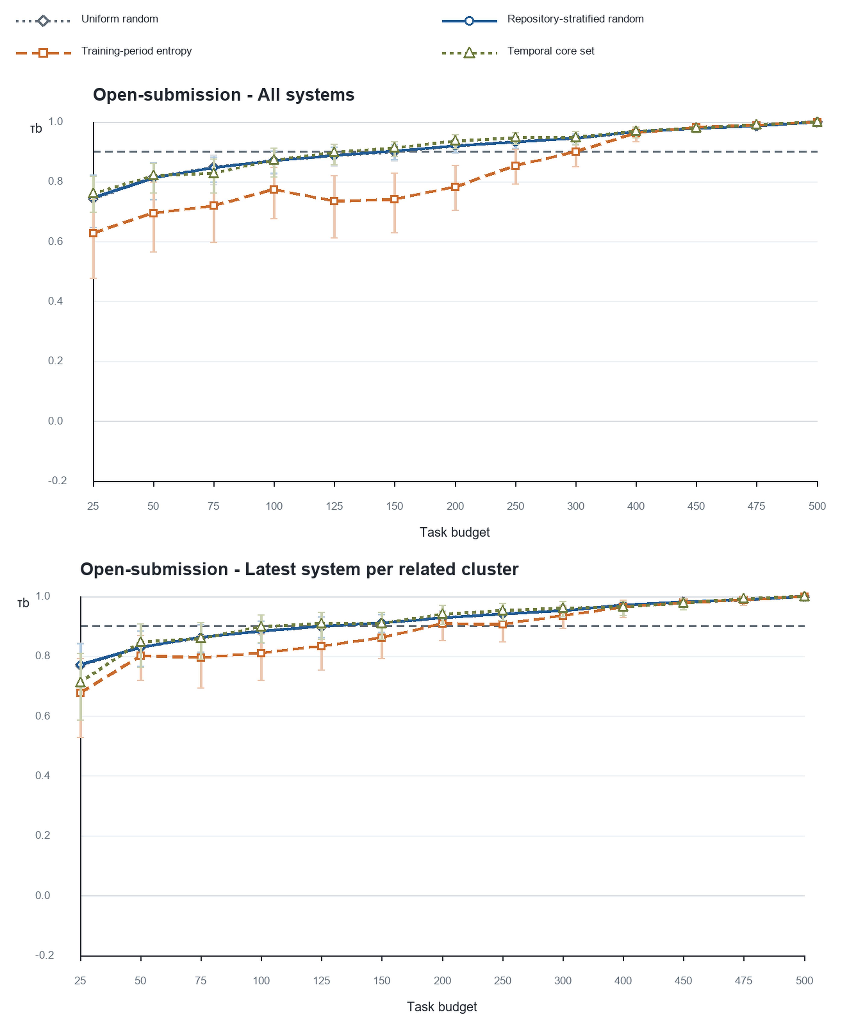
Fig. 2 (b) Held-out Kendall’s τ_b by task budget and scope in the standardized Bash-only panel
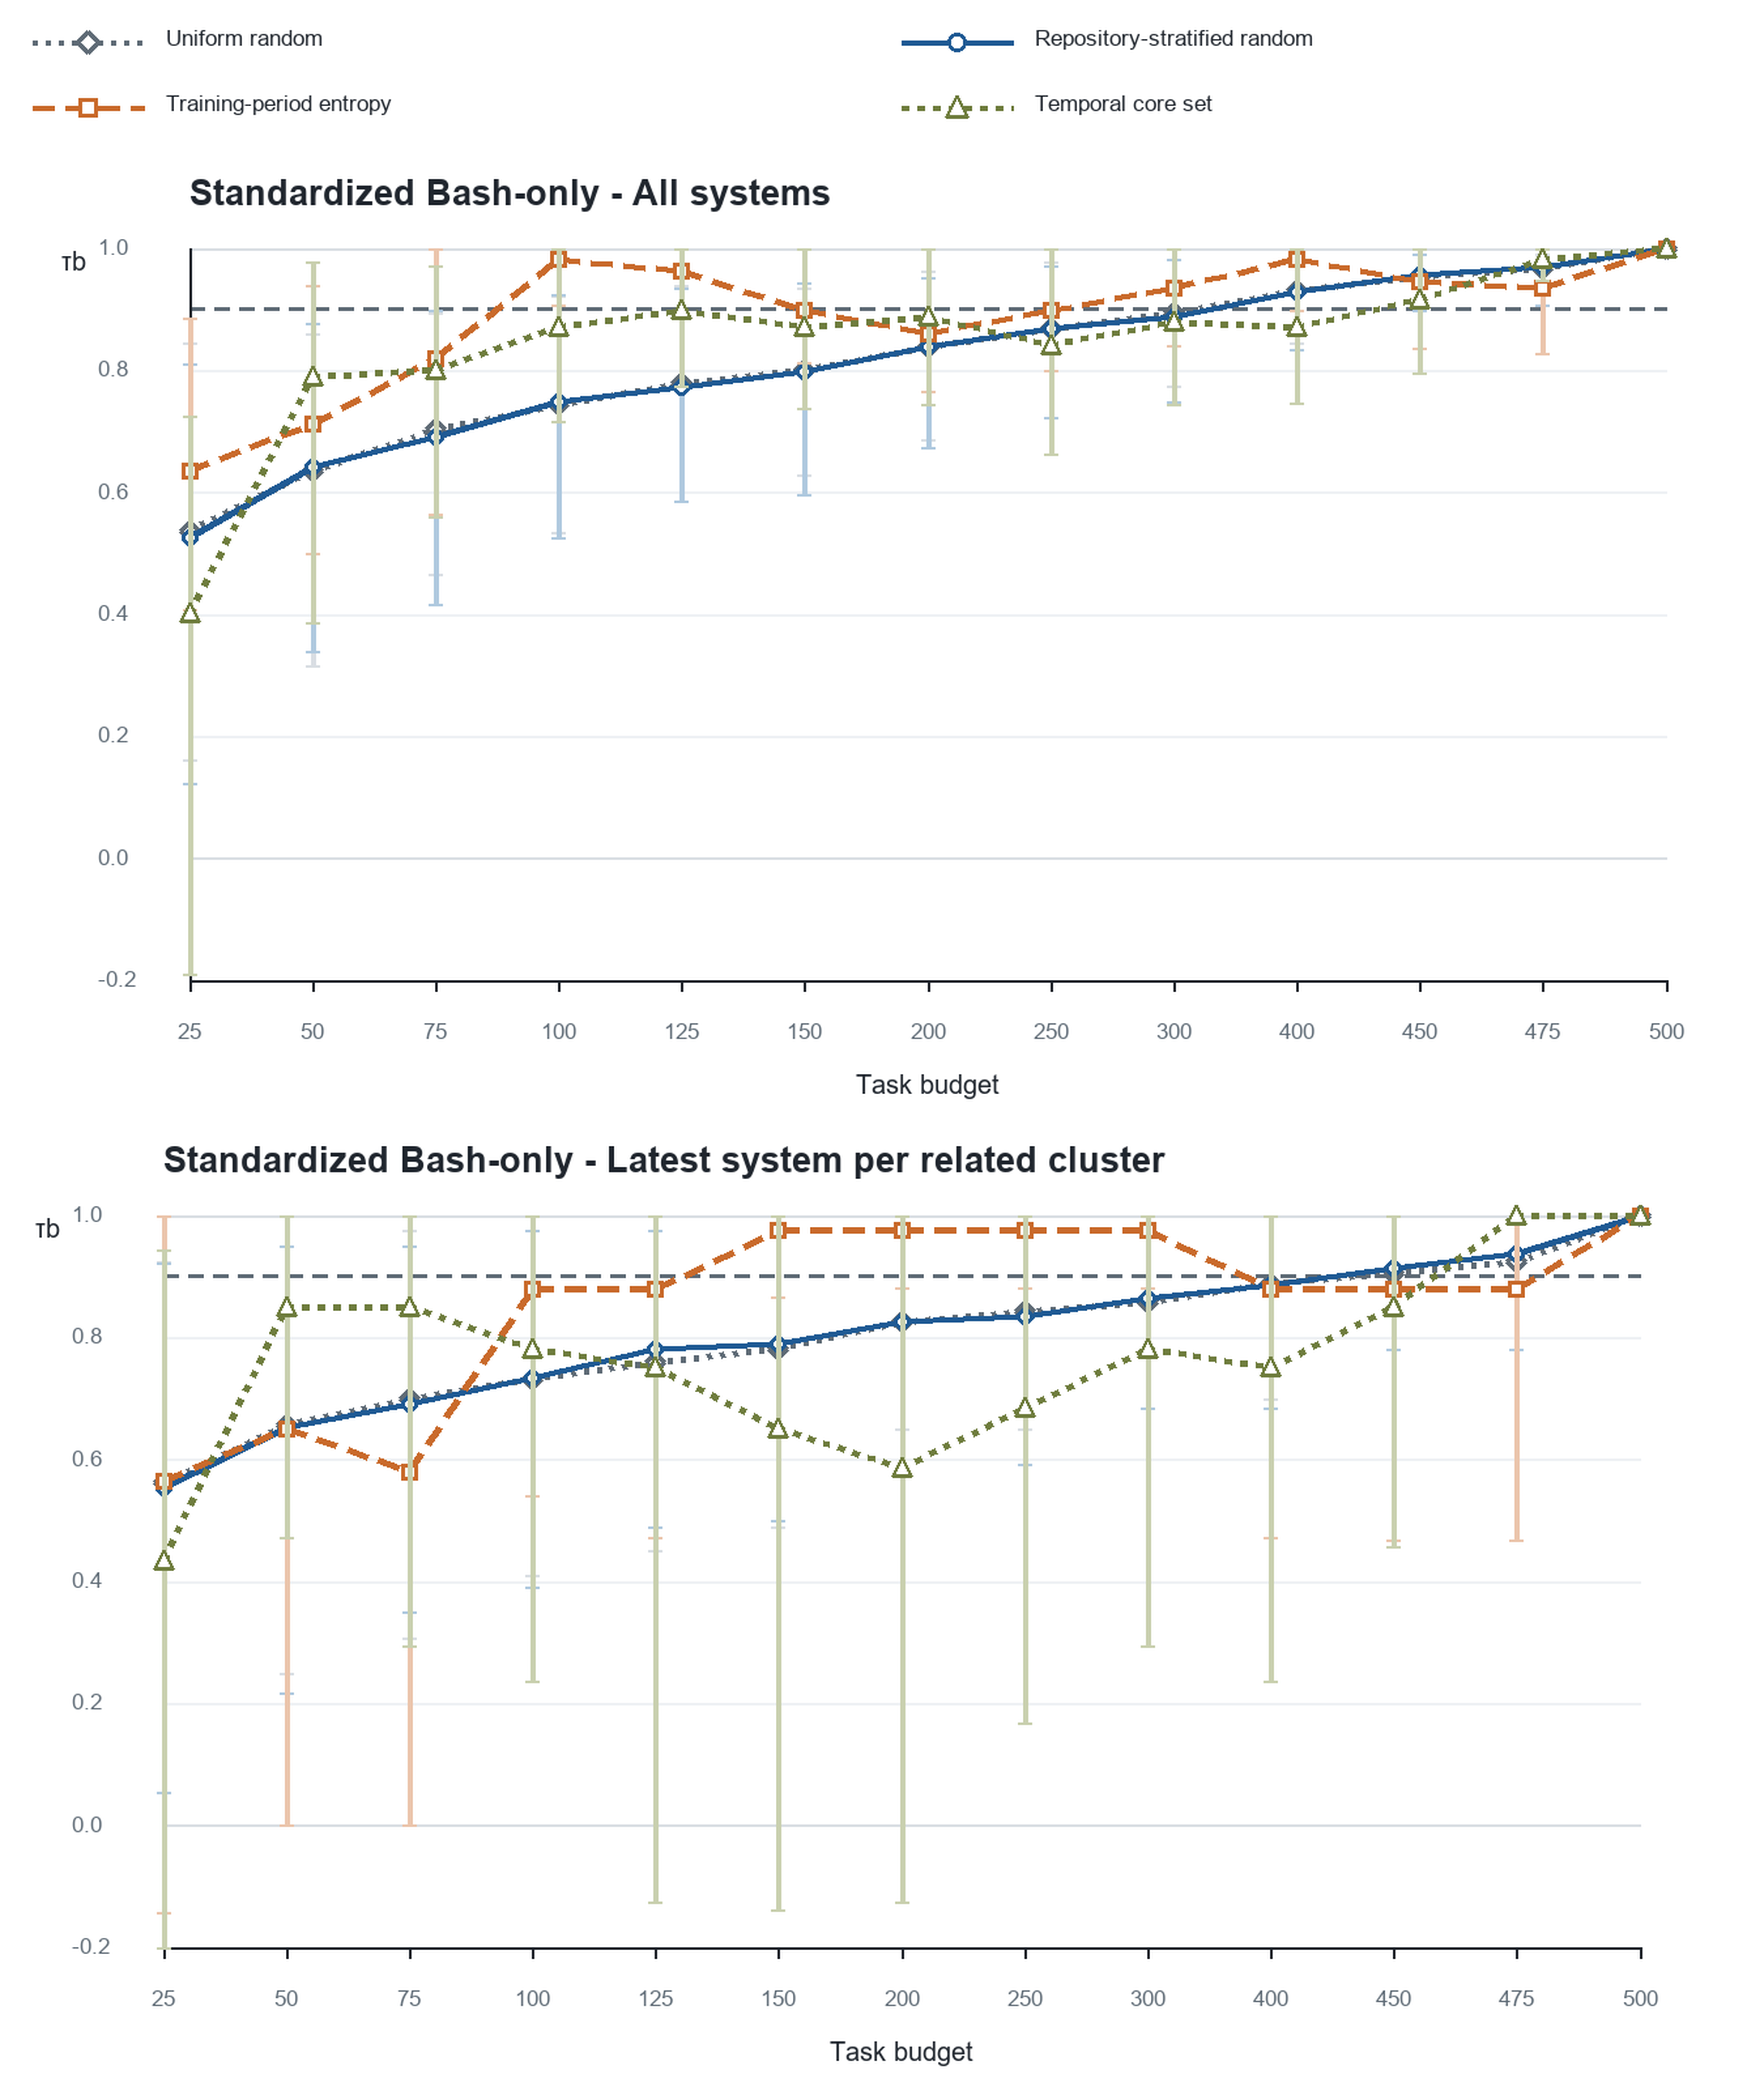
Table 4. First passing budgets within each panel and scope.
Panel and scope | Uniform random | Repository-stratified random | Entropy | Temporal core set
Open, all systems | 200 | 150 | 400 | 150
Open, cluster latest | 150 | 150 | 200 | 125
Standardized, all systems | 450 | 450 | 100 | 475
Standardized, cluster latest | 500 | 500 | 150 | 475

Dependence sensitivity changes the curves further. In the standardized panel, repository-stratified random sampling passes at 450 tasks with all systems (mean τ_{b} 0.956; 2.5th percentile 0.897), but fails at the same budget after retaining one system per provider cluster (0.914; 0.781). It reaches the positive control at 500 tasks. The apparent 10% random-sampling reduction is therefore attributable to a scope that gives repeated related systems more weight.
These cell-specific minima are descriptive. They cannot be aggregated by taking their maximum because a method can pass at a smaller budget and fail at a larger one.
Answer to RQ2. Ranking fidelity varies materially by later cohort and by the treatment of related systems. Budgets that appear adequate in the developmental panel do not transfer reliably to the standardized time-external validation panel.

5.3 RQ3 under the protocol-defined pointwise policy
Figure 3 applies the original primary rule at each exact budget and counts the number of passing panel-scope cells. Uniform random, repository-stratified random, and entropy first pass all four cells only at 500 tasks. The temporal core procedure first passes all four at 475 tasks, a 5% reduction. These are procedure-level budgets: the selected task identities need not match across cells.
Fig. 3 Number of panel-scope cells passing the primary policy at each exact budget. Gold outlines identify the first 4/4 budget
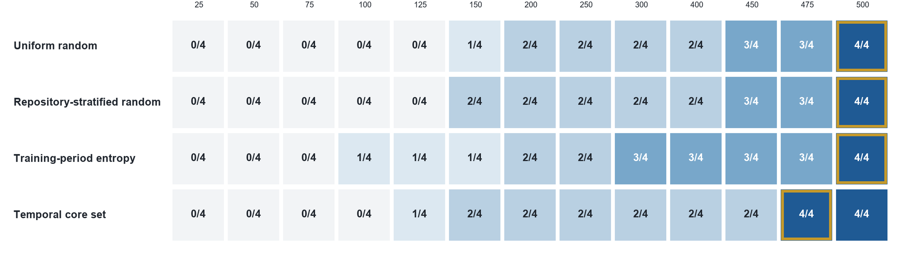
The entropy result deserves closer inspection. In the standardized cluster- latest scope, entropy passes at 150, 200, 250, and 300 tasks. At 300 tasks, τ_{b} is 0.976 and the cluster-bootstrap 2.5th percentile is 0.882. It then fails at 400, 450, and 475 tasks. At 400 tasks, τ_{b} falls to 0.878 and the lower bound to 0.471, although top-5 overlap remains 1.0. At 500 tasks, all metrics return to 1.0. Thus, a larger nested entropy subset can preserve the top group while changing enough pairwise orderings and ties to fail the global rank criterion.
This non-monotonicity explains why the all-system cross-panel entropy budget of 400 does not survive the robust rule. The open cells pass at 400, but the standardized cluster-latest cell does not. Only the 500-task endpoint passes all cells simultaneously.
Table 5. Protocol-defined pointwise procedure-budget decisions.
Selection procedure | All-system cross-panel budget | Four-cell common reliable budget | Reduction from 500
Uniform random | 450 | 500 | 0%
Repository-stratified random | 450 | 500 | 0%
Training-period entropy | 400 | 500 | 0%
Temporal core set | 475 | 475 | 5%

Pointwise answer to RQ3. Under the protocol-defined mixed-source pointwise policy, the procedure budgets are 500, 500, 500, and 475 tasks. Because the methods use different interval sources and the 475-task sets differ by scope, this is not evidence that the temporal-core heuristic is superior or that a single 475-task public subset is reliable.

5.4 Threshold sensitivity
The main negative finding is stable under the strict policy (Table 6). Both repository-stratified random sampling and entropy require 500 tasks, and the temporal core set requires 475. Under the lenient policy, entropy admits a 250-task exact procedure budget, corresponding to a 50% task reduction. This shows that an operational user willing to accept lower mean and lower-bound fidelity could choose a much smaller entropy subset, but that choice is a different reliability policy and cannot replace the primary conclusion.
Table 6. Exact procedure budgets under fixed sensitivity policies.
Policy | Uniform random | Repository-stratified random | Training-period entropy | Temporal core set
Lenient | 500 (0%) | 500 (0%) | 250 (50%) | 475 (5%)
Primary | 500 (0%) | 500 (0%) | 500 (0%) | 475 (5%)
Strict | 500 (0%) | 500 (0%) | 500 (0%) | 475 (5%)

5.5 Harmonized and curve-wise uncertainty
The harmonized bootstrap gives the same pointwise procedure budgets as Table 5, including 475 tasks for the temporal core set (Table 7). The unstandardized raw-deviation band forces every procedure to 500 tasks, but the budget-standardized cell-wise and joint max-t bands retain 475 for temporal core. Uniform random, repository-stratified random, and entropy remain at 500 under every harmonized definition.
Table 7. Harmonized procedure budgets under pointwise, raw-deviation, and standardized max-t curve-wise uncertainty.
Selection procedure | Pointwise | Raw cell-wise | Cell-wise max-t | Joint max-t
Uniform random | 500 | 500 | 500 | 500
Repository-stratified random | 500 | 500 | 500 | 500
Training-period entropy | 500 | 500 | 500 | 500
Temporal core set | 475 | 500 | 475 | 475

Table 8 explains the disagreement. At 475 tasks, the temporal-core pointwise lower bound in the standardized all-system cell is 0.947. The raw additive correction reduces it to 0.380 because one correction must absorb large unstandardized deviations elsewhere on the curve. The standardized cell-wise and joint bands are 0.907 and 0.890, both above the common 0.80 threshold. In the standardized cluster-latest cell, the corresponding raw and joint values are 0.066 and 0.951. The raw correction is therefore a deliberately severe stress test and should not be interpreted as the sole defensible conservative specification.
Table 8. Temporal-core lower bounds at 475 tasks under the four uncertainty definitions.
Panel and scope | Point estimate | Pointwise q.025 | Raw cell-wise | Cell-wise max-t | Joint max-t
Open, all systems | 0.990 | 0.982 | 0.916 | 0.978 | 0.973
Open, cluster latest | 0.992 | 0.982 | 0.863 | 0.977 | 0.971
Standardized, all systems | 0.981 | 0.947 | 0.380 | 0.907 | 0.890
Standardized, cluster latest | 1.000 | 1.000 | 0.066 | 0.963 | 0.951

The raw standardized-all correction is most often driven by the 250-task point (24% of replicates), whereas the raw standardized cluster-latest correction is most often driven by 25 tasks (25%). The joint standardized maximum is dispersed: its most frequent driver is the standardized cluster-latest 50-task point, but only in 7% of replicates. This diagnostic shows why standardization materially changes this diagnostic when budgets have very different variances.
The replicate-level minimum remains unstable before the positive control. For temporal core, 52% of pooled replicates first pass all four cells at 475 tasks (95% Wilson Monte Carlo interval conditional on the empirical resampling scheme: 51%–53%), and 56% select 475 under the rule requiring all larger candidate budgets to pass (55%–57%). Entropy's persistent-rule probabilities are 24% at 300, 29% at 400, and 45% at 500. Both random methods still require 500 under nested-prefix and independent-by-budget task draws.
Table 9. Five-seed Monte Carlo stability of common budgets and 475-task selection probabilities.
Selection procedure | Pointwise budget range | Raw cell-wise range | Joint max-t range | First-pass 475 probability range | Persistent-475 probability range
Uniform random | 500 | 500 | 500 | 5–6% | 11–12%
Repository-stratified random | 500 | 500 | 500 | 5–6% | 11–13%
Training-period entropy | 500 | 500 | 500 | 0–0% | 0–0%
Temporal core set | 475 | 500 | 475 | 51–52% | 55–57%

Across the five seeds, every method's pointwise, raw, and joint common budget is invariant (Table 9). For the standardized all-system temporal-core cell at 475 tasks, the seed-specific pointwise lower bound ranges from 0.946 to 0.947 and the joint max-t lower band from 0.843 to 0.911. The range is material but does not cross the 0.80 decision threshold.
Curve-wise answer to RQ3. Under the decision-family joint max-t analysis, the common procedure budgets are 500, 500, 500, and 475 tasks. The raw cell-wise sensitivity alone returns 500 for all four because its common unstandardized correction is dominated by high-variance curve regions. The supported reduction is therefore at most 5%, procedure-level, and dependent on the uncertainty construction.

5.6 Task identity, fixed selection, and clustering sensitivity
At 475 tasks, the deterministic scope-trained sets are similar but not equal (Table 10). The standardized temporal-core sets share 457 tasks (Jaccard 0.927), which directly rules out interpreting 475 as one common subset. The all-system-selected fixed-set sensitivity is still more consequential (Table 11): the temporal-core procedure then requires 500 tasks, while entropy passes at 400. Random fixed-set values are omitted because a single draw does not estimate either stochastic selection procedure.
Table 10. Task-set overlap between scope-trained deterministic selectors at the 475-task budget.
Panel | Deterministic procedure | Jaccard overlap | Shared tasks
Open | Training-period entropy | 0.996 | 474
Open | Temporal core set | 0.951 | 463
Standardized | Training-period entropy | 0.971 | 468
Standardized | Temporal core set | 0.927 | 457

Table 11. Fixed all-system selection sensitivity for deterministic procedures.
Selection procedure | Fixed all-system selection: common budget | Random task uncertainty included?
Training-period entropy | 400 | No
Temporal core set | 500 | No

Online Resource 1 (CSV, "Complete secondary metrics") contains one row for each of the 208 panel-scope-method-budget cells. Its columns identify the panel, scope, procedure, and budget and report tau-b, tie-aware top-k Jaccard, full and reduced top-set sizes, pairwise direction agreement, calibrated score MAE, repository coverage, and random-baseline percentile. This makes cases such as perfect top-k retention despite global-rank failure directly auditable.
Alternative cluster labels also change first-passing budgets. In the standardized panel, fixed all-system selections evaluated on model-family clusters yield 100 tasks for entropy and 475 for temporal core, compared with 100 and 500 under provider clusters. The agent-lineage alternative collapses to one standardized cluster and cannot support a bootstrap interval. In the open panel, temporal-core first-passing budgets range from 100 under model family to 400 under provider clustering. These values are exploratory because selection is fixed and stochastic task uncertainty is omitted; their spread shows that a cluster policy is part of the estimand, not a harmless data cleaning choice.

6 Discussion

6.1 The result is a limitation, not a selector victory
The developmental panel can support an attractive 150-task narrative for selected methods. That narrative fails under the standardized time-external validation panel and related-system sensitivity. Even the remaining 475-task temporal-core result depends on retraining the selector within each scope. It survives the budget-standardized joint max-t analysis but not the unstandardized raw band or the fixed-selection test. The strongest supported conclusion is therefore a limitation finding: the available public evidence supports at most a 5% procedure-level reduction, not one deployable 475-task set.
Entropy remains a useful diagnostic baseline. It is simple, deterministic, and can perform well under a lenient policy. Yet it is not a robust primary-policy solution, and the present study does not claim algorithmic novelty. The temporal-core heuristic likewise does not establish a generally superior selection method: its apparent 5% saving survives standardized joint curve control but disappears when one all-system-trained set is fixed across scopes.
Negative evidence is operationally valuable. A benchmark maintainer who adopted the developmental 150-task result would risk a materially different later leaderboard. Reporting that failure prevents a fragile optimization from becoming infrastructure.

6.2 More tasks do not guarantee greater rank fidelity
The non-monotone entropy curve is the study's main analytical warning. Even though entropy subsets are nested as the budget grows, the induced system ranking need not improve monotonically. Adding tasks can alter score ties and pairwise differences in directions that temporarily reduce τ_{b}. A decision procedure that takes the maximum of cell-specific minimum passing budgets silently assumes monotonicity and can therefore select a budget that fails one of its required cells.
The safe aggregation rule is computationally simple: enumerate the candidate budgets and test every required panel-scope cell at the same exact budget. If budgets are continuous or numerous, an implementation can still exploit structure, but it must not assume nesting of task sets implies monotonicity of the decision metric.
Enumeration alone does not address selection induced by scanning many noisy budgets. Curve-wise resampling exposes the distribution of the chosen minimum, and a simultaneous band can adjust the lower bound across the complete scan (Westfall and Young 1993; Hothorn et al. 2008). Such protection is relevant because inference after selecting among observed candidates is generally more demanding than inference for one prespecified target (Berk et al. 2013). Band construction matters: the raw unstandardized correction changes 475 to 500, whereas the joint standardized max-t band retains 475. A robustness analysis should therefore report its family, scaling, and driver budgets rather than treat one curve-wise construction as definitive.

6.3 Implications for benchmark maintenance
We recommend a versioned maintenance cycle.
1. Freeze source commits, task identifiers, outcome matrices, and metadata.
2. Select candidate task sets only from an earlier system cohort.
3. Validate on later systems in each execution environment separately.
4. Add dependence-aware scopes for agent families, providers, or shared scaffolds.
5. Distinguish a common procedure budget from a fixed task set; report task identity overlap and, when deployment requires one set, test it directly.
6. Evaluate exact budgets with curve-wise uncertainty and a full-benchmark positive control.
7. Re-run the protocol when the system population, harness, or benchmark materially changes.
This cycle parallels calls to re-evaluate empirical configurations as tools and benchmarks evolve (Golmohammadi et al. 2026) and to document dataset lineage throughout collection, maintenance, and use (Paullada et al. 2021). Versioned software, explicit manifests, and automated tests also follow established guidance for reliable scientific computing (Wilson et al. 2014). The cycle makes the reliability policy an explicit governance choice. A maintainer may prefer a lenient budget for rapid internal screening and retain the full benchmark for public ranking. What should be avoided is presenting the smaller screening set as if it preserved the primary-policy leaderboard.

6.4 Evaluation burden is not proportional cost
The task-reduction percentages in Tables 5 and 6 are counts, not measured runtime or monetary savings. Coding-agent evaluation includes repository setup, container creation, dependency installation, caching, retries, and fixed coordination overhead. More generally, a leaderboard's performance score need not capture operational attributes that matter to users (Ethayarajh and Jurafsky 2020). Removing 5% or 50% of tasks therefore need not reduce total cost by the same proportion. A deployment decision requires a separate cost model with observed per-task and fixed costs.

6.5 Relevance after SWE-bench Verified became unsuitable for frontier evaluation
The official 2026 warning means SWE-bench Verified should not be treated as a current frontier capability measure (OpenAI 2026). This narrows the direct operational recommendation: we do not propose a new permanent subset of SWE-bench Verified. However, the warning strengthens the broader maintenance motivation. A benchmark can lose construct validity while its task discrimination and system population also evolve. Newer coding-agent benchmarks will face the same temptation to reduce task sets. They should evaluate outcome correctness and time-forward ranking fidelity as distinct gates.

7 Threats to Validity

7.1 Construct validity
The primary construct is preservation of a full-benchmark ranking, not real-world software engineering ability. If the full benchmark contains flawed, contaminated, or unrepresentative tasks, high subset fidelity reproduces those limitations. Recent audits make this threat concrete (Aleithan et al. 2024; OpenAI 2026; Yu et al. 2025). Kendall’s τ_{b} captures global ordering with ties, but a user may care more about a specific decision such as top-5 membership. Our inclusive tie-aware Jaccard removes arbitrary name-based tie breaking, but the top set can exceed k. We report set sizes and pairwise diagnostics; the decision remains τ_{b} based.
The public score is a single binary-outcome aggregate. It does not represent patch quality, maintainability, efficiency, or repeated-run reliability. This gap between a leaderboard's measured attribute and broader user utility is a known construct-validity risk (Ethayarajh and Jurafsky 2020; Raji et al. 2021).

7.2 Internal validity
Source formats differ between panels. We mitigate this by analyzing them separately, requiring exact canonical identifiers, reconciling scores, and pinning commits. Submission date is an imperfect proxy for evaluation time and does not identify the exact harness version. Metadata-derived clusters may merge distinct systems or fail to join related systems. The cluster-latest analysis is therefore a sensitivity analysis rather than a definitive causal model of dependence. Model-family and provider alternatives change several first-passing budgets, and one standardized agent-lineage definition collapses to a single cluster. The published mapping makes these judgments auditable but does not eliminate misclassification.
Random baselines use finite repetitions and bootstrap intervals use finite resamples. The chosen counts (10,000 pooled curve replicates from five seeds; 500 task draws; 500 two-way, 1,000 cluster, and 2,000 repository resamples) balance stability and runtime. With only seven standardized provider clusters, percentile support is discrete, a setting in which cluster-bootstrap behavior warrants particular caution (Cameron et al. 2008). Across five seeds the 1,000-replicate lower bound varies by as much as 0.256 at some low-budget cells. The 475-task temporal-core cluster-latest lower bound is 1.0 under all tested seeds at both 1,000 and 5,000 repetitions, while the harmonized standardized all-system temporal-core pointwise lower bound at 475 varies only from 0.946 to 0.947. Its joint max-t lower band varies from 0.843 to 0.911. These are empirical sensitivity bounds, not exact confidence limits.
The Wilson intervals quantify only Monte Carlo error conditional on the empirical resampling scheme. They do not include uncertainty from panel selection, cluster definition, or a broader model population.
The thresholds are normative reliability policies rather than estimates of a universal acceptable τ_{b}. We expose lenient and strict policies to show how the conclusion depends on that choice.
The original intervals vary across uncertainty sources and use different lower-bound thresholds across stochastic and deterministic procedures. They remain within-method diagnostics, not a fair method ranking. The harmonized analysis aligns system-cluster resampling and the 0.80 lower-bound threshold; random procedures alone also redraw tasks because task selection is part of their estimand. The harmonized analysis is post hoc. Its raw band is unstandardized and cell-wise, while the max-t analysis uses budget-specific bootstrap standard deviations and controls the four-cell decision family. Neither construction establishes population coverage for the self-selected leaderboard.

7.3 Conclusion validity
The standardized held-out panel contains only 11 systems and seven provider clusters, which yields wide and discrete cluster-bootstrap intervals and limited power. Those wide intervals are part of the reliability question rather than noise to be ignored: a smaller task set is difficult to certify when the independent system population is small. Still, future standardized submissions could change the exact budgets.
We make no causal claim that time, model scale, or agent design caused the observed solve-rate or entropy changes. The panels are observational snapshots of a self-selected public leaderboard.
Scanning 13 budgets creates selection pressure. The original intervals are pointwise and the minimum passing budget can be unstable; curve-wise resampling, explicit raw and standardized simultaneous bands, driver diagnostics, and the persistent-rule distribution address but do not eliminate this issue (Berk et al. 2013; Hothorn et al. 2008). A future study should validate the chosen budget on an additional time window.

7.4 External validity
The study covers one 500-task Python benchmark and two SWE-bench execution formats. Results do not generalize numerically to other benchmarks, languages, task types, or private systems. Public submissions over-represent teams willing to publish results and may contain repeated variants. Sampling limitations of software engineering corpora are well documented (Baltes and Ralph 2022), and prominent benchmarks should not be treated as universal proxies for broader capability (Raji et al. 2021).
SWE-bench Verified's current unsuitability for frontier evaluation further limits direct use of the specific subsets. Scope-specific training also means that a procedure budget is not one deployable subset. The transferable result is the validation protocol and the demonstrated failure of monotone and pointwise common-budget aggregation, not the claim that 475 or 500 tasks is a universal coding-agent requirement.

8 Reproducibility
The reproduction package contains the complete standard-library Python pipeline, configuration, tests, frozen source manifest, data-quality report, 208 primary metric rows, harmonized curve metrics, budget-selection distributions, fixed-selection results, task-set overlaps, system-level cluster mapping, alternative-cluster results, bootstrap-stability checks, longitudinal summaries, a complete secondary-metric Online Resource, curve-band drivers, random-budget coupling sensitivity, analysis history, and an HTML diagnostic report. Tables 3–11 are generated directly from the machine-readable results. Version control, automated testing, and executable regeneration follow established scientific-computing and empirical-reporting guidance (Wilson et al. 2014; Ralph 2021).
Twenty-one unit and integration tests cover metric boundaries, tie-aware top-k sets, exact subset sizes, source parsing, cluster handling, decision thresholds, and the non-monotone common-budget regression, nested random paths, and joint four-cell curve resampling. The replication package contains 208 unique panel-scope-method-budget rows, no duplicate cells, and no missing primary rank metrics. The 500-task validator requires all 16 combinations of two panels, two scopes, and four methods; all reproduce τ_{b}=1, top-k Jaccard=1, and zero calibrated score error.
The upstream binary outcome matrices are not redistributed. The source manifest records immutable URLs and commits so a reproducer can recollect them. This choice respects upstream data ownership while retaining an auditable chain from source to result. The separation between scholarly citations and exact version identifiers follows the principles that data and software should be cited as research products while manifests identify the precise materials used (Data Citation Synthesis Group 2014; Smith et al. 2016).
Online Resource 2 provides the exact source and analysis identifiers, file inventory, checksums, and verification commands. Online Resource 1 provides the complete secondary-metric table used for diagnostic interpretation.

9 Conclusion
Task-set reduction for a coding-agent leaderboard must be evaluated as a future-ranking problem. In two temporal SWE-bench Verified panels, budgets that looked sufficient in a developmental cohort weakened under later standardized systems and related-system sensitivity. Under the primary and strict policies, uniform random, repository-stratified random, and entropy required all 500 tasks; the temporal-core procedure required 475. Under a common uncertainty definition with a standardized four-cell joint max-t band, the same 500/500/500/475 budgets remain. An unstandardized raw-deviation band instead forces all four to 500, demonstrating that the scaling and family of the band are part of the conclusion. Fixed selection and alternative cluster definitions further showed that neither task identity nor threshold crossing is invariant to the evaluation policy.
The observed non-monotonicity is consequential: a larger deterministic subset can fail after a smaller one passes. Common-budget decisions must therefore test one exact budget across every required panel and dependence scope rather than aggregate cell-specific minima. More broadly, benchmark subsets should be versioned, validated on later systems, and re-evaluated as tasks, harnesses, and system populations change. The result is not a recommended permanent subset of SWE-bench Verified, which is no longer a suitable frontier benchmark (OpenAI 2026). It is a reproducible warning about the limits of one-time benchmark compression and pointwise budget selection.

References
Aleithan R, Xue H, Mohajer MM, Nnorom E, Uddin G, Wang S (2024) SWE-Bench+: enhanced coding benchmark for LLMs. arXiv:2410.06992. https://doi.org/10.48550/arXiv.2410.06992
Baltes S, Ralph P (2022) Sampling in software engineering research: a critical review and guidelines. Empir Softw Eng 27:94. https://doi.org/10.1007/s10664-021-10072-8
Berk R, Brown L, Buja A, Zhang K, Zhao L (2013) Valid post-selection inference. Ann Stat 41(2):802–837. https://doi.org/10.1214/12-AOS1077
Bouthillier X, Delaunay P, Bronzi M, Trofimov A, Nichyporuk B, Szeto J, Mohammadi Sepahvand N, Raff E, Madan K, Voleti V, Ebrahimi Kahou S, Michalski V, Serdyuk D, Arbel T, Pal C, Varoquaux G, Vincent P (2021) Accounting for variance in machine learning benchmarks. Proc Mach Learn Syst 3. https://proceedings.mlsys.org/paper/2021/hash/0184b0cd3cfb185989f858a1d9f5c1eb-Abstract.html
Bowman SR, Dahl GE (2021) What will it take to fix benchmarking in natural language understanding? In: Proceedings of NAACL-HLT 2021, pp 4843–4855. https://doi.org/10.18653/v1/2021.naacl-main.385
Cameron AC, Gelbach JB, Miller DL (2008) Bootstrap-based improvements for inference with clustered errors. Rev Econ Stat 90(3):414–427. https://doi.org/10.1162/rest.90.3.414
Data Citation Synthesis Group (2014) Joint declaration of data citation principles. FORCE11, San Diego. https://doi.org/10.25490/a97f-egyk
Davison AC, Hinkley DV (1997) Bootstrap methods and their application. Cambridge University Press, Cambridge. https://doi.org/10.1017/CBO9780511802843
Dehghani M, Tay Y, Gritsenko AA, Zhao Z, Houlsby N, Diaz F, Metzler D, Vinyals O (2021) The benchmark lottery. arXiv:2107.07002. https://doi.org/10.48550/arXiv.2107.07002
Destefanis G, Yousefi L, Shepperd M, Tucker A, Swift S, Counsell S, Arzoky M (2026) An audit of machine learning experiments on software defect prediction. Empir Softw Eng 31:83. https://doi.org/10.1007/s10664-025-10797-w
Dror R, Shlomov S, Reichart R (2019) Deep dominance: how to properly compare deep neural models. In: Proceedings of the 57th Annual Meeting of the Association for Computational Linguistics, pp 2773–2785. https://doi.org/10.18653/v1/P19-1266
Efron B, Tibshirani R (1985) The bootstrap method for assessing statistical accuracy. Behaviormetrika 12:1–35. https://doi.org/10.2333/bhmk.12.17_1
Elbaum S, Malishevsky AG, Rothermel G (2002) Test case prioritization: a family of empirical studies. IEEE Trans Softw Eng 28(2):159–182. https://doi.org/10.1109/32.988497
Ethayarajh K, Jurafsky D (2020) Utility is in the eye of the user: a critique of NLP leaderboards. In: Proceedings of EMNLP 2020, pp 4846–4853. https://doi.org/10.18653/v1/2020.emnlp-main.393
Field CA, Welsh AH (2007) Bootstrapping clustered data. J R Stat Soc Series B Stat Methodol 69(3):369–390. https://doi.org/10.1111/j.1467-9868.2007.00593.x
Gama J, Žliobaitė I, Bifet A, Pechenizkiy M, Bouchachia A (2014) A survey on concept drift adaptation. ACM Comput Surv 46(4):44. https://doi.org/10.1145/2523813
Golmohammadi A, Zhang M, Arcuri A (2026) Tools and benchmarks evolve: what is their impact on parameter tuning in SBSE experiments? Empir Softw Eng 31:8. https://doi.org/10.1007/s10664-025-10733-y
Gusev R, Zaytsev A (2026) Benchmarking on tasks that matter: dataset selection for preserving model rankings. In: Proceedings of the 32nd ACM SIGKDD Conference on Knowledge Discovery and Data Mining. https://doi.org/10.1145/3770855.3817569
Harrold MJ, Gupta R, Soffa ML (1993) A methodology for controlling the size of a test suite. ACM Trans Softw Eng Methodol 2(3):270–285. https://doi.org/10.1145/152388.152391
Hothorn T, Bretz F, Westfall P (2008) Simultaneous inference in general parametric models. Biom J 50(3):346–363. https://doi.org/10.1002/bimj.200810425
Jimenez CE, Yang J, Wettig A, Yao S, Pei K, Press O, Narasimhan K (2024) SWE-bench: can language models resolve real-world GitHub issues? In: International Conference on Learning Representations. https://openreview.net/forum?id=VTF8yNQM66
Kaltenecker C, Mühlbauer S, Grebhahn A, Siegmund N, Apel S (2023) Performance evolution of configurable software systems: an empirical study. Empir Softw Eng 28:152. https://doi.org/10.1007/s10664-023-10338-3
Kendall MG (1945) The treatment of ties in ranking problems. Biometrika 33(3):239–251. https://doi.org/10.1093/biomet/33.3.239
Laaber C, Gall HC, Leitner P (2021) Applying test case prioritization to software microbenchmarks. Empir Softw Eng 26:133. https://doi.org/10.1007/s10664-021-10037-x
Martinez M, Franch X (2026) What’s in a benchmark? The case of SWE-Bench in automated program repair. In: Proceedings of ICSE-SEIP 2026, pp 647–658. https://doi.org/10.1145/3786583.3786904
OpenAI (2024) Introducing SWE-bench Verified. https://openai.com/index/introducing-swe-bench-verified/. Accessed 26 August 2026
OpenAI (2026) Why SWE-bench Verified no longer measures frontier coding capabilities. https://openai.com/index/why-we-no-longer-evaluate-swe-bench-verified/. Accessed 27 August 2026
Paullada A, Raji ID, Bender EM, Denton E, Hanna A (2021) Data and its (dis)contents: a survey of dataset development and use in machine learning research. Patterns 2(11):100336. https://doi.org/10.1016/j.patter.2021.100336
Raji ID, Denton E, Bender EM, Hanna A, Paullada A (2021) AI and the everything in the whole wide world benchmark. In: Advances in Neural Information Processing Systems, Datasets and Benchmarks Track 1. https://datasets-benchmarks-proceedings.neurips.cc/paper/2021/hash/084b6fbb10729ed4da8c3d3f5a3ae7c9-Abstract-round2.html
Ralph P (2021) ACM SIGSOFT empirical standards released. ACM SIGSOFT Softw Eng Notes 46(1):19. https://doi.org/10.1145/3437479.3437483
Smith AM, Katz DS, Niemeyer KE, FORCE11 Software Citation Working Group (2016) Software citation principles. PeerJ Comput Sci 2:e86. https://doi.org/10.7717/peerj-cs.86
SWE-bench Team (2026a) SWE-bench experiments repository, commit 1faa91c. GitHub [Software]. https://github.com/swe-bench/experiments/tree/1faa91cade0562ba62b66c1c99e71f7b72d96f13. Accessed 27 August 2026
SWE-bench Team (2026b) SWE-bench leaderboard website repository, commit f42505b. GitHub [Software]. https://github.com/swe-bench/swe-bench.github.io/tree/f42505b21a0eb31a9cc1204caafcbe0da6c1a259. Accessed 27 August 2026
Wang S, Wang C, Fu W, Min Y, Feng M, Guan I, Hu X, He C, Wang C, Yang K, Ren X, Huang F, Liu D, Zhang L (2025) Rethinking LLM evaluation: can we evaluate LLMs with 200x less data? arXiv:2510.10457. https://doi.org/10.48550/arXiv.2510.10457
Westfall PH, Young SS (1993) Resampling-based multiple testing: examples and methods for p-value adjustment. Wiley, New York. ISBN 978-0-471-55761-6
Wilson EB (1927) Probable inference, the law of succession, and statistical inference. J Am Stat Assoc 22(158):209–212. https://doi.org/10.1080/01621459.1927.10502953
Wilson G, Aruliah DA, Brown CT, Chue Hong NP, Davis M, Guy RT, Haddock SHD, Huff KD, Mitchell IM, Plumbley MD, Waugh B, White EP, Wilson P (2014) Best practices for scientific computing. PLoS Biol 12(1):e1001745. https://doi.org/10.1371/journal.pbio.1001745
Yoo S, Harman M (2012) Regression testing minimization, selection and prioritization: a survey. Softw Test Verif Reliab 22(2):67–120. https://doi.org/10.1002/stvr.430
Yu B, Zhu Y, He P, Kang D (2025) UTBoost: rigorous evaluation of coding agents on SWE-Bench. In: Proceedings of the 63rd Annual Meeting of the Association for Computational Linguistics, pp 3762–3774. https://doi.org/10.18653/v1/2025.acl-long.189

