**Does this project fully implement its concept?**

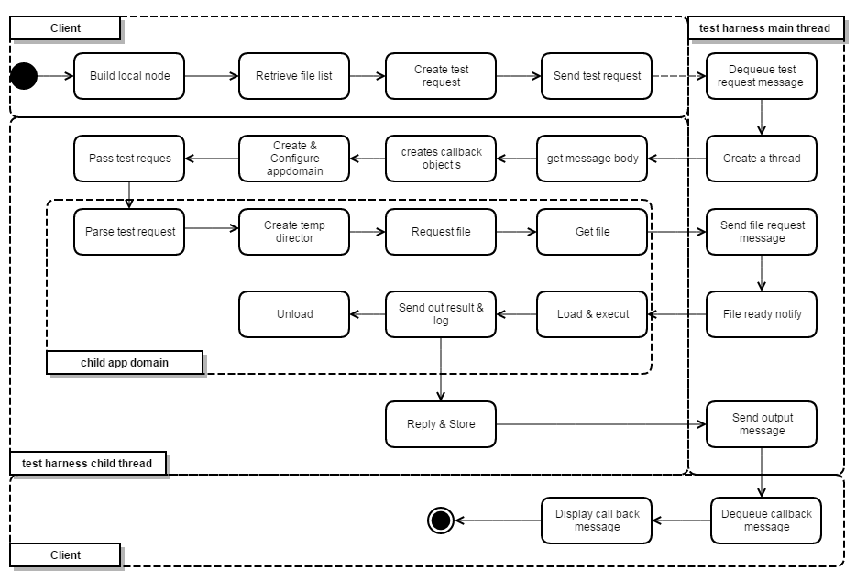

Project 4 didn’t follow the activity Project 3 designed for test harness child thread.

Instead of pass the test request into child app domain, I parse the test request and finished the file query task before entering the child app domain.

Retrieve file list is not implemented but it will be very easy to add because the functionality already finished in repository.

**Was the original concept practical?**

The original concept is overall practical, but the structure used in project4 appears easier to implement.

**Were there things you learned during the implementation that made the original concept less relevant or incomplete?**

In project 3, one critical issue is how the repository will notice the test harness that all file required available have been sent. In project 4, I just send a blank notice file which the test harness will expect.

Divide the labor of child domain to child thread makes the communication much easier.

The WCF channel is more complexed than OCD shown.

The combination of GUI and console simplified the origin design in OCD.