Group A – Project Plan

Table of Contents

1.0 Functional Requirements 1

1.1 Workload Generator (Web Client) 1

1.2 Web Server 2

1.3 Transaction Server 2

1.4 Client/Transaction Database 2

1.5 Auditing/Reporting Database 2

2.0 Architecture Analysis 2

3.0 Distribution Analysis 2

4.0 Stability Analysis 2

# 1.0 Functional Requirements

Auditing/Reporting Database

Receives information from all servers about received requests.

## 1.1 Web Client

Implement in HTML5

Required functions

Note: web client implementation can be left until the end of the project.

Adding a user

In the tool bar at the top of each page is a "Sign Up" link that leads to a page where one can enter their desired user name.

Cookie to store logged in username?

Logging in (no authentication)

In the tool bar at the top of each page is a "Log in" link that leads to a page where one can enter their user name.

Again, cookies?

Account summary

Show transaction history, status of accounts, current buy/sell triggers

Getting a stock quote

Only give access to quote page if logged in? I would imagine most services would require this.

Creating buy/sell order

Presumably show account balance and owned stocks. Inputs for stock name and amount to buy/sell.

Confirm buy/sell order

Buy/Sell page could have a confirmation box on another layer that appears when the web server gets the quote, has a countdown timer, and initiates a requote if the timer runs out once. Finally, give an option to cancel the trade.

Create Buy/Sell trigger

Similar to buy/sell order page, with the addition of the trigger amount.

Admin functions?

Perhaps have a special admin user that adds the dump commands to the user page? It's one way to trigger the generation of the logs. Full dump only supposed to be run from an admin account.

## 1.2 Workload Generator

Description

The workload generator was initially written in Python due to group familiarity with the language. Performance was not considered to be a key factor at this stage of development. Devising a functional system was the primary focus.

Advancements in the code may take the form of translation to C, and adding threads to parallelise the commands (keeping each users' commands in order).

Method of operation

The workload generator opens the provided workload file, reads each line sequentially, builds a command to send for processing, and connects to the web server to simulate a form submission from a web client.

An alternative being considered is to have the workload generator communicate directly to the transaction server.

## 1.3 Web Server

Takes commands from the workload generator or web client, sends to the transaction server for execution, and forwards the result to the web client.

## 1.4 Transaction Server

Accepts commands from the web client, executes the required operations to fulfill the command.

Example:

The user executes a QUOTE command. The transaction server would:

Receive the command from the web server

Contact the quote server for a quote

The received quote would be sent back to the web server to be sent to the client.

Report the quote request to the database for logging

## 1.5 Client/Transaction Database

Maintains records of user accounts and transactions, and responds to requests for information.

All incoming requests are tied to a username. If a user does not exist, a record will be generated for them and then the request processed.

User account table: user name, account balance

Transaction table: user name, action (buy/sell), stock name, number of shares, share price (and/or cryptokey from quote server)

# 2.0 Architecture Analysis

Figure 2.1 below shows the basic structure of the system. For the purpose of this project the workload generator will replace the web client.

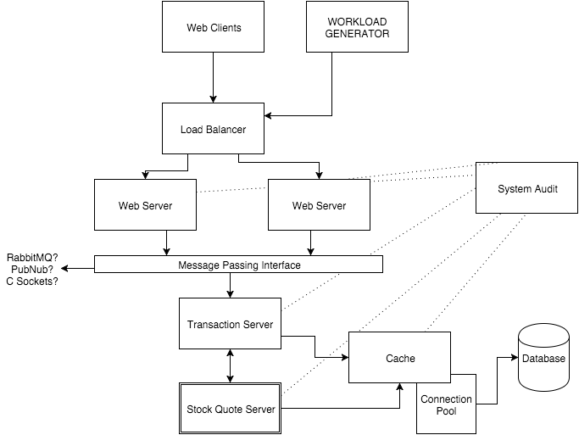Figure 2.1: First Architecture Diagram

# 3.0 Distribution Analysis

//To be decided at a later date

# 4.0 Stability Analysis

//To be decided at a later date