CprE 3810: Computer Organization and Assembly-Level Programming

Project Part 2 Report

Team Members: Graeme Anderson
Colten Stevens

Project Teams Group #: C_01
Refer to the highlighted language in the project 1 instruction for the context of the following questions.
[1.a] Come up with a global list of the datapath values and control signals that are required during each pipeline stage.
IF:
None
ID:
- Instruction
- PC
- Funct 3
- JumpWReg
- Jump
- Branch
EX:
- RS1 value
- RS2 value
- PC + 4
- Immediate
- Instruction
- ALUsrc
- ALUctrl
- AndLink
- Shift
- FlagMux
- FlagOrNFlag
MEM:
- EX Stage Result
- Instruction
- RS2 value
- Funct 3
- MemWrite
WB:
- Instruction
- Memory Output
- Ex Stage Result
- RegWrite
- Halt

[1.b.ii] high-level schematic drawing of the interconnection between components.
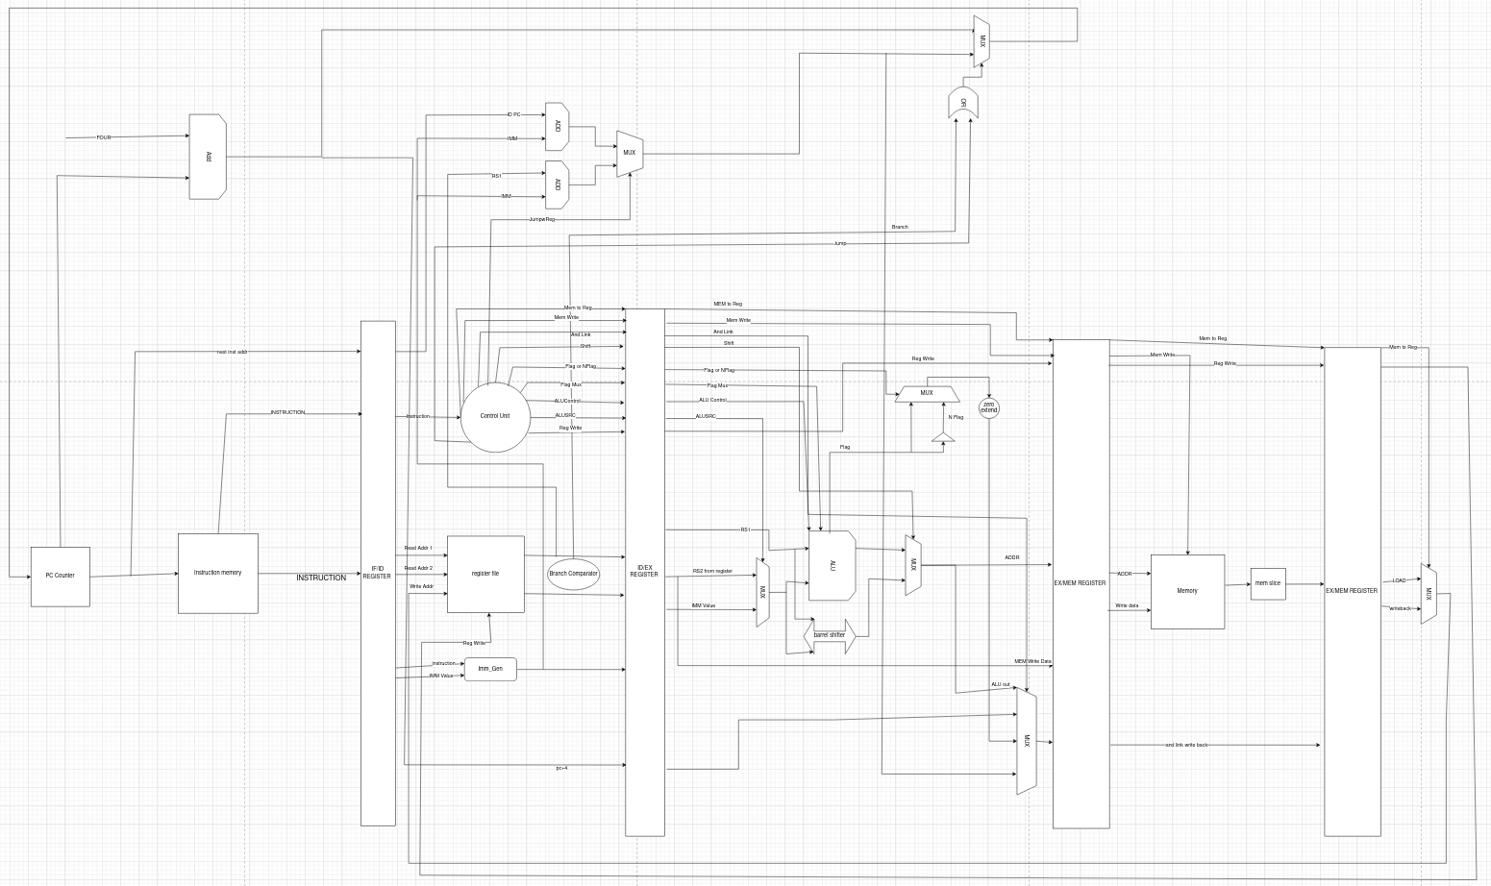
[1.c.i] include an annotated waveform in your writeup and provide a short discussion of result correctness.
Base Tests
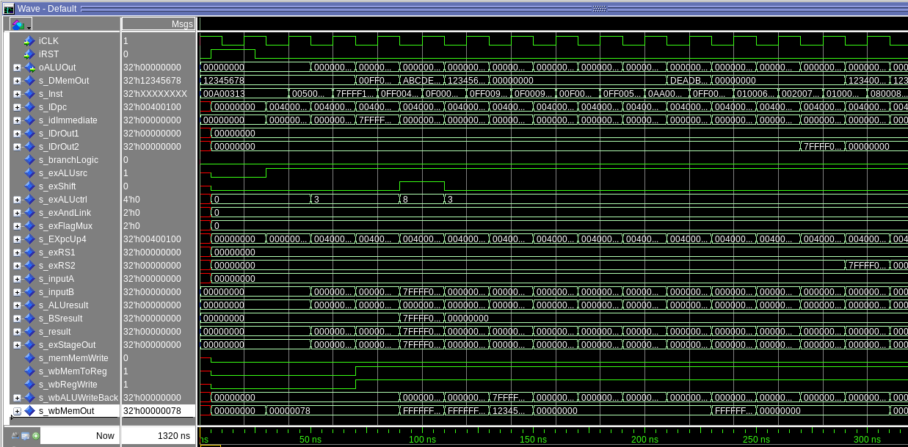
1 2 3 4 5 6 7 8 9 10 11 12 13 14 15 16
1. | 5. | 9. | 13.
2. | 6. | 10. | 14.
3. | 7. | 11. | 15.
4. | 8. | 12. | 16.

[1.c.ii] Include an annotated waveform in your writeup of two iterations or recursions of these programs executing correctly and provide a short discussion of result correctness. In your waveform and annotation, provide 3 different examples (at least one data-flow and one control-flow) of where you did not have to use the maximum number of NOPs.
Merge Sort
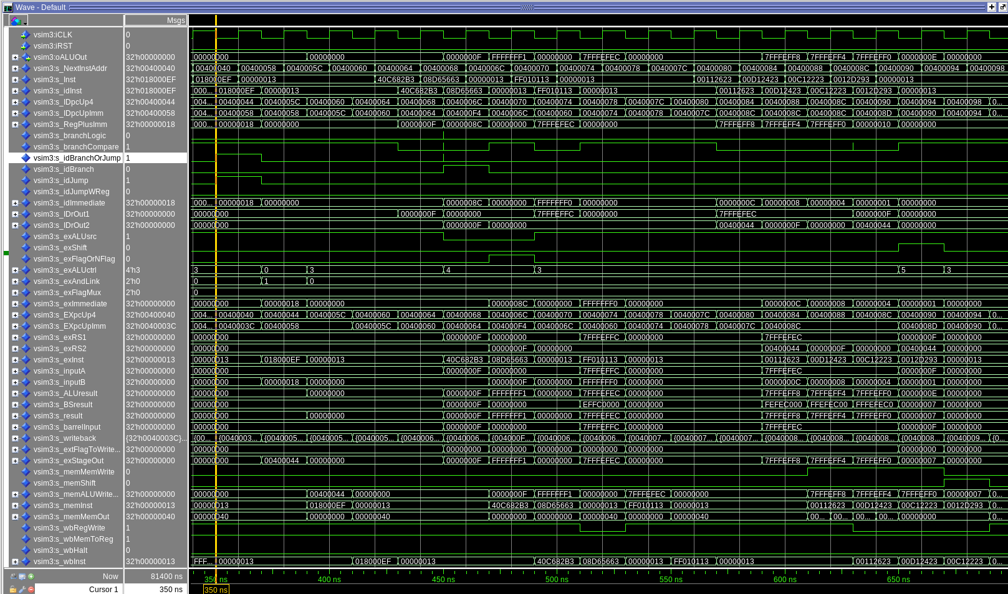
Iteration 1
1 2 3 4 5
1. | 5. | 9. | 13.
2. | 6. | 10. | 14.
3. | 7. | 11. | 15.
4. | 8. | 12. | 16.

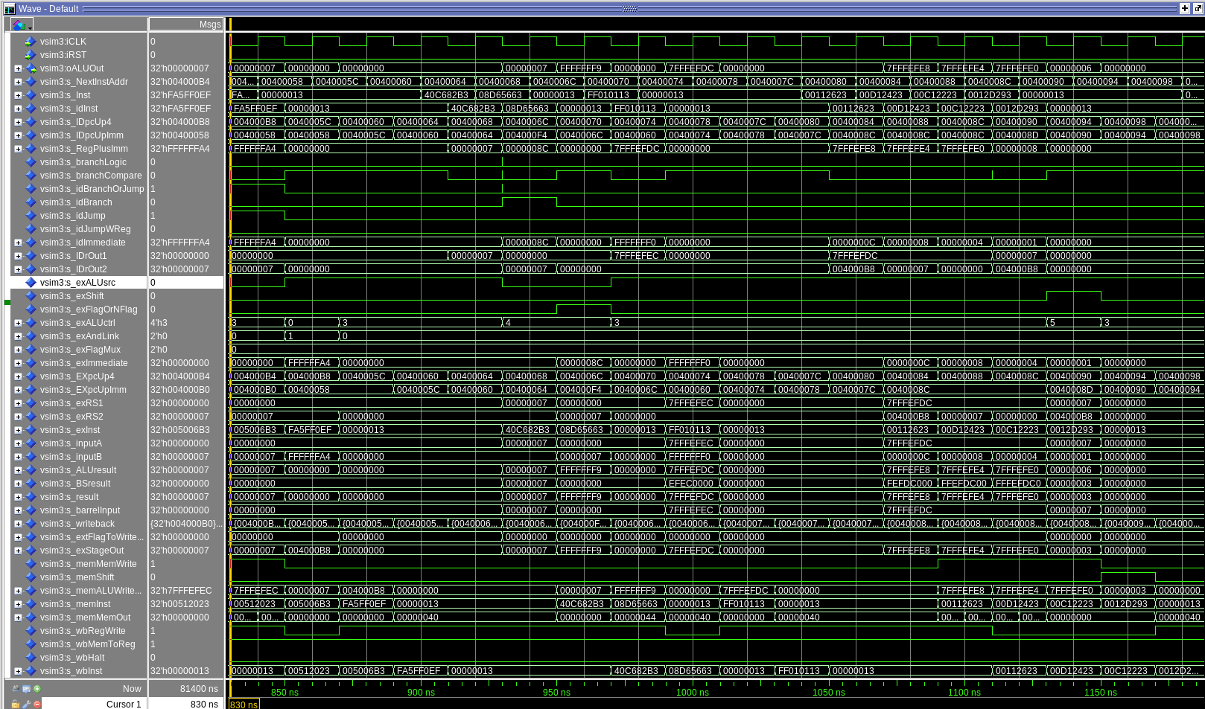
Iteration 2
1. | 5. | 9. | 13.
2. | 6. | 10. | 14.
3. | 7. | 11. | 15.
4. | 8. | 12. | 16.

[1.d] report the maximum frequency your software-scheduled pipelined processor can run at and determine what your critical path is (specify each module/entity/component that this path goes through).
31.59 MHz

Critical Path:
Imem → Register File → Adder For JALR → FetchUnit (Update PC)

[2.a.ii] Draw a simple schematic showing how you could implement stalling and flushing operations given an ideal N-bit register.
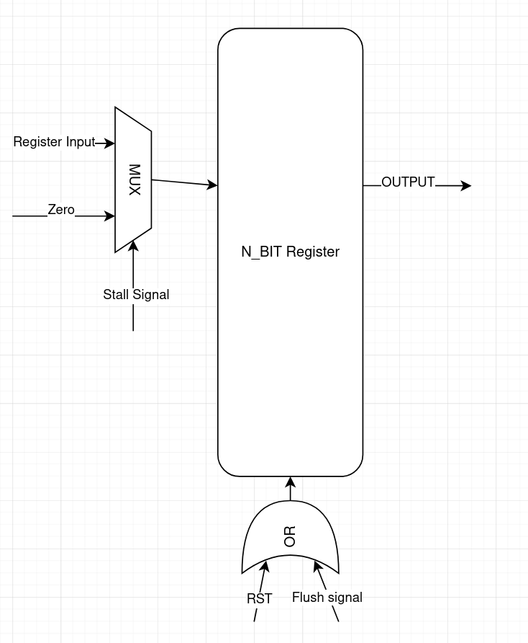

[2.a.iii] Create a testbench that instantiates all four of the registers in a single design. Show that values that are stored in the initial IF/ID register are available as expected four cycles later, and that new values can be inserted into the pipeline every single cycle. Most importantly, this testbench should also test that each pipeline register can be individually stalled or flushed.
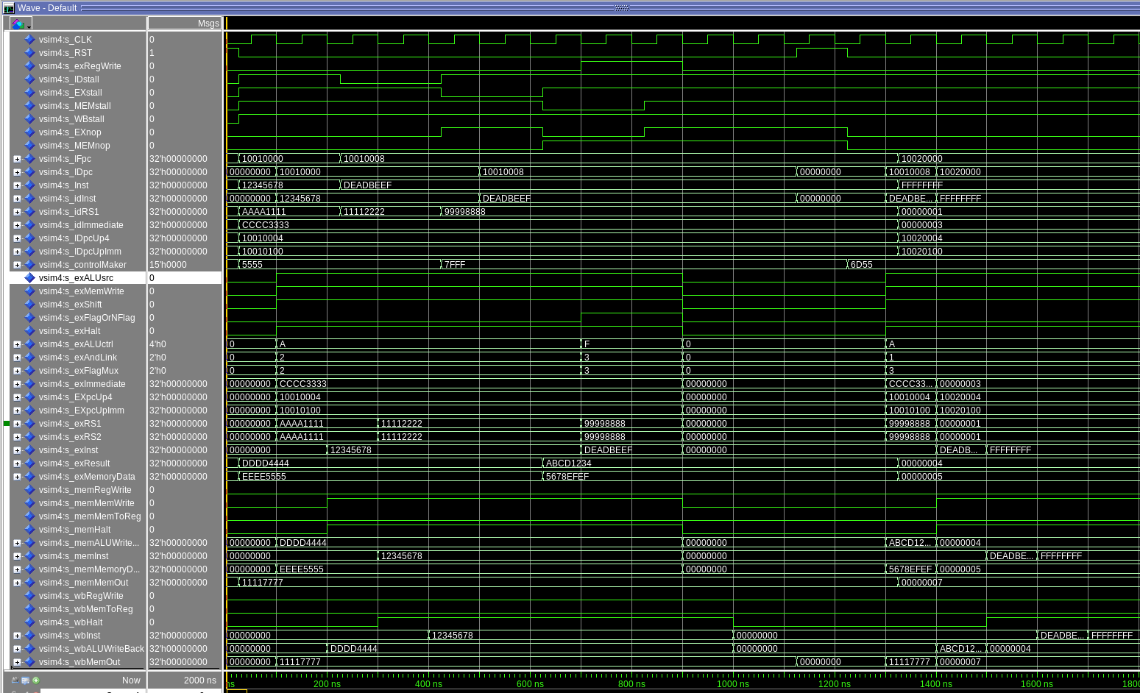

[2.b.i] list which instructions produce values, and what signals (i.e., bus names) in the pipeline these correspond to.
[2.b.ii] List which of these same instructions consume values, and what signals in the pipeline these correspond to.
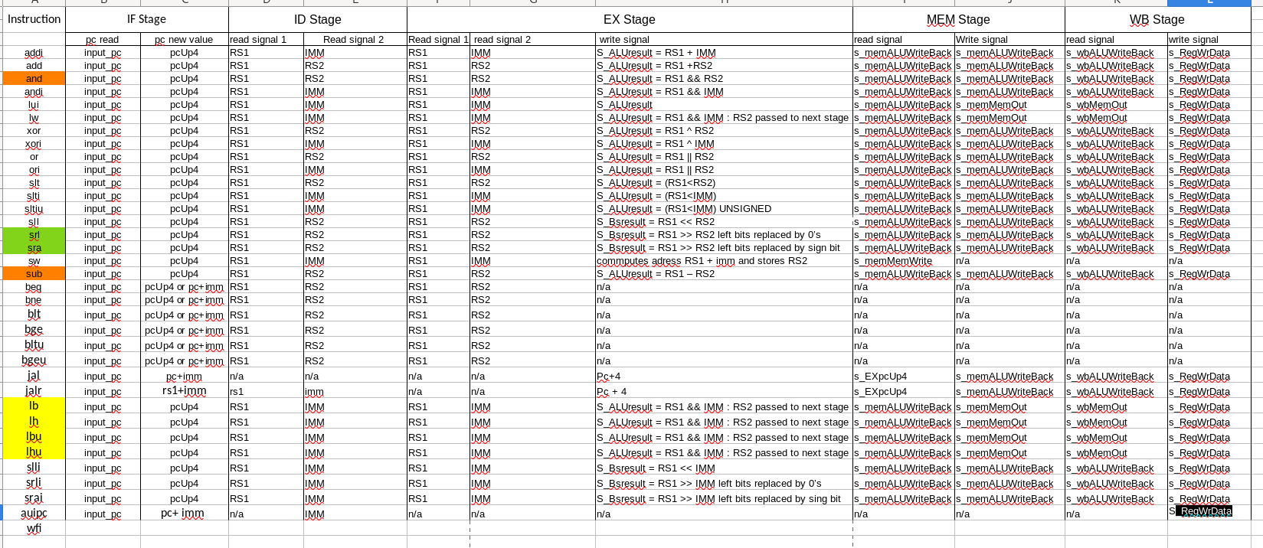
Combined consuming and producing signals into 1spreadsheet.

[2.b.iii] generalized list of potential data dependencies. From this generalized list, select those dependencies that can be forwarded (write down the corresponding pipeline stages that will be forwarding and receiving the data), and those dependencies that will require hazard stalls.

There a a total of 7 different types of hazards that can occur for both RS1/RS2:

1. EX-to-EX Forwarding (MEM → EX)

This hazard occurs when the instruction in EX needs a value that the previous instruction is producing in MEM. The value is not yet written back, but the ALU result is already available. The processor forwards the MEM ALU output directly into the EX ALU inputs to avoid stalling.

2. MEM-to-EX Forwarding (WB → EX)

This hazard happens when an instruction in EX depends on a result currently in the WB stage. The register file does not yet contain the correct value because WB writes at the end of the cycle. Therefore, the WB result is forwarded directly into the EX stage ALU inputs.

3. Load-Use Hazard (Load in MEM → Use in EX)

A load-use hazard occurs when a load instruction is in MEM and the next instruction in EX needs the loaded value. Since load data is only ready at the end of MEM, it cannot be forwarded in time. This requires inserting a one-cycle stall so the load can complete.

4. Store-Load Hazard (WB Load → MEM Store RS2)

This hazard appears when a store instruction in MEM needs RS2 data that is being loaded by an instruction currently in WB. The register file does not yet contain the correct value. The processor must forward the WB load value to the store data input to prevent writing the wrong data to memory.

5. Control Hazard (EX → ID)

A branch or jump instruction in ID may need a register value that an earlier instruction is still computing in EX. Because the branch decision depends on these registers, ID cannot read the correct value yet. The pipeline stalls so the EX stage can finish producing the needed value.

6. Control Hazard (MEM → ID)

This hazard occurs when a branch or jump instruction in ID depends on a register that an earlier instruction is writing in MEM. The value is not yet available in the register file. The processor forwards the MEM result to ID stage.

7. Register File Bypass (WB → ID)

When an instruction in ID reads a register that is being written by the current WB stage, it would normally read an outdated value. To prevent this, the processor bypasses the WB data directly to the ID stage operand path. This avoids a stall and ensures the instruction receives the updated value immediately.

[2.b.iv] global list of the datapath values and control signals that are required during each pipeline stage

IF STAGE:
IF register signals (going into ID register):
- s_IDpc,
- s_idInst : std_logic_vector(31 downto 0);

Fetch Unit Signals
- s_IDpcUp4 : std_logic_vector(31 downto 0);
- s_IdpcUpImm : std_logic_vector(31 downto 0);
- s_RegPlusImm : std_logic_vector(31 downto 0);
- s_branchLogic : std_logic;
- s_idBranchOrJump : std_logic;

[2.c.i] list all instructions that may result in a non-sequential PC update and in which pipeline stage that update occurs.
BEQ, BNE, BGE, BLT, BLTU, BGEU, JAL, JALR

[2.c.ii] For these instructions, list which stages need to be stalled and which stages need to be squashed/flushed relative to the stage each of these instructions is in.
For our implementation, when a control hazard occurs, we have to stall the IF stage by setting the IF/ID and PC registers’ write enable lines to 0.
Since we calculate all our non-sequential PC updating instructions in the ID stage, we have eliminated the need to squash or flush any stages.

[2.d] implement the hardware-scheduled pipeline using only structural VHDL. As with the previous processors that you have implemented, start with a high-level schematic drawing of the interconnection between components.
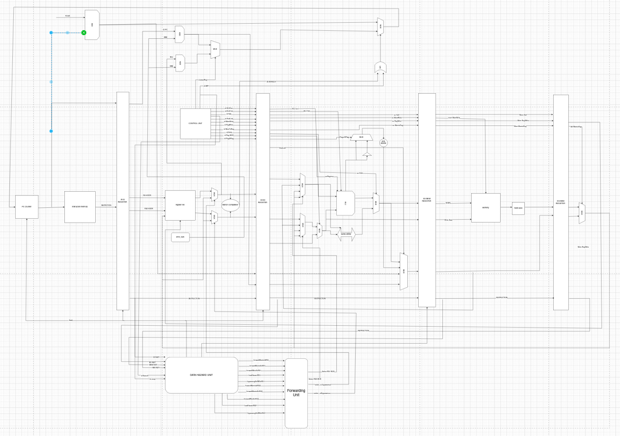

[2.e – i, ii, and iii] In your writeup, show the QuestaSim output for each of the following tests, and provide a discussion of result correctness. It may be helpful to also annotate the waveforms directly.

[2.e.i] Create a spreadsheet to track these cases and justify the coverage of your testing approach. Include this spreadsheet in your report as a table.

[2.e.ii] Create a spreadsheet to track these cases and justify the coverage of your testing approach. Include this spreadsheet in your report as a table.

[2.f] report the maximum frequency your hardware-scheduled pipelined processor can run at and determine what your critical path is (specify each module/entity/component that this path goes through).

31.20MHz

Critical Path: (JALR Instruction)
Imem → Register Bypass Multiplexer → Adder for JALR → FetchUnit (Updating PC register)

