Sprint 2 Plan

ScrumLite

2/6/16

Revision 4

2/19/16

Goal:

We need to restructure the all databases in order for it work better together. We need to expand upon the scrum board and fix the various glitches.

User Stories/ Tasks:

1. As a project manager, I want an easy to use and in depth SCRUM board.

Redo user stories/ task db tables

Add backlog

Change task status

Front end

1. As a project manager, I want to be able to keep track of meetings and various forms.

Burn-up charts

TSR’s

Better integrated tables

Redo team tables

Invite members

Accept Invites

Remove members

Front end

1. As a project member, I want to have access to important information and be able to share information with the rest of my team.

View team

Chat function scaffolding

Calendar scaffolding

Front end

Team Roles:

Manmeet Singh: Product Owner

Colton: Develeoper

Alessio Alba: Developer

Jake: Scrum Master

David: Developer

Muhammed Saber: Developer

Task Assignment:

Manmeet Singh: (1, Redo user stories/ task db tables, 2/17/16), (1, add backlog), (1, change task status, 2/17/16), (2, burn-up charts, 2/17/16)

Colton: (2, Better integrated tables, 2/17/16), (2, Redo Team tables, 2/17/16), (3, View Team), (3, Calendar scaffolding, 2/17/16)

Alessio Alba: (2, Better integrated tables, 2/17/16), (2, Remove members, 2/17/16)

Jake: (2, Better integrated tables, 2/17/16), (2, Redo Team tables, 2/17/16), (2, Invite members, 2/17/16), (2, Accept invites, 2/17/16)

David: (1, Front end, 2/17/16), (2, Front end, 2/17/16), (3, Front end, 2/17/16)

Muhammed: (3, Chat function scaffolding, 2/17/16)

Initial Burnup Chart:

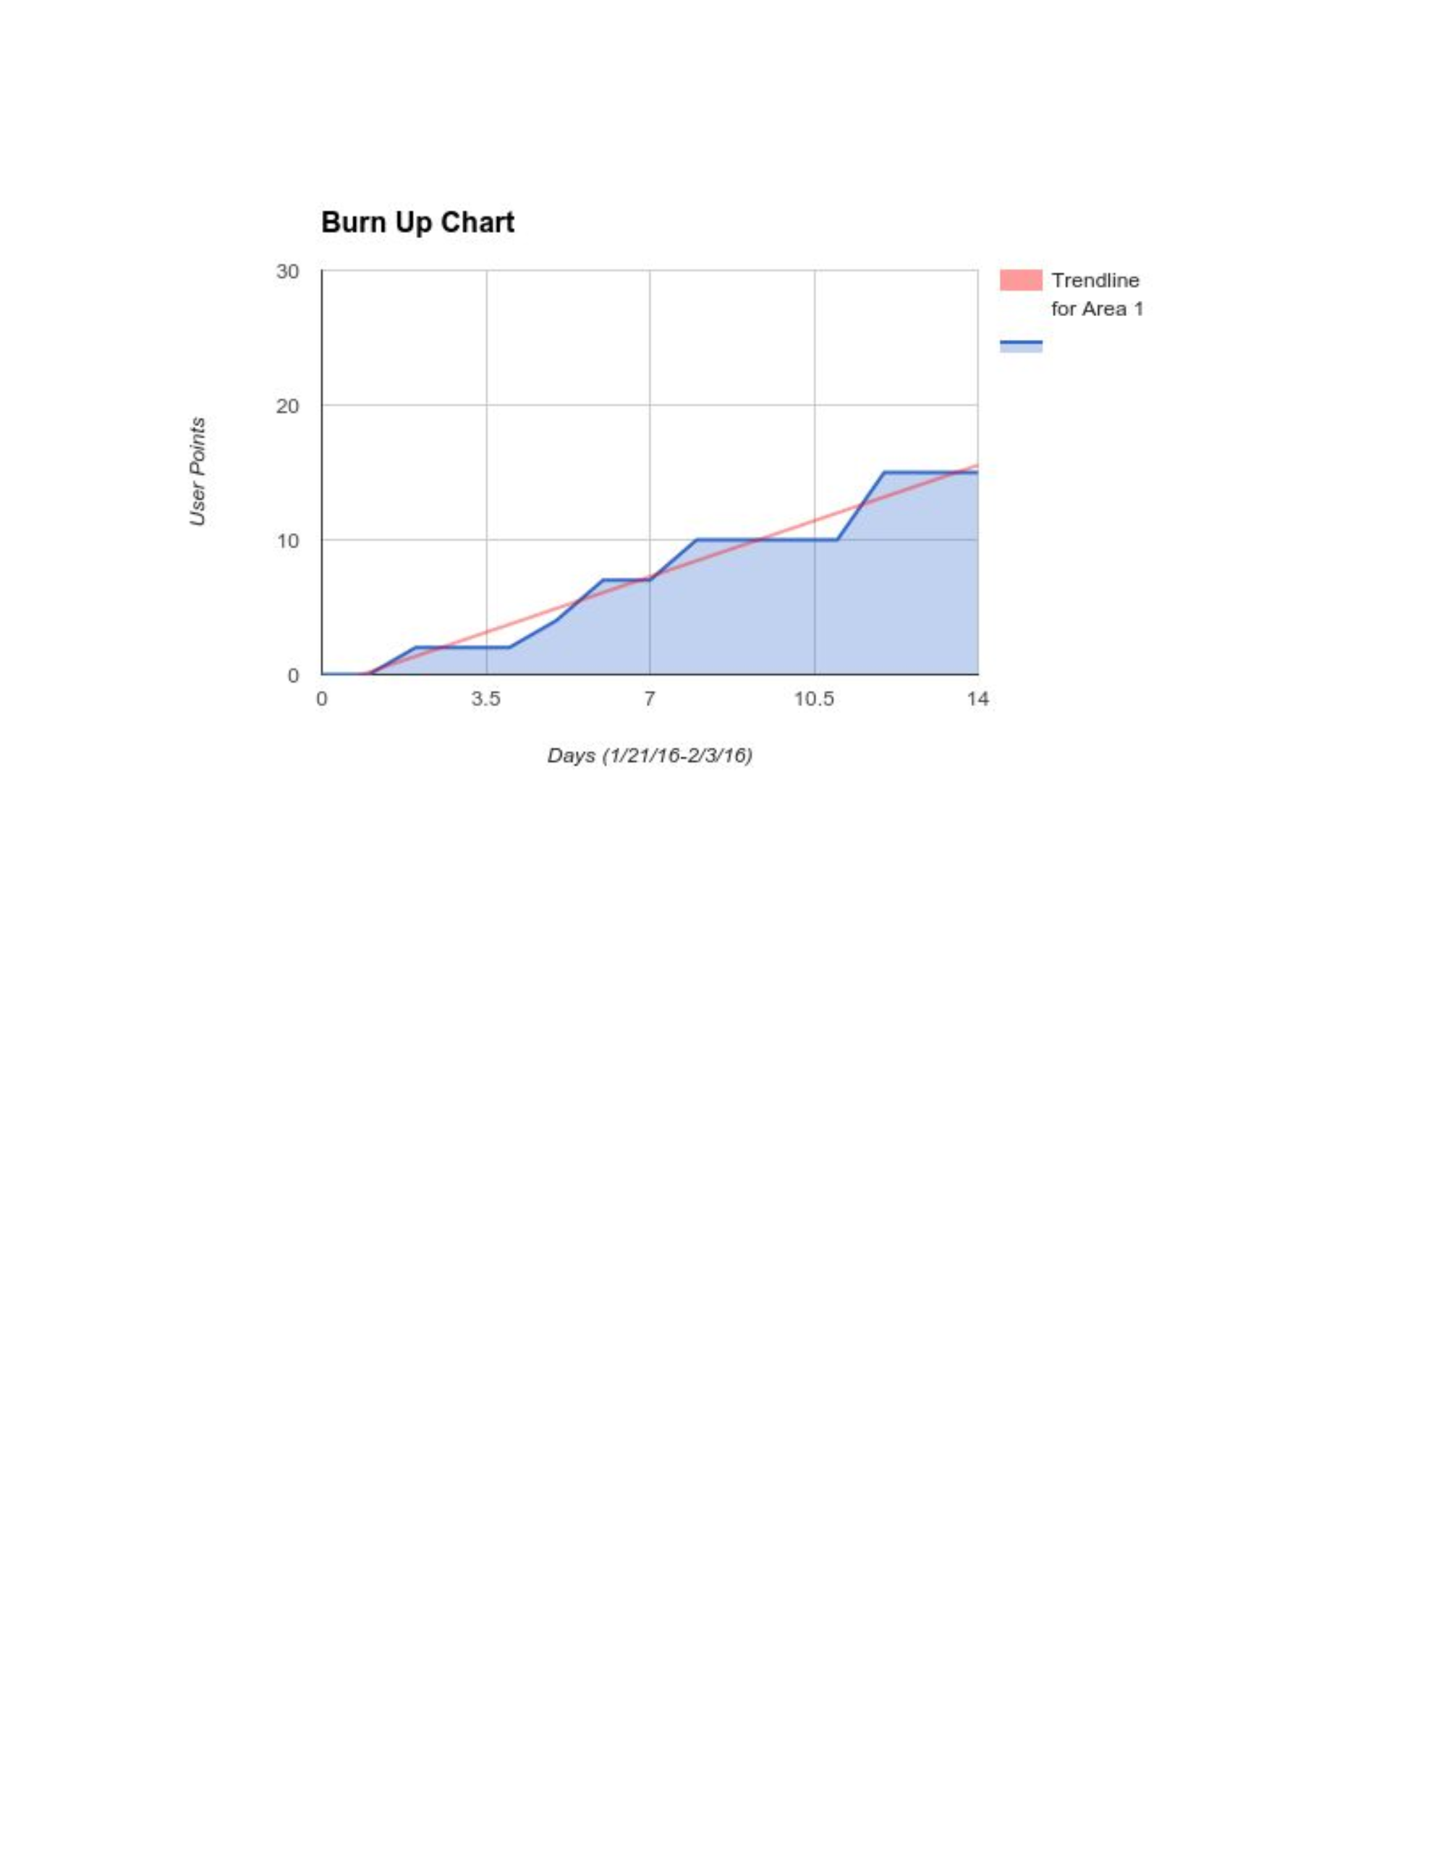

Scrum board: <https://trello.com/b/yhp1NgCI/scrum-board>

Scrum Times: MWF 2:00 Merrill Library